**41**

# Active Power Filters

Luis Morán University of Concepción, Concepción, Chile

Juan Dixon Catholic University of Chile, Santiago, Chile

Miguel Torres University of O'Higgins, Rancagua, Chile

## Abstract

The growing number of power-electronics-based equipment has produced an important impact on the quality of electric power supply. Both high-power industrial loads and domestic loads cause harmonics in the network voltages. At the same time, much of the equipment causing the disturbances is quite sensitive to deviations from the ideal sinusoidal line voltage. Therefore, power quality problems may originate in the system or may be caused by the consumer itself. For an increasing number of applications, conventional equipment is proving insufficient for mitigation of power quality problems. Harmonic distortion has traditionally been dealt with the use of passive LC filters. However, the application of passive filters for harmonic reduction may result in parallel resonances with the network impedance, over compensation of reactive power at fundamental frequency, and poor flexibility for dynamic compensation of different frequency harmonic components. The increased severity of power quality in power networks has attracted the attention of power engineers to develop dynamic and adjustable solutions to the power quality problems. Such equipment, generally known as active filters, are also called active power line conditioners and are able to compensate current and voltage harmonics and reactive power, regulate terminal voltage, suppress flicker, and improve voltage balance in three-phase systems. The advantage of active filtering is that it automatically adapts to changes in the network and load fluctuations. They can compensate for several harmonic orders, and are not affected by major changes in network characteristics, eliminating the risk of resonance between the filter and network impedance. Another plus is that they take up very little space compared with traditional passive compensators.

### KEYWORDS:

Power electronics; Active filters; Power quality; Harmonics; Power compensation

41.1 [Introduction](https://learning.oreilly.com/library/view/power-electronics-handbook/9780128114087/B9780128114070000465_1.xhtml#s0010)

41.2 [Types of Active Power Filters](https://learning.oreilly.com/library/view/power-electronics-handbook/9780128114087/B9780128114070000465_1.xhtml#s0015)

41.2.1 Shunt Active Power Filters

41.2.2 Power Circuit Topologies

41.2.3 Control Scheme

41.2.4 Power Circuit Design

41.2.5 Technical Specifications

41.3 [Series Active Power Filters](https://learning.oreilly.com/library/view/power-electronics-handbook/9780128114087/B9780128114070000465_1.xhtml#s0150)

41.3.1 Power Circuit Structure

41.3.2 Principles of Operation

41.3.3 Power Circuit Design

41.3.4 Control Issues

41.3.5 Control Circuit Implementation

41.3.6 Experimental Results

41.4 [Hybrid Active Power Filters](https://learning.oreilly.com/library/view/power-electronics-handbook/9780128114087/B9780128114070000465_1.xhtml#s0220)

41.4.1 Principles of Operation

41.4.2 The Hybrid Filter Compensation Performance

41.4.3 Experimental Results

41.5 [Predictive Control in Active Power Filters](https://learning.oreilly.com/library/view/power-electronics-handbook/9780128114087/B9780128114070000465_1.xhtml#s0255)

41.5.1 Predictive Current Control

41.5.2 Current Reference Generator

41.5.3 DC Voltage Control

41.5.4 Performance Evaluation

[Acknowledgments](https://learning.oreilly.com/library/view/power-electronics-handbook/9780128114087/B9780128114070000465_1.xhtml#ac0010)

[References](https://learning.oreilly.com/library/view/power-electronics-handbook/9780128114087/B9780128114070000465_2.xhtml#bi0010)

[Further Reading](https://learning.oreilly.com/library/view/power-electronics-handbook/9780128114087/B9780128114070000465_2.xhtml#fr0010)

## Acknowledgments

The authors would like to acknowledge the financial support from “FONDECYT” through the 1140419 project. The collaboration of Dr. Pablo Acuña from the University of New South Wales, Sydney, Australia, is also recognized.

## 41.1 Introduction

The growing number of power-electronics-based equipment has produced an important impact on the quality of electric power supply. Both high-power industrial loads and domestic loads cause harmonics in the network voltages. At the same time, much of the equipment causing the disturbances is quite sensitive to deviations from the ideal sinusoidal line voltage. Therefore, power quality problems may originate in the system or may be caused by the consumer itself. Moreover, in the last years, the growing concern related to power quality comes from the following:

• Consumers that are becoming increasingly aware of the power quality issues and being more informed about the consequences of harmonics, interruptions, sags, switching transients, etc. Motivated by deregulation, they are challenging the energy suppliers to improve the quality of the power delivered.

• The proliferation of load equipment with microprocessor-based controllers and power electronic devices that are sensitive to many types of power quality disturbances.

• Emphasis on increasing overall process productivity that has led to the installation of high-efficiency equipment, such as adjustable speed drives and power factor correction equipment. This in turn has resulted in an increase in harmonics injected into the power system, causing concern about their impact on the system behavior.

For an increasing number of applications, conventional equipment is proving insufficient for the mitigation of power quality problems. Harmonic distortion has traditionally been dealt with the use of passive LC filters. However, the application of passive filters for harmonic reduction may result in parallel resonances with the network impedance, over compensation of reactive power at fundamental frequency, and poor flexibility for dynamic compensation of different frequency harmonic components.

The increased severity of power quality in power networks has attracted the attention of power engineers to develop dynamic and adjustable solutions to the power quality problems. Such equipment, generally known as active filters, are also called active power line conditioners and are able to compensate current and voltage harmonics and reactive power, regulate terminal voltage, suppress flicker, and improve voltage balance in three-phase systems. The advantage of active filtering is that it automatically adapts to changes in the network and load fluctuations. They can compensate for several harmonic orders, and are not affected by major changes in network characteristics, eliminating the risk of resonance between the filter and network impedance. Another plus is that they take up very little space compared with traditional passive compensators.

## 41.2 Types of Active Power Filters

The technology of active power filter has been developed during the past two decades reaching maturity for harmonic compensation, reactive power, and voltage balance in ac power networks. All active power filters are developed with pulse-width-modulated (PWM) converters (current-source or voltage-source inverters). The current-fed PWM inverter bridge structure behaves as a nonsinusoidal current source to meet the harmonic current requirement of the nonlinear load. It has a self-supported dc reactor that ensures the continuous circulation of the dc current. They present good reliability but have important losses and require higher values of parallel capacitor filters at the ac terminals to remove unwanted current harmonics. Moreover, they cannot be used in multilevel or multistep mode configurations to allow compensation in higher power ratings.

The other converter used in active power filter topologies is the PWM voltage-source inverter (PWM-VSI). This converter is more convenient for active power filtering applications since it is lighter, cheaper, and expandable to multilevel and multistep versions, to improve its performance for high power rating compensation with lower switching frequencies. The PWM-VSI has to be connected to the ac mains through coupling reactors. An electrolytic capacitor keeps a dc voltage constant and ripple-free.

Active power filters can be classified based on the type of converter, topology, control scheme, and compensation characteristics. The most popular classification is based on the topology such as shunt, series, or hybrid. The hybrid configuration is a combination of passive and active compensation. The different active power filter topologies are shown in [Fig. 41.1](https://learning.oreilly.com/library/view/power-electronics-handbook/9780128114087/B9780128114070000465_1.xhtml#f0010).

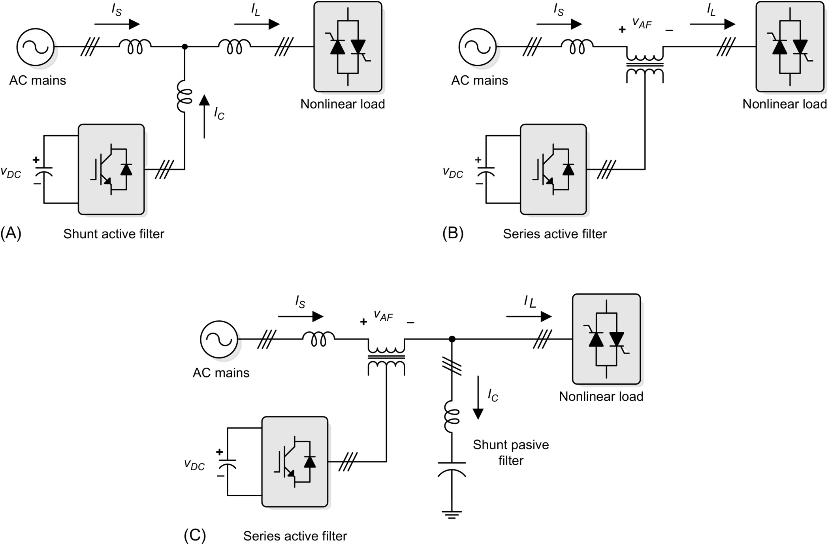

**FIG. 41.1** Active power filter topologies implemented with PWM-VSI: (A) shunt active power filter, (B) series active power filter, and (C) hybrid active power filter.

Shunt active power filters ([Fig. 41.1A](https://learning.oreilly.com/library/view/power-electronics-handbook/9780128114087/B9780128114070000465_1.xhtml#f0010)) are widely used to compensate current harmonics, reactive power, and load current unbalanced. It can also be used as a static var generator in power system networks for stabilizing and improving voltage profile. Series active power filters ([Fig. 41.1B](https://learning.oreilly.com/library/view/power-electronics-handbook/9780128114087/B9780128114070000465_1.xhtml#f0010)) is connected before the load in series with the ac mains, through a coupling transformer to eliminate voltage harmonics and to balance and regulate the terminal voltage of the load or line. The hybrid configuration is a combination of series active filter and passive shunt filter ([Fig. 41.1C](https://learning.oreilly.com/library/view/power-electronics-handbook/9780128114087/B9780128114070000465_1.xhtml#f0010)). This topology is very convenient for the compensation of high-power systems, because the rated power of the active filter is significantly reduced (about 10% of the load size), since the major part of the hybrid filter consists of the passive shunt LC filter used to compensate lower-order current harmonics and reactive power at fundamental frequency.

Due to the operation constraint, shunt or series active power filters can compensate only specific power quality problems. Therefore, the selection of the type of active power filter to improve power quality depends on the source of the problem as can be seen in [Table 41.1](https://learning.oreilly.com/library/view/power-electronics-handbook/9780128114087/B9780128114070000465_1.xhtml#t0010).

**Table 41.1**

**Active filter solutions to power quality problems**

|  |  |  |
| --- | --- | --- |
| **Active filter connection** | **Load on ac supply** | **AC supply on load** |
| Shunt | Current harmonic filtering |  |
| Reactive current compensation |  |
| Current unbalance |  |
| Voltage flicker |  |
| Series | Current harmonic filtering | Voltage sag/swell |
| Reactive current compensation | Voltage unbalance |
| Current unbalance | Voltage distortion |
| Voltage flicker | Voltage interruption |
| Voltage unbalance | Voltage flicker |
|  | Voltage notching |

The principles of operation of shunt, series, and hybrid active power filters are described in the following sections.

### 41.2.1 SHUNT ACTIVE POWER FILTERS

Shunt active power filters compensate current harmonics by injecting equal but opposite harmonic compensating current. In this case, the shunt active power filter operates as a current source injecting the harmonic components generated by the load but phase shifted by 180 degrees. As a result, components of harmonic currents contained in the load current are canceled by the effect of the active filter, and the source current remains sinusoidal and in phase with the respective phase-to-neutral voltage. This principle is applicable to any type of load considered as a harmonic source. Moreover, with an appropriate control scheme, the active power filter can also compensate the load power factor. In this way, the power distribution system sees the nonlinear load and the active power filter as an ideal resistor. The compensation characteristics of the shunt active power filter are shown in [Fig. 41.2](https://learning.oreilly.com/library/view/power-electronics-handbook/9780128114087/B9780128114070000465_1.xhtml#f0015).

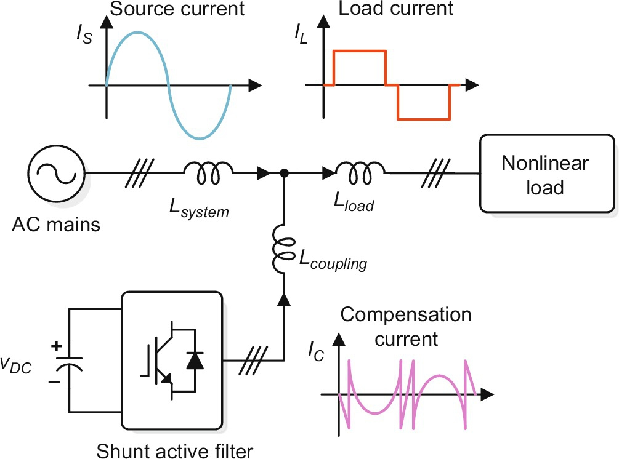

**FIG. 41.2** Compensation characteristics of a shunt active power filter.

### 41.2.2 POWER CIRCUIT TOPOLOGIES

Shunt active power filters are normally implemented with PWM-VSIs. In this type of application, the PWM-VSI operates as a current-controlled voltage source. Traditionally, two-level PWM-VSIs have been used to implement such system connected to the ac bus through a transformer. This type of configuration is aimed to compensate nonlinear load rated in the medium power range (hundreds of kilovolt-amperes) due to semiconductor rated value limitations. However, in the last years, multilevel PWM-VSIs have been proposed to develop active power filters for medium-voltage and higher rated power applications. Also, active power filters implemented with multiple VSIs connected in parallel to a dc bus but in series through a transformer or in cascade have been proposed in the technical literature. The different power circuit topologies are shown in [Fig. 41.3](https://learning.oreilly.com/library/view/power-electronics-handbook/9780128114087/B9780128114070000465_1.xhtml#f0020).

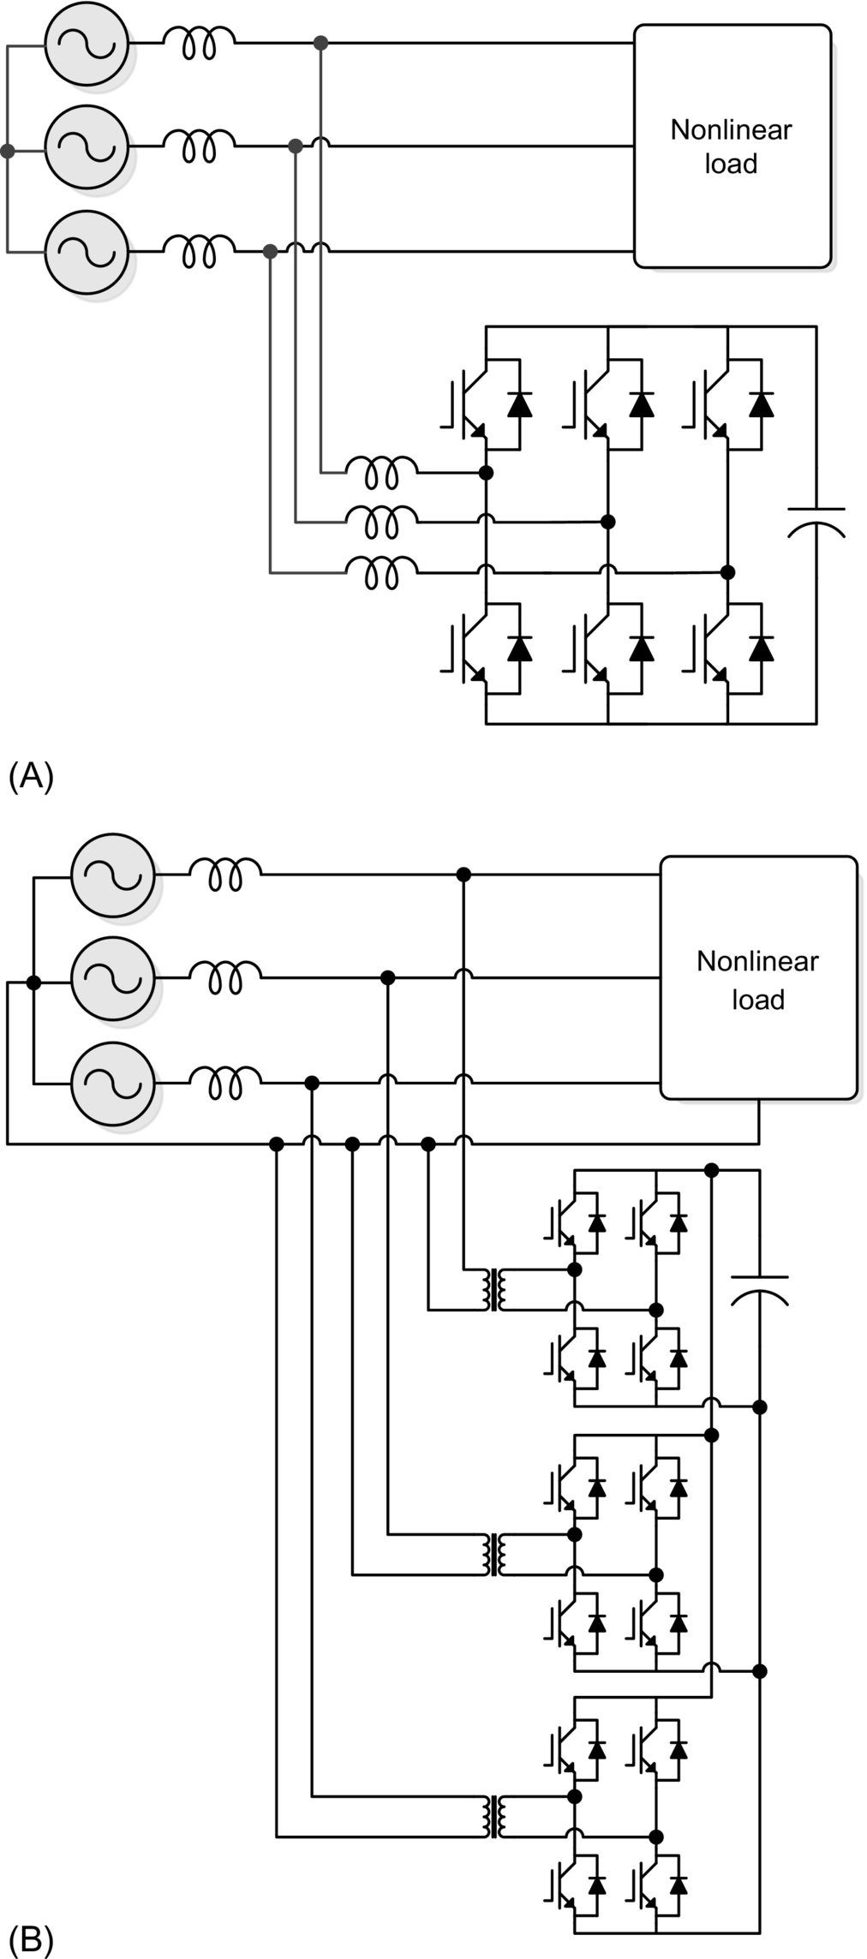

**FIG. 41.3** Shunt active power filter topologies implemented with PWM-VSIs: (A) a three-phase PWM unit and (B) three single-phase units in parallel to a common dc bus.

The use of VSI connected in cascade is an interesting alternative to compensate high-power nonlinear loads. The use of two PWM-VSI with different rated power allows the use of different switching frequencies, reducing switching stresses and commutation losses in the overall compensation system. The power circuit configuration of such a system is shown in [Fig. 41.4](https://learning.oreilly.com/library/view/power-electronics-handbook/9780128114087/B9780128114070000465_1.xhtml#f0025).

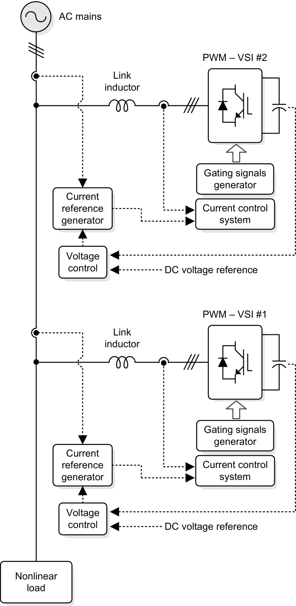

**FIG. 41.4** A shunt active power filter implemented with two PWM-VSI connected in cascade.

The VSI connected closer to the load compensates for the displacement power factor and lower-frequency current harmonic components ([Fig. 41.5B](https://learning.oreilly.com/library/view/power-electronics-handbook/9780128114087/B9780128114070000465_1.xhtml#f0030)), while the second compensates only high-frequency current harmonic components. The first converter requires higher rated power than the second and can operate at lower switching frequency. The compensation characteristics of the cascade shunt active power filter are shown in [Fig. 41.5](https://learning.oreilly.com/library/view/power-electronics-handbook/9780128114087/B9780128114070000465_1.xhtml#f0030).

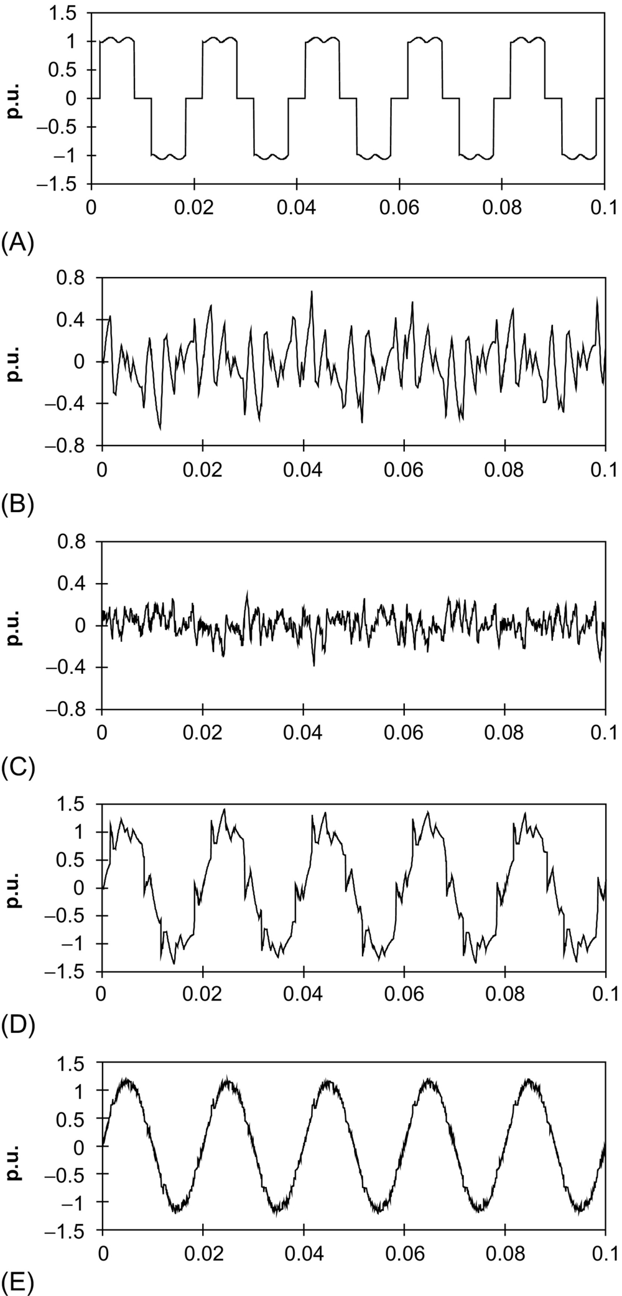

**FIG. 41.5** Current waveforms of active power filter implemented with two PWM-VSI in cascade: (A) load current waveform, (B) current waveform generated by PWM-VSI no. 1, (C) current waveform generated by PWM-VSI no. 2, (D) power system current waveform between the two inverters (*THDi*=13.7%), and (E) power system current waveform (*THDi*=4.5%).

In recent years, there has been an increasing interest in using multilevel inverters for high-power energy conversion, especially for drives and reactive power compensation. The use of neutral-point-clamped (NPC) inverters ([Fig. 41.6](https://learning.oreilly.com/library/view/power-electronics-handbook/9780128114087/B9780128114070000465_1.xhtml#f0035)) allows equal voltage shearing of the series-connected semiconductors in each phase. Basically, multilevel inverters have been developed for applications in medium-voltage ac motor drives and static var compensation. For these types of applications, the output voltage of the multilevel inverter must be able to generate an almost sinusoidal output current. In order to generate a near sinusoidal output current, the output voltage should not contain low-frequency harmonic components.

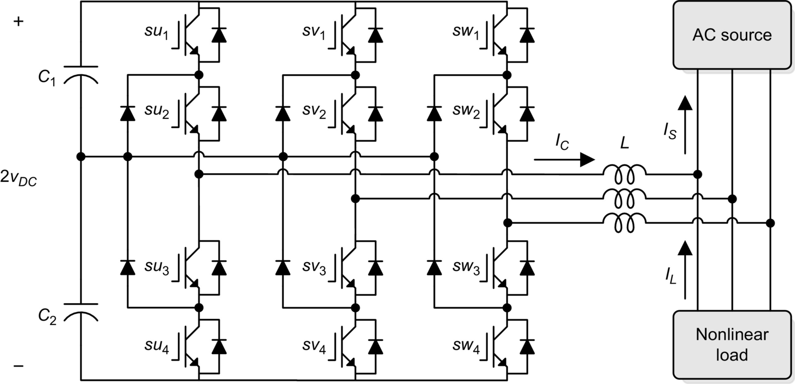

**FIG. 41.6** A shunt active power filter implemented with a three-level neutral-point-clamped VSI.

However, for active power filter applications, the three-level NPC inverter output voltage must be able to generate an output current that follows the respective reference current containing the harmonic and reactive component required by the load. Current and voltage waveforms obtained for a shunt active power filter implemented with a three-level NPC-VSI are shown in [Fig. 41.7](https://learning.oreilly.com/library/view/power-electronics-handbook/9780128114087/B9780128114070000465_1.xhtml#f0040).

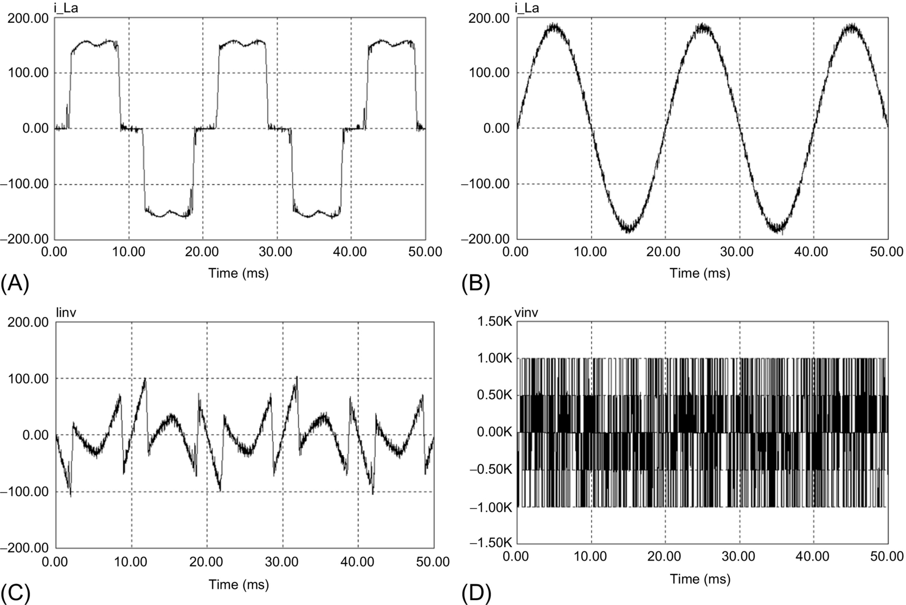

**FIG. 41.7** Current and voltage waveforms for a shunt active power filter implemented with a three-level NPC-VSI: (A) load current, (B) compensated system current (*THDi*=3.5%), (C) current generated by the shunt active power filter, and (D) inverter output voltage.

### 41.2.3 CONTROL SCHEME

The control scheme of a shunt active power filter must calculate the current reference waveform for each phase of the inverter, maintain the dc voltage constant, and generate the inverter gating signals. The block diagram of the control scheme of a shunt active power filter is shown in [Fig. 41.8](https://learning.oreilly.com/library/view/power-electronics-handbook/9780128114087/B9780128114070000465_1.xhtml#f0045).

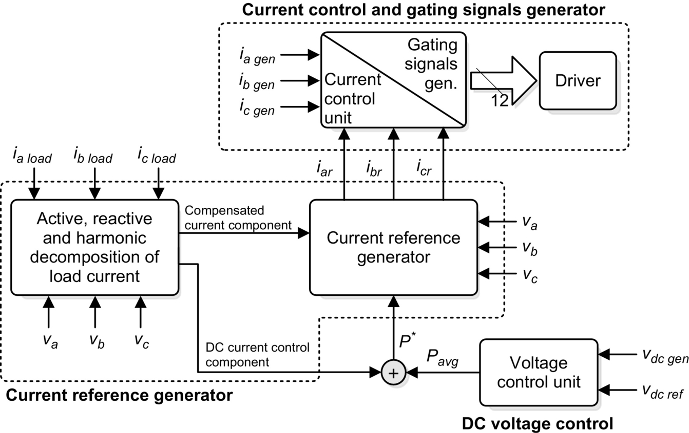

**FIG. 41.8** The block diagram of a shunt active power filter control scheme.

The current reference circuit generates the reference currents required to compensate the load current harmonics and reactive power and also try to maintain constant the dc voltage across the electrolytic capacitors. There are many possibilities to implement this type of control, and the most popular of them will be explained in this chapter. Also, the compensation effectiveness of an active power filter depends on its ability to follow with a minimum error and time delay the reference signal calculated to compensate the distorted load current. Finally, the dc voltage control unit must keep the total dc bus voltage constant and equal to a given reference value. The dc voltage control is achieved by adjusting the small amount of real power absorbed by the inverter. This small amount of real power is adjusted by changing the amplitude of the fundamental component of the reference current.

#### **41.2.3.1 Current Reference Generation**

There are many possibilities to determine the reference current required to compensate the nonlinear load. Normally, shunt active power filters are used to compensate the displacement power factor and low-frequency current harmonics generated by nonlinear loads. One alternative to determine the current reference required by the VSI is the use of the instantaneous reactive power theory, proposed by Akagi [[1](https://learning.oreilly.com/library/view/power-electronics-handbook/9780128114087/B9780128114070000465_2.xhtml#bb0010)], the other one is to obtain current components in *d*-*q* or synchronous reference frame [[2](https://learning.oreilly.com/library/view/power-electronics-handbook/9780128114087/B9780128114070000465_2.xhtml#bb0015)], and the third one is to force the system line current to follow a perfectly sinusoidal template in phase with the respective phase-to-neutral voltage.

##### **Instantaneous reactive power theory**

This concept is very popular and useful for this type of application and basically consists of a variable transformation from the *a*, *b*, *c* reference frame of the instantaneous power, voltage, and current signals to the *α*, *β* reference frame. The transformation equations from the *a*, *b*, *c* reference frame to the *α*, *β* coordinates can be derived from the phasor diagram shown in [Fig. 41.9](https://learning.oreilly.com/library/view/power-electronics-handbook/9780128114087/B9780128114070000465_1.xhtml#f0050).

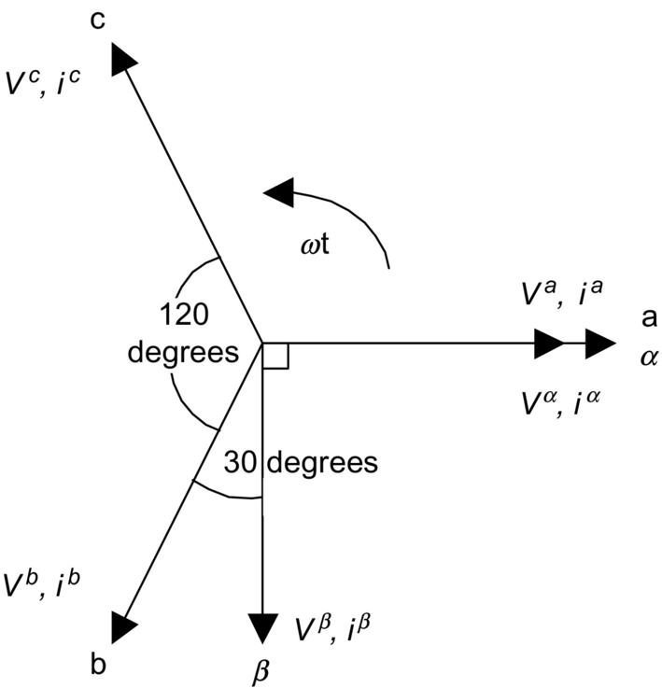

**FIG. 41.9** Transformation diagram from the *a*, *b*, *c* reference frame to the *α*, *β* coordinates.

The instantaneous values of voltages and currents in the *α*, *β* coordinates can be obtained from the following equations:

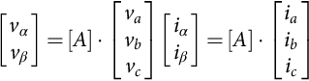 **(41.1)**

where *A* is the transformation matrix, derived from [Fig. 41.9](https://learning.oreilly.com/library/view/power-electronics-handbook/9780128114087/B9780128114070000465_1.xhtml#f0050) and is equal to

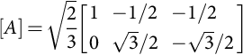 **(41.2)**

This transformation is valid if and only if  is equal to zero and also if the voltages are balanced and sinusoidal. The instantaneous active and reactive power in the *α*, *β* coordinates are calculated with the following expressions:

 **(41.3)**

**** **(41.4)**

It is evident that *p(t)* becomes equal to the conventional instantaneous real power defined in the *a*, *b*, *c* reference frame. However, in order to define the instantaneous reactive power, Akagi introduces a new instantaneous space vector defined by expression [(41.4)](https://learning.oreilly.com/library/view/power-electronics-handbook/9780128114087/B9780128114070000465_1.xhtml#fo0025) or by the vector equation:

 **(41.5)**

where the vector *q* is perpendicular to the plane of *α*, *β* coordinates, to be faced in compliance with a right-hand rule; *vα* is perpendicular to *iβ*; and *vβ* is perpendicular to *iα*. The physical meaning of the vector *q* is not “instantaneous power” because of the product of the voltage in one phase and the current in the other phase. On the contrary, *vαiα* and *vβiβ* in Eq. [(41.3)](https://learning.oreilly.com/library/view/power-electronics-handbook/9780128114087/B9780128114070000465_1.xhtml#fo0020) obviously mean “instantaneous power” because of the product of the voltage in one phase and the current in the same phase. Akagi named the new electric quantity defined in Eq. [(41.5)](https://learning.oreilly.com/library/view/power-electronics-handbook/9780128114087/B9780128114070000465_1.xhtml#fo0030) “instantaneous imaginary power,” which is represented by the product of the instantaneous voltage and current in different axes, but cannot be treated as a conventional quantity.

The expression of the currents in the  plane, as a function of the instantaneous power, is given by the following equation:

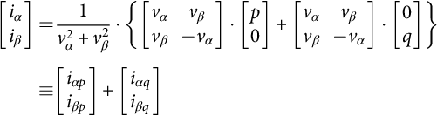 **(41.6)**

and the different components of the currents in the  plane are shown in the following expressions:

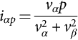 **(41.7)**

**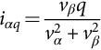** **(41.8)**

**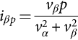** **(41.9)**

**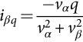** **(41.10)**

From Eqs. [(41.3)](https://learning.oreilly.com/library/view/power-electronics-handbook/9780128114087/B9780128114070000465_1.xhtml#fo0020) and [(41.4)](https://learning.oreilly.com/library/view/power-electronics-handbook/9780128114087/B9780128114070000465_1.xhtml#fo0025), the values of *p* and *q* can be expressed in terms of the dc components and the ac components, that is,

 **(41.11)**

**** **(41.12)**

where

 is the dc component of the instantaneous power *p* and is related to the conventional fundamental active current,

 is the ac component of the instantaneous power *p*; it does not have average value and is related to the harmonic currents caused by the ac component of the instantaneous real power.

 is the dc component of the imaginary instantaneous power *q* and is related to the reactive power generated by the fundamental components of voltages and currents.

 is the ac component of the instantaneous imaginary power *q* and it is related to the harmonic currents caused by the ac component of instantaneous reactive power.

In order to compensate reactive power (displacement power factor) and current harmonics generated by nonlinear loads, the reference signal of the shunt active power filter must include the values of , , and . In this case, the reference currents required by the shunt active power filters are calculated with the following expression:

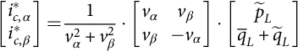 **(41.13)**

The final compensating currents including the zero-sequence components in *a*, *b*, *c* reference frame are the following:

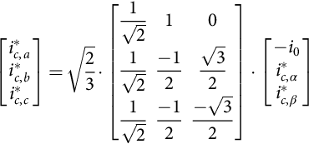 **(41.14)**

where the zero-sequence current component *i*0 is equal to . The block diagram of the circuit required to generate the reference currents defined in Eq. [(41.14)](https://learning.oreilly.com/library/view/power-electronics-handbook/9780128114087/B9780128114070000465_1.xhtml#fo0075) is shown in [Fig. 41.10](https://learning.oreilly.com/library/view/power-electronics-handbook/9780128114087/B9780128114070000465_1.xhtml#f0055).

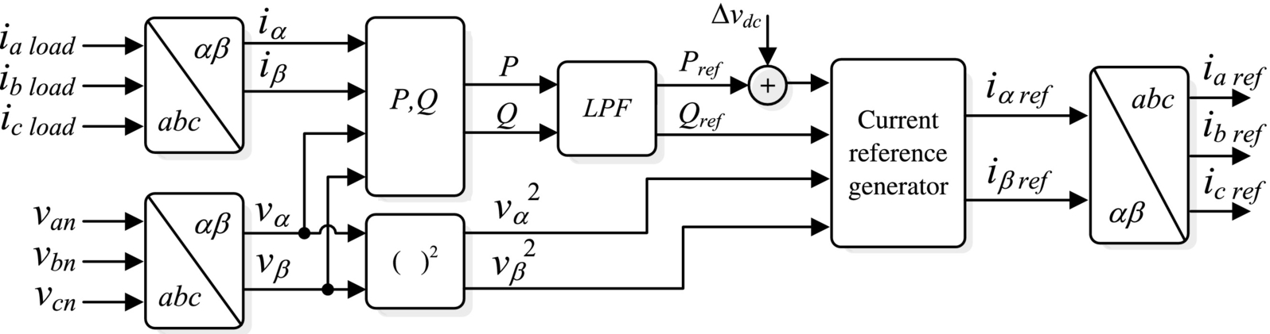

**FIG. 41.10** The block diagram of the current reference generator using *p-q* theory.

The advantage of instantaneous reactive power theory is that real and reactive power associated with fundamental components are dc quantities. These quantities can be extracted with a low-pass filter. Since the signal to be extracted is dc, filtering of the signal in the  reference frame is insensitive to any phase-shift errors introduced by the low-pass filter, improving compensation characteristics of the active power filter. The same advantage can be obtained by using the *synchronous reference frame method*, proposed in [[2](https://learning.oreilly.com/library/view/power-electronics-handbook/9780128114087/B9780128114070000465_2.xhtml#bb0015)]. In this case, transformation from *a*, *b*, *c* axes to *d*-*q* synchronous reference frame is done.

###### **Effects of the low-pass filter design characteristics in compensation performance**

A Butterworth filter is normally used due to the adequate frequency response. A second-order filter offers an appropriate relation between the transient response and the required attenuation characteristic. Higher-order filters achieve better filtering characteristic, but the settling time is increased. Since the low-pass filter cannot eliminate completely the low-frequency harmonic contained in the *p* and *q* signals, the shunt active power filter cannot compensate the entire low-frequency harmonic contained in the load current. Normally, the cutoff frequency is equal to 127 Hz with an attenuation factor of 15 dB for the first ac component to be eliminated, which means an 82.2% attenuation of the fifth and seventh harmonic components ([Fig. 41.11](https://learning.oreilly.com/library/view/power-electronics-handbook/9780128114087/B9780128114070000465_1.xhtml#f0060)). The expression that relates the system line current harmonic distortion with the LPF cutoff frequency and load power factor is shown in Eq. [(41.15)](https://learning.oreilly.com/library/view/power-electronics-handbook/9780128114087/B9780128114070000465_1.xhtml#fo0080):

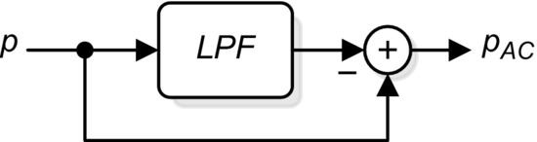

**FIG. 41.11** The low-pass filter block diagram used to extract the ac component of *p*.

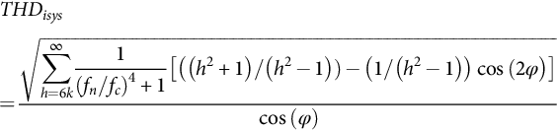 **(41.15)**

with *k*=1, 2, 3,… and *fh* is the frequency of the harmonic component of order *h* and *fc* is the LPF cutoff frequency.

[Fig. 41.12](https://learning.oreilly.com/library/view/power-electronics-handbook/9780128114087/B9780128114070000465_1.xhtml#f0065) shows the total harmonic distortion (THD) in the line currents introduced by the second-order Butterworth filtering characteristics, as a function of the cutoff frequency and considering a 50 Hz ac mains frequency. The harmonic distortion of the compensated line current depends on the load displacement power factor, as shown in Eq. [(41.15)](https://learning.oreilly.com/library/view/power-electronics-handbook/9780128114087/B9780128114070000465_1.xhtml#fo0080). If the cutoff frequency of the low-pass filter is changed, the active power filter compensation performance is affected and the transient response of the control scheme.

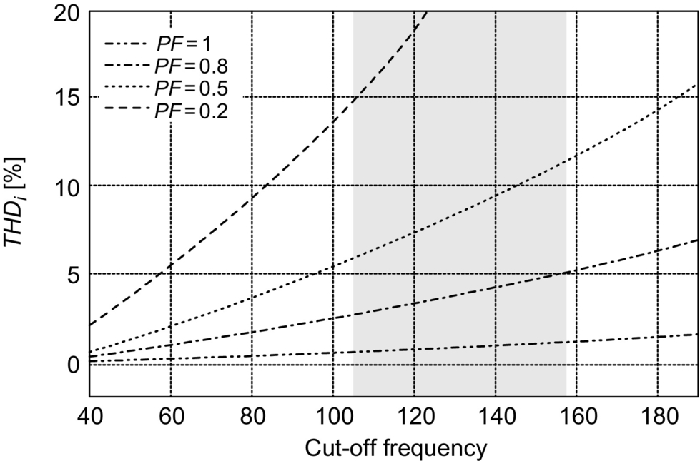

**FIG. 41.12** Harmonic distortion of the compensated line current as a function of the low-pass filter cutoff frequency, .

###### **Effects of the supply voltage distortion in compensation performance**

One of the most important characteristics of the instantaneous imaginary power concept is that in order to obtain the current reference signal required to compensate reactive and harmonic current components, the system phase-to-neutral voltages are used. In general, purely sinusoidal voltages are considered in previously reported analysis. In case voltage is purely sinusoidal, the dc components of *p* and *q* in the *α*–*β* plane are related with the fundamental components in the real *a, b, c* reference system. This is not the case if the system voltages are distorted or unbalanced, as it is demonstrated below.

It is assumed that the supply voltages have harmonic distortion, and these are represented by

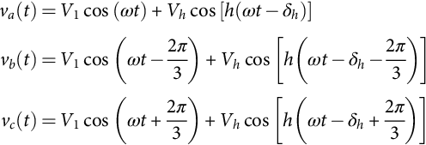 **(41.16)**

Since the harmonic voltage component introduces a dc component in *p* and *q*, compensation performance of the shunt active power filter is reduced, as shown in [Fig. 41.13](https://learning.oreilly.com/library/view/power-electronics-handbook/9780128114087/B9780128114070000465_1.xhtml#f0070). The larger the harmonic distortion in the system voltage is, the active power filter performance is more affected.

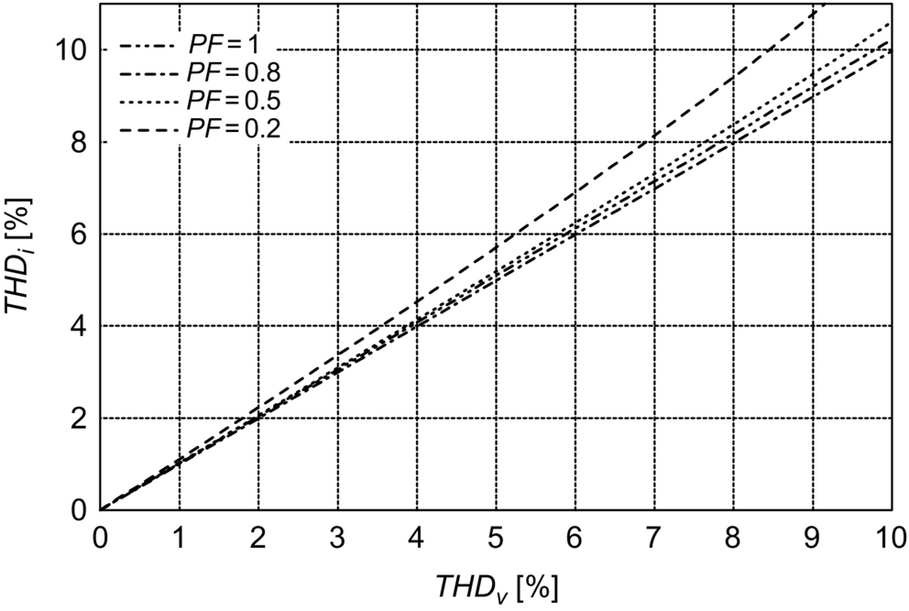

**FIG. 41.13** Harmonic distortion in the compensated line current as a function of the harmonic distortion in the system voltages, .

###### **Effects of the supply voltage unbalance in compensation performance**

Voltage unbalance also affects the active power filter compensation performance. In this analysis, the phase-to-neutral voltages of the ac supply are equal to

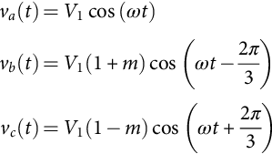 **(41.17)**

with .

If the low-pass filter is considered as ideal and the active filter follows exactly the current references, the compensated supply current (phase *a*) is

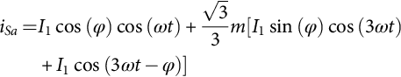 **(41.18)**

In this case, the active power filter is not able to fully compensate the system line current, since compensation performance depends on the voltage unbalance magnitude.

The unbalance is defined as a function of the positive and negative-sequence component as

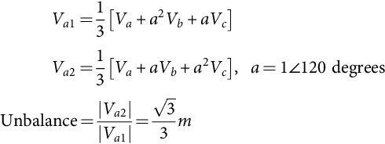 **(41.19)**

The harmonic distortion is equal to

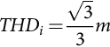 **(41.20)**

The relation between line current harmonic distortion and voltage unbalance is shown in [Fig. 41.14](https://learning.oreilly.com/library/view/power-electronics-handbook/9780128114087/B9780128114070000465_1.xhtml#f0075).

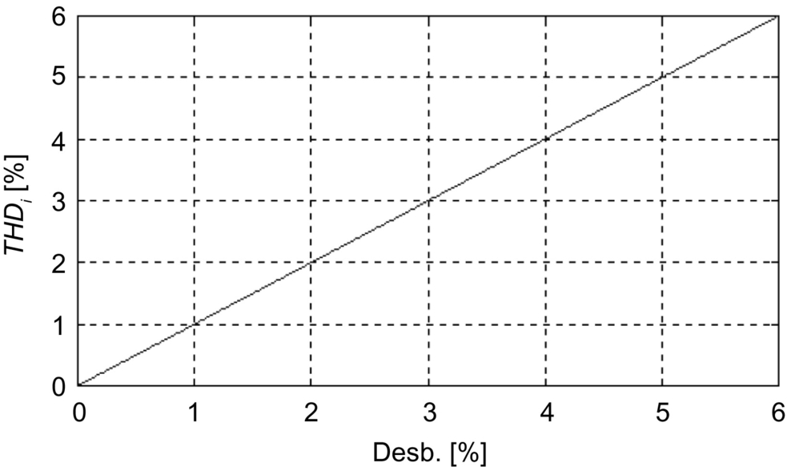

**FIG. 41.14** Harmonic distortion in the compensated line current as a function of the system voltages unbalance.

###### **Effects of the time delay introduced by the dsp in compensation performance**

If a DSP is used to derive the reference generation signals, a time delay, *T*, associated with the processing time is introduced in the calculation of the reference signals. Considering a simultaneous sampling, the ac mains compensated line current with an ideal low-pass filter in the control scheme (phase *a*) is

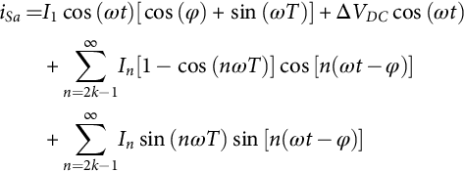 **(41.21)**

The time delay introduced by the DSP affects the compensation performance, especially when fast changes are present in the load current. Nevertheless, when *T* is small (), the effect in compensation performance is negligible.

In four-wire systems, unbalances in the load current also affect the generation of the adequate current reference signal that will assure high-performance active power filter compensation. This assumption can be proved by considering the following load currents:

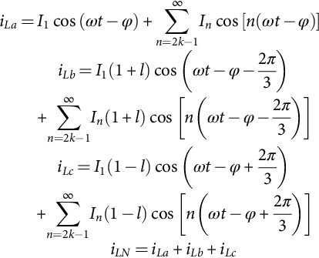 **(41.22)**

with , *k*=1, 2, 3,…

Eq. [(41.23)](https://learning.oreilly.com/library/view/power-electronics-handbook/9780128114087/B9780128114070000465_1.xhtml#fo0120) shows the presence of low-frequency even harmonics in the active power expression introduced by the load current unbalanced. These low-frequency current components force to reduce the cutoff frequency of the low-pass filter, close to 100 Hz, which affects the transient response of the active power filter:

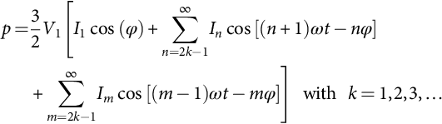 **(41.23)**

##### **Synchronous reference frame algorithm**

The block diagram of a current reference generator that uses the synchronous reference frame algorithm is shown in [Fig. 41.15](https://learning.oreilly.com/library/view/power-electronics-handbook/9780128114087/B9780128114070000465_1.xhtml#f0080).

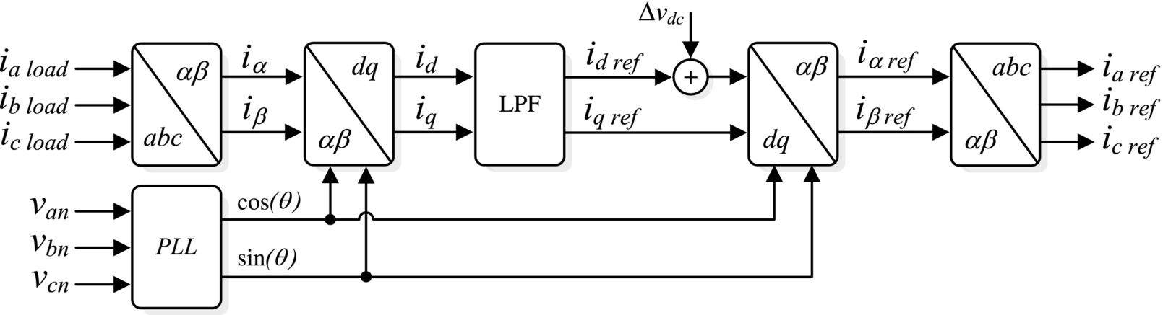

**FIG. 41.15** The circuit block diagram required to obtain current reference waveforms using the synchronous reference frame theory.

In this case, the real currents are transformed into a synchronous reference frame [[2](https://learning.oreilly.com/library/view/power-electronics-handbook/9780128114087/B9780128114070000465_2.xhtml#bb0015)]. The reference frame is synchronized with the ac mains voltage and is rotating at the same frequency. The transformation is defined by

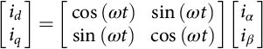 **(41.24)**

As for the instantaneous reactive power theory, *d* and *q* terms are composed by a dc and multiple ac components, such as  and . The compensation reference signals are obtained from the following expressions:  and . The compensated currents generated by the shunt active power filter are obtained from Eq. [(41.25)](https://learning.oreilly.com/library/view/power-electronics-handbook/9780128114087/B9780128114070000465_1.xhtml#fo0130):

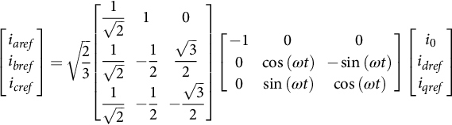 **(41.25)**

One of the most important characteristics of this algorithm is that the reference currents are obtained directly from the load currents without considering the source voltages. This is an important advantage since the generation of the reference signals is not affected by voltage unbalance or voltage distortion, therefore increasing the compensation robustness and performance. However, in order to transform from the  plane to the *d-q* synchronous reference frame, sine and cosine signals synchronized with the respective phase-to-neutral voltages are required. A phase-locked loop (PLL) per each phase, as the one shown in [Fig. 41.16](https://learning.oreilly.com/library/view/power-electronics-handbook/9780128114087/B9780128114070000465_1.xhtml#f0085), must be used.

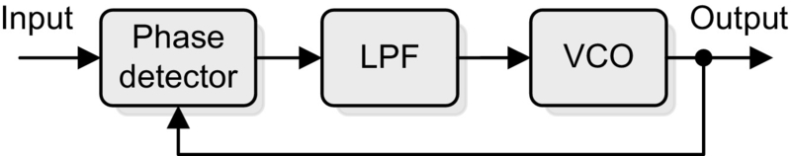

**FIG. 41.16** The PLL circuit block diagram.

Since the algorithm used to obtain the reference current presents the same mathematical procedure and operations that the ones required in the instantaneous reactive power concept, the effects introduced by the filter and DSP time delay are similar. Unbalanced load currents generate a different harmonic spectrum in the synchronous reference frame, and low-order harmonic components appear in the reference signal. In order to separate these uncharacteristic low-frequency current components, the cutoff frequency of the low-pass filter must be reduced.

##### **Peak detection method**

There are other possibilities to generate the current reference signal required to compensate reactive power and current harmonics. Basically, all the different schemes try to obtain the current reference signals that include the reactive components required to compensate the displacement power factor and the current harmonics generated by the nonlinear load. [Fig. 41.17](https://learning.oreilly.com/library/view/power-electronics-handbook/9780128114087/B9780128114070000465_1.xhtml#f0090) shows another scheme used to generate the current reference signals required by a shunt active power filter. In this case, the ac current generated by the inverter is forced to follow the reference signal obtained from the current reference generator. In this circuit, the distorted load current is filtered, extracting the fundamental component, *il*1. The band-pass filter is tuned at the fundamental frequency (50 or 60 Hz), so that the gain attenuation introduced in the filter output signal is zero and the phase-shift angle is 180 degrees. Thus, the filter output current is exactly equal to the fundamental component of the load current but phase shifted by 180 degrees. If the load current is added to the fundamental current component obtained from the second-order band-pass filter, the reference current waveform required to compensate only harmonic distortion is obtained. In order to provide the reactive power required by the load, the current signal obtained from the second-order band-pass filter *Il*1 is synchronized with the respective phase-to-neutral source voltage (see [Fig. 41.17](https://learning.oreilly.com/library/view/power-electronics-handbook/9780128114087/B9780128114070000465_1.xhtml#f0090)) so that the inverter ac output current is forced to lead the respective inverter output voltage, thereby generating the required reactive power and absorbing the real power necessary to supply the switching losses and also to maintain the dc voltage constant.

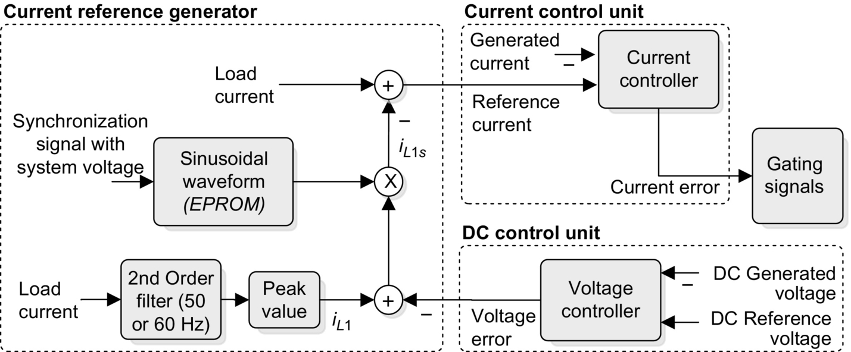

**FIG. 41.17** The block diagram of an active power filter control scheme that does not use the instantaneous reactive power concept.

The real power absorbed by the inverter is controlled by adjusting the amplitude of the fundamental current reference waveform, *Il*1, obtained from the reference current generator. The amplitude of this sinusoidal waveform is equal to the amplitude of the fundamental component of the load current plus or minus the error signal obtained from the dc voltage control unit. In this way, the current signal allows the inverter to supply the current harmonic components, the reactive power required by the load, and to absorb the small amount of active power necessary to cover the switching losses and to keep the dc voltage constant ([Fig. 41.18](https://learning.oreilly.com/library/view/power-electronics-handbook/9780128114087/B9780128114070000465_1.xhtml#f0095)).

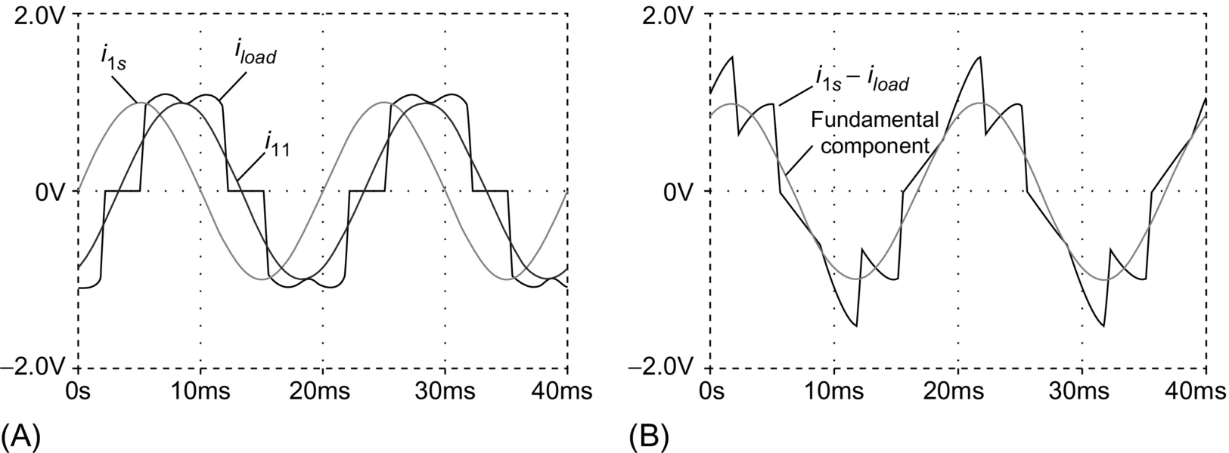

**FIG. 41.18** The procedure for the generation of the current reference waveform: (A) the load current *iload*, its fundamental component, *il*1, and the fundamental current component synchronized with the respective phase-to-neutral source voltage, *ils*, and (B) the synchronized fundamental current signal minus the load current, , and its fundamental component.

The main characteristic of this method is the direct derivation of the compensating component from the load current, without the use of any reference frame transformation [[1](https://learning.oreilly.com/library/view/power-electronics-handbook/9780128114087/B9780128114070000465_2.xhtml#bb0010),[2](https://learning.oreilly.com/library/view/power-electronics-handbook/9780128114087/B9780128114070000465_2.xhtml#bb0015)]. Nevertheless, this technique presents a low-frequency oscillation problem in the active power filter dc bus voltage. To improve this technique, a modification of the previous scheme ([Fig. 41.17](https://learning.oreilly.com/library/view/power-electronics-handbook/9780128114087/B9780128114070000465_1.xhtml#f0090)) is shown in [Fig. 41.19](https://learning.oreilly.com/library/view/power-electronics-handbook/9780128114087/B9780128114070000465_1.xhtml#f0100). The scheme is necessary for each phase. The expression for *iMa* is

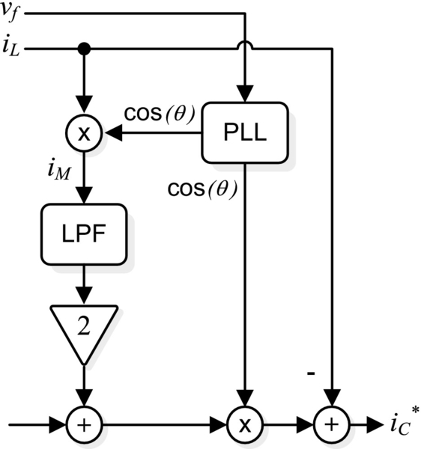

**FIG. 41.19** Modified version of the original peak detection method.

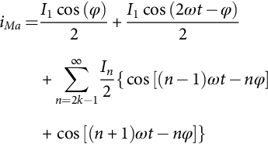 **(41.26)**

with *k*=1, 2, 3,…

[Fig. 41.20](https://learning.oreilly.com/library/view/power-electronics-handbook/9780128114087/B9780128114070000465_1.xhtml#f0105) shows the current harmonic distortion introduced by the low-pass filter used in the control scheme and the associated cutoff frequency. The current distortion of the compensated current depends on the phase angle of the fundamental load current component.

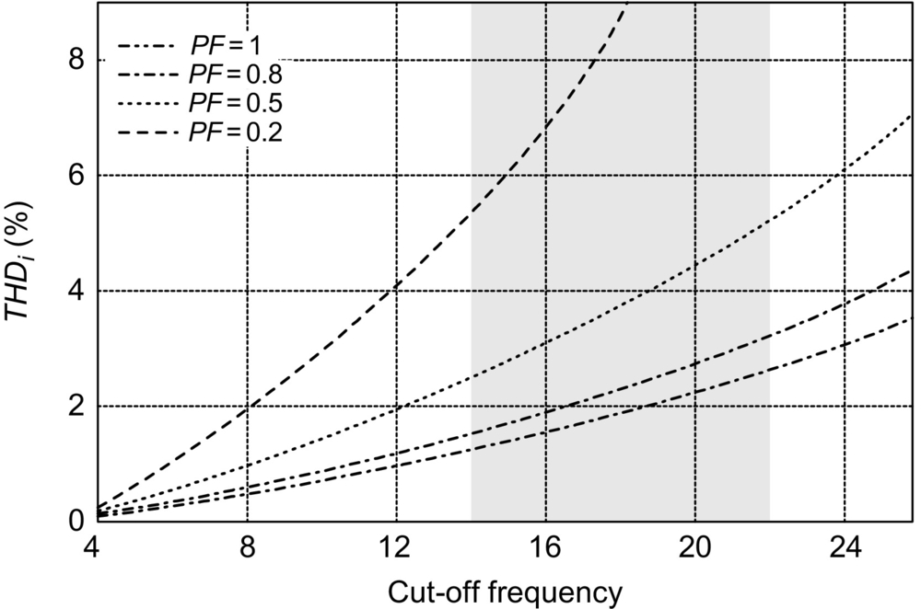

**FIG. 41.20** Harmonic distortion of the system line current as a function of the cutoff frequency of the low-pass filter and the load displacement power factor.

The supply voltage has no effect on the reference current generation. Synchronization with the ac mains voltage is the important issue in this scheme and in the synchronous reference frame theory. Unbalanced loads do not affect the reference generation. Nevertheless, the method cannot achieve active power balance in four-wire systems. The control circuit implementation of the peak detection method is simple and does not require complex calculation, so the processing time on a DSP is lower than the required in the two previous implementations, (*T*<10 s). The use of this method minimizes the distortion introduced on current harmonics.

###### **Technical comparison of the three different techniques**

In order to validate the effectiveness of the proposed analysis, a common industrial system is considered. The results are obtained using the previous equations and Matlab simulation results. The DSP delay introduced is using the processing time according to the DSP ADSP2187. The parameters considered are

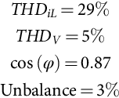

[Table 41.2](https://learning.oreilly.com/library/view/power-electronics-handbook/9780128114087/B9780128114070000465_1.xhtml#t0015) shows the numeric results.

**Table 41.2**

**Results of the considered case**

|  |  |  |  |
| --- | --- | --- | --- |
| **Technique** | ***THDiS*(%)** | **FP** | **Transient delay *td* (ms)** |
| PQ | 8.2 | 0.99 | 18.1 |
| DQ | 3.1 | 0.99 | 18.1 |
| DPVM | 2.3 | 0.99 | 56.8 |

[Table 41.3](https://learning.oreilly.com/library/view/power-electronics-handbook/9780128114087/B9780128114070000465_1.xhtml#t0020) shows a comparison of the three different techniques analyzed. The effects of the nonideal conditions are described for each technique.

**Table 41.3**

**Comparison of the techniques**

|  |  |  |  |
| --- | --- | --- | --- |
| **Parameter** | **PQ** | **SRF** | **PDM** |
| Load *PF* required to achieve full compensation | si12_e | si12_e | si14_e |
| Harmonic distortion voltage effect on the compensated current | si15_e | 0 | 0 |
| Unbalanced voltage effect | si16_e | 0 | 0 |
| Dynamic response under load changes (in function of *fc*, si17_e) | Fast (load balanced) | Fast (load balanced) | Slow |
| Capability of load balance | Yes (It is necessary to reduce cutoff frequency *fc*) | Yes (it is necessary to reduce cutoff frequency *fc*) | No |
| DSP delay time introduced | Minimum | Minimum | si18_e |

In conclusion, it can be mentioned that the compensation performance of the different techniques is similar under ideal conditions, but under the presence of unbalanced and voltage distortion, the synchronous reference frame algorithm presents the best performance, since it is insensitive to voltage perturbations. It is fundamental to consider adequately the cutoff frequency in the filter used to extract the ac component in the different techniques. If the frequency is changed, the compensation performance is affected as well as the transient response of the control scheme. In four-wire systems, unbalance in the load current also affects the generations of the adequate current reference. Unbalanced load currents generate a different harmonic spectrum in the dc reference frame, and low-order harmonic components appear in the reference signal; then, the cutoff frequency of the filter must be reduced.

#### **41.2.3.2 Current Modulator**

The effectiveness of an active power filter depends basically on the design characteristics of the current controller, the method implemented to generate the reference template and the modulation technique used. Most of the modulation techniques used in active power filters are based on PWM strategies. In this chapter, four of these methods, whose characteristics are their simplicity and effectiveness, are analyzed: periodical sampling control, hysteresis band control, triangular carrier control, and vector control. The first three methods have been tested with different waveform templates sinusoidal, quasisquare, and rectifier compensation current and were compared in terms of the harmonic content and distortion at the same switching frequency [[3](https://learning.oreilly.com/library/view/power-electronics-handbook/9780128114087/B9780128114070000465_2.xhtml#bb0020)]. The analysis shows that for sinusoidal current generation the best method is triangular carrier, followed by hysteresis band and periodical sampling. For other types of references, however, one strategy may be better than the others. Also, it was shown that each control method is affected in a different way by the switching time delays present in the driving circuitry and in the power semiconductors.

##### **Periodical sampling**

The periodical sampling method switches the power transistors of the converter during the transitions of a square-wave clock of fixed frequency (the sampling frequency). As shown in [Fig. 41.21](https://learning.oreilly.com/library/view/power-electronics-handbook/9780128114087/B9780128114070000465_1.xhtml#f0110), this type of control is very simple to implement since it requires a comparator and a D-type flip-flop per phase. The main advantage of this method is that the minimum time between switching transitions is limited to the period of the sampling clock. However, the actual switching frequency is not clearly defined.

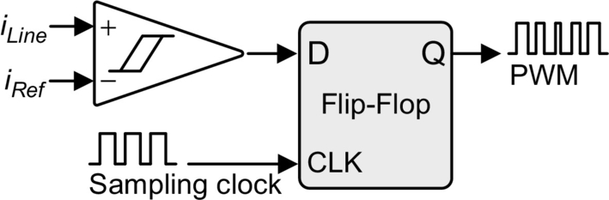

**FIG. 41.21** Control modulator block for periodical sampling method.

##### **Hysteresis band**

The hysteresis band method switches the transistors when the current error exceeds a fixed magnitude: the hysteresis band. As can be seen in [Fig. 41.22](https://learning.oreilly.com/library/view/power-electronics-handbook/9780128114087/B9780128114070000465_1.xhtml#f0115), this type of control needs a single comparator with hysteresis per phase. In this case, the switching frequency is not determined, but it can be estimated.

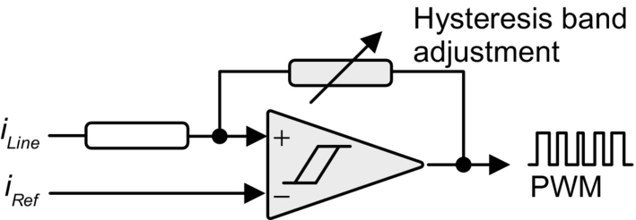

**FIG. 41.22** Control modulator block for hysteresis band.

##### **Triangular carrier**

The triangular carrier method, shown in [Fig. 41.23](https://learning.oreilly.com/library/view/power-electronics-handbook/9780128114087/B9780128114070000465_1.xhtml#f0120), compares the current error with fixed-amplitude and fixed-frequency triangular wave (the triangular carrier). The error is processed through a proportional-integral (PI) gain stage before the comparison with the triangular carrier takes place. As can be seen, this control scheme is more complex than the periodical sampling and hysteresis band. The values for the PI control gain *kp* and *ki* determine the transient response and steady-state error of the triangular carrier method. It was found empirically that the values for *kp* and *ki* shown in Eqs. [(41.27)](https://learning.oreilly.com/library/view/power-electronics-handbook/9780128114087/B9780128114070000465_1.xhtml#fo0145) and [(41.28)](https://learning.oreilly.com/library/view/power-electronics-handbook/9780128114087/B9780128114070000465_1.xhtml#fo0150) give a good dynamic performance under transient- and steady-state operating conditions:

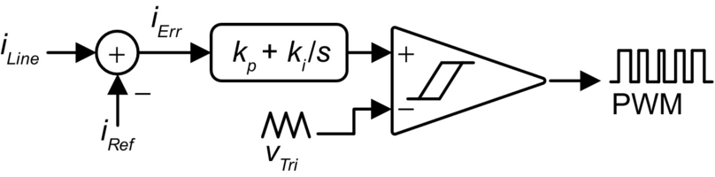

**FIG. 41.23** Control modulator block for triangular carrier method.

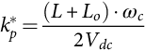 **(41.27)**

**** **(41.28)**

where  is the total series inductance seen by the converter; *ωc* is the triangular carrier frequency, whose amplitude is 1 V peak-peak; and *Vdc* is the dc supply voltage of the inverter.

##### **Vector control technique**

This current control technique proposed in [[4](https://learning.oreilly.com/library/view/power-electronics-handbook/9780128114087/B9780128114070000465_2.xhtml#bb0025)] divides the  reference frame of currents and voltages in six regions, phase shifted by 30 degrees ([Fig. 41.24](https://learning.oreilly.com/library/view/power-electronics-handbook/9780128114087/B9780128114070000465_1.xhtml#f0125)); identifies the region where the current vector error Δ*i* is located; and selects the inverter output voltage vector *Vinv* that will force Δ*i* to change in the opposite direction, keeping the inverter output current close to the reference signal.

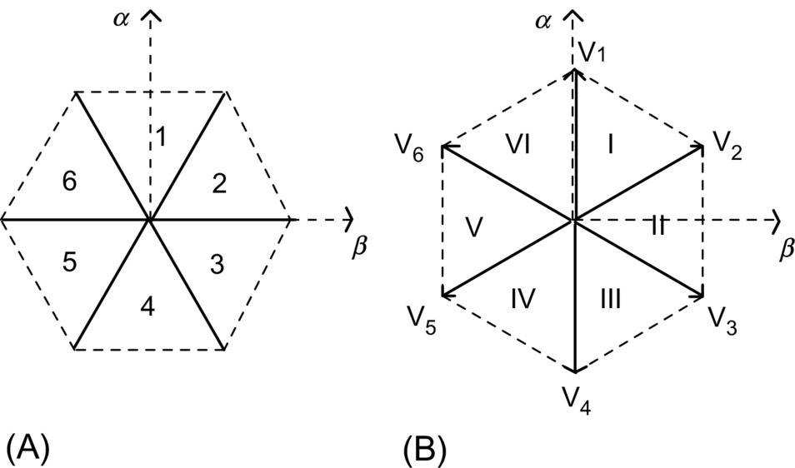

**FIG. 41.24** The hexagons defined in the  reference frame by the current control scheme: (A) the hexagon defined by the inverter output current vector and (B) the hexagon defined by the inverter output voltage vector.

[Fig. 41.25](https://learning.oreilly.com/library/view/power-electronics-handbook/9780128114087/B9780128114070000465_1.xhtml#f0130) shows the single-phase equivalent circuit of the shunt active power filter connected to a nonlinear load and to the power supply.

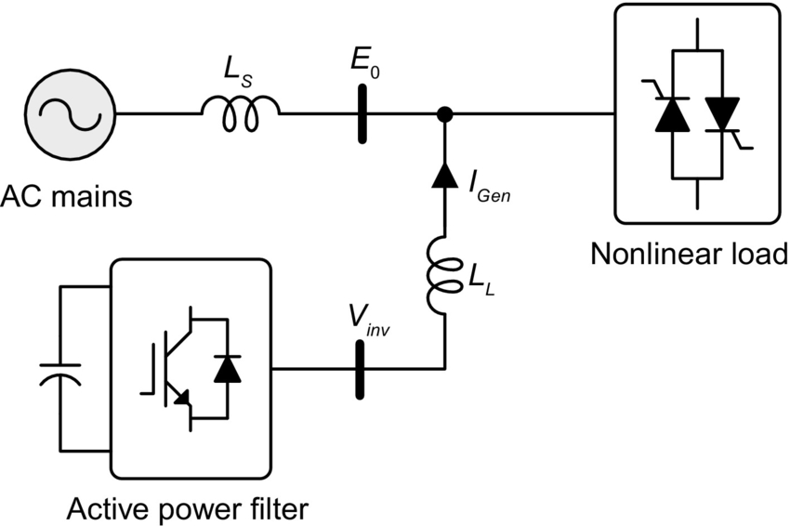

**FIG. 41.25** The single-phase equivalent circuit of a shunt active power filter connected to the power system.

The equation that relates the active power filter currents and voltages is obtained by applying Kirchhoff law to the equivalent circuit shown in [Fig. 41.25](https://learning.oreilly.com/library/view/power-electronics-handbook/9780128114087/B9780128114070000465_1.xhtml#f0130):

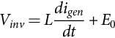 **(41.29)**

The current error vector Δ*i* is defined by the following expression:

 **(41.30)**

where *iref* represents the inverter reference current vector defined by the instantaneous reactive power concept. By replacing Eq. [(41.30)](https://learning.oreilly.com/library/view/power-electronics-handbook/9780128114087/B9780128114070000465_1.xhtml#fo0160) in Eq. [(41.29)](https://learning.oreilly.com/library/view/power-electronics-handbook/9780128114087/B9780128114070000465_1.xhtml#fo0155),

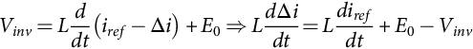 **(41.31)**

If , then Eq. [(41.31)](https://learning.oreilly.com/library/view/power-electronics-handbook/9780128114087/B9780128114070000465_1.xhtml#fo0165) becomes

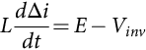 **(41.32)**

Eq. [(41.32)](https://learning.oreilly.com/library/view/power-electronics-handbook/9780128114087/B9780128114070000465_1.xhtml#fo0170) represents the active power filter state equation and shows that the current error vector variation *d*Δ*i*/*dt* is defined by the difference between the fictitious voltage vector E and the inverter output voltage vector *Vinv*. In order to keep *d*Δ*i*/*dt* close to zero, *Vinv* must be selected near *E*0.

The selection of the inverters' gating signals is defined by the region in which Δ*i* is located and by its amplitude. In order to improve the current control accuracy and associate time response, depending on the amplitude of Δ*i*, the following actions are defined:

− If , the gating signals of the inverter are not changed.

− If , the inverter gating signals are defined following mode a.

− If , the inverter gating signals are defined following mode b.

where *δ* and *h* are reference values that define the accuracy and the hysteresis window of the current control scheme.

##### **Mode a: Small changes in si97_e**

The selection of the inverter switching mode a can be explained with the following example. Assuming that the voltage vector *E* is located in region *I* ([Fig. 41.26A](https://learning.oreilly.com/library/view/power-electronics-handbook/9780128114087/B9780128114070000465_1.xhtml#f0135)) and the current error vector Δ*i* is in region 6 ([Fig. 41.26B](https://learning.oreilly.com/library/view/power-electronics-handbook/9780128114087/B9780128114070000465_1.xhtml#f0135)), the inverter voltage vectors, *Vinv*, located closest to *E* are *V*1 and *V*2. The vectors  and  define two vectors *Ld*Δ*i*/*dt*, located in regions III and V, respectively, as shown in [Fig. 41.26A](https://learning.oreilly.com/library/view/power-electronics-handbook/9780128114087/B9780128114070000465_1.xhtml#f0135), so in order to reduce the current vector error Δ*i*, *Ld*Δ*i*/*dt* must be located in region III. Thus, the inverter output voltage has to be equal to *V*1. In this way, Δ*i* will be forced to change in the opposite direction reducing its amplitude faster. By doing the same analysis for all the possible combinations, the inverter switching modes for each location of Δ*i* and *E* can be defined ([Table 41.4](https://learning.oreilly.com/library/view/power-electronics-handbook/9780128114087/B9780128114070000465_1.xhtml#t0025)).

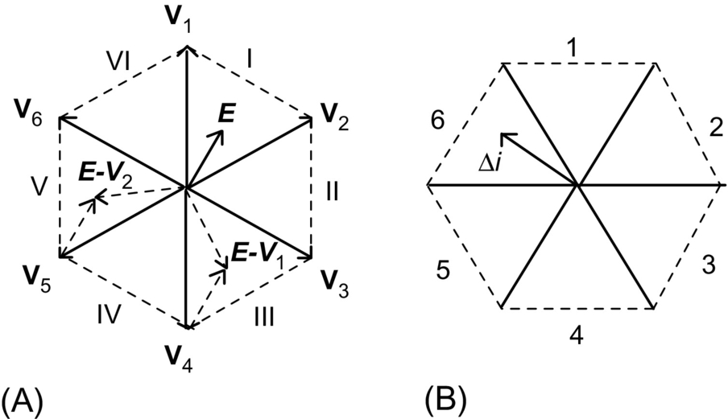

**FIG. 41.26** Selection of the inverter switching pattern according to the region where *Δi* and *E* are located: (A) the regions where *Ld*Δ*i*/*dt* is located and (B) the region where Δ*i* is located.

**Table 41.4**

**Inverter switching modes**

|  |  |  |  |  |  |  |
| --- | --- | --- | --- | --- | --- | --- |
| ***E* region** | **△*i* Region** | | | | | |
|  | **1** | **2** | **3** | **4** | **5** | **6** |
| I | *V*1 | *V*2 | *V*2 | si19_e | si19_e | si21_e |
| II | *V*2 | *V*2 | *V*3 | *V*3 | si19_e | si19_e |
| III | si19_e | *V*3 | *V*3 | *V*4 | *V*4 | si19_e |
| IV | si19_e | si19_e | *V*4 | *V*4 | *V*5 | *V*5 |
| V | *V*6 | si19_e | si19_e | *V*5 | *V*5 | *V*6 |
| VI | *V*1 | *V*1 | si19_e | si19_e | *V*6 | *V*6 |

*Vk* represents the inverter switching functions defined in [Table 41.5](https://learning.oreilly.com/library/view/power-electronics-handbook/9780128114087/B9780128114070000465_1.xhtml#t0030).

**Table 41.5**

**Relationship between switching function and inverter output voltage**

|  |  |  |  |  |
| --- | --- | --- | --- | --- |
| ***k*** | **Switch on phase *a*** | **Switch on phase *b*** | **Switch on phase *c*** | **Inverter output voltage *Vk*** |
| 0 | 4 | 6 | 2 | 0 |
| 1 | 1 | 6 | 2 | si32_e |
| 2 | 1 | 3 | 2 | si33_e |
| 3 | 4 | 3 | 2 | si34_e |
| 4 | 4 | 3 | 5 | si35_e |
| 5 | 4 | 6 | 5 | si36_e |
| 6 | 1 | 6 | 5 | si37_e |
| 7 | 1 | 3 | 5 | 0 |

##### **Mode b: Large changes in si100_e**

If Δ*i* becomes larger than *h* in a transient state, it is necessary to choose the switching mode in which the *d*Δ*i*/*dt* has the largest opposite direction to Δ*i*. In this case, the best inverter output voltage *Vinv* corresponds to the value located in the same region of Δ*i*.

The switching frequency may be fixed by controlling the time between commutations and not applying a new switching pattern if the time between two successive commutations is lower than a selected value ().

[Fig. 41.27](https://learning.oreilly.com/library/view/power-electronics-handbook/9780128114087/B9780128114070000465_1.xhtml#f0140) shows the block diagram of the inverter vector current control scheme implemented in a microcontroller. In [Fig. 41.27](https://learning.oreilly.com/library/view/power-electronics-handbook/9780128114087/B9780128114070000465_1.xhtml#f0140), ⁎*E* represents the region where the vector *E* is located, ⁎Δ*i*, the region of Δ*i*, *k*1 keeps the same value of *k* (no commutation in the inverter), *k*2 selects the new inverter output voltage from [Table 41.4](https://learning.oreilly.com/library/view/power-electronics-handbook/9780128114087/B9780128114070000465_1.xhtml#t0025), and *k*3 selects *Vinv* in the same region of Δ*i*.



**FIG. 41.27** The current control block diagram.

#### **41.2.3.3 Control Loop Design**

Active power filters based on self-controlled dc bus voltage require two control loops, one to control the inverter output current and the other to regulate the inverter dc voltage. Different design criteria have been presented in the technical literature; however, a classic design procedure using a PI controller will be presented in this chapter. In general, the design procedure for the current and voltage loops is based on the respective time-response requirements. Since the transient response of the active power is determined by the current control loop, its time response has to be fast enough to follow the current reference waveform closely. On the other hand, the time response of the dc voltage does not need to be fast and is selected to be at least 10 times slower than the current control loop time response. Thus, these two control systems can be decoupled and designed as two independent systems.

A PI controller is normally used for the current and the voltage control loops since it contributes to zero steady-state error in tracking the reference current and voltage signals, respectively.

##### **Design of the current control loop**

The design of the current control loop gains depends on the selected current modulator. In the case of selecting the triangular carrier technique, to generate the gating signals, the error between the generated current and the reference current is processed through a PI controller, and then, the output current error is compared with a fixed-amplitude and fixed-frequency triangular wave ([Fig. 41.23](https://learning.oreilly.com/library/view/power-electronics-handbook/9780128114087/B9780128114070000465_1.xhtml#f0120)). The advantage of this current modulator technique is that the output current of the converter has well-defined spectral line frequencies for the switching frequency components.

Since the active power filter is implemented with a voltage-source inverter, the ac output current is defined by the inverter ac output voltage. The block diagram of the current control loop for each phase is shown in [Fig. 41.28](https://learning.oreilly.com/library/view/power-electronics-handbook/9780128114087/B9780128114070000465_1.xhtml#f0145) where



**FIG. 41.28** The block diagram of the current control loop.

|  |  |
| --- | --- |
| *E* | phase-to-neutral source voltage, |
| *Z(s)* | impedance of the link reactor, |
| *Ks* | gain of the converter, and |
| *Gc(s)* | gain of the controller. |

The values of *Ks* and *Gc(s)* are given in Eqs. [(41.33)](https://learning.oreilly.com/library/view/power-electronics-handbook/9780128114087/B9780128114070000465_1.xhtml#fo0175) and [(41.34)](https://learning.oreilly.com/library/view/power-electronics-handbook/9780128114087/B9780128114070000465_1.xhtml#fo0180):

 **(41.33)**

**** **(41.34)**

From [Fig. 41.27](https://learning.oreilly.com/library/view/power-electronics-handbook/9780128114087/B9780128114070000465_1.xhtml#f0140) and Eq. [(41.34)](https://learning.oreilly.com/library/view/power-electronics-handbook/9780128114087/B9780128114070000465_1.xhtml#fo0180), the following expression is obtained:

 **(41.35)**

The characteristic equation of the current loop is given by

 **(41.36)**

The analysis of the characteristic equation proves that the current control loop is stable for all values of *Kp* and *Ki*. Also, this analysis shows that *Kp* determines the speed response and *Ki* defines the damping factor of the control loop. If *Kp* is too big, the error signal can exceed the amplitude of the triangular waveform, affecting the inverter switching frequency, and if *Ki* is too small, the gain of the PI controller decreases, which means that the generated current will not be able to follow the reference current closely. The active filter transient response can be improved by adjusting the gain of the proportional part (*Kp*) to equal one and the gain of the integrator (*Ki*) to equal the frequency of the triangular waveform.

##### **DC voltage control loop**

Voltage control of the dc bus is performed by adjusting the small amount of real power flowing into the dc capacitor, thus compensating for the conduction and switching losses. The voltage loop is designed to be at least 10 times slower than the current loop, hence the two loops can be considered decoupled. The dc voltage control loop needs not to be fast, since it only responds for steady-state operating conditions. Transient changes in the dc voltage are not permitted and are taken into consideration with the selection criteria of the appropriate electrolytic capacitor value.

### 41.2.4 POWER CIRCUIT DESIGN

The selection of the ac link reactor and the dc capacitor values affects directly the performance of the active power filter. Static var compensators implemented with voltage-source inverters present the same power circuit topology, but for this type of application, the criteria used to select the values of *Lr* and *C* are different. For reactive power compensation, the design of the synchronous link inductor, *Lr*, and the dc capacitor, *C*, is performed based on harmonic distortion constrain. That is, *Lr* must reduce the amplitude of the current harmonics generated by the inverter, while *C* must keep the dc voltage ripple factor below a given value. This design criteria cannot be applied in the active power filter since it must be able to generate distorted current waveforms. However, *Lr* must be specified so that it keeps the high-frequency switching ripple of the inverter ac output current smaller than a defined value.

#### **41.2.4.1 Design of the Synchronous Link Reactor**

The design of the synchronous link reactor depends on the current modulator used. The design criteria presented in this section are based considering that the triangular carrier modulator is used. The design of the synchronous reactor is performed with the constraint that for a given switching frequency the minimum slope of the inductor current is smaller than the slope of the triangular waveform that defines the switching frequency. In this way, the intersection between the current error signal and the triangular waveform will always exist. In the case of using another current modulator, the design criteria must allow an adequate value of *Lr* in order to ensure that the *di/dt* generated by the active power filter will be able to follow the inverter current reference closely. In the case of the triangular carrier technique, the slope of the triangular waveform, *λ*, is defined by

 **(41.37)**

where *ξ* is the amplitude of the triangular waveform, which has to be equal to the maximum permitted amount of ripple current, and *ft* is the frequency of the triangular waveform (i.e., the inverter switching frequency). The maximum slope of the inductor current is equal to

 **(41.38)**

Since the slope of the inductor current (*diL*/*dt*) has to be smaller than the slope of the triangular waveform (*λ*) and the ripple current is defined, from Eqs. [(41.37)](https://learning.oreilly.com/library/view/power-electronics-handbook/9780128114087/B9780128114070000465_1.xhtml#fo0195) and [(41.38)](https://learning.oreilly.com/library/view/power-electronics-handbook/9780128114087/B9780128114070000465_1.xhtml#fo0200), as

 **(41.39)**

#### **41.2.4.2 Design of the DC Capacitor**

Transient changes in the instantaneous power absorbed by the load generate voltage fluctuations across the dc capacitor. The amplitude of these voltage fluctuations can be controlled effectively with an appropriate dc capacitor value. It must be noticed that the dc voltage control loop stabilizes the capacitor voltage after a few cycles, but is not fast enough to limit the first voltage variations. The capacitor value obtained with this criteria is bigger than the value obtained based on the maximum dc voltage ripple constraint. For this reason, the voltage across the dc capacitor presents a smaller harmonic distortion factor. The maximum overvoltage generated across the dc capacitor is given by

 **(41.40)**

where *VC* max is the maximum voltage across the dc capacitor, *Vdc* is the steady-state dc voltage, and *ic*(*t*) is the instantaneous dc bus current. From Eq. [(41.40)](https://learning.oreilly.com/library/view/power-electronics-handbook/9780128114087/B9780128114070000465_1.xhtml#fo0210),

 **(41.41)**

Eq. [(41.41)](https://learning.oreilly.com/library/view/power-electronics-handbook/9780128114087/B9780128114070000465_1.xhtml#fo0215) defines the value of the dc capacitor, *C*, that will maintain the dc voltage fluctuation below Δ*V* p.u. The instantaneous value of the dc current is defined by the product of the inverter line currents with the respective switching functions. The mean value of the dc current that generates the maximum overvoltage can be estimated by

 **(41.42)**

In this expression, the inverter ac current is assumed to be sinusoidal. These operating conditions represent the worst case.

### 41.2.5 TECHNICAL SPECIFICATIONS

The standard specifications of shunt active power filters are the following:

• Number of phases: three phases and three wires or three phases and four wires (in case neutral currents need to be compensated)

• Input voltage: 200, 210, , 400, 420, , 

• Frequency: 50/60 Hz±5%

• Number of restraint harmonic orders: 2nd–25th

• Harmonic restraint factor: 85% or more at the rated output

• Type of rating: continuous

• Response: 1 ms or less

For shunt active power filter, the harmonic restraint factor is defined as , where  is the harmonic currents flowing on the source side when no measure is taken for harmonic suppression and  is the harmonic currents flowing on the source side when harmonics are suppressed using an active filter.

## 41.3 Series Active Power Filters

Series active power filters were introduced by the end of the 1980s [[5](https://learning.oreilly.com/library/view/power-electronics-handbook/9780128114087/B9780128114070000465_2.xhtml#bb0030)] and operate mainly as a voltage regulator and harmonic isolator between the nonlinear load and the utility system. The series-connected active power filter is more preferable to protect the consumer from an inadequate supply voltage quality. This type of approach is specially recommended for the compensation of voltage unbalances, voltage distortion, and voltage sags from the ac supply and for low-power applications represents an economically attractive alternative to UPS, since no energy storage (battery) is necessary and the overall rating of the components is smaller. The series active power filter injects a voltage component in series with the supply voltage and therefore can be regarded as a controlled voltage source, compensating voltage sags and swells on the load side ([Fig. 41.29](https://learning.oreilly.com/library/view/power-electronics-handbook/9780128114087/B9780128114070000465_1.xhtml#f0150)).



**FIG. 41.29** The series active power filter operating as a voltage compensator.

If passive LC filters are connected in parallel to the load, the series active power filter operates as a harmonic isolator forcing the load current harmonics to circulate mainly through the passive filter rather than the power distribution system (hybrid topology) ([Fig. 41.30](https://learning.oreilly.com/library/view/power-electronics-handbook/9780128114087/B9780128114070000465_1.xhtml#f0155)). The main advantage of this scheme is that the rated power of the series active power filter is a small fraction of the load kilovolt-ampere rating, typically 5%. However, the rated apparent power of the series active power filter may increase, in case voltage compensation is required.



**FIG. 41.30** Combination of series active power filter and passive filter for current harmonic compensation.

### 41.3.1 POWER CIRCUIT STRUCTURE

The topology of the series active power filter is shown in [Fig. 41.31](https://learning.oreilly.com/library/view/power-electronics-handbook/9780128114087/B9780128114070000465_1.xhtml#f0160). In most cases, the power circuit configuration is based on a three-phase PWM voltage-source inverter connected in series with the power lines through three single-phase coupling transformers. For certain type of applications, the three-phase PWM voltage-source converter can be replaced by three single-phase PWM inverters. However, this type of approach requires more power components, which increases the cost.



**FIG. 41.31** The series active power filter topology.

In order to operate as a harmonic isolator, a parallel LC filter must be connected between the nonlinear loads and the coupling transformers ([Fig. 41.30](https://learning.oreilly.com/library/view/power-electronics-handbook/9780128114087/B9780128114070000465_1.xhtml#f0155)). Current harmonic and voltage compensation are achieved by generating the appropriate voltage waveforms with the three-phase PWM voltage-source inverter, which are reflected in the power system through three coupling transformers. With an adequate control scheme, series active power filters can compensate for current harmonics generated by nonlinear loads, voltage unbalances, voltage distortion, and voltage sags or swells at the load terminals. However, it is very difficult to compensate the load power factor with this type of topology. In four-wire power distribution systems, series active power filters with the power topology can also compensate the current harmonic components that circulate through the neutral conductor.

### 41.3.2 PRINCIPLES OF OPERATION

Series active power filters compensate current system distortion caused by nonlinear loads by imposing a high-impedance path to the current harmonics, which forces the high-frequency currents to flow through the LC passive filter connected in parallel to the load ([Fig. 41.30](https://learning.oreilly.com/library/view/power-electronics-handbook/9780128114087/B9780128114070000465_1.xhtml#f0155)). The high impedance imposed by the series active power filter is created by generating a voltage of the same frequency that the current harmonic component needs to be eliminated. Voltage regulation or voltage unbalance can be corrected by compensating the fundamental frequency positive, negative, and zero-sequence voltage components of the power distribution system ([Fig. 41.29](https://learning.oreilly.com/library/view/power-electronics-handbook/9780128114087/B9780128114070000465_1.xhtml#f0150)). In this case, the series active power filter injects a voltage component in series with the supply voltage and therefore can be regarded as a controlled voltage source, compensating voltage regulation on the load side (sags or swells) and voltage unbalance. Voltage injection of arbitrary phase with respect to the load current implies active power transfer capabilities that increases the rating of the series active power filter and in most cases requires an energy storage element connected in the dc bus. Voltage and current waveforms shown in [Figs. 41.32](https://learning.oreilly.com/library/view/power-electronics-handbook/9780128114087/B9780128114070000465_1.xhtml#f0165)–[41.34](https://learning.oreilly.com/library/view/power-electronics-handbook/9780128114087/B9780128114070000465_1.xhtml#f0175) illustrate the compensation characteristics of a series active power filter operating with a shunt passive filter.



**FIG. 41.32** Load voltage waveforms for voltage unbalance compensation. Phase-to-neutral voltages at the load terminals before and after series compensation. (Compensation starts at 140 ms, current harmonic compensator not operating.)



**FIG. 41.33** System current waveforms for current harmonic compensation: (A) neutral current flowing to the ac mains before and after compensation and (B) line currents flowing to the ac mains before and after compensation. (Voltage unbalance compensator is not operating.)



**FIG. 41.34** Load voltages and system currents for voltage unbalance and current harmonic compensation, before and after compensation: (A) power system neutral current, (B) phase-to-neutral load voltages, and (C) power system line current.

### 41.3.3 POWER CIRCUIT DESIGN

The power circuit topology of the series active power filter is composed by the three-phase PWM voltage-source inverter, the second-order resonant LC filters, the coupling transformers, and the secondary ripple frequency filter ([Fig. 41.30](https://learning.oreilly.com/library/view/power-electronics-handbook/9780128114087/B9780128114070000465_1.xhtml#f0155)). The design characteristics for each of the power components are described below.

#### **41.3.3.1 PWM Voltage-Source Inverter**

Since series active power filter can compensate voltage unbalance and current harmonics simultaneously, the rated power of the PWM voltage-source inverter increases compared with other approaches that compensate only current harmonics, since voltage injection of arbitrary phase with respect to the load current implies active power transfer from the inverter to the system. Also, the transformer leakage inductance entails fundamental voltage drop and apparent power, which has to be supported by the inverter, reducing the series active filter inverter rating available for harmonic and voltage compensation. The rated apparent power required by the inverter can be obtained by calculating the apparent power generated in the primary of the coupling transformers. The voltage reflected across the primary winding of each coupling transformer is defined in Eq. [(41.43)](https://learning.oreilly.com/library/view/power-electronics-handbook/9780128114087/B9780128114070000465_1.xhtml#fo0225):

 **(41.43)**

where *Vseries* is the root-mean-square voltage across the primary winding of the coupling transformer. Eq. [(41.43)](https://learning.oreilly.com/library/view/power-electronics-handbook/9780128114087/B9780128114070000465_1.xhtml#fo0225) shows that the voltage across the primary winding of the transformer is defined by two terms. The first one is inversely proportional to the quality factor of the passive LC filter, while the second one depends on the voltage unbalance that needs to be compensated. *K*1 depends on the LC filter values, while *K*2 is equal to one. The current flowing through the primary winding of the coupling transformer, due to the harmonic currents (Eq. [41.44](https://learning.oreilly.com/library/view/power-electronics-handbook/9780128114087/B9780128114070000465_1.xhtml#fo0230)), can be obtained from the equivalent circuit shown in [Fig. 41.35](https://learning.oreilly.com/library/view/power-electronics-handbook/9780128114087/B9780128114070000465_1.xhtml#f0180):



**FIG. 41.35** The equivalent circuit of the series active power filter for harmonic components.

 **(41.44)**

where . The fundamental component of the primary current depends on the amplitude of the negative- and zero-sequence component of the source voltage due to the system unbalance.

#### **41.3.3.2 Coupling Transformer**

The purpose of the three coupling transformers is not only to isolate the PWM inverters from the source but also to match the voltage and current ratings of the PWM inverters with those of the power distribution system. The total apparent power required by each coupling transformer is one-third the total apparent power of the inverter. The turn ratio of the current transformer is specified according to the inverter dc bus voltage, *K*1 and *Vref*. The correct value of the turn ratio “*a*” must be specified according to the overall series active power filter performance. The turn ratio of the coupling transformer must be optimized through the simulation of the overall active power filter, since it depends on the values of different related parameters. In general, the transformer turn ratio must be high in order to reduce the amplitude of the inverter output current and to reduce the voltage induced across the primary winding. Also, the selection of the transformer turn ratio influences the performance of the ripple filter connected at the output of the PWM inverter. Taking into consideration all these factors, in general, the transformer turn ratio is selected equal to 1:20.

#### **41.3.3.3 Secondary Ripple Filter**

The design of the ripple filter connected in parallel to the secondary winding of the coupling transformer is performed following the method presented by Akagi in [[6](https://learning.oreilly.com/library/view/power-electronics-handbook/9780128114087/B9780128114070000465_2.xhtml#bb0035)]. However, it is important to notice that the design of the secondary ripple filter depends mainly on the coupling transformer turn ratio and the current modulator used to generate the inverter gating signals. If the triangular carrier is used, the frequency of the triangular waveform has to be considered in the design of the ripple filter. The ripple filter connected at the output of the inverter avoids the induction of the high-frequency ripple voltage generated by the PWM inverter switching pattern at the terminals of the primary winding of the coupling transformer. In this way, the voltage applied in series to the power system corresponds to the components required to compensate voltage unbalanced and current harmonics. The single-phase equivalent circuit is shown in [Fig. 41.36](https://learning.oreilly.com/library/view/power-electronics-handbook/9780128114087/B9780128114070000465_1.xhtml#f0185).



**FIG. 41.36** The single-phase equivalent circuit of the inverter output ripple filter.

The voltage reflected in the primary winding of the coupling transformer has the same waveform as that of the voltage across the filter capacitor. For low-frequency components, the inverter output voltage must be almost equal to the voltage across *Cfr*. However, for high-frequency components, most of the inverter output voltage must drop across *Lfr*, in which case the voltage at the capacitor terminals is almost zero. Moreover, *Cfr* and *Lfr* must be selected in order not to exceed the burden of the coupling transformer. The ripple filter must be designed for the carrier frequency of the PWM voltage-source inverter. To calculate *Cfr* and *Lfr*, the system equivalent impedance at the carrier frequency, *Zsys*, reflected in the secondary must be known. This impedance is equal to

 **(41.45)**

For the carrier frequency, the following design criteria must be satisfied:

|  |  |
| --- | --- |
| (i) si122_e | to ensure that at the carrier frequency most of the inverter output voltage will drop across *Lfr* |
| (ii) *XCfr* and si123_e | to ensure that the voltage divider is between *Lfr* and *Cfr* |

The small-rated LC passive filter exhibits a high-quality-factor circuit because of the high impedance on the output side. Oscillation between the small-rated inductor and capacitor may occur, causing undesirable high-frequency voltage across the ripple filter capacitor, which is reflected in the primary winding of the coupling transformer generating high-frequency current to flow through the power distribution system. It is important to note that this oscillation is very difficult to eliminate through the design and selection of the *Lfr* and *Cfr* values. However, it can be eliminated with the addition of a new control loop. The cause of the output voltage oscillation is explained with the help of [Fig. 41.37](https://learning.oreilly.com/library/view/power-electronics-handbook/9780128114087/B9780128114070000465_1.xhtml#f0190). The transfer function *Gp*(*s*) between the input voltage *Vi*(*s*) and the output voltage *VC*(*s*) is given by the following equation:



**FIG. 41.37** Single-phase equivalent circuit of series active power filter connected to the ripple filter.

 **(41.46)**

where  and .

Normally, the damping factor *ξ* is smaller than one, causing the voltage oscillation across the capacitor ripple filter, *Cfr*. Generally, relatively low impedance loads are connected to the output terminals of voltage-source PWM inverters. In these cases, the quality factor of the LC filter can be low, and the oscillation between the inductor *Lfr* and the capacitor *Cfr* is avoided [[7](https://learning.oreilly.com/library/view/power-electronics-handbook/9780128114087/B9780128114070000465_2.xhtml#bb0040)].

#### **41.3.3.4 Passive Filters**

Passive filters connected between the nonlinear load and the series active power filter play an important role in the compensation of the load current harmonics. With the connection of the passive filters, the series active power filter operates as a harmonic isolator. The harmonic isolation feature reduces the need for precise tuning of the passive filters and allows their design to be insensitive to the system impedance and eliminates the possibility of filter overloading due to supply voltage harmonics. The passive filter can be tuned to the dominant load current harmonic and can be designed to correct the load displacement power factor.

However, for industrial loads connected to stiff supply, it is difficult to design passive filters that can absorb a significant part of the load harmonic current, and therefore, its effectiveness deteriorates. Specially, for compensation of diode rectifier type of loads, where a small kilovolt-ampere passive filter is required, it is difficult to achieve the required tuning to absorb significant percentage of the load harmonic currents. For this type of application, the passive filter cannot be tuned exactly to the harmonic frequencies because they can be overloaded due to the system voltage distortion and/or system current harmonics.

The single-phase equivalent circuit of a passive LC filter connected in parallel to a nonlinear current source and to the power distribution system is shown in [Fig. 41.38](https://learning.oreilly.com/library/view/power-electronics-handbook/9780128114087/B9780128114070000465_1.xhtml#f0195). From this figure, the design procedure of this filter can be derived. The harmonic current component flowing through the passive filter *ifh* and the current component flowing through the source *ish* are given by the following expressions:



**FIG. 41.38** The single-phase equivalent circuit of the passive filter connected to a nonlinear load.

 **(41.47)**

At the resonant frequency, the inductive reactance of the passive filter is equal to the capacitive reactance of the filter, that is,

 **(41.48)**

Therefore, the resonant frequency of the passive filter is equal to

 **(41.49)**

The passive filter bandwidth is defined by the upper and lower cutoff frequency, at which values the filter current gain is −3 dB, as shown in [Fig. 41.39](https://learning.oreilly.com/library/view/power-electronics-handbook/9780128114087/B9780128114070000465_1.xhtml#f0200).



**FIG. 41.39** The passive filter bandwidth.

The magnitude of the passive filter impedance as a function of the frequency is shown in Fig. [41.40](https://learning.oreilly.com/library/view/power-electronics-handbook/9780128114087/B9780128114070000465_1.xhtml#f0205).



**FIG. 41.40** The frequency response of the passive LC filter.

At the resonant frequency, the passive filter magnitude is equal to the resistance. If the resistance is zero, the filter is in short circuit. The quality factor of the passive filter is defined by the following expression:

 **(41.50)**

It is important to note that the operation of the series active power filter with off-tuned passive filter has an adverse impact on the inverter power rating compared with the normal case. The more off-tuned the passive filter, the more rated apparent power is required by the series active power filter.

#### **41.3.3.5 Protection Requirements**

Short circuits in the power distribution system generate large currents that flow through the power lines until the circuit breaker operates clearing the fault. The total clearing time of a short circuit depends on the time delay imposed by the protection system. The clearing time cannot be instantaneous due to the operating time imposed by the overcurrent relay and by the total interruption time of the power circuit breaker. Although power system equipment, such us power transformers and cables, are designed to withstand short-circuit currents during at least 30 cycles, the active power filter may suffer severe damage during this short time. The withstand capability of the series active power filter depends mainly on the inverter power semiconductor characteristics.

Since the most important feature of series active power filters is the small-rated power required to compensate the power system, typically 10%–15% of the load rated apparent power, the inverter semiconductors are rated for low values of blocking voltages and continuous currents. This makes series active power filters more vulnerable to power system faults.

The block diagram of the protection scheme described in this section is shown in [Fig. 41.41](https://learning.oreilly.com/library/view/power-electronics-handbook/9780128114087/B9780128114070000465_1.xhtml#f0210). It consists of a varistor connected in parallel to the secondary winding of each coupling transformer and a couple of antiparallel thyristors [[8](https://learning.oreilly.com/library/view/power-electronics-handbook/9780128114087/B9780128114070000465_2.xhtml#bb0045)]. A special circuit detects the current flowing through the varistors and generates the gating signals of the antiparallel thyristors. The protection circuit of the series active power filter must protect only the PWM voltage-source inverter connected to the secondary of the coupling transformers and must not interfere with the protection scheme of the power distribution system. Since the primary of the active power filter coupling transformers is connected in series to the power distribution system, they operate as current transformers, so that their secondary windings cannot operate in open circuit. For this reason, if a short circuit is detected in the power distribution system, the PWM voltage-source inverter cannot be disconnected from the secondary of the current transformer. Therefore, the protection scheme must be able to limit the amplitude of the currents and voltages generated in the secondary circuits. This task is performed by the varistors and by the magnetic saturation characteristic of the transformers.



**FIG. 41.41** The series active power filter protection scheme.

The main advantages of the series active power filter protection scheme described in this section are the following:

(i) It is easy to implement and has a reduced cost.

(ii) It offers full protection against power distribution short-circuit currents.

(iii) It does not interfere with the power distribution system.

When short-circuit currents circulate through the power distribution system, the low saturation characteristic of the transformers increases the current ratio error and reduces the amplitude of the secondary currents. The larger secondary voltages induced by the primary short-circuit currents are clamped by the varistors, reducing the amplitude of the PWM voltage-source inverter currents. After a few cycles of duration of the short circuit, the PWM voltage-source inverter is bypassed through a couple of antiparallel thyristors, and at the same time, the gating signals applied to the PWM voltage-source inverter are removed. In this way, the PWM voltage-source inverter can be turned off. The principles of operation and the effectiveness of the protection scheme are shown in [Fig. 41.42](https://learning.oreilly.com/library/view/power-electronics-handbook/9780128114087/B9780128114070000465_1.xhtml#f0215).



**FIG. 41.42** Current waveforms of the series active power filter during a three-phase short circuit in the power distribution system set at 50 ms: (A) power distribution system line current, (B) current transformer secondary voltage, (C) inverter ac current, (D) current through an inverter leg, and (E) inverter dc bus current.

The secondary short-circuit currents will circulate through the antiparallel thyristors and the varistors until the fault is cleared by the protection equipment of the power distribution system.

By using the protection scheme described in this subsection, the voltage and currents reflected in the secondary of the coupling transformers are significantly reduced. When short-circuit currents circulate through the power distribution system, the low saturation characteristic of the coupling transformers increases the current ratio error and reduces the amplitude of the secondary voltages and currents. Moreover, the saturated high secondary voltages induced by the primary short-circuit currents are clamped by the varistors, reducing the amplitude of the PWM voltage-source inverter ac currents. Once the secondary current exceeds a predefined reference value, the PWM voltage-source inverter is bypassed through a couple of antiparallel thyristors, and then, the gating signals applied to the PWM voltage-source inverter are removed. The effectiveness of the protection scheme is shown in [Fig. 41.43](https://learning.oreilly.com/library/view/power-electronics-handbook/9780128114087/B9780128114070000465_1.xhtml#f0220).



**FIG. 41.43** Current waveforms for a line-to-line short circuit in the power distribution system. The protection scheme is implemented with the varistor, a couple of antiparallel thyristors, and a coupling transformer with low saturation characteristic: (A) current through the varistor, (B) current through the thyristors, and (C) inverter ac current.

By increasing the current ratio error due to the magnetic saturation, the energy dissipated in the secondary of the coupling transformer is significantly reduced. The total energy dissipated in the varistor for the different protection conditions is shown in [Fig. 41.44](https://learning.oreilly.com/library/view/power-electronics-handbook/9780128114087/B9780128114070000465_1.xhtml#f0225).



**FIG. 41.44** The total energy dissipated in the varistor during the power system short circuit for different protection schemes implementations: (A) only with the varistor used, (B) the varistor is connected in parallel to a bidirectional switch, and (C) with the complete protection scheme operating (including the coupling transformer with low saturation characteristics).

### 41.3.4 CONTROL ISSUES

The block diagram of a series active power filter control scheme that compensates current harmonics and voltage unbalance simultaneously is shown in [Fig. 41.45](https://learning.oreilly.com/library/view/power-electronics-handbook/9780128114087/B9780128114070000465_1.xhtml#f0230).



**FIG. 41.45** Compensation scheme for voltage unbalance correction.

Current and voltage reference waveforms are obtained by using the Park transformation (instantaneous reactive power theory) voltage unbalance that is compensated by calculating the negative- and zero-sequence fundamental components of the system voltages. These voltage components are added to the source voltages through the coupling transformers compensating the voltage unbalance at the load terminals. In order to reduce the amplitude of the current flowing through the neutral conductor, the zero-sequence components of the line currents are calculated. In this way, it is not necessary to sense the current flowing through the neutral conductor.

#### **41.3.4.1 Reference Signals Generator**

The compensation characteristics of series active power filters are defined mainly by the algorithm used to generate the reference signals required by the control system. These reference signals must allow current and voltage compensation with minimum time delay. Also, it is important that the accuracy of the information contained in the reference signals allows the elimination of the current harmonics and voltage unbalance present in the power system. Since the voltage and current control schemes are independent, the equations used to calculate the voltage reference signals are the following:

 **(41.51)**

The voltages *va*, *vb*, and *vc* correspond to the power system phase-to-neutral voltages before the current transformer. The reference voltage signals are obtained by making the positive-sequence component, *va*1, zero and then applying the inverse of the Fortescue transformation. In this way, the series active power filter compensates only voltage unbalance and not voltage regulation. The reference signals for the voltage unbalance control scheme are obtained by applying the following equations:

 **(41.52)**

In order to compensate current harmonics generated by the nonlinear loads, the following equations are used:

 **(41.53)**

where *i*0 is the fundamental zero-sequence component of the line current and is calculated using the Fortescue transformation Eq. [(41.50)](https://learning.oreilly.com/library/view/power-electronics-handbook/9780128114087/B9780128114070000465_1.xhtml#fo0260):

 **(41.54)**

In Eq. [(41.40)](https://learning.oreilly.com/library/view/power-electronics-handbook/9780128114087/B9780128114070000465_1.xhtml#fo0210), *pref*, *qref*, *vα*, and *vβ* are defined according to the instantaneous reactive power theory. In order to avoid the compensation of the zero-sequence fundamental frequency current, the reference signal *i*0 must be forced to circulate through a high-pass filter generating a current *i*0′ that is used to create the reference signal required to compensate current harmonics. Finally, the general equation that defines the references of the PWM voltage-source inverter required to compensate voltage unbalance and current harmonics is the following:

 **(41.55)**

where *K*1 is the gain of the coupling transformer that defines the magnitude of the impedance for high-frequency current components and *K*2 defines the degree of compensation for voltage unbalance, ideally *K*2 equals 1.

#### **41.3.4.2 Gating Signals Generator**

This circuit provides the gating signals of the three-phase PWM voltage-source inverter required to compensate voltage unbalance and current harmonic components. The current and voltage reference signals are added, and then, the amplitude of the resultant reference waveform is adjusted in order to increase the voltage utilization factor of the PWM inverter for steady-state operating conditions. The gating signals of the inverter are generated by comparing the resultant reference signal with a fixed-frequency triangular waveform. The triangular waveform helps to keep the inverter switching frequency constant ([Fig. 41.46](https://learning.oreilly.com/library/view/power-electronics-handbook/9780128114087/B9780128114070000465_1.xhtml#f0235)).



**FIG. 41.46** The block diagram of the gating signal generator.

A higher voltage utilization of the inverter is obtained if the amplitude of the resultant reference signal is adjusted for the steady-state operating condition of the series active power filter. In this case, the reference current and reference voltage waveforms are smaller. If the amplitude is adjusted for transient operating conditions, the required reference signals will have a larger value, creating a higher dc voltage in the inverter and defining a lower voltage utilization factor for steady-state operating conditions. The inverter switching frequency must be higher in order not to interfere with the current harmonics that need to be compensated.

### 41.3.5 CONTROL CIRCUIT IMPLEMENTATION

Since the control scheme of the series active power filter must translate the current harmonic components that need to be compensated in voltage signals, a proportional controller is used. The use of a PI controller is not recommended since it would modify the reference waveform and generate new current harmonic components. The gain for proportional controller depends on the load characteristics, and its value fluctuates between one and two.

Another important element used in the control scheme is the filter that allows to generate *pref* and *qref* ([Fig. 41.35](https://learning.oreilly.com/library/view/power-electronics-handbook/9780128114087/B9780128114070000465_1.xhtml#f0180)). The frequency response of this filter is very important and must not introduce any phase shift or attenuation to the low-frequency harmonic components that must be compensated. A high-pass first-order filter tuned at 15 Hz is adequate. This corner frequency is required when single-phase nonlinear loads are compensated. In this case, the dominant current harmonic is the third. An example of the filter that can be used is shown in [Fig. 41.47](https://learning.oreilly.com/library/view/power-electronics-handbook/9780128114087/B9780128114070000465_1.xhtml#f0240).



**FIG. 41.47** The first-order high-pass filter implemented for the calculation of *pref* and *qref* (, , and ).

The operator “*a*” required to calculate the sequence components of the system voltages (Fortescue transformation) can be obtained with the all-pass filter shown in [Fig. 41.48](https://learning.oreilly.com/library/view/power-electronics-handbook/9780128114087/B9780128114070000465_1.xhtml#f0245).



**FIG. 41.48** The all-pass filter used as a phase shifter.

The phase shift between *Vo* and *Vi* is given by the following expression:

 **(41.56)**

Since the phase shift is negative, the operator “*a*” is obtained by using an inverter (180 degrees) and then by tuning . The operator “*a*2” is obtained by phase shifting *Vi* by . *Vi* is synchronized with the system phase-to-neutral voltage *Van*.

### 41.3.6 EXPERIMENTAL RESULTS

The viability and effectiveness of series active power filters used to compensate current harmonics was proved in an experimental setup of 5 kVA. Current waveforms generated by a nonlinear load and using only passive filters and the combination of passive and the series active power filter are shown in [Figs. 41.49](https://learning.oreilly.com/library/view/power-electronics-handbook/9780128114087/B9780128114070000465_1.xhtml#f0250) and [41.50](https://learning.oreilly.com/library/view/power-electronics-handbook/9780128114087/B9780128114070000465_1.xhtml#f0255).



**FIG. 41.49** Experimental results without the operation of the series active power filter: (A) load current, (B) current flowing through the passive filter, and (C) current through the power supply.



**FIG. 41.50** Experimental results with the operation of the series active power filter: (A) load current, (B) current flowing through the passive filter, and (C) current through the power supply.

These figures show the effectiveness of the series active power filter, which reduces the overall *THD* of the current that flows through the power system from 28.9% (with the operation of only the passive filters) to 9% with the operation of the passive filters with the active power filter connected in series. The compensation of the current that flows through the neutral conductor is shown in [Fig. 41.51](https://learning.oreilly.com/library/view/power-electronics-handbook/9780128114087/B9780128114070000465_1.xhtml#f0260).



**FIG. 41.51** Experimental results of neutral current compensation: (A) current flowing through the neutral without the operation of the series active power filter and (B) current flowing through the neutral with the operation of the active power filter.

## 41.4 Hybrid Active Power Filters

Hybrid topologies composed of passive LC filters connected in series to an active power filter have already been proposed by the end of the 1980s [[2](https://learning.oreilly.com/library/view/power-electronics-handbook/9780128114087/B9780128114070000465_2.xhtml#bb0015),[5](https://learning.oreilly.com/library/view/power-electronics-handbook/9780128114087/B9780128114070000465_2.xhtml#bb0030),[6](https://learning.oreilly.com/library/view/power-electronics-handbook/9780128114087/B9780128114070000465_2.xhtml#bb0035),[9](https://learning.oreilly.com/library/view/power-electronics-handbook/9780128114087/B9780128114070000465_2.xhtml#bb0050),[10](https://learning.oreilly.com/library/view/power-electronics-handbook/9780128114087/B9780128114070000465_2.xhtml#bb0055)]. Hybrid topology improves significantly the compensation characteristics of simple passive filters, making the use of active power filter available for high-power applications, at a relatively lower cost. Moreover, the compensation characteristics of already installed passive filters can be significantly improved by connecting a series active power filter at its terminals, giving more flexibility to the compensation scheme. Most of the technical disadvantages of passive filters described before can be effectively attenuate if an active power filter is connected in series to the passive approach as shown in [Fig. 41.52](https://learning.oreilly.com/library/view/power-electronics-handbook/9780128114087/B9780128114070000465_1.xhtml#f0265).



**FIG. 41.52** The hybrid active power filter configuration.

The hybrid active power filter topology is shown in [Fig. 41.52](https://learning.oreilly.com/library/view/power-electronics-handbook/9780128114087/B9780128114070000465_1.xhtml#f0265). The active power filter is implemented with a three-phase PWM voltage-source inverter operating at fixed switching frequency and connected in series to the passive filter through a coupling transformer. Basically, the active power filter forces the utility line currents to become sinusoidal and in phase with the respective phase-to-neutral voltage, improving the compensation characteristics of the passive filter.

### 41.4.1 PRINCIPLES OF OPERATION

Since the active power filter is connected in series to the passive filter through a coupling transformer, it imposes a voltage signal at its primary terminals that forces the circulation of current harmonics through the passive filter, improving its compensation characteristics, independently of the variations in the selected resonant frequency of the passive filter. The block diagram of the proposed control scheme shown in [Fig. 41.53](https://learning.oreilly.com/library/view/power-electronics-handbook/9780128114087/B9780128114070000465_1.xhtml#f0270) consists of three modules: the dc voltage control, the voltage reference generator, and the inverter gating signal generator.



**FIG. 41.53** The hybrid active power filter topology and associated control scheme.

The voltage reference waveform required by the inverter control scheme is obtained by adjusting the amplitude of a sinusoidal reference waveform in phase with the respective phase-to-neutral voltage and then subtracting the respective ac line current ([Fig. 41.53](https://learning.oreilly.com/library/view/power-electronics-handbook/9780128114087/B9780128114070000465_1.xhtml#f0270)). The sinusoidal reference signal can be obtained from the voltage system (in case of low voltage distortion), or it can be generated from an EPROM synchronized with the respective phase-to-neutral voltage. The amplitude of this reference waveform controls the inverter dc voltage and the ac mains displacement power factor. The inverter dc voltage varies according with the amount of real power absorbed by the inverter, while the ac mains power factor depends on the amount of reactive power generated by the hybrid filter, which can be controlled by changing the amplitude of the fundamental component of the inverter output voltage.

The principles of operation for current harmonic and power factor compensation are explained with the help of the single-phase equivalent circuit shown in [Fig. 41.54](https://learning.oreilly.com/library/view/power-electronics-handbook/9780128114087/B9780128114070000465_1.xhtml#f0275). In the current harmonic compensation mode, the active filter improves the filtering characteristic of the passive filter by imposing a voltage harmonic waveform at its terminals with an amplitude value equals to



**FIG. 41.54** Single-phase equivalent circuits of the hybrid active power filter scheme: (A) for current harmonic compensation and (B) for displacement power factor compensation.

 **(41.57)**

where *ISh* is the harmonic content of the line current to be compensated and *K* is the active power filter gain. If the ac mains voltage is purely sinusoidal, the ratio between the harmonic component of the nonlinear load current and the harmonic component of the ac line current (attenuation factor) is obtained from [Fig. 41.54A](https://learning.oreilly.com/library/view/power-electronics-handbook/9780128114087/B9780128114070000465_1.xhtml#f0275) and is equal to

 **(41.58)**

Eq. [(41.58)](https://learning.oreilly.com/library/view/power-electronics-handbook/9780128114087/B9780128114070000465_1.xhtml#fo0300) shows that the filtering characteristics of the hybrid topology (*ISh*/*ILh*) depend on the value of the passive filter equivalent impedance, *ZF*. Moreover, since the tuned factor, *δ*, and the quality factor, *Q*, can modify the filter bandwidth and the passive filter harmonic equivalent impedance ([Fig. 41.55](https://learning.oreilly.com/library/view/power-electronics-handbook/9780128114087/B9780128114070000465_1.xhtml#f0280)), their values must be carefully selected in order to maintain the compensation effectiveness of the hybrid topology. In particular, a high value of the quality factor, *Q*, defines a large bandwidth of the passive filter, improving the compensation characteristics of the hybrid topology. On the other hand, a low value in the quality factor and/or a large value in the tuned factor increases the required voltage generated by the active power filter necessary to keep the same compensation effectiveness, which increases the active power filter rated power.



**FIG. 41.55** The attenuation factor of the line current harmonics for different frequency values.

[Fig. 41.55](https://learning.oreilly.com/library/view/power-electronics-handbook/9780128114087/B9780128114070000465_1.xhtml#f0280) shows how the active power filter gain, *K*, in Eq. [(41.57)](https://learning.oreilly.com/library/view/power-electronics-handbook/9780128114087/B9780128114070000465_1.xhtml#fo0295) affects the harmonic attenuation factor of the line currents. The attenuation factor of the line current harmonics expressed in percentage is obtained from Eq. [(41.59)](https://learning.oreilly.com/library/view/power-electronics-handbook/9780128114087/B9780128114070000465_1.xhtml#fo0305) and is shown in [Fig. 41.56](https://learning.oreilly.com/library/view/power-electronics-handbook/9780128114087/B9780128114070000465_1.xhtml#f0285), for a power distribution system with two passive filters tuned at fifth and seventh harmonics.



**FIG. 41.56** System line current *THD* vs *K* factor.

 **(41.59)**

Eq. [(41.59)](https://learning.oreilly.com/library/view/power-electronics-handbook/9780128114087/B9780128114070000465_1.xhtml#fo0305) indicates that the total harmonic distortion of the line current decreases if *K* increases. In other words, a better hybrid filter compensation is obtained for larger values of voltage harmonic components generated by the active power filter. Also, it is shown that the compensation capability of the hybrid filter depends on the compensation characteristic of the passive filter, that is, the filter impedance value and tuned frequency will affect the active filter rated power required to satisfy the system line current compensation requirements.

Displacement power factor correction can be achieved by controlling the voltage drop across the passive filter capacitor. In order to do that, a voltage at fundamental frequency is generated at the inverter ac terminals, with an amplitude equals to

 **(41.60)**

Displacement power factor control can be achieved since at fundamental frequency the passive filter equivalent impedance is capacitive. The reactive power generated by the passive filter is obtained by changing the voltage imposed by the active power filter across the passive filter capacitor terminals. The passive filter fundamental current component is defined by the following expression:

 **(41.61)**

Eq. [(41.61)](https://learning.oreilly.com/library/view/power-electronics-handbook/9780128114087/B9780128114070000465_1.xhtml#fo0315) proves that the equivalent capacitance at fundamental frequency *Cγ* can be modified by changing *β*. The reactive power generated by the active filter is *β* times the reactive power generated by the passive filter and can be defined by

 **(41.62)**

Eq. [(41.62)](https://learning.oreilly.com/library/view/power-electronics-handbook/9780128114087/B9780128114070000465_1.xhtml#fo0320) shows that if , the active power filter generates a voltage at fundamental frequency in phase with *VT*, reducing the reactive power that flows to the load. If , the active power filter generates a voltage at fundamental frequency phase shifted by 180 degrees with respect to *VT*, increasing the reactive power that flows to the load. In other words, by selecting a *β* positive or negative, the hybrid topology can generate or absorb reactive power at fundamental frequency, compensating for leading or lagging displacement power factor of the nonlinear load. This is achieved by changing the voltage across the passive filter capacitor *CF*.

### 41.4.2 THE HYBRID FILTER COMPENSATION PERFORMANCE

The design characteristics of the passive filters have an important influence on the compensation performance of the hybrid topology. The tuned frequency and quality factor of the passive filter directly influence the compensation characteristics of the hybrid topology. If these two factors are not properly selected, the rated power of the active filter must be increased in order to get the required compensation performance. The tuned factor, *δ*, in per unit with respect to the resonant frequency is defined by Eq. [(41.63)](https://learning.oreilly.com/library/view/power-electronics-handbook/9780128114087/B9780128114070000465_1.xhtml#fo0325):

 **(41.63)**

Here, *δ* defines the magnitude in which the passive filter resonant frequency changes due to the variations in the power system frequency and modifications in the values of the passive filter parameters *L* and *C*. The values of *L* and *C* can change due to aging conditions, temperature, or design tolerances. The tuning factor, *δ*, can also be defined as

 **(41.64)**

The quality factor, *Q*, of the passive filter is defined by Eq. [(41.65)](https://learning.oreilly.com/library/view/power-electronics-handbook/9780128114087/B9780128114070000465_1.xhtml#fo0335):

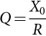 **(41.65)**

where *X*0 is equal to

 **(41.66)**

The passive filter quality factor, *Q*, defines the ratio between the passive filter reactance with respect to its resistance. In order to have a passive filter low impedance value in a limited frequency bandwidth, defined by the maximum expected changes of the rated power system frequency, it is necessary to reduce *X*0 or increase the passive filter resistance *R*, reducing the value of *Q*. However, if *R* increases, the equivalent impedance of the passive filter at the resonant frequency will increase, with the associated power losses, increasing the overall passive filter operational cost. On the other hand, the larger the value of *Q*, the lower is the passive filter equivalent impedance at the resonant frequency, increasing the currents harmonic components across the filter, at the resonant operating point.

#### **41.4.2.1 Effects of the Power System Equivalent Impedance**

The influence of the power system equivalent impedance on the hybrid filter compensation performance is related with its effects on the passive filter, since if the system equivalent impedance is lower than the passive filter equivalent impedance at the resonant frequency, most of the load current harmonics will flow mainly to the power distribution system. In order to compensate this negative effect on the hybrid filter compensation performance, *K* must be increased, as shown in Eq. [(41.57)](https://learning.oreilly.com/library/view/power-electronics-handbook/9780128114087/B9780128114070000465_1.xhtml#fo0295), increasing the active power filter rated power.

[Fig. 41.57](https://learning.oreilly.com/library/view/power-electronics-handbook/9780128114087/B9780128114070000465_1.xhtml#f0290) shows how the system equivalent impedance affects the relation between the system current *THD* with the active filter gain, *K*, in a power distribution system with passive filters tuned at the fifth and seventh harmonics. If *Zs* decreases, the current system *THD* increases, so in order to keep the same compensation performance of the hybrid scheme, the active power filter gain, *K*, must be increased. On the other hand, if *Zs* is high, it is not necessary to increase *K* in order to ensure a low *THD* value in the system current.



**FIG. 41.57** Relation between the *THD* of the line current vs the active power filter gain, *K*, for different values of the system equivalent impedance.

#### **41.4.2.2 Effects of the Passive Filter Quality Factor**

The quality factor, *Q*, defines the passive filter bandwidth. A passive filter with a high quality factor, *Q*, presents a larger bandwidth and better compensation characteristics. Eq. [(41.67)](https://learning.oreilly.com/library/view/power-electronics-handbook/9780128114087/B9780128114070000465_1.xhtml#fo0345) defines the quality factor value in terms of the passive filter parameters *L*, *R*, and *C*. This equation shows that if *R* or *C* decreases, *Q* increases, and the filter bandwith becomes larger, improving the hybrid scheme compensation characteristics:

 **(41.67)**

Although by decreasing *R* or *C* the passive filter quality factor is improved, each element produces a different effect in the hybrid filtering behavior. For example, by increasing *R*, the filter equivalent impedance at the resonant frequency becomes bigger, affecting the current harmonic compensation characteristics at this specific frequency.

[Fig. 41.58](https://learning.oreilly.com/library/view/power-electronics-handbook/9780128114087/B9780128114070000465_1.xhtml#f0295) illustrates how the system current *THD* changes with different values of *C* while keeping the filter tuned factor, *δ*, constant. It is important to note that the larger the value of *C*, the better is the compensation characteristic of the hybrid scheme. An appropriate value of *C* must be selected, since *C* cannot be increased too much. If *C* is too big, the fundamental component of the filter current will increase, overloading the hybrid filter and generating a large amount of reactive power to the power distribution system. A similar analysis is made for the value of the resistance, showing the results in [Fig. 41.59](https://learning.oreilly.com/library/view/power-electronics-handbook/9780128114087/B9780128114070000465_1.xhtml#f0300).



**FIG. 41.58** *THD* of the system line current vs the *K* factor for different values of filter capacitor.



**FIG. 41.59** *THD* of the system line current vs the *K* factor for different values of filter resistor.

#### **41.4.2.3 Effects of the Passive Filter Tuned Factor**

The tuned factor, *δ*, is defined in Eq. [(41.63)](https://learning.oreilly.com/library/view/power-electronics-handbook/9780128114087/B9780128114070000465_1.xhtml#fo0325). This factor affects the hybrid scheme performance especially at the passive filter resonant frequency, since *δ* defines the changes in the system frequency, affecting the value of the passive filter resonant frequency. [Fig. 41.60](https://learning.oreilly.com/library/view/power-electronics-handbook/9780128114087/B9780128114070000465_1.xhtml#f0305) shows how the system current *THD* changes with respect to the active power filter gain, *K*, for different values of passive filter tuned factors. The larger the value of *δ*, the filtering performance of the hybrid filter becomes worst.



**FIG. 41.60** *THD* of the system line current vs the *K* factor for different values of tuned factor.

### 41.4.3 EXPERIMENTAL RESULTS

A laboratory prototype using IGBT switches was implemented and tested in the compensation of a six-pulse controlled rectifier. The inverter was operated at 4 kHz switching frequency. Steady-state experimental results are illustrated in [Figs. 41.61](https://learning.oreilly.com/library/view/power-electronics-handbook/9780128114087/B9780128114070000465_1.xhtml#f0310) and [41.62](https://learning.oreilly.com/library/view/power-electronics-handbook/9780128114087/B9780128114070000465_1.xhtml#f0315).



**FIG. 41.61** Experimental ac line current waveform with passive filtering compensation: (A) line current waveform () and (B) line current frequency spectrum.



**FIG. 41.62** Experimental ac line current waveform with hybrid filter compensation: (A) line current waveform () and (B) associated frequency spectrum.

In case resonance is generated between the passive filter and system equivalent reactance, the system current *THD* increases to 60%. By connecting the active power filter, the line current *THD* is reduced to 4.9%, as shown in [Figs. 41.63](https://learning.oreilly.com/library/view/power-electronics-handbook/9780128114087/B9780128114070000465_1.xhtml#f0320) and [41.64](https://learning.oreilly.com/library/view/power-electronics-handbook/9780128114087/B9780128114070000465_1.xhtml#f0325).



**FIG. 41.63** Experimental ac line current waveform for resonant compensation: (A) line current waveform () and (B) associated frequency spectrum.



**FIG. 41.64** Experimental ac line current waveform with hybrid topology compensation: (A) line current waveform () and (B) associated frequency spectrum.

## 41.5 Predictive Control in Active Power Filters

Traditionally, active power filters have been controlled using pretuned controllers, such as PI-type or adaptive, for the current and for the dc voltage loops. PI controllers must be designed based on the equivalent linear model, while predictive controllers use the nonlinear model, which is closer to real operating conditions. Providing an accurate model is used, a predictive controller improves the performance of the active power filter, especially during transient operating conditions, because it can quickly follow the current reference signal while maintaining a constant dc voltage.

[Fig. 41.65](https://learning.oreilly.com/library/view/power-electronics-handbook/9780128114087/B9780128114070000465_1.xhtml#f0330) shows the equivalent circuit of a shunt APF application. One advantage of using model-based predictive control in active power filter applications is that the power converter model and parameter are well-known or can be easily determined. These parameters are obtained from the converter output ripple filter (*Zf*) and the power system equivalent impedance (*Zs*). The former is known from the design stage of the active power filter, and the latter can be determined using well-known standard procedures of calculation or online estimation.



**FIG. 41.65** Three-phase equivalent circuit of the proposed shunt APF.

### 41.5.1 PREDICTIVE CURRENT CONTROL

The block diagram of the proposed digital predictive current control scheme is shown in [Fig. 41.66](https://learning.oreilly.com/library/view/power-electronics-handbook/9780128114087/B9780128114070000465_1.xhtml#f0335). This control scheme entails an optimization algorithm that is implemented in a microprocessor. Consequently, the analysis has to be developed using discrete mathematics in order to consider additional restrictions such as time delays and approximations. The essence of model-based predictive control is the use of the model of the system to be controlled to predict the future state of some of its variables. The controller then, according to a predefined optimization criterion, selects the optimum switching pattern that has to be applied to the power converter in order for it to achieve the future state with minimum error. The predictive control algorithm can be implemented with three main blocks, as shown in [Fig. 41.66](https://learning.oreilly.com/library/view/power-electronics-handbook/9780128114087/B9780128114070000465_1.xhtml#f0335).



**FIG. 41.66** Block diagram of the proposed predictive current control.

#### **41.5.1.1 Current Reference Generator**

This unit is designed to generate the required current reference that is used to compensate the undesirable load current components. In this case, the system voltages, the load currents, and the dc voltage converter are measured, while the neutral output current and neutral load current are generated directly from these signals.

#### **41.5.1.2 Prediction Model**

The converter model is used to predict the output converter current. Since the controller operates in discrete time, both the controller and the system model must be represented in a discrete-time domain. The discrete-time model consists of a recursive matrix equation that represents this prediction system. This means that for a given sampling time *Ts*, knowing the converter switching states and control variables at instant *kTs*, it is possible to predict the next states at any instant [*k*+1]*Ts*. Due to the first-order nature of the state equations that describe the model in [(41.68)](https://learning.oreilly.com/library/view/power-electronics-handbook/9780128114087/B9780128114070000465_1.xhtml#fo0350) and [(41.69)](https://learning.oreilly.com/library/view/power-electronics-handbook/9780128114087/B9780128114070000465_1.xhtml#fo0355), a sufficiently accurate first-order approximation of the derivative is considered:

 **(41.68)**

**** **(41.69)**

Therefore, the 16 possible output current predicted values can be obtained from [(41.68)](https://learning.oreilly.com/library/view/power-electronics-handbook/9780128114087/B9780128114070000465_1.xhtml#fo0350) as

 **(41.70)**

#### **41.5.1.3 Cost Function**

In order to select the optimal switching state that must be applied to the power converter, the 16 predicted values obtained for *io*[*k*+1] are compared with the reference using a cost function g, as follows:

 **(41.71)**

The output current (*io*) is equal to the reference (*io*⁎) when *g*=0. Therefore, the optimization goal of the cost function is to achieve a *g*-value close to zero. During each sampling state, the voltage vector *vxn* that minimizes the cost function is found and then applied to the converter in the next sampling state.

### 41.5.2 CURRENT REFERENCE GENERATOR

A *dq*-based current reference generator scheme is used to obtain the active power filter current reference signals (see “[Synchronous Reference Frame Algorithm](https://learning.oreilly.com/library/view/power-electronics-handbook/9780128114087/B9780128114070000465_1.xhtml#s0065)” section). This scheme presents a fast and accurate signal-tracking capability. This characteristic avoids voltage fluctuations that deteriorate the current reference signal affecting compensation performance. The current reference signals are obtained from the corresponding load currents as shown in [Fig. 41.67](https://learning.oreilly.com/library/view/power-electronics-handbook/9780128114087/B9780128114070000465_1.xhtml#f0340). The cutoff frequency of the LPF used in this example is 20 Hz.



**FIG. 41.67** A *dq*-based current reference generator block diagram.

The current that flows through the neutral of the load is compensated by injecting the same instantaneous value obtained from the phase currents but with a phase shift of 180 degrees as shown in [(41.72)](https://learning.oreilly.com/library/view/power-electronics-handbook/9780128114087/B9780128114070000465_1.xhtml#fo0370):

 **(41.72)**

### 41.5.3 DC VOLTAGE CONTROL

The dc voltage converter is controlled with a traditional PI controller. This is an important issue in the evaluation, since the cost function [(41.71)](https://learning.oreilly.com/library/view/power-electronics-handbook/9780128114087/B9780128114070000465_1.xhtml#fo0365) is designed using only current references, in order to avoid the use of weighting factors. Generally, these weighting factors are obtained experimentally, and they are not well defined when different operating conditions are required. Additionally, the slow dynamic response of the voltage across the electrolytic capacitor does not affect the current transient response. For this reason, the PI controller represents a simple and effective alternative for the dc voltage control.

The dc voltage remains constant (with a minimum value of √6*vs*(*rms*)) until the active power absorbed by the converter decreases to a level where it is unable to compensate for its losses. The active power absorbed by the converter is controlled by adjusting the amplitude of the active power reference signal *ie*, which is in phase with each phase voltage. The equivalent closed-loop transfer function of the given system with a PI controller is

 **(41.73)**

Since the time response of the dc voltage control loop does not need to be fast, a damping factor *ζ*=1 and a natural angular speed *ωn*=2*π*100 rad/s are used to obtain a critically damped response with minimal voltage oscillation. The corresponding integral time *Ti*=1/*a* and proportional gain *Kp* can be calculated as

 **(41.74)**

**** **(41.75)**

### 41.5.4 PERFORMANCE EVALUATION

The compensation effectiveness of the active power filter is corroborated in a 2 kVA experimental setup. In order to verify the effectiveness of the current harmonic compensation, a six-pulse rectifier was selected as a nonlinear load. A step load change was applied to evaluate the transient response of the dc voltage loop. Finally, an unbalanced load was used to validate the performance of the neutral current compensation. The proposed predictive control algorithm was programmed using an S-function block that allows simulation of a discrete model that can be easily implemented in a real-time interface (RTI) on the dSPACE DS1103 R&D control board. The complete control loop is executed by the controller every 20 μs, while the selected switching state is available at 16 μs. An average switching frequency of 4.64 kHz is obtained.

[Fig. 41.68](https://learning.oreilly.com/library/view/power-electronics-handbook/9780128114087/B9780128114070000465_1.xhtml#f0345) shows the transient response of the compensation scheme. [Fig. 41.68A](https://learning.oreilly.com/library/view/power-electronics-handbook/9780128114087/B9780128114070000465_1.xhtml#f0345) shows that the line current becomes sinusoidal when the active power filter starts compensating and the dc voltage behaves as expected. [Fig. 41.68B](https://learning.oreilly.com/library/view/power-electronics-handbook/9780128114087/B9780128114070000465_1.xhtml#f0345) indicates that the total harmonic distortion of the line current (THDi) is reduced from 27.1% to 4.5%. This is a consequence of the good tracking characteristic of the current references, as shown in [Fig. 41.68D](https://learning.oreilly.com/library/view/power-electronics-handbook/9780128114087/B9780128114070000465_1.xhtml#f0345).



**FIG. 41.68** Experimental waveforms of transient response after the connection of the APF. (A) Load current *iLu*, active power filter current *iou*, dc voltage converter *vdc*, and system current *isu*. (B) Frequency spectrum of the load and system currents. (C) System voltage and currents, *vsu* and *isu*, *isv*, and *isw*. (D) Detailed view of the tracking characteristic of the APF current *iou*.

In [Fig. 41.69](https://learning.oreilly.com/library/view/power-electronics-handbook/9780128114087/B9780128114070000465_1.xhtml#f0350), the transient response of the active power filter under a step load change is shown. In this case, a step load change is applied from 0.6 to 1.0 p.u. The line currents remain sinusoidal, and the dc voltage returns to its reference with a typical transient response of an underdamped second-order system (maximum overshoot of 5% and two grid cycles of settling time).



**FIG. 41.69** Experimental results for step load change (0.6–1.0 p.u.). Load current *iLu*, active power filter current *iou*, system current *isu*, and dc voltage converter *vdc*.

Finally, the load connected to phase u was increased from 1.0 to 1.3 p.u. The corresponding waveforms are shown in [Fig. 41.70](https://learning.oreilly.com/library/view/power-electronics-handbook/9780128114087/B9780128114070000465_1.xhtml#f0355). [Fig. 41.70A](https://learning.oreilly.com/library/view/power-electronics-handbook/9780128114087/B9780128114070000465_1.xhtml#f0355) shows that the active filter is capable of compensating the current in the neutral conductor with a fast transient response. Moreover, [Fig. 41.70B](https://learning.oreilly.com/library/view/power-electronics-handbook/9780128114087/B9780128114070000465_1.xhtml#f0355) shows that the system neutral current ion is effectively compensated and eliminated and system currents remain balanced even if an 11% current imbalance is applied.



**FIG. 41.70** Experimental results for step unbalanced phase u load change (1.0–1.3 p.u.). (A) Load current *iLu*, load neutral current *iLn*, active power filter neutral current *ion*, and system neutral current *isn*. (B) System currents *isu*, *isv*, *isw*, and *isn*.

## References

[1] Akagi H., Kanazawa Y., Nabae A. Instantaneous reactive power compensators comprising switching devices without energy storage components. *IEEE Trans. Ind. Appl.* 1984;IA-20(3):625–630.

[2] Bhattacharya S., Divan D. *Design and implementation of a hybrid series active filter system.* In: Power Electronics Specialists Conference, 1995. PESC '95 Record., 26th Annual IEEE, vol. 1; 1995:189–195 vol. 1.

[3] Dixon J., Tepper S., Moran L. Practical evaluation of different modulation techniques for current-controlled voltage source inverters. *IEE Proc. Electr. Power Appl.* 1996;143(4):301–306.

[4] Nabae A., Ogasawara S., Akagi H. A novel control scheme for current-controlled PWM inverters. *IEEE Trans. Ind. Appl.* 1986;IA-22(4):697–701.

[5] Peng F.Z., Akagi H., Nabae A. A new approach to harmonic compensation in power systems-a combined system of shunt passive and series active filters. *IEEE Trans. Ind. Appl.* 1990;26(6):983–990.

[6] Peng F.Z., Akagi H., Nabae A. Compensation characteristics of the combined system of shunt passive and series active filters. *IEEE Trans. Ind. Appl.* 1993;29(1):144–152.

[7] Tanaka T., Wada K., Akagi H. *A new control scheme of series active filters.* In: Presented at the IPEC; 1995:376–381.

[8] Moran L.A., Pastorini I., Dixon J., Wallace R. A fault protection scheme for series active power filters. *IEEE Trans. Power Electron.* 1999;14(5):928–938.

[9] Fujita H., Yamasaki T., Akagi H. A hybrid active filter for damping of harmonic resonance in industrial power systems. *IEEE Trans. Power Electron.* 2000;15(2):215–222.

[10] Fukuda S., Endoh T. Control method for a combined active filter system employing a current source converter and a high pass filter. *IEEE Trans. Ind. Appl.* 1995;31(3):590–597.

## Further Reading

[1] Zou Z.X., Zhou K., Wang Z., Cheng M. Frequency-adaptive fractional-order repetitive control of shunt active power filters. *IEEE Trans. Ind. Electron.* 2015;62(3):1659–1668.

[2] Lee T.L., Wang Y.C., Li J.C., Guerrero J.M. Hybrid active filter with variable conductance for harmonic resonance suppression in industrial power systems. *IEEE Trans. Ind. Electron.* 2015;62(2):746–756.

[3] Kanjiya P., Khadkikar V., Zeineldin H.H. Optimal control of shunt active power filter to meet IEEE Std. 519 current harmonic constraints under nonideal supply condition. *IEEE Trans. Ind. Electron.* 2015;62(2):724–734.

[4] Das D., Kandula R.P., Muñoz J.A., Divan D., Harley R.G., Schatz J.E. An Integrated controllable network transformer-hybrid active filter system. *IEEE Trans. Ind. Appl.* 2015;51(2):1692–1701.

[5] Acuña P., Morán L., Rivera M., Aguilera R., Burgos R., Agelidis V.G. A single-objective predictive control method for a multivariable single-phase three-level NPC converter-based active power filter. *IEEE Trans. Ind. Electron.* 2015;62(7):4598–4607.

[6] Santos W.R.N., et al. The transformerless single-phase universal active power filter for harmonic and reactive power compensation. *IEEE Trans. Power Electron.* 2014;29(7):3563–3572.

[7] Rahmani S., Hamadi A., Al-Haddad K., Dessaint L.A. A combination of shunt hybrid power filter and thyristor-controlled reactor for power quality. *IEEE Trans. Ind. Electron.* 2014;61(5):2152–2164.

[8] Acuña P., Morán L., Rivera M., Dixon J., Rodriguez J. Improved active power filter performance for renewable power generation systems. *IEEE Trans. Power Electron.* 2014;29(2):687–694.

[9] Trinh Q.N., Lee H.H. An advanced current control strategy for three-phase shunt active power filters. *IEEE Trans. Ind. Electron.* 2013;60(12):5400–5410.

[10] Hernandez J.E., Kandula R.P., Lambert F.C., Divan D. A practical directional third harmonic hybrid active filter for medium-voltage utility applications. *IEEE Trans. Ind. Appl.* 2013;49(6):2674–2683.

[11] Angulo M., Ruiz-Caballero D.A., Lago J., Heldwein M.L., Mussa S.A. Active power filter control strategy with implicit closed-loop current control and resonant controller. *IEEE Trans. Ind. Electron.* 2013;60(7):2721–2730.

[12] Liu J., Zanchetta P., Degano M., Lavopa E. Control design and implementation for high performance shunt active filters in aircraft power grids. *IEEE Trans. Ind. Electron.* 2012;59(9):3604–3613.

[13] Lam C.S., Choi W.H., Wong M.C., Han Y.D. Adaptive DC-link voltage-controlled hybrid active power filters for reactive power compensation. *IEEE Trans. Power Electron.* 2012;27(4):1758–1772.

[14] Bhattacharya A., Chakraborty C., Bhattacharya S. Parallel-connected shunt hybrid active power filters operating at different switching frequencies for improved performance. *IEEE Trans. Ind. Electron.* 2012;59(11):4007–4019.

[15] Akagi H., Isozaki K. A hybrid active filter for a three-phase 12-pulse diode rectifier used as the front end of a medium-voltage motor drive. *IEEE Trans. Power Electron.* 2012;27(1):69–77.

[16] Acuña P., Moran L., Dixon J. Current harmonics compensation for electrolytic processes using a series active scheme. *IET Power Electron.* 2012;5(8):1254–1261.

[17] dos Santos E.C., Jacobina C.B., Dias J.A.A., Rocha N. Single-phase to three-phase universal active power filter. *IEEE Trans. Power Deliv.* 2011;26(3):1361–1371.

[18] Bhattacharya A., Chakraborty C. A shunt active power filter with enhanced performance using ANN-based predictive and adaptive controllers. *IEEE Trans. Ind. Electron.* 2011;58(2):421–428.

[19] Varschavsky A., Dixon J., Rotella M., Moran L. Cascaded nine-level inverter for hybrid-series active power filter, using industrial controller. *IEEE Trans. Ind. Electron.* 2010;57(8):2761–2767.

[20] Prasai A., Sastry J., Divan D.M. Dynamic capacitor (D-CAP): an integrated approach to reactive and harmonic compensation. *IEEE Trans. Ind. Appl.* 2010;46(6):2518–2525.

[21] Maza-Ortega J.M., Rosendo-Macias J.A., Gomez-Exposito A., Ceballos-Mannozzi S., Barragan-Villarejo M. Reference current computation for active power filters by running DFT techniques. *IEEE Trans. Power Deliv.* 2010;25(3):1986–1995.

[22] Akagi H., Kondo R. A transformerless hybrid active filter using a three-level pulsewidth modulation (PWM) converter for a medium-voltage motor drive. *IEEE Trans. Power Electron.* 2010;25(6):1365–1374.

[23] Luo A., Shuai Z., Shen Z.J., Zhu W., Xu X. Design considerations for maintaining DC-side voltage of hybrid active power filter with injection circuit. *IEEE Trans. Power Electron.* 2009;24(1):75–84.

[24] Flores P., Dixon J., Ortuzar M., Carmi R., Barriuso P., Moran L. Static var compensator and active power filter with power injection capability, using 27-level inverters and photovoltaic cells. *IEEE Trans. Ind. Electron.* 2009;56(1):130–138.

[25] Corasaniti V.F., Barbieri M.B., Arnera P.L., Valla M.I. Hybrid active filter for reactive and harmonics compensation in a distribution network. *IEEE Trans. Ind. Electron.* 2009;56(3):670–677.

[26] Aredes M., Akagi H., Watanabe E.H., Salgado E.V., EncarnaÇÃo L.F. Comparisons between the p–q and p–q–r theories in three-phase four-wire systems. *IEEE Trans. Power Electron.* 2009;24(4):924–933.

[27] Akagi H., Hatada T. Voltage balancing control for a three-level diode-clamped converter in a medium-voltage transformerless hybrid active filter. *IEEE Trans. Power Electron.* 2009;24(3):571–579.

[28] Superti-Furga G., Todeschini G. Discussion on instantaneous p #x2013; q strategies for control of active filters. *IEEE Trans. Power Electron.* 2008;23(4):1945–1955.

[29] Ramos-Carranza H.A., Medina A., Chang G.W. Real-time shunt active power filter compensation. *IEEE Trans. Power Deliv.* 2008;23(4):2623–2625.

[30] Mahomar J., Moran L., Guzman J., Dixon J. A new mathematic algorithm to analyze power distribution systems with active compensation and nonlinear loads. *IEEE Trans. Power Deliv.* 2008;23(4):2535–2544.

[31] Lee T.L., Cheng P.T., Akagi H., Fujita H. A dynamic tuning method for distributed active filter systems. *IEEE Trans. Ind. Appl.* 2008;44(2):612–623.

[32] Herrera R.S., SalmerÓn P., Kim H. Instantaneous reactive power theory applied to active power filter compensation: different approaches, assessment, and experimental results. *IEEE Trans. Ind. Electron.* 2008;55(1):184–196.

[33] Chen B.S., JoÓs G. Direct power control of active filters with averaged switching frequency regulation. *IEEE Trans. Power Electron.* 2008;23(6):2729–2737.

[34] Bina M.T., Bhat A.K.S. Averaging technique for the modeling of STATCOM and active filters. *IEEE Trans. Power Electron.* 2008;23(2):723–734.

[35] Asiminoaei L., Blaabjerg F., Hansen S., Th'gersen P. Adaptive compensation of reactive power with shunt active power filters. *IEEE Trans. Ind. Appl.* 2008;44(3):867–877.

[36] Asiminoaei L., Aeloiza E., Enjeti P.N., Blaabjerg F. Shunt active-power-filter topology based on parallel interleaved inverters. *IEEE Trans. Ind. Electron.* 2008;55(3):1175–1189.

[37] Tangtheerajaroonwong W., Hatada T., Wada K., Akagi H. Design and performance of a transformerless shunt hybrid filter integrated into a three-phase diode rectifier. *IEEE Trans. Power Electron.* 2007;22(5):1882–1889.

[38] Singh B.N., Singh B., Chandra A., Rastgoufard P., Al-Haddad K. An improved control algorithm for active filters. *IEEE Trans. Power Deliv.* 2007;22(2):1009–1020.

[39] Montero M.I.M., Cadaval E.R., Gonzalez F.B. Comparison of control strategies for shunt active power filters in three-phase four-wire systems. *IEEE Trans. Power Electron.* 2007;22(1):229–236.

[40] Herrera R.S., Salmeron P. Instantaneous reactive power theory: a comparative evaluation of different formulations. *IEEE Trans. Power Deliv.* 2007;22(1):595–604.

[41] Gonzalez S.A., Garcia-Retegui R., Benedetti M. Harmonic computation technique suitable for active power filters. *IEEE Trans. Ind. Electron.* 2007;54(5):2791–2796.

[42] Fujita H., Akagi H. Voltage-regulation performance of a shunt active filter intended for installation on a power distribution system. *IEEE Trans. Power Electron.* 2007;22(3):1046–1053.

[43] Asiminoaei L., Lascu C., Blaabjerg F., Boldea I. Performance improvement of shunt active power filter with dual parallel topology. *IEEE Trans. Power Electron.* 2007;22(1):247–259.

[44] Singh B., Verma V. An indirect current control of hybrid power filter for varying loads. *IEEE Trans. Power Deliv.* 2006;21(1):178–184.

[45] Ortuzar M.E., Carmi R.E., Dixon J.W., Moran L. Voltage-source active power filter based on multilevel converter and ultracapacitor DC link. *IEEE Trans. Ind. Electron.* 2006;53(2):477–485.

[46] Lin B.R., Huang C.H. Implementation of a three-phase capacitor-clamped active power filter under unbalanced condition. *IEEE Trans. Ind. Electron.* 2006;53(5):1621–1630.

[47] Cheng P.T., Lee T.L. Distributed active filter systems (DAFSs): a new approach to power system harmonics. *IEEE Trans. Ind. Appl.* 2006;42(5):1301–1309.

[48] Kim S., Enjeti P.N. A new hybrid active power filter (APF) topology. *IEEE Trans. Power Electron.* 2002;17(1):48–54.

[49] Singh B., Al-Haddad K., Chandra A. A review of active filters for power quality improvement. *IEEE Trans. Ind. Electron.* 1999;46(5):960–971.

[50] Thomas T., Haddad K., Joos G., Jaafari A. Design and performance of active power filters. *IEEE Ind. Appl. Mag.* 1998;4(5):38–46.

[51] Bhattacharya S., Frank T.M., Divan D.M., Banerjee B. Active filter system implementation. *IEEE Ind. Appl. Mag.* 1998;4(5):47–63.

[52] Akagi H. Control strategy and site selection of a shunt active filter for damping of harmonic propagation in power distribution systems. *IEEE Trans. Power Deliv.* 1997;12(1):354–363.

[53] Fujita H., Tominaga S., Akagi H. Analysis and design of a DC voltage-controlled static VAr compensator using quad-series voltage-source inverters. *IEEE Trans. Ind. Appl.* 1996;32(4):970–978.

[54] Bhavaraju V.B., Enjeti P.N. An active line conditioner to balance voltages in a three-phase system. *IEEE Trans. Ind. Appl.* 1996;32(2):287–292.

[55] Tanaka T., Akagi H. A new method of harmonic power detection based on the instantaneous active power in three-phase circuits. *IEEE Trans. Power Deliv.* 1995;10(4):1737–1742.

[56] Moran L.A., Dixon J.W., Wallace R.R. A three-phase active power filter operating with fixed switching frequency for reactive power and current harmonic compensation. *IEEE Trans. Ind. Electron.* 1995;42(4):402–408.

[57] Aredes M., Watanabe E.H. New control algorithms for series and shunt three-phase four-wire active power filters. *IEEE Trans. Power Deliv.* 1995;10(3):1649–1656.

[58] Campos A., Joos G., Ziogas P.D., Lindsay J.F. Analysis and design of a series voltage unbalance compensator based on a three-phase VSI operating with unbalanced switching functions. *IEEE Trans. Power Electron.* 1994;9(3):269–274.

[59] Akagi H. Trends in active power line conditioners. *IEEE Trans. Power Electron.* 1994;9(3):263–268.

[60] Watanabe E.H., Stephan R.M., Aredes M. New concepts of instantaneous active and reactive powers in electrical systems with generic loads. *IEEE Trans. Power Deliv.* 1993;8(2):697–703.

[61] Moran L., Ziogas P.D., Joos G. A solid-state high-performance reactive-power compensator. *IEEE Trans. Ind. Appl.* 1993;29(5):969–978.

**42**

# EMI Effects of Power Converters

Andrzej M. Trzynadlowski University of Nevada, Reno, NV, United States

## Abstract

This chapter is devoted to the effects of electromagnetic interference (EMI) generated by power electronic converters. The switch-mode operation of those converters is explained as a cause of the interference. Measurements of conducted EMI are described, and basic EMI parameters are defined. Common EMI filters and their mathematical models are introduced. Random pulse-width modulation as a means of EMI mitigation is presented. Other means of electromagnetic noise suppression, such as grounding and shielding, are reviewed. Various standards of the electromagnetic compatibility (EMC) are listed along the international institutions issuing those standards. List of useful references and Internet links concludes the chapter.

### KEYWORDS

Power electronic converters; Electromagnetic interference; Filters; Random pulse-width modulation; Standards

42.1 [Introduction](https://learning.oreilly.com/library/view/power-electronics-handbook/9780128114087/B9780128114070000477.xhtml#s0010)

42.2 [Power Converters as Sources of EMI](https://learning.oreilly.com/library/view/power-electronics-handbook/9780128114087/B9780128114070000477.xhtml#s0015)

42.3 [Measurements of Conducted EMI](https://learning.oreilly.com/library/view/power-electronics-handbook/9780128114087/B9780128114070000477.xhtml#s0020)

42.4 [EMI Filters](https://learning.oreilly.com/library/view/power-electronics-handbook/9780128114087/B9780128114070000477.xhtml#s0025)

42.5 [Random Pulse Width Modulation](https://learning.oreilly.com/library/view/power-electronics-handbook/9780128114087/B9780128114070000477.xhtml#s0030)

42.6 [Other Means of Noise Suppression](https://learning.oreilly.com/library/view/power-electronics-handbook/9780128114087/B9780128114070000477.xhtml#s0035)

42.7 [EMC Standards](https://learning.oreilly.com/library/view/power-electronics-handbook/9780128114087/B9780128114070000477.xhtml#s0040)

[References](https://learning.oreilly.com/library/view/power-electronics-handbook/9780128114087/B9780128114070000477.xhtml#bi0010)

[Further Reading](https://learning.oreilly.com/library/view/power-electronics-handbook/9780128114087/B9780128114070000477.xhtml#fr0010)

## 42.1 Introduction

The term “electromagnetic interference” (EMI) refers to the disturbance in operation of an engineering system due to an electromagnetic impact of the same system or other systems. Conducted electric noise and radiated electromagnetic noise are typical culprits. Watching TV during work hours in industrial centers of Western Europe in the late 1960s was virtually impossible, due to operation of large dc drives and inadequate efforts to fight the EMI threat. Today, proliferation of power electronic converters and communication devices makes EMI mitigation as important as ever, because of the high and growing number of both the potential perpetrators and victims of EMI. To ensure electromagnetic compatibility (EMC), various EMI norms have been established. The issue of EMI is closely linked to that of susceptibility of an electronic circuit to external disturbances. Considering a multicircuit system, if each constituent circuit does not emit above-limit EMI and is immune to below-limit EMI, then each circuit is electromagnetically compatible with the system.

The institution historically entrusted with development of international EMC standards is Comité International Special des Perturbations Radioelectriques (CISPR), founded in 1933, and now forming part of International Electrotechnical Commission (IEC). Drawing on CISPR expertise, numerous other international and national organizations issue norms pertaining to various aspects of EMC. Specific EMI limits are set for internal use by individual countries and organizations, such as armed forces or large corporations. Manufacturers of electric apparatus and systems must comply with the EMC standards to have an access to the market.

In this chapter, EMI effects of power electronic converters are illustrated, and basic terms and units are introduced. EMI measurement techniques and preventive measures are described, and EMC standardization efforts are examined.

## 42.2 Power Converters as Sources of EMI

The switch-mode operation of power electronic converters results in rippled currents. Also, rapid changes of the switched voltages induce currents in parasitic (stray) capacitances that couple the converter with other closely spaced circuits. Distorted currents drawn from the power grid produce distorted voltage drops generating pervasive voltage noise. In general, the voltage disturbances can be divided into three classes: (1) noise, (2) short-duration impulses superimposed on the mains voltage, and (3) transients.

Electromagnetic disturbances travel by conduction on wiring (conducted EMI), radiation in space (radiated EMI), and intercircuit capacitive or inductive coupling. Below 10 MHz, the EMI spreads mainly by conduction, whereas at higher frequencies mostly by radiation. The frequency range of 0.15–30 MHz occupies an important place in EMC norms because it covers the radio and TV broadcast. According to those norms, in that range, it is the conducted EMI that must be measured and suppressed, whereas measurements of the radiated EMI are required only under special circumstances. Power electronic equipment typically produces EMI that is broadband and contained within a frequency range from the operating frequency to several megahertz. Recently, the very low-frequency range of 10–150 kHz has been receiving an increased attention. Consequently, with respect to most power electronic converters, it is the conducted EMI that is considered a major nuisance.

Conducted EMI appears in the form of common-mode (CM) and differential-mode (DM) voltages and currents. These two modes are illustrated in [Fig. 42.1](https://learning.oreilly.com/library/view/power-electronics-handbook/9780128114087/B9780128114070000477.xhtml#f0010), which depicts an adjustable-speed ac drive with a PWM voltage-source inverter. CM currents, *i*cm, flow to the ground through parasitic capacitances, *C*p, whereas DM currents, *i*dm, flow only in the wires of the system. Considering the two-wire dc line supplying the inverter, the rms CM voltage, *V*cm(2), is defined as

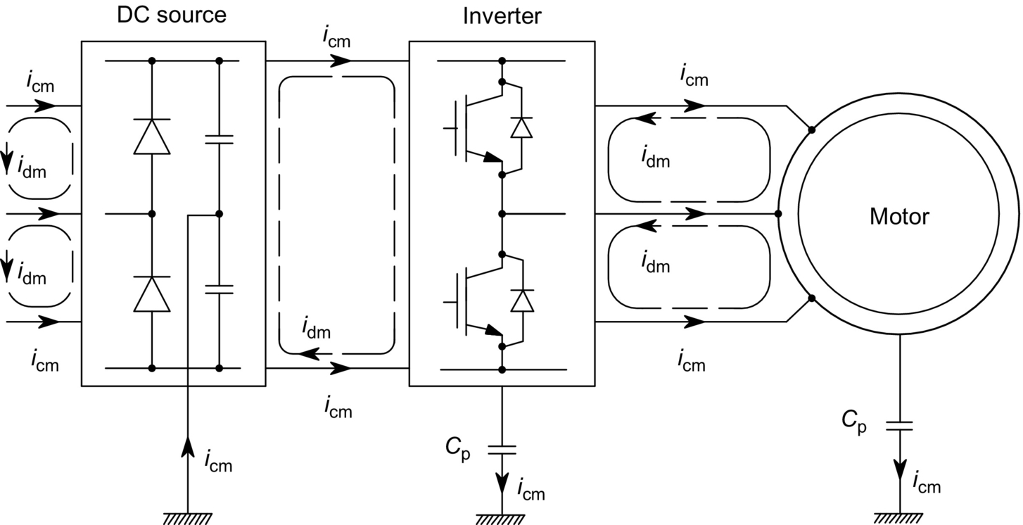

**FIG. 42.1** AC drive system with PWM voltage-source inverter.

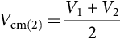 **(42.1)**

and the rms DM voltage, *V*dm(2), as

 **(42.2)**

where *V*1 and *V*2 are line-to-ground voltages of the two wires. The rms CM and DM currents, *I*cm(2) and *I*dm(2), are defined as

 **(42.3)**

**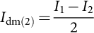** **(42.4)**

For the three-wire supply and load ac lines, the rms CM voltage, *V*cm(3), and current, *I*cm(3), are defined as

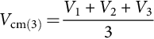 **(42.5)**

**** **(42.6)**

where subscript “3” applies to the third wire. The DM voltage and current, if measured with respect to ac wires 1 and 2, are defined by Eqs. [(42.2)](https://learning.oreilly.com/library/view/power-electronics-handbook/9780128114087/B9780128114070000477.xhtml#fo0015) and [(42.4)](https://learning.oreilly.com/library/view/power-electronics-handbook/9780128114087/B9780128114070000477.xhtml#fo0025) as for the two-wire system.

To illustrate EMI generation by PWM power converters, a typical waveform of output current of the inverter in [Fig. 42.1](https://learning.oreilly.com/library/view/power-electronics-handbook/9780128114087/B9780128114070000477.xhtml#f0010) is shown in [Fig. 42.2](https://learning.oreilly.com/library/view/power-electronics-handbook/9780128114087/B9780128114070000477.xhtml#f0015). The fundamental sine wave dominates, but the high-frequency current ripple is also observable. As seen in [Fig. 42.3](https://learning.oreilly.com/library/view/power-electronics-handbook/9780128114087/B9780128114070000477.xhtml#f0020), numerous clusters of higher harmonics appear in the frequency spectrum of the current. Their locations coincide with multiples of the switching frequency (here 2 kHz), which, as in all PWM converters, is much higher than the fundamental frequency (here 9 Hz) of the ac output (or input) voltage.

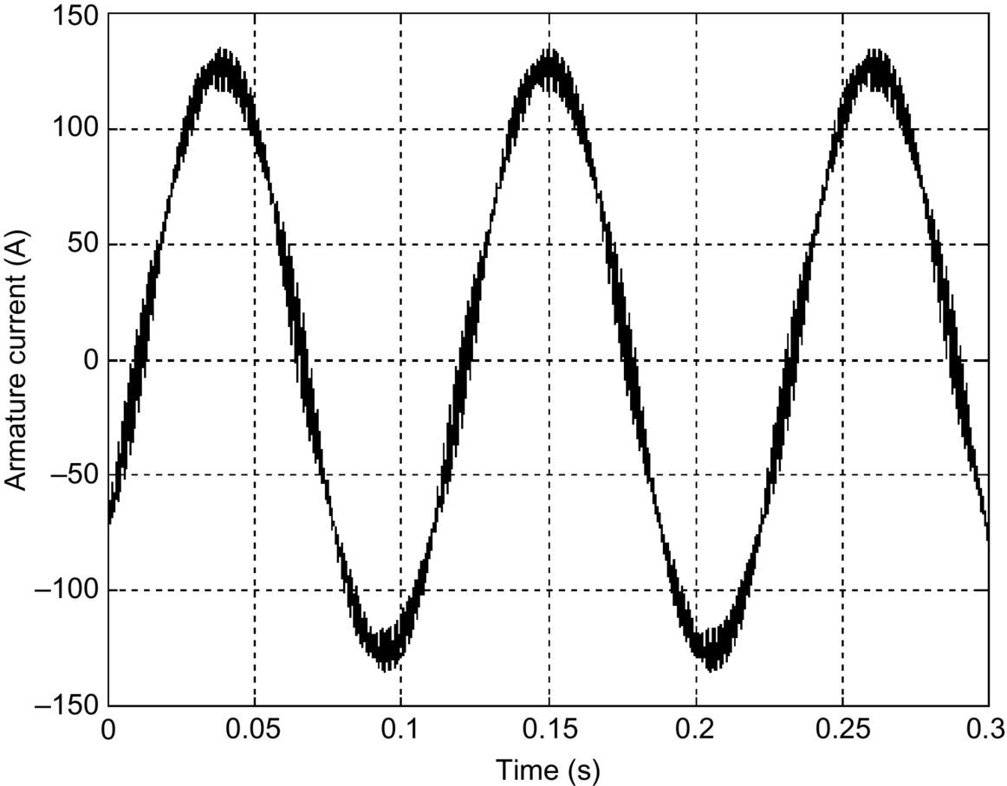

**FIG. 42.2** Waveform of output current of PWM voltage-source inverter.

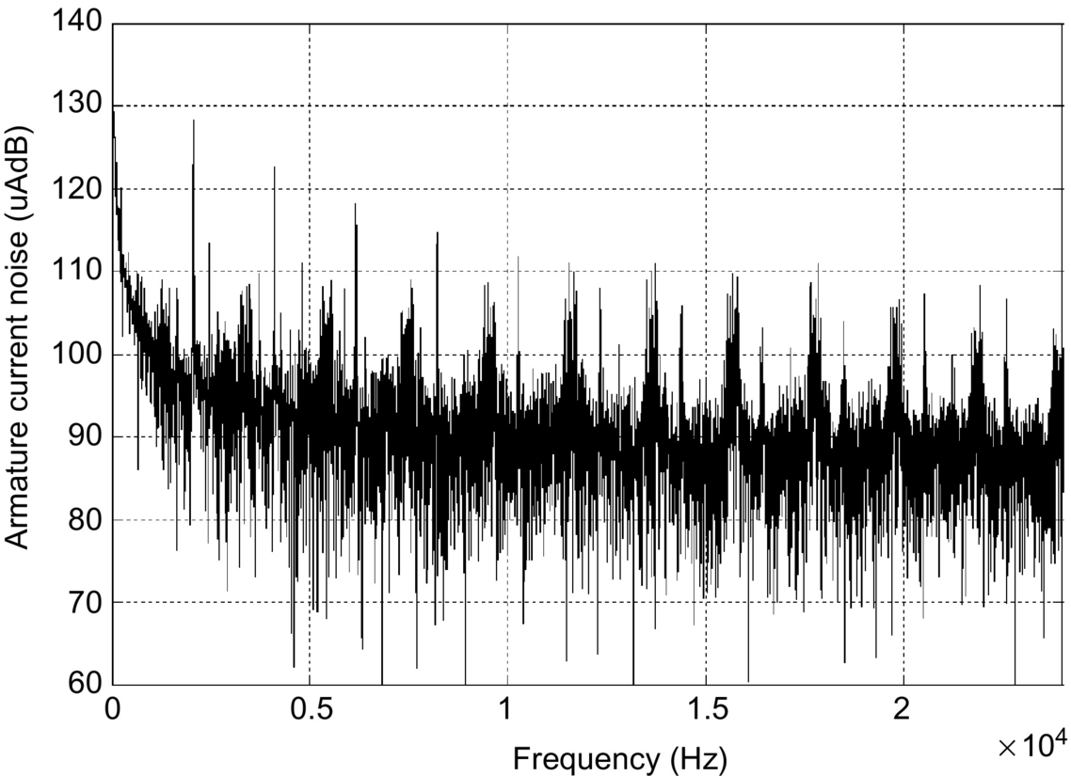

**FIG. 42.3** Frequency spectrum of current in [Fig. 42.2](https://learning.oreilly.com/library/view/power-electronics-handbook/9780128114087/B9780128114070000477.xhtml#f0015).

The range of frequency in [Fig. 42.3](https://learning.oreilly.com/library/view/power-electronics-handbook/9780128114087/B9780128114070000477.xhtml#f0020) is narrow (24 kHz). A wide-range frequency spectrum of current of another inverter is shown in [Fig. 42.4](https://learning.oreilly.com/library/view/power-electronics-handbook/9780128114087/B9780128114070000477.xhtml#f0025). It can be seen that the harmonics become progressively less prominent when the frequency increases. This observation justifies the already mentioned focus on the frequencies below 30 MHz.

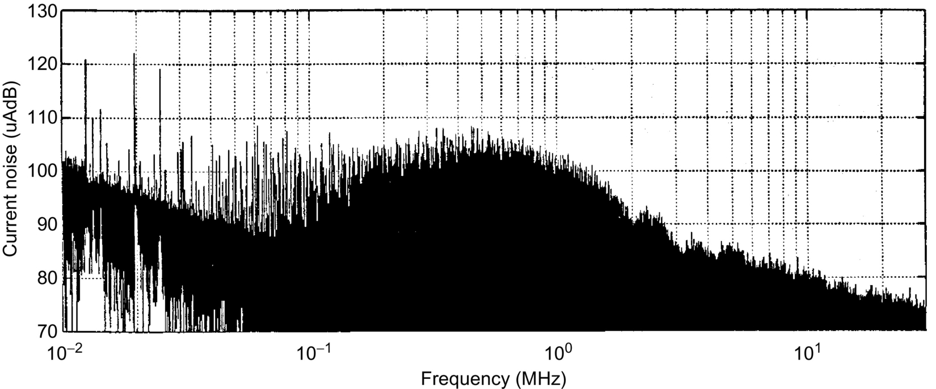

**FIG. 42.4** Wide-range frequency spectrum of inverter current.

The fast ON-OFF and OFF-ON state transition of switches, whose switching times are typically in the order of a fraction of microsecond, also causes EMI. It is due to the high *dv*/*dt* ratios, which generate transient charge currents in the interwire capacitances of cables, intrawinding capacitances of transformers and p-n junctions of power diodes. Transient circuit-to-ground currents through parasitic capacitances also produce EMI. If not filtered out, the transients appear in current waveforms as spikes on top of the fundamental sinusoid. The circuit-to-ground current spikes constitute CM emissions, whereas the ripple current and periodic current spikes, coincident with the switching pattern of the converter, comprise DM emissions.

Power electronic converters tend to generate current-related interference at their input, injecting noise to the power grid, and voltage-related interference at their outputs. It may disturb operation of communication and control systems in proximity to the converter. Considering the popular low-power dc-to-dc converters, the flyback and buck converters produce particularly noisy input currents because the semiconductor switch is directly in series with the input power line. In conjunction with the finite source impedance, the EMI from dc-to-dc converters conducted by the line can cause disturbance of operation of system operating from a common power bus. Disturbances can also be caused by emissions radiated from converters with very high switching frequencies. The radiated EMI is most often a magnetic field, due to the typically low voltages and high currents involved, but electric fields can sometimes also be a nuisance, especially with respect to the own control circuitry of the converter. Power lines can also radiate EMI produced by the current noise drawn from converters.

## 42.3 Measurements of Conducted EMI

Mitigation of conducted EMI is of major practical importance in power electronic systems. Therefore, the topic of EMI measurements in this chapter is limited to the 10 kHz–30 MHz frequency range. The related terms, units, instruments, and techniques are subsequently described. Concerning the radiated interference, the reader is referred to one of many publications covering the radio-frequency (RF) aspects of EMC, for example [[1](https://learning.oreilly.com/library/view/power-electronics-handbook/9780128114087/B9780128114070000477.xhtml#bb0010)–[5](https://learning.oreilly.com/library/view/power-electronics-handbook/9780128114087/B9780128114070000477.xhtml#bb0030)].

The basic quantity of a signal is power. Because of the potentially wide magnitude ranges involved, the decibel (dB) system is often used in which 1 W serves as the reference. In the dB system, signal power, *P*(dBW), expressed in dBW, is calculated from the power in watts, *P*(W), as

 **(42.7)**

If milliwatts, mW, often abbreviated as “m,” is considered; then

 **(42.8)**

However, in EMI measurements, it is voltage that is commonly used, and voltage probes are employed. Power is proportional to the square of voltage. Thus, taking 1 V as reference, voltage in the logarithmic scale, *V*(dbV), is defined as

 **(42.9)**

In practice, the reference voltage is usually 1 μV, and

 **(42.10)**

If the commonly used resistance of 50 Ω is employed in the measurements, conversions of *P*(dBm) into V(dB*μ*V) and vice versa can be made from the equation:

 **(42.11)**

Current probes for EMI measurements are used when limits on conducted EMI are expressed in units of current. Denoting the terminal-pair transfer impedance of a current probe by *Z*T, current expressed in dB*μ*A, is given by

 **(42.12)**

where

 **(42.13)**

To characterize broadband coherent (continuous spectrum) signals, an amplitude density function, *A*, is used in place of a discrete amplitude measure. The so-called broadband unit is 1 V/Hz. In EMC techniques, the 1 μV/MHz unit is more convenient. The conversion equations are

 **(42.14)**

and

 **(42.15)**

where *B*(MHz) is the measurement bandwidth, usually 9 kHz, that is, 0.009 MHz.

Conducted emissions are measured using EMI receivers, which usually measure voltage from an appropriate probe. Basically, the EMI receiver is a tunable voltmeter; its block diagram is shown in [Fig. 42.5](https://learning.oreilly.com/library/view/power-electronics-handbook/9780128114087/B9780128114070000477.xhtml#f0030). Modern EMI receivers cover extremely wide frequency ranges, for example, from 9 kHz to 18 GHz.

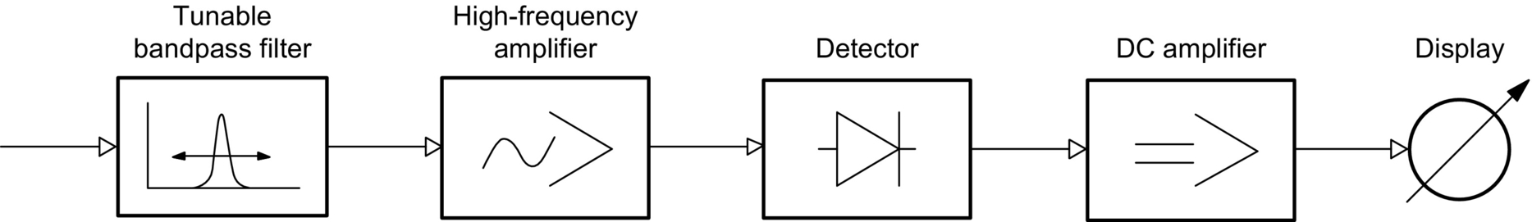

**FIG. 42.5** Block diagram of EMI receiver.

To allow comparison of EMI measurement results, precise specifications for the detector have been established. The most common types are peak, quasi-peak, and average detectors. They are based on RC circuits having different charging and discharging time constants. It must be mentioned that the displays are usually calibrated to the rms value of an equivalent sinusoidal signal, whereas the actual detector often measures a different characteristic of the culprit noise.

Measurement of the peak EMI is important because of the ubiquity of impulsive sources and sensitivity of many types of electronic circuits to impulses. The peak detectors have a short charging time constant, in the order of a fraction of microsecond, and a very long discharging time constant, in the order of tens of seconds. The quasi-peak detectors, strongly recommended by CISPR, have been primarily developed to emulate the human ear acting as a broadcast disturbance sensor. The charging and discharging time constants are 1 and 160 ms, respectively. The average detector is characterized by a long integration time constant, in the order of a second. For the 0.15–30 MHz frequency range, CISPR requires that an EMI measuring instrument have a 9 kHz bandwidth of the filter at 6 dB (from  to kHz from the central frequency value) and that the measurement accuracy for a sinusoidal signal be less than 2 dB.

To increase the accuracy within wide ranges of the frequency and magnitude of signals, modern EMI receivers have several measuring channels. Each channel contains an independent quasi-peak detector, and the saturation and threshold levels of individual channels differ from each other. Output signals of the detectors are added in a circuit operating the display.

For comparability of EMI measurements, an interface circuit is inserted between the EMI source and the mains. This circuit is called a line impedance stabilization network (LISN) or artificial mains. The LISN produces a standard load impedance for the EMI source and filters out high-frequency disturbances on the mains, which could distort measurement results. An example of single-phase LISN recommended by CISPR 16—a publication devoted to proper EMI testing—is shown in [Fig. 42.6](https://learning.oreilly.com/library/view/power-electronics-handbook/9780128114087/B9780128114070000477.xhtml#f0035). In the equipment under test (EUT) block, the positive and negative line terminals are denoted by P and N, respectively, whereas grounded terminal is denoted by G. The load resistance, *R*L, specified by CISPR 16 is 50 Ω. The switch, S, allows transition from the CM to DM measurements. Three-phase LISNs are also available. Refer to the manual of a given LISN for operating instructions.

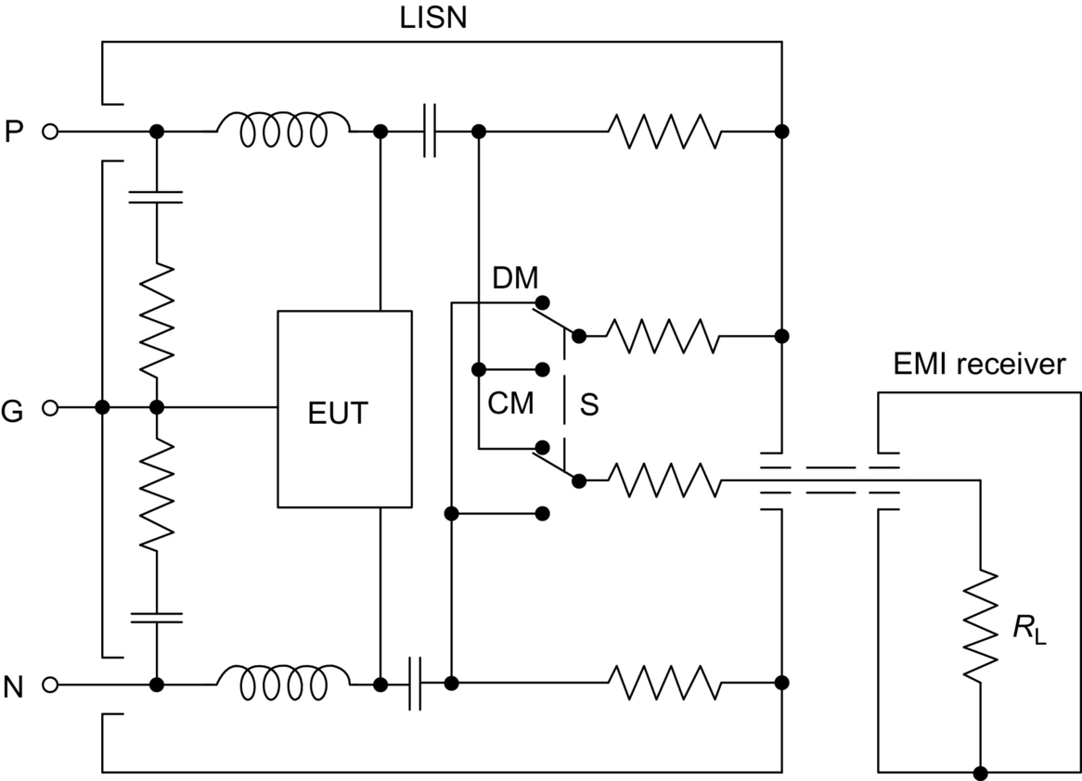

**FIG. 42.6** Simplified circuit diagram of a LISN.

For quick qualitative EMI measurements, for example, when developing an EMI filter, a spectrum analyzer can be employed. A direct view of the interference levels over a wide frequency range is very convenient. The frequency axis can be switched to a linear or logarithmic scale, whereas the magnitude is usually displayed in dBm. True peak and average detectors are available. Spectrum analyzers are rms calibrated, so that the reading is correct for sinusoidal waveforms only, such as discrete harmonics of the measured noise. For impulse disturbances, correct peak values are obtained. For broadband measurements, corrections must be made to convert the true peak to quasi-peak and to account for the difference in measurement bandwidths. For help, refer to the manual of a given spectrum analyzer.

Technical details of EMI measurements for EMC compliance are too vast, a topic to be fully covered here. The reader is referred to such authoritative sources as the already mentioned CISPR publication 16 and books [[1](https://learning.oreilly.com/library/view/power-electronics-handbook/9780128114087/B9780128114070000477.xhtml#bb0010)–[6](https://learning.oreilly.com/library/view/power-electronics-handbook/9780128114087/B9780128114070000477.xhtml#bb0035)].

## 42.4 EMI Filters

EMI generated in power electronic systems usually exceeds the allowable levels, so it must be reduced. The most common means of EMI mitigation are low-pass filters, often called radio-frequency (RF) filters. They are installed on the input and output sides of power converters. The filters are simple capacitive (C) or inductive-capacitive (LC) circuits. Resistors are sometimes added to dampen possible resonances caused by converters with high switching frequencies.

Choke coils are employed as the inductive components of the filters. They are usually single-layer solenoid structures with relatively low coefficients of inductance. In the case of CM EMI filters, two or three windings are placed on the same closed iron core. The windings are so arranged that the coil impedance for the CM noise is high, but that for the load current and DM noise is low. A single-phase CM choke coil is shown in [Fig. 42.7](https://learning.oreilly.com/library/view/power-electronics-handbook/9780128114087/B9780128114070000477.xhtml#f0040). Again, letters P, N, and G denote the positive, negative, and ground terminals of the mains. It can be seen that magnetomotive forces ℱL and ℱdm produced by the load current *i*L and DM noise current *i*dm in the upper and lower parts of the coil cancel each other. As a result, the magnetic flux Φcm12 in the core is generated only by magnetomotive forces ℱcm1 and ℱcm2 produced by the CM noise currents *i*cm1 and *i*cm2.

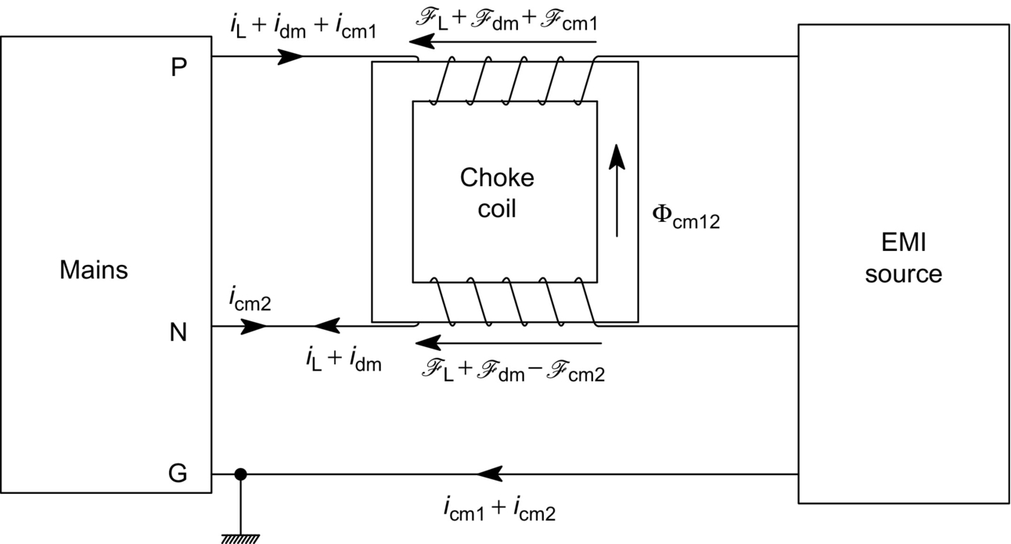

**FIG. 42.7** Single-phase CM choke coil.

Capacitors employed in EMI filters must have low parasitic series inductance, low dielectric and ohmic losses, and stable capacitance versus frequency characteristics. Paper, metalized paper, polystyrene, and ceramic capacitors are widely used. The so-called multifunction ceramic (MFC) capacitors can suppress the high-frequency noise and absorb impulse-type transients. According to their electric connection mode, capacitors in power line filters can be classified as X and Y capacitors, the former posing no threat of electric shock to personnel, even in the case of a breakdown. Y capacitors are typically used for attenuation of the CM noise in power line filters, but they require stricter safety standards and higher reliability than X capacitors.

To reduce the parasitic inductance, contributed mostly by the leads, the so-called feedthrough capacitors have been developed for use in EMI filters. The wire conducting the load current passes through the capacitor structure, instead of the capacitor being connected between it and the ground. This is illustrated in [Figs. 42.8](https://learning.oreilly.com/library/view/power-electronics-handbook/9780128114087/B9780128114070000477.xhtml#f0045) and [42.9](https://learning.oreilly.com/library/view/power-electronics-handbook/9780128114087/B9780128114070000477.xhtml#f0050). [Fig. 42.8A](https://learning.oreilly.com/library/view/power-electronics-handbook/9780128114087/B9780128114070000477.xhtml#f0045) shows the structure of the feedthrough capacitor, and its electric symbol is shown in [Fig. 42.8B](https://learning.oreilly.com/library/view/power-electronics-handbook/9780128114087/B9780128114070000477.xhtml#f0045). [Fig. 42.9A](https://learning.oreilly.com/library/view/power-electronics-handbook/9780128114087/B9780128114070000477.xhtml#f0050) shows that in a conventional capacitor, the parasitic inductances, *L*p, of the leads are in series with the capacitance, *C*. The total inductance is thus 2*L*p. In contrast, as seen in [Fig. 42.9B](https://learning.oreilly.com/library/view/power-electronics-handbook/9780128114087/B9780128114070000477.xhtml#f0050), in the feedthrough capacitor, lead inductances are connected in parallel to each other, so that the total inductance is *L*p/2.

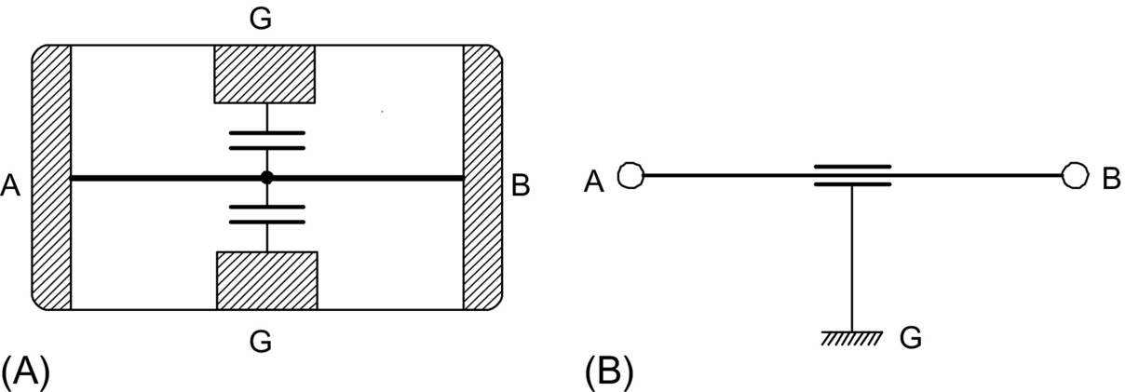

**FIG. 42.8** Feedthrough capacitor: (A) structure and (B) electric symbol.

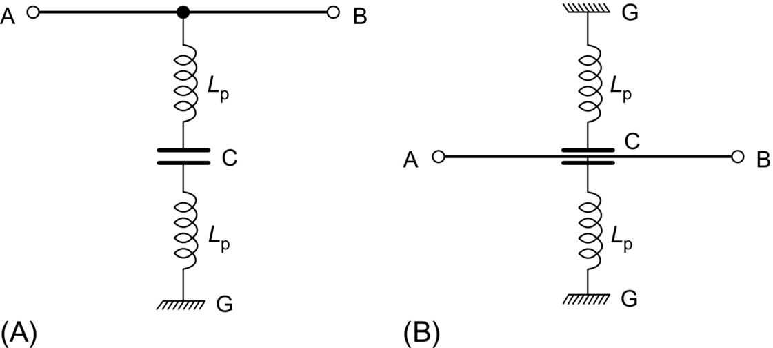

**FIG. 42.9** Parasitic inductances of the leads: (A) conventional capacitor and (B) feedthrough capacitor.

From the very beginning of modern power electronics, capacitors have been employed in the so-called snubbers. In the simplest embodiment, a snubber circuit consists of a capacitor with a resistor connected in series to dampen possible resonance with parasitic inductances. The snubber is placed across a semiconductor power switch to improve the switching conditions and keep the switch within its safe operating area. Snubbers reduce the EMI, which is particularly strong when the switch turns off and interrupts the load current.

Noise suppression capacitors connected to various other points in a power electronic system are also widely used, although they do not mitigate the EMI as effectively as LC filters with choke coils. Capacitive filters most often appear at the input and output of power electronic converters. They can be connected between lines or line to ground.

Basic topologies of low-pass LC filters are illustrated in [Fig. 42.10](https://learning.oreilly.com/library/view/power-electronics-handbook/9780128114087/B9780128114070000477.xhtml#f0055). It must be stressed that EMI filters must be placed in all wires of a power electronic system. Most common configurations are shown in [Fig. 42.11](https://learning.oreilly.com/library/view/power-electronics-handbook/9780128114087/B9780128114070000477.xhtml#f0060) for a two-wire system. The filters attenuate both the CM and DM conducted EMI. An extension of the T-type filter on a three-wire system is shown in [Fig. 42.12](https://learning.oreilly.com/library/view/power-electronics-handbook/9780128114087/B9780128114070000477.xhtml#f0065). Similar extension can be made with respect to the other topologies of filters.

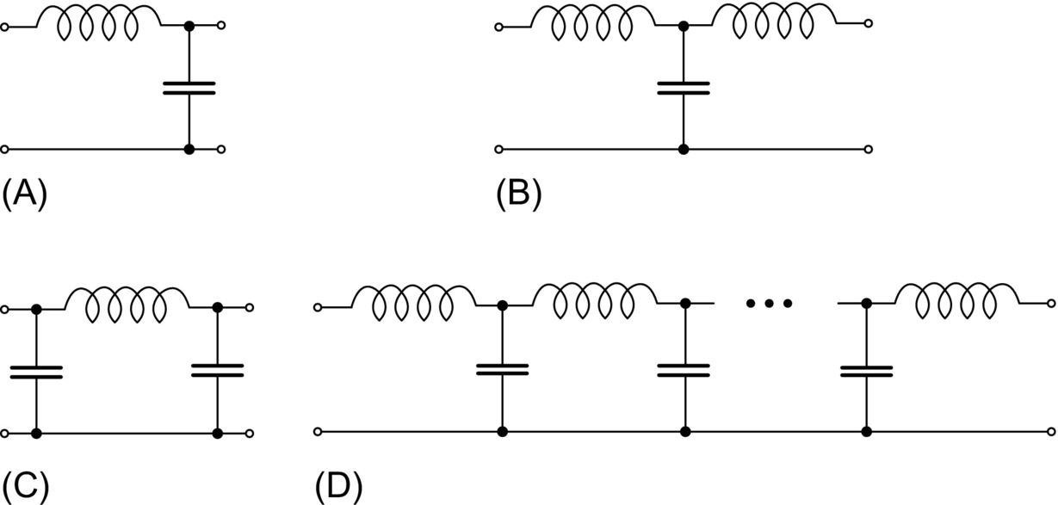

**FIG. 42.10** Basic topologies of low-pass LC filters: (A) inverted gamma (Γ′), (B) pi (*Π*), (C) tee (T), and (D) multistage.

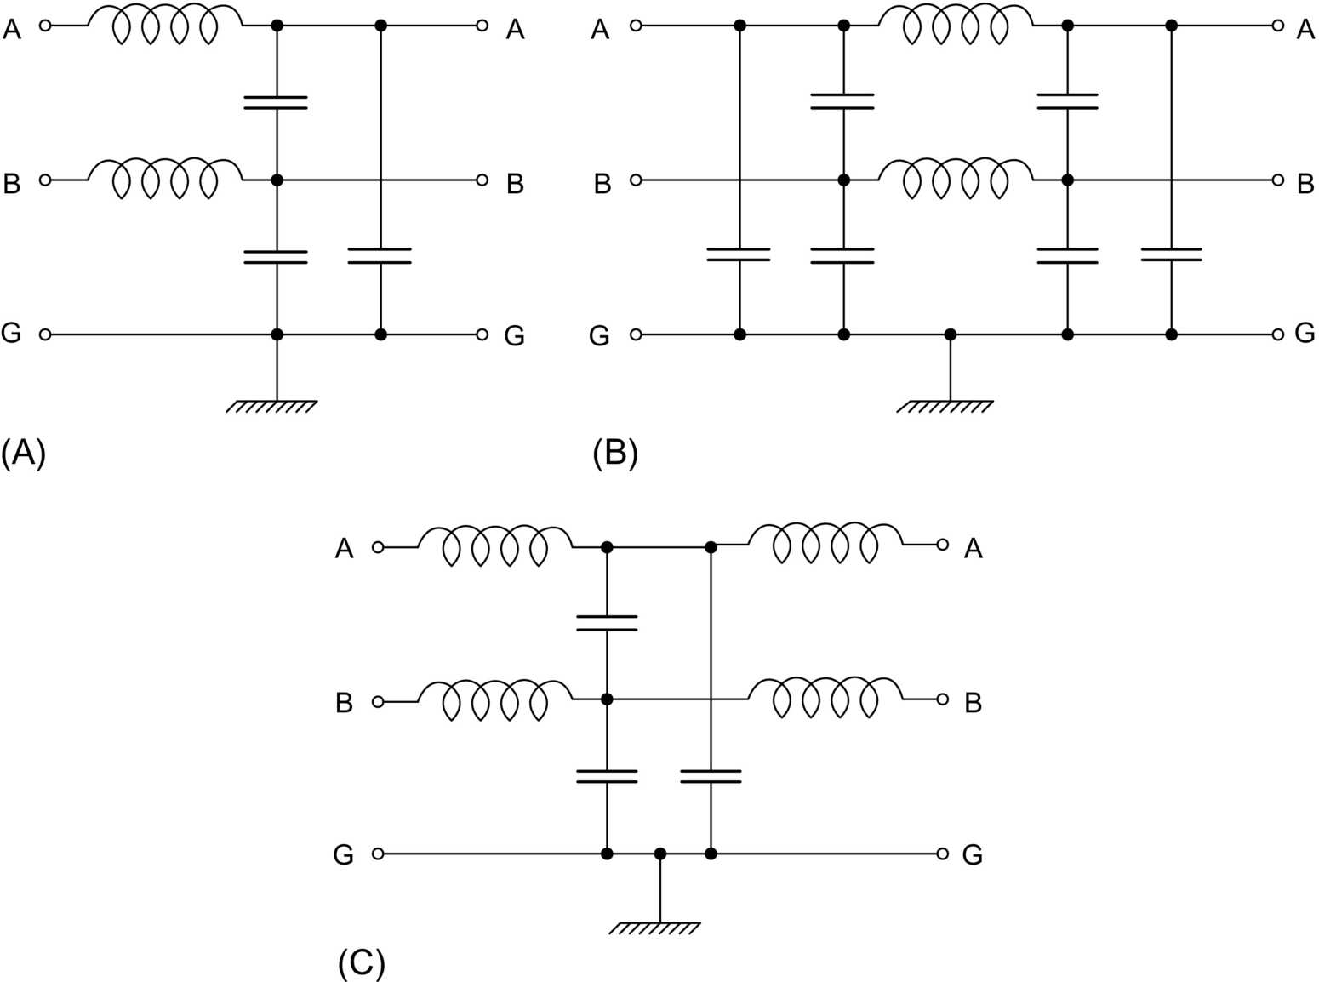

**FIG. 42.11** EMI filters in a two-wire power electronic system: (A) inverted gamma (Γ′), (B) pi (*Π*), and (C) tee (T).

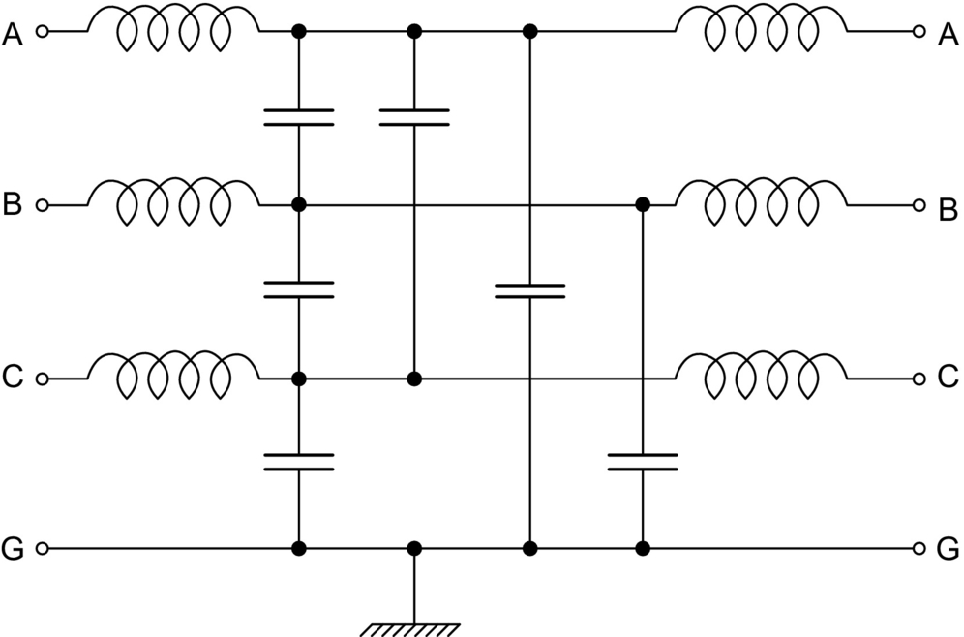

**FIG. 42.12** T-type EMI filter in a three-wire power electronic system.

An example arrangement of the CM and DM EMI filters in the ac drive system of [Fig. 42.1](https://learning.oreilly.com/library/view/power-electronics-handbook/9780128114087/B9780128114070000477.xhtml#f0010) is shown in [Figs. 42.13](https://learning.oreilly.com/library/view/power-electronics-handbook/9780128114087/B9780128114070000477.xhtml#f0070) and [42.14](https://learning.oreilly.com/library/view/power-electronics-handbook/9780128114087/B9780128114070000477.xhtml#f0075), respectively. In the actual system, both types of filters are installed, and the two separate circuit diagrams have been used for an instructional purpose only.

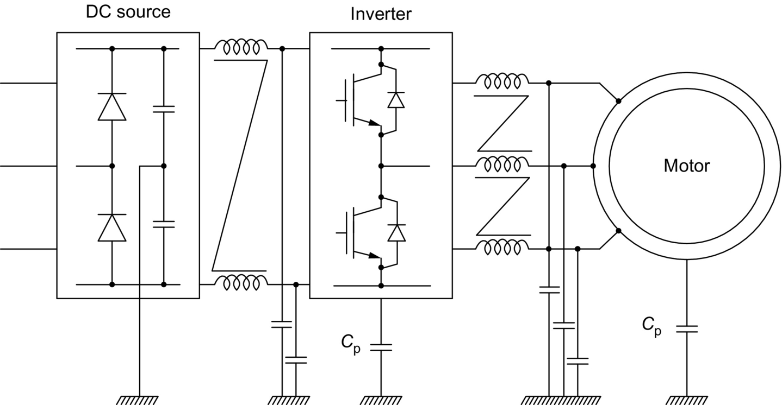

**FIG. 42.13** Placement of CM EMI filters in the drive system of [Fig. 42.1](https://learning.oreilly.com/library/view/power-electronics-handbook/9780128114087/B9780128114070000477.xhtml#f0010).

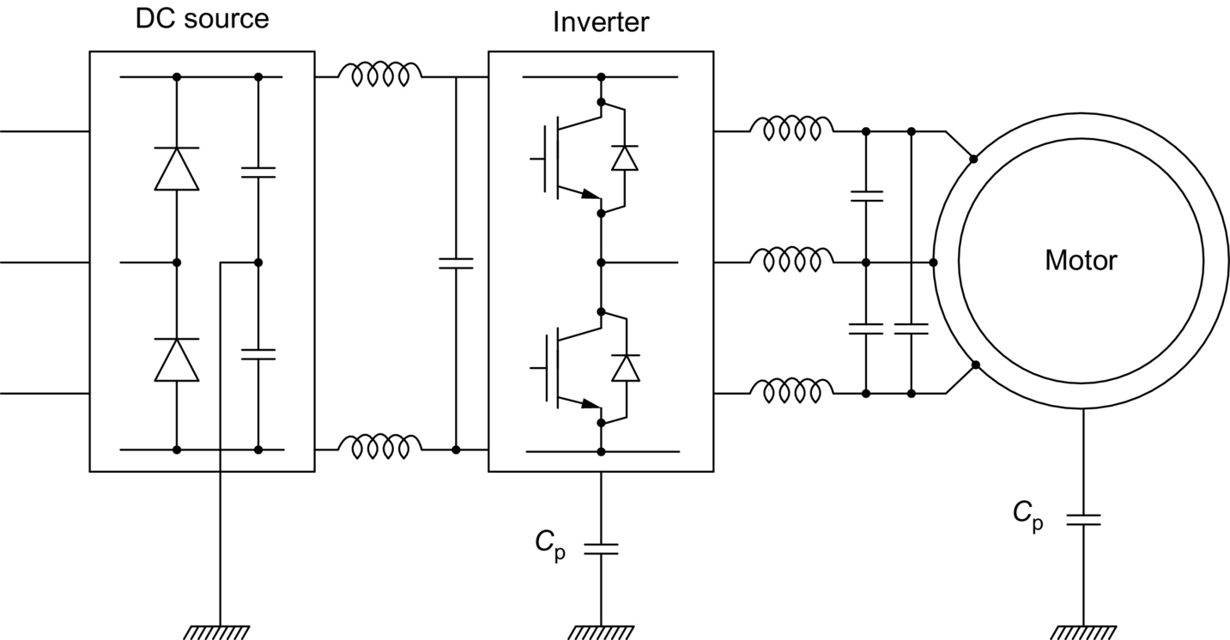

**FIG. 42.14** Placement of DM EMI filters in the drive system of [Fig. 42.1](https://learning.oreilly.com/library/view/power-electronics-handbook/9780128114087/B9780128114070000477.xhtml#f0010).

The main parameter of EMI filters is the insertion loss (IL). For a given frequency, *f*, IL can be determined by measuring the voltage, *V*G, of a sinusoidal signal generator and then connecting the filter to the generator and measuring the voltage, *V*F, at the filter's output. Then,

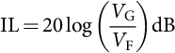 **(42.16)**

The insertion loss is usually given as an IL(*f*) graph with logarithmic coordinates. For filter design, the two-port network theory is employed, using the transmission, *A*, parameters expressing the dynamic relations between the input and output variables of a two-port network. Specifically,

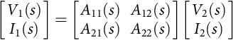 **(42.17)**

where *V*1 denotes the input (EMI-source side) voltage of the network, *I*1 is the input current, *V*2 is the output voltage, and *I*2 is the output current, whereas *s* denotes the Laplace variable (complex frequency). The transmission parameters are defined as

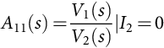 **(42.18)**

**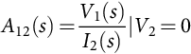** **(42.19)**

**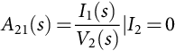** **(42.20)**

**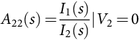** **(42.21)**

Once the transmission parameters for a given filter are determined using the transient analysis of its circuit, the insertion loss can be found from the following equation:

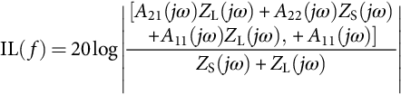 **(42.22)**

where . Then, the IL(*f*) graph can be plotted, as illustrated in [Fig. 42.15](https://learning.oreilly.com/library/view/power-electronics-handbook/9780128114087/B9780128114070000477.xhtml#f0080) for an actual commercial EMI filter.

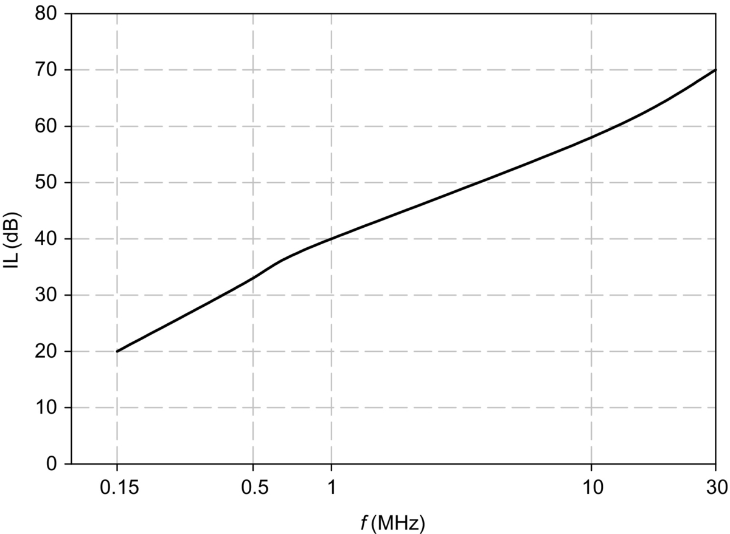

**FIG. 42.15** An example insertion loss versus frequency graph for an EMI filter.

The insertion loss is approximately proportional to the total inductance and capacitance (total LC) and square of the frequency. Because of the cost and size associated with the total LC value of the filter, an optimal filter is the one with a minimum total LC value, which still mitigates the EMI sufficiently to satisfy the pertaining norm. A difficulty in optimizing the EMI filter design consists in the mismatched impedance conditions under which the filters operate. From the point of view of a manufacturer of the filters, the source and load impedances are unknown. However, from the user's viewpoint, estimating the source and load impedances allows for better selection of the filter configuration. Specifically, for low source and load impedance, the “T” filter is recommended. The “*Π*” configuration is best for high source and load impedance, whereas for low source and high load impedance, the “Γ′” (LC) filter is preferred. Finally, for high source and low load impedance, the “*Γ*” (CL) topology is favored. If possible, multiple-stage filter topologies should be employed.

Practical design of EMI filters is complicated by the fact that there are no ideal inductors and capacitors. Considering the equivalent electric circuit of an inductor in [Fig. 42.16A](https://learning.oreilly.com/library/view/power-electronics-handbook/9780128114087/B9780128114070000477.xhtml#f0085) and that of a capacitor in [Fig. 42.16B](https://learning.oreilly.com/library/view/power-electronics-handbook/9780128114087/B9780128114070000477.xhtml#f0085), it can be seen that at very high frequencies, the impedance of the parasitic components, marked by the subscript “p,” may dominate that of the main component. Thus, the reactance of the parasitic capacitance, *C*p, of the inductor can make the overall impedance to decrease with the frequency, and the reactance of the parasitic inductance, *L*p, of the capacitor can make the overall impedance of the capacitor to increase. That is why manufacturers of EMI filters and their components go to great lengths to minimize the parasitics.

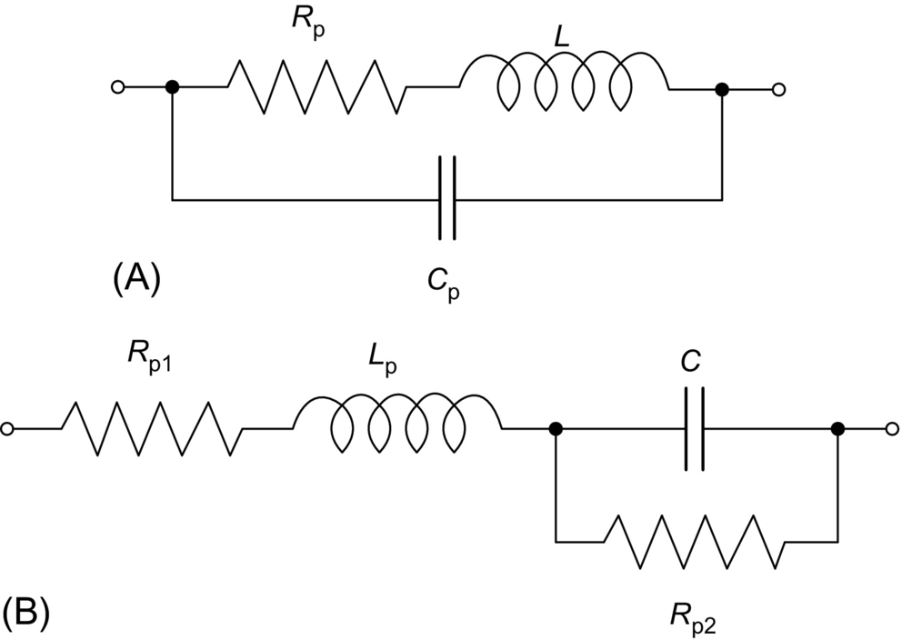

**FIG. 42.16** High-frequency equivalent circuits of (A) capacitor and (B) inductor.

In the common case of power electronic converters fed from the grid, the so-called power line filter is installed between the grid and converter. It protects the converter and its load from external disturbances and, vice versa, screens out the grid from EMI generated in the converter. Voltage impulses originated within the grid are particularly hazardous for the converter, and varistors are used in the filter to attenuate the impulses. An example of commercial power line filter is shown in [Fig. 42.17](https://learning.oreilly.com/library/view/power-electronics-handbook/9780128114087/B9780128114070000477.xhtml#f0090). In the drive system in [Fig. 42.1](https://learning.oreilly.com/library/view/power-electronics-handbook/9780128114087/B9780128114070000477.xhtml#f0010), the filter would be connected to the three-phase input terminals of the dc source (rectifier).

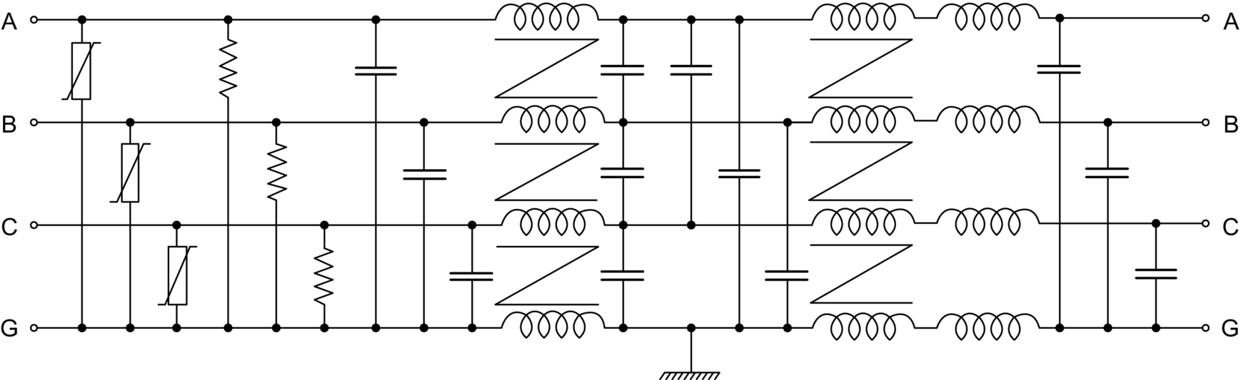

**FIG. 42.17** Power line filter.

Numerous vendors offer a variety of power line and EMI filters with a wide range of voltage and current ratings. Thus, designers of power converters and converter-fed systems have a choice of quality products, without the need for designing their own filters. Useful details of the process of EMI filters design can be found in [[7](https://learning.oreilly.com/library/view/power-electronics-handbook/9780128114087/B9780128114070000477.xhtml#bb0040),[8](https://learning.oreilly.com/library/view/power-electronics-handbook/9780128114087/B9780128114070000477.xhtml#bb0045)].

Active EMI filters, although very effective, are less common than the passive filters described because of their increased complexity and cost. They are based on the feedback principle, generating currents that neutralize the noise currents. In the dc-to-dc converters, they are also employed to limit inrush currents, for example, during the so-called hot swapping, when a faulty electronic board is replaced without interrupting operation of the system. In certain three-phase systems with power converters such as ac drives, the CM voltage noise, apart from producing external interference, causes internal problems, for example, accelerated wear of bearings. The so-called CM voltage cancellers are one of the means to mitigate those problems. Such a voltage canceller in the drive system of [Fig. 42.1](https://learning.oreilly.com/library/view/power-electronics-handbook/9780128114087/B9780128114070000477.xhtml#f0010) is shown in [Fig. 42.18](https://learning.oreilly.com/library/view/power-electronics-handbook/9780128114087/B9780128114070000477.xhtml#f0095).

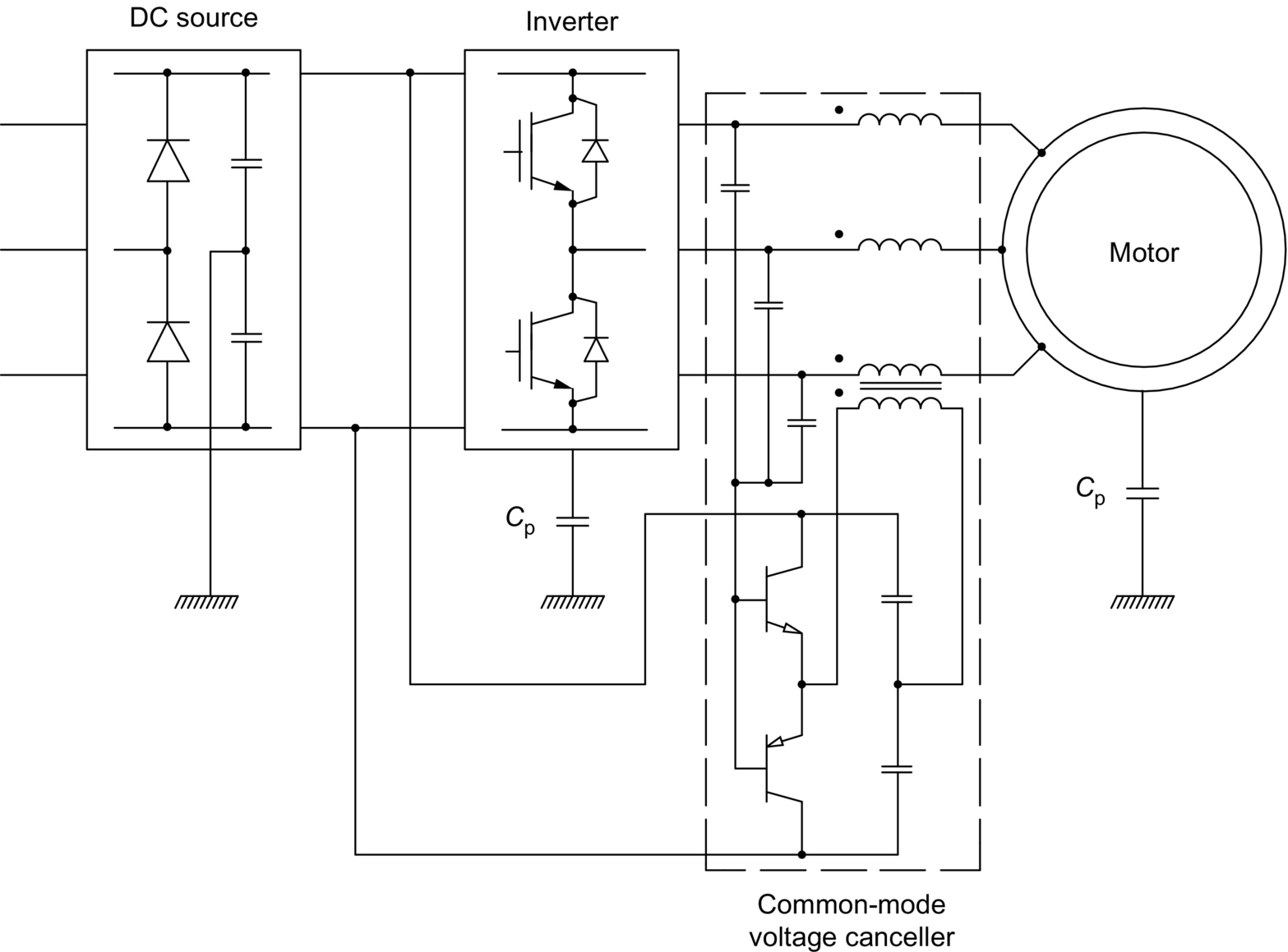

**FIG. 42.18** Common-mode voltage canceller.

## 42.5 Random Pulse Width Modulation

Suppression of the low-frequency noise originating from the PWM operating mode of most power converters is particularly difficult. As already pointed out in [Section 42.1](https://learning.oreilly.com/library/view/power-electronics-handbook/9780128114087/B9780128114070000477.xhtml#s0010), the noise, mostly harmonics of the voltages and currents, appears in the frequency spectra as harmonic clusters around multiples of the switching frequency, *f*sw. As seen in [Fig. 42.3](https://learning.oreilly.com/library/view/power-electronics-handbook/9780128114087/B9780128114070000477.xhtml#f0020), the highest magnitudes of the harmonics appear at the lower end of the frequency range, while the insertion loss of EMI filters progressively increases with the frequency, as shown in [Fig. 42.15](https://learning.oreilly.com/library/view/power-electronics-handbook/9780128114087/B9780128114070000477.xhtml#f0080). Thus, at low frequencies, effectiveness of the filters decreases. Increasing the total LC value helps, but it results in corresponding increase of the cost and bulk of the filters. Therefore, mitigation of harmonics by means of special PWM strategies is the best solution for filter minimization.

Most of the commercial PWM power converters are characterized by a fixed switching frequency, *f*sw, defined here as a reciprocal of the switching period, *T*sw. The switching period constitutes the length of a switching interval, which houses pulses of switching variables of the converter, one pulse per variable. Duty ratio of a given pulse varies from 0 to 1; that is, the width (duration) of the pulse is in the range of . It has been demonstrated in many publications, for example, [[9](https://learning.oreilly.com/library/view/power-electronics-handbook/9780128114087/B9780128114070000477.xhtml#bb0050)] that if individual switching periods are randomly varied, then the discrete harmonic power (watts) of spectra of the voltages and currents of the converter is transferred to continuous power spectral density (watts/hertz). This strategy of random pulse-width modulation (RPWM) results in significant mitigation of both the acoustic and electromagnetic noise associated with the current harmonics [[10](https://learning.oreilly.com/library/view/power-electronics-handbook/9780128114087/B9780128114070000477.xhtml#bb0055),[11](https://learning.oreilly.com/library/view/power-electronics-handbook/9780128114087/B9780128114070000477.xhtml#bb0060)]. Accumulated experience and theoretical considerations show that varying *T*sw from 0.5 to 1.5 of the average switching period, *T*sw,ave, is sufficient. Thus, the *n*th switching period is determined as

 **(42.23)**

where *rn* is a uniform-probability random number in the 0–1 range.

For convenience, in practical digital modulators for PWM converters, the switching cycles coincide with the sampling cycles of the modulator, that is, , where *f*smp denotes the sampling frequency (not to be confused with the much higher clock frequency). Consequently, the varying switching rate is associated with identically varying sampling rate. When a single digital system performs more tasks than just PWM, the random sampling rate is a disadvantage. For instance, in a control system, the sampling rate defines the control bandwidth, and it is selected at a specific trade-off level. Therefore, an RPWM technique with a fixed sampling rate but variable switching frequency is more practical. [Fig. 42.19](https://learning.oreilly.com/library/view/power-electronics-handbook/9780128114087/B9780128114070000477.xhtml#f0100) illustrates (A) the most common, nonrandom PWM technique with fixed-period and coinciding sampling and switching cycles; (B) RPWM with randomly varied and coinciding sampling and switching cycles; and (C) RPWM with fixed sampling periods and randomly varied switching periods, subsequently referred to as variable-delay RPWM (VD-RPWM).

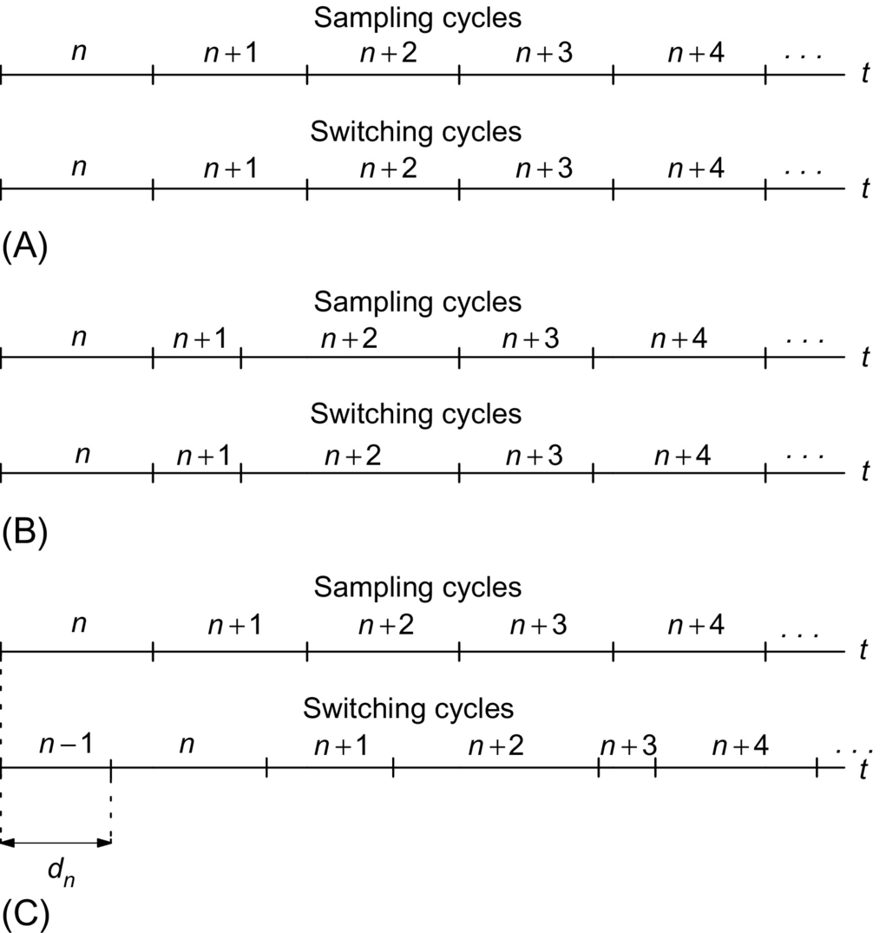

**FIG. 42.19** Illustration of PWM techniques: (A) fixed-period and coinciding sampling and switching cycles, (B) randomly varied and coinciding sampling and switching cycles, and (C) fixed-period sampling cycles and variable-period switching cycles (VD-RPWM).

As seen in [Fig. 42.19C](https://learning.oreilly.com/library/view/power-electronics-handbook/9780128114087/B9780128114070000477.xhtml#f0100), the switching cycles in the VD-RPWM method are delayed with respect to the corresponding sampling cycles by a randomly varied time delay, *d*. The value of *d* for the *n*th switching cycle is calculated as

 **(42.24)**

where  denotes the sampling period. When in two consecutive switching cycles, denoted by *k* and , *r*k is close to 1, and  is close to 0; the second, , switching cycle may be too short; that is, its length, , may be lower than the minimum allowable length, *T*sw,min. Therefore, in case of such occurrence,  is set to *T*sw,min, or another value of *r*k is selected. As a result, the switching periods vary from *T*min to 2*T*smp. The average switching period, *T*sw,ave, equals the sampling period, *T*smp.

Any PWM strategy based on the concept of switching cycles can be employed within the RPWM method. For instance, the popular space-vector modulation can be used in three-phase voltage-source inverters. As long as the average switching period is sufficiently short, the quality of output current is similar to that in a converter with a fixed switching frequency having the same period. An example spectrum of the output current of a voltage-source inverter controlled using the VD-RPWM is shown in [Fig. 42.20](https://learning.oreilly.com/library/view/power-electronics-handbook/9780128114087/B9780128114070000477.xhtml#f0105). It is the same converter whose current spectrum, with fixed-period PWM, was shown in [Fig. 42.3](https://learning.oreilly.com/library/view/power-electronics-handbook/9780128114087/B9780128114070000477.xhtml#f0020). The noise suppression by 10 dB*μ*A is easily observable. A spectrum corresponding to that in [Fig. 42.4](https://learning.oreilly.com/library/view/power-electronics-handbook/9780128114087/B9780128114070000477.xhtml#f0025) is shown in [Fig. 42.21](https://learning.oreilly.com/library/view/power-electronics-handbook/9780128114087/B9780128114070000477.xhtml#f0110). Here, the EMI mitigation, by about 20 dBμA, is even stronger.

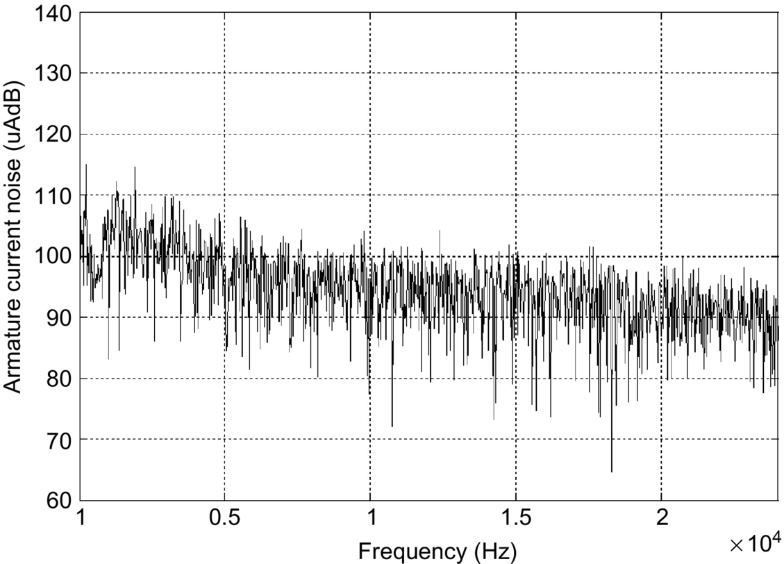

**FIG. 42.20** Frequency spectrum of output current of a voltage-source inverter with VD-RPWM.

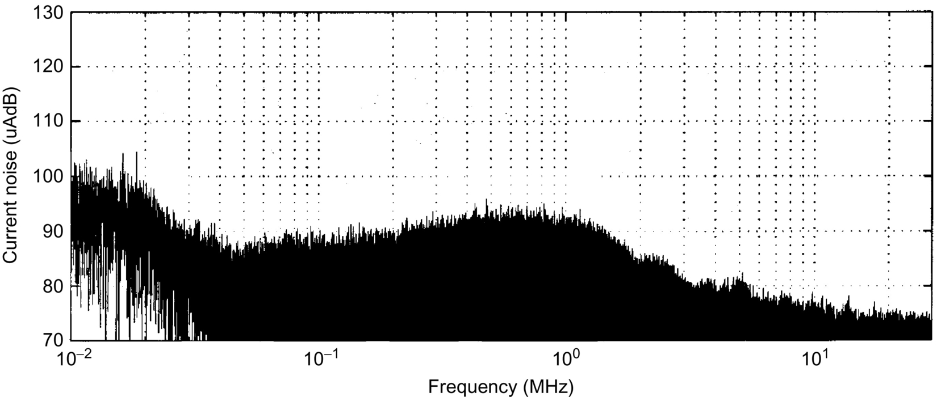

**FIG. 42.21** Wide-range frequency spectrum of inverter current with VD-RPWM.

Although RPWM is not a perfect tool for EMI mitigation, it effectively eliminates high harmonics of the input and output currents and output voltages in PWM power converters. The EMI filters are usually still needed for the suppression of transients, impulses, and high-frequency noise. However, their total LC value can be greatly reduced. The RPWM technique with random switching and sampling periods is a little more effective than the VD-RPWM because of the somewhat greater freedom of randomization, and it is recommended for converters whose pulse-width modulator operates independently of the rest of the system.

It is worth mentioning that PWM techniques have been developed that reduce the CM noise in three-phase inverters by elimination (or significant reduction) of the so-called zero states, in which all the three-phase terminals are clamped by the inverter switches to one of the dc buses. Other solutions involve addition of a fourth leg to the inverter or use of multilevel inverters.

## 42.6 Other Means of Noise Suppression

In addition to filters and PWM methods, means of mitigation of EMI effects in systems with power electronic converters include grounding, shielding, and minimization of electromagnetic coupling. When skillfully used, they can significantly reduce the EMI and circuit susceptibility at a low extra cost.

Effects of grounding on the EMI must be considered in the context of the whole system employing power electronic converters. Grounding of electric equipment has historically been based on the requirements of safe and reliable power distribution, maximum protection against overvoltages (including lightning strikes and electrostatic buildup), and safe-touch conditions for personnel during ground faults. The so-called safety ground (green wire in the United States) protects personnel and equipment by conducting fault current, operating a circuit breaker or fuse, and limiting the voltage to ground during faults. This type of grounding can be termed low-frequency grounding. The earth ground is made using buried rods, plates, or grids. Note that the ground wiring for lightning protection must be isolated from other grounding conductors, and the lightning current may not pass through any circuit breaker or fuse. Considering the drive system in [Fig. 42.1](https://learning.oreilly.com/library/view/power-electronics-handbook/9780128114087/B9780128114070000477.xhtml#f0010) and assuming the “Y” connection of the secondary windings of the supplying transformer, the neutral of the transformer can be ungrounded, directly grounded, or connected to the ground through a resistor. Each of these arrangements has advantages and disadvantages, but the resistance-grounded system has gained the greatest popularity because the line-to-ground faults do not cause immediate shutdown of the system. Proper selection of the grounding resistance allows sufficient limitation of the ground fault currents and the voltage to ground to avoid equipment failures.

The high-frequency grounding, which should be considered separately from the low-frequency scheme, has a strong impact on the CM EMI. The general rule for proper high-frequency grounding design is to understand the CM noise path and to reroute the noise away from the sensitive electronics. A single-point grounding scheme is theoretically the best, although the existence of many stray system-to-ground capacitances makes it practically a multipoint grounding above certain frequencies. Physical capacitors are often used to augment the stray capacitances, for example, between the chassis and the grounding wire, to reduce the CM noise voltage. High-power parts of a system should be connected the closest to the single-point ground, with the most sensitive circuits the furthest from it.

Most practical systems with power converters include cables, for example, those connecting the inverter to the motor in the drive in [Fig. 42.1](https://learning.oreilly.com/library/view/power-electronics-handbook/9780128114087/B9780128114070000477.xhtml#f0010). The cables act as antennas for the radiated EMI, and they are receptors in the electromagnetic coupling. Shielding the cables significantly reduces those unwanted phenomena. Such types of cables as the aluminum-armor or braided-shield ones offer very good protection from EMI. In particular, they prevent interference with sensitive equipment by providing an isolated and predictable metallic path for the CM noise. The shield is usually bonded with the ground wire at both ends of the cable. For industrial installations, such as drive systems in a factory, use of grounded steel conduits to carry cables is a convenient and effective solution. Shielding can also be applied to other than cables, parts of the electronic circuitry, such as circuit enclosures.

As illustrated in [Fig. 42.22](https://learning.oreilly.com/library/view/power-electronics-handbook/9780128114087/B9780128114070000477.xhtml#f0115), the electromagnetic noise coupling can be capacitive (electric field) or inductive (magnetic field). The noise source voltage is denoted by *v*n, and the stray capacitance, *C*12, and mutual inductance, *M*12, link wires 1 and 2 transmitting noise from the source. The coupling capacitances and inductances should therefore be minimized. The simplest, but not always practical, approach is to increase the distances between noise sources and receivers. Shielding is a good protection from electromagnetic noise coupling, and the unshielded leads extending beyond the shield should be possibly short [[12](https://learning.oreilly.com/library/view/power-electronics-handbook/9780128114087/B9780128114070000477.xhtml#bb0065)].

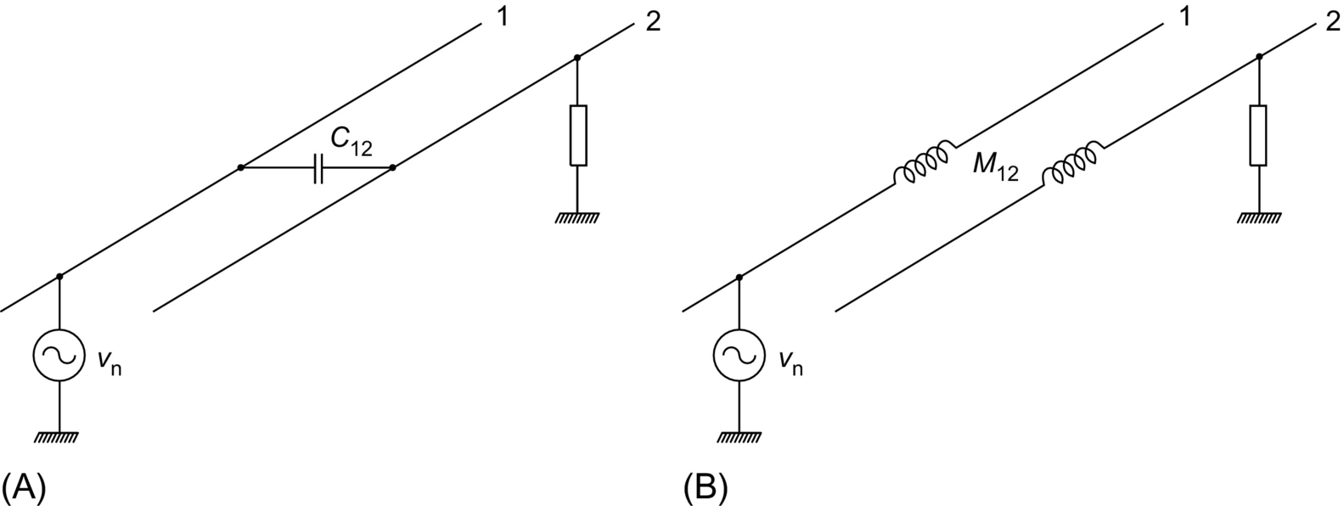

**FIG. 42.22** Electromagnetic coupling: (A) capacitive and (B) inductive.

Electromagnetic noise coupling can also be minimized by proper circuit geometry. The potential noise source should not be placed in parallel to the potential noise receiver. Perpendicular placement is best. Twisting two interconnecting wires helps as well because currents in individual wires flow in opposite directions, producing magnetic fields that cancel each other.

EMI reduction techniques should also be considered at the printed circuit board (PCB) level. Proper grounding, power distribution, and interconnection techniques, depending on whether the PCB contains analog or digital circuitry, improve immunity to both the internal and external noise sources. This highly specialized topic extends the tutorial scope of this publication.

A thorough compendium of various means of EMI mitigation in inverter-fed ac drive systems can be found in [[12](https://learning.oreilly.com/library/view/power-electronics-handbook/9780128114087/B9780128114070000477.xhtml#bb0065)]. It should be stressed that EMI suppression techniques should be considered in early stages of the design. Otherwise, the designed system would be likely to have serious and expensive to fix noise problems.

## 42.7 EMC Standards

The number of institutions involved in regulations and recommendations that concern EMI is quite large, and to an average person, the issue of EMC standards can be somewhat confusing. EMC is defined as the ability of equipment to function satisfactorily in its electromagnetic environment without introducing intolerable disturbances to anything in that environment. EMC requirements entail two major items: emissions and susceptibility or its opposition—the immunity. Electromagnetic disturbance is any phenomenon that may degrade the performance of a device or system or adversely affect the living and inert matter. The term “EMI” pertains to that performance degradation. It is worth mentioning that in the colloquial engineering language, EMI is often meant as emissions and EMC as immunity, which is inexact. In the important US military standard, MIL-STD 461, the emissions and immunity requirements are referred to as conducted/radiated emissions (CE/RE) and conducted/radiated susceptibility (CS/RS).

In the United States, it is the Federal Communications Commission (FCC) that sets the general EMC requirements, but medical products are regulated by the Food and Drug Administration (FDA). The FCC rules and regulations, title 47, part 15, subpart B concerns *any unintentional radiator (device or system) that generates and uses timing pulses at a rate in excess of 9000 pulses (cycles) per second and uses digital techniques.* Clearly, that mandatory requirement applies to almost every product that employs a microprocessor. It is illegal to sell or advertise for the sale of any product regulated under part 15, subpart B until its emissions have been measured and found to be in compliance. Products regulated by part 15, subpart B are divided in two classes. Class A devices are those marketed for use in commercial applications, whereas the domestic applications belong to class B. As illustrated in [Fig. 42.23](https://learning.oreilly.com/library/view/power-electronics-handbook/9780128114087/B9780128114070000477.xhtml#f0120), class B limits are more stringent than those for class A products, and the class B administrative *certification* process is more rigorous than the class A *verification* process. The American National Standards Institute (ANSI) standard C63.4 defines the required emission test procedures. However, there are no FCC regulations pertaining to product immunity to electromagnetic fields.

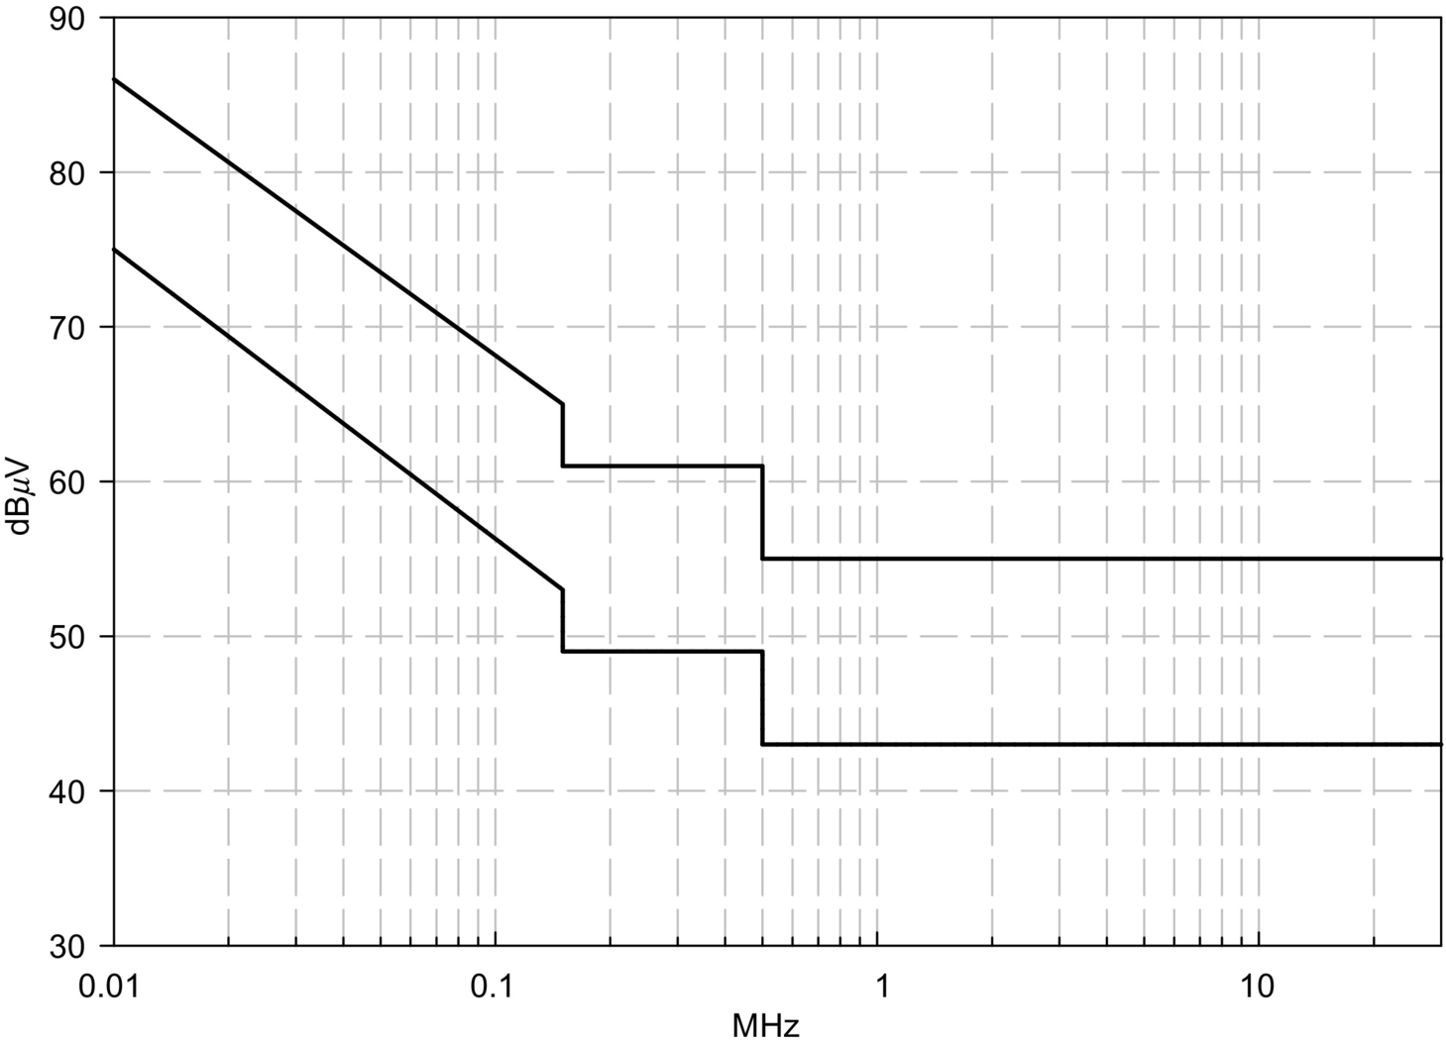

**FIG. 42.23** FCC conducted emissions limits. Upper trace, class A, and lower trace, class B.

EMC requirements for products used by the US military are listed in the already mentioned MIL-STD-461. This standard is applicable to a wide range of systems, from power tools to computer workstations. Unlike the FCC regulations, MIL-STD-461 specifies limits for both the emissions and immunity. The ANSI and Institute of Electrical and Electronics Engineers (IEEE) also publish EMC standards, as do, for internal use, private organizations, such as the Society of Automotive Engineers (SAE) and automobile manufacturers.

Under provisions of the General Agreement on Tariffs and Trade (GATT) and its successor, the World Trade Organization (WTO), member countries are obliged to adopt international standards for national use. With respect to the EMC, international standards are primarily developed by the International Electrotechnical Commission (IEC) and its International Special Committee on Radio Interference (CISPR); both were already mentioned in the introduction to this chapter. The series of IEC standards, IEC 61000-1 through IEC 61000-6, covers all aspects of EMC. The FCC standards are harmonized to IEC standards, as are the European Norms (EN) used in the European Union (EU). Some specific EMC standards have also been published by the International Organization for Standardization (ISO).

In 1992, the EU eliminated internal borders, necessitating a common system for establishing EMC standards and accreditation, testing, and certification procedures. The “new approach” and “global approach” have been initiated; their goal are to include EU directives into national laws of EU states, harmonize national standards with the European standards, and ensure validity of test reports and conformity certificates between all member states.

According to the “new approach,” technical contents have been removed from the European directives and entrusted to the European standard bodies, which are Comitè Europèen de Normalization (CEN), Comitè Europèen de Normalization Electrotechnique (CENELEC), and European Telecommunication Standards Institute (ETSI). The key European directive 89/336/EEC “electromagnetic compatibility” gives only a general definition of the *essential protection requirements* for all electric and electronic equipment and systems while referring to CENELEC and ETSI standards for technical details. The “global approach” requires every product on the European market to have the permanent “CE” marking, which indicates that the affixer declares and takes full responsibility of the conformity to all applicable European directives.

The EMC directive 89/336/EEC sets up emission and immunity requirements. It defines (a) components, (b) systems, and (c) installations. The directive applies only to components performing direct function and to the systems. Standards referred to the directive are divided into basic standards, generic standards, and product standards. The basic standards define general EMC requirements and testing procedures, without specifying any limit values or assessment criteria. Generic standards specify the requirements for products in specific electromagnetic environments. For instance, EN 50081-1 applies to emissions in residential, commercial, and light industrial equipment, including power supplies for industrial equipment, and EN 50081-2 to emissions in industrial environments. Respective immunity norms are EN 50082-1 and EN 50082-2. Product standards address EMC requirements for certain products and product families, such as household appliances, information technology equipment, or generic light industrial equipment; various European norms are employed as the product standards.

The IEC 555-2 (EN 60555-2), IEC 1000-3-2 (EN 61000-3-2), and IEC 1000-3-4 are emission standards for low-frequency harmonics, closely associated with operation of power electronic converters. Voltage fluctuations and flicker (*impression of unsteadiness of visual sensation induced by a light stimulus whose luminance or spectral distribution fluctuates in time*) emission limits are defined in IEC 555-3 (EN 555-3), IEC 1000-3-3 (EN 61000-3-3), and IEC 1000-3-5. IEC 61000-4-7 and IEC 61000-4-15 define the required instrumentation for EMI measurements. Radio-frequency conducted and radiated emissions are dealt with in EN 55011, EN 55014, and EN 55022, whereas CISPR 16 is the basic standard for radio-interference measurements. Finally, IEC 1000-4-1 through IEC 1000-4-12 are immunity standards.

EMC standards are continuously being developed and revised. Therefore, it is important to keep track of standards' publication dates (DoP) and dates of withdrawal (DoW) of conflicting earlier standards. Temporary EN standards are called ENV. Numerous Internet resources are available, in particular:

• American National Standards Institute (ANSI)

• Canadian Standards Association

• Electronic Industries Association (EIA)

• European Telecommunications Standards Institute (ETSI)

• Federal Communications Commission (FCC)

• IEEE Standards Association

• International Electrotechnical Commission (IEC)

• International Organization for Standardization (ISO)

• National Institute of Standards and Technology (NIST)

• NSSN, A National Resource for Global Standards

• Society of Automotive Engineers (SAE)

• Standards Australia

• VCCI (Japanese EMC Regulation and Certification)

• Verband Deutscher Elektrotechniker e. V. (VDE–German standards)

For more EMC information links, go to <http://www.dbtechnology.co.uk/links.htm> and

<https://en.wikipedia.org/wiki/List_of_common_EMC_test_standards>. A comprehensive treatment of contemporary EMC issues in power electronic and power distribution systems can be found in [[13](https://learning.oreilly.com/library/view/power-electronics-handbook/9780128114087/B9780128114070000477.xhtml#bb0070),[14](https://learning.oreilly.com/library/view/power-electronics-handbook/9780128114087/B9780128114070000477.xhtml#bb0075)].

## References

[1] Weston D.A. *Electromagnetic Compatibility: Principles and Applications.* third ed. Boca Raton, FL: CRC Press; 2016.

[2] Kaiser K.L. *Electromagnetic Compatibility Handbook.* Boca Raton, FL: CRC Press; 2005.

[3] Andre P.G., Wyatt K. *EMI Troubleshooting Cookbook for Product Designers.* Edison, NJ: SciTech Publishing; 2014.

[4] Paul C.R. *Introduction to Electromagnetic Compatibility.* second ed. Hoboken, NJ: John Wiley; 2009.

[5] Ott H.W. *Electromagnetic Compatibility Engineering.* second ed. Hoboken, NJ: John Wiley; 2009.

[6] Cost F., Laboure E. *Electromagnetic Compatibility in Power Electronics.* Hoboken, NJ: John Wiley; 2014.

[7] Ozenbaugh R.L. *EMI Filter Design.* second ed. New York: Marcel Dekker; 2001.

[8] Nave M.J. *Power Line Filter Design for Switched-Mode Power Supplies.* New York: Van Nostrand Reinhold; 1991.

[9] Kirlin R.L., Bech M.M., Trzynadlowski A.M. Analysis of power and power spectral density in PWM inverters with randomized switching frequency. *IEEE Trans. Ind. Electron.* 2002;49(2):486–499.

[10] Vilathgamuwa M., Deng J., Tseng K.J. EMI suppression with switching frequency modulated DC-DC converters. *IEEE Ind. Appl. Mag.* 1999;5(6):27–33.

[11] Trzynadlowski A.M., Zigliotto M., Bech M.M. Random pulse width modulation quiets motors, reduces EMI. *PCIM Power Electron. Syst. Mag.* 1999;55–58.

[12] Tong X.C. *Advanced Materials and Design for Electromagnetic Interference Shielding.* Boca Raton, FL: CRC Press; 2009.

[13] Skibinski G.L., Kerkman R.J., Schlegel D. EMI emissions of modern PWM AC drives. *IEEE Ind. Appl. Mag.* 1999;5(6):47–80.

[14] Rosetto L., Tenti P., Zuccato A. Electromagnetic compatibility issues. *IEEE Ind. Appl. Mag.* 1999;5(6):34–46.

## Further Reading

[1] Lattarulo F. *Electromagnetic Compatibility in Power Systems.* Amsterdam: Elsevier; 2007.

**43**

# Power Electronics Standards

Yuri Khersonsky IEEE, Sunnyvale, CA, United States

## Abstract

As in any rapidly advancing technology, power electronics standards are the risk mitigation tool, which allow using collective practical experience of many generations of engineers. Knowledge of the standards accelerates acceptance of power electronics and allows doing things right from the first time. Typically, standards formulate what is required and should be considered leaving to user decisions how requirements of the standards are implemented.

### KEYWORDS

Power electronics; Communication; Control architecture; IEEE standards; Risk reduction; Power electronics standards; IEC standards; Mandatory standards

43.1 [Introduction](https://learning.oreilly.com/library/view/power-electronics-handbook/9780128114087/B9780128114070000489.xhtml#s0010)

43.2 [General Review of Power Electronics Standards](https://learning.oreilly.com/library/view/power-electronics-handbook/9780128114087/B9780128114070000489.xhtml#s0015)

43.3 [Examples of IEEE Power Electronics Standards](https://learning.oreilly.com/library/view/power-electronics-handbook/9780128114087/B9780128114070000489.xhtml#s0020)

43.3.1 IEEE Std 1662-2016 “Recommended Practice for the Design and Application of Power Electronics in Electrical Power Systems”

43.3.2 IEEE Std 1676-2010 “Guide for Control Architecture for High Power Electronics (1 MW and Greater) in Electric Power Transmission and Distribution Systems”

43.3.3 IEEE Std 1826-2012 “IEEE Standard for Power Electronics Open System Interfaces in Zonal Electrical Distribution Systems Rated Above 100 kW”

43.4 [Conclusions](https://learning.oreilly.com/library/view/power-electronics-handbook/9780128114087/B9780128114070000489.xhtml#s0040)

[Further Reading](https://learning.oreilly.com/library/view/power-electronics-handbook/9780128114087/B9780128114070000489.xhtml#bi0010)

## 43.1 Introduction

Famous admiral Rickover often made the point that what was needed to get things done in the world of technology was engineering more than science. He also said: “Engineering is a profession which affects the material basis of everyone's life. To practice a profession one must have acquired mastery of an academic discipline as well as a technique for applying this special knowledge to the problems of everyday life. A profession is therefore intellectual in content, practical in application.”

Dr. Henry Petroski, specialist in failure analysis and professor of civil engineering at Duke University, put it in these words: “Engineers are not superhuman. That they make mistakes is forgivable; that they catch them is imperative. Thus it is the essence of modern engineering not only to be able to check one's own work but also to have one's work checked and to be able to check the work of others.”

As in any rapidly advancing technology, power electronics standards are the risk mitigation tool, which allow using collective practical experience of many generations of engineers. Knowledge of the standards accelerates acceptance of power electronics and allows doing things right from the first time. Typically, standards formulate what is required and should be considered leaving to user decisions how requirements of the standards are implemented.

## 43.2 General Review of Power Electronics Standards

All power electronics standards are application-specific and could be categorized as follows:

1. Recommended professional engineering standards developed by engineering societies, manufacturing associations, and testing laboratories

2. Mandatory regulation standards developed or adapted by country or local authorities for operation of power electronics in their area of jurisdiction

3. End user- or customer-specific standards mutually agreed by user and manufacturer.

The major international developers of power electronics engineering standards are the Institute of Electrical and Electronics Engineers (IEEE), International Electrotechnical Commission (IEC), National Electrical Manufacturers Association (NEMA), and Underwriters Laboratories (UL). Each standard organization has its own procedures for developing standards:

• IEEE Working Groups develop standards through a consensus development process, which brings together volunteers representing varied viewpoints and interests to achieve the final product. These standards are approved only when a 75% consensus is reached. IEEE standards are creating technical base for customer's selection and acceptance of products and the technical base for codes, rules, and regulations by different enforcing and regulating authorities.

• IEC technical committees by specialists from participating countries develop IEC standards expressing an international consensus of opinion on the relevant subjects from all interested IEC National Committees having equal voting rights. Each participating country is responsible for enforcement of standards.

• NEMA technical committees of representatives from members of association develop NEMA standards. NEMA members are responsible for compliance with standards.

• UL specialists develop UL standards with inputs from manufacturers and consumers. Compliance with standards required for power electronics products liability insurance or by end users and consumers.

There are many standards for power electronics components, but the list of power electronics standards as an equipment is relatively short:

• IEEE Std 1100 (Emerald Book), IEEE Recommended Practice for Powering and Grounding Electronic Equipment

• IEEE Std 1303 Guide for Static Var Compensator Field Tests

• IEEE Std 1409 Guide for Application of Power Electronics for Power Quality Improvement on Distribution Systems Rated 1 kV Through 38 kV

• IEEE Std 1566 IEEE Standard for Performance of Adjustable Speed AC Drives Rated 375 kW and Larger

• IEEE Std 1515 IEEE Recommended Practice for Electronic Power Subsystems: Parameter Definitions, Test Conditions, and Test Methods

• IEEE Std. 1573 IEEE Recommended Practice for Electronic Power Subsystems: Parameters, Interfaces, Elements, and Performance

• IEEE Std 1585 IEEE Guide for the Functional Specification of Medium Voltage (1–35 kV) Electronic Series Devices for Compensation of Voltage Fluctuations

• IEEE Std 1662-2008 Guide for the Design and Application of Power Electronics in Electrical Power Systems on Ships

• IEEE Std 1676 IEEE Guide for Control Architecture for High Power Electronics (1 MW and Greater) Used in Electric Power Transmission and Distribution Systems

• IEEE Std 1688 Standard for requirements for the Control of Electromagnetic Interference Characteristics of Replaceable Electronic Modules

• IEC 60146, Semiconductor converters—Basic requirements: Part 1-1: Line Commutated converters and Part 1-2: Self-commutated semiconductor converters including d. c. converters

• IEC 61800 all parts, Adjustable speed electrical power drive systems

• ANSI/UL 347A Medium Voltage Power Conversion Equipment

• ANSI/UL 508C-2008 Power Conversion Equipment

• ANSI/UL 61800-5 all parts, Adjustable Speed Electrical Power Drive Systems

• NEMA Standards Publication ICS 1.1 Safety Guidelines for the Application, Installation, and Maintenance of Solid-State Control

• NEMA ICS 7.2 Application Guide for AC Adjustable Speed Drive Systems

• NEMA Standards Publication IC 10 Industrial Control and Systems Part 2: Static AC Transfer Equipment

• UL 1008S Standard for Solid-State Transfer Switches

## 43.3 Examples of IEEE Power Electronics Standards

### **43.3.1 IEEE STD 1662-2016 “RECOMMENDED PRACTICE FOR THE DESIGN AND APPLICATION OF POWER ELECTRONICS IN ELECTRICAL POWER SYSTEMS”**

This standard was sponsored by the Industrial Applications Society (IAS) and cosponsored by the Power Electronics Society (PELS). The standard recommends that power electronics equipment should do the following:

• Take self-protection actions regardless of the status of communications by reflexive actions to maintain continuity of power.

• Respond to internal and downstream faults.

• Sustain communications and ability to perform control actions following a loss of input voltage to permit detection, isolation, and system reconfiguration following a casualty condition.

• Latch parameter values at the time of the fault and communicate status to higher-level outside controllers.

• Interact with other power electronics equipment for power flow management and fault handling.

• High-resistance grounding preferable on the source side of isolated and otherwise ungrounded three-wire, three-phase distribution systems with voltages over 1000 V and aggregated power above 1.5 MW.

• PE should have a minimum efficiency of 95% (5% total losses) at rated load condition. PE should be provided with an overload rating of 150% for 1 min.

Three sets of test recommended to be conducted on power electronics equipment:

• Type test—Test of one or more devices made to a certain design to demonstrate that the design meets certain specifications.

• Production test—A test conducted on every unit of equipment prior to shipment.

• Commissioning test—A test conducted when the equipment is installed to verify correct operation.

### 43.3.2 IEEE STD 1676-2010 “GUIDE FOR CONTROL ARCHITECTURE FOR HIGH POWER ELECTRONICS (1 MW AND GREATER) IN ELECTRIC POWER TRANSMISSION AND DISTRIBUTION SYSTEMS”

This standard sponsored by the IEEE Power Engineering Society (PES) recommends the use of Power Electronics Building Block (PEBB) concept in electric power systems. It recommends PEBB multilayer control architecture and states, for example:

• The interface between layers should be designed to enable layer modularity such that replacement of any layer should not induce modifications in other layers.

• The communication speed requirements at the lowest or hardware layer are the greatest and decline with each higher control layer.

• In order to preserve the hierarchical architecture, horizontal communication between layers should be avoided.

• It is also recommended that each converter have its own independent switch control to serve its hardware control.

### 43.3.3 IEEE STD 1826-2012 “IEEE STANDARD FOR POWER ELECTRONICS OPEN SYSTEM INTERFACES IN ZONAL ELECTRICAL DISTRIBUTION SYSTEMS RATED ABOVE 100 KW”

This standard was sponsored by the Industrial Applications Society (IAS) and cosponsored by the Power Electronics Society (PELS). The standard applies in cases where power electronics is the interface between the zones and extends application of IEEE Standards 1662 and 1676. It states that each power electronics device attached to the power bus shall meet following criteria:

1. Each device shall conform to standard control and power interfaces.

2. Each device shall have functionality that lets it “play well” with other power electronics devices including having the same protection and safety features.

3. Each device shall be capable of information exchange and reconfiguration of the system in response to load demands, changes of the mission, or new technologies insertion.

Any standard is always available from standard publishers.

## 43.4 Conclusions

• The best definition of the importance of standards is the famous saying by Admiral Rickover: “You have to learn from the mistakes of others. You won't live long enough to make them all yourself.”

• Standards establish baseline for customer's selection and acceptance of products.

• Standards are collective practical experience of many generations of engineers. They are the best tools to avoid mistakes and do things right from the first attempt.

• Standards are risk reduction in applying new power electronics technologies by combining established industrial practices with the latest innovations and modern analytic tools.

• Standards are best defense from outrageous regulators demands and frivolous lawsuits.

• The latest editions of any standard are always available from the standard publisher.

## Further Reading

[1] IEEE Std. 1662-2016 Recommended Practice for Design and Application of Power Electronics in Electrical Power Systems.

[2] IEEE Std. 1566-2015, Standard for Performance of Adjustable Speed AC Drives Rated 375 kW and Larger.

[3] IEEE 1826-2012, Standard for Power Electronics Open System Interfaces in Zonal Electrical Distribution Systems Rated Above 100 kW.

[4] IEEE Std 1676-2010, Guide for Control Architecture for High Power Electronics (1 MW and Greater) Used in Electric Power Transmission and Distribution Systems.

[5] Yuri Khersonsky, Standards for Ships and Oil Platforms, IEEE Industry Applications Magazine, Jan/Feb 2016.

[6] Yuri Khersonsky, PEBB Concept and the IEEE Power Electronics Standards, IEEE International Symposium on Industrial Electronics, Bari, Italy, 4–7 July 2010.

[7] Yuri Khersonsky, IEEE Power Electronics Standards-the necessary tools for every power electronics engineer, Applied Power Electronics Conference APEC 2010, Palm Spring, CA, February 26, 2010.

[8] Yuri Khersonsky, Role of standards in Power Electronics Rap session presentation, APEC 2008, Feb 24–28, 2008, Austin TX.

**SECTION VIII**

Simulation and Packaging

**44**

# Computer Simulation of Power Electronics and Motor Drives

Michael Giesselmann Texas Tech University, Lubbock, TX, United States

## Abstract

This chapter shows how power electronics, electric motors, and drives can be simulated with modern spice-based software simulation tools. The focus will be on LTspice, which is widely used and available for free download for all contemporary (2016) Windows 7, 8, and 10 PCs. The LTspice examples have been developed for the current LTspice IV version of the software [[1](https://learning.oreilly.com/library/view/power-electronics-handbook/9780128114087/B9780128114070000490.xhtml#bb0010)]. LTspice lends itself especially well to simulations of switch-mode power electronics circuits since it was designed to support Linear Technologies' family of products. This product line includes a large number of switch-mode power conversion parts. This manifests itself in the stability of the simulator during switching transitions. The author found the use of these examples is very beneficial in an educational environment, since the examples can be shared with students to enhance their understanding of the lecture material. The concepts and examples presented here can also be used for serious professional work. In fact, the author has used these tools with great success in many research projects. In addition to LTspice, PTC Mathcad [[2](https://learning.oreilly.com/library/view/power-electronics-handbook/9780128114087/B9780128114070000490.xhtml#bb0015)] has been used to derive and present the underlying equations. Equations created in Mathcad look as perfect as in the best typesetting software, but they can also be evaluated numerically and manipulated symbolically to derive additional equations and to validate the underlying theory.

### KEYWORDS

Simulation of power electronics; Modeling of AC induction machines; Sensorless vector control; Induction motor control; Avoiding/mitigating convergence problems

44.1 [Introduction](https://learning.oreilly.com/library/view/power-electronics-handbook/9780128114087/B9780128114070000490.xhtml#s0010)

44.2 [Use of Simulation Tools for Design and Analysis](https://learning.oreilly.com/library/view/power-electronics-handbook/9780128114087/B9780128114070000490.xhtml#s0015)

44.3 [Simulation of Power Electronics Circuits With LTspice](https://learning.oreilly.com/library/view/power-electronics-handbook/9780128114087/B9780128114070000490.xhtml#s0020)

44.4 [Simulations of Power Electronic Circuits and Electric Machines](https://learning.oreilly.com/library/view/power-electronics-handbook/9780128114087/B9780128114070000490.xhtml#s0025)

44.5 [Simulations of AC Induction Machines Using Field Oriented (Vector) Control](https://learning.oreilly.com/library/view/power-electronics-handbook/9780128114087/B9780128114070000490.xhtml#s0030)

44.6 [Simulation of Sensorless Vector Control Using LTspice](https://learning.oreilly.com/library/view/power-electronics-handbook/9780128114087/B9780128114070000490.xhtml#s0035)

44.7 [Conclusions](https://learning.oreilly.com/library/view/power-electronics-handbook/9780128114087/B9780128114070000490.xhtml#s0040)

[References](https://learning.oreilly.com/library/view/power-electronics-handbook/9780128114087/B9780128114070000490.xhtml#bi0010)

## 44.1 Introduction

This chapter shows how power electronics, electric motors, and drives can be simulated with modern spice-based software simulation tools. The focus will be on LTspice, which is widely used and available for free download for all contemporary (2016) Windows 7, 8, and 10 PCs. The LTspice examples have been developed for the current LTspice IV version of the software [[1](https://learning.oreilly.com/library/view/power-electronics-handbook/9780128114087/B9780128114070000490.xhtml#bb0010)]. LTspice lends itself especially well to simulations of switch-mode power electronics circuits since it was designed to support Linear Technologies' family of products. This product line includes a large number of switch-mode power conversion parts. This manifests itself in the stability of the simulator during switching transitions. The author found the use of these examples is very beneficial in an educational environment, since the examples can be shared with students to enhance their understanding of the lecture material. The concepts and examples presented here can also be used for serious professional work. In fact, the author has used these tools with great success in many research projects. In addition to LTspice, PTC Mathcad [[2](https://learning.oreilly.com/library/view/power-electronics-handbook/9780128114087/B9780128114070000490.xhtml#bb0015)] has been used to derive and present the underlying equations. Equations created in Mathcad look as perfect as in the best typesetting software, but they can also be evaluated numerically and manipulated symbolically to derive additional equations and to validate the underlying theory.

The software examples have been developed to illustrate advanced techniques for the simulation of power electronics and motor drives but not to teach the basic features of LTspice. For that, the reader shall be referred to the online documentation [[1](https://learning.oreilly.com/library/view/power-electronics-handbook/9780128114087/B9780128114070000490.xhtml#bb0010)]. In addition, it is assumed that the reader is familiar with the basics of power electronics and electric machines, specifically AC induction machines. For a review, the reader shall be referred to [[3](https://learning.oreilly.com/library/view/power-electronics-handbook/9780128114087/B9780128114070000490.xhtml#bb0020)] for power electronics and [[4](https://learning.oreilly.com/library/view/power-electronics-handbook/9780128114087/B9780128114070000490.xhtml#bb0025),[5](https://learning.oreilly.com/library/view/power-electronics-handbook/9780128114087/B9780128114070000490.xhtml#bb0030)] for induction machines.

## 44.2 Use of Simulation Tools for Design and Analysis

It is appropriate to reflect upon the value of simulations and its place in the design and analysis process before any in-depth discussion of specific simulation examples. Computer simulations enable engineers to study the behavior of complex and powerful systems without actually building or operating them. Simulations therefore have a place in the analysis of existing equipment and the design of new systems. In addition, computer simulations enable engineers to safely study high-power circuits including abnormal operating conditions without actually creating such conditions in a real environment.

However, even the most advanced simulation software cannot perfectly represent all effects in real hardware. The accuracy of the results depends on the accuracy of the component models and the proper identification and inclusion of parasitic circuit elements such as parasitic inductance, capacitance, and mutual coupling. Discrepancies between simulation and experimental results often occur if the underlying assumptions for the device model have been exceeded. For example, an attempt to model transformer inrush with a transformer model that assumes linear magnetics would not yield useful results.

In particular, the precise prediction of voltage and current traces during fast switching transitions in power electronics circuits has been proven to be difficult. To obtain useful results, extensive experimental validation, advanced device models (and the values for their parameters!), and detailed knowledge of parasitic elements, including the ones associated with the packaging of the circuit elements, are necessary. Therefore, the exact prediction of waveforms during switching transitions shall be excluded from the discussions in this chapter. Consequently, the author prefers to measure parameters such as voltage rise and fall times and over- and undershoot on actual circuitry in the laboratory.

Sometimes, users of spice-based simulators claim that the simulations of power electronics circuits with steep signal transitions are difficult due to convergence problems. However, with the proper techniques of gate signal generation, we can simulate just about any given circuit with little or no convergence problems in many spice-based tools. In addition, if convergence problems are avoided, simulations run much faster and larger numbers of individual transitions can be studied. This is achieved by generating gate signals using dependent sources with mathematical functions that produce switching signals that are differentiable throughout the transition. Being able to run simulations with a large number of transitions fast and without convergence problems gives a lot of insight into the cycle-by-cycle and the system level behavior of a power electronics circuit. An excellent application for these cycle-by-cycle simulations is the development and verification of control strategies for the power semiconductors in power electronics circuits.

Dependent voltage and current sources included in LTspice can be used to study large and complex systems like field-oriented (also called vector) control of induction machines if the proper mathematical control functions are used. Details are given below. In the examples for vector control of induction motors, the power electronics inverter is replaced with a dependent voltage source that represents the short-term average (filtering away the high-frequency voltage components associated with the switching frequency) of the output of a three-phase inverter. These examples represent system level simulations, which could have also been done using programs like MatLab/Simulink. However, circuit simulation software also provides the option of studying actual circuit level details in complex systems. To demonstrate this capability, the start-up of an induction motor, fed by a three-phase inverter with actual switch-mode operation, is presented.

In all modeling cases, the user needs to define the goal of the simulation effort. In other words, the user must answer the question “What information shall be obtained through the simulation of the circuit or system?” The user must then select the appropriate simulation software and the appropriate models. This process requires a detailed understanding of the properties and limitations of the device models and the sensitivity of the results to the limitations of the models. In order to obtain such an understanding, it is often recommended and necessary to perform numerous simulation test runs, carefully scrutinize the results, and compare them with measured data, results from other simulation packages, or otherwise known facts.

## 44.3 Simulation of Power Electronics Circuits With LTspice

The first example of a power electronics circuit is a step-down (also called buck) converter with synchronous rectification. For the purpose of synchronous rectification, the diode, which connects the inductor to ground in the regular circuit, is replaced with a power MOSFET transistor. The benefit of this circuit is that the power MOSFET represents a purely resistive channel in the on state. This channel does not have a residual, current independent, voltage drop like the p-n junction of a diode. Therefore, the voltage drop across the MOSFET can be much lower than what can be achieved with diodes. The results are reduced losses and increased efficiency. To achieve this, the lower MOSFET must be turned on whenever the upper MOSFET is turned off.

[Fig. 44.1](https://learning.oreilly.com/library/view/power-electronics-handbook/9780128114087/B9780128114070000490.xhtml#f0010) shows a simulation setup for a synchronous buck converter. This converter steps down from 12 V input voltage to 3.3 V at the output. As mentioned before, the key element of this example is the circuit for the generation of the gate-drive signals for the MOSFETs. The basic principle of the operation of the gate-drive circuit is the well-known carrier-based scheme [[3](https://learning.oreilly.com/library/view/power-electronics-handbook/9780128114087/B9780128114070000490.xhtml#bb0020)], where a control voltage is compared with a triangular carrier with fixed amplitude. The dependent voltage source *tri* on the left border of [Fig. 44.1](https://learning.oreilly.com/library/view/power-electronics-handbook/9780128114087/B9780128114070000490.xhtml#f0010) generates the triangular carrier. Eq. [(44.1)](https://learning.oreilly.com/library/view/power-electronics-handbook/9780128114087/B9780128114070000490.xhtml#fo0010) shown below gives the closed form equation for the triangular carrier wave. The output range of the function shown in Eq. [(44.1)](https://learning.oreilly.com/library/view/power-electronics-handbook/9780128114087/B9780128114070000490.xhtml#fo0010) is between 0.0 and 1.0:

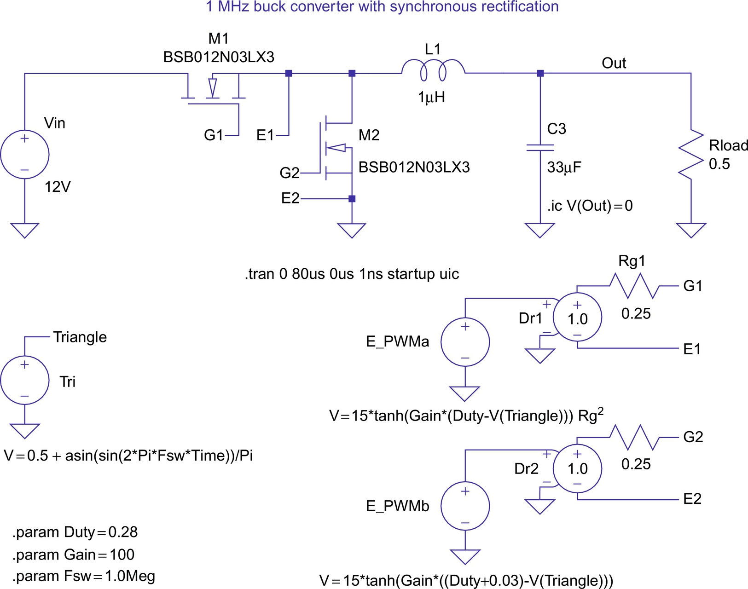

**FIG. 44.1** LTspice simulation setup for a synchronous buck converter.

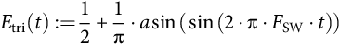 **(44.1)**

For the generation of the gate-drive signals, the carrier wave is compared with a control signal that can have values between 0.0 and 1.0, corresponding to a duty cycle input between 0% and 100%. Dependent voltage sources *E\_PWMa* and *E\_PWMb* in [Fig. 44.1](https://learning.oreilly.com/library/view/power-electronics-handbook/9780128114087/B9780128114070000490.xhtml#f0010) generate the PWM signals for the MOSFETs *M1* and *M2*, which are included in the LTspice library. A hyperbolic tangent function is used to create a PWM waveform with smooth transitions to aid in convergence. [Fig. 44.2](https://learning.oreilly.com/library/view/power-electronics-handbook/9780128114087/B9780128114070000490.xhtml#f0015) shows a plot of a hyperbolic tangent function to illustrate the concept. The *Gain* parameter is used to steepen the curve to resemble realistic PWM signal transitions. In [Fig. 44.2](https://learning.oreilly.com/library/view/power-electronics-handbook/9780128114087/B9780128114070000490.xhtml#f0015), the *Gain* is varied between 1 and 5. In the control functions for *E\_PWMa* and *E\_PWMb*, the factor 15 in front of the tanh function generates an output voltage that varies between −15 and +15 V. Note the inverse polarities on the inputs of sources *Dr1* and *Dr2* generate the complementary gate-drive signals.

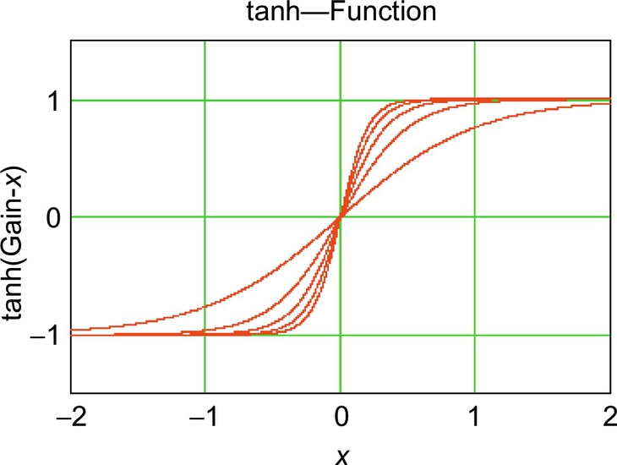

**FIG. 44.2** Plot of a hyperbolic tangent function used to generate smooth PWM signals.

Careful inspection of [Fig. 44.1](https://learning.oreilly.com/library/view/power-electronics-handbook/9780128114087/B9780128114070000490.xhtml#f0010) shows that 3% duty cycle *0.03* is added to generate the gate-drive signal of the lower (synchronous rectification) MOSFET to create some blanking time between the drive signals and avoid cross conduction between the MOSFETs *M1* and *M2*.

[Fig. 44.3](https://learning.oreilly.com/library/view/power-electronics-handbook/9780128114087/B9780128114070000490.xhtml#f0020) shows the calculated voltage and current traces for the synchronous buck converter. The top-level pane shows the generated triangle carrier. It has a frequency (Fsw; see parameter statement in [Fig. 44.1](https://learning.oreilly.com/library/view/power-electronics-handbook/9780128114087/B9780128114070000490.xhtml#f0010)) of 1.0 MHz. The graph below the triangle signal shows the inductor current and the current in the load resistor. The bottom trace shows the capacitor voltage, which has a steady-state value of 3.3 V.

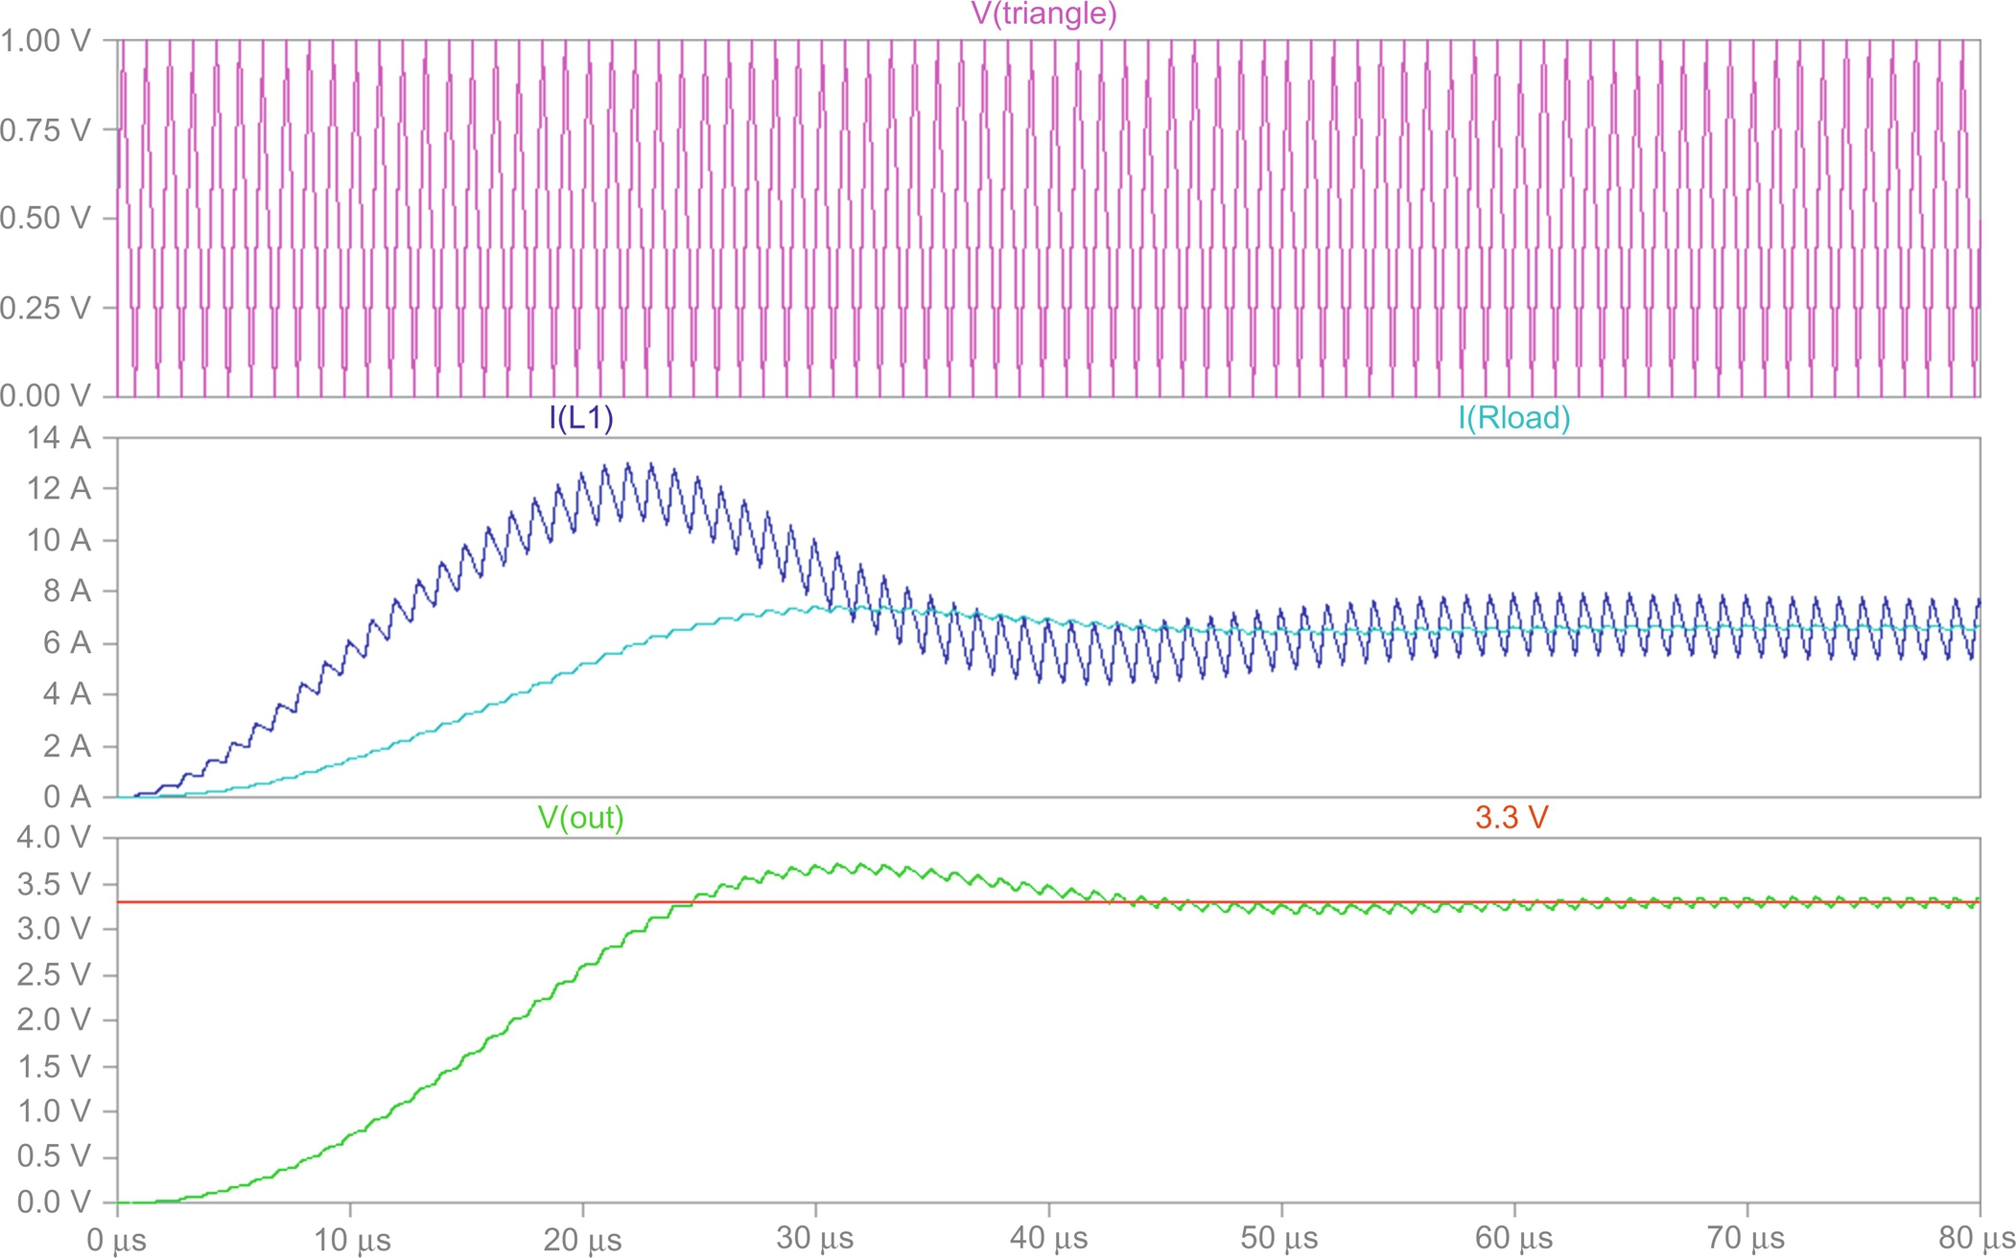

**FIG. 44.3** Output waveforms for the synchronous buck converter.

In addition to the cycle-by-cycle simulation of a DC-DC converter, it is also possible to use a time-averaged replacement for the MOSFET transistors used in the circuit in [Fig. 44.1](https://learning.oreilly.com/library/view/power-electronics-handbook/9780128114087/B9780128114070000490.xhtml#f0010). In fact, a common time-averaged model can be used for the buck, the boost, the buck-boost, and the Cuk converter as long as they operate with continuous inductor current. The time-averaged model has the advantage that it can run much faster since it does not have to follow each switching transition. It is also possible to perform DC and AC sweep analyses. A DC sweep would sweep the duty cycle over a wide range and show the output voltage as a function of the duty cycle. An AC sweep analysis would sweep the frequency of an AC signal, which is superimposed on top of the duty cycle bias signal. The AC sweep allows the study of the behavior of the converter, including a feedback control system, in the frequency domain for traditional stability analysis and system tuning. A detailed description of this time-averaged modeling technique, including detailed examples, is given in [[6](https://learning.oreilly.com/library/view/power-electronics-handbook/9780128114087/B9780128114070000490.xhtml#bb0035)].

To illustrate the capabilities of the LTspice simulation program, the next example shows a complete three-phase inverter using six power MOSFETs. This circuit is shown in [Fig. 44.4](https://learning.oreilly.com/library/view/power-electronics-handbook/9780128114087/B9780128114070000490.xhtml#f0025). Such an inverter needs antiparallel diodes connected across each power semiconductor to ensure that the load current can flow continuously. These diodes are often called freewheeling diodes. Here, the freewheeling diodes are an integral part of every power MOSFETs (body diodes) and are therefore not visible. The inverter drives a three-phase load, which represents the 5 hp induction motor used later. The R and L values represent rated load conditions. The load is connected to the inverter output terminals via labels (A,B,C).

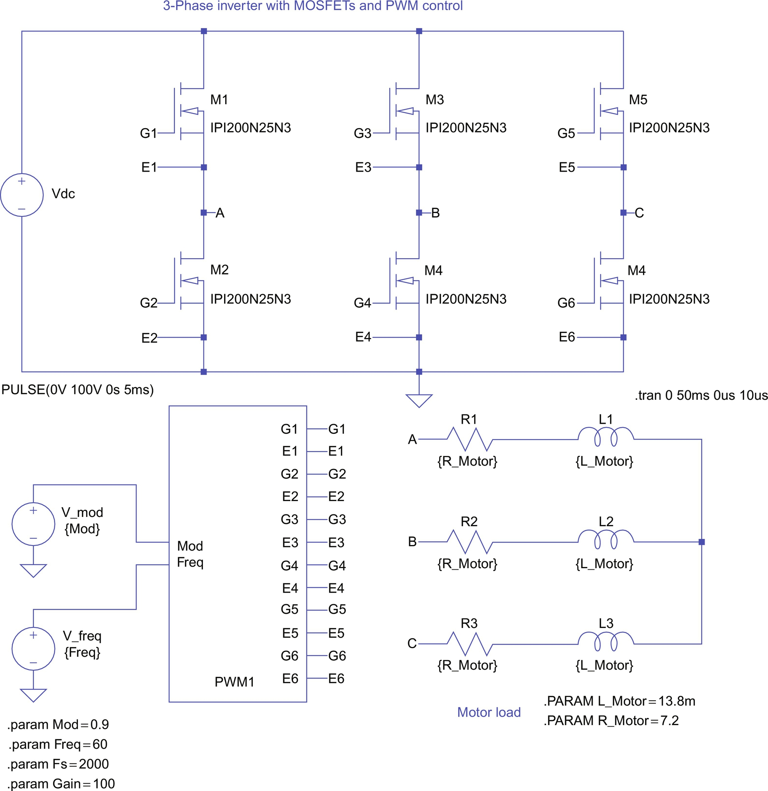

**FIG. 44.4** Circuit for a three-phase inverter with MOSFETs.

Due to the number of elements involved, the circuit for the gate-drive signal generation is contained in a custom part named *PWM1*. Custom parts like this can easily be generated using the “Hierarchy—Create a New Symbol” menu path in the LTspice schematic editor. Double-clicking on the part reveals the associated subcircuit that is shown in [Fig. 44.5](https://learning.oreilly.com/library/view/power-electronics-handbook/9780128114087/B9780128114070000490.xhtml#f0030). The arrow-shaped symbols on the right side of [Fig. 44.5](https://learning.oreilly.com/library/view/power-electronics-handbook/9780128114087/B9780128114070000490.xhtml#f0030) named *G1*, *E1*, *G2*, etc. are called interface ports and are the outputs of the gate-drive circuit to the MOSFETs. These interface ports provide the connection between the subcircuit and the ports of the custom part. These ports on the custom part are created using the “Edit—Add Pin/Port” menu path in the LTspice schematic editor. The arrow-shaped symbols on the left side of [Fig. 44.5](https://learning.oreilly.com/library/view/power-electronics-handbook/9780128114087/B9780128114070000490.xhtml#f0030) are inputs for the fundamental output frequency and the modulation index. The names of these ports in the subcircuit (must!) correspond to the names of the ports of the custom symbol.

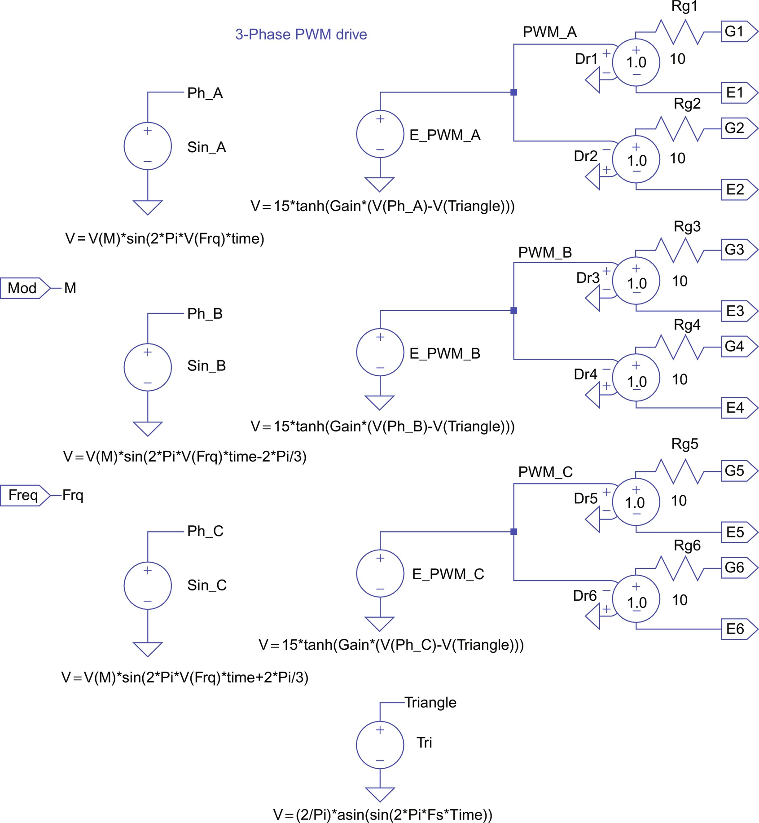

**FIG. 44.5** PWM generation subcircuit for a three-phase MOSFET inverter.

The circuit shown in [Fig. 44.5](https://learning.oreilly.com/library/view/power-electronics-handbook/9780128114087/B9780128114070000490.xhtml#f0030) is similar to the gate-drive generation circuit discussed before. As in the PWM generation circuitry shown in [Fig. 44.1](https://learning.oreilly.com/library/view/power-electronics-handbook/9780128114087/B9780128114070000490.xhtml#f0010), a triangular carrier is compared with a reference signal. In this case, three reference signals, one for each phase, are compared with 3 PWM sources (*E\_PWM\_A*, *E\_PWM\_B*, and *E\_PWM\_C*) to create the gate-drive signals for all three phases. Again, the factor 15 in front of the tanh functions generates an output voltage that varies between −15 and +15 V for driving the gates of the MOSFETs. Here, the triangular carrier signal is symmetrical with respect to the time axis and covers the range from  to 1.0. The closed form expression for the triangular carrier is given by Eq. [(44.2)](https://learning.oreilly.com/library/view/power-electronics-handbook/9780128114087/B9780128114070000490.xhtml#fo0015):

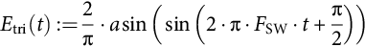 **(44.2)**

The three reference signals are sinusoidal signals with equal amplitude and a relative phase shift of 120*°*. For linear modulation, the amplitude range of the reference signals is limited to the amplitude of the triangular carrier, for example, 1 V. The ratio of the reference wave amplitude and the (fixed) carrier amplitude is called amplitude modulation ratio *Mod*. In the circuit shown in [Fig. 44.4](https://learning.oreilly.com/library/view/power-electronics-handbook/9780128114087/B9780128114070000490.xhtml#f0025), *Mod* has a value of 0.9. This value is defined by a parameter symbol at the top level and therefore represents a global parameter, which is visible throughout all levels of the hierarchy. The amplitude of the phase-to-neutral voltage of each inverter leg is equal to half of *Vdc* (shown in [Fig. 44.4](https://learning.oreilly.com/library/view/power-electronics-handbook/9780128114087/B9780128114070000490.xhtml#f0025)) multiplied with the amplitude modulation ratio. The frequency and wave shape of the phase-to-neutral voltage of each phase leg is equal to the reference waveform if the high-frequency components resulting from the carrier wave are filtered away. Each inverter leg can be viewed as a power amplifier for its reference voltage. In fact, in drive applications, inverters are often called “servo-amplifiers.” The load typically reacts only to the low-frequency components of the inverter output voltage. The high-frequency components, which include the triangular carrier frequency (also called switching frequency) and its harmonics, are typically “just a blur” for the load. These are especially true in recent times, where switching frequencies of 20 kHz and above are possible. As an added benefit, audible noise is avoided at these frequency levels.

The complementary sources *Dr1/Dr2*, *Dr3/Dr4*, and *Dr5/Dr5* in combination with the gate resistors will generate the control voltages for the transistor pairs of each leg. Using this circuitry will ensure that during switching transitions in each phase leg, the gate voltage of the transistor that is turning off will fall below the turn-on threshold before the gate voltage of the transistor that is turning on reaches that threshold. Therefore, a shoot through, meaning a short circuit between the positive and negative bus, is avoided.

[Fig. 44.6](https://learning.oreilly.com/library/view/power-electronics-handbook/9780128114087/B9780128114070000490.xhtml#f0035) shows the simulation results for the three-phase inverter. The timescale is slightly stretched, to better show the details of the PWM signals. The line-to-line voltage *VAB* and the load current in all three phases are shown. Due to the inductors contained in the load, the current cannot instantaneously change and follow the PWM signal. Therefore, the load currents are almost pure sinusoids with very little ripple. This is representative of the real line currents in induction motors.

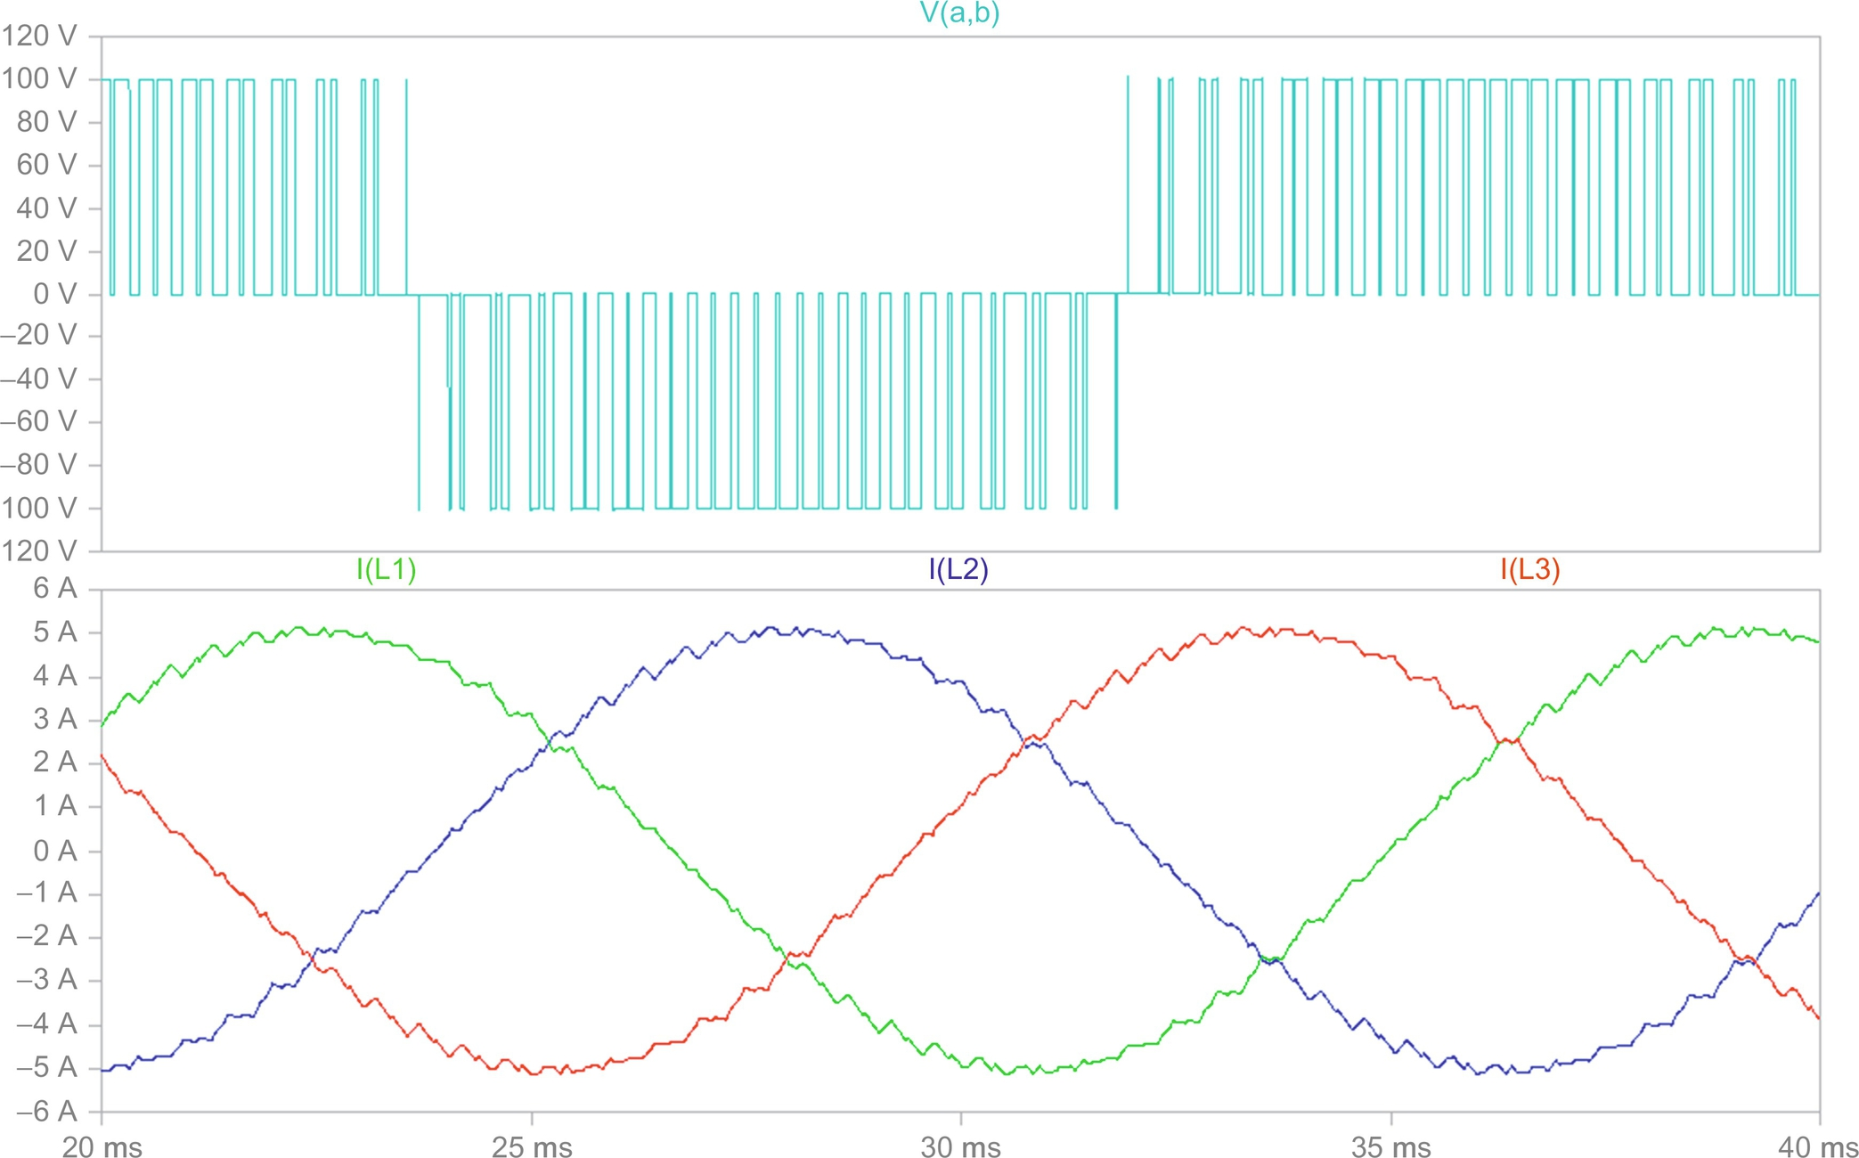

**FIG. 44.6** Output waveforms of the three-phase inverter with MOSFETs.

[Fig. 44.7](https://learning.oreilly.com/library/view/power-electronics-handbook/9780128114087/B9780128114070000490.xhtml#f0040) shows an example where the MOSFETs in [Fig. 44.4](https://learning.oreilly.com/library/view/power-electronics-handbook/9780128114087/B9780128114070000490.xhtml#f0025) have been replaced with insulated gate bipolar transistors (IGBTs). The spice model of the particular IGBTs shown here is included on the right side of the schematic. Note that freewheeling diodes are needed, if IGBTs are used. The freewheeling diodes carry the load current when the IGBTs are turned off to provide a continuous path for the current. This is very important, since the load can have a substantial inductive component. Whenever the diodes are conducting, energy flows momentarily back to the source. In the case of power MOSFETs, the diodes (often called body diodes) are an integral part of the device. In the symbol graphic of LTspice, these body diodes are not shown for MOSFETs. For this circuit, the gate-drive circuit and the results are the same as for the three-phase inverter with power MOSFETs. This circuit returns the same results than the one shown in [Fig. 44.6](https://learning.oreilly.com/library/view/power-electronics-handbook/9780128114087/B9780128114070000490.xhtml#f0035) except that the simulation runs a lot longer (minutes rather than seconds) due to the complexity of the IGBT models.

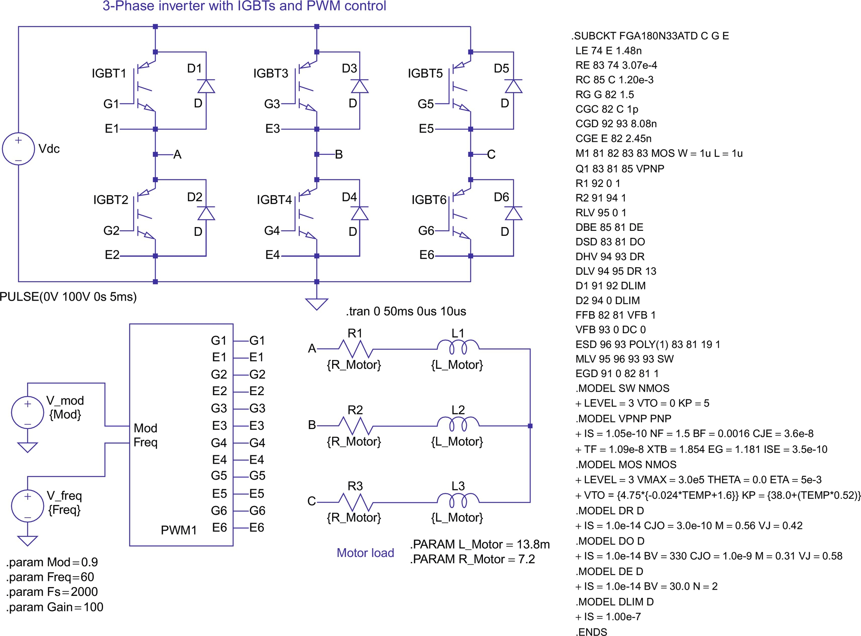

**FIG. 44.7** Three-phase inverter circuit with IGBTs.

## 44.4 Simulations of Power Electronic Circuits and Electric Machines

In the following, the start-up of an induction motor, fed by a three-phase inverter similar to the ones shown in [Figs. 44.4](https://learning.oreilly.com/library/view/power-electronics-handbook/9780128114087/B9780128114070000490.xhtml#f0025) and [44.7](https://learning.oreilly.com/library/view/power-electronics-handbook/9780128114087/B9780128114070000490.xhtml#f0040), is presented. For this purpose, the simple passive load in [Figs. 44.4](https://learning.oreilly.com/library/view/power-electronics-handbook/9780128114087/B9780128114070000490.xhtml#f0025) and [44.7](https://learning.oreilly.com/library/view/power-electronics-handbook/9780128114087/B9780128114070000490.xhtml#f0040) has been replaced by a complete dynamic model of an induction motor. Also, the MOSFETs or IGBTs from [Figs. 44.4](https://learning.oreilly.com/library/view/power-electronics-handbook/9780128114087/B9780128114070000490.xhtml#f0025) and [44.7](https://learning.oreilly.com/library/view/power-electronics-handbook/9780128114087/B9780128114070000490.xhtml#f0040), respectively, have been replaced by generic voltage-controlled switches. This will increase the simulation speed even more dramatically compared with the case with IGBTs with very little effect on accuracy since this simulation is meant to study the start-up behavior of an induction motor. For this and further discussions, it is assumed that the reader is familiar with the theory of induction machines and in particular their dynamic behavior. A number of excellent references are given at the end of this chapter [[4](https://learning.oreilly.com/library/view/power-electronics-handbook/9780128114087/B9780128114070000490.xhtml#bb0025),[5](https://learning.oreilly.com/library/view/power-electronics-handbook/9780128114087/B9780128114070000490.xhtml#bb0030),[7](https://learning.oreilly.com/library/view/power-electronics-handbook/9780128114087/B9780128114070000490.xhtml#bb0040),[8](https://learning.oreilly.com/library/view/power-electronics-handbook/9780128114087/B9780128114070000490.xhtml#bb0045)]. The induction motor symbol represents the electromechanical model of an induction motor. The model is suitable for studies of electric and mechanical transients and steady-state conditions. The output pin on the motor shaft represents the mechanical output. The voltage on this pin represents the mechanical angular velocity using the relation 1 V=1 rad/s. In addition, any current drawn from or fed into this terminal represents applied motor or generator torque according to the relation 1 A=1 N m. Due to these definitions, the electric power associated with the voltage of the motor shaft (with respect to ground) is identical to the mechanical power. Following the well-known theory, the induction motor model has been derived for a two-phase (direct and quadrature, D, Q) equivalent motor. Attached to the motor is a bidirectional two-phase to three-phase converter module. This module is voltage and current invariant. This means that the voltage and current levels in the two-phase and the three-phase machine are equal. Consequently, the power in the two-phase machine is only two-thirds of the power in the three-phase circuit. This is accounted for in the calculation of the electromagnetic torque (factor 3/2; see Eq. [(44.4)](https://learning.oreilly.com/library/view/power-electronics-handbook/9780128114087/B9780128114070000490.xhtml#fo0025)). The internally generated torque can be monitored on the output labeled *Torque* on top of the sleeve around the motor shaft. The linear load in [Fig. 44.8](https://learning.oreilly.com/library/view/power-electronics-handbook/9780128114087/B9780128114070000490.xhtml#f0045) is a symbol that represents an appropriately sized resistor to the ground representing rated power that is 5 hp for this example.

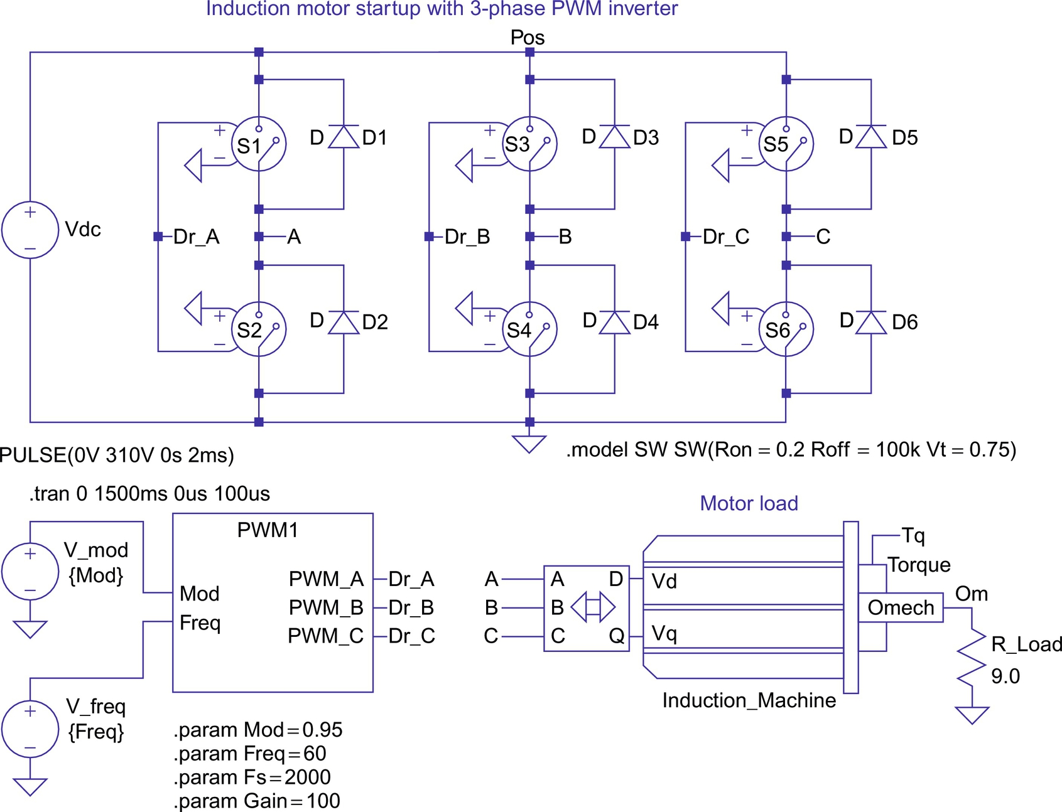

**FIG. 44.8** Induction motor start-up with three-phase inverter circuit.

In [Fig. 44.8](https://learning.oreilly.com/library/view/power-electronics-handbook/9780128114087/B9780128114070000490.xhtml#f0045), the motor is represented by a custom symbol called *induction machine*. The symbol can be easily created using the “Hierarchy—Create a New Symbol” menu path in the LTspice schematic editor. The editor provides standard graphic elements (lines, rectangles, circles, etc.) so that professional-looking symbols can easily be created.

Double-clicking on the motor symbol reveals the associated subcircuit that implements its function. This subcircuit is shown in [Fig. 44.9](https://learning.oreilly.com/library/view/power-electronics-handbook/9780128114087/B9780128114070000490.xhtml#f0050). The left part of this subcircuit represents the electric model. The electric model calculates the stator and rotor currents, with the stator voltages and the mechanical speed of the machine being input parameters. However, it is also possible without any changes to feed stator currents (with controlled current sources) into the D and Q inputs. This option is useful for vector control applications, which are discussed later.

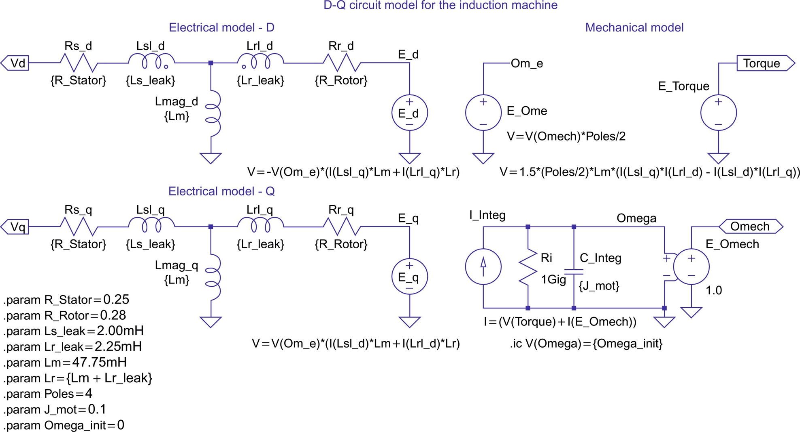

**FIG. 44.9** Subcircuit for induction motor model.

The equation system for the electric model of a two-phase induction machine is given by Eq. [(44.3)](https://learning.oreilly.com/library/view/power-electronics-handbook/9780128114087/B9780128114070000490.xhtml#fo0020). The theory for this equation system is derived in [[4](https://learning.oreilly.com/library/view/power-electronics-handbook/9780128114087/B9780128114070000490.xhtml#bb0025),[5](https://learning.oreilly.com/library/view/power-electronics-handbook/9780128114087/B9780128114070000490.xhtml#bb0030),[7](https://learning.oreilly.com/library/view/power-electronics-handbook/9780128114087/B9780128114070000490.xhtml#bb0040),[8](https://learning.oreilly.com/library/view/power-electronics-handbook/9780128114087/B9780128114070000490.xhtml#bb0045)]. The equation system and the model are formulated for the stationary reference frame. This reference frame assumes that the frame of the machine is stationary and the voltages and currents of the rotor are equivalent AC values with stator frequency.

From machine theory, we know that the actual rotor currents have slip frequency. Another reference frame is the synchronous (also called excitation) reference frame. In this reference frame, the stator of a fictitious machine is assumed to rotate with synchronous speed. The advantage of this reference frame is that the input frequency is zero (DC), which makes it easy to derive the principle of vector control by extending the theory of DC machines to AC machines:

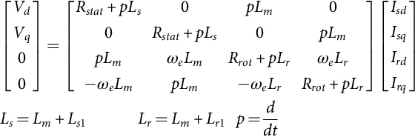 **(44.3)**

In typical implementations of vector control using digital signal processors (DSPs), the synchronous reference frame is used internally to calculate the reference values for the currents in the D- and Q-axis. These values are then transformed to the stationary reference frame in an additional step. Sometimes, still other reference frames are used, and it is possible to generate a universal electric model with a reference frame speed input. This model could then be used for any reference frame.

The electric model in [Fig. 44.9](https://learning.oreilly.com/library/view/power-electronics-handbook/9780128114087/B9780128114070000490.xhtml#f0050) implements the equation system shown in Eq. [(44.3)](https://learning.oreilly.com/library/view/power-electronics-handbook/9780128114087/B9780128114070000490.xhtml#fo0020). The circuit closely resembles the well-known T-equivalent circuit for the steady-state analysis of induction machines. Two instances of the T-equivalent circuit are necessary to implement the two-phase (D, Q) model. The right part of the schematic in [Fig. 44.9](https://learning.oreilly.com/library/view/power-electronics-handbook/9780128114087/B9780128114070000490.xhtml#f0050) represents the mechanical model. This circuitry calculates the internally generated electromagnetic torque, using the rotor and stator currents as input values. The equation for the internal electromagnetic torque of the induction machine is given by Eq. [(44.4)](https://learning.oreilly.com/library/view/power-electronics-handbook/9780128114087/B9780128114070000490.xhtml#fo0025) [[4](https://learning.oreilly.com/library/view/power-electronics-handbook/9780128114087/B9780128114070000490.xhtml#bb0025),[5](https://learning.oreilly.com/library/view/power-electronics-handbook/9780128114087/B9780128114070000490.xhtml#bb0030),[7](https://learning.oreilly.com/library/view/power-electronics-handbook/9780128114087/B9780128114070000490.xhtml#bb0040),[8](https://learning.oreilly.com/library/view/power-electronics-handbook/9780128114087/B9780128114070000490.xhtml#bb0045)]. The factor 3/2 accounts for the fact that the real motor is a three-phase machine. The generated torque is used to calculate the angular acceleration of the motor shaft considering the load torque and the moment of inertia. Integration of the angular acceleration yields the rotor speed, which is used in the electric model:

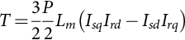 **(44.4)**

Since almost all induction machines are three-phase machines, it is often desirable to have a machine model with a three-phase input. Therefore, a bidirectional two-phase to three-phase converter module, which can be attached to the motor, has been developed. A subcircuit for this module is shown in [Fig. 44.10](https://learning.oreilly.com/library/view/power-electronics-handbook/9780128114087/B9780128114070000490.xhtml#f0055).

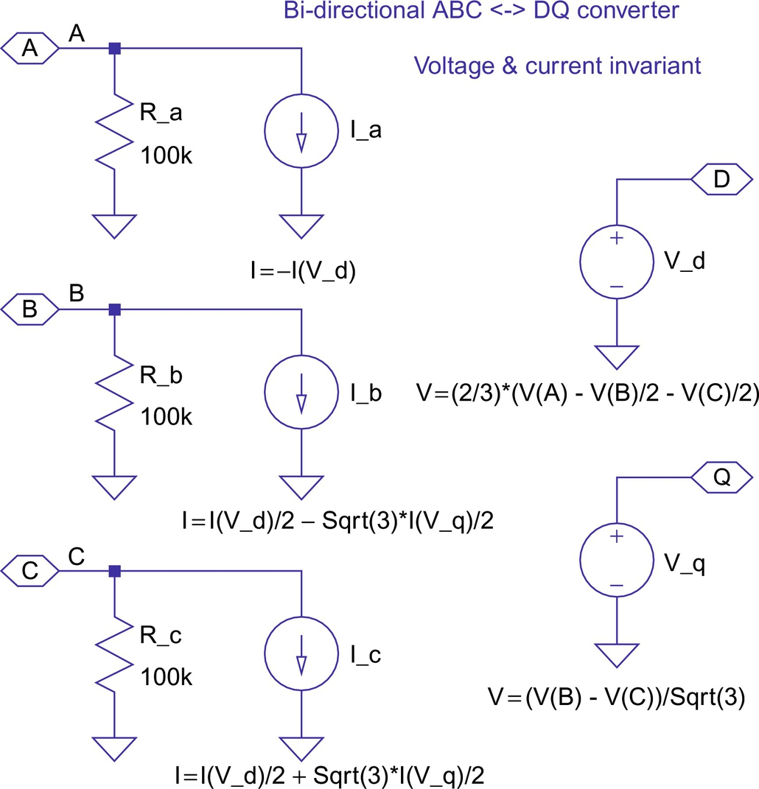

**FIG. 44.10** Subcircuit for the ABC-DQ transformation module.

This circuit is truly bidirectional, meaning that the circuit can be fed with voltage or current sources from either side. The equation system for this voltage and current-invariant transformation is given by Eq. [(44.5)](https://learning.oreilly.com/library/view/power-electronics-handbook/9780128114087/B9780128114070000490.xhtml#fo0030). This transformation is sometimes called “Clark” or “ABC-DQ” transformation. The voltage *V*0 in Eq. [(44.5)](https://learning.oreilly.com/library/view/power-electronics-handbook/9780128114087/B9780128114070000490.xhtml#fo0030) denotes a zero-sequence voltage, which is assumed to be zero and not implemented in the subcircuit shown in [Fig. 44.10](https://learning.oreilly.com/library/view/power-electronics-handbook/9780128114087/B9780128114070000490.xhtml#f0055). This voltage would only have nonzero values for unbalanced conditions. An interesting detail of the subcircuit in [Fig. 44.10](https://learning.oreilly.com/library/view/power-electronics-handbook/9780128114087/B9780128114070000490.xhtml#f0055) is the addition of high-value resistors on each input. These resistors provide a small current path from the three-phase input to the ground and ensure stable operation if the module is fed with current sources;

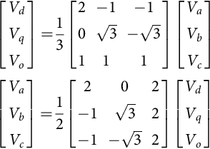 **(44.5)**

[Fig. 44.11](https://learning.oreilly.com/library/view/power-electronics-handbook/9780128114087/B9780128114070000490.xhtml#f0060) shows the result for the start-up of the induction motor for the circuit of [Fig. 44.8](https://learning.oreilly.com/library/view/power-electronics-handbook/9780128114087/B9780128114070000490.xhtml#f0045). The motor is a 5 hp, 208 V, 4-pole machine. The detailed parameters are shown in [Table 44.1](https://learning.oreilly.com/library/view/power-electronics-handbook/9780128114087/B9780128114070000490.xhtml#t0010). The PWM generation was derived from the example shown in [Fig. 44.4](https://learning.oreilly.com/library/view/power-electronics-handbook/9780128114087/B9780128114070000490.xhtml#f0025). The top trace in [Fig. 44.11](https://learning.oreilly.com/library/view/power-electronics-handbook/9780128114087/B9780128114070000490.xhtml#f0060) shows the mechanical angular velocity with a scale of 1 V=1 rad/s. The middle trace shows the developed electromagnetic torque, including the level for the rated steady-state torque (20 N m as commanded by the load in [Fig. 44.8](https://learning.oreilly.com/library/view/power-electronics-handbook/9780128114087/B9780128114070000490.xhtml#f0045)) and the zero level. This graph shows the typical oscillatory torque production of the induction machine for an uncontrolled line start. The scale for this graph is 1 V=1 N m. The bottom trace of [Fig. 44.11](https://learning.oreilly.com/library/view/power-electronics-handbook/9780128114087/B9780128114070000490.xhtml#f0060) shows the input current for phase A.

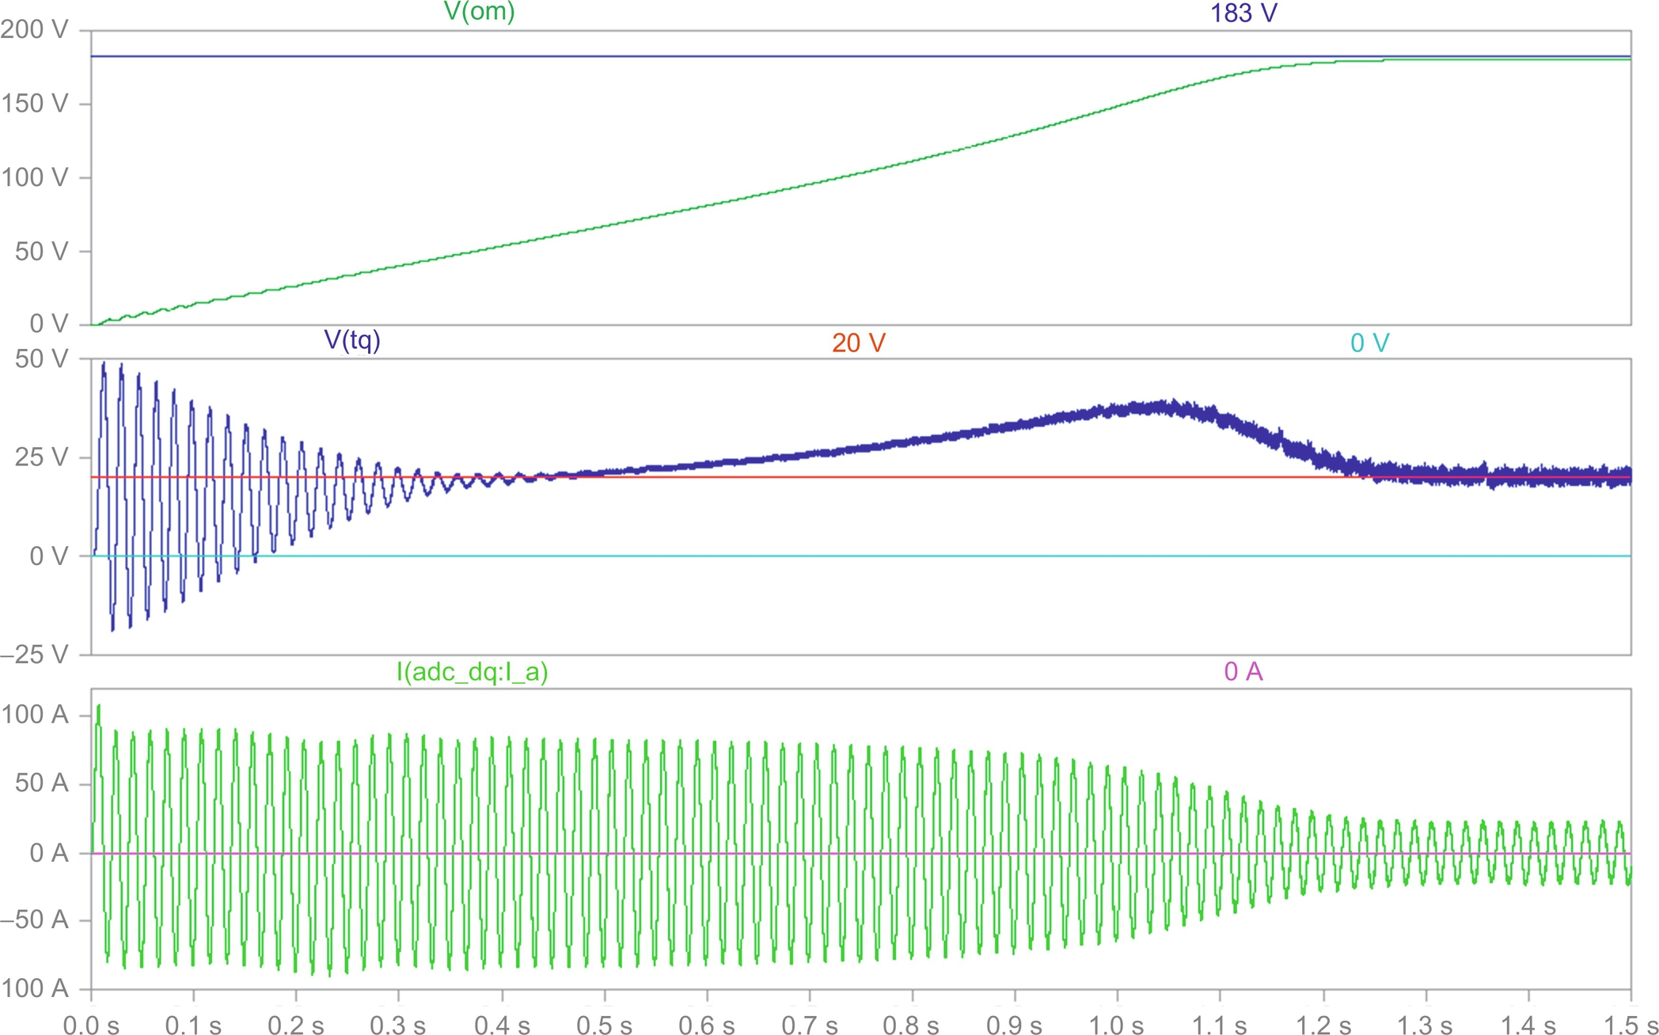

**FIG. 44.11** Induction motor start-up with three-phase inverter circuit.

**Table 44.1**

**List of all attributes used for the 5 hp, 208 V, 4-pole induction motor**

**Attributes**

R\_Stator=0.25 Ω

R\_Rotor=0.28 Ω

Ls\_leak=2.00 mH

Lr\_leak=2.25 mH

Lm=47.75 mH

Ls=Lm+Ls\_leak

Lr=Lm+Lr\_leak

kT=1.5⁎(Poles/2)⁎Lm/Lr

Tau\_r=Lr/R\_Rotor

Sigma=1−Lm⁎Lm/(Ls⁎Lr)

Poles=4

J\_mot=0.1 kg m2

Omega\_init=0

It is evident that the current trace is an almost perfect sinusoid, despite the fact that the input voltage is a PWM waveform. Also, the trace for the torque shows only a small high-frequency ripple. The reason is, of course, that the motor windings are inductive and represent a low-pass filter for the applied voltages. Nevertheless, recent research suggests that filtering the output voltage of the inverter is advantageous anyway, because it significantly reduces the voltage stress on the windings and suppresses displacement currents through the bearings [[9](https://learning.oreilly.com/library/view/power-electronics-handbook/9780128114087/B9780128114070000490.xhtml#bb0050)].

## 44.5 Simulations of AC Induction Machines Using Field Oriented (Vector) Control

The following examples will demonstrate the use of LTspice for simulations of field-oriented control (FOC) of AC induction machines. Again, it is assumed that the reader is familiar with the basics of induction machine theory. Often times, FOC is also called vector control, and both expressions can be used interchangeably. The theory of vector control is described in detail in [[4](https://learning.oreilly.com/library/view/power-electronics-handbook/9780128114087/B9780128114070000490.xhtml#bb0025),[7](https://learning.oreilly.com/library/view/power-electronics-handbook/9780128114087/B9780128114070000490.xhtml#bb0040),[8](https://learning.oreilly.com/library/view/power-electronics-handbook/9780128114087/B9780128114070000490.xhtml#bb0045)]. The idea was originally proposed in the 1960s by Hasse and Blaschke, working at the Technical University of Darmstadt [[10](https://learning.oreilly.com/library/view/power-electronics-handbook/9780128114087/B9780128114070000490.xhtml#bb0055)]. The author had the privilege of taking one of Prof. Hasse's classes on machine control as an undergraduate student. The basic idea of FOC is to inject currents into the stator of an induction machine such that the magnetic flux level and the production of electromagnetic torque can be independently controlled and the dynamics of the machine resembles that of a separately excited DC machine. The previously discussed two-phase model for the induction machine is very helpful for studies of vector control and shall be used in all examples. If a two-phase induction motor model for the synchronous (or excitation) reference frame is used, the similarities between the control of a separately excited DC machine and vector control of an AC induction machine will be most evident. In this case, the D input corresponds to the field excitation input of the DC machine, and both inputs are fed with DC current. Assuming unsaturated machines, the current into the D input of the induction machine or the field current in the DC machine directly controls the flux level. The Q input of the induction machine would correspond to the armature winding input of the DC machine, and again, both inputs would receive DC current. These currents would directly control the production of electromagnetic torque with a linear relation (constant *kT*) between the current level and the torque level. Furthermore, the Q component of the current would not change the flux level established by the D component (no cross coupling). To make such a simulation work, it would finally be necessary to calculate the slip value that corresponds to the commanded torque and use this value to calculate the speed of the synchronous reference frame of the machine model.

Of course, this is very interesting from an academic standpoint, and the author uses this example in a semester-long lecture on machines and drives. However, it should again be noted that a machine represented by a model with a synchronous reference frame would have a stator, which rotates with synchronous speed. Of course, this is not realistic, and therefore, it is more interesting to generate a simulation example that uses the previously discussed motor model for the stationary reference frame. This motor must be supplied with AC voltages and currents with a frequency determined mostly by the rotor speed and to a small extent (slip value) by the commanded torque. We still compute DC values representing the commanded flux and torque, but we transform these DC values to appropriate AC values. In the following example, we will assume that we can measure the actual rotor speed with a sensor. For this purpose, many types of sensors are available on the market. If we add the slip speed to the measured rotor speed, we obtain the synchronous speed for the given operating point. We determine the slip speed from the torque command. With this synchronous speed, we can transform the DC flux and torque command values from the synchronous reference frame to the stationary reference frame. We accomplish this by using a rotational transformation according to the matrix equations in Eq. [(44.6)](https://learning.oreilly.com/library/view/power-electronics-handbook/9780128114087/B9780128114070000490.xhtml#fo0035). This rotational transformation is also called “Park” transformation. As shown in Eq. [(44.6)](https://learning.oreilly.com/library/view/power-electronics-handbook/9780128114087/B9780128114070000490.xhtml#fo0035), the transformation is bidirectional, and the product of the transformation matrices yields the unity matrix:

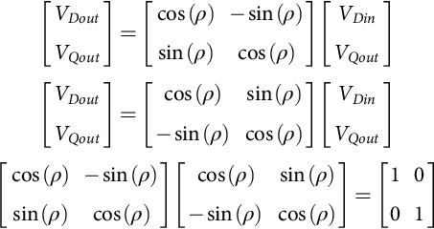 **(44.6)**

For the following discussion, we shall define the transformation that produces AC values from DC inputs as a positive vector transformation and the reverse operation consequently a negative vector transformation. The matrix equation for the positive vector transformation is shown on the left side of Eq. [(44.6)](https://learning.oreilly.com/library/view/power-electronics-handbook/9780128114087/B9780128114070000490.xhtml#fo0035). The negative transformation is very useful to extract DC values from AC voltages and currents for diagnostic and feedback control purposes. Both rotational transformations use the angle, *α*, in the equations. This angle can be interpreted as the momentary rotational displacement angle between two Cartesian coordinate systems, one containing the input values and the other the output values. This angle is obtained by integration of the angular velocity with which the coordinate systems are rotating (typically the synchronous speed).

In summary, we replaced a theoretical motor model using a synchronous reference frame by a reference frame transformation of the supply voltages and currents. In fact, modern DSPs are capable to perform both the Clark and the Park transformations in both directions at very high speeds. These DSPs are well supported with proved reference designs, including free software examples.

[Fig. 44.12](https://learning.oreilly.com/library/view/power-electronics-handbook/9780128114087/B9780128114070000490.xhtml#f0065) shows the top level of a simulation example that implements vector control for an induction machine with a stationary reference frame model. The motor model and the associated subcircuits ([Fig. 44.9](https://learning.oreilly.com/library/view/power-electronics-handbook/9780128114087/B9780128114070000490.xhtml#f0050)) are identical to the ones used for the circuit shown in [Fig. 44.8](https://learning.oreilly.com/library/view/power-electronics-handbook/9780128114087/B9780128114070000490.xhtml#f0045). As discussed above, the actual speed of the rotor is used as an input signal for the control unit. This scheme is known as indirect vector control and represents one of the most often used control methods. The symbol for the controller uses the same parameters as the motor. This is necessary to achieve correct field orientation. In real systems, the controller must be told or somehow determine the machine parameters. The machine parameters are contained in *.param* statements. If these *.param* statements are used at the top level of the hierarchy, they are global to the simulation, but if they are contained in a subcircuit, they are local to that subcircuit. Here, the vector controller and the induction motor both have local parameters, which enables us to study the influence of parameter mismatch on the performance of the control.

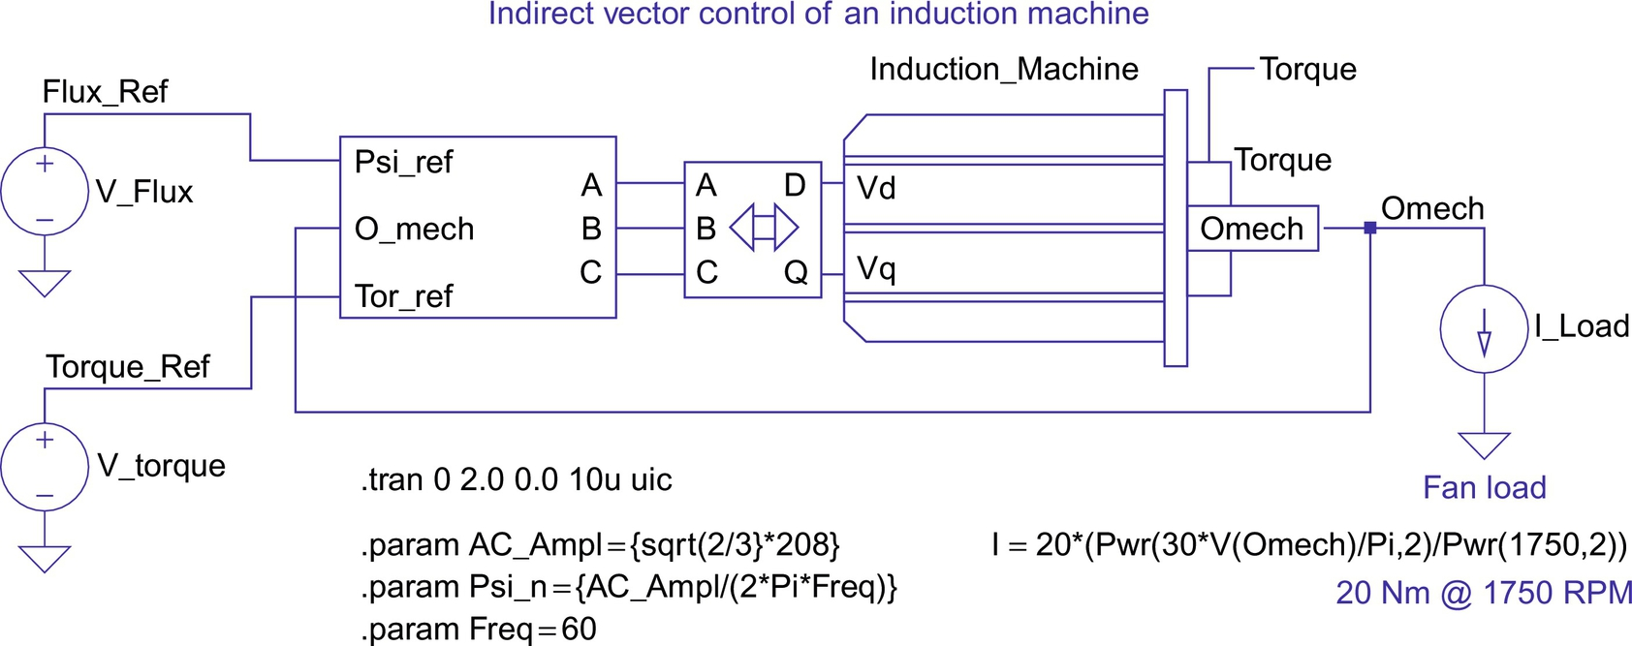

**FIG. 44.12** Top-level circuit for indirect vector control of induction motors.

[Fig. 44.12](https://learning.oreilly.com/library/view/power-electronics-handbook/9780128114087/B9780128114070000490.xhtml#f0065) shows a dependent current source that represents a fan load for the motor. The current of this source represents the load torque and is proportional to the square of the mechanical speed of the motor shaft. That speed is represented by the voltage on the *Omech* terminal. The controlling equation is scaled such that the load draws the rated torque (20 A=20 N m) at rated speed (1750 RPM). In this fashion, many more mechanical properties and devices can be modeled. For example, a mechanical flywheel is simply represented by a capacitor to the ground. Due to the scaling factors for the angular velocity and the torque, a flywheel with  would be a capacitor with a value of *C*=1 F. The compliance of a driveshaft (elastic twisting by the applied torque) can be modeled by a series inductor. By including both capacitors and inductors, effects like mechanical resonance can be included in a model.

[Fig. 44.13](https://learning.oreilly.com/library/view/power-electronics-handbook/9780128114087/B9780128114070000490.xhtml#f0070) shows the subcircuit for the vector control unit. The central part is a vector rotator for positive direction. This element transforms the DC reference values for the flux (D-axis) and the torque (Q-axis) to the stationary reference frame. The input angle for the vector rotator is the integral of the synchronous angular velocity. The signal called *Omech* is the measured rotor speed. The subcircuit for the vector rotator is shown in [Fig. 44.14](https://learning.oreilly.com/library/view/power-electronics-handbook/9780128114087/B9780128114070000490.xhtml#f0075).

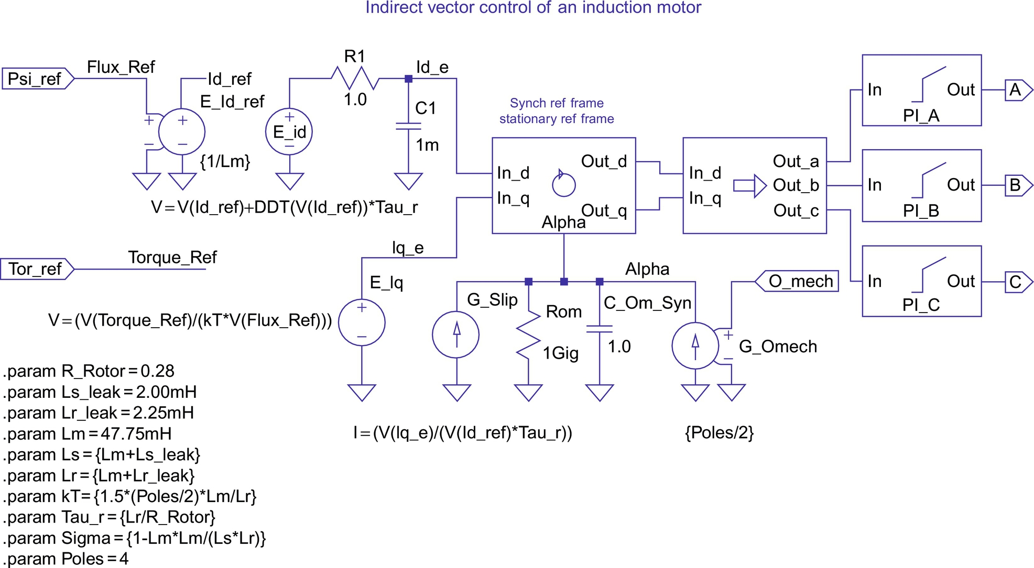

**FIG. 44.13** Subcircuit for indirect vector control of induction motors.

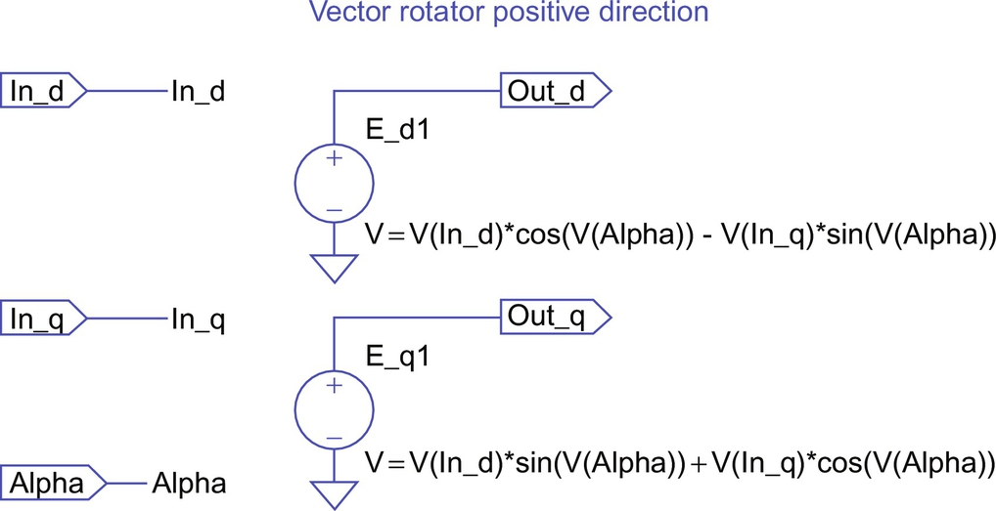

**FIG. 44.14** Schematic for subcircuit for vector rotator.

This speed is multiplied with the number of pole pairs (*poles*/2) to obtain the electric angular velocity. Then, the slip value (see Eq. [(44.7)](https://learning.oreilly.com/library/view/power-electronics-handbook/9780128114087/B9780128114070000490.xhtml#fo0040) for slip frequency calculation for vector control) appropriate to the torque command is added, and the resulting signal is routed through an integrator to generate the input angle for the vector rotator.

In the D-axis, a differentiator function *DDT(V(Id\_ref))* is used in a compensation element (see Eq. [(44.8)](https://learning.oreilly.com/library/view/power-electronics-handbook/9780128114087/B9780128114070000490.xhtml#fo0045) for D-axis reference current for vector control) that assures that the actual flux in the machine follows the commanded signal without delay. The input and output values of the vector rotator are voltage signals that correspond 1:1 to current signals. (In a real controller, the currents are typically scaled values in the memory of a DSP.) The vector controller calculates the appropriate currents that need to be injected into the machine to perform as desired. The currents are then transformed into three-phase values using the equations of [(44.5)](https://learning.oreilly.com/library/view/power-electronics-handbook/9780128114087/B9780128114070000490.xhtml#fo0030) and fed into three voltage sources with PI current loop feedback that represents a realistic implementation using a voltage-source PWM inverter. Alternatively, the PI current loops could be replaced with ideal current sources that are available in LTspice:

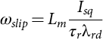 **(44.7)**

**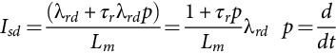** **(44.8)**

[Fig. 44.15](https://learning.oreilly.com/library/view/power-electronics-handbook/9780128114087/B9780128114070000490.xhtml#f0080) shows the results obtained for the circuit shown in [Fig. 44.12](https://learning.oreilly.com/library/view/power-electronics-handbook/9780128114087/B9780128114070000490.xhtml#f0065) with perfect tuning of the vector controller. Perfect tuning means that the controller precisely knows all motor parameters at all times (including resistance changes due to heating of the windings). The two traces in the pane at the top of [Fig. 44.15](https://learning.oreilly.com/library/view/power-electronics-handbook/9780128114087/B9780128114070000490.xhtml#f0080) represent the traces for the D and Q input signals of the vector rotator. The upper trace in the bottom pane of [Fig. 44.15](https://learning.oreilly.com/library/view/power-electronics-handbook/9780128114087/B9780128114070000490.xhtml#f0080) shows the reference value for the flux scaled by a factor of 50. It is evident that the flux level is being changed at the same time when 20 N m of torque is commanded (and produced). This proves that with exact tuning the torque and the flux can be independently controlled, which is true for correct FOC. Below the trace for the flux reference are the traces for the torque reference and the actual torque, which are perfectly on top of each other. This provides the easiest way to judge the quality of the correct field orientation.

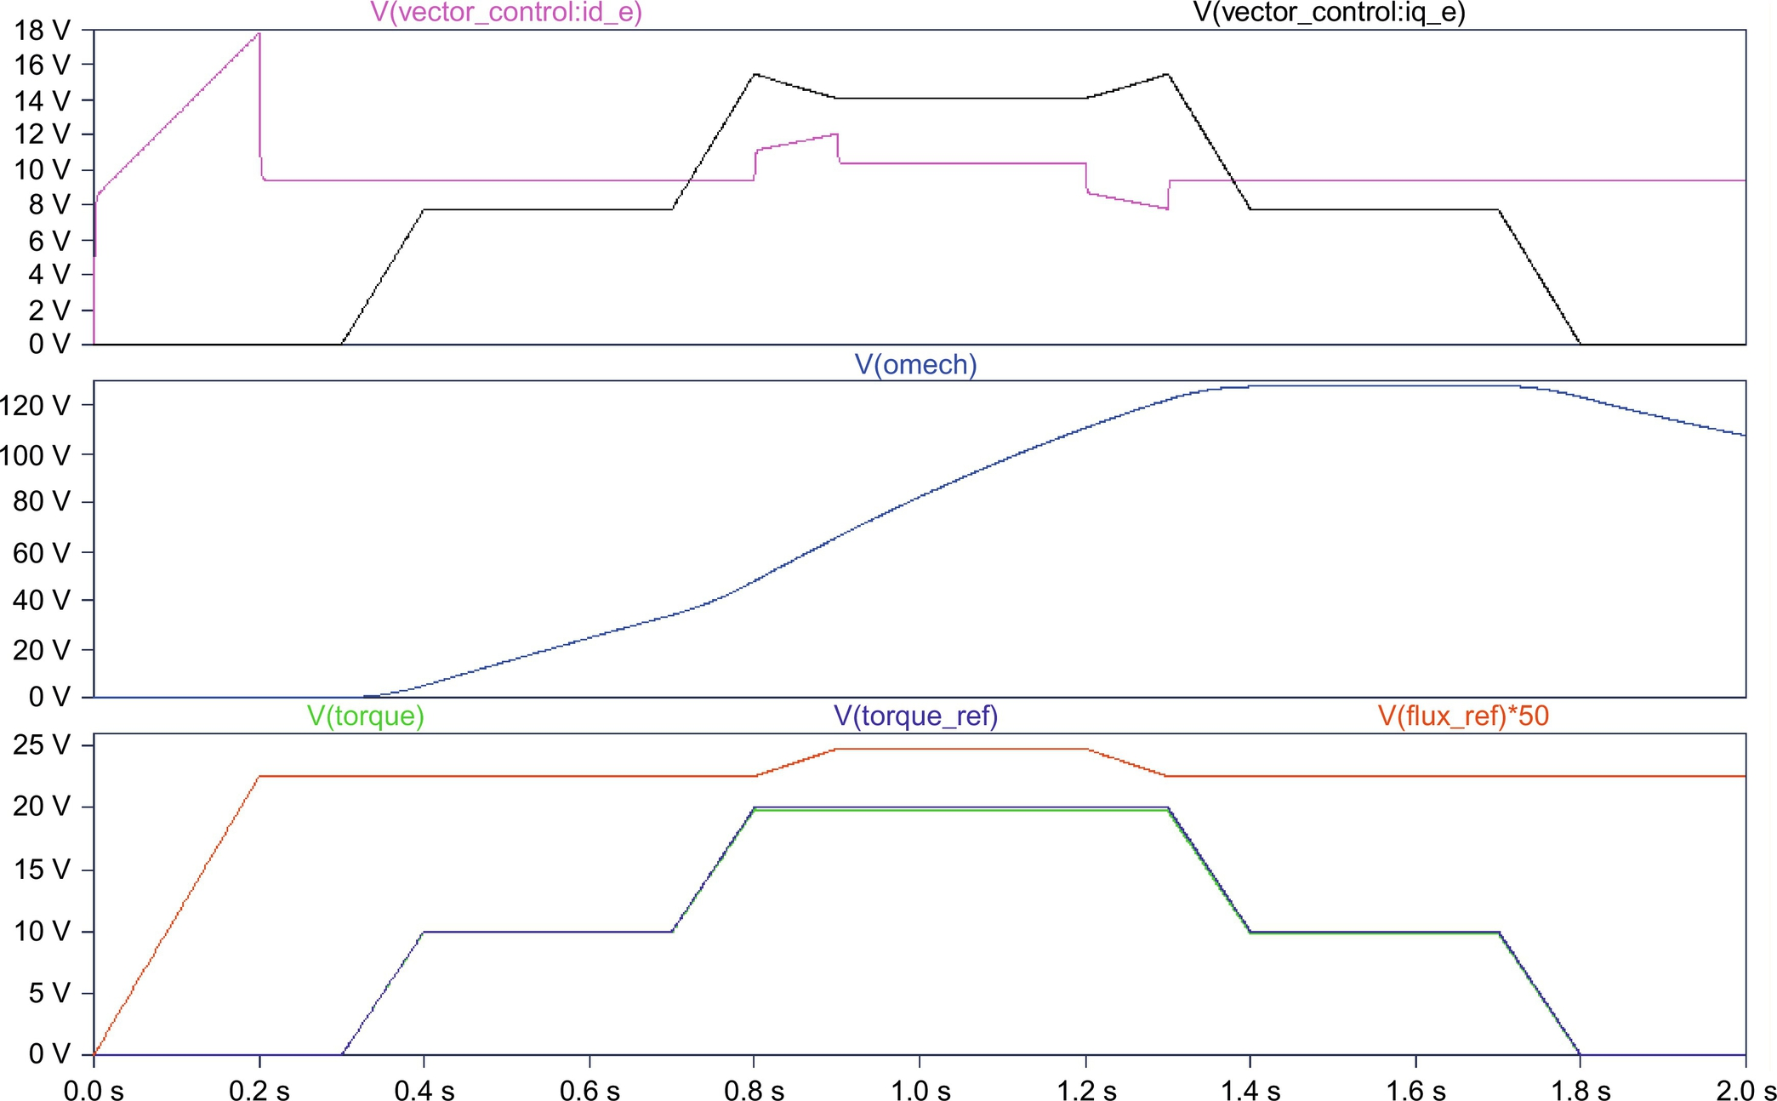

**FIG. 44.15** Results for indirect vector control with perfect tuning.

The center pane shows the trace for the mechanical angular velocity. It can be seen that the machine accelerates whenever torque is developed and slows down due to the load when the torque command is driven to zero.

[Fig. 44.16](https://learning.oreilly.com/library/view/power-electronics-handbook/9780128114087/B9780128114070000490.xhtml#f0085) is an example of the results obtained from a detuned vector controller. The circuit is identical to the circuit in [Fig. 44.12](https://learning.oreilly.com/library/view/power-electronics-handbook/9780128114087/B9780128114070000490.xhtml#f0065), except for the fact that the rotor resistance value in the controller was increased to 125%, which is thought to be attributed to heating of the rotor bars. It is obvious that the traces for the commanded and the actually produced torque are no longer identical. This is especially true, during times when the flux is changing. Detuning is actually a real problem in industrial vector control applications. Detuning is caused by the fact that the machine parameters are not precisely known to begin with and/or are changing during the operation of the machine. The values of the winding resistance are most commonly increasing due to heating of the machine during operation at high load.

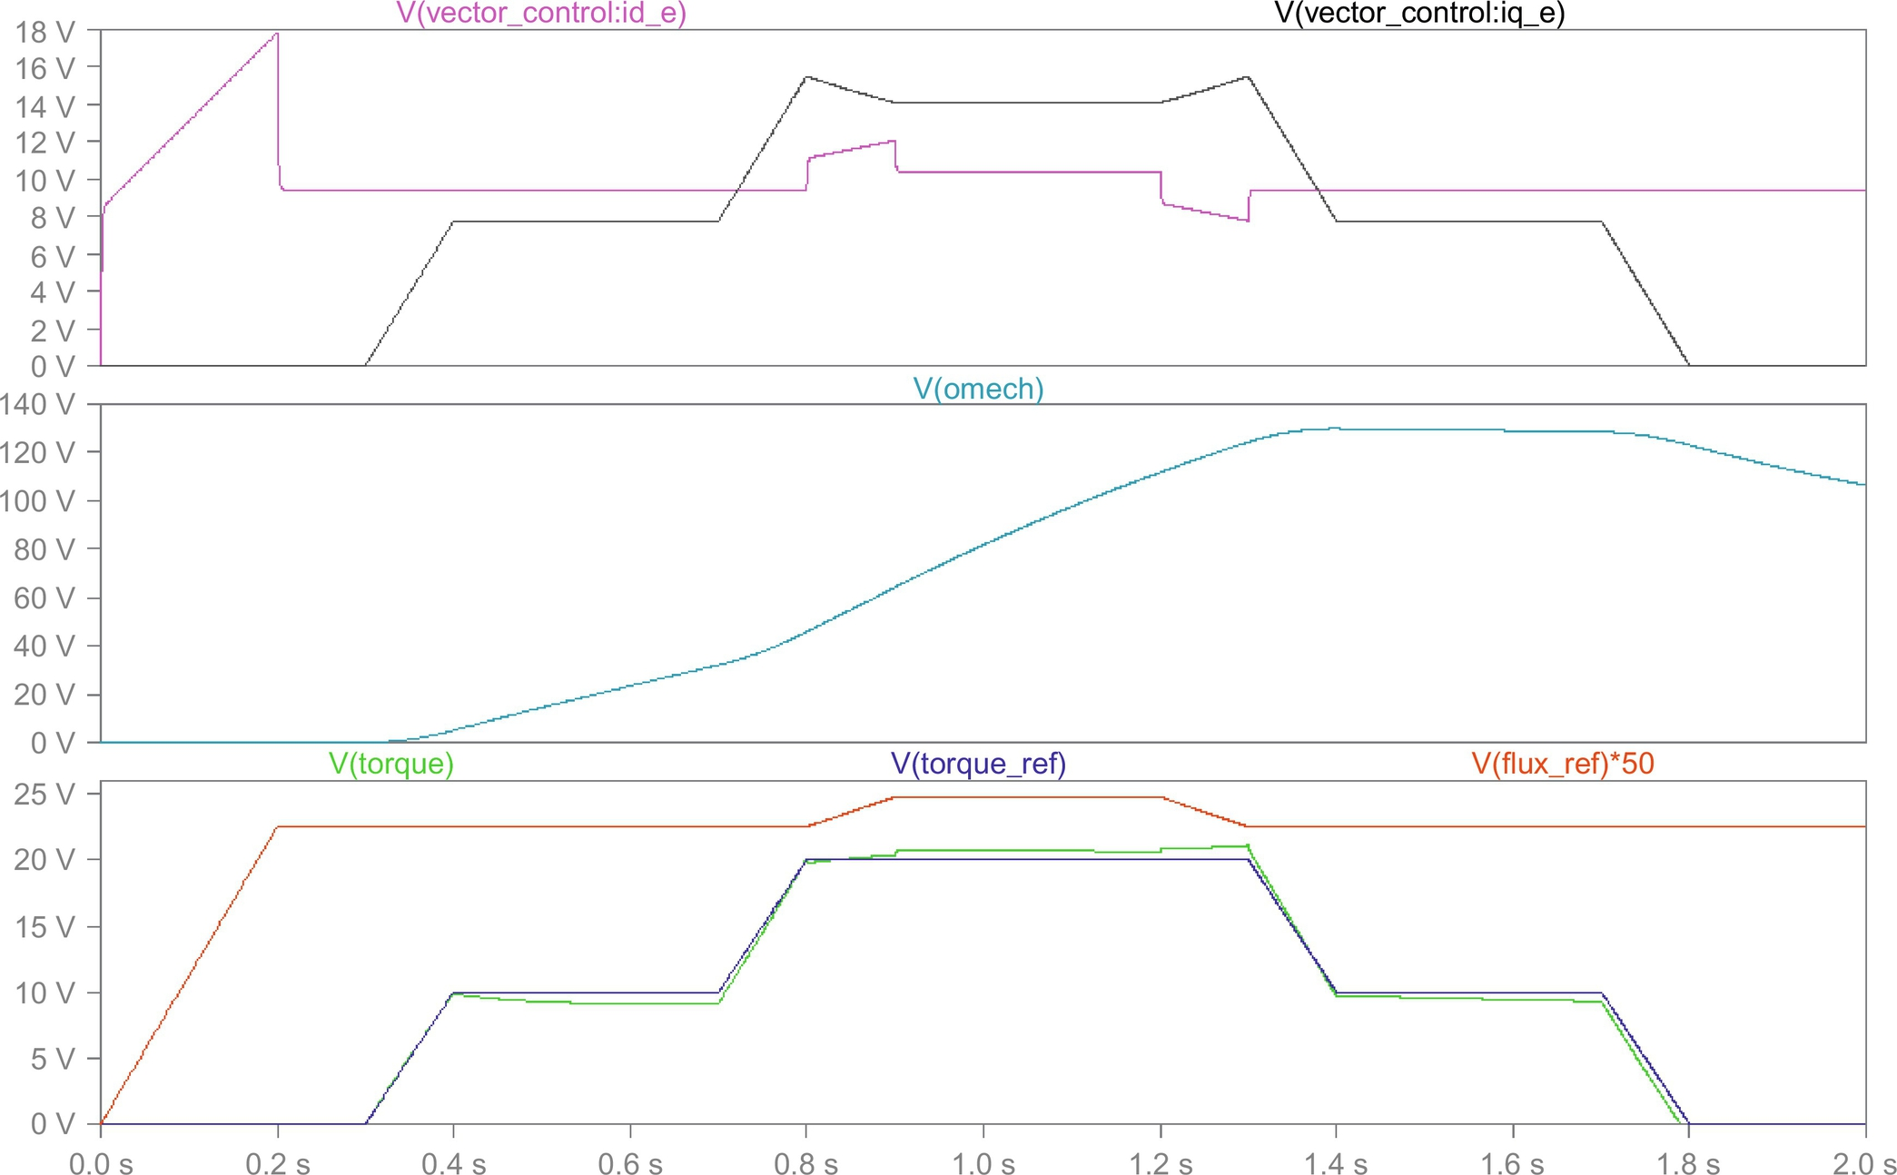

**FIG. 44.16** Results for indirect vector control with 125% rotor resistance resulting in imperfect tuning.

## 44.6 Simulation of Sensorless Vector Control Using LTspice

In the previous example, the advantages of vector control have been shown. However, for the implementation of the control scheme, a sensor for the mechanical speed was used. This poses a problem for applications where a vector drive is to be retrofitted into existing equipment. The motor installation may not easily allow the installation of a mechanical speed sensor. Therefore, engineers have thought to replace the mechanical speed sensor with a speed observer, which is a mathematical model that is evaluated by the control processor (typically a DSP), which is also performing the standard vector control computations. The algorithm for the observer uses the measured stator voltages and currents for the D- and Q-axes as input parameters. It also relies on the knowledge of the machine model and on the correct machine parameters (rotor and stator resistance, mutual and leakage inductance, etc.). The following example shows a vector control implementation using a speed observer. The vector controller has been derived from the previous example shown in [Fig. 44.13](https://learning.oreilly.com/library/view/power-electronics-handbook/9780128114087/B9780128114070000490.xhtml#f0070). However, the speed sensor signal was replaced by a speed observer. Careful examination of the derivation [[4](https://learning.oreilly.com/library/view/power-electronics-handbook/9780128114087/B9780128114070000490.xhtml#bb0025)] of the speed observer reveals that it is easier to calculate the synchronous angular velocity, which is ultimately desired, than the angular velocity of the rotor. Therefore, the observer was modified, and the calculation of the rotor speed and the subsequent addition of the slip speed were foregone. The speed observer used here basically solves the D, Q equation system of the induction machine shown in Eq. [(44.3)](https://learning.oreilly.com/library/view/power-electronics-handbook/9780128114087/B9780128114070000490.xhtml#fo0020), with the only difference that some of the dependent variables are now independent and vice versa. In addition to the synchronous angular velocity, the observer provides the values of the rotor flux, which could be used in the D-axis signal path.

[Fig. 44.17](https://learning.oreilly.com/library/view/power-electronics-handbook/9780128114087/B9780128114070000490.xhtml#f0090) shows the top level of a simulation project for sensorless vector control. The top view of this circuit is very similar to the circuit for the indirect vector control represented by [Fig. 44.12](https://learning.oreilly.com/library/view/power-electronics-handbook/9780128114087/B9780128114070000490.xhtml#f0065) except for the missing motor-speed feedback. The model for the motor and the motor's parameters are precisely the same as in the example for the indirect vector control. Double-clicking the control block reveals the associated subcircuit, which is shown in [Fig. 44.18](https://learning.oreilly.com/library/view/power-electronics-handbook/9780128114087/B9780128114070000490.xhtml#f0095). As mentioned before, this subcircuit is similar to the subcircuit for the indirect vector control. However, the signal from the motor-speed sensor is replaced by the speed observer. In our case, the speed observer directly provides the synchronous angular velocity. Therefore, it is not necessary to calculate the slip speed and add it to the rotor speed to obtain the synchronous speed.

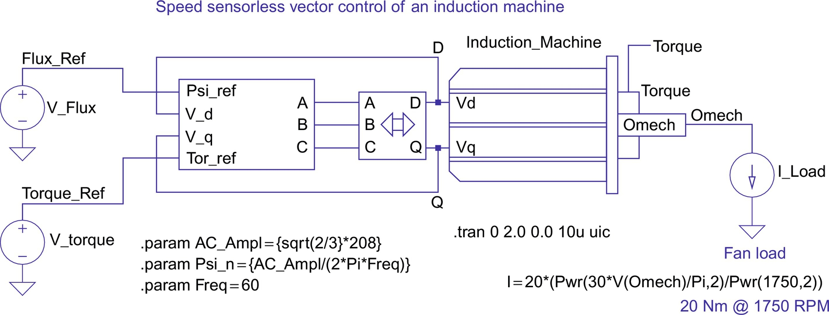

**FIG. 44.17** Top level of simulation circuit for sensorless vector control.

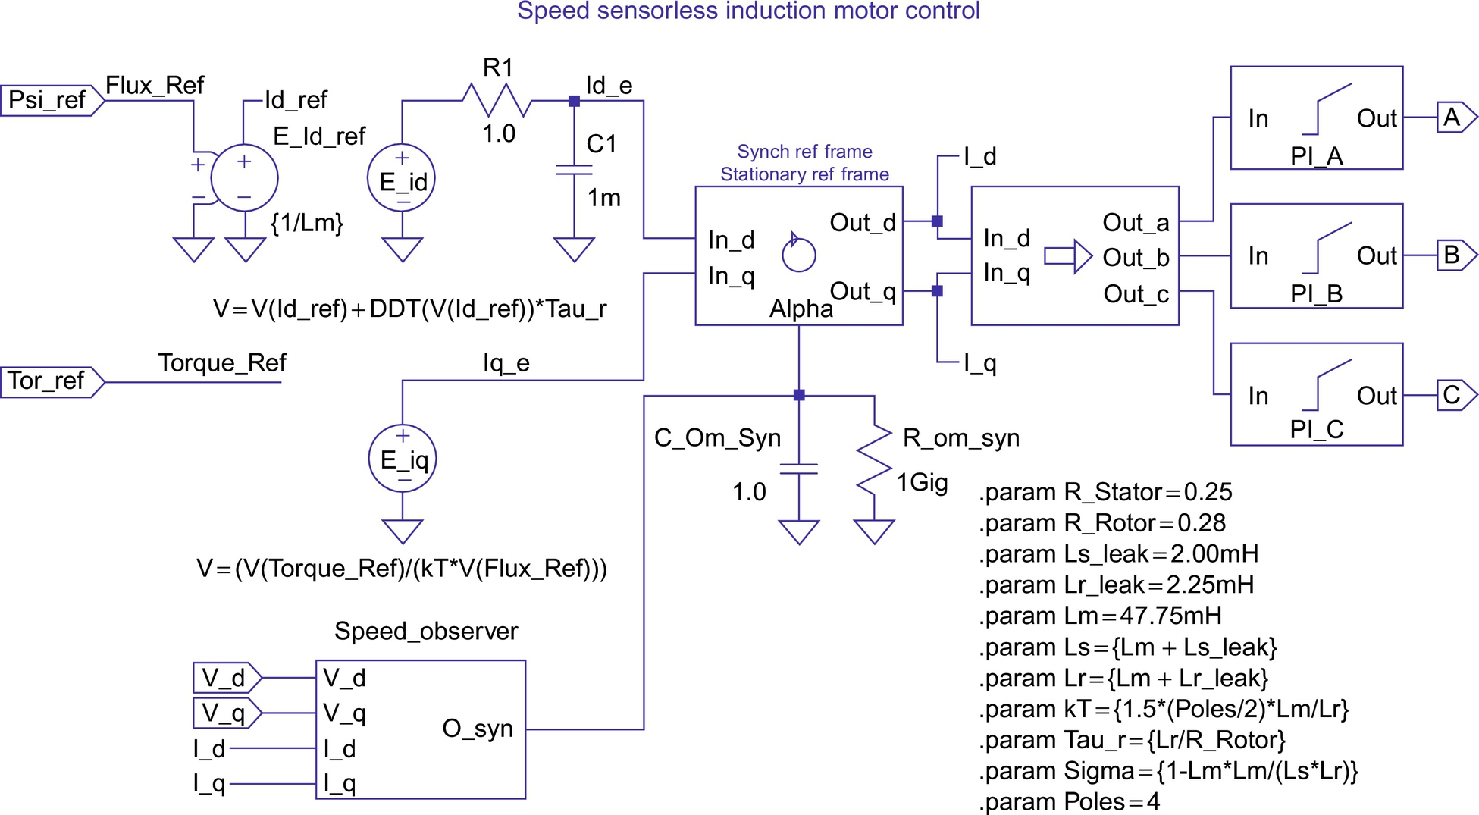

**FIG. 44.18** Subcircuit for sensorless vector controller.

[Fig. 44.19](https://learning.oreilly.com/library/view/power-electronics-handbook/9780128114087/B9780128114070000490.xhtml#f0100) shows the subcircuit for the speed observer. The speed observer uses the stator voltages and currents for the D- and Q-axis as input variables. After subtracting the voltage drop across the winding resistance and the leakage inductance of the stator from the stator input voltage and scaling the result by *Lr/Lm*, the observer calculates the D and Q components of the rotor flux by integration. Since the input values are in the stationary reference frame, so are the results. The observer also calculates the magnitude of the rotor flux (Eq. [(44.9)](https://learning.oreilly.com/library/view/power-electronics-handbook/9780128114087/B9780128114070000490.xhtml#fo0050)) and then calculates the synchronous angular velocity (Eq. [44.10](https://learning.oreilly.com/library/view/power-electronics-handbook/9780128114087/B9780128114070000490.xhtml#fo0055)) by evaluating the rate of change of the ratio of the D and Q components. The mathematical relationships are given by Eqs. [(44.9)](https://learning.oreilly.com/library/view/power-electronics-handbook/9780128114087/B9780128114070000490.xhtml#fo0050) and [(44.10)](https://learning.oreilly.com/library/view/power-electronics-handbook/9780128114087/B9780128114070000490.xhtml#fo0055) [[4](https://learning.oreilly.com/library/view/power-electronics-handbook/9780128114087/B9780128114070000490.xhtml#bb0025)]:

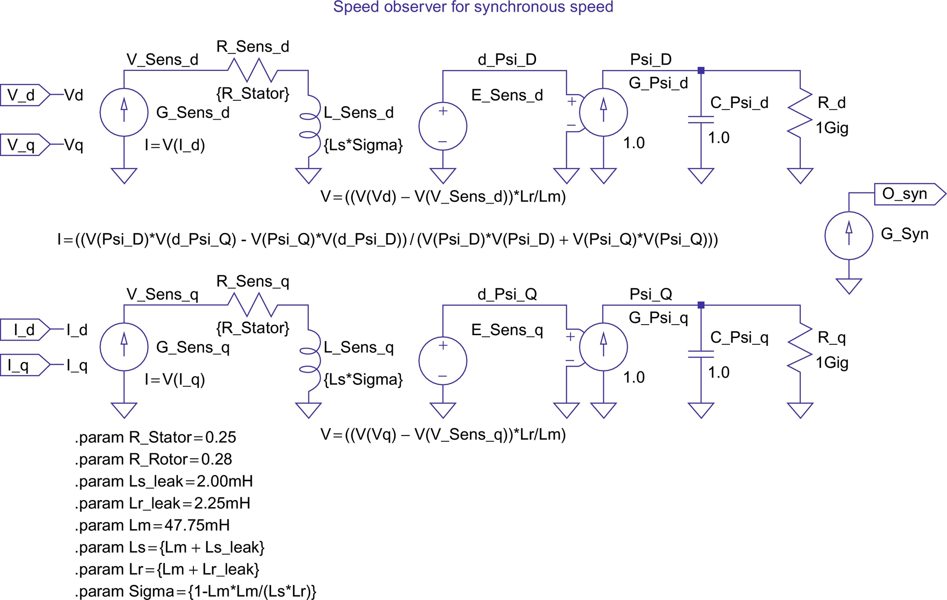

**FIG. 44.19** Subcircuit for speed observer for sensorless vector controller.

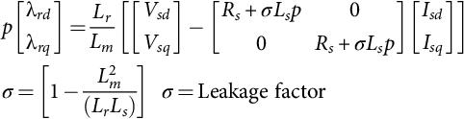 **(44.9)**

**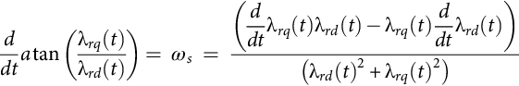** **(44.10)**

[Fig. 44.20](https://learning.oreilly.com/library/view/power-electronics-handbook/9780128114087/B9780128114070000490.xhtml#f0105) shows the output for the speed sensorless vector control project as it presents itself in the LTspice waveform display for perfect tuning of the speed observer. A comparison of the traces for the torque and the torque command (they are perfectly on top of each other) shows that the scheme works extremely well. It even works for a start from zero speed, which is typically not the case in real systems. The reason is that the uncertainties of the winding resistance values (note that they change with temperature) create errors in observers like this one. The problem is worst at low speeds, because at low speeds and associated low stator frequencies, the uncertain winding resistance represents the largest part of the total machine impedance.

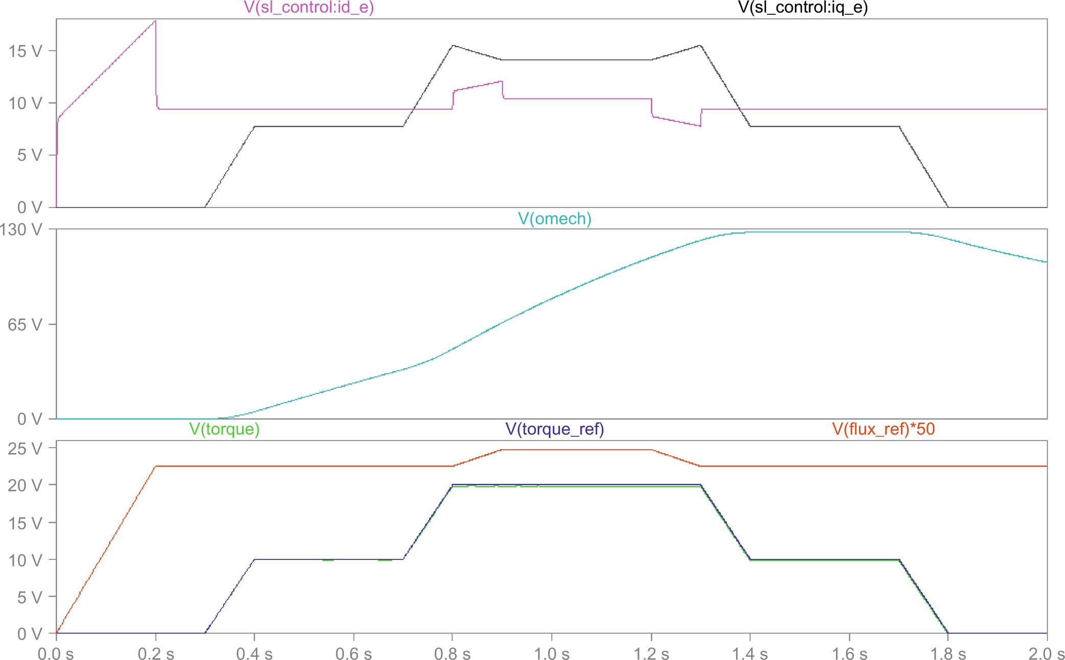

**FIG. 44.20** Simulation results for sensorless vector control with perfect observer tuning.

[Fig. 44.21](https://learning.oreilly.com/library/view/power-electronics-handbook/9780128114087/B9780128114070000490.xhtml#f0110) shows the output for the speed sensorless vector control example with increased values for the stator resistance (0.28 Ω instead of 0.25 Ω). A comparison of the traces for the torque and the torque command now shows that the control does not work well in this case. This confirms that at low speeds including zero speed, an actual speed sensor is required for proper field-oriented control.

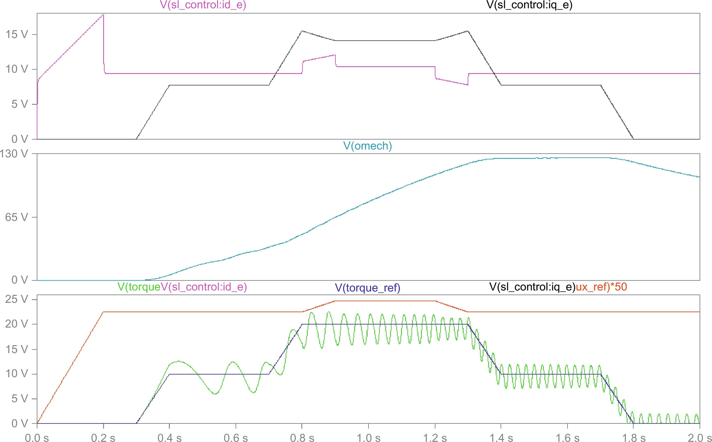

**FIG. 44.21** Simulation results for sensorless vector control with detuned stator resistance.

## 44.7 Conclusions

In this chapter, the capabilities of LTspice [[1](https://learning.oreilly.com/library/view/power-electronics-handbook/9780128114087/B9780128114070000490.xhtml#bb0010)] have been used to simulate a number of examples from the power electronics, machines, and drive area. The advantage of LTspice is that it is based on the almost universal spice simulation language, which can be seen as the worldwide de facto standard for circuit simulation. The reader should always validate any model before it is used for critical engineering decisions. It was pointed out in the introduction that model validation often means verification that the limitations of the model are not exceeded.

In addition to the detailed examples, some general guidelines on the uses of simulation for analysis and design have been developed. All tested simulations yielded excellent results. The simulation time for each project shown was typically less than a minute on a contemporary (2016) PC. The author hopes that the reader has gotten an insight and appreciation of the power of modern circuit simulation codes and some useful ideas and inspirations for projects of his/her own.

## References

[1] Linear Technology, 1630 McCarthy Blvd., Milpitas, CA 95035-7417, LTspice IV, <http://www.linear.com/designtools/software/>. Accessed February 23, 2017.

[2] PTC, 140 Kendrick Street, Needham, MA 02494, USA, <http://www.ptc.com/engineering-math-software/mathcad> Accessed February 23, 2017.

[3] Mohan N., Undeland T., Robbins W. *Power Electronics, Converters, Applications, and Design.* second ed. New York: John Wiley & Sons; 1995.0-471-58408-8.

[4] Trzynadlowski A.M. *The Field Orientation Principle in Control of Induction Motors.* Boston, MA: Kluwer Academic Publishers, Inc.; 1994.0-7923-9420-8.

[5] Krause P.C., Wasynczuk O., Sudhoff S.D. *Analysis of Electric Machinery.* Hoboken, NJ: IEEE Press; 1995.0-7803-1101-9.

[6] Giesselmann M.G. *Averaged and cycle by cycle switching models for buck, boost, buck-boost and cuk converters with common average switch model.* In: Proceedings of the 32nd Intersociety Energy Conversion Engineering Conference, IECEC-97, Honolulu, Hawaii, July 27–Aug. 01, 1997; 1997.

[7] Novotny D.W., Lipo T.A. *Vector Control and Dynamics of AC Drives.* New York, NY: Oxford Science Publications; 1996.0-19-856439-2.

[8] Vas P. Vector Control of AC Machines. *Monographs in Electrical and Electronic Engineering.* Oxford/New York: Oxford Science Publications, vol. 22, Clarendon Press/Oxford University Press; 1990.0-19-859370-8.

[9] Von Jouanne A., Rendusara D., Enjeti P., Gray W. Filtering techniques to minimize the effect of long motor leads on PWM inverter fed AC motor drive systems. *IEEE Trans. Ind. Appl.* 1996;32(4):919–926. doi:10.1109/28.511650.

[10] K. Hasse, Zur Dynamik Drehzahlgeregelter Antriebe mit Stromrichter gespeisten Asynchron-Kurzschlussläufermachinen (On the Dynamics of Adjustable Speed Drives with converter-fed Squirrel Cage Induction Machines), Ph.D. Dissertation, Technical University of Darmstadt, 1969.

**45**

# Design for Reliability of Power Electronic Systems

Yongheng Yang Aalborg University, Aalborg, Denmark

Huai Wang Aalborg University, Aalborg, Denmark

Ariya Sangwongwanich Aalborg University, Aalborg, Denmark

Frede Blaabjerg Aalborg University, Aalborg, Denmark

## Abstract

Power density, efficiency, cost, and reliability are the major challenges when designing a power electronic system. Latest advancements in power semiconductor devices (e.g., silicon carbide devices) and topological innovations have vital contributions to power density and efficiency. Nevertheless, dedicated heat sink systems for thermal management are required to dissipate the power losses in power electronic systems; otherwise, the power devices will be heated up and eventually fail to operate. In addition, in many mission critical applications (e.g., marine systems), the operating condition (i.e., mission profiles) is usually harsh, where the input power can change quickly and randomly, resulting in considerable temperature swings in the power electronics. This may induce failures to the power electronic systems. If remain untreated (i.e., ill-designed system without considering reliability), the cost for maintenance will increase, thus affecting the reputation for the manufacturers and, more important, the cost of energy in renewables. Hence, it calls for highly reliable power electronic systems, where the reliability together with various common design parameters should be taken into account in the design phase. Clearly, it is a prerequisite to know the main life-limiting factors in order to predict the lifetime. Then, the design for reliability (DfR) can be performed. In this chapter, the technological challenges in the DfR of power electronic systems are addressed and how the power electronics are loaded considering mission profiles is demonstrated. Further, the DfR approach is systematically exemplified in grid-connected photovoltaic power electronic systems.

### KEYWORDS

Reliability; Design for reliability; Power electronics; Failure mechanism; Physics of failure; Mission profile; Thermal loading; Cost of energy; Renewables

45.1 [Introduction](https://learning.oreilly.com/library/view/power-electronics-handbook/9780128114087/B9780128114070000519.xhtml#s0010)

45.2 [Power Electronic Converters and Mission Profiles](https://learning.oreilly.com/library/view/power-electronics-handbook/9780128114087/B9780128114070000519.xhtml#s0015)

45.2.1 Power Electronic Converters for Wind Power Systems

45.2.2 Power Electronic Converters for PV Power Systems

45.2.3 Mission Profiles for Power Electronic Converters

45.3 [Design for Reliability (DfR) of Power Electronic Systems](https://learning.oreilly.com/library/view/power-electronics-handbook/9780128114087/B9780128114070000519.xhtml#s0050)

45.3.1 Mission Profile Translation

45.3.2 Thermal Loading Interpretation

45.3.3 Lifetime Model of Power Devices

45.3.4 Monte Carlo Reliability Assessment

45.3.5 System-Level Reliability Analysis

45.4 [Case Study](https://learning.oreilly.com/library/view/power-electronics-handbook/9780128114087/B9780128114070000519.xhtml#s0080)

45.4.1 Mission Profile Translation

45.4.2 Thermal Loading Interpretation

45.4.3 Lifetime Model of Power Devices

45.4.4 Monte Carlo Reliability Assessment

45.4.5 System-Level Reliability Analysis

45.4.6 Design for Reliability (DfR) Results

45.5 [Summary](https://learning.oreilly.com/library/view/power-electronics-handbook/9780128114087/B9780128114070000519.xhtml#s0115)

[References](https://learning.oreilly.com/library/view/power-electronics-handbook/9780128114087/B9780128114070000519.xhtml#bi0010)

## 45.1 Introduction

Due to the foreseen exhaustion of fossil-based energies, many countries are turning to the renewable energy technologies [[1](https://learning.oreilly.com/library/view/power-electronics-handbook/9780128114087/B9780128114070000519.xhtml#bb0010),[2](https://learning.oreilly.com/library/view/power-electronics-handbook/9780128114087/B9780128114070000519.xhtml#bb0015)]. Among those, wind and solar photovoltaic (PV) systems have attracted more attentions in the past decades [[2](https://learning.oreilly.com/library/view/power-electronics-handbook/9780128114087/B9780128114070000519.xhtml#bb0015)]. However, the incompatibility of renewable sources and loads requires an intermediate processing stage, which is typically achieved by power electronics [[2](https://learning.oreilly.com/library/view/power-electronics-handbook/9780128114087/B9780128114070000519.xhtml#bb0015)–[4](https://learning.oreilly.com/library/view/power-electronics-handbook/9780128114087/B9780128114070000519.xhtml#bb0025),[4a](https://learning.oreilly.com/library/view/power-electronics-handbook/9780128114087/B9780128114070000519.xhtml#bb0325)]. In conventional electric systems (e.g., motor drive systems), the role of power electronics is also obvious, as they are heavily involved in controlling the loads—motors. That is, the power electronic technology is the key to optimal energy harvesting and also friendly energy system integration. Moreover, this technology is developing with new and emerging power devices [[5](https://learning.oreilly.com/library/view/power-electronics-handbook/9780128114087/B9780128114070000519.xhtml#bb0030),[6](https://learning.oreilly.com/library/view/power-electronics-handbook/9780128114087/B9780128114070000519.xhtml#bb0035)] with extraordinary performances in terms of switching speed and efficiency. In all, power electronics will be extensively used in many applications in the future.

In practice, the design of power electronic systems is mainly cost-driven, and thus there are three major concerns: power density, efficiency, and reliability [[7](https://learning.oreilly.com/library/view/power-electronics-handbook/9780128114087/B9780128114070000519.xhtml#bb0040),[8](https://learning.oreilly.com/library/view/power-electronics-handbook/9780128114087/B9780128114070000519.xhtml#bb0045)]. Efficiency improvements can be achieved through developing power-lossless topologies (also, including soft-switching techniques) and advancing the power semiconductor devices. As an intuitive way, minimizing the number of conversion stages can contribute to high efficiencies. Notably, the topological simplification also has adverse impacts (e.g., the leakage current issue in transformerless PV inverters), which thus requires new dedicated control strategies. Alternatively, the latest advancements in power semiconductor technologies, for example, wide bandgap power devices like silicon carbide (SiC) transistors, offer much room to improve the efficiency of power electronic systems [[6](https://learning.oreilly.com/library/view/power-electronics-handbook/9780128114087/B9780128114070000519.xhtml#bb0035)–[10](https://learning.oreilly.com/library/view/power-electronics-handbook/9780128114087/B9780128114070000519.xhtml#bb0055)]. For instance, as reported in [[11](https://learning.oreilly.com/library/view/power-electronics-handbook/9780128114087/B9780128114070000519.xhtml#bb0060)–[13](https://learning.oreilly.com/library/view/power-electronics-handbook/9780128114087/B9780128114070000519.xhtml#bb0070)], the PV power electronic systems with wide bandgap devices have achieved a remarkable efficiency of above 99%, meaning that very few losses exist. The high-efficiency performance has boosted the PV market, where commercial PV inverters employing new devices are available. Furthermore, the wide bandgap power semiconductors feature a high-switching frequency operation capability, and thus, incorporating soft-switching techniques can further improve the efficiency [[14](https://learning.oreilly.com/library/view/power-electronics-handbook/9780128114087/B9780128114070000519.xhtml#bb0075)].

As discussed above, higher power density and efficiency of power electronic systems are relatively achievable. However, according to a survey [[15](https://learning.oreilly.com/library/view/power-electronics-handbook/9780128114087/B9780128114070000519.xhtml#bb0080)], the power electronic converter itself has become one of the most fragile parts in the entire system. For instance, in that study, the unscheduled maintenance events due to power electronics account for 37% of the total events in a utility-scale PV power plants, as shown in [Fig. 45.1](https://learning.oreilly.com/library/view/power-electronics-handbook/9780128114087/B9780128114070000519.xhtml#f0010). Those unscheduled maintenance events require human intervention (system repairing or maintenance), thus affecting the overall production and the maintenance costs, as observed in [Fig. 45.1](https://learning.oreilly.com/library/view/power-electronics-handbook/9780128114087/B9780128114070000519.xhtml#f0010). In the end, the cost of PV energy will go up drastically due to the high failure rate of power inverters in PV systems. Hence, as aforementioned, high reliability of power electronics is in urgent need on top of efficiency.

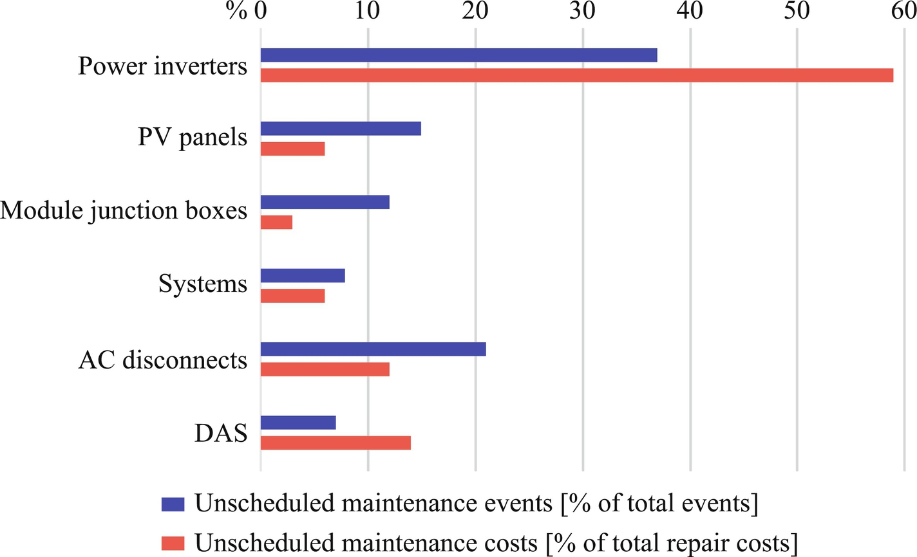

**FIG. 45.1** Five years of real-field experience in failures of a utility-scale PV power plants (data acquisition systems (DAS)) [[15](https://learning.oreilly.com/library/view/power-electronics-handbook/9780128114087/B9780128114070000519.xhtml#bb0080)].

As for reliability, more challenging issues should be addressed [[16](https://learning.oreilly.com/library/view/power-electronics-handbook/9780128114087/B9780128114070000519.xhtml#bb0085)–[23](https://learning.oreilly.com/library/view/power-electronics-handbook/9780128114087/B9780128114070000519.xhtml#bb0120)]. Prediction in lifetime of the power electronics is the first task so that the reliability can be taken as a performance factor in the design phase of power electronic systems, which is referred to as the design for reliability (DfR) [[24](https://learning.oreilly.com/library/view/power-electronics-handbook/9780128114087/B9780128114070000519.xhtml#bb0125)–[26](https://learning.oreilly.com/library/view/power-electronics-handbook/9780128114087/B9780128114070000519.xhtml#bb0135)]. In the past, the statistical analysis has been the dominant approach for lifetime prediction, where the reliability models (typically, constant failure rates) of subsystems are defined. For instance, a handbook—MIL-HDBK-217 F [[27](https://learning.oreilly.com/library/view/power-electronics-handbook/9780128114087/B9780128114070000519.xhtml#bb0140)]—has been widely adopted to predict the lifetime of electronic equipment for decades. However, in this handbook, the models are outdated, and the associated failure rates are considered as constants. Thus, this handbook has been revoked. It is also worth to point out that the predicted lifetime or reliability based on this handbook has limited or no direct guiding value for the system design [[28](https://learning.oreilly.com/library/view/power-electronics-handbook/9780128114087/B9780128114070000519.xhtml#bb0145)]. It is difficult to use the predicted reliability data to design new products or systems with higher reliability, not to mention the control to enhance the reliability performance. With the still increasing demands for high reliability, the analysis approach has to be shifted to the physics-of-failure (PoF) analysis [[19](https://learning.oreilly.com/library/view/power-electronics-handbook/9780128114087/B9780128114070000519.xhtml#bb0100)–[22](https://learning.oreilly.com/library/view/power-electronics-handbook/9780128114087/B9780128114070000519.xhtml#bb0115)], where the root causes, failure mechanisms, and mission profiles are in focus [[20](https://learning.oreilly.com/library/view/power-electronics-handbook/9780128114087/B9780128114070000519.xhtml#bb0105),[29](https://learning.oreilly.com/library/view/power-electronics-handbook/9780128114087/B9780128114070000519.xhtml#bb0150),[30](https://learning.oreilly.com/library/view/power-electronics-handbook/9780128114087/B9780128114070000519.xhtml#bb0155)]. This (i.e., the PoF-based DfR) enables more predictable and controllable power electronic systems with high reliability.

In light of the above discussion, this chapter briefly discusses the mainstream power electronic converters for wind and PV power systems. More importantly, the DfR approach is explained in detail, including a short description of the failure mechanisms. Case studies on a 6-kW single-phase grid-connected PV inverter system have been provided to better illustrate the DfR approach considering mission profiles. Finally, concluding remarks and discussions on future research trends in the reliability of power electronics are provided.

## 45.2 Power Electronic Converters and Mission Profiles

Design and operation of power electronic systems for both wind and PV power systems are strongly dependent on the grid requirements. [Fig. 45.2](https://learning.oreilly.com/library/view/power-electronics-handbook/9780128114087/B9780128114070000519.xhtml#f0015) shows the general demands for grid-connected PV and wind power systems, where the power electronic system is the key component, acting as “the brain” of the entire system. The objectives of those power electronic systems are to manage the power demand from the local operators and end customers [[31](https://learning.oreilly.com/library/view/power-electronics-handbook/9780128114087/B9780128114070000519.xhtml#bb0160),[32](https://learning.oreilly.com/library/view/power-electronics-handbook/9780128114087/B9780128114070000519.xhtml#bb0165)]. A very common requirement is to transfer the PV and wind energy to the grid, according to its inherent characteristics (i.e., applying maximum power point tracking techniques). Other specific demands can be summarized as (a) reliable/secure power supply; (b) high efficiency, low cost, small volume, and effective protection; (c) control of active and reactive power injected into the grid; (d) dynamic grid support (e.g., fault ride-through operation); and (e) system monitoring and communication. In all, as the core of power conversion systems, the reliability of power electronic systems is of strong concern. In the following, some of the state-of-the-art power electronic converter solutions for wind and PV systems are introduced.

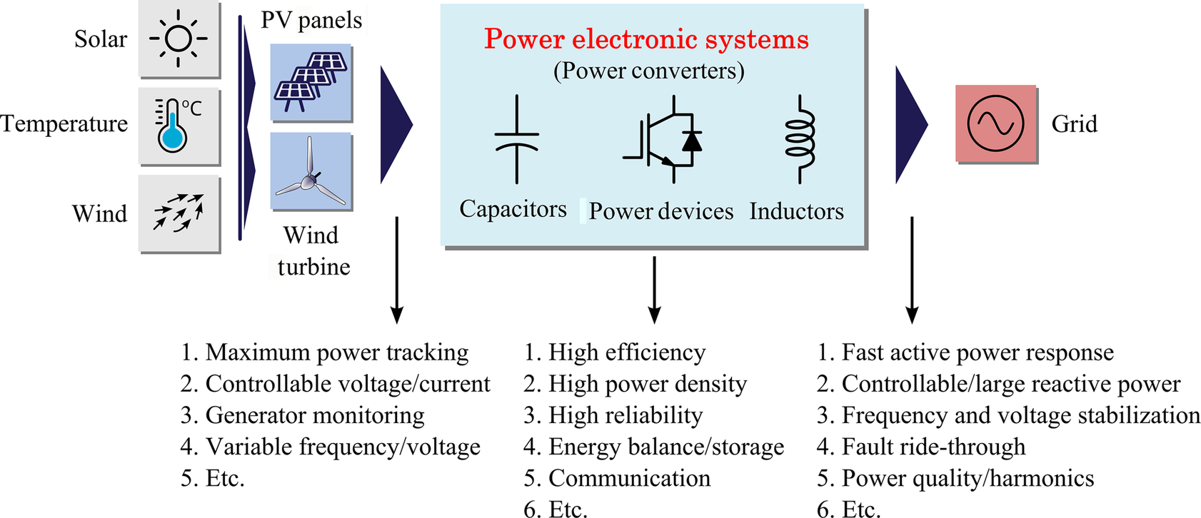

**FIG. 45.2** Demands for grid-connected PV and wind power systems at different stages in the system.

### 45.2.1 POWER ELECTRONIC CONVERTERS FOR WIND POWER SYSTEMS

According to the types of generator, power electronics, speed controllability, and the way in which the aerodynamic power is limited, the wind-turbine system (WTS) designs can be categorized into four types:

• Fixed speed wind turbine (WT) systems

• Partial variable speed WT with variable rotor resistance

• Variable speed WT with partial-scale frequency converter

• Variable speed WT with full-scale power converter

Among those configurations, the latter two shown in [Fig. 45.3](https://learning.oreilly.com/library/view/power-electronics-handbook/9780128114087/B9780128114070000519.xhtml#f0020) currently dominate the markets, which will be further employed in future wind power systems. As observed in [Fig. 45.3](https://learning.oreilly.com/library/view/power-electronics-handbook/9780128114087/B9780128114070000519.xhtml#f0020) and aforementioned, the power electronic converters are very important, and they have various power ratings. In the past, the doubly fed induction generator (DFIG) with partial-scale power electronic converters was the most favorable concept (see [Fig. 45.3A](https://learning.oreilly.com/library/view/power-electronics-handbook/9780128114087/B9780128114070000519.xhtml#f0020)). However, the synchronous generator (SG) or asynchronous generator (AG) with full-scale power electronic converters (see [Fig. 45.3B](https://learning.oreilly.com/library/view/power-electronics-handbook/9780128114087/B9780128114070000519.xhtml#f0020)) has taken over today's wind power markets [[33](https://learning.oreilly.com/library/view/power-electronics-handbook/9780128114087/B9780128114070000519.xhtml#bb0170),[34](https://learning.oreilly.com/library/view/power-electronics-handbook/9780128114087/B9780128114070000519.xhtml#bb0175)].

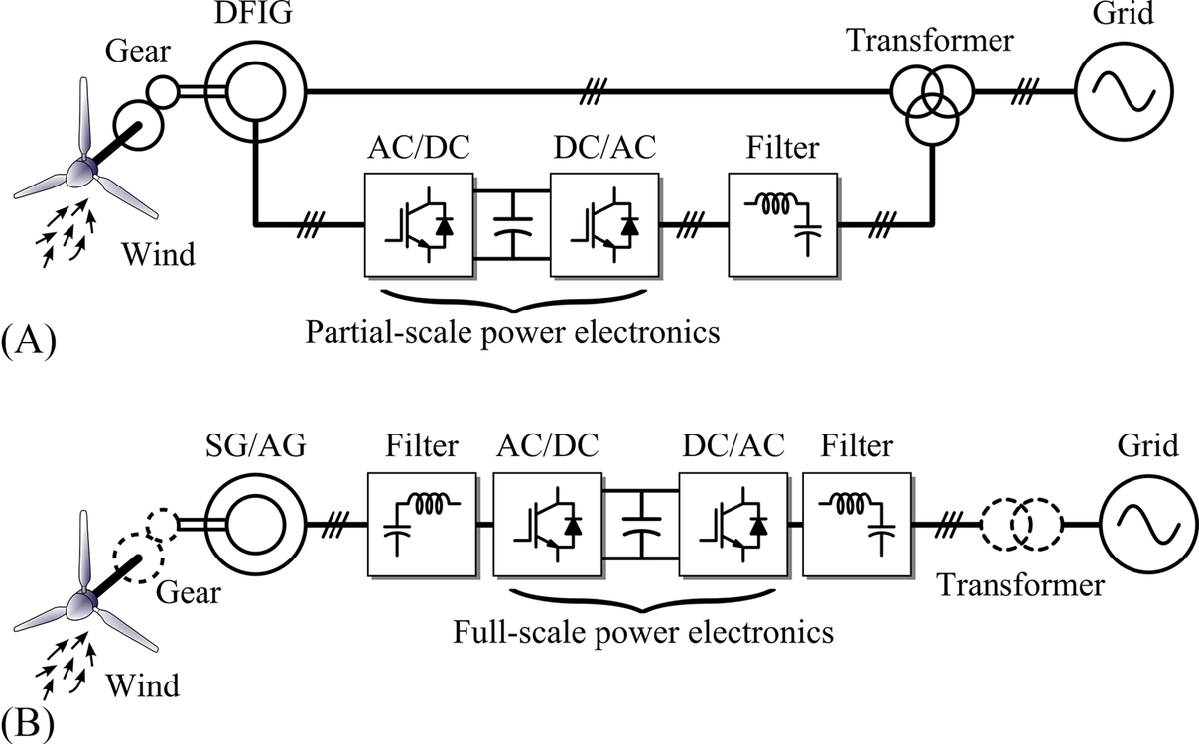

**FIG. 45.3** Two dominant power-electronic-based WTS configurations: (A) partial-scale back-to-back power-converter-based wind turbine system with a doubly fed induction generator (DFIG) and (B) full-scale back-to-back power-converter-based wind turbine system with a synchronous or asynchronous generator (SG/AG).

For the power electronic converters, there are many ways to configure. The most commonly adopted three-phase converter is the two-level voltage source converter (2L-VSC), as shown in [Fig. 45.4](https://learning.oreilly.com/library/view/power-electronics-handbook/9780128114087/B9780128114070000519.xhtml#f0025). The popularity of this converter topology lies in its structural and control simplicity. However, the continuous increase in power capacity of an individual wind turbine [[35](https://learning.oreilly.com/library/view/power-electronics-handbook/9780128114087/B9780128114070000519.xhtml#bb0180),[36](https://learning.oreilly.com/library/view/power-electronics-handbook/9780128114087/B9780128114070000519.xhtml#bb0185)] highly stressed the 2L-VSC and thus leading to a lower efficiency. From this standpoint, the multilevel converter technology is getting more and more attentions in wind power applications, since they can achieve more output voltage levels, higher voltage, and larger output power [[33](https://learning.oreilly.com/library/view/power-electronics-handbook/9780128114087/B9780128114070000519.xhtml#bb0170)–[37](https://learning.oreilly.com/library/view/power-electronics-handbook/9780128114087/B9780128114070000519.xhtml#bb0190)]. [Fig. 45.5](https://learning.oreilly.com/library/view/power-electronics-handbook/9780128114087/B9780128114070000519.xhtml#f0030) shows the power converter schematics of the most successfully commercialized multilevel converter, that is, the three-level neutral-point-clamped (3L-NPC) converter. As mentioned, the 3L-NPC enables the use of smaller filters (reduced system volume), while the major drawback is the unequal power loss distribution. This in return may challenge the reliability of the entire power electronic converter system. To tackle this issue, multicell converter topologies by connecting converter cells in parallel or in series are developed and also commercially adopted in practice (e.g., Gamesa and Siemens) [[38](https://learning.oreilly.com/library/view/power-electronics-handbook/9780128114087/B9780128114070000519.xhtml#bb0195),[39](https://learning.oreilly.com/library/view/power-electronics-handbook/9780128114087/B9780128114070000519.xhtml#bb0200)].

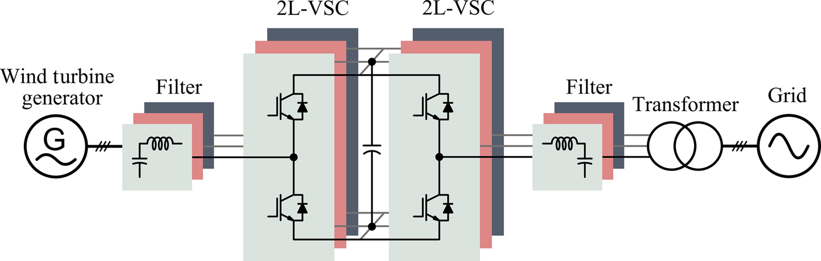

**FIG. 45.4** Two-level VSC back-to-back (2L-VSC BTB) power electronic converters for wind turbine power systems.

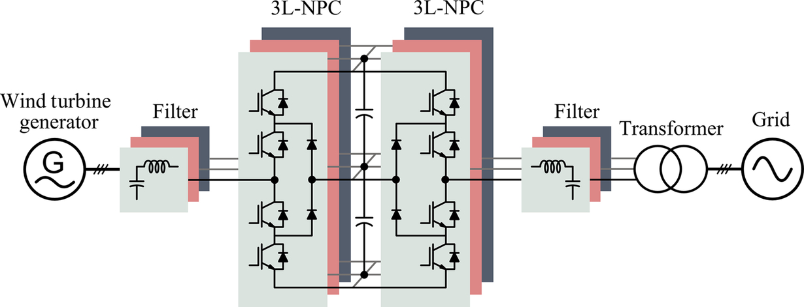

**FIG. 45.5** Three-level neutral-point-clamped back-to-back (3L-NPC BTB) converter for wind turbine power systems.

### 45.2.2 POWER ELECTRONIC CONVERTERS FOR PV POWER SYSTEMS

According to the state-of-the-art technologies, there are certain concepts [[26](https://learning.oreilly.com/library/view/power-electronics-handbook/9780128114087/B9780128114070000519.xhtml#bb0135),[39a](https://learning.oreilly.com/library/view/power-electronics-handbook/9780128114087/B9780128114070000519.xhtml#bb0330)] to organize and deliver the PV power to the grid, as shown in [Fig. 45.6](https://learning.oreilly.com/library/view/power-electronics-handbook/9780128114087/B9780128114070000519.xhtml#f0035). Each of the concepts consists of a couple of power electronic converters (e.g., dc-dc converters and dc-ac inverters) that are configured in different structures, depending on the applications and power ratings. For instance, modular PV converters ([Fig. 45.6A](https://learning.oreilly.com/library/view/power-electronics-handbook/9780128114087/B9780128114070000519.xhtml#f0035)) of small volume and high scalability are commonly adopted in small energy conversion systems. However, in order to connect modular PV converters to the grid, high conversion ratio dc-dc converters may be required, or a dc grid is necessary (see [Fig. 45.6A and B](https://learning.oreilly.com/library/view/power-electronics-handbook/9780128114087/B9780128114070000519.xhtml#f0035)). In contrast, string, multistring, or central inverters can directly be connected to the grid and they are developed as shown in [Fig. 45.6B and C](https://learning.oreilly.com/library/view/power-electronics-handbook/9780128114087/B9780128114070000519.xhtml#f0035). Nevertheless, when compared with wind power systems, the PV utilization is still at a residential level with lower power ratings. Hence, string and multistring inverters with the exemplified configuration of [Fig. 45.6B](https://learning.oreilly.com/library/view/power-electronics-handbook/9780128114087/B9780128114070000519.xhtml#f0035) are dominant on the markets, and the single-phase connection is more often to see [[40](https://learning.oreilly.com/library/view/power-electronics-handbook/9780128114087/B9780128114070000519.xhtml#bb0205),[41](https://learning.oreilly.com/library/view/power-electronics-handbook/9780128114087/B9780128114070000519.xhtml#bb0210)].

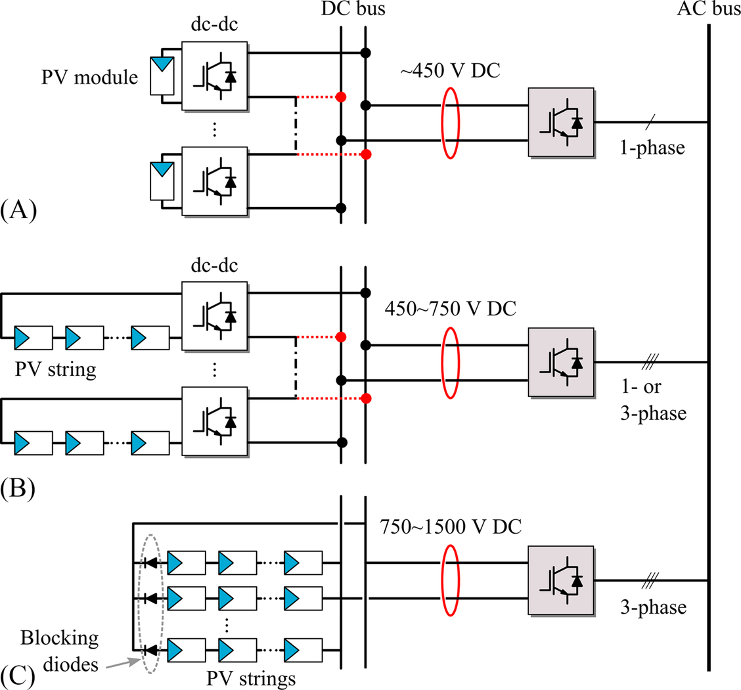

**FIG. 45.6** Different grid-connected photovoltaic conversion systems: (A) module converters (low-power applications); (B) string or multi-string inverters (medium-power applications), where the dc-dc converters are optional; and (C) central inverters (high-power applications, e.g., commercial and utility-scale systems).

[Fig. 45.7](https://learning.oreilly.com/library/view/power-electronics-handbook/9780128114087/B9780128114070000519.xhtml#f0040) exemplifies a single-phase grid-connected PV system with an LCL filter, where a full-bridge inverter has been employed. Additionally, to have a higher efficiency, transformerless PV inverters are preferred [[40](https://learning.oreilly.com/library/view/power-electronics-handbook/9780128114087/B9780128114070000519.xhtml#bb0205)]. However, the side effects (e.g., leakage currents) brought by the removal of isolation transformers have to be addressed. Although single-phase configurations are more common, increasing demands in power and voltage also push the ratings of PV systems higher, as demonstrated in [Fig. 45.6](https://learning.oreilly.com/library/view/power-electronics-handbook/9780128114087/B9780128114070000519.xhtml#f0035). Those large PV power plants, rated over tens and even hundreds of megawatts (MW), adopt many central inverters with the power rating of up to 900 kW. A typical large-scale PV power plant is shown in [Fig. 45.8](https://learning.oreilly.com/library/view/power-electronics-handbook/9780128114087/B9780128114070000519.xhtml#f0045), in which the traditional three-phase full-bridge inverter can be adopted. Notably, the cables and power devices may have to bear large currents, and seen from this point, multilevel power electronic converter technologies might be more promising to large-scale PV systems [[42](https://learning.oreilly.com/library/view/power-electronics-handbook/9780128114087/B9780128114070000519.xhtml#bb0215)–[44](https://learning.oreilly.com/library/view/power-electronics-handbook/9780128114087/B9780128114070000519.xhtml#bb0225)]. In that case, disconnecting a large amount of dc currents is yet challenging.

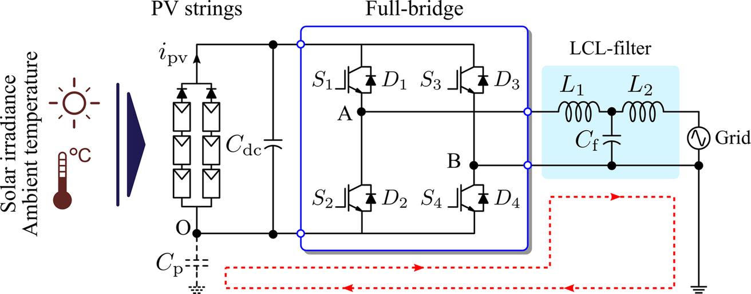

**FIG. 45.7** Single-phase single-stage transformerless full-bridge string inverter with an LCL filter, where *i*pv represents the PV output current and *C*p is the parasitic capacitor between the PV panels (strings) and the ground. The dashed line with arrows indicates possible leakage currents circulating through the parasitic capacitor *C*p.

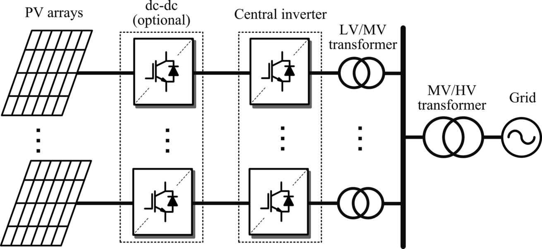

**FIG. 45.8** Typical large-scale PV power plant based on central inverters for utility applications in the MW range (low voltage (LV); medium voltage (MV); high voltage (HV)).

### 45.2.3 MISSION PROFILES FOR POWER ELECTRONIC CONVERTERS

A mission profile is normally referred to as a simplified representation of relevant conditions under which the system is operating [[45](https://learning.oreilly.com/library/view/power-electronics-handbook/9780128114087/B9780128114070000519.xhtml#bb0230),[46](https://learning.oreilly.com/library/view/power-electronics-handbook/9780128114087/B9780128114070000519.xhtml#bb0235)]. As a result, the mission profiles for power electronic converters determine the loading of power electronic components, and thereby, they are closely related to the cost and reliability performances. In renewable energy applications, the mission profiles are relatively tough: they need to withstand a large amount of power (even up to a few MWs) and perform a series of complicated functions required from the grid, and meanwhile, they also operate under harsh environments like day-night temperature swings, dust, vibration, humidity, and salty ambience. Moreover, the operating hours for wind turbines can be up to 120,000 h, and for a PV inverter, they might be operating 80,000 h in a 20-year life span [[19](https://learning.oreilly.com/library/view/power-electronics-handbook/9780128114087/B9780128114070000519.xhtml#bb0100),[20](https://learning.oreilly.com/library/view/power-electronics-handbook/9780128114087/B9780128114070000519.xhtml#bb0105)]. Notably, today, even longer operation hours are discussed. In this section, typical mission profiles for wind and PV applications are exemplified, including wind speed, solar irradiance level, and ambient temperature.

#### **45.2.3.1 Wind Speed**

As the input of the entire wind power system, the wind energy quantified by the wind speed is an important factor that can determine the design, control, maintenance, energy yield, and eventually also the system cost. During the construction and design phases, assumptions have to be made about the wind conditions that the wind turbines will be exposed to. Typically, wind classes are used that are determined by three parameters—the average wind speed, extreme 50-year gust, and turbulence. Because the loading of power electronic converters are mainly caused by wind speed level and its variations, the knowledge of the wind class is of crucial importance for the reliability calculation and performances. The commonly adopted classifications of wind conditions are from an IEC standard [[47](https://learning.oreilly.com/library/view/power-electronics-handbook/9780128114087/B9780128114070000519.xhtml#bb0240)]. [Fig. 45.9](https://learning.oreilly.com/library/view/power-electronics-handbook/9780128114087/B9780128114070000519.xhtml#f0050) shows the distribution under different wind classes, where the Weibull function is used to describe the distribution characteristics.

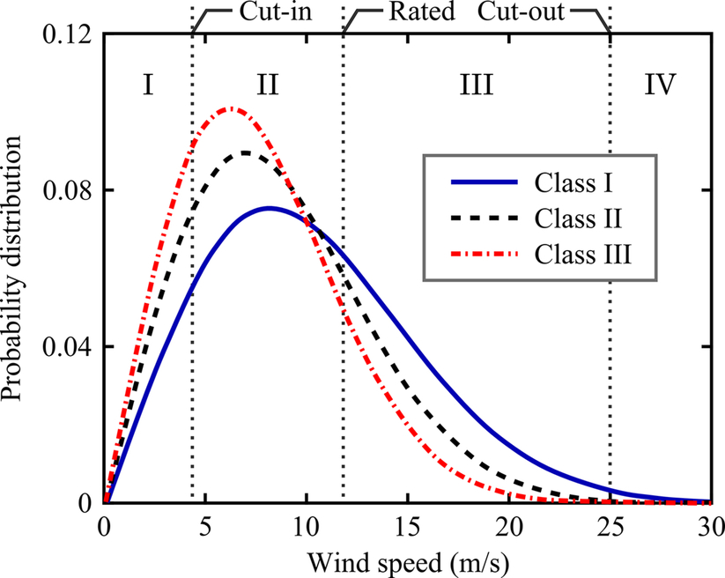

**FIG. 45.9** Distributions of the wind speeds under different wind classes and operation of wind turbines (region I, no power generation below cut-in wind speed; region II, maximum power point tracking generation; region III, constant power generation; and region IV, no power generation above cut-out wind speed) [[47](https://learning.oreilly.com/library/view/power-electronics-handbook/9780128114087/B9780128114070000519.xhtml#bb0240)].

Additionally, a field-recorded annual wind speed profile is illustrated in [Fig. 45.10](https://learning.oreilly.com/library/view/power-electronics-handbook/9780128114087/B9780128114070000519.xhtml#f0055) [[48](https://learning.oreilly.com/library/view/power-electronics-handbook/9780128114087/B9780128114070000519.xhtml#bb0245)], which is based on 1-h averaged at 80-m hub height for a wind farm located near Germany with the latitude of 54.25° and the longitude of 8.20°. The shown wind speed belongs to the IEC class I—high with an average wind speed of 8.5–10 m/s. It can be seen in [Fig. 45.10](https://learning.oreilly.com/library/view/power-electronics-handbook/9780128114087/B9780128114070000519.xhtml#f0055) that the wind speed fluctuates significantly. Without proper controls of the mechanical and electrical parts, the fluctuations may be transferred to the grid and cause grid stability problems. Moreover, the power electronic components may suffer from largely cyclical loadings and thus accelerating the degradation and challenging the lifetime. As a result, the roughness class and fluctuation of wind speeds should be considered in the control and design of the power electronics for wind power systems [[34](https://learning.oreilly.com/library/view/power-electronics-handbook/9780128114087/B9780128114070000519.xhtml#bb0175)].

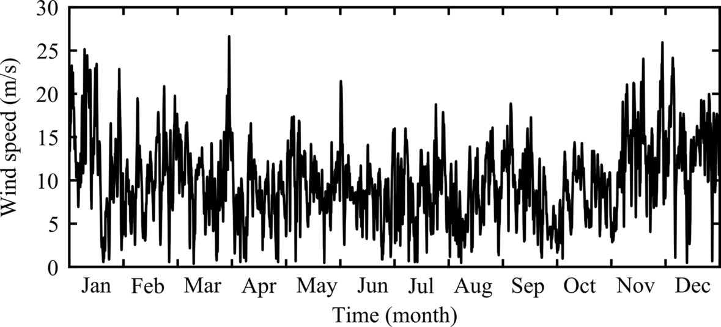

**FIG. 45.10** One-year wind speed profile at a wind farm near Germany (recorded at 80-m height and 1-h averaged).

#### **45.2.3.2 Solar Irradiance**

Wind speeds directly affect the power outputs of wind power systems, while solar irradiance level and ambient temperature are determining the output power of PV power systems. Actually, the mission profile (i.e., solar irradiance and ambient temperature) is a reflection of the intermittent nature of the solar PV energy, and consequently, it has an inherent relationship with the entire system performance. [Figs. 45.11](https://learning.oreilly.com/library/view/power-electronics-handbook/9780128114087/B9780128114070000519.xhtml#f0060) and [45.12](https://learning.oreilly.com/library/view/power-electronics-handbook/9780128114087/B9780128114070000519.xhtml#f0065) show annual solar irradiance and ambient temperature profiles for PV systems in Aalborg, Denmark, respectively. It can be observed that both the solar irradiance level and the ambient temperature vary significantly through a year. It is thus required to develop dedicated MPPT control systems in order to increase the energy yield. Moreover, like the case for wind power systems, the resultant fluctuating power from a PV power system may incur stability issues—especially when the PV penetration is getting larger and larger.

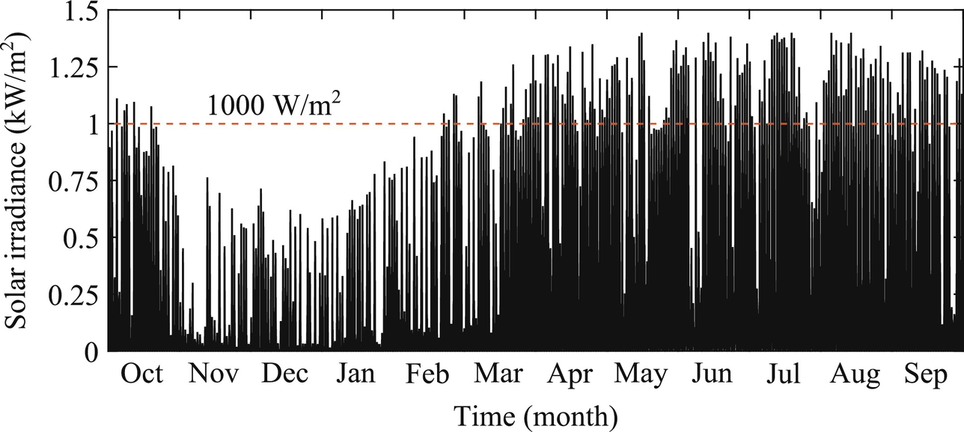

**FIG. 45.11** Yearly solar irradiance level from recorded data (5 min per sampling data) for PV systems.

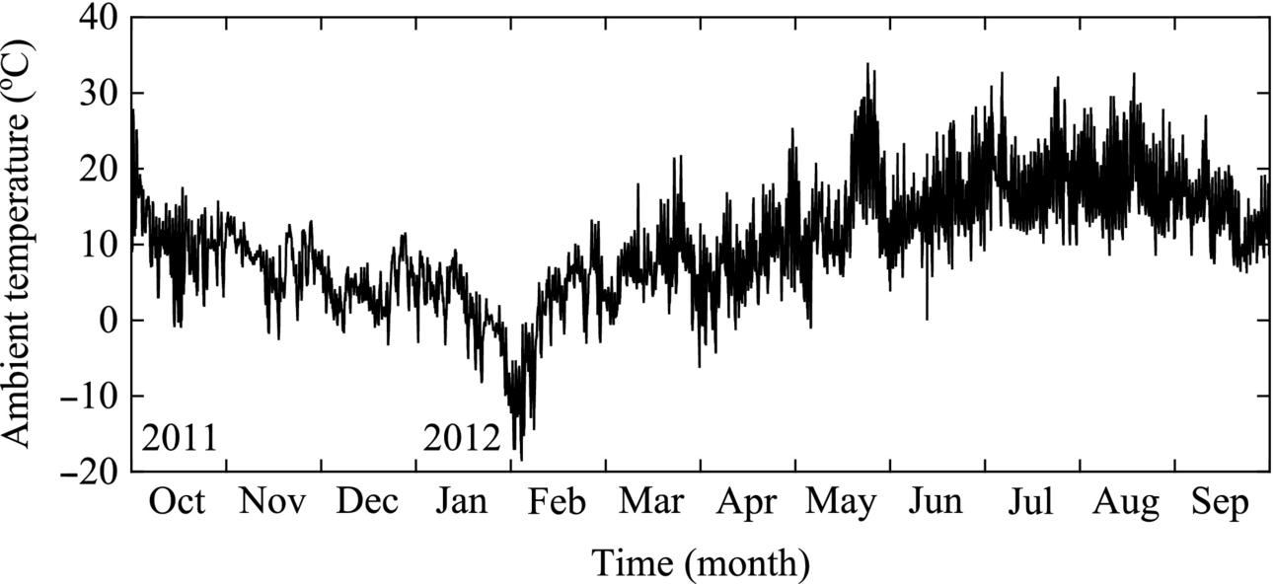

**FIG. 45.12** Yearly ambient temperature profile from recorded data (5 min per sampling data) for PV systems.

#### **45.2.3.3 Ambient Temperature**

In many applications, the power electronic systems are exposed to a harsh environment, where the ambient temperature is also time-varying, as shown in [Fig. 45.12](https://learning.oreilly.com/library/view/power-electronics-handbook/9780128114087/B9780128114070000519.xhtml#f0065). The ambient temperature variation inevitably imposes thermal stresses on the power electronic systems, and thus, the reliability is affected by the ambient temperature. For PV power systems, as mentioned previously, the ambient temperature also affects the power outputs. Consequently, those aspects related to mission profiles have to be carefully considered in the control and design phases of power electronic systems.

## 45.3 Design for Reliability (DfR) of Power Electronic Systems

As discussed in [Section 45.2](https://learning.oreilly.com/library/view/power-electronics-handbook/9780128114087/B9780128114070000519.xhtml#s0015), the power electronic system is the core of the energy conversion or processing system. Hence, the design of the entire system is centered on the power electronic systems, including power density, efficiency, and reliability. All those considered parameters aim to further reduce the cost but increase the manufacturability. For the design of high power density and high efficiency, technological achievements are dictated by topological innovations and semiconductor advancements, as mentioned at the beginning of this chapter.

To design a power electronic system with a specific reliability target, a top-down reliability allocation to the component level is necessary. [Fig. 45.13](https://learning.oreilly.com/library/view/power-electronics-handbook/9780128114087/B9780128114070000519.xhtml#f0070) shows a typical architecture to illustrate this concept. The failure causes of a power electronic system could be hardware, software, and human errors. While this chapter focuses on the hardware reliability, the failure from software and human errors can be considered according to the software reliability modeling and the field operation experiences in human error rates. A certain level of the reliability budget should be allocated for the software failure and human errors accordingly. For the hardware part, there are long-term degradation related wear-out failures and single-event-related catastrophic failures. The wear-out failure of power electronic components usually can be modeled based on long-term operation conditions and their respective lifetime models, which contribute partially to the failure events. The single-event-related catastrophic failure does have associated failure mechanisms, while it is difficult to predict accurately by models. Instead, it can be obtained based on field operation experiences of the products or similar products. An ideal design is to avoid any wear-out failure of power electronic components within the specified service life of the power electronic system of interest. However, it is usually not feasible due to both design cost constraints and component property uncertainties to a certain degree. Based on the budgets for software failures, human errors, single-event-related catastrophic failures, and the system-level reliability target, the reliability design budget of hardware assemblies associated with wear-out failure mechanisms can be determined. The component-level reliability design target can then be allocated. The wear-out failure mechanisms of key power electronic components and the lifetime prediction methods have been well discussed in [[20](https://learning.oreilly.com/library/view/power-electronics-handbook/9780128114087/B9780128114070000519.xhtml#bb0105)]. As an example, [Section 45.4](https://learning.oreilly.com/library/view/power-electronics-handbook/9780128114087/B9780128114070000519.xhtml#s0080) demonstrates how to size the IGBT power devices to achieve a specific reliability target.

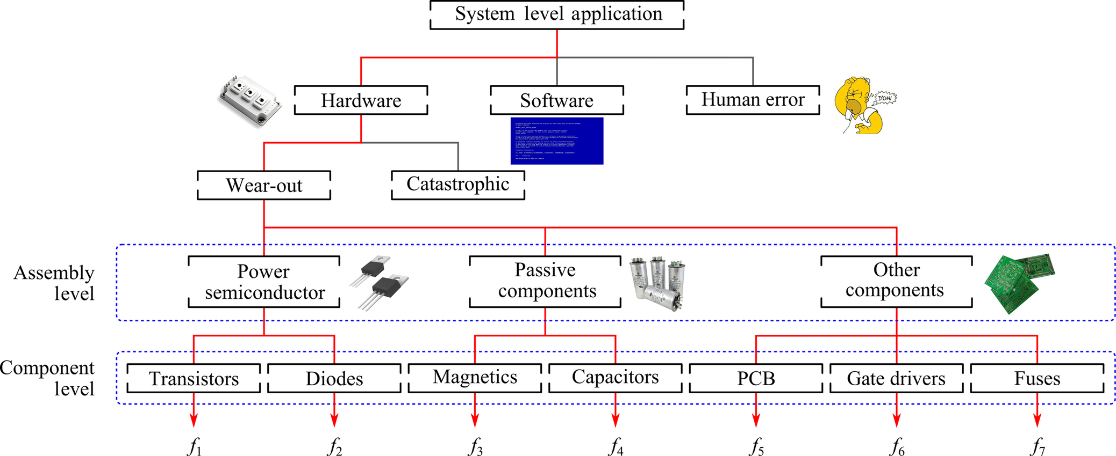

**FIG. 45.13** From system-level reliability specification to component-level reliability design budgets (printed circuit board (PCB); *fk* stands for failures with *k* being 1, 2, 3, ..., 7).

[Fig. 45.14A](https://learning.oreilly.com/library/view/power-electronics-handbook/9780128114087/B9780128114070000519.xhtml#f0075) shows the influencing factors in the design and operation phases of power electronic systems, where it can be observed that the design involves many factors. More important, it is seen in [Fig. 45.14A](https://learning.oreilly.com/library/view/power-electronics-handbook/9780128114087/B9780128114070000519.xhtml#f0075) that unexpected failures will occur during the operation, resulting in costly maintenance [[24](https://learning.oreilly.com/library/view/power-electronics-handbook/9780128114087/B9780128114070000519.xhtml#bb0125)]. Accordingly, the design of high reliability is becoming mission critical in power electronic systems, as it is the key parameter affecting the levelized cost of energy (LCOE) [[49](https://learning.oreilly.com/library/view/power-electronics-handbook/9780128114087/B9780128114070000519.xhtml#bb0250),[50](https://learning.oreilly.com/library/view/power-electronics-handbook/9780128114087/B9780128114070000519.xhtml#bb0255)]:

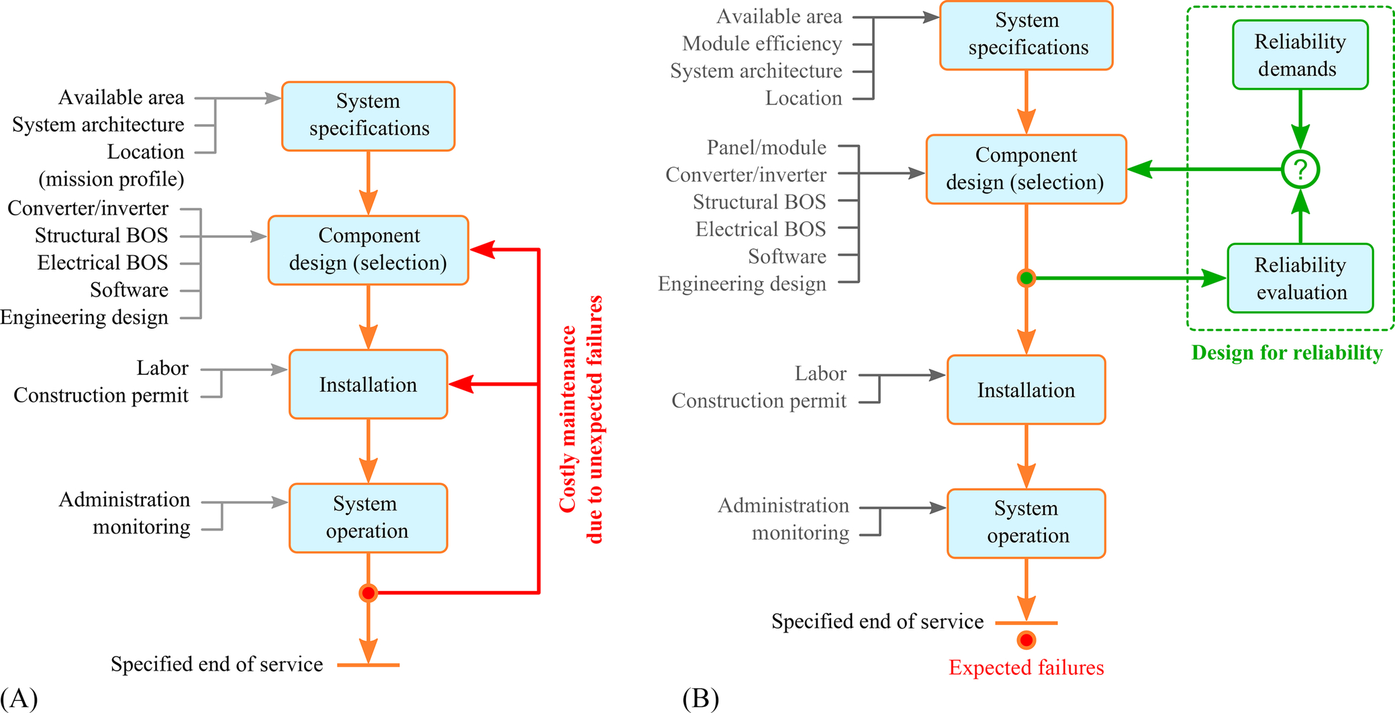

**FIG. 45.14** Factors considered in the design and operation phases of power electronic systems (e.g., PV systems; balance of system (BOS)): (A) conventional design and (B) with reliability demands.

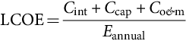 **(45.1)**

where *C*int is the initial development cost, *C*cap represents the capital cost, *C*o&m indicates the operational and maintenance cost, and *E*annual denotes the average annual energy production in the lifetime cycle of the system. More specifically, a power electronic system of high reliability will reduce the cost for operational and maintenance and also increase the service time (i.e., more energy production). Eventually, the cost of energy is lowered.

In order to lower the unscheduled maintenance cost, potential failures should be anticipated as early as possible and input into the design flow. This initiates a more promising solution to improving the reliability of power electronic systems, as shown in [Fig. 45.14B](https://learning.oreilly.com/library/view/power-electronics-handbook/9780128114087/B9780128114070000519.xhtml#f0075), being the DfR approach. The inclusion of reliability enables a quick identification of design flaws or weakness and thus feeds back to the design for corrections (e.g., reselection of components). After a few iterations, the reliability demands can be fulfilled before the installation/construction of the power electronic system. As a consequence, significant cost reduction in the design phase and shorter development cycles can be attained while also targeting for higher reliability. Clearly, the failures or downtimes of the designed power electronic systems are predictable, demonstrated in [Fig. 45.14B](https://learning.oreilly.com/library/view/power-electronics-handbook/9780128114087/B9780128114070000519.xhtml#f0075).

It should be pointed out that the reliability prediction is the first task for the DfR process, and it involves in multiple disciplines from the PoF point of view. [Fig. 45.15](https://learning.oreilly.com/library/view/power-electronics-handbook/9780128114087/B9780128114070000519.xhtml#f0080) depicts the detailed reliability evaluation process of the DfR approach, which shows that the reliability analysis has three major tasks:

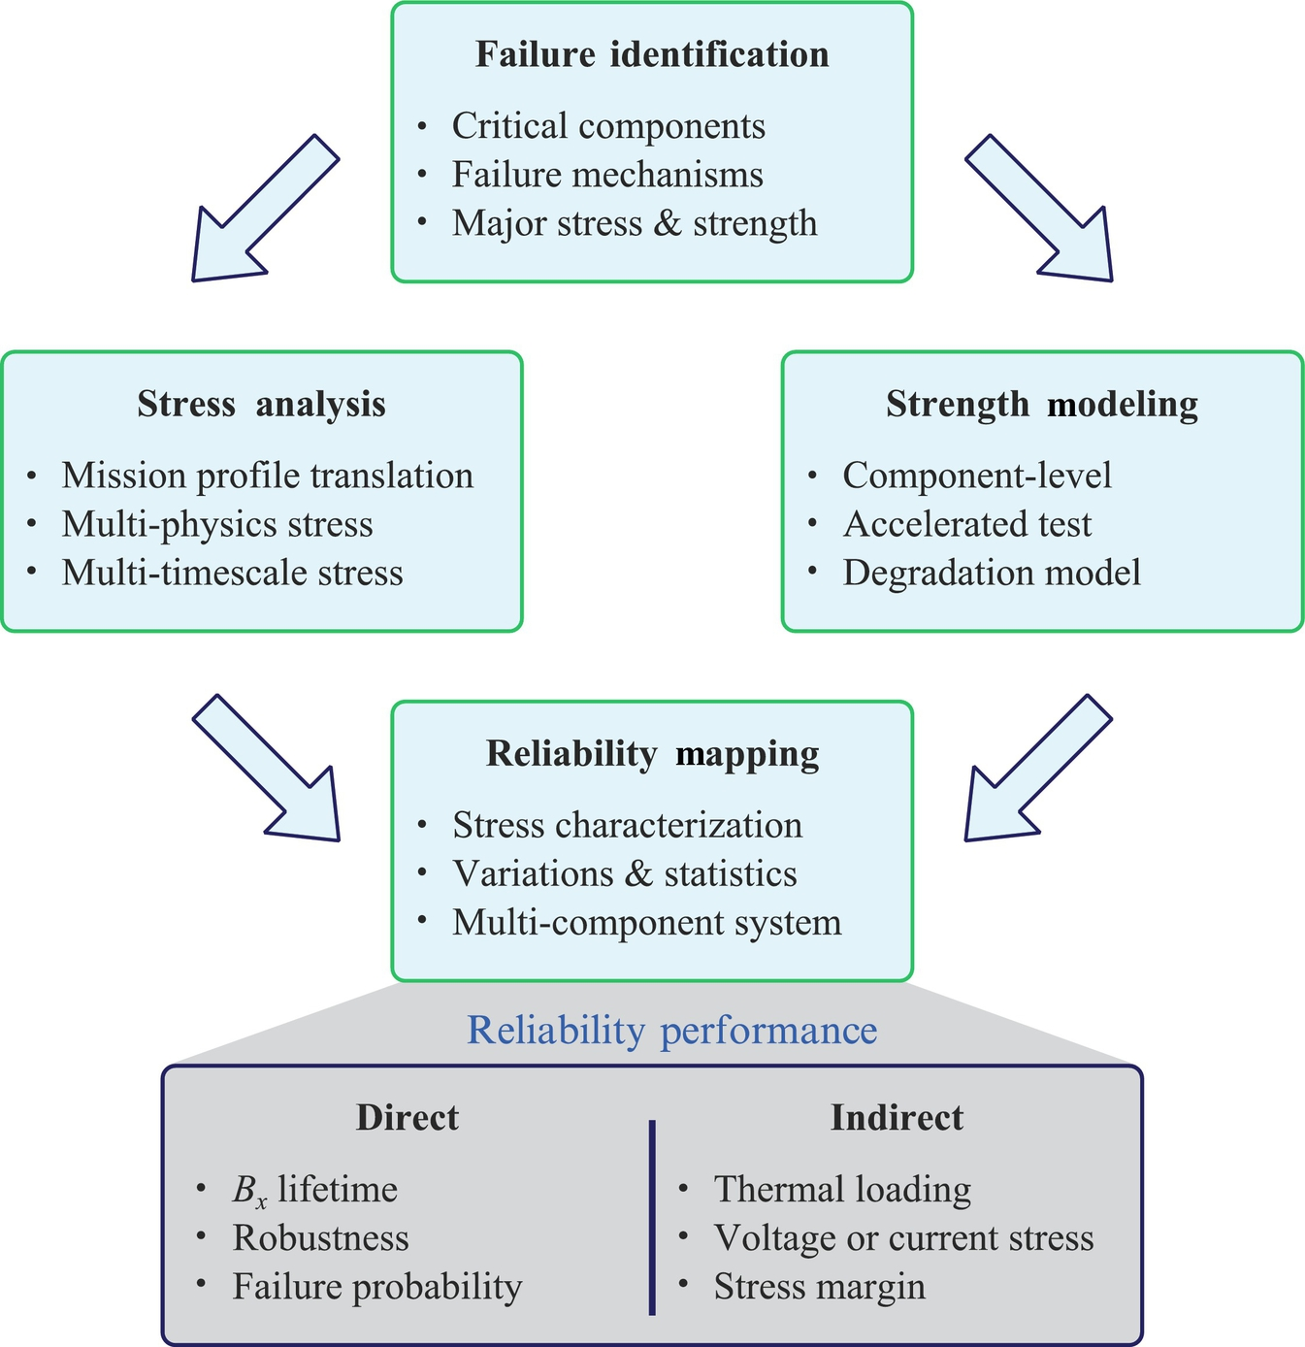

**FIG. 45.15** Reliability prediction process of the design for reliability (DfR) approach for power electronic systems, where the *Bx* lifetime indicates the time by which *x* percent of a population of the evaluated system will have failed.

• Failure identification

• Stress analysis and strength modeling

• Reliability mapping.

More specifically, the critical components and the major failure mechanisms of power electronics are identified through physics analysis and real-field experience. Accordingly, the corresponding stresses and the ability of power electronic components to withstand the stresses are tested and modeled. Finally, counting algorithms and statistical distributions are adopted to map the stress and strength information to the reliability metrics of the power electronic system. The reliability indicators can be direct performances like the *Bx* lifetime, robustness, and failure probability or indirect performances [[24](https://learning.oreilly.com/library/view/power-electronics-handbook/9780128114087/B9780128114070000519.xhtml#bb0125)]. Here, the *Bx* lifetime indicates the time by which *x* percent of a population of the system under study will have failed.

For a specific power electronic system, the DfR approach included in the [Fig. 45.14](https://learning.oreilly.com/library/view/power-electronics-handbook/9780128114087/B9780128114070000519.xhtml#f0075) and the reliability predication process detailed in [Fig. 45.15](https://learning.oreilly.com/library/view/power-electronics-handbook/9780128114087/B9780128114070000519.xhtml#f0080) enable analyzing the power converter candidates in terms of reliability. Here, the failure mechanisms have to be identified first. As discussed in [[20](https://learning.oreilly.com/library/view/power-electronics-handbook/9780128114087/B9780128114070000519.xhtml#bb0105)], for power electronic converters, the major failures are related to the temperature in power devices. Nevertheless, on condition that the failure mechanisms are identified, it is possible to directly translate mission profiles into thermal loading on the power electronic components of the selected candidates. As a result, the reliability is obtained and can be compared with the demand. The process is further summarized as follows:

• Mission profile translation

• Thermal loading interpretation

• Lifetime model of power devices

• Monte Carlo reliability assessment

• System-level reliability analysis

which is also discussed in detail in the following.

### 45.3.1 MISSION PROFILE TRANSLATION

In the DfR approach, the knowledge of the power converter operating conditions during the entire operation is essential [[20](https://learning.oreilly.com/library/view/power-electronics-handbook/9780128114087/B9780128114070000519.xhtml#bb0105),[51](https://learning.oreilly.com/library/view/power-electronics-handbook/9780128114087/B9780128114070000519.xhtml#bb0260)]. In this respect, a mission profile of the power electronic converters, which represents the operating condition of the system, is needed. Then, the mission profiles have to be translated into thermal loading of power electronic systems (e.g., junction temperature variations of the devices), which can be done in the following way.

Once the mission profiles are obtained, the power production of the power electronic system can be estimated considering the electrical characteristic model. Taking into account the conversion efficiency, the power losses dissipated in the power devices can be estimated. Notably, this loss calculation is usually implemented with a lookup table (LUT), in order to assist the long-term simulation (e.g., an annual mission profile). In that case, the power losses are calculated for a certain set of operating conditions (e.g., the input power from 0 to 100% of the rated power), and the power losses under other operating conditions can be interpolated from the constructed LUT. Then, the thermal model of the power devices in the power electronic converter is required in order to obtain the device junction temperature loading.

### 45.3.2 THERMAL LOADING INTERPRETATION

By applying the previous process, the junction temperature of the power electronic device *Tj* under a specific mission profile can be obtained. However, the device junction temperature is usually an irregular loading profile, due to the dynamics of mission profiles (e.g., the solar irradiance and ambient temperature for PV power systems). Thus, a cycle-counting algorithm such as a rainflow analysis is usually employed, in order to divide the irregular thermal loading cycle into several regular thermal loading cycles [[52](https://learning.oreilly.com/library/view/power-electronics-handbook/9780128114087/B9780128114070000519.xhtml#bb0265)]. By doing so, the information such as the mean junction temperature *Tjm*, the cycle amplitude Δ*Tj*, and the cycle period *t*on can be obtained, which can then be applied to the lifetime (degradation) model of the selected power electronic devices of the converter candidates.

### 45.3.3 LIFETIME MODEL OF POWER DEVICES

Any component in a power electronic system (e.g., power semiconductors and capacitors) can cause failures of the entire system. In that regard, it leads to a complicated analysis, as the components may have a cross effect of the reliability on each other. For simplicity, only the temperature-related failure mechanisms of the power device are considered. In fact, the power device has been reported as one of the most critical components in power electronic systems [[15](https://learning.oreilly.com/library/view/power-electronics-handbook/9780128114087/B9780128114070000519.xhtml#bb0080),[16](https://learning.oreilly.com/library/view/power-electronics-handbook/9780128114087/B9780128114070000519.xhtml#bb0085)]. Hence, it is a natural thought to consider temperature-related lifetime models [[53](https://learning.oreilly.com/library/view/power-electronics-handbook/9780128114087/B9780128114070000519.xhtml#bb0270),[54](https://learning.oreilly.com/library/view/power-electronics-handbook/9780128114087/B9780128114070000519.xhtml#bb0275)].

Normally, the lifetime of the power device is expressed by considering the life consumption (LC), which indicates how much life of the device has been consumed (or damaged) during operations. The LC is calculated by using the Miner's rule as [[52](https://learning.oreilly.com/library/view/power-electronics-handbook/9780128114087/B9780128114070000519.xhtml#bb0265)]

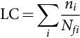 **(45.2)**

where *ni* is the number of cycles (obtained from the thermal loading interpretation) for a certain *Tjm*, Δ*Tj*, and *t*on, and *Nfi* is the number of cycles to failure calculated at that specific stress condition. For instance, if the number of cycles *n*i is counted from an annual mission profile, the LC calculated in [(45.2)](https://learning.oreilly.com/library/view/power-electronics-handbook/9780128114087/B9780128114070000519.xhtml#fo0015) will represent a yearly LC of the power device. When the LC accumulates to unity, the power electronic device is considered to reach its end of life, and the lifetime for the single power electronic device is predicted.

### 45.3.4 MONTE CARLO RELIABILITY ASSESSMENT

Actually, the lifetime prediction of the power device obtained from [(45.2)](https://learning.oreilly.com/library/view/power-electronics-handbook/9780128114087/B9780128114070000519.xhtml#fo0015) can be taken as an ideal case, where all the power devices fail at the same rate. In reality, there are uncertainties in the time to failure of the power devices, mainly introduced by parametric variations in the lifetime model and changes in the stresses. Therefore, it is more common to express the lifetime prediction in terms of statistical values (e.g., using the probability of failures), rather than the fixed values. In order to do so, a Monte Carlo analysis should be performed, which is aimed to introduce variations in the system parameters, and simulate the result with a large number of samples. With the large enough number of samples, the results will converge to the expected value.

This approach can be employed for estimating the power devices lifetime [[55](https://learning.oreilly.com/library/view/power-electronics-handbook/9780128114087/B9780128114070000519.xhtml#bb0280)–[57](https://learning.oreilly.com/library/view/power-electronics-handbook/9780128114087/B9780128114070000519.xhtml#bb0290)]. In this method, all the parameters in the lifetime model have to be modeled by a distribution function with a certain range of variations. Then, following the Monte Carlo simulation approach, a certain number of samples from each parametric distribution are randomly taken to calculate the lifetime of the power electronic device. Accordingly, a set of results is obtained, which can then be represented with a certain distribution function (e.g., Weibull distribution) [[58](https://learning.oreilly.com/library/view/power-electronics-handbook/9780128114087/B9780128114070000519.xhtml#bb0295)]. The probability density function (PDF) of this lifetime prediction result is usually referred to as a lifetime distribution (failure distribution) *f*(*x*), while its cumulative distribution function (CDF) is considered as an unreliability function *F*(*x*). Eventually, the *Bx* lifetime can be obtained from the unreliability function of the power electronic device.

### 45.3.5 SYSTEM-LEVEL RELIABILITY ANALYSIS

A power electronic system usually has many power devices, and each power electronic device has its own unreliability function *F*(*x*). In order to perform the system-level reliability assessment, the reliability block diagram of the entire system should be constructed [[16](https://learning.oreilly.com/library/view/power-electronics-handbook/9780128114087/B9780128114070000519.xhtml#bb0085)]. The reliability block diagram represents how the reliability of components in the system interacts with each other. For a system with *n* components and the entire power electronic system cannot function if any of the *n* components fails, the total unreliability of system *F*tot(*x*) can be calculated as

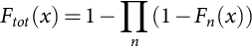 **(45.3)**

where *Fn*(*x*) is the unreliability function of the *n-*th component. Once the total unreliability function of the inverter system *F*tot(*x*) is obtained, the *Bx* lifetime of the entire power electronic system can be estimated in a similar way as it has been done for a single power electronic component. However, it should be pointed out that the system-level reliability analysis approach (i.e., the reliability block diagram) can be applied to any power electronic system. For different converter topologies, the reliability block diagram may be different from [(45.3)](https://learning.oreilly.com/library/view/power-electronics-handbook/9780128114087/B9780128114070000519.xhtml#fo0020), depending on the number of power devices and their operational principles.

Following the above steps, the reliability of a power electronic system can be predicted, and then, it can be compared with the design target (i.e., the reliability demand). This DfR flow especially includes the reliability in the design and thus avoids slow and expensive feedbacks or iterations. From this standpoint, the DfR approach can significantly accelerate the power electronic system design, while maintaining lower design costs and also better reliable products.

## 45.4 Case Study

In the DfR approach, the reliability target (i.e., the reliability demand) has to be specified at the beginning of the design phase, as shown in [Fig. 45.14B](https://learning.oreilly.com/library/view/power-electronics-handbook/9780128114087/B9780128114070000519.xhtml#f0075). The reliability target is considered as a design objective, which should be fulfilled in the end of the design process. Following the diagram in [Fig. 45.14B](https://learning.oreilly.com/library/view/power-electronics-handbook/9780128114087/B9780128114070000519.xhtml#f0075), the DfR approach is demonstrated on a single-phase 6 -kW PV power system referring to [Fig. 45.7](https://learning.oreilly.com/library/view/power-electronics-handbook/9780128114087/B9780128114070000519.xhtml#f0040). To recap, the entire DfR flow for the PV power electronic system is represented in [Fig. 45.16](https://learning.oreilly.com/library/view/power-electronics-handbook/9780128114087/B9780128114070000519.xhtml#f0085). As the PV power production is mainly affected by the solar irradiance level and the ambient temperature conditions, these two parameters are considered as the mission profile of the PV power electronic system, as also shown in [Fig. 45.16](https://learning.oreilly.com/library/view/power-electronics-handbook/9780128114087/B9780128114070000519.xhtml#f0085). In the case study, the mission profiles in [Figs. 45.11](https://learning.oreilly.com/library/view/power-electronics-handbook/9780128114087/B9780128114070000519.xhtml#f0060) and [45.12](https://learning.oreilly.com/library/view/power-electronics-handbook/9780128114087/B9780128114070000519.xhtml#f0065) are adopted. The targeted lifetime for the power electronic system is above 25 years. Three power electronic devices with the rated current of 15, 30, and 50 A from leading manufacturers are selected for comparison.

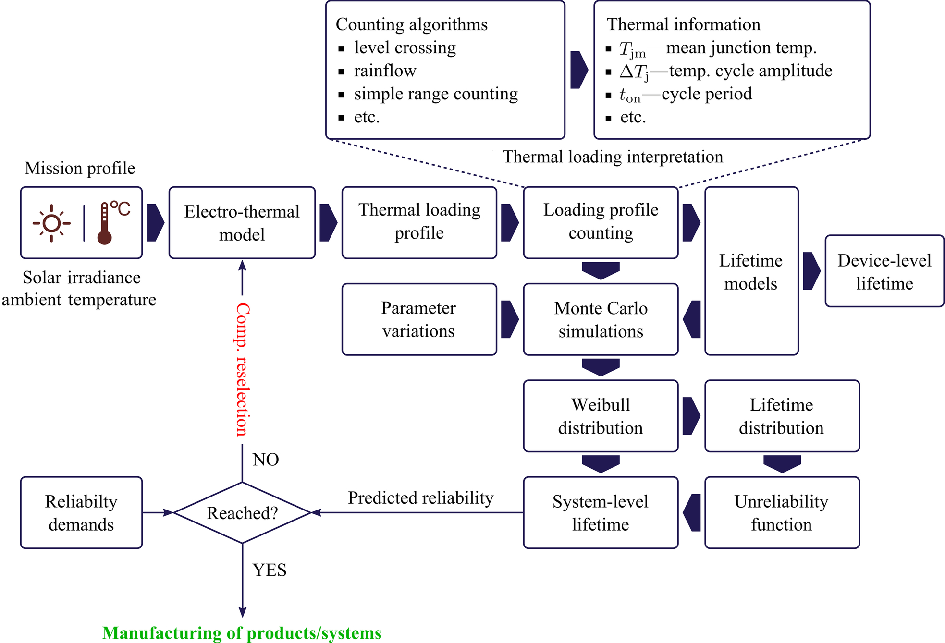

**FIG. 45.16** Complete DfR structure for the power electronic systems in PV applications.

### 45.4.1 MISSION PROFILE TRANSLATION

From the given mission profile, the PV power production (*P*pv) can be determined by using the PV panel electrical characteristic model. Then, the actual input power seen by the PV inverter (*P*in) is obtained by taking the MPPT algorithm efficiency (*η*MPPT) into account. In order to estimate the power losses in the power devices (*P*loss), a PV inverter loss model is employed. This can be obtained by considering the switching losses and conduction losses of the power devices in the inverter. After that, the thermal model of the power devices can be applied in order to obtain the junction temperature profile of the power devices (*Tj*) during the entire operation, which is implemented by using an LUT, as mentioned previously, in order to enable a long-term mission profile translation (e.g., yearly mission profiles) [[59](https://learning.oreilly.com/library/view/power-electronics-handbook/9780128114087/B9780128114070000519.xhtml#bb0300)]. [Fig. 45.17](https://learning.oreilly.com/library/view/power-electronics-handbook/9780128114087/B9780128114070000519.xhtml#f0090) summarizes the above process.

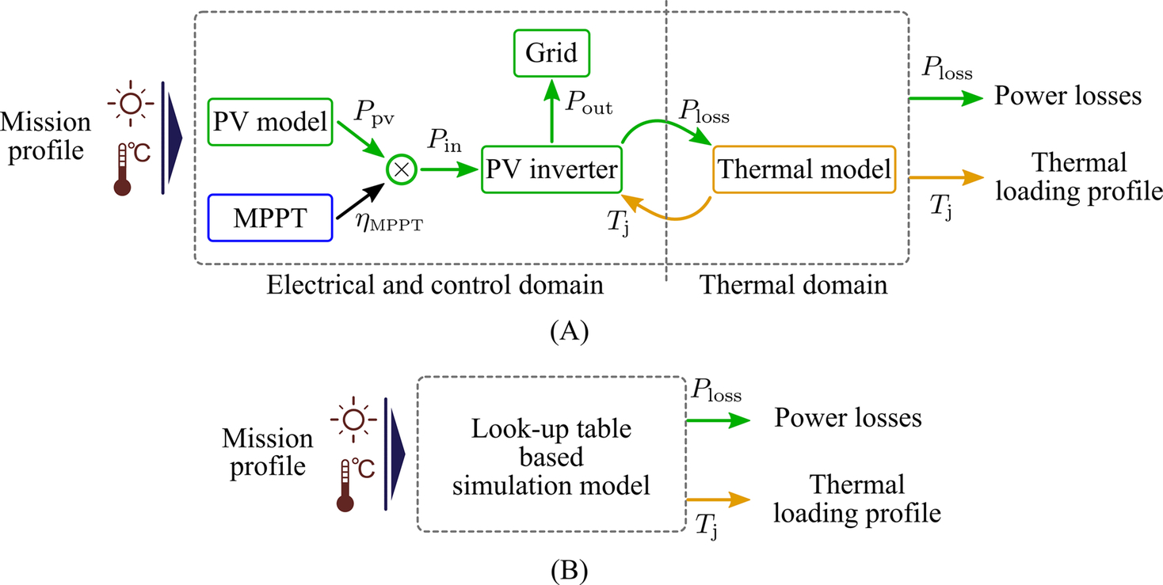

**FIG. 45.17** Mission profile translation to power losses *P*loss and thermal loading *Tj*: (A) for short-term mission profiles and (B) for long-term mission profiles.

As an example (for the 600 V/30 A device), one of the translated thermal loading profiles under the mission profile ([Figs. 45.11](https://learning.oreilly.com/library/view/power-electronics-handbook/9780128114087/B9780128114070000519.xhtml#f0060) and [45.12](https://learning.oreilly.com/library/view/power-electronics-handbook/9780128114087/B9780128114070000519.xhtml#f0065)) is shown in [Fig. 45.18](https://learning.oreilly.com/library/view/power-electronics-handbook/9780128114087/B9780128114070000519.xhtml#f0095). The cycle amplitude (△*Tj*) and the mean junction temperature (*Tjm*) are presented in [Fig. 45.18A and B](https://learning.oreilly.com/library/view/power-electronics-handbook/9780128114087/B9780128114070000519.xhtml#f0095), respectively. The impact of the mission profile can be observed in [Fig. 45.18](https://learning.oreilly.com/library/view/power-electronics-handbook/9780128114087/B9780128114070000519.xhtml#f0095) from the thermal loading of the power device, where the cycle amplitude profile follows the variation in the solar irradiance profile (i.e., part of the mission profile). The long-term variation in the mean junction temperature has the similar tendency as the ambient temperature profile in [Fig. 45.12](https://learning.oreilly.com/library/view/power-electronics-handbook/9780128114087/B9780128114070000519.xhtml#f0065) with a short-term variation imposed by the variation in the solar irradiance profile in [Fig. 45.11](https://learning.oreilly.com/library/view/power-electronics-handbook/9780128114087/B9780128114070000519.xhtml#f0060).

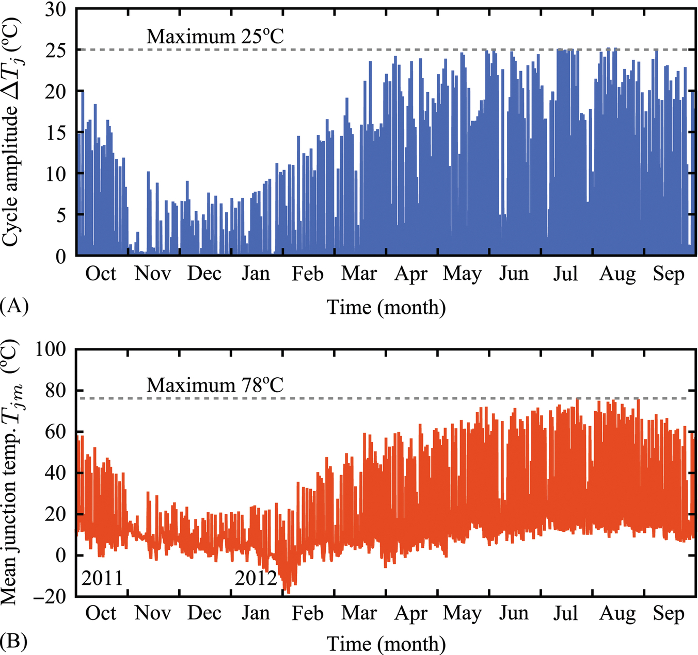

**FIG. 45.18** Thermal loading of the power device in the single-phase full-bridge PV inverter under a yearly mission profile: (A) cycle amplitude and (B) mean junction temperature.

### 45.4.2 THERMAL LOADING INTERPRETATION

The junction temperature profile shown in [Fig. 45.18](https://learning.oreilly.com/library/view/power-electronics-handbook/9780128114087/B9780128114070000519.xhtml#f0095) reflects the impact of mission profiles on the thermal loading of the power electronic system. However, it provides limited qualitative information about the thermal loading of the power devices, as the cycle amplitude (△*Tj*) and the mean value of the junction temperature (*Tjm*) are an irregular profile due to the mission profile dynamics. In other words, it cannot be directly applied to an empirical lifetime model. Thus, a cycle-counting algorithm such as rainflow analysis is normally employed in order to divide the irregular profile into several regular thermal cycles [[52](https://learning.oreilly.com/library/view/power-electronics-handbook/9780128114087/B9780128114070000519.xhtml#bb0265)]. With this analysis, the qualitative information such as the number of cycles *ni* at a certain cycle amplitude *△Tj*, mean junction temperature *Tjm*, and cycle period *t*on can be obtained and applied to the lifetime model. Details of the rainflow algorithm can be found in [[30](https://learning.oreilly.com/library/view/power-electronics-handbook/9780128114087/B9780128114070000519.xhtml#bb0155),[60](https://learning.oreilly.com/library/view/power-electronics-handbook/9780128114087/B9780128114070000519.xhtml#bb0305),[61](https://learning.oreilly.com/library/view/power-electronics-handbook/9780128114087/B9780128114070000519.xhtml#bb0310)].

### 45.4.3 LIFETIME MODEL OF POWER DEVICES

The lifetime model of the interested power component is required for the lifetime prediction. In the case study, the lifetime of the power electronic systems (devices) is considered. Several lifetime models of the power electronic devices, components, or modules have been developed. A recently developed IGBT lifetime model that considers the thermal cycle period *t*on is adopted [[53](https://learning.oreilly.com/library/view/power-electronics-handbook/9780128114087/B9780128114070000519.xhtml#bb0270)], and it is expressed as

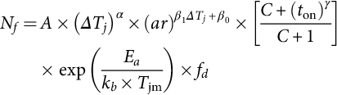 **(45.4)**

where *Nf*, *△Tj*, *Tjm*, and *t*on are defined previously. The other parameters are constants that are given in [Table 45.1](https://learning.oreilly.com/library/view/power-electronics-handbook/9780128114087/B9780128114070000519.xhtml#t0010). Using the interpreted thermal loading information and [(45.4)](https://learning.oreilly.com/library/view/power-electronics-handbook/9780128114087/B9780128114070000519.xhtml#fo0025), the LC of the power electronic components can be obtained according to [(45.2)](https://learning.oreilly.com/library/view/power-electronics-handbook/9780128114087/B9780128114070000519.xhtml#fo0015). When the LC is accumulated to unity, the power electronic device reaches its end of life, as mentioned previously.

**Table 45.1**

**Parameters of the lifetime model of an IGBT module [**[**53**](https://learning.oreilly.com/library/view/power-electronics-handbook/9780128114087/B9780128114070000519.xhtml#bb0270)**]**

|  |  |  |
| --- | --- | --- |
| **Parameter** | **Value** | **Experimental Condition** |
| *A* | 3.4368×1014 |  |
| *α* | −4.923 | 64≤*△Tj*≤113 K |
| *β*1 | −9.012×10−3 |  |
| *β*0 | 1.942 | 0.19≤*ar*≤0.42 |
| *C* | 1.434 |  |
| *γ* | −1.208 | 0.07≤*t*on≤63 s |
| *fd* | 0.6204 |  |
| *Ea* | 0.06606 eV | 32.5≤*Tj*≤122 °C |
| *kB* | 8.6173324×10−5 eV/K |  |

### 45.4.4 MONTE CARLO RELIABILITY ASSESSMENT

The reliability metric is usually expressed in terms of statistical values, rather than a fixed value obtained previously, due to the uncertainties in the lifetime prediction. The uncertainties can be introduced by the component-parametric variations (e.g., due to the manufacturing process), lifetime- parametric variations (e.g., due to the test data), and variations in the stresses (e.g., variations in the PV power production due to the PV panel aging). In order to include the impact of those uncertainties into the lifetime prediction, a Monte Carlo analysis is employed [[26](https://learning.oreilly.com/library/view/power-electronics-handbook/9780128114087/B9780128114070000519.xhtml#bb0135),[62](https://learning.oreilly.com/library/view/power-electronics-handbook/9780128114087/B9780128114070000519.xhtml#bb0315)], according to the flow shown in [Fig. 45.16](https://learning.oreilly.com/library/view/power-electronics-handbook/9780128114087/B9780128114070000519.xhtml#f0085).

In the Monte Carlo analysis, variations are introduced to the lifetime model of [(45.4)](https://learning.oreilly.com/library/view/power-electronics-handbook/9780128114087/B9780128114070000519.xhtml#fo0025) and also the stressors, where the parameters can be modeled with a certain distribution function (e.g., a normal distribution), as illustrated in [Fig. 45.19](https://learning.oreilly.com/library/view/power-electronics-handbook/9780128114087/B9780128114070000519.xhtml#f0100). Following the Monte Carlo approach, a large set of populations are taken randomly from the distribution in [Fig. 45.19](https://learning.oreilly.com/library/view/power-electronics-handbook/9780128114087/B9780128114070000519.xhtml#f0100) and applied to the lifetime model. Therefore, the lifetime distribution (or time-to-failure distribution) can be obtained and fitted with a specific distribution function. Normally, the lifetime distribution of the wear-out failure follows the Weibull distribution, and the Weibull probability density function (Weibull PDF) is shown in [Fig. 45.20A](https://learning.oreilly.com/library/view/power-electronics-handbook/9780128114087/B9780128114070000519.xhtml#f0105). Notably, it is also possible to analyze the influence of an individual parametric variation by using the sensitivity study. This can be used for identifying the crucial parameter that limits the lifetime of the component (which may be redesigned). For instance, a controlled cooling unit may be required, if the lifetime is sensitive to the mean junction temperature.

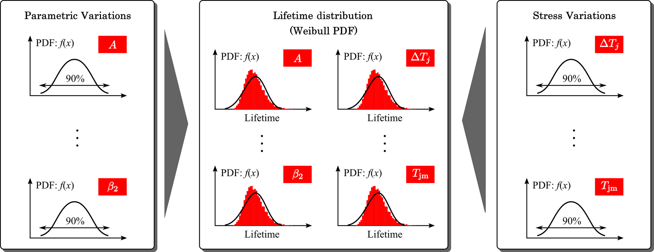

**FIG. 45.19** Sensitivity analysis of the parametric variations by using the Monte Carlo analysis (probability density function (PDF)).

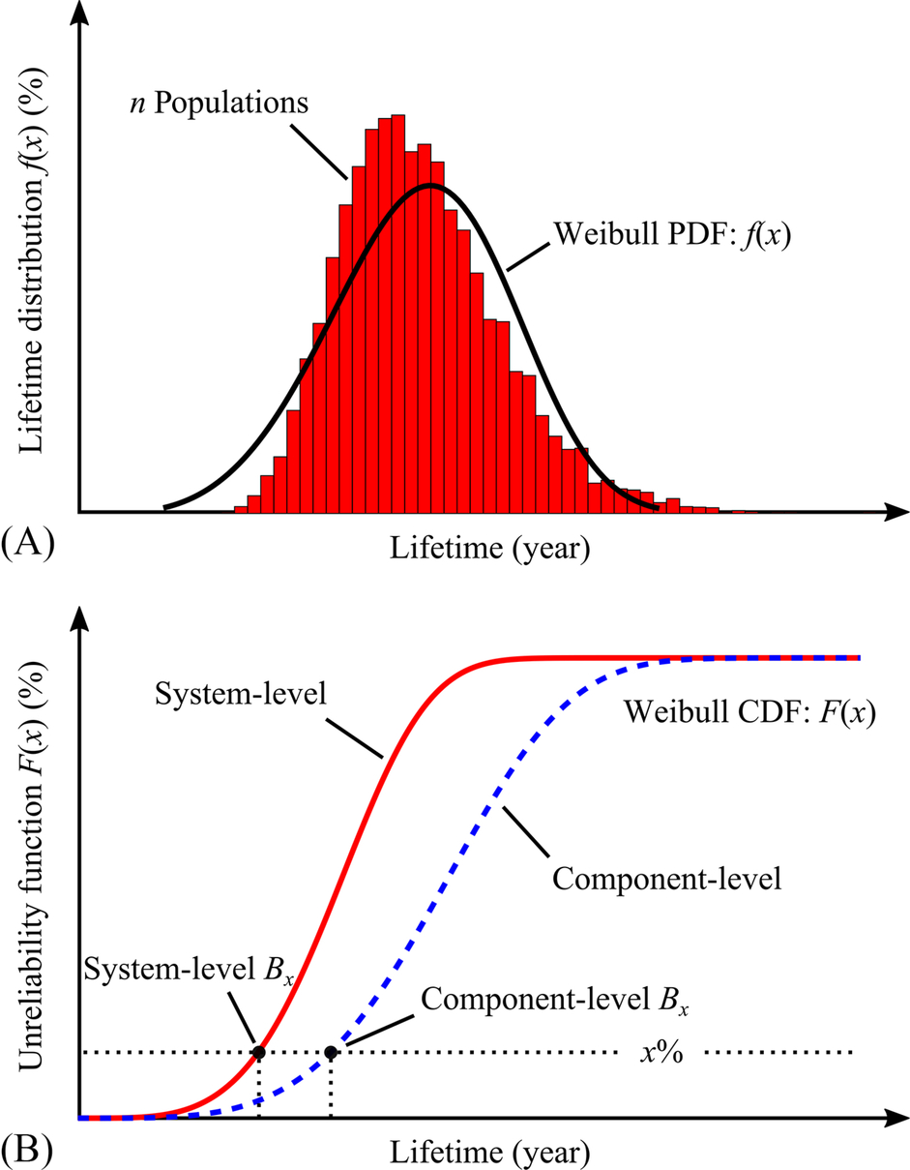

**FIG. 45.20** Results from the Monte Carlo simulation (probability density function (PDF) and cumulative distribution function (CDF)): (A) lifetime distribution of one single power device (i.e., the Weibull PDF) with *n* populations and (B) unreliability function (i.e., the Weibull CDF) of one single power device (component level) and full-bridge inverter with four power devices (system level).

From the lifetime distribution (i.e., the Weibull PDF), the reliability of one single power device (e.g., component level) can be determined by considering the CDF of the lifetime distribution. The Weibull CDF distribution (Weibull CDF) shown in [Fig. 45.20B](https://learning.oreilly.com/library/view/power-electronics-handbook/9780128114087/B9780128114070000519.xhtml#f0105) is referred to as the unreliability function, as it represents the percentage of failure population overtime. The *Bx* lifetime can be obtained from the unreliability function. For instance, the *B*1 and *B*10 lifetime of the power device, which indicates the time when 1% and 10% of the population have failed, are the commonly used reliability metrics.

### 45.4.5 SYSTEM-LEVEL RELIABILITY ANALYSIS

In many cases, the system under consideration consists of several components, where each component has its own unreliability function. The *Bx* lifetime of one single component may not accurately reflect the *Bx* lifetime of the overall power electronic system. Thus, the system-level reliability assessment is performed using the reliability block diagram. For the full-bridge PV inverter shown in [Fig. 45.7](https://learning.oreilly.com/library/view/power-electronics-handbook/9780128114087/B9780128114070000519.xhtml#f0040), the system-level reliability block diagram consists of a series connection of four components, as the failure of any power device (e.g., *S*1, *S*2, *S*3, or *S*4) will lead to the loss of functionality of the entire power electronic system. Thus, according to [(45.3)](https://learning.oreilly.com/library/view/power-electronics-handbook/9780128114087/B9780128114070000519.xhtml#fo0020), the system-level unreliability function can be calculated as

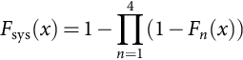 **(45.5)**

where *F*sys(*x*) is the system-level unreliability function and *Fn*(*x*) is the component-level unreliability function of the *n*-th component. The system-level unreliability function of the PV inverter (e.g., four devices) is shown in [Fig. 45.20B](https://learning.oreilly.com/library/view/power-electronics-handbook/9780128114087/B9780128114070000519.xhtml#f0105), where it can be noticed that the system-level unreliability is in general higher than the component-level unreliability (i.e., *F*sys(*x*)≥*Fn*(*x*)), resulting in the lower *Bx* lifetime for the system level.

### 45.4.6 DESIGN FOR RELIABILITY (DFR) RESULTS

The reliability analysis is carried out with three selected power devices following the above. As specified in the reliability target, the system-level lifetime of the PV power electronic system should be higher than 25 years. This is the benchmark for selecting the most suitable power electronic device among the three candidates. The DfR results are shown in [Fig. 45.21](https://learning.oreilly.com/library/view/power-electronics-handbook/9780128114087/B9780128114070000519.xhtml#f0110). The lifetime distribution of each device obtained from the Monte Carlo analysis is shown in [Fig. 45.21A](https://learning.oreilly.com/library/view/power-electronics-handbook/9780128114087/B9780128114070000519.xhtml#f0110), where it can be seen that the lifetime distribution of the three power electronic devices shows significant difference. A majority of the population with the 15-A power devices fail after 10 years of operation, while most of the population with the 30- and 50-A power devices can survive after 100 and 250 years of operation, respectively. However, it should be noted that in such cases other parameters will determine the lifetime. Additionally, the ratings of the two devices are over designed compared with the rating of the system under study (i.e., 6-kW). Both lead to the relatively long lifetime.

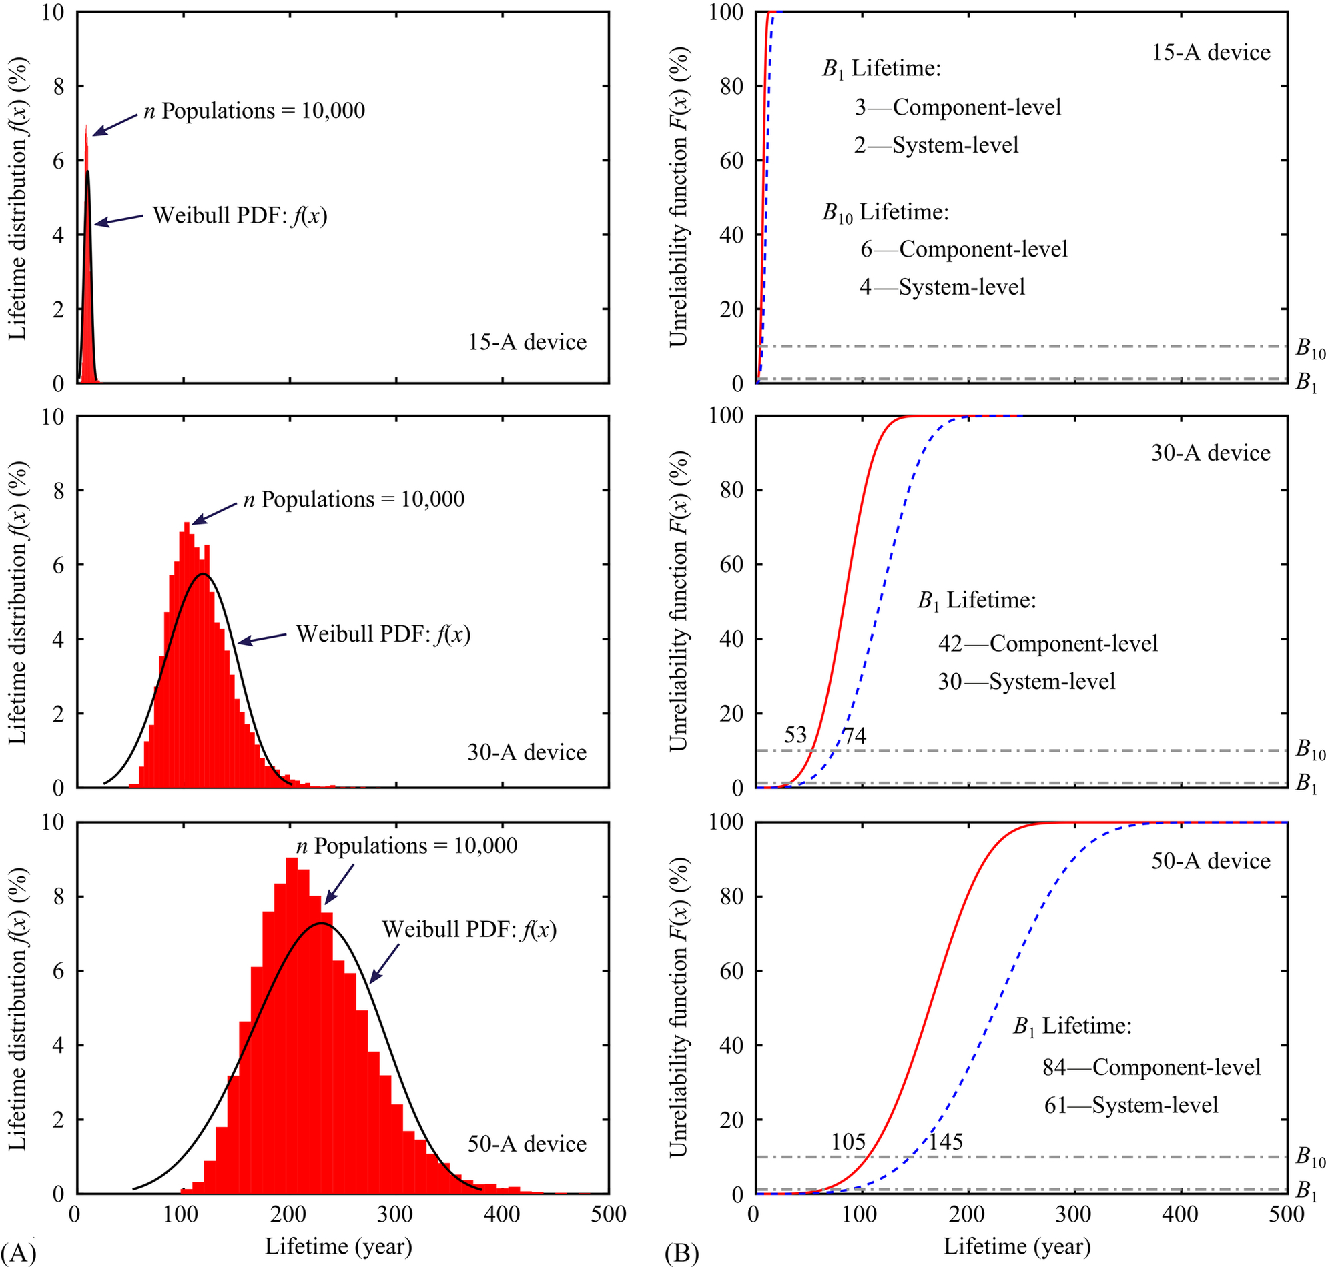

**FIG. 45.21** Design for reliability (DfR) results of the power electronic system for single-phase PV applications obtained from the Monte Carlo simulation with 10,000 populations: (A) lifetime distribution of one single power device (i.e., the Weibull PDF function) and (B) unreliability function (i.e., the Weibull CDF function) of one single power device (component level) and full-bridge inverter with four power devices (system level). Note that there are other factors leading to the so long lifetime.

Based on the lifetime distribution in [Fig. 45.21A](https://learning.oreilly.com/library/view/power-electronics-handbook/9780128114087/B9780128114070000519.xhtml#f0110), the unreliability function can be obtained, as it is shown in [Fig. 45.21B](https://learning.oreilly.com/library/view/power-electronics-handbook/9780128114087/B9780128114070000519.xhtml#f0110), where the *Bx* lifetime is also indicated. For example, it can be seen from [Fig. 45.21B](https://learning.oreilly.com/library/view/power-electronics-handbook/9780128114087/B9780128114070000519.xhtml#f0110) that the system-level *B*1 lifetime of the PV inverter is 2 years if the 15-A power devices are selected. This means that the power electronic system with 15-A power devices did not meet the reliability target of 25 years under the given mission profile. On the other hand, the PV inverter with 30- and 50-A power devices has the system-level *B*1 lifetime of 30 and 61 years, respectively. Therefore, either the 30- or 50-A power device can be used in the full-bridge power electronic system that fulfills the reliability target. In most cases, the cost of the power devices with the current rating of 30 A will be lower than that of the 50-A power devices. Thus, the 30-A power electronic device is considered to be the most suitable candidate to be used in the PV power system in order to achieve the system-level *B*1 lifetime higher than 25 years. However, it is also worth mentioning that the predicted lifetime is relatively long, since there are many other factors influencing the reliability. In this case study, only the failure mechanism related the junction temperature is considered. To improve the reliability prediction, more failure mechanisms as well as possible coupling effects should be taken into account. It in return may make the analysis become more complicated. Nevertheless, the above demonstrates a way to lifetime prediction, and thus enables the DfR in power electronic systems.

## 45.5 Summary

The reliability demands for power electronic systems have been identified in this chapter. The state of the art in power electronic converters for wind and PV power systems have been briefly reviewed, from which it is known that the power electronic systems play a vital role in the power conversion. The conventional design of power electronic systems focuses on power density and efficiency. However, the power electronic system is also one of the most life-limiting parts, and thus, the reliability should be included in the design phase, being the design for reliability (DfR) approach, as demonstrated in this chapter. Multidisciplinary efforts in component physics, reliability engineering, system engineering, and power electronics are necessary to implement the DfR approach. Many challenges still exit in mission profile modeling, lifetime modeling, reliability data in software, human errors, single-event catastrophic failures, and reliability-oriented design tools as discussed in [[20](https://learning.oreilly.com/library/view/power-electronics-handbook/9780128114087/B9780128114070000519.xhtml#bb0105)]. Other relevant studies related to this chapter have been collectively presented in [[63](https://learning.oreilly.com/library/view/power-electronics-handbook/9780128114087/B9780128114070000519.xhtml#bb0320)], which provides an overview of the recent advancements in the area of reliability of power electronic converter systems and also reliability testing.

## References

[1] International Renewable Energy Agency (IRENA). 2016. Renewable capacity statistics 2016. Tech. Rep., pp. 1–56, Apr. 2016. Last retrieved on Nov. 26, 2016. [Online]. Available: <http://www.irena.org/DocumentDownloads/Publications/IRENA_RE_Capacity_Statistics_2016.pdf>.

[2] Blaabjerg F., Ionel D.M., Yang Y., Wang H. Renewable energy systems technology overview and perspectives. In: Blaabjerg F., Ionel D., eds. *Renewable Energy Devices and Systems with Simulations in MATLAB and ANSYS.* CRC Press LLC; 2017:1–16 Chapter 1.

[3] Blaabjerg F., Ma K., Yang Y. Power electronics—the key technology for renewable energy systems. In: *Proceedings of EVER.* 2014:1–11.

[4] Carrasco J.M., Franquelo L.G., Bialasiewicz J.T., Galvan E., Portillo Guisado R.C., Prats M.A.M., Leon J.I., Moreno-Alfonso N. Power-electronic systems for the grid integration of renewable energy sources: a survey. *IEEE Trans. Ind. Electron.* 2006;53(4):1002–1016.

[4a] Blaabjerg F., Chen Z., Kjaer S.B. Power electronics as efficient interface in dispersed power generation systems. *IEEE Trans. Power Electron.* 2004;19(5):1184–1194.

[5] van Wyk J.D., Lee F.C. On a future for power electronics. *IEEE J. Emerg. Sel. Top. Power Electron.* 2013;1(2):59–72.

[6] Balda J.C., Mantooth A. Power-semiconductor devices and components for new power converter developments: a key enabler for ultrahigh efficiency power electronics. *IEEE Power Electron. Mag.* 2016;3(2):53–56.

[7] Kasper M., Bortis D., Deboy G., W. Kolar J. Design of a highly efficient (97.7%) and very compact (2.2 kW/dm3) isolated AC-DC telecom power supply module based on the multi-cell ISOP converter approach. *IEEE Trans. Power Electron.* 2017;32(10):7750–7769.

[8] D. Bortis, D. Neumayr, J.W. Kolar, ηρ-Pareto optimization and comparative evaluation of inverter concepts considered for the GOOGLE Little Box Challenge, in: Proceedings of IEEE COMPEL, Trondheim, 2016, pp. 1–5.

[9] Khazaka R., Mendizabal L., Henry D., Hanna R. Survey of high temperature reliability of power electronics packaging components. *IEEE Trans. Power Electron.* 2015;30(5):2456–2464.

[10] Colmenares J., Sadik D.P., Hilber P., Nee H.P. Reliability analysis of a high-efficiency SiC three-phase inverter. *IEEE J. Emerg. Sel. Top. Power Electron.* 2016;4(3):996–1006.

[11] B. Burger, D. Kranzer, Extreme high efficiency PV-power converters, in: Proceedings of EPE - ECCE Europe, 2009, pp. 1–13.

[12] M.H. Todorovic, F. Carastro, T. Schuetz, R. Roesner, L. Stevanovic, G. Mandrusiak, et al., SiC MW PV inverter, Proceedings of PCIM Europe, 2016, pp. 1–8.

[13] Y. Furusho, K. Fujii, 1-MW solar power conditioning system with boost converter using all-SiC power module, in: Proceedings of CIPS, 2016, pp. 1–5.

[14] Kasper M., Burkart R.M., Deboy G., Kolar J.W. ZVS of Power MOSFETs Revisited. *IEEE Trans. Power Electron.* 2016;31(12):8063–8067.

[15] Moore L.M., Post H.N. Five years of operating experience at a large, utility-scale photovoltaic generating plant. *Prog. Photovolt. Res. Appl.* 2008;16(3):249–259.

[16] Yang S., Bryant A., Mawby P., Xiang D., Ran L., Tavner P. An industry-based survey of reliability in power electronic converters. *IEEE Trans. Ind. Appl.* 2011;47(3):1441–1451.

[17] Song Y., Wang B. Survey on reliability of power electronic systems. *IEEE Trans. Power Electron.* 2013;28(1):591–604.

[18] Yang S., Xiang D., Bryant A., Mawby P., Ran L., Tavner P. Condition monitoring for device reliability in power electronic converters: a review. *IEEE Trans. Power Electron.* 2010;25(11):2734–2752.

[19] Wang H., Liserre M., Blaabjerg F. Toward reliable power electronics: challenges, design tools, and opportunities. *IEEE Ind. Electron. Mag.* 2013;7(2):17–26.

[20] Wang H., Liserre M., Blaabjerg F., de Place Rimmen P., Jacobsen J.B., Kvisgaard T., Landkildehus J. Transitioning to physics-of-failure as a reliability driver in power electronics. *IEEE J. Emerg. Sel. Top. Power Electron.* 2014;2(1):97–114.

[21] Oh H., Han B., McCluskey P., Han C., Youn B.D. Physics-of-failure, condition monitoring, and prognostics of insulated gate bipolar transistor modules: a review. *IEEE Trans. Power Electron.* 2015;30(5):2413–2426.

[22] Yang L., Agyakwa P.A., Johnson C.M. Physics-of-failure lifetime prediction models for wire bond interconnects in power electronic modules. *IEEE Trans. Device Mat. Rel.* 2013;13(1):9–17.

[23] Dhople S.V., Davoudi A., Domínguez-García A.D., Chapman P.L. A unified approach to reliability assessment of multiphase dc-dc converters in photovoltaic energy conversion systems. *IEEE Trans. Power Electron.* 2012;27(2):739–751.

[24] Y. Yang, V.S. Sularea, K. Ma, F. Blaabjerg, Advanced design tools for the reliability of power electronics—case studies on a photovoltaic (PV) system, in: Proceedings of IECON, 2015, pp. 2828–2833.

[25] X. Shi, A.M. Bazzi, Solar photovoltaic power electronic systems: design for reliability approach, in: Proceedings of EPE-ECCE Europe, 2015, pp. 1–8.

[26] Yang Y., Sangwongwanich A., Blaabjerg F. Design for reliability of power electronics for grid-connected photovoltaic systems. *CPSS Trans. Power Electron. Appl.* 2016;1(1):92–103.

[27] U.S. Department of Defense, MIL-HDBK-217F—Military Handbook for Reliability Prediction of Electronic Equipment. Department of Defense, Washington DC, USA, Dec. 1991.

[28] C. Jais, B. Werner, D. Das, Reliability predictions—continue reliance on a misleading approach, in: Proceedings of RAMS, 2013, pp. 1–6.

[29] Song Y., Wang B. Evaluation methodology and control strategies for improving reliability of HEV power electronic system. *IEEE Trans. Veh. Technol.* 2014;63(8):3661–3676.

[30] Ma X., Guo Y., Wang L., Ji W. Exploration of the reliability of automotive electronic power steering system using device junction electrothermal profile cycle. *IEEE Access.* 2016;4:7054–7062.

[31] Teodorescu R., Liserre M., Rodriguez P. *Grid Converters for Photovoltaic and Wind Power Systems.* Hoboken, NJ, USA: Wiley; 2011.

[32] Blaabjerg F., Teodorescu R., Liserre M., Timbus A.V. Overview of control and grid synchronization for distributed power generation systems. *IEEE Trans. Ind. Electron.* 2006;53(5):1398–1409.

[33] Blaabjerg F., Ma K. Future on power electronics for wind turbine systems. *IEEE J. Emerg. Sel. Top. Power Electron.* 2013;1(3):139–152.

[34] Blaabjerg F., Ma K. Wind energy systems. *Proc. the IEEE.* 2017;1–19. doi:10.1109/JPROC.2017.2695485 early access.

[35] Liserre M., Cardenas R., Molinas M., Rodriguez J. Overview of multi-MW wind turbines and wind parks. *IEEE Trans. Ind. Electron.* 2011;58(4):1081–1095.

[36] K. Ma, F. Blaabjerg, Multilevel converters for 10 MW wind turbines, in: Proceedings of EPE’11, Aug. 30, 2011–Sept. 1, 2011, pp. 1–10.

[37] Rodriguez J., Bernet S., Steimer P.K., Lizama I.E. A survey on neutral-point-clamped inverters. *IEEE Trans. Ind. Electron.* 2010;57(7):2219–2230.

[38] B. Andresen, J. Birk, A high power density converter system for the Gamesa G10x 4.5 MW Wind turbine, in: Proceedings of EPE, 2007, pp. 1–7.

[39] R. Jones, P. Waite, Optimised power converter for multi-MW direct drive permanent magnet wind turbines, in: Proceedings of EPE, 2011, pp. 1–10.

[39a] Blaabjerg F., Yang Y., Yang D., Wang X. Distributed power-generation systems and protection. *Proc. IEEE.* 2017;105(7):1311–1331.

[40] Yang Y., Blaabjerg F. Overview of single-phase grid-connected photovoltaic systems. *Electr. Power Compo. Sys.* 2015;43(12):1352–1363.

[41] Rahim N.A., Saidur R., Solangi K.H., Othman M., Amin N. Survey of grid-connected photovoltaic inverters and related systems. *Clean Technol. Environ. Policy.* 2012;14(4):521–533.

[42] Xiao B., Hang L., Mei J., Riley C., Tolbert L.M., Ozpineci B. Modular cascaded H-bridge multilevel PV inverter with distributed MPPT for grid-connected applications. *IEEE Trans. Ind. Appl.* 2015;51(2):1722–1731.

[43] Islam M.R., Guo Y., Zhu J. A multilevel medium-voltage inverter for step-up-transformer-less grid connection of photovoltaic power plants. *IEEE J. Photovoltaics.* 2014;4(3):881–889.

[44] Nademi H., Das A., Burgos R., Norum L.E. A new circuit performance of modular multilevel inverter suitable for photovoltaic conversion plants. *IEEE J. Emerg. Sel. Top. Power Electron.* 2016;4(2):393–404.

[45] Ciappa M. Lifetime prediction on the base of mission profiles. *Microelectron. Reliab.* 2005;45(9–11):1293–1298.

[46] Chan F., Calleja H. Reliability estimation of three single-phase topologies in grid-connected PV systems. *IEEE Trans. Ind. Electron.* 2011;58(7):2683–2689.

[47] IEC Standard. *Wind turbines—part I: design requirements, IEC 61400-1.* third ed. 2005.

[48] Ma K., Liserre M., Blaabjerg F., Kerekes T. Thermal loading and lifetime estimation for power device considering mission profiles in wind power converter. *IEEE Trans. Power Electron.* 2015;30(2):590–602.

[49] C. Kost, J.N. Mayer, J. Thomsen, N. Hartmann, C. Senkpiel, S. Philipps, et al., Levelized cost of electricity renewable energy technologies, Tech. Rep., Fraunhofer Institute for Solar Energy Systems ISE, 2013. Last retrieved on Nov. 27, 2016. [Online]. Available: <https://www.ise.fraunhofer.de/en/publications/veroeffentlichungen-pdf-dateien-en/studien-und-konzeptpapiere/study-levelized-cost-of-electricity-renewable-energies.pdf>.

[50] M. Woodhouse, R. Jones-Albertus, D. Feldman, R. Fu, K. Horowitz, D. Chung, et al., The role of advancements in solar photovoltaic efficiency, reliability, and costs, Tech. Rep. (NREL/TP-6A20-65872), National Renewable Energy Laboratory (NREL) of the U.S. Department of Energy, May 2016. Last retrieved on Nov. 27, 2016. [Online]. Available: <http://www.nrel.gov/docs/fy16osti/65800.pdf>.

[51] Musallam M., Yin C., Bailey C., Johnson M. Mission profile-based reliability design and real-time life consumption estimation in power electronics. *IEEE Trans. Power Electron.* 2015;30(5):2601–2613.

[52] Huang H., Mawby P.A. A lifetime estimation technique for voltage source inverters. *IEEE Trans. Power Electron.* 2013;28(8):4113–4119.

[53] U. Scheuermann, R. Schmidt, P. Newman, Power cycling testing with different load pulse durations, in: Proceedings of PEMD, 2014, pp. 1–6.

[54] I.F. Kovacevic, U. Drofenik, J.W. Kolar, New physical model for lifetime estimation of power modules, in: Proceedings of IPEC—ECCE ASIA, 2010, pp. 2106–2114.

[55] Reigosa P.D., Wang H., Yang Y., Blaabjerg F. Prediction of bond wire fatigue of IGBTs in a PV inverter under a long-term operation. *IEEE Trans. Power Electron.* 2016;31(10):7171–7182.

[56] Y. Shen, H. Wang, Y. Yang, P.D. Reigosa, F. Blaabjerg, Mission profile based sizing of IGBT chip area for PV inverter applications, in: Proceedings of PEDG, 2016, pp. 1–8.

[57] D. Zhou, H. Wang, F. Blaabjerg, S.K. Kaer, D. Blom-Hansen, System-level reliability assessment of power stage in fuel cell application, in: Proceedings of ECCE, 2016, pp. 1–8.

[58] ZVEI. *How to measure lifetime for robustness validation—step by step, Rev. 1.9, 2012.* Last retrieved on Jul. 14, 2017. [Online]. Available: <https://www.zvei.org/fileadmin/user_upload/Presse_und_Medien/Publikationen/2013/Oktober/How_to_Measure_Lifetime_for_Robustness_Validation_-_Step_by_Step/Robustness-Valdiation-Step-by-Step.pdf>.

[59] Y. Yang, H. Wang, F. Blaabjerg, K. Ma, Mission profile based multi-disciplinary analysis of power modules in single-phase transformerless photovoltaic inverters, in: Proceedings of EPE, 2013, spp. 1–10.

[60] GopiReddy L.R., Tolbert L.M., Ozpineci B., Pinto J.O.P. Rainflow Algorithm-Based Lifetime Estimation of Power Semiconductors in Utility Applications. *IEEE Trans. Ind. Appl.* 2015;51(4):3368–3375.

[61] Musallam M., Johnson C.M. An efficient implementation of the rainflow counting algorithm for life consumption estimation. *IEEE Trans. Rel.* 2012;61(4):978–986.

[62] Ma K., Wang H., Blaabjerg F. New approaches to reliability assessment: using physics-of-failure for prediction and design in power electronics systems. *IEEE Power Electron. Mag.* 2016;3(4):28–41.

[63] Chung H., Wang H., Blaabjerg F., Pecht M. *Reliability of power electronic converter systems, the Institution of Engineering and Technology (IET).* 2015.978-1-84919-901-8.

**46**

# Thermal Modeling and Analysis of Power Electronic Components and Systems

Peter R. Wilson University of Bath, Bath, United Kingdom

## Abstract

This chapter will introduce some basic techniques for modeling thermal circuits using lumped equivalent circuits that can be used in power electronic circuits. The fundamental thermal circuit concepts are introduced, and the methods by which these can be used in a practical manner by the power electronics designer are discussed.

### KEYWORDS

Device modeling; Magnetic components; Thermal conduction; Convection; Radiation; Thermal modeling; Transient thermal impedance; Numerical methods

46.1 [Introduction](https://learning.oreilly.com/library/view/power-electronics-handbook/9780128114087/B9780128114070000520.xhtml#s0010)

46.2 [Background](https://learning.oreilly.com/library/view/power-electronics-handbook/9780128114087/B9780128114070000520.xhtml#s0015)

46.3 [Semiconductor Device Modelling](https://learning.oreilly.com/library/view/power-electronics-handbook/9780128114087/B9780128114070000520.xhtml#s0020)

46.4 [Magnetic Components](https://learning.oreilly.com/library/view/power-electronics-handbook/9780128114087/B9780128114070000520.xhtml#s0025)

46.5 [Thermal Conduction](https://learning.oreilly.com/library/view/power-electronics-handbook/9780128114087/B9780128114070000520.xhtml#s0030)

46.6 [Convection](https://learning.oreilly.com/library/view/power-electronics-handbook/9780128114087/B9780128114070000520.xhtml#s0035)

46.7 [Radiation](https://learning.oreilly.com/library/view/power-electronics-handbook/9780128114087/B9780128114070000520.xhtml#s0040)

46.8 [Steady State Thermal Circuit Modeling](https://learning.oreilly.com/library/view/power-electronics-handbook/9780128114087/B9780128114070000520.xhtml#s0045)

46.9 [Dynamic Thermal Circuit Modeling](https://learning.oreilly.com/library/view/power-electronics-handbook/9780128114087/B9780128114070000520.xhtml#s0050)

46.10 [Approximating Distributed Thermal Behaviour Using Ladder Networks](https://learning.oreilly.com/library/view/power-electronics-handbook/9780128114087/B9780128114070000520.xhtml#s0055)

46.11 [Transient Thermal Impedance](https://learning.oreilly.com/library/view/power-electronics-handbook/9780128114087/B9780128114070000520.xhtml#s0060)

46.12 [Procedure to Calculate the Transient Thermal Impedance](https://learning.oreilly.com/library/view/power-electronics-handbook/9780128114087/B9780128114070000520.xhtml#s0065)

46.13 [Finite Element Numerical Methods](https://learning.oreilly.com/library/view/power-electronics-handbook/9780128114087/B9780128114070000520.xhtml#s0070)

46.14 [Dynamic Thermal Equivalent Circuit Models](https://learning.oreilly.com/library/view/power-electronics-handbook/9780128114087/B9780128114070000520.xhtml#s0075)

46.15 [Summary](https://learning.oreilly.com/library/view/power-electronics-handbook/9780128114087/B9780128114070000520.xhtml#s0080)

[References](https://learning.oreilly.com/library/view/power-electronics-handbook/9780128114087/B9780128114070000520.xhtml#bi0010)

## 46.1 Introduction

In the field of power electronics, most of the challenges arise from the thermal management and our ability to predict the behavior of circuits under varied and extreme temperature conditions. It is particularly important in power electronics to understand the effects of temperature as this fundamentally affects so many aspects of the design from component values to tolerances, reliability, performance, and robustness. This chapter will therefore focus on understanding how to model and analyze thermal models relating to power electronic components and systems.

Heat is transported by three main mechanisms, conduction, convection, and radiation [[1](https://learning.oreilly.com/library/view/power-electronics-handbook/9780128114087/B9780128114070000520.xhtml#bb0010)], and all three mechanisms can be important in power electronics, although the first two are generally the most significant. Heat transport occurs in three dimensions, which can make detailed analysis difficult; therefore one objective in modeling thermal behavior in power electronic systems is to reduce the problem to a simpler level and make it easier for the designer to get approximate but sufficiently accurate answers to design questions. A particular issue for the power electronics designer is that not only is the thermal behavior a requirement to accurately model the system but also is the interdependence with the device behavior. Power devices contribute heat due to losses and switching behavior, and this also contributes to self-heating effects that fundamentally affect their behavior. In some devices, this can become a serious problem. In power electronic circuits, there are also significant effects due to the variability of passive components such as resistance, capacitance, and magnetic components due to temperature, and these must all be taken into account when understanding the overall circuit behavior in this context. Finally, the environment temperature will also have a major impact on the performance of the power electronic circuit, and an effective and efficient approach is required to modeling such thermal effects.

## 46.2 Background

Modeling and simulation of thermal effects has been at the heart of power electronics for many years, with engineers attempting to understand fundamental device behavior needing to understand specific thermal behavior to provide model parameters that would accurately reflect the true model behavior [[2](https://learning.oreilly.com/library/view/power-electronics-handbook/9780128114087/B9780128114070000520.xhtml#bb0015),[3](https://learning.oreilly.com/library/view/power-electronics-handbook/9780128114087/B9780128114070000520.xhtml#bb0020)]. Using simple thermal resistance and capacitance models (discussed in more detail later in this chapter) either integrated in the device models [[4](https://learning.oreilly.com/library/view/power-electronics-handbook/9780128114087/B9780128114070000520.xhtml#bb0025)] or extending the SPICE simulator to include thermal effects directly in the models [[5](https://learning.oreilly.com/library/view/power-electronics-handbook/9780128114087/B9780128114070000520.xhtml#bb0030)], the use of equivalent “lumped element” models has been used for more than 25 years to improve our understanding of temperature and its effect on semiconductor device operation. This has been a particular issue for the bipolar device community due to the “thermal runaway” characteristics of these devices; however, the use of similar techniques by the power electronics community has become common [[6](https://learning.oreilly.com/library/view/power-electronics-handbook/9780128114087/B9780128114070000520.xhtml#bb0035)]. This is still an ongoing research issue primarily due to the difficulty of accurately obtaining thermally dependent parameters for the device and package thermal circuit and also making empirical measurements that can confirm the validity of the approach. In this chapter, we will look at some techniques that can be applied to modeling thermal behavior and some approaches to implement some form of modeling to understand at least the basic thermal behavior of power electronic devices and systems.

## 46.3 Semiconductor Device Modelling

Simulation Program with Integrated Circuit Emphasis (SPICE) building block models exist for diodes and MOSFETs in most circuit simulators already, but they were generally designed for low-voltage and small current integrated circuit applications as the name of the program suggests. They do not (usually) have bulk effects or dynamic thermal behavior, which is essential for power electronics. Like any semiconductor device power diode, MOSFETS and IGBTs are highly nonlinear and depend fundamentally on temperature. If we consider the humble diode equation [(46.1)](https://learning.oreilly.com/library/view/power-electronics-handbook/9780128114087/B9780128114070000520.xhtml#fo0010),

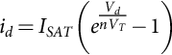 **(46.1)**

Eq. [(46.1)](https://learning.oreilly.com/library/view/power-electronics-handbook/9780128114087/B9780128114070000520.xhtml#fo0010) relates the diode current in a nonlinear fashion to the diode voltage where *ISAT* is the saturation current, *Vd* is the junction voltage, *VT*=*kT/q* is the thermal voltage, and *n* is the emission coefficient. It is obvious that the thermal voltage depends directly on the temperature. This type of approach has been used in SPICE (and other circuit simulators for many years), where the simulator temperature is defined as a global variable and used in semiconductor device models, with the assumption being that the circuit will be in a thermal steady state and this can be defined precisely by the designer. In some simulators, such as SABER, the temperature can be defined hierarchically so that a circuit or even device can have a unique temperature, but this is still effectively static. A breakthrough was to make the temperature of the device a dynamic variable that could be modeled using a thermal circuit at the same time as the electric circuit, and by using electric analogies, the integrated device behavior could be made more accurate.

Another key issue with the modeling power devices was to take a different approach to that of the low-power IC designers and to create models of power devices such as diodes, MOSFETs, and IGBTs that were more appropriate to this context. This was the “lumped-charge” approach [[7](https://learning.oreilly.com/library/view/power-electronics-handbook/9780128114087/B9780128114070000520.xhtml#bb0040)], and this model handles the forward and reverse recovery characteristics much better than the basic low-voltage model. It has been implemented in Saber for more than 20 years, and the general approach has been extended to a wide variety of power semiconductor models [[8](https://learning.oreilly.com/library/view/power-electronics-handbook/9780128114087/B9780128114070000520.xhtml#bb0045)] and to other simulators such as Modelica [[9](https://learning.oreilly.com/library/view/power-electronics-handbook/9780128114087/B9780128114070000520.xhtml#bb0050)].

Often, power electronics designers do not understand the detail of model that is required to solve their design problem, and this relates directly to the implementation of a thermal model too. This can be encapsulated in a series of questions such as the following:

• Do you need a detailed physics model?

• Do you need cycle by cycle accuracy?

• Can you characterize the data well enough to achieve the accuracy?

These questions (and the answers to them) will often dictate the type of model to be used and the resulting complexity of system to analyze.

## 46.4 Magnetic Components

Magnetic components that include a nonlinear ferrite core are some of the most difficult to model in a power electronic system. The nonlinear BH curve that defines the magnetic behavior of the inductors and transformers in a power electronic system has a profound effect on the behavior of the system as a whole. It is also highly thermally dependent, and therefore, it is useful to be able to model this.

A basic BH curve is shown in [Fig. 46.1](https://learning.oreilly.com/library/view/power-electronics-handbook/9780128114087/B9780128114070000520.xhtml#f0010), and this illustrates the effect of high magnetic field strength (causing saturation) and the remanence effect that leads to hysteresis. This is difficult enough to model without thermal effects (e.g., see the Jiles-Atherton approach [[10](https://learning.oreilly.com/library/view/power-electronics-handbook/9780128114087/B9780128114070000520.xhtml#bb0055)–[12](https://learning.oreilly.com/library/view/power-electronics-handbook/9780128114087/B9780128114070000520.xhtml#bb0065)]), and this has been implemented in most circuit simulators; however, the problem for power electronic circuit designers is that the BH curve can vary with temperature as shown in [Fig. 46.2](https://learning.oreilly.com/library/view/power-electronics-handbook/9780128114087/B9780128114070000520.xhtml#f0015).

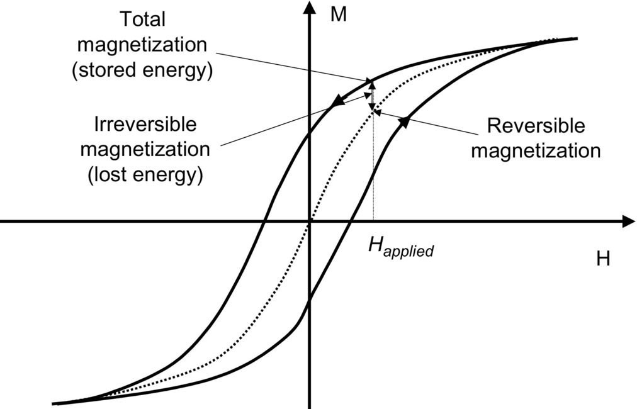

**FIG. 46.1** Basic magnetic material BH curve.

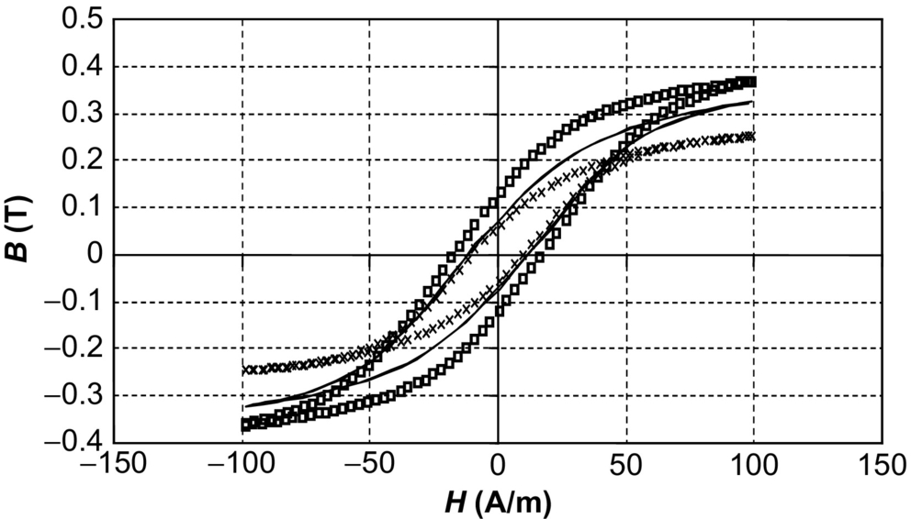

**FIG. 46.2** BH curve temperature variation (□=27°C, –=95°C, and ×=125°C).

This can be managed in a simulation model by not only including a thermal pin, in a similar manner to the power semiconductor devices, but also making it self-heating to take into account eddy currents or losses that contribute to the overall thermal behavior [[13](https://learning.oreilly.com/library/view/power-electronics-handbook/9780128114087/B9780128114070000520.xhtml#bb0070)].

In order to understand the methods of integrating thermal behavior into power electronic circuits, it is useful to first review the principles in thermal modeling.

## 46.5 Thermal Conduction

The conduction of heat through materials is by far the simplest transport mechanism to analyze. The transport of heat with conduction is described by the Fourier heat equation given in Eq. [(46.1)](https://learning.oreilly.com/library/view/power-electronics-handbook/9780128114087/B9780128114070000520.xhtml#fo0010):

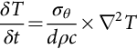 **(46.2)**

where *ρ* is the density and *c* is the specific heat. The heat flux (power flow per unit area) can be found at any point using Eq. [(46.3)](https://learning.oreilly.com/library/view/power-electronics-handbook/9780128114087/B9780128114070000520.xhtml#fo0020):

 **(46.3)**

As with all partial differential equations, the solution of the Fourier equation can only be performed exactly for a few simple sets of boundary and initial conditions. Solutions can be found numerically or using approximate methods if we consider the conduction of heat through a square plate of area *A* and thickness *d* as shown in [Fig. 46.3](https://learning.oreilly.com/library/view/power-electronics-handbook/9780128114087/B9780128114070000520.xhtml#f0020).

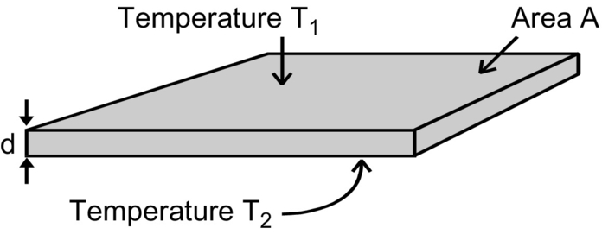

**FIG. 46.3** Block of material for thermal conduction.

The two surfaces are at uniform temperatures *T*1 and *T*2. If it is the case that *d*≪*A*, then we can make the assumption that the heat loss from the edges may be neglected and the resulting heat flow is in one dimension. The heat flow through the plate can therefore be calculated using Eq. [(46.4)](https://learning.oreilly.com/library/view/power-electronics-handbook/9780128114087/B9780128114070000520.xhtml#fo0025):

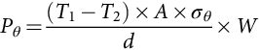 **(46.4)**

where *σθ* is the thermal conductivity. Notice the use of the subscript *θ* to emphasize that both the power and conductivity are thermal. Eq. [(46.4)](https://learning.oreilly.com/library/view/power-electronics-handbook/9780128114087/B9780128114070000520.xhtml#fo0025) is often written in the form shown in Eq. [(46.5)](https://learning.oreilly.com/library/view/power-electronics-handbook/9780128114087/B9780128114070000520.xhtml#fo0030):

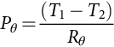 **(46.5)**

where *Rθ* is the *thermal resistance* of the plate, given by Eq. [(46.6)](https://learning.oreilly.com/library/view/power-electronics-handbook/9780128114087/B9780128114070000520.xhtml#fo0035):

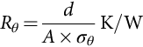 **(46.6)**

It is useful to see that the magnitude of thermal resistances for commonly used materials (in this case assuming a plate of area 10−4 m2 (1 cm×1 cm) and thickness 1 mm) is shown in [Table 46.1](https://learning.oreilly.com/library/view/power-electronics-handbook/9780128114087/B9780128114070000520.xhtml#t0010).

**Table 46.1**

**Thermal conductivity and resistance of a range of materials**

|  |  |  |
| --- | --- | --- |
| **Material** | **Thermal conductivity (W/K/m)** | **Thermal resistance (K/W)** |
| Aluminum | 217 | 0.046 |
| Copper | 394 | 0.025 |
| Gold | 291 | 0.034 |
| Lead | 34.3 | 0.29 |
| Tin | 63 | 0.16 |
| PCB (FR4) | 0.3 | 33 |
| Alumina | 27.6 | 0.36 |
| Diamond | 630 | 0.016 |
| Silicon | 150 | 0.067 |
| GaN | 130 | 0.077 |
| Silicon carbide | 500 | 0.02 |

[Table 46.1](https://learning.oreilly.com/library/view/power-electronics-handbook/9780128114087/B9780128114070000520.xhtml#t0010) is interesting in that as we might expect, copper is an extremely good conductor; however, it is particularly interesting to look at three common materials for power electronic devices, silicon, gallium nitride, and silicon carbide. They all have excellent thermal properties; however, silicon carbide is particularly good making it advantageous for power electronic applications where thermal management is crucial.

The equation for conduction of heat has the same form as Ohm's law, making it easy to draw a direct analogy between the thermal and electric resistance equations:

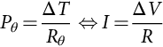 **(46.7)**

The analogy is drawn that *P* is equivalent to *I*, *T* is equivalent to *V*, and *Rθ* is equivalent to *R*. *T* in the thermal model is defined as an *across* variable, that is, only differences between points are specified. This means that as for voltage, there must be a reference node. This is usually the ambient temperature, *Ta*. *P* is a through variable in the same that in an electric circuit, current must flow around a closed loop.

## 46.6 Convection

Convection is the process by which heat is transferred from a solid surface to a nonsolid, such as air or water. The convection process involves the motion of the fluid relative to the solid surface and the processes by which heat is transferred across the interface.

There are two main forms of convection, *natural* or *free* convection, where the motion of the fluid is produced by the change in density with temperature, and *forced* convection, where the motion is generated by an external mechanism, a fan or a pump.

Convection is most effective where the hot surface is vertical. The air is heated by the plate and rises by the “chimney effect.” Forced airflow parallel to the plate will increase heat transfer. Heat transfer will depend on surface area, height, and temperature difference ([Fig. 46.4](https://learning.oreilly.com/library/view/power-electronics-handbook/9780128114087/B9780128114070000520.xhtml#f0025)). The process of convection is complex and not readily amenable to analysis; therefore, empirical methods have been developed, allowing models to be created based on these measurements.

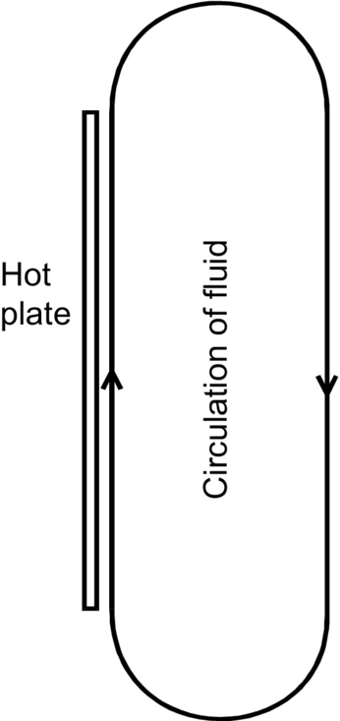

**FIG. 46.4** Convection concept of fluid circulation.

## 46.7 Radiation

The final concept of heat transfer is radiation. In this context, radiation refers to the transfer of heat by electromagnetic radiation. The basic equation for heat transfer by radiation is the Stefan-Boltzmann law that is given in Eq. [(46.8)](https://learning.oreilly.com/library/view/power-electronics-handbook/9780128114087/B9780128114070000520.xhtml#fo0045):

 **(46.8)**

where *T* is the absolute temperature of the radiating surface (K), *Ta* is the ambient temperature of the surrounding objects (K), *A* is the area (m2), and *E* is a constant known as the emissivity. The emissivity may vary from as low as 0.05 for polished aluminum to 0.9 for black oxidized aluminum.

In order to put the power loss by radiation into context, consider a 1 cm2 black anodized aluminum plate. The plate is at a temperature of 373 K, and the ambient temperature is at 323 K.

Taking into account the heat loss from both sides of the plate, the power loss is given by Eq. [(46.9)](https://learning.oreilly.com/library/view/power-electronics-handbook/9780128114087/B9780128114070000520.xhtml#fo0050):

 **(46.9)**

With a heat sink using natural convection, radiation will play a role in removing heat. The difference between a shiny aluminum heat sink and the same sink anodized black is of order 5%–25%, and the advantage rises with temperature.

Now, we have covered the basics of thermal behavior; we can investigate how to implement useful models for inclusion in power electronic circuits.

## 46.8 Steady State Thermal Circuit Modeling

For the thermal circuit model to be of use, it must be possible to define the temperature at well-defined points that are defined as the nodes of the thermal circuit. It must also be possible to define the heat flux and thermal resistance between these points, which implies that we therefore have a *lumped* model. At this stage, we are considering the steady state only, where the temperatures have stabilized into an equilibrium condition.

It is essentially the same as describing an electric circuit in terms of nodes connected by electric components, which is valid as long as it is not necessary to consider distributed effects (such as a transmission line). The lumped components in the thermal circuit are generally less well defined than their electric counterparts, due to the uncertainty in characterization of the thermal parameters and approximations made to obtain the parameters.

If we consider the example of a transistor that is bolted to a heat sink, as shown in [Fig. 46.5](https://learning.oreilly.com/library/view/power-electronics-handbook/9780128114087/B9780128114070000520.xhtml#f0030), we can see that there are five temperatures to consider in this model, starting from the junction temperature of the device (*Tj*), the header temperature (*Th*), the case temperature (*Tc*), the heat sink (*Ts*), and finally the ambient temperature (*Ta*).

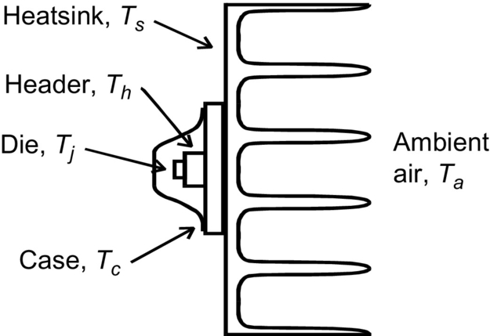

**FIG. 46.5** Transistor bolted to a heat sink.

The heat flow into the thermal circuit from the device is the power dissipation (in watts) from the power device, which is analogous to current in the electric domain. At this point, the obvious question is how do we model this thermal circuit in such a way that we can calculate all the intermediate temperatures based on a power dissipation value from the power transistor? We can represent each of the individual thermal elements as a thermal resistance connected in series with a thermal heat source as shown in [Fig. 46.6](https://learning.oreilly.com/library/view/power-electronics-handbook/9780128114087/B9780128114070000520.xhtml#f0035).

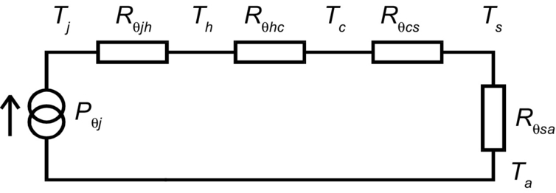

**FIG. 46.6** Equivalent thermal circuit of power device and heat sink.

In this example, the thermal circuit has been represented by four resistors with five nodes. In practice, *R*q*jh* and *R*q*hc* would not readily be measured separately and so would be grouped together as *R*qjc, a parameter measured by the manufacturer. The heat-sink supplier would specify *R*q*sa*, and the contact resistance between case and heat sink would depend on mounting method surface conditions. The junction temperature can be estimated using Eq. [(46.10)](https://learning.oreilly.com/library/view/power-electronics-handbook/9780128114087/B9780128114070000520.xhtml#fo0055):

 **(46.10)**

and the heat-sink temperature can also be estimated from Equation [(46.11)](https://learning.oreilly.com/library/view/power-electronics-handbook/9780128114087/B9780128114070000520.xhtml#fo0060):

 **(46.11)**

This lumped approach starts to become very effective when the situation becomes more complex as it can be easily modeled using SPICE or other circuit simulators, such as the case when there are several devices mounted on the same heat sink as shown in [Fig. 46.7](https://learning.oreilly.com/library/view/power-electronics-handbook/9780128114087/B9780128114070000520.xhtml#f0040).

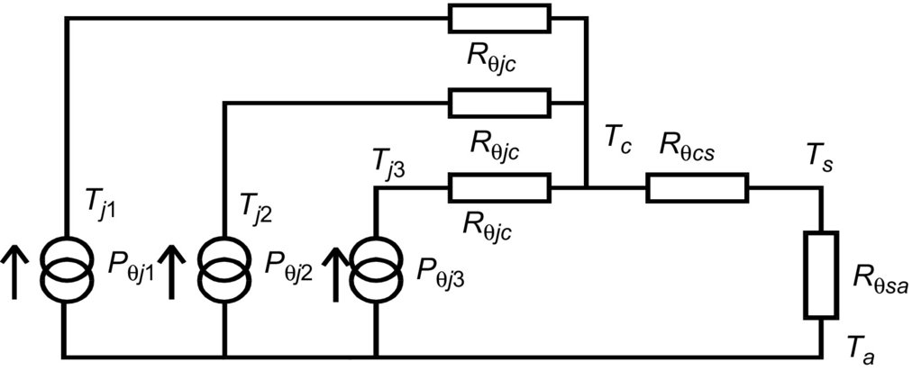

**FIG. 46.7** Several transistors mounted on the same heat sink.

This circuit can quickly be solved and the resulting heatsink temperature estimated.

## 46.9 Dynamic Thermal Circuit Modeling

So far, only steady-state thermal circuits have been considered. There are however many situations where it is required to model the transient behavior, such as when the dynamic electric behavior changes (say under peak inrush current conditions or a failure current). When heat is applied to an object, the temperature will increase at a rate determined by the heat input and the *thermal capacity* of the object. Although the scenario has moved from steady state to dynamic, the assumption is still being made that a single temperature may be assigned to the object, that is, a lumped model rather than a distributed one. This will not necessarily be the case, but it is a necessary assumption for the lumped component model. Generally, some kind of average temperature will be used. The thermal capacity of a lumped component of the thermal circuit is given by Eq. [(46.12)](https://learning.oreilly.com/library/view/power-electronics-handbook/9780128114087/B9780128114070000520.xhtml#fo0065):

 **(46.12)**

where *m* is the mass of the component and *cs* the specific heat of the material. In terms of the circuit model, the thermal capacity is analogous to an electric capacitor. A transistor on a heat sink may therefore be represented by [Fig. 46.8](https://learning.oreilly.com/library/view/power-electronics-handbook/9780128114087/B9780128114070000520.xhtml#f0045).

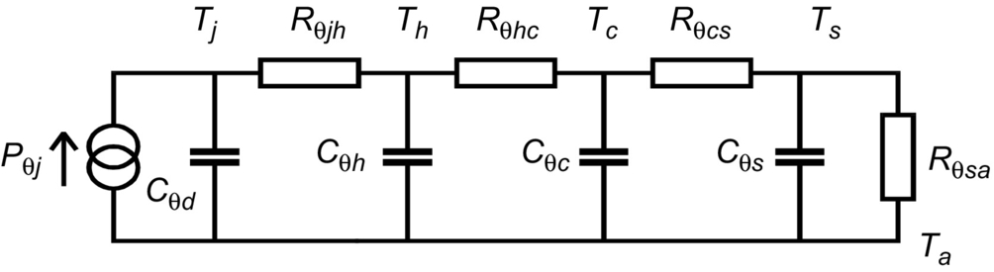

**FIG. 46.8** Adding thermal capacitance to the thermal model.

This model is useful, but there are still issues to resolve. If we consider the heat sink, a thermal capacity *Rθs* has been ascribed to it, and this is relatively well defined. In the model, the temperature drop across the heat sink itself has been neglected. The thermal resistances either side of the capacitor are interface resistances, with no significant thermal capacity. Similarly, the case presents a relatively large thermal capacity but little thermal resistance. The header and the die however are different. Here, they have both been considered as two lumped components. This is not a very good assumption as in reality the thermal resistance and thermal capacity in both header and die are distributed.

## 46.10 Approximating Distributed Thermal Behaviour Using Ladder Networks

One solution to the problem of approximating a distributed thermal network is to use a thermal ladder network. The thermal resistance is divided into n sections of *Rθ/n* and the capacitance into n capacitances of value *Cθ/n*. This is exactly the same problem that arises in distributed electric networks (such as transmission lines), and the same approach may be taken as shown in [Fig. 46.9](https://learning.oreilly.com/library/view/power-electronics-handbook/9780128114087/B9780128114070000520.xhtml#f0050). However, it should be noted that there is no obvious equivalent to an inductance in the thermal domain.

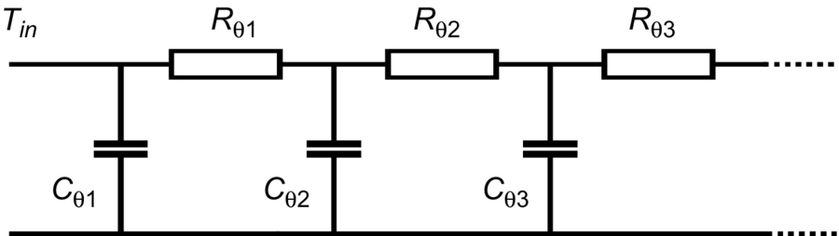

**FIG. 46.9** Thermal ladder network.

## 46.11 Transient Thermal Impedance

The ladder network approach is useful but is a hard work to analyze. A simpler approach is needed and that approach is the transient thermal impedance. When considering active devices mounted on a heat sink, the external part can be adequately described by the simple thermal resistance—thermal capacity concept. The problem area is the internal behavior of the device. The central idea is to replace the internal thermal resistance by a thermal impedance that depends on the temporal variation of the power dissipated. The objective is to accurately estimate the maximum junction temperature.

A typical data sheet graph (for the International Rectifier IRF 450 n-type power MOSFET in a modified TO-3 package, a 500 V 12 A device) of thermal impedance is shown in [Fig. 46.10](https://learning.oreilly.com/library/view/power-electronics-handbook/9780128114087/B9780128114070000520.xhtml#f0055), with the thermal impedance plotted against the pulse duration on the x-axis and the family of curves showing how the duty ratio affects the effective thermal impedance, normalized to the thermal resistance. For this device, the thermal resistance is found on the data sheet as the parameter *RthJC* and is 0.83°C/W, and the junction to ambient thermal resistance is 30°C/W. (For comparison, a TO-240 package—device is denoted by IRFM450—has a junction to ambient thermal resistance of 48°C/W.)

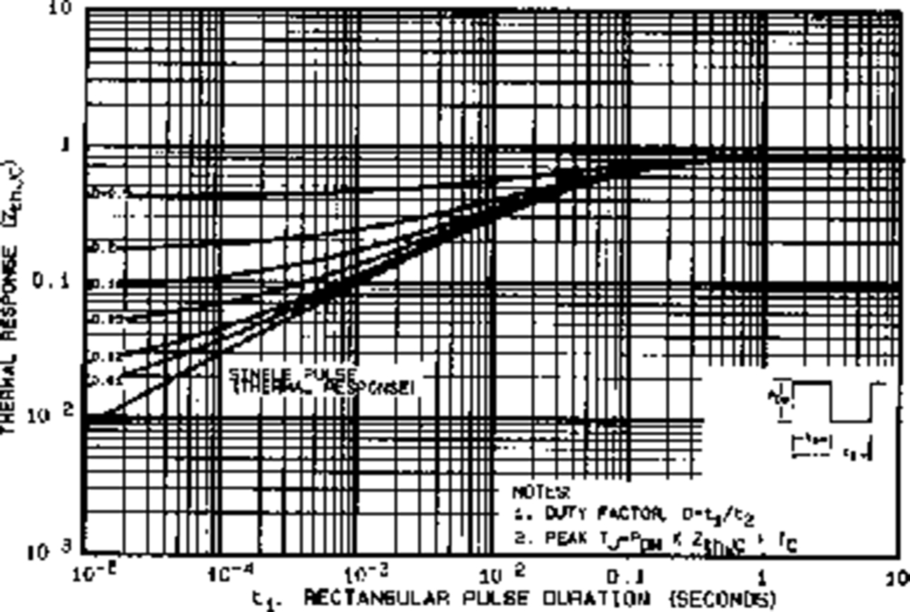

**FIG. 46.10** Thermal impedance for International Rectifier IRF450.

The starting point is the response of the junction temperature to a unit step of input power, when the case temperature is constant. The temperature after a time *t* is the equivalent of the maximum temperature reached by the junction for a single pulse of duration *t*. The steady-state response is a rise of temperature equal to the thermal resistance *R*q*jc*.

The dynamic response of the junction temperature can be seen in [Fig. 46.11](https://learning.oreilly.com/library/view/power-electronics-handbook/9780128114087/B9780128114070000520.xhtml#f0060), where the temperature will rise smoothly to the steady-state value.

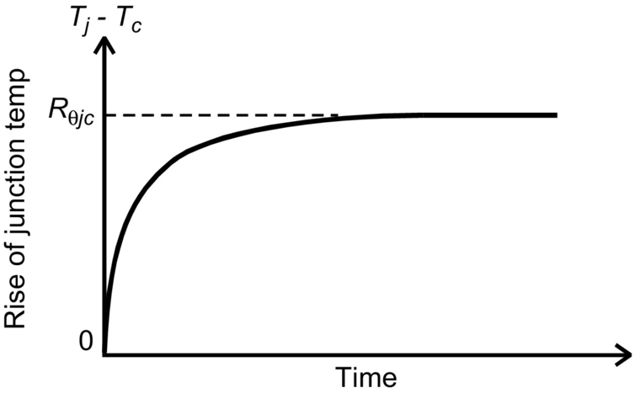

**FIG. 46.11** Response of junction temperature over time.

The rise of junction temperature above the case temperature for a pulse of length *t* is defined as the thermal impedance for a pulse of length *t*. This is for a pulse of unit height. If the pulse has an amplitude *Pm* and duration *t*, the maximum junction temperature is given by Eq. [(46.13)](https://learning.oreilly.com/library/view/power-electronics-handbook/9780128114087/B9780128114070000520.xhtml#fo0070):

 **(46.13)**

If the pulses are repetitive with a duration *t* and duty ratio *D* (Period *t/D*), the maximum temperature will rise above the value for a single pulse of duration *t* as shown in [Fig. 46.12](https://learning.oreilly.com/library/view/power-electronics-handbook/9780128114087/B9780128114070000520.xhtml#f0065).

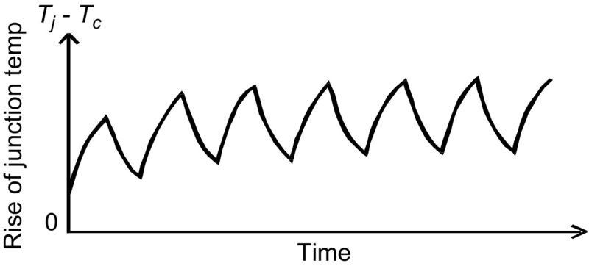

**FIG. 46.12** Response of junction temperature to repeated pulses.

With multiple pulses, the temperature oscillates, the magnitude of the oscillation decreasing with increasing frequency. In the limit, the ripple will approach zero, with a temperature rise corresponding to the mean power (*Pm*×*D*) multiplied by the thermal resistance. Measured values for thermal impedance can be seen on manufacturer's data sheets. The graphs show the thermal impedance normalized to the thermal resistance, as a function of pulse width and duty ratio.

## 46.12 Procedure to Calculate the Transient Thermal Impedance

The procedure to use thermal impedance to calculate the temperature difference between junction and case starts by calculating the approximate power pulse by an equivalent square pulse of equal area and same height based on the actual pulse as shown in [Fig. 46.13](https://learning.oreilly.com/library/view/power-electronics-handbook/9780128114087/B9780128114070000520.xhtml#f0070). From this figure, it is possible to deduce equivalent pulse width, *teq*. The way to do this is to estimate the area under the actual curve (using a trapezoidal approach) and from the maximum value calculate the equivalent pulse width based on the rectangular area required. The duty ratio can then be calculated based on the ratio of the equivalent pulse width and the switching period.

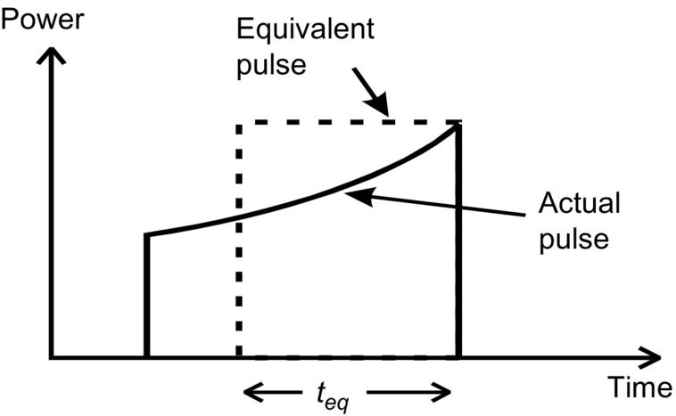

**FIG. 46.13** Equivalent pulse based on actual pulse shape.

With the equivalent pulse width and the derived duty ratio, the graph of thermal impedance can be used to look up the appropriate value.

The maximum difference (effectively the steady state) can then be calculated by multiplying the peak pulse power by the value of thermal impedance obtained from the data sheet. In practice, the pulsing thermal behavior we see in [Fig. 46.12](https://learning.oreilly.com/library/view/power-electronics-handbook/9780128114087/B9780128114070000520.xhtml#f0065) will be filtered out by the time the case is taken into account, and the calculation of case temperature may be made using the average power and the external thermal resistances.

## 46.13 Finite Element Numerical Methods

The solution of the Fourier heat equation in anything but the simplest cases requires the use of numerical methods such as the finite element method. For the steady state, the Fourier equation reduces to the Laplace equation in Eq. [(46.14)](https://learning.oreilly.com/library/view/power-electronics-handbook/9780128114087/B9780128114070000520.xhtml#fo0075):

 **(46.14)**

and the heat flux (power per unit area) at any point is given by Eq. [(46.15)](https://learning.oreilly.com/library/view/power-electronics-handbook/9780128114087/B9780128114070000520.xhtml#fo0080):

 **(46.15)**

The Laplace equation occurs in many physical systems, and the solution of it is a standard problem; however, due to the complexity of most real-world systems, finite element techniques are the preferred technique to obtain a numerical solution. Solutions for the temperature distribution in physical geometries can be obtained using commercial software packages designed to implement the finite element method. In most cases, this will give the equilibrium or steady-state solution rather than the transient behavior. In order to calculate, the transient thermal distribution requires the use of repeated finite element simulations for different initial conditions and applied heat flow values (as in the pulsed example shown in [Fig. 46.13](https://learning.oreilly.com/library/view/power-electronics-handbook/9780128114087/B9780128114070000520.xhtml#f0070)). This can take a high level of computation to complete and for complex geometries can take a long time to complete.

## 46.14 Dynamic Thermal Equivalent Circuit Models

When the calculations get more complex than a simple junction to case and junction to ambient calculation, then the choice for the power electronics design engineer is to either create a complex geometric model for the device, case, heat sink, and environment and then conduct extensive, repeated finite element analyses or more commonly use equivalent circuit models instead.

One obvious circuit that is often used to provide an increased level of detail, which effectively approximates the finite element model in one dimension, is the ladder circuit. For example, if we take the IRF450 device we have looked at previously, we can see that the junction to case thermal resistance *RthJC* is 0.83°C/W; therefore, if we create a 10-section RC ladder network, then each individual thermal resistance will be 0.083 C/W (one-tenth of the overall thermal resistance). In the steady state, this will be identical to the lumped model we looked at previously in this chapter ([Fig. 46.14](https://learning.oreilly.com/library/view/power-electronics-handbook/9780128114087/B9780128114070000520.xhtml#f0075)). It is possible to calculate an appropriate value for the ladder capacitances; however, in most cases, it is just as quick (and certainly easier) to use a simulation to experiment with the capacitance values to obtain the best matching of time dependence with the data for the device.

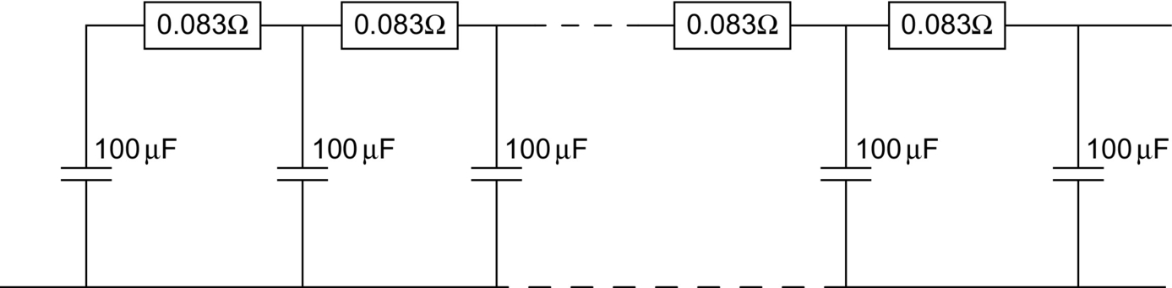

**FIG. 46.14** Dynamic thermal ladder model example.

If a heat flow (current in an electric analogous circuit) is applied, then the voltage will represent the thermal impedance over time, and this can be matched to the data sheet transient thermal impedance. For example, using the Saber simulator, we can define a thermal circuit using dedicated thermal resistance and capacitance models (although we could equally well use SPICE models for electric analogues), as shown in [Fig. 46.15](https://learning.oreilly.com/library/view/power-electronics-handbook/9780128114087/B9780128114070000520.xhtml#f0080).

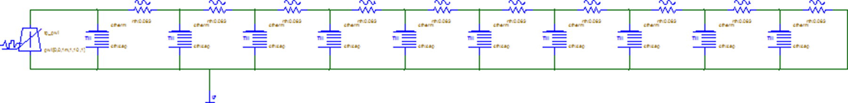

**FIG. 46.15** Thermal ladder simulation test circuit.

Varying the capacitance value allows the response of the transient thermal impedance to be obtained from the temperature across the whole ladder network. In this case, we can vary the capacitance on each leg from 200 to 2000 μF, with the resulting responses as shown in [Fig. 46.16](https://learning.oreilly.com/library/view/power-electronics-handbook/9780128114087/B9780128114070000520.xhtml#f0085).

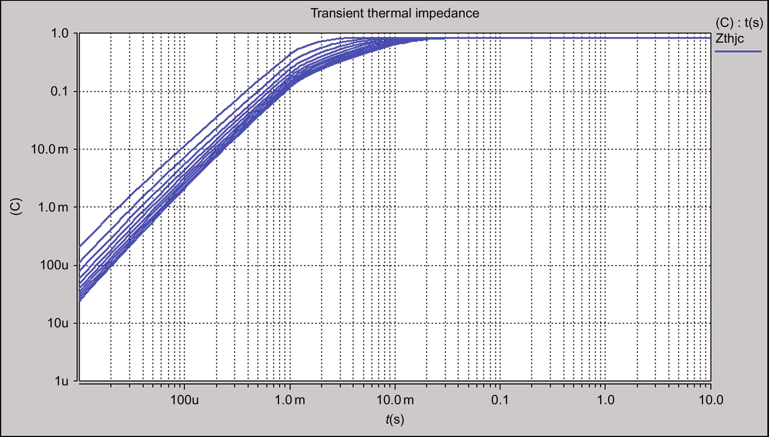

**FIG. 46.16** Transient thermal impedance variation due to ladder capacitance.

The same circuit can be used to test the behavior of the thermal circuit to a pulsed heat source, much as would be the case when a power device is switched on and off, and we can simulate this using the same test circuit, but with a pulse heat source ([Fig. 46.17](https://learning.oreilly.com/library/view/power-electronics-handbook/9780128114087/B9780128114070000520.xhtml#f0090)). Using a period of 1 ms and a duty ratio of 0.2, we can see the temperature response as follows (when the capacitance is defined as 400 μF).

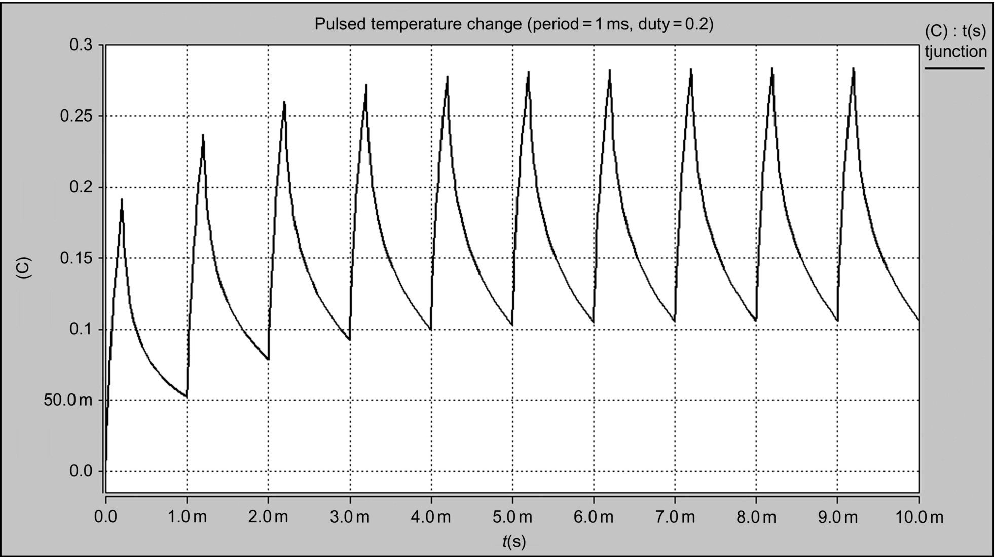

**FIG. 46.17** Pulsed heat source temperature change at 1 kHz and duty ratio=0.2.

When the heat source pulse period is reduced to 100 μs (i.e., 10 kHz), the ripple on the temperature reduces significantly ([Fig. 46.18](https://learning.oreilly.com/library/view/power-electronics-handbook/9780128114087/B9780128114070000520.xhtml#f0095)).

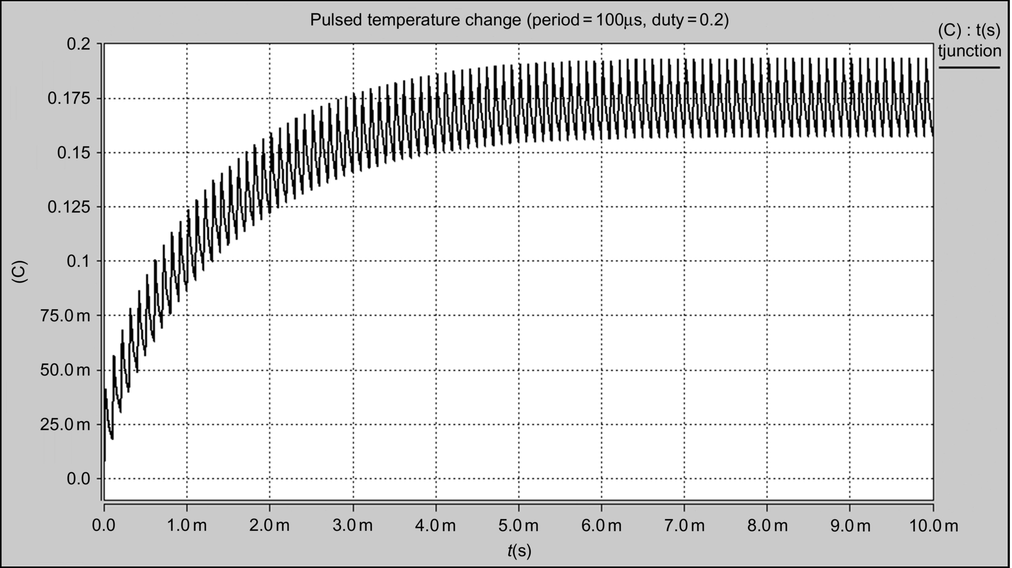

**FIG. 46.18** Pulsed heat source temperature change at 10 kHz duty ratio=0.2.

One of the limitations with the ladder network is that it will tend to underestimate the thermal impedance for higher duty ratios, and while it is certainly very useful, it must be used with caution. It is possible to increase the accuracy by increasing the number of thermal RC stages; however, obviously, there will be a price to pay in terms of simulation speed as a result.

It is also very useful to note that the thermal models can be linked directly to the electric simulations with the power electronics, either using electric analogy models (i.e., electric resistance to represent thermal resistance) or more commonly in modern multiple-domain simulators directly as thermal models. It is, however, true to say that in most cases, the time constants of the thermal circuits are much longer than the switching periods of the power electronics and the user should therefore be prepared for running long simulations to achieve the steady-state temperature changes. Nevertheless, it can be extremely illuminating and helpful in understanding the true thermal state of the power electronics.

## 46.15 Summary

Thermal properties of devices, packages, and heat sinks can be modeled in a relatively simple and efficient manner using a number of simple lumped-model techniques. While this gives a good starting point for estimating the thermal impact on circuit performance, it is clearly a complex and interlinked area that requires detailed analysis to gain highly accurate solutions. However, the use of such models can help the designer gain an insight as to the effect of temperature on device and circuit behavior and as a result can profoundly improve the ultimate design. If the designer takes a “worst-case-scenario” approach to modeling thermal behavior, then they greatly increase their chances of obtaining a robust and efficient design that can cope with extremes of temperature in the environment or due to the device behavior.

## References

[1] Zemansky M.W. *Heat and Thermodynamics.* fifth ed. New York: McGraw-Hill Book Company Inc.; 1968.

[2] Fox R.M., Lee S.G. Scalable small-signal model for BJT self-heating. *IEEE Electron. Device Lett.* 1991;12(12):649–651. doi:10.1109/55.116943.

[3] Fukahori K., Gray P.R. Computer simulation of integrated circuits in the presence of electrothermal interaction. *IEEE J. Solid-State Circuits.* 1976;SC-11:834–846.

[4] R.S. Vogelsong, C. Brzezinski, Extending spice for electro-thermal simulation, in: Proceedings of IEEE Custom Integrated Circuits Conference, May 1989, pp. 21.4.1–21.4.40.

[5] Munro P.C., Ye F.Q. Simulating the current mirror with a self-heating BJT model. *IEEE J. Solid-State Circuits.* 1991;26(9):1321–1324. doi:10.1109/4.84951.

[6] Hefner A.R., Blackburn D.L. Simulating the dynamic electrothermal behavior of power electronic circuits and systems. *IEEE Trans. Power Electron.* 1993;8(4):376–385.

[7] Ma Cliff L., Lauritzen Peter O., Sigg Jakob. Modeling of power diodes with the lumped-charge modeling technique. *IEEE Trans. Power Electron.* 1997;12(3):398–405.

[8] Budihardjo I., Lauritzen P.O. The lumped-charge power MOSFET model, including parameter extraction. *IEEE Trans. Power Electron.* 1995;10(5):379–387.

[9] D. Patrick, T. Schmitt, M. Andres, Behavioral modeling of power semiconductors in modelica, in: Proceedings of the 10th International Modelica Conference, March 10–12, 2014, Lund; Sweden. No. 096. Linköping University Electronic Press.

[10] Jiles D.C., Atherton D.L. Theory of ferromagnetic hysteresis (invited). *J. Appl. Phys.* 1984;55(6):2115–2120.

[11] Jiles D.C., Atherton D.L. Theory of ferromagnetic hysteresis. *J. Magn. Magn. Mater.* 1986;61:48–60.

[12] Jiles D.C., Atherton D.L. Ferromagnetic hysteresis. *IEEE Trans. Magn.* 1983;19(5):2183–2185.

[13] Wilson P.R., Ross J.N., Brown A.D. Simulation of magnetic component models in electric circuits including dynamic thermal effects. *IEEE Trans. Power Electron.* 2002;17(1):55–65. doi:10.1109/63.988670.

# Index

Note: Page numbers followed by *f* indicate figures, and *t* indicate tables.

**A**

ACM strategy *See* [Average current control (ACM) strategy](https://learning.oreilly.com/library/view/power-electronics-handbook/9780128114087/B9780128114070099931_1.xhtml#ie0173)

Active-clamp flyback converter [355](https://learning.oreilly.com/library/view/power-electronics-handbook/9780128114087/B978012811407000012X.xhtml#s0080), [358*f*](https://learning.oreilly.com/library/view/power-electronics-handbook/9780128114087/B978012811407000012X.xhtml#f0115)

Active-clamp resonant DC link inverter [373–374](https://learning.oreilly.com/library/view/power-electronics-handbook/9780128114087/B978012811407000012X.xhtml#s0200), [373*f*](https://learning.oreilly.com/library/view/power-electronics-handbook/9780128114087/B978012811407000012X.xhtml#f0260)

Active filters

hybrid filters

configuration [1366–1368](https://learning.oreilly.com/library/view/power-electronics-handbook/9780128114087/B9780128114070000465_1.xhtml#p0915), [1368*f*](https://learning.oreilly.com/library/view/power-electronics-handbook/9780128114087/B9780128114070000465_1.xhtml#f0265)

experimental setup [1372](https://learning.oreilly.com/library/view/power-electronics-handbook/9780128114087/B9780128114070000465_1.xhtml#s0250), [1373*f*](https://learning.oreilly.com/library/view/power-electronics-handbook/9780128114087/B9780128114070000465_1.xhtml#f0315)

passive filter quality factor [1370–1371](https://learning.oreilly.com/library/view/power-electronics-handbook/9780128114087/B9780128114070000465_1.xhtml#p0995), [1371*f*](https://learning.oreilly.com/library/view/power-electronics-handbook/9780128114087/B9780128114070000465_1.xhtml#f0295)

power system equivalent impedance [1371](https://learning.oreilly.com/library/view/power-electronics-handbook/9780128114087/B9780128114070000465_1.xhtml#s0235), [1371*f*](https://learning.oreilly.com/library/view/power-electronics-handbook/9780128114087/B9780128114070000465_1.xhtml#f0290)

principles of operation [1368–1370](https://learning.oreilly.com/library/view/power-electronics-handbook/9780128114087/B9780128114070000465_1.xhtml#s0225), [1368–1370*f*](https://learning.oreilly.com/library/view/power-electronics-handbook/9780128114087/B9780128114070000465_1.xhtml#f0270)

tuned factor [1370–1372](https://learning.oreilly.com/library/view/power-electronics-handbook/9780128114087/B9780128114070000465_1.xhtml#p0980), [1372*f*](https://learning.oreilly.com/library/view/power-electronics-handbook/9780128114087/B9780128114070000465_1.xhtml#f0305)

nonlinear load [1342](https://learning.oreilly.com/library/view/power-electronics-handbook/9780128114087/B9780128114070000465_1.xhtml#p0175)

power quality problems [1343](https://learning.oreilly.com/library/view/power-electronics-handbook/9780128114087/B9780128114070000465_1.xhtml#p0195), [1343*t*](https://learning.oreilly.com/library/view/power-electronics-handbook/9780128114087/B9780128114070000465_1.xhtml#t0010)

predictive control

block diagram [1372–1374](https://learning.oreilly.com/library/view/power-electronics-handbook/9780128114087/B9780128114070000465_1.xhtml#p1050), [1374*f*](https://learning.oreilly.com/library/view/power-electronics-handbook/9780128114087/B9780128114070000465_1.xhtml#f0335)

cost function [1374](https://learning.oreilly.com/library/view/power-electronics-handbook/9780128114087/B9780128114070000465_1.xhtml#s0275)

current reference generator [1374–1375](https://learning.oreilly.com/library/view/power-electronics-handbook/9780128114087/B9780128114070000465_1.xhtml#s0265), [1375*f*](https://learning.oreilly.com/library/view/power-electronics-handbook/9780128114087/B9780128114070000465_1.xhtml#f0340)

dc voltage converter [1375](https://learning.oreilly.com/library/view/power-electronics-handbook/9780128114087/B9780128114070000465_1.xhtml#s0285)

discrete-time model [1374](https://learning.oreilly.com/library/view/power-electronics-handbook/9780128114087/B9780128114070000465_1.xhtml#p1060)

equivalent circuit [1372](https://learning.oreilly.com/library/view/power-electronics-handbook/9780128114087/B9780128114070000465_1.xhtml#p1045), [1374*f*](https://learning.oreilly.com/library/view/power-electronics-handbook/9780128114087/B9780128114070000465_1.xhtml#f0330)

performance evaluation [1375–1376](https://learning.oreilly.com/library/view/power-electronics-handbook/9780128114087/B9780128114070000465_1.xhtml#s0290), [1376–1377*f*](https://learning.oreilly.com/library/view/power-electronics-handbook/9780128114087/B9780128114070000465_1.xhtml#f0345)

PWM-VSI [1342](https://learning.oreilly.com/library/view/power-electronics-handbook/9780128114087/B9780128114070000465_1.xhtml#p0180)

series filters

coupling transformers [1360](https://learning.oreilly.com/library/view/power-electronics-handbook/9780128114087/B9780128114070000465_1.xhtml#s0175)

experimental setup [1366](https://learning.oreilly.com/library/view/power-electronics-handbook/9780128114087/B9780128114070000465_1.xhtml#s0215), [1367*f*](https://learning.oreilly.com/library/view/power-electronics-handbook/9780128114087/B9780128114070000465_1.xhtml#f0250)

gating signals [1365–1366](https://learning.oreilly.com/library/view/power-electronics-handbook/9780128114087/B9780128114070000465_1.xhtml#s0205), [1366*f*](https://learning.oreilly.com/library/view/power-electronics-handbook/9780128114087/B9780128114070000465_1.xhtml#f0235)

implementation [1360*f*](https://learning.oreilly.com/library/view/power-electronics-handbook/9780128114087/B9780128114070000465_1.xhtml#f0180), [1366](https://learning.oreilly.com/library/view/power-electronics-handbook/9780128114087/B9780128114070000465_1.xhtml#s0210), [1366*f*](https://learning.oreilly.com/library/view/power-electronics-handbook/9780128114087/B9780128114070000465_1.xhtml#f0240)

Park transformation [1364](https://learning.oreilly.com/library/view/power-electronics-handbook/9780128114087/B9780128114070000465_1.xhtml#p0845)

passive filter [1358](https://learning.oreilly.com/library/view/power-electronics-handbook/9780128114087/B9780128114070000465_1.xhtml#p0680), [1358*f*](https://learning.oreilly.com/library/view/power-electronics-handbook/9780128114087/B9780128114070000465_1.xhtml#f0155), [1361–1362](https://learning.oreilly.com/library/view/power-electronics-handbook/9780128114087/B9780128114070000465_1.xhtml#s0185), [1361–1362*f*](https://learning.oreilly.com/library/view/power-electronics-handbook/9780128114087/B9780128114070000465_1.xhtml#f0195)

principles of operation [1358–1359*f*](https://learning.oreilly.com/library/view/power-electronics-handbook/9780128114087/B9780128114070000465_1.xhtml#f0150), [1359](https://learning.oreilly.com/library/view/power-electronics-handbook/9780128114087/B9780128114070000465_1.xhtml#s0160)

protection requirements [1362–1363](https://learning.oreilly.com/library/view/power-electronics-handbook/9780128114087/B9780128114070000465_1.xhtml#s0190), [1362–1364*f*](https://learning.oreilly.com/library/view/power-electronics-handbook/9780128114087/B9780128114070000465_1.xhtml#f0210)

PWM voltage-source inverter [1359–1360](https://learning.oreilly.com/library/view/power-electronics-handbook/9780128114087/B9780128114070000465_1.xhtml#s0170), [1360*f*](https://learning.oreilly.com/library/view/power-electronics-handbook/9780128114087/B9780128114070000465_1.xhtml#f0180)

reference signals [1364–1365](https://learning.oreilly.com/library/view/power-electronics-handbook/9780128114087/B9780128114070000465_1.xhtml#s0200), [1365*f*](https://learning.oreilly.com/library/view/power-electronics-handbook/9780128114087/B9780128114070000465_1.xhtml#f0230)

secondary ripple filter [1360–1361](https://learning.oreilly.com/library/view/power-electronics-handbook/9780128114087/B9780128114070000465_1.xhtml#s0180), [1360–1361*f*](https://learning.oreilly.com/library/view/power-electronics-handbook/9780128114087/B9780128114070000465_1.xhtml#f0185)

structure of [1358–1359](https://learning.oreilly.com/library/view/power-electronics-handbook/9780128114087/B9780128114070000465_1.xhtml#s0155), [1358*f*](https://learning.oreilly.com/library/view/power-electronics-handbook/9780128114087/B9780128114070000465_1.xhtml#f0155)

voltage harmonics [1342–1343](https://learning.oreilly.com/library/view/power-electronics-handbook/9780128114087/B9780128114070000465_1.xhtml#p0190), [1342*f*](https://learning.oreilly.com/library/view/power-electronics-handbook/9780128114087/B9780128114070000465_1.xhtml#f0010)

voltage sags and swells [1357–1358](https://learning.oreilly.com/library/view/power-electronics-handbook/9780128114087/B9780128114070000465_1.xhtml#p0675), [1358*f*](https://learning.oreilly.com/library/view/power-electronics-handbook/9780128114087/B9780128114070000465_1.xhtml#f0150)

shunt filters

block diagram [1344](https://learning.oreilly.com/library/view/power-electronics-handbook/9780128114087/B9780128114070000465_1.xhtml#p0235), [1347*f*](https://learning.oreilly.com/library/view/power-electronics-handbook/9780128114087/B9780128114070000465_1.xhtml#f0045)

compensation characteristics [1343](https://learning.oreilly.com/library/view/power-electronics-handbook/9780128114087/B9780128114070000465_1.xhtml#s0020), [1343*f*](https://learning.oreilly.com/library/view/power-electronics-handbook/9780128114087/B9780128114070000465_1.xhtml#f0015)

configuration [1343](https://learning.oreilly.com/library/view/power-electronics-handbook/9780128114087/B9780128114070000465_1.xhtml#p0215), [1344*f*](https://learning.oreilly.com/library/view/power-electronics-handbook/9780128114087/B9780128114070000465_1.xhtml#f0025)

control loop design [1353*f*](https://learning.oreilly.com/library/view/power-electronics-handbook/9780128114087/B9780128114070000465_1.xhtml#f0120), [1355–1356](https://learning.oreilly.com/library/view/power-electronics-handbook/9780128114087/B9780128114070000465_1.xhtml#s0115), [1356*f*](https://learning.oreilly.com/library/view/power-electronics-handbook/9780128114087/B9780128114070000465_1.xhtml#f0140)

current and voltage waveforms [1344](https://learning.oreilly.com/library/view/power-electronics-handbook/9780128114087/B9780128114070000465_1.xhtml#p0230), [1346*f*](https://learning.oreilly.com/library/view/power-electronics-handbook/9780128114087/B9780128114070000465_1.xhtml#f0040)

current harmonics [1342–1343](https://learning.oreilly.com/library/view/power-electronics-handbook/9780128114087/B9780128114070000465_1.xhtml#p0190), [1342*f*](https://learning.oreilly.com/library/view/power-electronics-handbook/9780128114087/B9780128114070000465_1.xhtml#f0010)

displacement power factor [1343](https://learning.oreilly.com/library/view/power-electronics-handbook/9780128114087/B9780128114070000465_1.xhtml#p0220), [1345*f*](https://learning.oreilly.com/library/view/power-electronics-handbook/9780128114087/B9780128114070000465_1.xhtml#f0030)

DSP [1349–1350](https://learning.oreilly.com/library/view/power-electronics-handbook/9780128114087/B9780128114070000465_1.xhtml#s0060)

hysteresis band [1353](https://learning.oreilly.com/library/view/power-electronics-handbook/9780128114087/B9780128114070000465_1.xhtml#s0090), [1353*f*](https://learning.oreilly.com/library/view/power-electronics-handbook/9780128114087/B9780128114070000465_1.xhtml#f0115)

implementation [1343](https://learning.oreilly.com/library/view/power-electronics-handbook/9780128114087/B9780128114070000465_1.xhtml#p0210), [1344*f*](https://learning.oreilly.com/library/view/power-electronics-handbook/9780128114087/B9780128114070000465_1.xhtml#f0020)

instantaneous reactive power theory [1345–1350](https://learning.oreilly.com/library/view/power-electronics-handbook/9780128114087/B9780128114070000465_1.xhtml#s0040), [1347–1348*f*](https://learning.oreilly.com/library/view/power-electronics-handbook/9780128114087/B9780128114070000465_1.xhtml#f0050)

inverter switching mode [1354–1355](https://learning.oreilly.com/library/view/power-electronics-handbook/9780128114087/B9780128114070000465_1.xhtml#s0105), [1355–1356*f*](https://learning.oreilly.com/library/view/power-electronics-handbook/9780128114087/B9780128114070000465_1.xhtml#f0135), [1355*t*](https://learning.oreilly.com/library/view/power-electronics-handbook/9780128114087/B9780128114070000465_1.xhtml#t0025)

LPF [1348](https://learning.oreilly.com/library/view/power-electronics-handbook/9780128114087/B9780128114070000465_1.xhtml#p0320), [1348*f*](https://learning.oreilly.com/library/view/power-electronics-handbook/9780128114087/B9780128114070000465_1.xhtml#f0060)

NPC inverters [1343](https://learning.oreilly.com/library/view/power-electronics-handbook/9780128114087/B9780128114070000465_1.xhtml#p0225), [1346*f*](https://learning.oreilly.com/library/view/power-electronics-handbook/9780128114087/B9780128114070000465_1.xhtml#f0035)

peak detection method [1351–1353](https://learning.oreilly.com/library/view/power-electronics-handbook/9780128114087/B9780128114070000465_1.xhtml#s0070), [1352*f*](https://learning.oreilly.com/library/view/power-electronics-handbook/9780128114087/B9780128114070000465_1.xhtml#f0095)

periodical sampling method [1353](https://learning.oreilly.com/library/view/power-electronics-handbook/9780128114087/B9780128114070000465_1.xhtml#s0085), [1353*f*](https://learning.oreilly.com/library/view/power-electronics-handbook/9780128114087/B9780128114070000465_1.xhtml#f0110)

reference currents [1345](https://learning.oreilly.com/library/view/power-electronics-handbook/9780128114087/B9780128114070000465_1.xhtml#p0240)

standard specifications [1357](https://learning.oreilly.com/library/view/power-electronics-handbook/9780128114087/B9780128114070000465_1.xhtml#p0630)

supply voltage distortion [1348–1349](https://learning.oreilly.com/library/view/power-electronics-handbook/9780128114087/B9780128114070000465_1.xhtml#s0050), [1349*f*](https://learning.oreilly.com/library/view/power-electronics-handbook/9780128114087/B9780128114070000465_1.xhtml#f0070)

supply voltage unbalance [1349](https://learning.oreilly.com/library/view/power-electronics-handbook/9780128114087/B9780128114070000465_1.xhtml#s0055), [1350*f*](https://learning.oreilly.com/library/view/power-electronics-handbook/9780128114087/B9780128114070000465_1.xhtml#f0075)

synchronous link reactor [1356–1357](https://learning.oreilly.com/library/view/power-electronics-handbook/9780128114087/B9780128114070000465_1.xhtml#s0130)

synchronous reference frame algorithm [1350–1351](https://learning.oreilly.com/library/view/power-electronics-handbook/9780128114087/B9780128114070000465_1.xhtml#s0065), [1350–1351*f*](https://learning.oreilly.com/library/view/power-electronics-handbook/9780128114087/B9780128114070000465_1.xhtml#f0080)

techniques [1352–1353](https://learning.oreilly.com/library/view/power-electronics-handbook/9780128114087/B9780128114070000465_1.xhtml#s0075), [1353*t*](https://learning.oreilly.com/library/view/power-electronics-handbook/9780128114087/B9780128114070000465_1.xhtml#t0015)

triangular carrier method [1353–1354](https://learning.oreilly.com/library/view/power-electronics-handbook/9780128114087/B9780128114070000465_1.xhtml#s0095), [1353*f*](https://learning.oreilly.com/library/view/power-electronics-handbook/9780128114087/B9780128114070000465_1.xhtml#f0120)

vector control technique [1354](https://learning.oreilly.com/library/view/power-electronics-handbook/9780128114087/B9780128114070000465_1.xhtml#s0100), [1354*f*](https://learning.oreilly.com/library/view/power-electronics-handbook/9780128114087/B9780128114070000465_1.xhtml#f0125)

Actively neutral point clamped (ANPC) converter [874](https://learning.oreilly.com/library/view/power-electronics-handbook/9780128114087/B9780128114070000301.xhtml#s0360), [874*f*](https://learning.oreilly.com/library/view/power-electronics-handbook/9780128114087/B9780128114070000301.xhtml#f0190)

Active power factor correctors

boost corrector [536](https://learning.oreilly.com/library/view/power-electronics-handbook/9780128114087/B9780128114070000179.xhtml#s0045), [537*f*](https://learning.oreilly.com/library/view/power-electronics-handbook/9780128114087/B9780128114070000179.xhtml#f0050)

buck-boost corrector [536](https://learning.oreilly.com/library/view/power-electronics-handbook/9780128114087/B9780128114070000179.xhtml#s0050), [537*f*](https://learning.oreilly.com/library/view/power-electronics-handbook/9780128114087/B9780128114070000179.xhtml#f0055)

buck corrector [535–536](https://learning.oreilly.com/library/view/power-electronics-handbook/9780128114087/B9780128114070000179.xhtml#s0040), [536*f*](https://learning.oreilly.com/library/view/power-electronics-handbook/9780128114087/B9780128114070000179.xhtml#f0045)

Cuk corrector [537](https://learning.oreilly.com/library/view/power-electronics-handbook/9780128114087/B9780128114070000179.xhtml#s0055), [538*f*](https://learning.oreilly.com/library/view/power-electronics-handbook/9780128114087/B9780128114070000179.xhtml#f0060)

flyback corrector [538](https://learning.oreilly.com/library/view/power-electronics-handbook/9780128114087/B9780128114070000179.xhtml#s0060), [538*f*](https://learning.oreilly.com/library/view/power-electronics-handbook/9780128114087/B9780128114070000179.xhtml#f0065)

forward converter [538–539](https://learning.oreilly.com/library/view/power-electronics-handbook/9780128114087/B9780128114070000179.xhtml#s0065), [539*f*](https://learning.oreilly.com/library/view/power-electronics-handbook/9780128114087/B9780128114070000179.xhtml#f0070)

forward-flyback converter [538–539](https://learning.oreilly.com/library/view/power-electronics-handbook/9780128114087/B9780128114070000179.xhtml#s0065), [539*f*](https://learning.oreilly.com/library/view/power-electronics-handbook/9780128114087/B9780128114070000179.xhtml#f0070)

Sepic corrector [537](https://learning.oreilly.com/library/view/power-electronics-handbook/9780128114087/B9780128114070000179.xhtml#s0055), [538*f*](https://learning.oreilly.com/library/view/power-electronics-handbook/9780128114087/B9780128114070000179.xhtml#f0060)

single-stage quasi Z-source corrector [539–540](https://learning.oreilly.com/library/view/power-electronics-handbook/9780128114087/B9780128114070000179.xhtml#s0070), [540*f*](https://learning.oreilly.com/library/view/power-electronics-handbook/9780128114087/B9780128114070000179.xhtml#f0075)

Zeta corrector [537](https://learning.oreilly.com/library/view/power-electronics-handbook/9780128114087/B9780128114070000179.xhtml#s0055), [538*f*](https://learning.oreilly.com/library/view/power-electronics-handbook/9780128114087/B9780128114070000179.xhtml#f0060)

Active power filter [264](https://learning.oreilly.com/library/view/power-electronics-handbook/9780128114087/B978012811407000009X.xhtml#s0135), [265*f*](https://learning.oreilly.com/library/view/power-electronics-handbook/9780128114087/B978012811407000009X.xhtml#f0280)

Active rectifier *See* [Synchronous rectifier (SR)](https://learning.oreilly.com/library/view/power-electronics-handbook/9780128114087/B9780128114070099931_3.xhtml#ie4029)

AC voltage controllers [417–418](https://learning.oreilly.com/library/view/power-electronics-handbook/9780128114087/B9780128114070000143_1.xhtml#p0165)

applications

ac switch with on/off control [448](https://learning.oreilly.com/library/view/power-electronics-handbook/9780128114087/B9780128114070000143_2.xhtml#p0845)

fan/pump drives [447–448](https://learning.oreilly.com/library/view/power-electronics-handbook/9780128114087/B9780128114070000143_2.xhtml#p0835)

four-quadrant ac voltage controller [447–448](https://learning.oreilly.com/library/view/power-electronics-handbook/9780128114087/B9780128114070000143_2.xhtml#p0835), [448*f*](https://learning.oreilly.com/library/view/power-electronics-handbook/9780128114087/B9780128114070000143_2.xhtml#f0225)

induction motors, soft starting [448](https://learning.oreilly.com/library/view/power-electronics-handbook/9780128114087/B9780128114070000143_2.xhtml#p0840)

integral cycle control [448](https://learning.oreilly.com/library/view/power-electronics-handbook/9780128114087/B9780128114070000143_2.xhtml#p0850)

static ac switches [447](https://learning.oreilly.com/library/view/power-electronics-handbook/9780128114087/B9780128114070000143_2.xhtml#p0830)

single-phase AC-AC voltage controller

basic power circuit [418](https://learning.oreilly.com/library/view/power-electronics-handbook/9780128114087/B9780128114070000143_1.xhtml#p0175), [418*f*](https://learning.oreilly.com/library/view/power-electronics-handbook/9780128114087/B9780128114070000143_1.xhtml#f0010)

bidirectional full-wave symmetrical control [418](https://learning.oreilly.com/library/view/power-electronics-handbook/9780128114087/B9780128114070000143_1.xhtml#p0175), [418*f*](https://learning.oreilly.com/library/view/power-electronics-handbook/9780128114087/B9780128114070000143_1.xhtml#f0010)

with on/off control [421–422](https://learning.oreilly.com/library/view/power-electronics-handbook/9780128114087/B9780128114070000143_1.xhtml#s0025), [422*f*](https://learning.oreilly.com/library/view/power-electronics-handbook/9780128114087/B9780128114070000143_1.xhtml#f0050)

phase-controlled single-phase AC voltage controller [419–421](https://learning.oreilly.com/library/view/power-electronics-handbook/9780128114087/B9780128114070000143_1.xhtml#s0020), [419–420*f*](https://learning.oreilly.com/library/view/power-electronics-handbook/9780128114087/B9780128114070000143_1.xhtml#f0015)

unidirectional half-wave asymmetrical voltage control [418](https://learning.oreilly.com/library/view/power-electronics-handbook/9780128114087/B9780128114070000143_1.xhtml#p0175), [418*f*](https://learning.oreilly.com/library/view/power-electronics-handbook/9780128114087/B9780128114070000143_1.xhtml#f0010)

three-phase AC-AC voltage controllers

fully controlled three-phase three-wire AC voltage controller [424–425](https://learning.oreilly.com/library/view/power-electronics-handbook/9780128114087/B9780128114070000143_1.xhtml#s0040), [424*f*](https://learning.oreilly.com/library/view/power-electronics-handbook/9780128114087/B9780128114070000143_1.xhtml#f0065), [426*f*](https://learning.oreilly.com/library/view/power-electronics-handbook/9780128114087/B9780128114070000143_1.xhtml#f0075)

phase-controlled three-phase AC voltage controllers [422–425](https://learning.oreilly.com/library/view/power-electronics-handbook/9780128114087/B9780128114070000143_1.xhtml#s0030), [423*f*](https://learning.oreilly.com/library/view/power-electronics-handbook/9780128114087/B9780128114070000143_1.xhtml#f0060)

Adaptive network-based fuzzy control system (ANFIS)

learning algorithm [1239*f*](https://learning.oreilly.com/library/view/power-electronics-handbook/9780128114087/B9780128114070000404.xhtml#f0155), [1240–1242](https://learning.oreilly.com/library/view/power-electronics-handbook/9780128114087/B9780128114070000404.xhtml#s0195), [1241–1242*f*](https://learning.oreilly.com/library/view/power-electronics-handbook/9780128114087/B9780128114070000404.xhtml#f0165)

NFC [1223–1224*f*](https://learning.oreilly.com/library/view/power-electronics-handbook/9780128114087/B9780128114070000404.xhtml#f0020), [1239–1240](https://learning.oreilly.com/library/view/power-electronics-handbook/9780128114087/B9780128114070000404.xhtml#s0165), [1239–1240*f*](https://learning.oreilly.com/library/view/power-electronics-handbook/9780128114087/B9780128114070000404.xhtml#f0155)

structure of [1239](https://learning.oreilly.com/library/view/power-electronics-handbook/9780128114087/B9780128114070000404.xhtml#p0760), [1239*f*](https://learning.oreilly.com/library/view/power-electronics-handbook/9780128114087/B9780128114070000404.xhtml#f0150)

A/D conversion [1307–1308](https://learning.oreilly.com/library/view/power-electronics-handbook/9780128114087/B978012811407000043X.xhtml#s0030)

Adhesive bond [161](https://learning.oreilly.com/library/view/power-electronics-handbook/9780128114087/B9780128114070000064.xhtml#o0140)

Adjustable speed synchronous condenser (ASSC) [901](https://learning.oreilly.com/library/view/power-electronics-handbook/9780128114087/B9780128114070000313.xhtml#s0125), [902*f*](https://learning.oreilly.com/library/view/power-electronics-handbook/9780128114087/B9780128114070000313.xhtml#f0180)

Air-conditioning (A/C) pump [1084](https://learning.oreilly.com/library/view/power-electronics-handbook/9780128114087/B9780128114070000362.xhtml#p0505), [1084*t*](https://learning.oreilly.com/library/view/power-electronics-handbook/9780128114087/B9780128114070000362.xhtml#t0035)

Air-driven turbines based off-shore technologies [749–750](https://learning.oreilly.com/library/view/power-electronics-handbook/9780128114087/B9780128114070000258.xhtml#s0240), [749–750*f*](https://learning.oreilly.com/library/view/power-electronics-handbook/9780128114087/B9780128114070000258.xhtml#f0165)

Alkaline fuel cell (AFC) [1097](https://learning.oreilly.com/library/view/power-electronics-handbook/9780128114087/B9780128114070000374.xhtml#s0040), [1097*f*](https://learning.oreilly.com/library/view/power-electronics-handbook/9780128114087/B9780128114070000374.xhtml#f0020)

All-electric range (AER) [1032–1033](https://learning.oreilly.com/library/view/power-electronics-handbook/9780128114087/B9780128114070000350.xhtml#p0855), [1033*f*](https://learning.oreilly.com/library/view/power-electronics-handbook/9780128114087/B9780128114070000350.xhtml#f0070)

Alternate phase opposition disposition PWM (APOD-PWM) method [406](https://learning.oreilly.com/library/view/power-electronics-handbook/9780128114087/B9780128114070000131.xhtml#p0705), [409*f*](https://learning.oreilly.com/library/view/power-electronics-handbook/9780128114087/B9780128114070000131.xhtml#f0165)

Aluminum conductor steel-reinforced (ACSR) conductor [832](https://learning.oreilly.com/library/view/power-electronics-handbook/9780128114087/B9780128114070000295.xhtml#p0205)

Ampere’s magnetic circuit law [576](https://learning.oreilly.com/library/view/power-electronics-handbook/9780128114087/B9780128114070000192.xhtml#s0045), [576*f*](https://learning.oreilly.com/library/view/power-electronics-handbook/9780128114087/B9780128114070000192.xhtml#f0030)

Ancillary services [906–907](https://learning.oreilly.com/library/view/power-electronics-handbook/9780128114087/B9780128114070000313.xhtml#s0155), [907*f*](https://learning.oreilly.com/library/view/power-electronics-handbook/9780128114087/B9780128114070000313.xhtml#f0235)

ANNs *See* [Artificial neural networks (ANNs)](https://learning.oreilly.com/library/view/power-electronics-handbook/9780128114087/B9780128114070099931_1.xhtml#ie0114)

ANPC converter *See* [Actively neutral point clamped (ANPC) converter](https://learning.oreilly.com/library/view/power-electronics-handbook/9780128114087/B9780128114070099931_1.xhtml#ie0064)

Antilock braking system (ABS) [1072](https://learning.oreilly.com/library/view/power-electronics-handbook/9780128114087/B9780128114070000362.xhtml#p0245), [1076–1077](https://learning.oreilly.com/library/view/power-electronics-handbook/9780128114087/B9780128114070000362.xhtml#p0350)

Application-specific integrated circuits (ASICs) controller [286](https://learning.oreilly.com/library/view/power-electronics-handbook/9780128114087/B9780128114070000106.xhtml#p0480)

Artificial neural networks (ANNs)

advantages [1245](https://learning.oreilly.com/library/view/power-electronics-handbook/9780128114087/B9780128114070000416.xhtml#p0090)

conventional function approximator [1246](https://learning.oreilly.com/library/view/power-electronics-handbook/9780128114087/B9780128114070000416.xhtml#s0020), [1246*f*](https://learning.oreilly.com/library/view/power-electronics-handbook/9780128114087/B9780128114070000416.xhtml#f0010)

electric drives [1257–1259](https://learning.oreilly.com/library/view/power-electronics-handbook/9780128114087/B9780128114070000416.xhtml#s0110), [1258*f*](https://learning.oreilly.com/library/view/power-electronics-handbook/9780128114087/B9780128114070000416.xhtml#f0150)

induction motor drives

control scheme [1255–1257](https://learning.oreilly.com/library/view/power-electronics-handbook/9780128114087/B9780128114070000416.xhtml#s0105), [1257–1258*f*](https://learning.oreilly.com/library/view/power-electronics-handbook/9780128114087/B9780128114070000416.xhtml#f0140)

flux and torque estimation [1248–1249](https://learning.oreilly.com/library/view/power-electronics-handbook/9780128114087/B9780128114070000416.xhtml#s0040)

off-line trained configuration [1249](https://learning.oreilly.com/library/view/power-electronics-handbook/9780128114087/B9780128114070000416.xhtml#s0050), [1250*f*](https://learning.oreilly.com/library/view/power-electronics-handbook/9780128114087/B9780128114070000416.xhtml#f0055)

on-line trained configuration [1249–1253](https://learning.oreilly.com/library/view/power-electronics-handbook/9780128114087/B9780128114070000416.xhtml#s0055)

RWC algorithm [1255](https://learning.oreilly.com/library/view/power-electronics-handbook/9780128114087/B9780128114070000416.xhtml#p0385)

speed estimation [1247–1248](https://learning.oreilly.com/library/view/power-electronics-handbook/9780128114087/B9780128114070000416.xhtml#s0035), [1248–1249*f*](https://learning.oreilly.com/library/view/power-electronics-handbook/9780128114087/B9780128114070000416.xhtml#f0035)

SRE block [1254–1255](https://learning.oreilly.com/library/view/power-electronics-handbook/9780128114087/B9780128114070000416.xhtml#s0080)

neural function approximator [1246–1247](https://learning.oreilly.com/library/view/power-electronics-handbook/9780128114087/B9780128114070000416.xhtml#s0025), [1246–1247*f*](https://learning.oreilly.com/library/view/power-electronics-handbook/9780128114087/B9780128114070000416.xhtml#f0015)

power converters [1259–1260](https://learning.oreilly.com/library/view/power-electronics-handbook/9780128114087/B9780128114070000416.xhtml#s0115), [1259*f*](https://learning.oreilly.com/library/view/power-electronics-handbook/9780128114087/B9780128114070000416.xhtml#f0155)

ASSC *See* [Adjustable speed synchronous condenser (ASSC)](https://learning.oreilly.com/library/view/power-electronics-handbook/9780128114087/B9780128114070099931_1.xhtml#ie0101)

Asynchronous generator (AG) [1425](https://learning.oreilly.com/library/view/power-electronics-handbook/9780128114087/B9780128114070000519.xhtml#p0165), [1425*f*](https://learning.oreilly.com/library/view/power-electronics-handbook/9780128114087/B9780128114070000519.xhtml#f0020)

Automobiles

alternative machines

axial-air-gap/axial-flux machine [1082–1083](https://learning.oreilly.com/library/view/power-electronics-handbook/9780128114087/B9780128114070000362.xhtml#s0150), [1082*f*](https://learning.oreilly.com/library/view/power-electronics-handbook/9780128114087/B9780128114070000362.xhtml#f0095)

combined starter/alternator approach [1080](https://learning.oreilly.com/library/view/power-electronics-handbook/9780128114087/B9780128114070000362.xhtml#p0425)

cylindrical wound rotor [1080](https://learning.oreilly.com/library/view/power-electronics-handbook/9780128114087/B9780128114070000362.xhtml#s0130), [1081*f*](https://learning.oreilly.com/library/view/power-electronics-handbook/9780128114087/B9780128114070000362.xhtml#f0080)

induction machine [1080–1081](https://learning.oreilly.com/library/view/power-electronics-handbook/9780128114087/B9780128114070000362.xhtml#s0135)

permanent-magnet synchronous machine [1080*f*](https://learning.oreilly.com/library/view/power-electronics-handbook/9780128114087/B9780128114070000362.xhtml#f0075), [1082](https://learning.oreilly.com/library/view/power-electronics-handbook/9780128114087/B9780128114070000362.xhtml#s0145)

switched reluctance machine [1081–1082](https://learning.oreilly.com/library/view/power-electronics-handbook/9780128114087/B9780128114070000362.xhtml#s0140), [1081–1082*f*](https://learning.oreilly.com/library/view/power-electronics-handbook/9780128114087/B9780128114070000362.xhtml#f0085)

automotive electric system

dual-voltage architectures [1085–1086](https://learning.oreilly.com/library/view/power-electronics-handbook/9780128114087/B9780128114070000362.xhtml#s0180), [1085–1086*f*](https://learning.oreilly.com/library/view/power-electronics-handbook/9780128114087/B9780128114070000362.xhtml#f0100)

future load [1083–1084](https://learning.oreilly.com/library/view/power-electronics-handbook/9780128114087/B9780128114070000362.xhtml#s0165), [1084*t*](https://learning.oreilly.com/library/view/power-electronics-handbook/9780128114087/B9780128114070000362.xhtml#t0035)

higher fuel efficiency [1084](https://learning.oreilly.com/library/view/power-electronics-handbook/9780128114087/B9780128114070000362.xhtml#s0170)

requirements [1083](https://learning.oreilly.com/library/view/power-electronics-handbook/9780128114087/B9780128114070000362.xhtml#p0490)

voltage specifications [1084–1085](https://learning.oreilly.com/library/view/power-electronics-handbook/9780128114087/B9780128114070000362.xhtml#s0175), [1085*t*](https://learning.oreilly.com/library/view/power-electronics-handbook/9780128114087/B9780128114070000362.xhtml#t0040)

EHPS system [1075](https://learning.oreilly.com/library/view/power-electronics-handbook/9780128114087/B9780128114070000362.xhtml#s0075)

electric air conditioner [1074–1075](https://learning.oreilly.com/library/view/power-electronics-handbook/9780128114087/B9780128114070000362.xhtml#s0070)

electric and environmental conditions

electromagnetic compatibility [1068–1069](https://learning.oreilly.com/library/view/power-electronics-handbook/9780128114087/B9780128114070000362.xhtml#s0030), [1069–1070*t*](https://learning.oreilly.com/library/view/power-electronics-handbook/9780128114087/B9780128114070000362.xhtml#t0015)

EMI [1070–1071](https://learning.oreilly.com/library/view/power-electronics-handbook/9780128114087/B9780128114070000362.xhtml#s0035), [1070–1071*f*](https://learning.oreilly.com/library/view/power-electronics-handbook/9780128114087/B9780128114070000362.xhtml#f0015)

factors [1068](https://learning.oreilly.com/library/view/power-electronics-handbook/9780128114087/B9780128114070000362.xhtml#p0165), [1071–1072](https://learning.oreilly.com/library/view/power-electronics-handbook/9780128114087/B9780128114070000362.xhtml#p0225)

static voltage ranges [1068](https://learning.oreilly.com/library/view/power-electronics-handbook/9780128114087/B9780128114070000362.xhtml#s0025), [1069*t*](https://learning.oreilly.com/library/view/power-electronics-handbook/9780128114087/B9780128114070000362.xhtml#t0010)

temperature extremes [1071–1072](https://learning.oreilly.com/library/view/power-electronics-handbook/9780128114087/B9780128114070000362.xhtml#p0230), [1072*t*](https://learning.oreilly.com/library/view/power-electronics-handbook/9780128114087/B9780128114070000362.xhtml#t0025)

electric vehicles [1086–1088](https://learning.oreilly.com/library/view/power-electronics-handbook/9780128114087/B9780128114070000362.xhtml#s0185)

electromagnetic actuators [1074](https://learning.oreilly.com/library/view/power-electronics-handbook/9780128114087/B9780128114070000362.xhtml#s0065), [1074*f*](https://learning.oreilly.com/library/view/power-electronics-handbook/9780128114087/B9780128114070000362.xhtml#f0045)

EPS system [1075](https://learning.oreilly.com/library/view/power-electronics-handbook/9780128114087/B9780128114070000362.xhtml#s0075)

HID lamps [1072–1073](https://learning.oreilly.com/library/view/power-electronics-handbook/9780128114087/B9780128114070000362.xhtml#s0050), [1073*f*](https://learning.oreilly.com/library/view/power-electronics-handbook/9780128114087/B9780128114070000362.xhtml#f0030)

Lundell alternator

alternator output power *vs.* operating point [1078](https://learning.oreilly.com/library/view/power-electronics-handbook/9780128114087/B9780128114070000362.xhtml#p0385)

permanent magnets [1079](https://learning.oreilly.com/library/view/power-electronics-handbook/9780128114087/B9780128114070000362.xhtml#s0110)

simple electric model [1078](https://learning.oreilly.com/library/view/power-electronics-handbook/9780128114087/B9780128114070000362.xhtml#p0385), [1078*f*](https://learning.oreilly.com/library/view/power-electronics-handbook/9780128114087/B9780128114070000362.xhtml#f0065)

structure and circuitry [1077](https://learning.oreilly.com/library/view/power-electronics-handbook/9780128114087/B9780128114070000362.xhtml#p0370), [1078*f*](https://learning.oreilly.com/library/view/power-electronics-handbook/9780128114087/B9780128114070000362.xhtml#f0060)

switched-mode rectifier [1079–1080](https://learning.oreilly.com/library/view/power-electronics-handbook/9780128114087/B9780128114070000362.xhtml#p0420), [1080*f*](https://learning.oreilly.com/library/view/power-electronics-handbook/9780128114087/B9780128114070000362.xhtml#f0075)

third-harmonic booster diodes [1079](https://learning.oreilly.com/library/view/power-electronics-handbook/9780128114087/B9780128114070000362.xhtml#s0105), [1079*f*](https://learning.oreilly.com/library/view/power-electronics-handbook/9780128114087/B9780128114070000362.xhtml#f0070)

twin-rotor [1079](https://learning.oreilly.com/library/view/power-electronics-handbook/9780128114087/B9780128114070000362.xhtml#s0115)

motor speed control [1075](https://learning.oreilly.com/library/view/power-electronics-handbook/9780128114087/B9780128114070000362.xhtml#s0080), [1075*f*](https://learning.oreilly.com/library/view/power-electronics-handbook/9780128114087/B9780128114070000362.xhtml#f0050)

multiplexed load control

conventional direct switching architecture [1068*f*](https://learning.oreilly.com/library/view/power-electronics-handbook/9780128114087/B9780128114070000362.xhtml#f0010), [1075](https://learning.oreilly.com/library/view/power-electronics-handbook/9780128114087/B9780128114070000362.xhtml#p0340), [1076*f*](https://learning.oreilly.com/library/view/power-electronics-handbook/9780128114087/B9780128114070000362.xhtml#f0055)

point-of-load switching [1075–1076](https://learning.oreilly.com/library/view/power-electronics-handbook/9780128114087/B9780128114070000362.xhtml#p0345), [1076*f*](https://learning.oreilly.com/library/view/power-electronics-handbook/9780128114087/B9780128114070000362.xhtml#f0055)

remote switching architecture [1075–1077](https://learning.oreilly.com/library/view/power-electronics-handbook/9780128114087/B9780128114070000362.xhtml#p0345), [1076*f*](https://learning.oreilly.com/library/view/power-electronics-handbook/9780128114087/B9780128114070000362.xhtml#f0055), [1077*t*](https://learning.oreilly.com/library/view/power-electronics-handbook/9780128114087/B9780128114070000362.xhtml#t0030)

piezoelectric ultrasonic motors [1073–1074](https://learning.oreilly.com/library/view/power-electronics-handbook/9780128114087/B9780128114070000362.xhtml#s0060), [1074*f*](https://learning.oreilly.com/library/view/power-electronics-handbook/9780128114087/B9780128114070000362.xhtml#f0035)

present-day automobiles [1067–1068](https://learning.oreilly.com/library/view/power-electronics-handbook/9780128114087/B9780128114070000362.xhtml#s0015), [1068*f*](https://learning.oreilly.com/library/view/power-electronics-handbook/9780128114087/B9780128114070000362.xhtml#f0010)

PWM lighting system [1073](https://learning.oreilly.com/library/view/power-electronics-handbook/9780128114087/B9780128114070000362.xhtml#s0055)

Auxiliary resonant commutated pole inverter (ARCPI) [371](https://learning.oreilly.com/library/view/power-electronics-handbook/9780128114087/B978012811407000012X.xhtml#o0210), [379–380](https://learning.oreilly.com/library/view/power-electronics-handbook/9780128114087/B978012811407000012X.xhtml#p1080), [381*f*](https://learning.oreilly.com/library/view/power-electronics-handbook/9780128114087/B978012811407000012X.xhtml#f0350)

Average current control (ACM) strategy [546–547](https://learning.oreilly.com/library/view/power-electronics-handbook/9780128114087/B9780128114070000179.xhtml#s0090), [547*f*](https://learning.oreilly.com/library/view/power-electronics-handbook/9780128114087/B9780128114070000179.xhtml#f0130)

Averaging [11](https://learning.oreilly.com/library/view/power-electronics-handbook/9780128114087/B9780128114070000015.xhtml#p0515)

**B**

Backstepping control

buck–boost converter [1215–1217](https://learning.oreilly.com/library/view/power-electronics-handbook/9780128114087/B9780128114070000398_5.xhtml#en0115), [1215–1216*f*](https://learning.oreilly.com/library/view/power-electronics-handbook/9780128114087/B9780128114070000398_5.xhtml#f0410)

Lyapunov function [1213–1214](https://learning.oreilly.com/library/view/power-electronics-handbook/9780128114087/B9780128114070000398_5.xhtml#p2600)

single phase dc-ac inverter [1217–1218](https://learning.oreilly.com/library/view/power-electronics-handbook/9780128114087/B9780128114070000398_5.xhtml#en0120), [1217–1218*f*](https://learning.oreilly.com/library/view/power-electronics-handbook/9780128114087/B9780128114070000398_5.xhtml#f0420)

tracking error [1214](https://learning.oreilly.com/library/view/power-electronics-handbook/9780128114087/B9780128114070000398_5.xhtml#p2680)

zero error [1213–1215](https://learning.oreilly.com/library/view/power-electronics-handbook/9780128114087/B9780128114070000398_5.xhtml#p2605)

Base resistance-controlled thyristor (BRT) [71](https://learning.oreilly.com/library/view/power-electronics-handbook/9780128114087/B9780128114070000039.xhtml#s0185), [71*f*](https://learning.oreilly.com/library/view/power-electronics-handbook/9780128114087/B9780128114070000039.xhtml#f0145)

Basic lightning impulse insulation level (BIL) [845](https://learning.oreilly.com/library/view/power-electronics-handbook/9780128114087/B9780128114070000295.xhtml#p0785)

Battery electric vehicle (BEV) [1024](https://learning.oreilly.com/library/view/power-electronics-handbook/9780128114087/B9780128114070000350.xhtml#p0605)

advantages [1029](https://learning.oreilly.com/library/view/power-electronics-handbook/9780128114087/B9780128114070000350.xhtml#p0745)

architecture [1029](https://learning.oreilly.com/library/view/power-electronics-handbook/9780128114087/B9780128114070000350.xhtml#p0745), [1029*f*](https://learning.oreilly.com/library/view/power-electronics-handbook/9780128114087/B9780128114070000350.xhtml#f0040)

coil design

circular and rectangular shape [1119](https://learning.oreilly.com/library/view/power-electronics-handbook/9780128114087/B9780128114070000386.xhtml#p0315), [1119*f*](https://learning.oreilly.com/library/view/power-electronics-handbook/9780128114087/B9780128114070000386.xhtml#f0065)

configuration [1118](https://learning.oreilly.com/library/view/power-electronics-handbook/9780128114087/B9780128114070000386.xhtml#p0310), [1119*f*](https://learning.oreilly.com/library/view/power-electronics-handbook/9780128114087/B9780128114070000386.xhtml#f0060)

dual-pole coil [1119](https://learning.oreilly.com/library/view/power-electronics-handbook/9780128114087/B9780128114070000386.xhtml#p0320), [1119*f*](https://learning.oreilly.com/library/view/power-electronics-handbook/9780128114087/B9780128114070000386.xhtml#f0070)

magnetic field shape [1119](https://learning.oreilly.com/library/view/power-electronics-handbook/9780128114087/B9780128114070000386.xhtml#p0325), [1120*f*](https://learning.oreilly.com/library/view/power-electronics-handbook/9780128114087/B9780128114070000386.xhtml#f0075)

magnetic field shield [1120](https://learning.oreilly.com/library/view/power-electronics-handbook/9780128114087/B9780128114070000386.xhtml#p0340), [1120*f*](https://learning.oreilly.com/library/view/power-electronics-handbook/9780128114087/B9780128114070000386.xhtml#f0090)

single-pole coil [1119](https://learning.oreilly.com/library/view/power-electronics-handbook/9780128114087/B9780128114070000386.xhtml#p0320), [1119*f*](https://learning.oreilly.com/library/view/power-electronics-handbook/9780128114087/B9780128114070000386.xhtml#f0070)

structure of [1119](https://learning.oreilly.com/library/view/power-electronics-handbook/9780128114087/B9780128114070000386.xhtml#p0330), [1120*f*](https://learning.oreilly.com/library/view/power-electronics-handbook/9780128114087/B9780128114070000386.xhtml#f0080)

use of core [1120](https://learning.oreilly.com/library/view/power-electronics-handbook/9780128114087/B9780128114070000386.xhtml#p0335), [1120*f*](https://learning.oreilly.com/library/view/power-electronics-handbook/9780128114087/B9780128114070000386.xhtml#f0085)

disadvantage [1029](https://learning.oreilly.com/library/view/power-electronics-handbook/9780128114087/B9780128114070000350.xhtml#p0750)

emission regulations [1029](https://learning.oreilly.com/library/view/power-electronics-handbook/9780128114087/B9780128114070000350.xhtml#p0740)

fuel cell [1091–1092](https://learning.oreilly.com/library/view/power-electronics-handbook/9780128114087/B9780128114070000374.xhtml#p0115), [1096](https://learning.oreilly.com/library/view/power-electronics-handbook/9780128114087/B9780128114070000374.xhtml#p0255), [1103](https://learning.oreilly.com/library/view/power-electronics-handbook/9780128114087/B9780128114070000374.xhtml#p0840)

ICE [1029](https://learning.oreilly.com/library/view/power-electronics-handbook/9780128114087/B9780128114070000350.xhtml#p0740)

misalignments [1120](https://learning.oreilly.com/library/view/power-electronics-handbook/9780128114087/B9780128114070000386.xhtml#s0055), [1121*f*](https://learning.oreilly.com/library/view/power-electronics-handbook/9780128114087/B9780128114070000386.xhtml#f0095)

static EV chargers [1118](https://learning.oreilly.com/library/view/power-electronics-handbook/9780128114087/B9780128114070000386.xhtml#s0045), [1118*f*](https://learning.oreilly.com/library/view/power-electronics-handbook/9780128114087/B9780128114070000386.xhtml#f0050)

BDCM *See* [Brushless DC motor (BDCM)](https://learning.oreilly.com/library/view/power-electronics-handbook/9780128114087/B9780128114070099931_1.xhtml#ie0224)

Betz’s law [742–743](https://learning.oreilly.com/library/view/power-electronics-handbook/9780128114087/B9780128114070000258.xhtml#s0175), [743*f*](https://learning.oreilly.com/library/view/power-electronics-handbook/9780128114087/B9780128114070000258.xhtml#f0115)

BEV *See* [Battery electric vehicle (BEV)](https://learning.oreilly.com/library/view/power-electronics-handbook/9780128114087/B9780128114070099931_1.xhtml#ie0183)

Bidirectional buck converter [285](https://learning.oreilly.com/library/view/power-electronics-handbook/9780128114087/B9780128114070000106.xhtml#p0450)

Bidirectional-controlled thyristor (BCT) [50](https://learning.oreilly.com/library/view/power-electronics-handbook/9780128114087/B9780128114070000039.xhtml#p0190)

Bidirectional flyback converter [285](https://learning.oreilly.com/library/view/power-electronics-handbook/9780128114087/B9780128114070000106.xhtml#p0450), [285*f*](https://learning.oreilly.com/library/view/power-electronics-handbook/9780128114087/B9780128114070000106.xhtml#f0085)

Bi-directional thyristors [73](https://learning.oreilly.com/library/view/power-electronics-handbook/9780128114087/B9780128114070000039.xhtml#s0205), [73–74*f*](https://learning.oreilly.com/library/view/power-electronics-handbook/9780128114087/B9780128114070000039.xhtml#f0165)

Bipolar junction transistors (BJT) [24](https://learning.oreilly.com/library/view/power-electronics-handbook/9780128114087/B9780128114070000027.xhtml#p0495)

buck-boost converter [31](https://learning.oreilly.com/library/view/power-electronics-handbook/9780128114087/B9780128114070000027.xhtml#p0655), [31*f*](https://learning.oreilly.com/library/view/power-electronics-handbook/9780128114087/B9780128114070000027.xhtml#f0185)

chopper driver with DC motor [31](https://learning.oreilly.com/library/view/power-electronics-handbook/9780128114087/B9780128114070000027.xhtml#p0660), [31*f*](https://learning.oreilly.com/library/view/power-electronics-handbook/9780128114087/B9780128114070000027.xhtml#f0190)

duty cycle [31](https://learning.oreilly.com/library/view/power-electronics-handbook/9780128114087/B9780128114070000027.xhtml#p0655)

MRT [31](https://learning.oreilly.com/library/view/power-electronics-handbook/9780128114087/B9780128114070000027.xhtml#p0660)

PSPICE model [32](https://learning.oreilly.com/library/view/power-electronics-handbook/9780128114087/B9780128114070000027.xhtml#s0100), [32*t*](https://learning.oreilly.com/library/view/power-electronics-handbook/9780128114087/B9780128114070000027.xhtml#t0015)

BLDC machines *See* [Brushless DC (BLDC) machines](https://learning.oreilly.com/library/view/power-electronics-handbook/9780128114087/B9780128114070099931_1.xhtml#ie0223)

Boost converter [279–280](https://learning.oreilly.com/library/view/power-electronics-handbook/9780128114087/B9780128114070000106.xhtml#s0055), [280*f*](https://learning.oreilly.com/library/view/power-electronics-handbook/9780128114087/B9780128114070000106.xhtml#f0050)

Boost inverter [295](https://learning.oreilly.com/library/view/power-electronics-handbook/9780128114087/B9780128114070000118_1.xhtml#p0350)

Boost-type AC-DC power factor correction circuit

drain-source voltage and current [365](https://learning.oreilly.com/library/view/power-electronics-handbook/9780128114087/B978012811407000012X.xhtml#p0525), [367*f*](https://learning.oreilly.com/library/view/power-electronics-handbook/9780128114087/B978012811407000012X.xhtml#f0190)

hard-switched circuit [361](https://learning.oreilly.com/library/view/power-electronics-handbook/9780128114087/B978012811407000012X.xhtml#p0480), [365*f*](https://learning.oreilly.com/library/view/power-electronics-handbook/9780128114087/B978012811407000012X.xhtml#f0170)

idealized waveforms [361](https://learning.oreilly.com/library/view/power-electronics-handbook/9780128114087/B978012811407000012X.xhtml#p0485), [366*f*](https://learning.oreilly.com/library/view/power-electronics-handbook/9780128114087/B978012811407000012X.xhtml#f0185)

operating modes [361–365](https://learning.oreilly.com/library/view/power-electronics-handbook/9780128114087/B978012811407000012X.xhtml#p0485), [366*f*](https://learning.oreilly.com/library/view/power-electronics-handbook/9780128114087/B978012811407000012X.xhtml#f0180)

soft switching [361](https://learning.oreilly.com/library/view/power-electronics-handbook/9780128114087/B978012811407000012X.xhtml#p0480), [365*f*](https://learning.oreilly.com/library/view/power-electronics-handbook/9780128114087/B978012811407000012X.xhtml#f0175)

Brushless DC (BLDC) machines [743–744](https://learning.oreilly.com/library/view/power-electronics-handbook/9780128114087/B9780128114070000258.xhtml#s0185), [744*f*](https://learning.oreilly.com/library/view/power-electronics-handbook/9780128114087/B9780128114070000258.xhtml#f0120)

Brushless DC motor (BDCM) [793](https://learning.oreilly.com/library/view/power-electronics-handbook/9780128114087/B9780128114070000271.xhtml#p0590), [794*f*](https://learning.oreilly.com/library/view/power-electronics-handbook/9780128114087/B9780128114070000271.xhtml#f0130) *See also* [Permanent-magnet alternating current (PMAC) motors](https://learning.oreilly.com/library/view/power-electronics-handbook/9780128114087/B9780128114070099931_2.xhtml#ie2433)

back emf [976](https://learning.oreilly.com/library/view/power-electronics-handbook/9780128114087/B9780128114070000349_1.xhtml#p1050), [976*f*](https://learning.oreilly.com/library/view/power-electronics-handbook/9780128114087/B9780128114070000349_1.xhtml#f0245)

rotor configuration [975](https://learning.oreilly.com/library/view/power-electronics-handbook/9780128114087/B9780128114070000349_1.xhtml#p1040), [975*f*](https://learning.oreilly.com/library/view/power-electronics-handbook/9780128114087/B9780128114070000349_1.xhtml#f0230)

sensorless operation [977](https://learning.oreilly.com/library/view/power-electronics-handbook/9780128114087/B9780128114070000349_1.xhtml#s0205)

trapezoidal-wave motor [970*f*](https://learning.oreilly.com/library/view/power-electronics-handbook/9780128114087/B9780128114070000349_1.xhtml#f0185), [976–977](https://learning.oreilly.com/library/view/power-electronics-handbook/9780128114087/B9780128114070000349_1.xhtml#s0200), [976*f*](https://learning.oreilly.com/library/view/power-electronics-handbook/9780128114087/B9780128114070000349_1.xhtml#f0245)

Buck-boost converter

basic converter [280–281](https://learning.oreilly.com/library/view/power-electronics-handbook/9780128114087/B9780128114070000106.xhtml#s0065), [281*f*](https://learning.oreilly.com/library/view/power-electronics-handbook/9780128114087/B9780128114070000106.xhtml#f0055)

flyback converter [281–282](https://learning.oreilly.com/library/view/power-electronics-handbook/9780128114087/B9780128114070000106.xhtml#s0070), [281*f*](https://learning.oreilly.com/library/view/power-electronics-handbook/9780128114087/B9780128114070000106.xhtml#f0060)

Buck converter *See* [Step-down DC-DC converter](https://learning.oreilly.com/library/view/power-electronics-handbook/9780128114087/B9780128114070099931_3.xhtml#ie3832)

**C**

California Air Resources Board (CARB) [1029](https://learning.oreilly.com/library/view/power-electronics-handbook/9780128114087/B9780128114070000350.xhtml#p0740)

California Fuel Cell Partnership (CaFCP) [1108](https://learning.oreilly.com/library/view/power-electronics-handbook/9780128114087/B9780128114070000374.xhtml#p1000)

Capacitive power transfer (CPT) [712](https://learning.oreilly.com/library/view/power-electronics-handbook/9780128114087/B9780128114070000246.xhtml#u0030), [712*f*](https://learning.oreilly.com/library/view/power-electronics-handbook/9780128114087/B9780128114070000246.xhtml#f0010), [1117](https://learning.oreilly.com/library/view/power-electronics-handbook/9780128114087/B9780128114070000386.xhtml#s0030), [1117*f*](https://learning.oreilly.com/library/view/power-electronics-handbook/9780128114087/B9780128114070000386.xhtml#f0040)

Capacitor charging power supply (CCPS) [633–634](https://learning.oreilly.com/library/view/power-electronics-handbook/9780128114087/B9780128114070000209_2.xhtml#p2150), [634*f*](https://learning.oreilly.com/library/view/power-electronics-handbook/9780128114087/B9780128114070000209_2.xhtml#f0325)

Carrier-based PWM

experimental implementation

DSP TMS320F2812 [491](https://learning.oreilly.com/library/view/power-electronics-handbook/9780128114087/B9780128114070000167_2.xhtml#p1275)

fifth-harmonic injection scheme [491](https://learning.oreilly.com/library/view/power-electronics-handbook/9780128114087/B9780128114070000167_2.xhtml#p1285), [493–494*f*](https://learning.oreilly.com/library/view/power-electronics-handbook/9780128114087/B9780128114070000167_2.xhtml#f0280)

five-phase carrier-based PWM [491](https://learning.oreilly.com/library/view/power-electronics-handbook/9780128114087/B9780128114070000167_2.xhtml#p1280), [492*f*](https://learning.oreilly.com/library/view/power-electronics-handbook/9780128114087/B9780128114070000167_2.xhtml#f0270)

SVPWM with large and medium vectors [491](https://learning.oreilly.com/library/view/power-electronics-handbook/9780128114087/B9780128114070000167_2.xhtml#p1290), [494–495*f*](https://learning.oreilly.com/library/view/power-electronics-handbook/9780128114087/B9780128114070000167_2.xhtml#f0290)

fifth harmonic injection PWM [488](https://learning.oreilly.com/library/view/power-electronics-handbook/9780128114087/B9780128114070000167_2.xhtml#s0175)

offset/triangular zero-sequence injection PWM [488–489](https://learning.oreilly.com/library/view/power-electronics-handbook/9780128114087/B9780128114070000167_2.xhtml#s0180), [489*f*](https://learning.oreilly.com/library/view/power-electronics-handbook/9780128114087/B9780128114070000167_2.xhtml#f0250)

space-vector PWM [508](https://learning.oreilly.com/library/view/power-electronics-handbook/9780128114087/B9780128114070000167_3.xhtml#p1560)

advantages [489–490](https://learning.oreilly.com/library/view/power-electronics-handbook/9780128114087/B9780128114070000167_2.xhtml#s0190)

principle [489](https://learning.oreilly.com/library/view/power-electronics-handbook/9780128114087/B9780128114070000167_2.xhtml#p1185)

for sinusoidal output [490–491](https://learning.oreilly.com/library/view/power-electronics-handbook/9780128114087/B9780128114070000167_2.xhtml#s0195), [490–491*f*](https://learning.oreilly.com/library/view/power-electronics-handbook/9780128114087/B9780128114070000167_2.xhtml#f0255)

SPWM [488](https://learning.oreilly.com/library/view/power-electronics-handbook/9780128114087/B9780128114070000167_2.xhtml#s0170)

with zero sequence signal

modulation signals [486–487](https://learning.oreilly.com/library/view/power-electronics-handbook/9780128114087/B9780128114070000167_2.xhtml#p1105)

principle of operation [486–487](https://learning.oreilly.com/library/view/power-electronics-handbook/9780128114087/B9780128114070000167_2.xhtml#p1105), [487*f*](https://learning.oreilly.com/library/view/power-electronics-handbook/9780128114087/B9780128114070000167_2.xhtml#f0240)

PWM waveform generation [486–487](https://learning.oreilly.com/library/view/power-electronics-handbook/9780128114087/B9780128114070000167_2.xhtml#p1105), [487*f*](https://learning.oreilly.com/library/view/power-electronics-handbook/9780128114087/B9780128114070000167_2.xhtml#f0245)

Carrier-based technique [289](https://learning.oreilly.com/library/view/power-electronics-handbook/9780128114087/B9780128114070000118_1.xhtml#p0185)

Carrier level-shifted PWM (CLS-PWM) [406](https://learning.oreilly.com/library/view/power-electronics-handbook/9780128114087/B9780128114070000131.xhtml#o0105), [409*f*](https://learning.oreilly.com/library/view/power-electronics-handbook/9780128114087/B9780128114070000131.xhtml#f0165)

Carrier phase-shifted PWM (CPS-PWM) [406](https://learning.oreilly.com/library/view/power-electronics-handbook/9780128114087/B9780128114070000131.xhtml#o0100), [407–408*f*](https://learning.oreilly.com/library/view/power-electronics-handbook/9780128114087/B9780128114070000131.xhtml#f0155)

Cascaded H-bridges [386](https://learning.oreilly.com/library/view/power-electronics-handbook/9780128114087/B9780128114070000131.xhtml#p0120)

advantages [387](https://learning.oreilly.com/library/view/power-electronics-handbook/9780128114087/B9780128114070000131.xhtml#s0025)

disadvantages [388](https://learning.oreilly.com/library/view/power-electronics-handbook/9780128114087/B9780128114070000131.xhtml#s0030)

output phase voltage waveform [386](https://learning.oreilly.com/library/view/power-electronics-handbook/9780128114087/B9780128114070000131.xhtml#p0140), [387*f*](https://learning.oreilly.com/library/view/power-electronics-handbook/9780128114087/B9780128114070000131.xhtml#f0015)

single-phase structure [386](https://learning.oreilly.com/library/view/power-electronics-handbook/9780128114087/B9780128114070000131.xhtml#p0135), [386*f*](https://learning.oreilly.com/library/view/power-electronics-handbook/9780128114087/B9780128114070000131.xhtml#f0010)

three-phase wye-connection structure [387](https://learning.oreilly.com/library/view/power-electronics-handbook/9780128114087/B9780128114070000131.xhtml#p0165), [387*f*](https://learning.oreilly.com/library/view/power-electronics-handbook/9780128114087/B9780128114070000131.xhtml#f0020)

with transformers [388](https://learning.oreilly.com/library/view/power-electronics-handbook/9780128114087/B9780128114070000131.xhtml#p0210), [388*f*](https://learning.oreilly.com/library/view/power-electronics-handbook/9780128114087/B9780128114070000131.xhtml#f0025)

Cascaded topology

high-voltage pulse transformer

advantage [622](https://learning.oreilly.com/library/view/power-electronics-handbook/9780128114087/B9780128114070000209_1.xhtml#p1770)

autotransformer-type cascade layout [621](https://learning.oreilly.com/library/view/power-electronics-handbook/9780128114087/B9780128114070000209_1.xhtml#p1685), [621*f*](https://learning.oreilly.com/library/view/power-electronics-handbook/9780128114087/B9780128114070000209_1.xhtml#f0210)

galvanic isolated power supplies [621](https://learning.oreilly.com/library/view/power-electronics-handbook/9780128114087/B9780128114070000209_1.xhtml#p1725)

modular pulsed generator simplified layout [622](https://learning.oreilly.com/library/view/power-electronics-handbook/9780128114087/B9780128114070000209_1.xhtml#p1810), [623*f*](https://learning.oreilly.com/library/view/power-electronics-handbook/9780128114087/B9780128114070000209_1.xhtml#f0220)

principles [622](https://learning.oreilly.com/library/view/power-electronics-handbook/9780128114087/B9780128114070000209_1.xhtml#p1775)

secondary windings in series [621](https://learning.oreilly.com/library/view/power-electronics-handbook/9780128114087/B9780128114070000209_1.xhtml#p1710), [621*f*](https://learning.oreilly.com/library/view/power-electronics-handbook/9780128114087/B9780128114070000209_1.xhtml#f0210)

series-connected secondary winding transformers [621](https://learning.oreilly.com/library/view/power-electronics-handbook/9780128114087/B9780128114070000209_1.xhtml#p1725), [622*f*](https://learning.oreilly.com/library/view/power-electronics-handbook/9780128114087/B9780128114070000209_1.xhtml#f0215)

series-stacked modulator topology [620](https://learning.oreilly.com/library/view/power-electronics-handbook/9780128114087/B9780128114070000209_1.xhtml#p1660), [620*f*](https://learning.oreilly.com/library/view/power-electronics-handbook/9780128114087/B9780128114070000209_1.xhtml#f0205)

CCM *See* [Continuous conduction mode (CCM)](https://learning.oreilly.com/library/view/power-electronics-handbook/9780128114087/B9780128114070099931_1.xhtml#ie0292)

CCPS *See* [Capacitor charging power supply (CCPS)](https://learning.oreilly.com/library/view/power-electronics-handbook/9780128114087/B9780128114070099931_1.xhtml#ie0236)

CCVSI *See* [Current-controlled VSI (CCVSI)](https://learning.oreilly.com/library/view/power-electronics-handbook/9780128114087/B9780128114070099931_1.xhtml#ie0340)

Central plant inverter [804](https://learning.oreilly.com/library/view/power-electronics-handbook/9780128114087/B9780128114070000271.xhtml#s0185), [804*f*](https://learning.oreilly.com/library/view/power-electronics-handbook/9780128114087/B9780128114070000271.xhtml#f0225)

Class-D inverter [718](https://learning.oreilly.com/library/view/power-electronics-handbook/9780128114087/B9780128114070000246.xhtml#s0070), [718*f*](https://learning.oreilly.com/library/view/power-electronics-handbook/9780128114087/B9780128114070000246.xhtml#f0055)

Class-E inverter [718–719](https://learning.oreilly.com/library/view/power-electronics-handbook/9780128114087/B9780128114070000246.xhtml#s0075), [719*f*](https://learning.oreilly.com/library/view/power-electronics-handbook/9780128114087/B9780128114070000246.xhtml#f0070)

Classical thyristor [91*f*](https://learning.oreilly.com/library/view/power-electronics-handbook/9780128114087/B9780128114070000040.xhtml#f0140), [92](https://learning.oreilly.com/library/view/power-electronics-handbook/9780128114087/B9780128114070000040.xhtml#p0290)

Coal-fired power stations *See* [Thermoelectric power plants](https://learning.oreilly.com/library/view/power-electronics-handbook/9780128114087/B9780128114070099931_3.xhtml#ie4073)

Color rendering index (CRI) [689](https://learning.oreilly.com/library/view/power-electronics-handbook/9780128114087/B9780128114070000234.xhtml#p0230)

Common mode converter [775](https://learning.oreilly.com/library/view/power-electronics-handbook/9780128114087/B978012811407000026X.xhtml#o0165), [776*f*](https://learning.oreilly.com/library/view/power-electronics-handbook/9780128114087/B978012811407000026X.xhtml#f0085)

Common-mode (CM) filters [1382](https://learning.oreilly.com/library/view/power-electronics-handbook/9780128114087/B9780128114070000477.xhtml#p0080), [1382*f*](https://learning.oreilly.com/library/view/power-electronics-handbook/9780128114087/B9780128114070000477.xhtml#f0010)

Commutation number [515–516](https://learning.oreilly.com/library/view/power-electronics-handbook/9780128114087/B9780128114070000167_3.xhtml#p1830)

Conductor temperature model (CTM) [838](https://learning.oreilly.com/library/view/power-electronics-handbook/9780128114087/B9780128114070000295.xhtml#p0435)

Connaught Bridge Power Station [831*f*](https://learning.oreilly.com/library/view/power-electronics-handbook/9780128114087/B9780128114070000295.xhtml#f0030)

Constant-frequency multiresonant (CF-MR) switch [352–355](https://learning.oreilly.com/library/view/power-electronics-handbook/9780128114087/B978012811407000012X.xhtml#p0335), [354*f*](https://learning.oreilly.com/library/view/power-electronics-handbook/9780128114087/B978012811407000012X.xhtml#f0095)

Constant frequency peak current control [549](https://learning.oreilly.com/library/view/power-electronics-handbook/9780128114087/B9780128114070000179.xhtml#s0105), [549–550*f*](https://learning.oreilly.com/library/view/power-electronics-handbook/9780128114087/B9780128114070000179.xhtml#f0150)

Constant resistance region [33](https://learning.oreilly.com/library/view/power-electronics-handbook/9780128114087/B9780128114070000027.xhtml#s0120)

Constant voltage-to-frequency ratio strategy (CVFRS) [1268–1269](https://learning.oreilly.com/library/view/power-electronics-handbook/9780128114087/B9780128114070000428.xhtml#p0610), [1272*f*](https://learning.oreilly.com/library/view/power-electronics-handbook/9780128114087/B9780128114070000428.xhtml#f0055)

Continuous conduction mode (CCM) [277](https://learning.oreilly.com/library/view/power-electronics-handbook/9780128114087/B9780128114070000106.xhtml#p0150), [553*t*](https://learning.oreilly.com/library/view/power-electronics-handbook/9780128114087/B9780128114070000179.xhtml#t0010)

AC-DC PFC converter [544](https://learning.oreilly.com/library/view/power-electronics-handbook/9780128114087/B9780128114070000179.xhtml#p0580), [546*f*](https://learning.oreilly.com/library/view/power-electronics-handbook/9780128114087/B9780128114070000179.xhtml#f0125)

ACM strategy [546–547](https://learning.oreilly.com/library/view/power-electronics-handbook/9780128114087/B9780128114070000179.xhtml#s0090), [547*f*](https://learning.oreilly.com/library/view/power-electronics-handbook/9780128114087/B9780128114070000179.xhtml#f0130)

charge control [549–550](https://learning.oreilly.com/library/view/power-electronics-handbook/9780128114087/B9780128114070000179.xhtml#s0115), [551*f*](https://learning.oreilly.com/library/view/power-electronics-handbook/9780128114087/B9780128114070000179.xhtml#f0165)

constant frequency peak current control [549](https://learning.oreilly.com/library/view/power-electronics-handbook/9780128114087/B9780128114070000179.xhtml#s0105), [549–550*f*](https://learning.oreilly.com/library/view/power-electronics-handbook/9780128114087/B9780128114070000179.xhtml#f0150)

control system [219](https://learning.oreilly.com/library/view/power-electronics-handbook/9780128114087/B9780128114070000088.xhtml#p0395), [220*f*](https://learning.oreilly.com/library/view/power-electronics-handbook/9780128114087/B9780128114070000088.xhtml#f0100)

current waveform [541](https://learning.oreilly.com/library/view/power-electronics-handbook/9780128114087/B9780128114070000179.xhtml#u0040), [545*f*](https://learning.oreilly.com/library/view/power-electronics-handbook/9780128114087/B9780128114070000179.xhtml#f0110)

dc voltage control loop dynamic behavior [220](https://learning.oreilly.com/library/view/power-electronics-handbook/9780128114087/B9780128114070000088.xhtml#p0415), [221*f*](https://learning.oreilly.com/library/view/power-electronics-handbook/9780128114087/B9780128114070000088.xhtml#f0110)

high-power applications [544](https://learning.oreilly.com/library/view/power-electronics-handbook/9780128114087/B9780128114070000179.xhtml#p0575)

hysteresis control [549](https://learning.oreilly.com/library/view/power-electronics-handbook/9780128114087/B9780128114070000179.xhtml#s0110), [551*f*](https://learning.oreilly.com/library/view/power-electronics-handbook/9780128114087/B9780128114070000179.xhtml#f0160)

I2 average current mode control [547–548](https://learning.oreilly.com/library/view/power-electronics-handbook/9780128114087/B9780128114070000179.xhtml#s0095), [547*f*](https://learning.oreilly.com/library/view/power-electronics-handbook/9780128114087/B9780128114070000179.xhtml#f0135)

inductor current behavior [219](https://learning.oreilly.com/library/view/power-electronics-handbook/9780128114087/B9780128114070000088.xhtml#p0385), [220*f*](https://learning.oreilly.com/library/view/power-electronics-handbook/9780128114087/B9780128114070000088.xhtml#f0095)

input current and voltage [219–220](https://learning.oreilly.com/library/view/power-electronics-handbook/9780128114087/B9780128114070000088.xhtml#p0405), [220*f*](https://learning.oreilly.com/library/view/power-electronics-handbook/9780128114087/B9780128114070000088.xhtml#f0105)

multiloop controls [544](https://learning.oreilly.com/library/view/power-electronics-handbook/9780128114087/B9780128114070000179.xhtml#p0580)

nonlinear-carrier control [550–551](https://learning.oreilly.com/library/view/power-electronics-handbook/9780128114087/B9780128114070000179.xhtml#s0120), [551*f*](https://learning.oreilly.com/library/view/power-electronics-handbook/9780128114087/B9780128114070000179.xhtml#f0170)

single-phase boost rectifier

control system [219](https://learning.oreilly.com/library/view/power-electronics-handbook/9780128114087/B9780128114070000088.xhtml#p0395), [220*f*](https://learning.oreilly.com/library/view/power-electronics-handbook/9780128114087/B9780128114070000088.xhtml#f0100)

dc voltage control loop dynamic behavior [220](https://learning.oreilly.com/library/view/power-electronics-handbook/9780128114087/B9780128114070000088.xhtml#p0415), [221*f*](https://learning.oreilly.com/library/view/power-electronics-handbook/9780128114087/B9780128114070000088.xhtml#f0110)

inductor current behavior [219](https://learning.oreilly.com/library/view/power-electronics-handbook/9780128114087/B9780128114070000088.xhtml#p0385), [220*f*](https://learning.oreilly.com/library/view/power-electronics-handbook/9780128114087/B9780128114070000088.xhtml#f0095)

input current and voltage [219–220](https://learning.oreilly.com/library/view/power-electronics-handbook/9780128114087/B9780128114070000088.xhtml#p0405), [220*f*](https://learning.oreilly.com/library/view/power-electronics-handbook/9780128114087/B9780128114070000088.xhtml#f0105)

variable frequency peak current control [548–549](https://learning.oreilly.com/library/view/power-electronics-handbook/9780128114087/B9780128114070000179.xhtml#s0100), [548*f*](https://learning.oreilly.com/library/view/power-electronics-handbook/9780128114087/B9780128114070000179.xhtml#f0140)

voltage control

capacitor voltage control [551–552](https://learning.oreilly.com/library/view/power-electronics-handbook/9780128114087/B9780128114070000179.xhtml#s0130), [552*f*](https://learning.oreilly.com/library/view/power-electronics-handbook/9780128114087/B9780128114070000179.xhtml#f0180)

inductor voltage control [552](https://learning.oreilly.com/library/view/power-electronics-handbook/9780128114087/B9780128114070000179.xhtml#s0135), [552*f*](https://learning.oreilly.com/library/view/power-electronics-handbook/9780128114087/B9780128114070000179.xhtml#f0185)

input circuit and phasor diagram [551](https://learning.oreilly.com/library/view/power-electronics-handbook/9780128114087/B9780128114070000179.xhtml#p0775), [552*f*](https://learning.oreilly.com/library/view/power-electronics-handbook/9780128114087/B9780128114070000179.xhtml#f0175)

Continuous control set MPC (CCS-MPC) [1326–1327](https://learning.oreilly.com/library/view/power-electronics-handbook/9780128114087/B9780128114070000441.xhtml#p0140)

Continuously variable speed systems

electrical/power electronics control [817](https://learning.oreilly.com/library/view/power-electronics-handbook/9780128114087/B9780128114070000271.xhtml#s0350), [817*f*](https://learning.oreilly.com/library/view/power-electronics-handbook/9780128114087/B9780128114070000271.xhtml#f0305)

electrical variable speed systems [816](https://learning.oreilly.com/library/view/power-electronics-handbook/9780128114087/B9780128114070000271.xhtml#s0335)

electric/mechanical control [816](https://learning.oreilly.com/library/view/power-electronics-handbook/9780128114087/B9780128114070000271.xhtml#s0330)

mechanical control [816](https://learning.oreilly.com/library/view/power-electronics-handbook/9780128114087/B9780128114070000271.xhtml#s0315)

Controllable displacement factor frequency changer (CDFFC) [436–437](https://learning.oreilly.com/library/view/power-electronics-handbook/9780128114087/B9780128114070000143_1.xhtml#p0625)

Converter-inverter-brake (CIB) module [163](https://learning.oreilly.com/library/view/power-electronics-handbook/9780128114087/B9780128114070000064.xhtml#u0025), [165*f*](https://learning.oreilly.com/library/view/power-electronics-handbook/9780128114087/B9780128114070000064.xhtml#f0060)

Convertible static converter (CSC) [906](https://learning.oreilly.com/library/view/power-electronics-handbook/9780128114087/B9780128114070000313.xhtml#s0150)

Correlated color temperature (CCT) [689](https://learning.oreilly.com/library/view/power-electronics-handbook/9780128114087/B9780128114070000234.xhtml#p0225)

Coupled magnetic resonance system (CMRS) [1120](https://learning.oreilly.com/library/view/power-electronics-handbook/9780128114087/B9780128114070000386.xhtml#p0335), [1120*f*](https://learning.oreilly.com/library/view/power-electronics-handbook/9780128114087/B9780128114070000386.xhtml#f0085)

CPT *See* [Capacitive power transfer (CPT)](https://learning.oreilly.com/library/view/power-electronics-handbook/9780128114087/B9780128114070099931_1.xhtml#ie0235)

Critical conduction mode (CRM) techniques

advantages [561–563](https://learning.oreilly.com/library/view/power-electronics-handbook/9780128114087/B9780128114070000179.xhtml#p1065)

current waveform [541](https://learning.oreilly.com/library/view/power-electronics-handbook/9780128114087/B9780128114070000179.xhtml#u0050), [546*f*](https://learning.oreilly.com/library/view/power-electronics-handbook/9780128114087/B9780128114070000179.xhtml#f0120)

diode reverse-recovery problem [543](https://learning.oreilly.com/library/view/power-electronics-handbook/9780128114087/B9780128114070000179.xhtml#p0565)

disadvantages [561–563](https://learning.oreilly.com/library/view/power-electronics-handbook/9780128114087/B9780128114070000179.xhtml#p1065)

hysteretic control [561](https://learning.oreilly.com/library/view/power-electronics-handbook/9780128114087/B9780128114070000179.xhtml#p1060)

in low-power applications [561–563](https://learning.oreilly.com/library/view/power-electronics-handbook/9780128114087/B9780128114070000179.xhtml#p1065)

VOT control [561–563](https://learning.oreilly.com/library/view/power-electronics-handbook/9780128114087/B9780128114070000179.xhtml#p1065)

CSIs *See* [Current-source inverters (CSIs)](https://learning.oreilly.com/library/view/power-electronics-handbook/9780128114087/B9780128114070099931_1.xhtml#ie0363)

Ćuk converter [282](https://learning.oreilly.com/library/view/power-electronics-handbook/9780128114087/B9780128114070000106.xhtml#s0075), [282*f*](https://learning.oreilly.com/library/view/power-electronics-handbook/9780128114087/B9780128114070000106.xhtml#f0065)

Current-based maximum power point tracker (CMPPT) [772](https://learning.oreilly.com/library/view/power-electronics-handbook/9780128114087/B978012811407000026X.xhtml#s0060)

Current-controlled VSI (CCVSI)

AC line voltage regulation [803–804](https://learning.oreilly.com/library/view/power-electronics-handbook/9780128114087/B9780128114070000271.xhtml#p0900)

bidirectional power flow [800–801](https://learning.oreilly.com/library/view/power-electronics-handbook/9780128114087/B9780128114070000271.xhtml#p0830)

CCVSI-based DGS [802–803](https://learning.oreilly.com/library/view/power-electronics-handbook/9780128114087/B9780128114070000271.xhtml#p0860)

equivalent circuit [802](https://learning.oreilly.com/library/view/power-electronics-handbook/9780128114087/B9780128114070000271.xhtml#p0855), [802*f*](https://learning.oreilly.com/library/view/power-electronics-handbook/9780128114087/B9780128114070000271.xhtml#f0210)

grid current [803](https://learning.oreilly.com/library/view/power-electronics-handbook/9780128114087/B9780128114070000271.xhtml#p0865)

Kalbarri power-conditioning system [803](https://learning.oreilly.com/library/view/power-electronics-handbook/9780128114087/B9780128114070000271.xhtml#p0895), [803*f*](https://learning.oreilly.com/library/view/power-electronics-handbook/9780128114087/B9780128114070000271.xhtml#f0220)

load reactive power [803](https://learning.oreilly.com/library/view/power-electronics-handbook/9780128114087/B9780128114070000271.xhtml#p0870)

phasor diagram [802–803](https://learning.oreilly.com/library/view/power-electronics-handbook/9780128114087/B9780128114070000271.xhtml#p0860), [802*f*](https://learning.oreilly.com/library/view/power-electronics-handbook/9780128114087/B9780128114070000271.xhtml#f0215)

power flow control [801](https://learning.oreilly.com/library/view/power-electronics-handbook/9780128114087/B9780128114070000271.xhtml#p0835)

Current-fed parallel resonant inverters

equivalent circuit [698](https://learning.oreilly.com/library/view/power-electronics-handbook/9780128114087/B9780128114070000234.xhtml#p0535), [698*f*](https://learning.oreilly.com/library/view/power-electronics-handbook/9780128114087/B9780128114070000234.xhtml#f0095)

input current [698](https://learning.oreilly.com/library/view/power-electronics-handbook/9780128114087/B9780128114070000234.xhtml#p0540)

operating waveforms [698](https://learning.oreilly.com/library/view/power-electronics-handbook/9780128114087/B9780128114070000234.xhtml#p0535), [698*f*](https://learning.oreilly.com/library/view/power-electronics-handbook/9780128114087/B9780128114070000234.xhtml#f0095)

output voltage [698–699](https://learning.oreilly.com/library/view/power-electronics-handbook/9780128114087/B9780128114070000234.xhtml#p0545), [699*f*](https://learning.oreilly.com/library/view/power-electronics-handbook/9780128114087/B9780128114070000234.xhtml#f0100)

parallel resonant circuit [700](https://learning.oreilly.com/library/view/power-electronics-handbook/9780128114087/B9780128114070000234.xhtml#p0605), [700*f*](https://learning.oreilly.com/library/view/power-electronics-handbook/9780128114087/B9780128114070000234.xhtml#f0105)

phase angle [699](https://learning.oreilly.com/library/view/power-electronics-handbook/9780128114087/B9780128114070000234.xhtml#p0555)

resonant tank natural frequency [700](https://learning.oreilly.com/library/view/power-electronics-handbook/9780128114087/B9780128114070000234.xhtml#p0600)

self-oscillating current-fed push-pull electronic ballast [700](https://learning.oreilly.com/library/view/power-electronics-handbook/9780128114087/B9780128114070000234.xhtml#p0615), [700*f*](https://learning.oreilly.com/library/view/power-electronics-handbook/9780128114087/B9780128114070000234.xhtml#f0110)

total harmonic distortion [699](https://learning.oreilly.com/library/view/power-electronics-handbook/9780128114087/B9780128114070000234.xhtml#p0560), [699*f*](https://learning.oreilly.com/library/view/power-electronics-handbook/9780128114087/B9780128114070000234.xhtml#f0100)

voltage stress [699](https://learning.oreilly.com/library/view/power-electronics-handbook/9780128114087/B9780128114070000234.xhtml#p0590)

Current-fed resonant ballasts [693–694](https://learning.oreilly.com/library/view/power-electronics-handbook/9780128114087/B9780128114070000234.xhtml#s0055), [693*f*](https://learning.oreilly.com/library/view/power-electronics-handbook/9780128114087/B9780128114070000234.xhtml#f0060)

Current model [1250](https://learning.oreilly.com/library/view/power-electronics-handbook/9780128114087/B9780128114070000416.xhtml#p0255)

Current-source inverters (CSIs) [289](https://learning.oreilly.com/library/view/power-electronics-handbook/9780128114087/B9780128114070000118_1.xhtml#p0180)

feedback techniques [331–332](https://learning.oreilly.com/library/view/power-electronics-handbook/9780128114087/B9780128114070000118_2.xhtml#s0265), [331*f*](https://learning.oreilly.com/library/view/power-electronics-handbook/9780128114087/B9780128114070000118_2.xhtml#f0315)

motor control [77](https://learning.oreilly.com/library/view/power-electronics-handbook/9780128114087/B9780128114070000039.xhtml#p0775), [79*f*](https://learning.oreilly.com/library/view/power-electronics-handbook/9780128114087/B9780128114070000039.xhtml#f0245)

regenerative operating mode [336](https://learning.oreilly.com/library/view/power-electronics-handbook/9780128114087/B9780128114070000118_2.xhtml#s0295), [336*f*](https://learning.oreilly.com/library/view/power-electronics-handbook/9780128114087/B9780128114070000118_2.xhtml#f0350)

single-phase inverters

ideal waveforms [291–293](https://learning.oreilly.com/library/view/power-electronics-handbook/9780128114087/B9780128114070000118_1.xhtml#p0295), [295*f*](https://learning.oreilly.com/library/view/power-electronics-handbook/9780128114087/B9780128114070000118_1.xhtml#f0040)

operation rules [291](https://learning.oreilly.com/library/view/power-electronics-handbook/9780128114087/B9780128114070000118_1.xhtml#p0265)

output filter [293](https://learning.oreilly.com/library/view/power-electronics-handbook/9780128114087/B9780128114070000118_1.xhtml#p0300), [296*f*](https://learning.oreilly.com/library/view/power-electronics-handbook/9780128114087/B9780128114070000118_1.xhtml#f0045)

switch states [291](https://learning.oreilly.com/library/view/power-electronics-handbook/9780128114087/B9780128114070000118_1.xhtml#p0290), [294*t*](https://learning.oreilly.com/library/view/power-electronics-handbook/9780128114087/B9780128114070000118_1.xhtml#t0020)

topology [291](https://learning.oreilly.com/library/view/power-electronics-handbook/9780128114087/B9780128114070000118_1.xhtml#p0260), [294*f*](https://learning.oreilly.com/library/view/power-electronics-handbook/9780128114087/B9780128114070000118_1.xhtml#f0035)

three-phase inverters

carrier-based PWM techniques [310–313](https://learning.oreilly.com/library/view/power-electronics-handbook/9780128114087/B9780128114070000118_1.xhtml#s0140), [311–313*f*](https://learning.oreilly.com/library/view/power-electronics-handbook/9780128114087/B9780128114070000118_1.xhtml#f0155)

DC link voltage [316–317](https://learning.oreilly.com/library/view/power-electronics-handbook/9780128114087/B9780128114070000118_2.xhtml#s0175), [318*f*](https://learning.oreilly.com/library/view/power-electronics-handbook/9780128114087/B9780128114070000118_2.xhtml#f0205)

selective harmonic elimination [314](https://learning.oreilly.com/library/view/power-electronics-handbook/9780128114087/B9780128114070000118_1.xhtml#s0150), [315–316*f*](https://learning.oreilly.com/library/view/power-electronics-handbook/9780128114087/B9780128114070000118_1.xhtml#f0175)

space-vector-based modulating techniques [314–316](https://learning.oreilly.com/library/view/power-electronics-handbook/9780128114087/B9780128114070000118_2.xhtml#s0155)

square-wave operation [313–314](https://learning.oreilly.com/library/view/power-electronics-handbook/9780128114087/B9780128114070000118_1.xhtml#s0145), [314*f*](https://learning.oreilly.com/library/view/power-electronics-handbook/9780128114087/B9780128114070000118_1.xhtml#f0170)

switch states [310](https://learning.oreilly.com/library/view/power-electronics-handbook/9780128114087/B9780128114070000118_1.xhtml#p0675), [310*t*](https://learning.oreilly.com/library/view/power-electronics-handbook/9780128114087/B9780128114070000118_1.xhtml#t0035)

topology [309](https://learning.oreilly.com/library/view/power-electronics-handbook/9780128114087/B9780128114070000118_1.xhtml#p0665), [310*f*](https://learning.oreilly.com/library/view/power-electronics-handbook/9780128114087/B9780128114070000118_1.xhtml#f0150)

Current total harmonic distortion (THD*i*) [532](https://learning.oreilly.com/library/view/power-electronics-handbook/9780128114087/B9780128114070000179.xhtml#p0205)

Cycloconverters

applications

ac commutatorless motor [448–449](https://learning.oreilly.com/library/view/power-electronics-handbook/9780128114087/B9780128114070000143_2.xhtml#p0865)

constant frequency power supplies [449](https://learning.oreilly.com/library/view/power-electronics-handbook/9780128114087/B9780128114070000143_2.xhtml#p0875)

cycloconverter-fed induction motors [449](https://learning.oreilly.com/library/view/power-electronics-handbook/9780128114087/B9780128114070000143_2.xhtml#p0870)

cycloconverter-fed synchronous motors [448–449](https://learning.oreilly.com/library/view/power-electronics-handbook/9780128114087/B9780128114070000143_2.xhtml#p0860)

frequency changers [425–427](https://learning.oreilly.com/library/view/power-electronics-handbook/9780128114087/B9780128114070000143_1.xhtml#p0400), [448](https://learning.oreilly.com/library/view/power-electronics-handbook/9780128114087/B9780128114070000143_2.xhtml#p0855)

interties between AC power systems [449](https://learning.oreilly.com/library/view/power-electronics-handbook/9780128114087/B9780128114070000143_2.xhtml#p0890)

ring motor [448–449](https://learning.oreilly.com/library/view/power-electronics-handbook/9780128114087/B9780128114070000143_2.xhtml#p0865)

static VAR generation [449](https://learning.oreilly.com/library/view/power-electronics-handbook/9780128114087/B9780128114070000143_2.xhtml#p0885)

variable speed AC drives [448](https://learning.oreilly.com/library/view/power-electronics-handbook/9780128114087/B9780128114070000143_2.xhtml#p0860)

VSCF generation [449](https://learning.oreilly.com/library/view/power-electronics-handbook/9780128114087/B9780128114070000143_2.xhtml#p0880)

basic principle [425–427](https://learning.oreilly.com/library/view/power-electronics-handbook/9780128114087/B9780128114070000143_1.xhtml#p0400)

control scheme

control circuit block diagram [433](https://learning.oreilly.com/library/view/power-electronics-handbook/9780128114087/B9780128114070000143_1.xhtml#p0525), [434*f*](https://learning.oreilly.com/library/view/power-electronics-handbook/9780128114087/B9780128114070000143_1.xhtml#f0150)

converter group selection and blanking circuit [434](https://learning.oreilly.com/library/view/power-electronics-handbook/9780128114087/B9780128114070000143_1.xhtml#p0545)

cosine modulating voltages [432–433](https://learning.oreilly.com/library/view/power-electronics-handbook/9780128114087/B9780128114070000143_1.xhtml#p0510), [433*f*](https://learning.oreilly.com/library/view/power-electronics-handbook/9780128114087/B9780128114070000143_1.xhtml#f0140)

firing signals [432–433](https://learning.oreilly.com/library/view/power-electronics-handbook/9780128114087/B9780128114070000143_1.xhtml#p0510), [433*f*](https://learning.oreilly.com/library/view/power-electronics-handbook/9780128114087/B9780128114070000143_1.xhtml#f0135)

logic and trigger circuit [434](https://learning.oreilly.com/library/view/power-electronics-handbook/9780128114087/B9780128114070000143_1.xhtml#p0540)

natural sampling [434–435](https://learning.oreilly.com/library/view/power-electronics-handbook/9780128114087/B9780128114070000143_1.xhtml#p0550)

P-converter and N-converter output voltages [433](https://learning.oreilly.com/library/view/power-electronics-handbook/9780128114087/B9780128114070000143_1.xhtml#p0520), [433*f*](https://learning.oreilly.com/library/view/power-electronics-handbook/9780128114087/B9780128114070000143_1.xhtml#f0145)

reference source [433–434](https://learning.oreilly.com/library/view/power-electronics-handbook/9780128114087/B9780128114070000143_1.xhtml#p0535), [434*f*](https://learning.oreilly.com/library/view/power-electronics-handbook/9780128114087/B9780128114070000143_1.xhtml#f0155)

regular sampling [434–435](https://learning.oreilly.com/library/view/power-electronics-handbook/9780128114087/B9780128114070000143_1.xhtml#p0550)

six-pulse noncirculating current cycloconverter-fed synchronous motor drive [435](https://learning.oreilly.com/library/view/power-electronics-handbook/9780128114087/B9780128114070000143_1.xhtml#p0555)

synchronizing circuit [433](https://learning.oreilly.com/library/view/power-electronics-handbook/9780128114087/B9780128114070000143_1.xhtml#p0530)

forced commutated cycloconverter [436–437](https://learning.oreilly.com/library/view/power-electronics-handbook/9780128114087/B9780128114070000143_1.xhtml#s0100), [437*f*](https://learning.oreilly.com/library/view/power-electronics-handbook/9780128114087/B9780128114070000143_1.xhtml#f0160) *See also* [Matrix converters (MC))](https://learning.oreilly.com/library/view/power-electronics-handbook/9780128114087/B9780128114070099931_2.xhtml#ie1903)

grid-controlled mercury-arc rectifiers [425–427](https://learning.oreilly.com/library/view/power-electronics-handbook/9780128114087/B9780128114070000143_1.xhtml#p0400)

harmonics and input current waveform [435–436](https://learning.oreilly.com/library/view/power-electronics-handbook/9780128114087/B9780128114070000143_1.xhtml#s0075)

input displacement/power factor [436](https://learning.oreilly.com/library/view/power-electronics-handbook/9780128114087/B9780128114070000143_1.xhtml#s0080)

naturally commutated cycloconverter [427](https://learning.oreilly.com/library/view/power-electronics-handbook/9780128114087/B9780128114070000143_1.xhtml#p0405), [436–437](https://learning.oreilly.com/library/view/power-electronics-handbook/9780128114087/B9780128114070000143_1.xhtml#p0625)

power quality degradation [436](https://learning.oreilly.com/library/view/power-electronics-handbook/9780128114087/B9780128114070000143_1.xhtml#p0620)

simulation analysis [436](https://learning.oreilly.com/library/view/power-electronics-handbook/9780128114087/B9780128114070000143_1.xhtml#s0090)

single-phase to single-phase cycloconverter [427–429](https://learning.oreilly.com/library/view/power-electronics-handbook/9780128114087/B9780128114070000143_1.xhtml#s0050), [427–428*f*](https://learning.oreilly.com/library/view/power-electronics-handbook/9780128114087/B9780128114070000143_1.xhtml#f0085)

source impedance effect [436](https://learning.oreilly.com/library/view/power-electronics-handbook/9780128114087/B9780128114070000143_1.xhtml#s0085)

three-phase six-pulse and twelve-pulse cycloconverter [432](https://learning.oreilly.com/library/view/power-electronics-handbook/9780128114087/B9780128114070000143_1.xhtml#s0065), [432*f*](https://learning.oreilly.com/library/view/power-electronics-handbook/9780128114087/B9780128114070000143_1.xhtml#f0125)

three-phase three-pulse cycloconverter [429–432](https://learning.oreilly.com/library/view/power-electronics-handbook/9780128114087/B9780128114070000143_1.xhtml#s0060), [429–431*f*](https://learning.oreilly.com/library/view/power-electronics-handbook/9780128114087/B9780128114070000143_1.xhtml#f0105)

variable-speed constant-frequency systems [425–427](https://learning.oreilly.com/library/view/power-electronics-handbook/9780128114087/B9780128114070000143_1.xhtml#p0400)

variable-voltage variable-frequency ac drives [425–427](https://learning.oreilly.com/library/view/power-electronics-handbook/9780128114087/B9780128114070000143_1.xhtml#p0400)

**D**

Darlington-connected amplifier [662](https://learning.oreilly.com/library/view/power-electronics-handbook/9780128114087/B9780128114070000222.xhtml#p0185), [662*f*](https://learning.oreilly.com/library/view/power-electronics-handbook/9780128114087/B9780128114070000222.xhtml#f0035)

DC–AC utility inverters

HVDC transmission system [77](https://learning.oreilly.com/library/view/power-electronics-handbook/9780128114087/B9780128114070000039.xhtml#p0760), [78*f*](https://learning.oreilly.com/library/view/power-electronics-handbook/9780128114087/B9780128114070000039.xhtml#f0220)

three-phase controlled rectifier [77](https://learning.oreilly.com/library/view/power-electronics-handbook/9780128114087/B9780128114070000039.xhtml#p0755), [77*f*](https://learning.oreilly.com/library/view/power-electronics-handbook/9780128114087/B9780128114070000039.xhtml#f0215)

12-pulse converter [77](https://learning.oreilly.com/library/view/power-electronics-handbook/9780128114087/B9780128114070000039.xhtml#p0765), [78*f*](https://learning.oreilly.com/library/view/power-electronics-handbook/9780128114087/B9780128114070000039.xhtml#f0225)

DC choppers

PWM control [276](https://learning.oreilly.com/library/view/power-electronics-handbook/9780128114087/B9780128114070000106.xhtml#p0130)

step-down chopper [276](https://learning.oreilly.com/library/view/power-electronics-handbook/9780128114087/B9780128114070000106.xhtml#p0135), [276–277*f*](https://learning.oreilly.com/library/view/power-electronics-handbook/9780128114087/B9780128114070000106.xhtml#f0010)

step-up chopper [276–277](https://learning.oreilly.com/library/view/power-electronics-handbook/9780128114087/B9780128114070000106.xhtml#p0145), [277*f*](https://learning.oreilly.com/library/view/power-electronics-handbook/9780128114087/B9780128114070000106.xhtml#f0020)

DC–DC converters

applications [287–288](https://learning.oreilly.com/library/view/power-electronics-handbook/9780128114087/B9780128114070000106.xhtml#s0095)

bidirectional converter [285](https://learning.oreilly.com/library/view/power-electronics-handbook/9780128114087/B9780128114070000106.xhtml#p0450), [285*f*](https://learning.oreilly.com/library/view/power-electronics-handbook/9780128114087/B9780128114070000106.xhtml#f0085)

buck-boost converter

basic converter [280–281](https://learning.oreilly.com/library/view/power-electronics-handbook/9780128114087/B9780128114070000106.xhtml#s0065), [281*f*](https://learning.oreilly.com/library/view/power-electronics-handbook/9780128114087/B9780128114070000106.xhtml#f0055)

flyback converter [281–282](https://learning.oreilly.com/library/view/power-electronics-handbook/9780128114087/B9780128114070000106.xhtml#s0070), [281*f*](https://learning.oreilly.com/library/view/power-electronics-handbook/9780128114087/B9780128114070000106.xhtml#f0060)

charge regulators [788](https://learning.oreilly.com/library/view/power-electronics-handbook/9780128114087/B9780128114070000271.xhtml#s0060), [788*f*](https://learning.oreilly.com/library/view/power-electronics-handbook/9780128114087/B9780128114070000271.xhtml#f0070)

control principles

ASICs controller [286](https://learning.oreilly.com/library/view/power-electronics-handbook/9780128114087/B9780128114070000106.xhtml#p0480)

control-to-output transfer function [287](https://learning.oreilly.com/library/view/power-electronics-handbook/9780128114087/B9780128114070000106.xhtml#p0495)

current-mode control [285–286](https://learning.oreilly.com/library/view/power-electronics-handbook/9780128114087/B9780128114070000106.xhtml#p0470), [286*f*](https://learning.oreilly.com/library/view/power-electronics-handbook/9780128114087/B9780128114070000106.xhtml#f0090)

dynamic characteristics [286–287](https://learning.oreilly.com/library/view/power-electronics-handbook/9780128114087/B9780128114070000106.xhtml#p0485)

hysteretic control [286](https://learning.oreilly.com/library/view/power-electronics-handbook/9780128114087/B9780128114070000106.xhtml#p0475)

voltage-mode control [285](https://learning.oreilly.com/library/view/power-electronics-handbook/9780128114087/B9780128114070000106.xhtml#p0455), [286*f*](https://learning.oreilly.com/library/view/power-electronics-handbook/9780128114087/B9780128114070000106.xhtml#f0090)

Ćuk converter [282](https://learning.oreilly.com/library/view/power-electronics-handbook/9780128114087/B9780128114070000106.xhtml#s0075), [282*f*](https://learning.oreilly.com/library/view/power-electronics-handbook/9780128114087/B9780128114070000106.xhtml#f0065)

DC choppers

PWM control [276](https://learning.oreilly.com/library/view/power-electronics-handbook/9780128114087/B9780128114070000106.xhtml#p0130)

step-down chopper [276](https://learning.oreilly.com/library/view/power-electronics-handbook/9780128114087/B9780128114070000106.xhtml#p0135), [276–277*f*](https://learning.oreilly.com/library/view/power-electronics-handbook/9780128114087/B9780128114070000106.xhtml#f0010)

step-up chopper [276–277](https://learning.oreilly.com/library/view/power-electronics-handbook/9780128114087/B9780128114070000106.xhtml#p0145), [277*f*](https://learning.oreilly.com/library/view/power-electronics-handbook/9780128114087/B9780128114070000106.xhtml#f0020)

functions [275](https://learning.oreilly.com/library/view/power-electronics-handbook/9780128114087/B9780128114070000106.xhtml#p0090)

hard-switching PWM converters [275–276](https://learning.oreilly.com/library/view/power-electronics-handbook/9780128114087/B9780128114070000106.xhtml#p0125)

high-frequency electronic power processors [275](https://learning.oreilly.com/library/view/power-electronics-handbook/9780128114087/B9780128114070000106.xhtml#p0090)

parasitic components

capacitance and resistance, series connection [283](https://learning.oreilly.com/library/view/power-electronics-handbook/9780128114087/B9780128114070000106.xhtml#p0385)

effects [284](https://learning.oreilly.com/library/view/power-electronics-handbook/9780128114087/B9780128114070000106.xhtml#p0440), [284*f*](https://learning.oreilly.com/library/view/power-electronics-handbook/9780128114087/B9780128114070000106.xhtml#f0075)

efficiency [284](https://learning.oreilly.com/library/view/power-electronics-handbook/9780128114087/B9780128114070000106.xhtml#p0435)

peak-to-peak ripple voltage [283–284](https://learning.oreilly.com/library/view/power-electronics-handbook/9780128114087/B9780128114070000106.xhtml#p0390)

voltage ripple waveforms [283](https://learning.oreilly.com/library/view/power-electronics-handbook/9780128114087/B9780128114070000106.xhtml#p0405), [283*f*](https://learning.oreilly.com/library/view/power-electronics-handbook/9780128114087/B9780128114070000106.xhtml#f0070)

resonant and soft-switching converters [275–276](https://learning.oreilly.com/library/view/power-electronics-handbook/9780128114087/B9780128114070000106.xhtml#p0125)

step-down (buck) converter

basic converter [277–278](https://learning.oreilly.com/library/view/power-electronics-handbook/9780128114087/B9780128114070000106.xhtml#s0025)

transformer versions [278–279](https://learning.oreilly.com/library/view/power-electronics-handbook/9780128114087/B9780128114070000106.xhtml#s0030)

step-up (boost) converter [279–280](https://learning.oreilly.com/library/view/power-electronics-handbook/9780128114087/B9780128114070000106.xhtml#s0055), [280*f*](https://learning.oreilly.com/library/view/power-electronics-handbook/9780128114087/B9780128114070000106.xhtml#f0050)

synchronous converter [284–285](https://learning.oreilly.com/library/view/power-electronics-handbook/9780128114087/B9780128114070000106.xhtml#p0445), [285*f*](https://learning.oreilly.com/library/view/power-electronics-handbook/9780128114087/B9780128114070000106.xhtml#f0080)

DC line-interactive UPS system [648](https://learning.oreilly.com/library/view/power-electronics-handbook/9780128114087/B9780128114070000210.xhtml#s0050), [648*f*](https://learning.oreilly.com/library/view/power-electronics-handbook/9780128114087/B9780128114070000210.xhtml#f0065)

DCM *See* [Discontinuous conduction mode (DCM)](https://learning.oreilly.com/library/view/power-electronics-handbook/9780128114087/B9780128114070099931_1.xhtml#ie0591)

Depth of discharge (DOD) [787](https://learning.oreilly.com/library/view/power-electronics-handbook/9780128114087/B9780128114070000271.xhtml#p0285), [787*f*](https://learning.oreilly.com/library/view/power-electronics-handbook/9780128114087/B9780128114070000271.xhtml#f0055)

Design for reliability (DfR)

architecture [1429–1430](https://learning.oreilly.com/library/view/power-electronics-handbook/9780128114087/B9780128114070000519.xhtml#p0215), [1430*f*](https://learning.oreilly.com/library/view/power-electronics-handbook/9780128114087/B9780128114070000519.xhtml#f0070)

cash flow [1430](https://learning.oreilly.com/library/view/power-electronics-handbook/9780128114087/B9780128114070000519.xhtml#p0220), [1431*f*](https://learning.oreilly.com/library/view/power-electronics-handbook/9780128114087/B9780128114070000519.xhtml#f0075)

lifetime model [1432](https://learning.oreilly.com/library/view/power-electronics-handbook/9780128114087/B9780128114070000519.xhtml#s0065), [1435](https://learning.oreilly.com/library/view/power-electronics-handbook/9780128114087/B9780128114070000519.xhtml#s0095), [1435*t*](https://learning.oreilly.com/library/view/power-electronics-handbook/9780128114087/B9780128114070000519.xhtml#t0010)

mission profile

ambient temperature [1429](https://learning.oreilly.com/library/view/power-electronics-handbook/9780128114087/B9780128114070000519.xhtml#s0045), [1429*f*](https://learning.oreilly.com/library/view/power-electronics-handbook/9780128114087/B9780128114070000519.xhtml#f0065)

cost and reliability performances [1426–1428](https://learning.oreilly.com/library/view/power-electronics-handbook/9780128114087/B9780128114070000519.xhtml#p0185)

renewable energy [1426–1428](https://learning.oreilly.com/library/view/power-electronics-handbook/9780128114087/B9780128114070000519.xhtml#p0185)

solar irradiance [1428–1429](https://learning.oreilly.com/library/view/power-electronics-handbook/9780128114087/B9780128114070000519.xhtml#s0040), [1429*f*](https://learning.oreilly.com/library/view/power-electronics-handbook/9780128114087/B9780128114070000519.xhtml#f0060)

translation [1432–1433](https://learning.oreilly.com/library/view/power-electronics-handbook/9780128114087/B9780128114070000519.xhtml#s0055), [1434–1435*f*](https://learning.oreilly.com/library/view/power-electronics-handbook/9780128114087/B9780128114070000519.xhtml#f0090)

wind speed [1428](https://learning.oreilly.com/library/view/power-electronics-handbook/9780128114087/B9780128114070000519.xhtml#s0035), [1428*f*](https://learning.oreilly.com/library/view/power-electronics-handbook/9780128114087/B9780128114070000519.xhtml#f0055)

Monte Carlo assessment [1432–1433](https://learning.oreilly.com/library/view/power-electronics-handbook/9780128114087/B9780128114070000519.xhtml#s0070), [1435–1436](https://learning.oreilly.com/library/view/power-electronics-handbook/9780128114087/B9780128114070000519.xhtml#s0100), [1436–1437*f*](https://learning.oreilly.com/library/view/power-electronics-handbook/9780128114087/B9780128114070000519.xhtml#f0100)

potential failures [1430](https://learning.oreilly.com/library/view/power-electronics-handbook/9780128114087/B9780128114070000519.xhtml#p0225), [1431*f*](https://learning.oreilly.com/library/view/power-electronics-handbook/9780128114087/B9780128114070000519.xhtml#f0075)

prediction process [1430](https://learning.oreilly.com/library/view/power-electronics-handbook/9780128114087/B9780128114070000519.xhtml#p0230), [1431*f*](https://learning.oreilly.com/library/view/power-electronics-handbook/9780128114087/B9780128114070000519.xhtml#f0080), [1432](https://learning.oreilly.com/library/view/power-electronics-handbook/9780128114087/B9780128114070000519.xhtml#p0255)

PV systems [1426](https://learning.oreilly.com/library/view/power-electronics-handbook/9780128114087/B9780128114070000519.xhtml#s0025), [1427*f*](https://learning.oreilly.com/library/view/power-electronics-handbook/9780128114087/B9780128114070000519.xhtml#f0035), [1433](https://learning.oreilly.com/library/view/power-electronics-handbook/9780128114087/B9780128114070000519.xhtml#p0335), [1434*f*](https://learning.oreilly.com/library/view/power-electronics-handbook/9780128114087/B9780128114070000519.xhtml#f0085)

results [1437](https://learning.oreilly.com/library/view/power-electronics-handbook/9780128114087/B9780128114070000519.xhtml#s0110), [1438*f*](https://learning.oreilly.com/library/view/power-electronics-handbook/9780128114087/B9780128114070000519.xhtml#f0110)

system-level analysis [1433](https://learning.oreilly.com/library/view/power-electronics-handbook/9780128114087/B9780128114070000519.xhtml#s0075), [1436](https://learning.oreilly.com/library/view/power-electronics-handbook/9780128114087/B9780128114070000519.xhtml#s0105), [1437*f*](https://learning.oreilly.com/library/view/power-electronics-handbook/9780128114087/B9780128114070000519.xhtml#f0105)

thermal loading interpretation [1432](https://learning.oreilly.com/library/view/power-electronics-handbook/9780128114087/B9780128114070000519.xhtml#s0060), [1434–1435](https://learning.oreilly.com/library/view/power-electronics-handbook/9780128114087/B9780128114070000519.xhtml#s0090), [1435*f*](https://learning.oreilly.com/library/view/power-electronics-handbook/9780128114087/B9780128114070000519.xhtml#f0095)

unscheduled maintenance cost [1430](https://learning.oreilly.com/library/view/power-electronics-handbook/9780128114087/B9780128114070000519.xhtml#p0225), [1431*f*](https://learning.oreilly.com/library/view/power-electronics-handbook/9780128114087/B9780128114070000519.xhtml#f0075)

utility-scale power plants [1423–1424](https://learning.oreilly.com/library/view/power-electronics-handbook/9780128114087/B9780128114070000519.xhtml#p0120), [1424*f*](https://learning.oreilly.com/library/view/power-electronics-handbook/9780128114087/B9780128114070000519.xhtml#f0010)

wind systems

configurations [1425](https://learning.oreilly.com/library/view/power-electronics-handbook/9780128114087/B9780128114070000519.xhtml#p0165), [1425*f*](https://learning.oreilly.com/library/view/power-electronics-handbook/9780128114087/B9780128114070000519.xhtml#f0020)

grid-connected [1424](https://learning.oreilly.com/library/view/power-electronics-handbook/9780128114087/B9780128114070000519.xhtml#p0135), [1425*f*](https://learning.oreilly.com/library/view/power-electronics-handbook/9780128114087/B9780128114070000519.xhtml#f0015)

3L-NPC BTB [1425–1426](https://learning.oreilly.com/library/view/power-electronics-handbook/9780128114087/B9780128114070000519.xhtml#p0170), [1426*f*](https://learning.oreilly.com/library/view/power-electronics-handbook/9780128114087/B9780128114070000519.xhtml#f0030)

2L-VSC BTB [1425–1426](https://learning.oreilly.com/library/view/power-electronics-handbook/9780128114087/B9780128114070000519.xhtml#p0170), [1426*f*](https://learning.oreilly.com/library/view/power-electronics-handbook/9780128114087/B9780128114070000519.xhtml#f0025)

types [1425](https://learning.oreilly.com/library/view/power-electronics-handbook/9780128114087/B9780128114070000519.xhtml#p0140)

DFIG *See* [Doubly-fed induction generator (DFIG)](https://learning.oreilly.com/library/view/power-electronics-handbook/9780128114087/B9780128114070099931_1.xhtml#ie0631)

DfR *See* [Design for Reliability (DfR)](https://learning.oreilly.com/library/view/power-electronics-handbook/9780128114087/B9780128114070099931_1.xhtml#ie0466)

Diac [73](https://learning.oreilly.com/library/view/power-electronics-handbook/9780128114087/B9780128114070000039.xhtml#p0695)

cross section [73](https://learning.oreilly.com/library/view/power-electronics-handbook/9780128114087/B9780128114070000039.xhtml#p0695), [73*f*](https://learning.oreilly.com/library/view/power-electronics-handbook/9780128114087/B9780128114070000039.xhtml#f0170)

*i*-*v* plot [73](https://learning.oreilly.com/library/view/power-electronics-handbook/9780128114087/B9780128114070000039.xhtml#p0695), [73*f*](https://learning.oreilly.com/library/view/power-electronics-handbook/9780128114087/B9780128114070000039.xhtml#f0170)

lighting control circuits [79](https://learning.oreilly.com/library/view/power-electronics-handbook/9780128114087/B9780128114070000039.xhtml#p0800), [80*f*](https://learning.oreilly.com/library/view/power-electronics-handbook/9780128114087/B9780128114070000039.xhtml#f0260)

Diesel hybrid PV systems [786](https://learning.oreilly.com/library/view/power-electronics-handbook/9780128114087/B9780128114070000271.xhtml#p0215), [786*f*](https://learning.oreilly.com/library/view/power-electronics-handbook/9780128114087/B9780128114070000271.xhtml#f0045)

Differential-mode (DM) filters [1382](https://learning.oreilly.com/library/view/power-electronics-handbook/9780128114087/B9780128114070000477.xhtml#p0080), [1382*f*](https://learning.oreilly.com/library/view/power-electronics-handbook/9780128114087/B9780128114070000477.xhtml#f0010)

Digital PFC control technique (DPFC) [564](https://learning.oreilly.com/library/view/power-electronics-handbook/9780128114087/B9780128114070000179.xhtml#u0200)

Digital signal processors (DSPs)

active power filters [1349–1350](https://learning.oreilly.com/library/view/power-electronics-handbook/9780128114087/B9780128114070000465_1.xhtml#s0060)

induction motors

skew [1317](https://learning.oreilly.com/library/view/power-electronics-handbook/9780128114087/B978012811407000043X.xhtml#p0525)

spatial orientation *See* [(Field-oriented control (FOC))](https://learning.oreilly.com/library/view/power-electronics-handbook/9780128114087/B9780128114070099931_1.xhtml#ie0899)

squirrel-cage induction motor [1317](https://learning.oreilly.com/library/view/power-electronics-handbook/9780128114087/B978012811407000043X.xhtml#p0525)

three-phase stator windings [1317](https://learning.oreilly.com/library/view/power-electronics-handbook/9780128114087/B978012811407000043X.xhtml#p0530)

PMAC motors

algorithm [1312–1313](https://learning.oreilly.com/library/view/power-electronics-handbook/9780128114087/B978012811407000043X.xhtml#s0070), [1313*f*](https://learning.oreilly.com/library/view/power-electronics-handbook/9780128114087/B978012811407000043X.xhtml#f0075)

back EMF [1309](https://learning.oreilly.com/library/view/power-electronics-handbook/9780128114087/B978012811407000043X.xhtml#p0270), [1309*f*](https://learning.oreilly.com/library/view/power-electronics-handbook/9780128114087/B978012811407000043X.xhtml#f0045)

controller requirements [1311](https://learning.oreilly.com/library/view/power-electronics-handbook/9780128114087/B978012811407000043X.xhtml#s0065), [1312*f*](https://learning.oreilly.com/library/view/power-electronics-handbook/9780128114087/B978012811407000043X.xhtml#f0070)

mathematical model [1309](https://learning.oreilly.com/library/view/power-electronics-handbook/9780128114087/B978012811407000043X.xhtml#s0050)

motor-control system [1310–1311](https://learning.oreilly.com/library/view/power-electronics-handbook/9780128114087/B978012811407000043X.xhtml#s0060), [1310–1312*f*](https://learning.oreilly.com/library/view/power-electronics-handbook/9780128114087/B978012811407000043X.xhtml#f0055)

torque generation [1309–1310](https://learning.oreilly.com/library/view/power-electronics-handbook/9780128114087/B978012811407000043X.xhtml#s0055), [1310*f*](https://learning.oreilly.com/library/view/power-electronics-handbook/9780128114087/B978012811407000043X.xhtml#f0050)

PMSM

algorithm [1316–1317](https://learning.oreilly.com/library/view/power-electronics-handbook/9780128114087/B978012811407000043X.xhtml#s0100), [1317–1318*f*](https://learning.oreilly.com/library/view/power-electronics-handbook/9780128114087/B978012811407000043X.xhtml#f0110)

controller requirements [1316](https://learning.oreilly.com/library/view/power-electronics-handbook/9780128114087/B978012811407000043X.xhtml#s0095), [1316*f*](https://learning.oreilly.com/library/view/power-electronics-handbook/9780128114087/B978012811407000043X.xhtml#f0105)

control topology [1315–1316](https://learning.oreilly.com/library/view/power-electronics-handbook/9780128114087/B978012811407000043X.xhtml#s0090), [1315–1316*f*](https://learning.oreilly.com/library/view/power-electronics-handbook/9780128114087/B978012811407000043X.xhtml#f0090)

mathematical model [1314–1315](https://learning.oreilly.com/library/view/power-electronics-handbook/9780128114087/B978012811407000043X.xhtml#s0080), [1314*f*](https://learning.oreilly.com/library/view/power-electronics-handbook/9780128114087/B978012811407000043X.xhtml#f0085)

rotor reference frame [1315](https://learning.oreilly.com/library/view/power-electronics-handbook/9780128114087/B978012811407000043X.xhtml#s0085)

Diode-clamped multilevel inverter

advantages [389](https://learning.oreilly.com/library/view/power-electronics-handbook/9780128114087/B9780128114070000131.xhtml#s0040)

application [389](https://learning.oreilly.com/library/view/power-electronics-handbook/9780128114087/B9780128114070000131.xhtml#p0235)

disadvantages [389](https://learning.oreilly.com/library/view/power-electronics-handbook/9780128114087/B9780128114070000131.xhtml#s0045)

three-phase six-level diode-clamped inverter

line voltage waveform [389](https://learning.oreilly.com/library/view/power-electronics-handbook/9780128114087/B9780128114070000131.xhtml#p0225), [389*f*](https://learning.oreilly.com/library/view/power-electronics-handbook/9780128114087/B9780128114070000131.xhtml#f0035)

structure [388–389](https://learning.oreilly.com/library/view/power-electronics-handbook/9780128114087/B9780128114070000131.xhtml#p0220), [388*f*](https://learning.oreilly.com/library/view/power-electronics-handbook/9780128114087/B9780128114070000131.xhtml#f0030)

voltage levels and switch states [388–389](https://learning.oreilly.com/library/view/power-electronics-handbook/9780128114087/B9780128114070000131.xhtml#p0220), [389*t*](https://learning.oreilly.com/library/view/power-electronics-handbook/9780128114087/B9780128114070000131.xhtml#t0010)

Direct-current (DC) motor drives

characteristics

damping factor [949](https://learning.oreilly.com/library/view/power-electronics-handbook/9780128114087/B9780128114070000349_1.xhtml#p0405)

dynamic and steady-state responses [947](https://learning.oreilly.com/library/view/power-electronics-handbook/9780128114087/B9780128114070000349_1.xhtml#p0385)

example [949](https://learning.oreilly.com/library/view/power-electronics-handbook/9780128114087/B9780128114070000349_1.xhtml#p0415)

separately excited dc motors [947–948](https://learning.oreilly.com/library/view/power-electronics-handbook/9780128114087/B9780128114070000349_1.xhtml#p0390), [948*f*](https://learning.oreilly.com/library/view/power-electronics-handbook/9780128114087/B9780128114070000349_1.xhtml#f0015)

series-excited dc motors [947–948](https://learning.oreilly.com/library/view/power-electronics-handbook/9780128114087/B9780128114070000349_1.xhtml#p0390), [948*f*](https://learning.oreilly.com/library/view/power-electronics-handbook/9780128114087/B9780128114070000349_1.xhtml#f0015)

speed response [949](https://learning.oreilly.com/library/view/power-electronics-handbook/9780128114087/B9780128114070000349_1.xhtml#p0410)

torque [947](https://learning.oreilly.com/library/view/power-electronics-handbook/9780128114087/B9780128114070000349_1.xhtml#p0380)

undamped natural frequency [949](https://learning.oreilly.com/library/view/power-electronics-handbook/9780128114087/B9780128114070000349_1.xhtml#p0405)

commutator brush [947](https://learning.oreilly.com/library/view/power-electronics-handbook/9780128114087/B9780128114070000349_1.xhtml#p0370)

drive system [952–953](https://learning.oreilly.com/library/view/power-electronics-handbook/9780128114087/B9780128114070000349_1.xhtml#s0045), [952–953*f*](https://learning.oreilly.com/library/view/power-electronics-handbook/9780128114087/B9780128114070000349_1.xhtml#f0060)

operational factors [953](https://learning.oreilly.com/library/view/power-electronics-handbook/9780128114087/B9780128114070000349_1.xhtml#s0050)

PWM switching converter drive [950–952](https://learning.oreilly.com/library/view/power-electronics-handbook/9780128114087/B9780128114070000349_1.xhtml#s0040), [951–952*f*](https://learning.oreilly.com/library/view/power-electronics-handbook/9780128114087/B9780128114070000349_1.xhtml#f0050)

thyristor converter [949–950](https://learning.oreilly.com/library/view/power-electronics-handbook/9780128114087/B9780128114070000349_1.xhtml#s0035), [949–951*f*](https://learning.oreilly.com/library/view/power-electronics-handbook/9780128114087/B9780128114070000349_1.xhtml#f0030)

Direct-drive permanent-magnet linear generator-based buoy applications [750](https://learning.oreilly.com/library/view/power-electronics-handbook/9780128114087/B9780128114070000258.xhtml#s0245), [751*f*](https://learning.oreilly.com/library/view/power-electronics-handbook/9780128114087/B9780128114070000258.xhtml#f0175)

Direct matrix converters (DMC) [459](https://learning.oreilly.com/library/view/power-electronics-handbook/9780128114087/B9780128114070000167_1.xhtml#p0210)

Direct methanol fuel cell (DMFC) [1099](https://learning.oreilly.com/library/view/power-electronics-handbook/9780128114087/B9780128114070000374.xhtml#s0055)

Direct multiphase matrix converters (DMMC) [508](https://learning.oreilly.com/library/view/power-electronics-handbook/9780128114087/B9780128114070000167_3.xhtml#p1575), [516](https://learning.oreilly.com/library/view/power-electronics-handbook/9780128114087/B9780128114070000167_3.xhtml#p1835)

Direct switch matrix circuits [7](https://learning.oreilly.com/library/view/power-electronics-handbook/9780128114087/B9780128114070000015.xhtml#o0090)

Direct torque control (DTC) technique [1042](https://learning.oreilly.com/library/view/power-electronics-handbook/9780128114087/B9780128114070000350.xhtml#p0970)

Direct transfer function (DTF) approach [441](https://learning.oreilly.com/library/view/power-electronics-handbook/9780128114087/B9780128114070000143_1.xhtml#p0700)

Discharge lamps

breakdown phase [687](https://learning.oreilly.com/library/view/power-electronics-handbook/9780128114087/B9780128114070000234.xhtml#o0135), [688*f*](https://learning.oreilly.com/library/view/power-electronics-handbook/9780128114087/B9780128114070000234.xhtml#f0035)

CCT [689](https://learning.oreilly.com/library/view/power-electronics-handbook/9780128114087/B9780128114070000234.xhtml#p0225)

CRI [689](https://learning.oreilly.com/library/view/power-electronics-handbook/9780128114087/B9780128114070000234.xhtml#p0230)

current and voltage waveforms [695](https://learning.oreilly.com/library/view/power-electronics-handbook/9780128114087/B9780128114070000234.xhtml#p0450), [695–696*f*](https://learning.oreilly.com/library/view/power-electronics-handbook/9780128114087/B9780128114070000234.xhtml#f0070)

discharge pressure [688–689](https://learning.oreilly.com/library/view/power-electronics-handbook/9780128114087/B9780128114070000234.xhtml#p0205)

discharge tube [687](https://learning.oreilly.com/library/view/power-electronics-handbook/9780128114087/B9780128114070000234.xhtml#p0160), [687*f*](https://learning.oreilly.com/library/view/power-electronics-handbook/9780128114087/B9780128114070000234.xhtml#f0025)

electromagnetic ballast [690–691](https://learning.oreilly.com/library/view/power-electronics-handbook/9780128114087/B9780128114070000234.xhtml#s0025), [690*f*](https://learning.oreilly.com/library/view/power-electronics-handbook/9780128114087/B9780128114070000234.xhtml#f0040)

electronic ballasts

advantages [685](https://learning.oreilly.com/library/view/power-electronics-handbook/9780128114087/B9780128114070000234.xhtml#p0125)

definition [685](https://learning.oreilly.com/library/view/power-electronics-handbook/9780128114087/B9780128114070000234.xhtml#p0125)

general block diagram [691–692](https://learning.oreilly.com/library/view/power-electronics-handbook/9780128114087/B9780128114070000234.xhtml#s0035), [691*f*](https://learning.oreilly.com/library/view/power-electronics-handbook/9780128114087/B9780128114070000234.xhtml#f0050)

high-power-factor ballasts [705–708](https://learning.oreilly.com/library/view/power-electronics-handbook/9780128114087/B9780128114070000234.xhtml#s0105)

nonresonant ballasts [692–693](https://learning.oreilly.com/library/view/power-electronics-handbook/9780128114087/B9780128114070000234.xhtml#s0045), [693*f*](https://learning.oreilly.com/library/view/power-electronics-handbook/9780128114087/B9780128114070000234.xhtml#f0055)

resonant ballasts [693–695](https://learning.oreilly.com/library/view/power-electronics-handbook/9780128114087/B9780128114070000234.xhtml#s0050)

resonant inverters *See* [(Resonant inverters)](https://learning.oreilly.com/library/view/power-electronics-handbook/9780128114087/B9780128114070099931_2.xhtml#ie3170)

equivalent lamp resistance [696](https://learning.oreilly.com/library/view/power-electronics-handbook/9780128114087/B9780128114070000234.xhtml#p0475)

equivalent resistance *vs.* power characteristic [697](https://learning.oreilly.com/library/view/power-electronics-handbook/9780128114087/B9780128114070000234.xhtml#p0500), [697*f*](https://learning.oreilly.com/library/view/power-electronics-handbook/9780128114087/B9780128114070000234.xhtml#f0080)

estimated electric data [696–697](https://learning.oreilly.com/library/view/power-electronics-handbook/9780128114087/B9780128114070000234.xhtml#p0485), [696*t*](https://learning.oreilly.com/library/view/power-electronics-handbook/9780128114087/B9780128114070000234.xhtml#t0020)

fluorescent lamps [689](https://learning.oreilly.com/library/view/power-electronics-handbook/9780128114087/B9780128114070000234.xhtml#o0155)

gas discharge, voltage-current characteristics [687](https://learning.oreilly.com/library/view/power-electronics-handbook/9780128114087/B9780128114070000234.xhtml#p0180), [688*f*](https://learning.oreilly.com/library/view/power-electronics-handbook/9780128114087/B9780128114070000234.xhtml#f0030)

high-pressure discharge lamps [688](https://learning.oreilly.com/library/view/power-electronics-handbook/9780128114087/B9780128114070000234.xhtml#o0150)

high-pressure mercury vapor lamps [689](https://learning.oreilly.com/library/view/power-electronics-handbook/9780128114087/B9780128114070000234.xhtml#o0165)

high-pressure sodium lamps [689](https://learning.oreilly.com/library/view/power-electronics-handbook/9780128114087/B9780128114070000234.xhtml#o0170)

inductive ballast [697](https://learning.oreilly.com/library/view/power-electronics-handbook/9780128114087/B9780128114070000234.xhtml#p0510), [698*f*](https://learning.oreilly.com/library/view/power-electronics-handbook/9780128114087/B9780128114070000234.xhtml#f0090)

integrating sphere [686](https://learning.oreilly.com/library/view/power-electronics-handbook/9780128114087/B9780128114070000234.xhtml#p0150), [687*f*](https://learning.oreilly.com/library/view/power-electronics-handbook/9780128114087/B9780128114070000234.xhtml#f0020)

low-frequency electric data [696](https://learning.oreilly.com/library/view/power-electronics-handbook/9780128114087/B9780128114070000234.xhtml#p0470), [696*t*](https://learning.oreilly.com/library/view/power-electronics-handbook/9780128114087/B9780128114070000234.xhtml#t0015)

low-pressure discharge lamps [688](https://learning.oreilly.com/library/view/power-electronics-handbook/9780128114087/B9780128114070000234.xhtml#o0145)

low-pressure sodium lamps [689](https://learning.oreilly.com/library/view/power-electronics-handbook/9780128114087/B9780128114070000234.xhtml#o0160)

luminous efficacy [686](https://learning.oreilly.com/library/view/power-electronics-handbook/9780128114087/B9780128114070000234.xhtml#p0155)

luminous flux [686](https://learning.oreilly.com/library/view/power-electronics-handbook/9780128114087/B9780128114070000234.xhtml#p0145)

Mader-Horn linear model [697](https://learning.oreilly.com/library/view/power-electronics-handbook/9780128114087/B9780128114070000234.xhtml#p0505), [697*f*](https://learning.oreilly.com/library/view/power-electronics-handbook/9780128114087/B9780128114070000234.xhtml#f0085)

nocturnal vision [685](https://learning.oreilly.com/library/view/power-electronics-handbook/9780128114087/B9780128114070000234.xhtml#p0140)

photopic curve [685](https://learning.oreilly.com/library/view/power-electronics-handbook/9780128114087/B9780128114070000234.xhtml#p0140), [686*f*](https://learning.oreilly.com/library/view/power-electronics-handbook/9780128114087/B9780128114070000234.xhtml#f0015)

power factor [696](https://learning.oreilly.com/library/view/power-electronics-handbook/9780128114087/B9780128114070000234.xhtml#p0480)

pressure values [688–689](https://learning.oreilly.com/library/view/power-electronics-handbook/9780128114087/B9780128114070000234.xhtml#p0205)

scotopic curve [685](https://learning.oreilly.com/library/view/power-electronics-handbook/9780128114087/B9780128114070000234.xhtml#p0140), [686*f*](https://learning.oreilly.com/library/view/power-electronics-handbook/9780128114087/B9780128114070000234.xhtml#f0015)

spectral energy distribution [685](https://learning.oreilly.com/library/view/power-electronics-handbook/9780128114087/B9780128114070000234.xhtml#p0130), [686*f*](https://learning.oreilly.com/library/view/power-electronics-handbook/9780128114087/B9780128114070000234.xhtml#f0010)

SPICE-based programs [697](https://learning.oreilly.com/library/view/power-electronics-handbook/9780128114087/B9780128114070000234.xhtml#p0505), [697*f*](https://learning.oreilly.com/library/view/power-electronics-handbook/9780128114087/B9780128114070000234.xhtml#f0085)

warm-up phase [688](https://learning.oreilly.com/library/view/power-electronics-handbook/9780128114087/B9780128114070000234.xhtml#o0140), [688*f*](https://learning.oreilly.com/library/view/power-electronics-handbook/9780128114087/B9780128114070000234.xhtml#f0035)

Discontinuous conduction mode (DCM) [278](https://learning.oreilly.com/library/view/power-electronics-handbook/9780128114087/B9780128114070000106.xhtml#p0170), [559*t*](https://learning.oreilly.com/library/view/power-electronics-handbook/9780128114087/B9780128114070000179.xhtml#t0015)

AC-DC power supply

postregulator [559–560](https://learning.oreilly.com/library/view/power-electronics-handbook/9780128114087/B9780128114070000179.xhtml#p1030)

preregulator [559–560](https://learning.oreilly.com/library/view/power-electronics-handbook/9780128114087/B9780128114070000179.xhtml#p1030), [560*f*](https://learning.oreilly.com/library/view/power-electronics-handbook/9780128114087/B9780128114070000179.xhtml#f0230)

single-stage single-switch PFC [560](https://learning.oreilly.com/library/view/power-electronics-handbook/9780128114087/B9780128114070000179.xhtml#p1035), [562*f*](https://learning.oreilly.com/library/view/power-electronics-handbook/9780128114087/B9780128114070000179.xhtml#f0240)

S4-PFC converter [560](https://learning.oreilly.com/library/view/power-electronics-handbook/9780128114087/B9780128114070000179.xhtml#p1055), [563*f*](https://learning.oreilly.com/library/view/power-electronics-handbook/9780128114087/B9780128114070000179.xhtml#f0245)

two-switch single-stage PFC [560](https://learning.oreilly.com/library/view/power-electronics-handbook/9780128114087/B9780128114070000179.xhtml#p1035), [561*f*](https://learning.oreilly.com/library/view/power-electronics-handbook/9780128114087/B9780128114070000179.xhtml#f0235)

active current waveform shaping principle [220–222](https://learning.oreilly.com/library/view/power-electronics-handbook/9780128114087/B9780128114070000088.xhtml#p0420)

advantage [552–553](https://learning.oreilly.com/library/view/power-electronics-handbook/9780128114087/B9780128114070000179.xhtml#p0800)

current waveform [541](https://learning.oreilly.com/library/view/power-electronics-handbook/9780128114087/B9780128114070000179.xhtml#u0045), [545*f*](https://learning.oreilly.com/library/view/power-electronics-handbook/9780128114087/B9780128114070000179.xhtml#f0115)

low- to medium-level power application [544](https://learning.oreilly.com/library/view/power-electronics-handbook/9780128114087/B9780128114070000179.xhtml#p0575)

operating principle with fixed switching frequency [220–222](https://learning.oreilly.com/library/view/power-electronics-handbook/9780128114087/B9780128114070000088.xhtml#o0125), [221–223*f*](https://learning.oreilly.com/library/view/power-electronics-handbook/9780128114087/B9780128114070000088.xhtml#f0115)

operating principle with variable switching frequency [220–222](https://learning.oreilly.com/library/view/power-electronics-handbook/9780128114087/B9780128114070000088.xhtml#p0420), [221*f*](https://learning.oreilly.com/library/view/power-electronics-handbook/9780128114087/B9780128114070000088.xhtml#f0115)

PFC capabilities

boost converter [554–555](https://learning.oreilly.com/library/view/power-electronics-handbook/9780128114087/B9780128114070000179.xhtml#s0155), [554*f*](https://learning.oreilly.com/library/view/power-electronics-handbook/9780128114087/B9780128114070000179.xhtml#f0195)

buck-boost converter [555–556](https://learning.oreilly.com/library/view/power-electronics-handbook/9780128114087/B9780128114070000179.xhtml#s0160), [555*f*](https://learning.oreilly.com/library/view/power-electronics-handbook/9780128114087/B9780128114070000179.xhtml#f0200)

buck converter topology [553–554](https://learning.oreilly.com/library/view/power-electronics-handbook/9780128114087/B9780128114070000179.xhtml#s0150), [554*f*](https://learning.oreilly.com/library/view/power-electronics-handbook/9780128114087/B9780128114070000179.xhtml#f0190)

Cuk converter [557](https://learning.oreilly.com/library/view/power-electronics-handbook/9780128114087/B9780128114070000179.xhtml#s0175), [557*f*](https://learning.oreilly.com/library/view/power-electronics-handbook/9780128114087/B9780128114070000179.xhtml#f0215)

flyback converter [556](https://learning.oreilly.com/library/view/power-electronics-handbook/9780128114087/B9780128114070000179.xhtml#s0165), [556*f*](https://learning.oreilly.com/library/view/power-electronics-handbook/9780128114087/B9780128114070000179.xhtml#f0205)

flyboost converter [558–559](https://learning.oreilly.com/library/view/power-electronics-handbook/9780128114087/B9780128114070000179.xhtml#s0185), [559*f*](https://learning.oreilly.com/library/view/power-electronics-handbook/9780128114087/B9780128114070000179.xhtml#f0225)

forward converter [556–557](https://learning.oreilly.com/library/view/power-electronics-handbook/9780128114087/B9780128114070000179.xhtml#s0170), [556*f*](https://learning.oreilly.com/library/view/power-electronics-handbook/9780128114087/B9780128114070000179.xhtml#f0210)

input characteristics [553–559](https://learning.oreilly.com/library/view/power-electronics-handbook/9780128114087/B9780128114070000179.xhtml#p0805)

Sepic converter [557](https://learning.oreilly.com/library/view/power-electronics-handbook/9780128114087/B9780128114070000179.xhtml#s0175), [557*f*](https://learning.oreilly.com/library/view/power-electronics-handbook/9780128114087/B9780128114070000179.xhtml#f0215)

Zeta converter [557–558](https://learning.oreilly.com/library/view/power-electronics-handbook/9780128114087/B9780128114070000179.xhtml#s0180), [558*f*](https://learning.oreilly.com/library/view/power-electronics-handbook/9780128114087/B9780128114070000179.xhtml#f0220)

single-phase boost rectifier

active current waveform shaping principle [220–222](https://learning.oreilly.com/library/view/power-electronics-handbook/9780128114087/B9780128114070000088.xhtml#p0420)

operating principle with fixed switching frequency [220–222](https://learning.oreilly.com/library/view/power-electronics-handbook/9780128114087/B9780128114070000088.xhtml#o0125), [221–223*f*](https://learning.oreilly.com/library/view/power-electronics-handbook/9780128114087/B9780128114070000088.xhtml#f0115)

operating principle with variable switching frequency [220–222](https://learning.oreilly.com/library/view/power-electronics-handbook/9780128114087/B9780128114070000088.xhtml#p0420), [221*f*](https://learning.oreilly.com/library/view/power-electronics-handbook/9780128114087/B9780128114070000088.xhtml#f0115)

single-stage single-switch converter [542](https://learning.oreilly.com/library/view/power-electronics-handbook/9780128114087/B9780128114070000179.xhtml#p0560)

Discretely variable speed systems [815](https://learning.oreilly.com/library/view/power-electronics-handbook/9780128114087/B9780128114070000271.xhtml#s0285)

Discrete-time model [1328–1329](https://learning.oreilly.com/library/view/power-electronics-handbook/9780128114087/B9780128114070000441.xhtml#s0035), [1329*f*](https://learning.oreilly.com/library/view/power-electronics-handbook/9780128114087/B9780128114070000441.xhtml#f0040)

Dissipative passive snubbers [339–340](https://learning.oreilly.com/library/view/power-electronics-handbook/9780128114087/B978012811407000012X.xhtml#p0185)

Distributed generation system (DGS) [800–801](https://learning.oreilly.com/library/view/power-electronics-handbook/9780128114087/B9780128114070000271.xhtml#p0830), [801*f*](https://learning.oreilly.com/library/view/power-electronics-handbook/9780128114087/B9780128114070000271.xhtml#f0195)

Double-conversion UPS *See* [On-line UPS system](https://learning.oreilly.com/library/view/power-electronics-handbook/9780128114087/B9780128114070099931_2.xhtml#ie2369)

Double-ended flyback regulator [672](https://learning.oreilly.com/library/view/power-electronics-handbook/9780128114087/B9780128114070000222.xhtml#p0480), [673*f*](https://learning.oreilly.com/library/view/power-electronics-handbook/9780128114087/B9780128114070000222.xhtml#f0115)

Double-ended forward regulator [676](https://learning.oreilly.com/library/view/power-electronics-handbook/9780128114087/B9780128114070000222.xhtml#p0590), [676*f*](https://learning.oreilly.com/library/view/power-electronics-handbook/9780128114087/B9780128114070000222.xhtml#f0130)

Double-sided cooling, power module

using DBC structure [169](https://learning.oreilly.com/library/view/power-electronics-handbook/9780128114087/B9780128114070000064.xhtml#s0105)

using press-pack structure [169](https://learning.oreilly.com/library/view/power-electronics-handbook/9780128114087/B9780128114070000064.xhtml#s0115), [169*f*](https://learning.oreilly.com/library/view/power-electronics-handbook/9780128114087/B9780128114070000064.xhtml#f0115)

wire-bond-free packaging techniques [169](https://learning.oreilly.com/library/view/power-electronics-handbook/9780128114087/B9780128114070000064.xhtml#p0475)

Doubly-fed induction generator (DFIG) [745–746](https://learning.oreilly.com/library/view/power-electronics-handbook/9780128114087/B9780128114070000258.xhtml#s0200), [745*f*](https://learning.oreilly.com/library/view/power-electronics-handbook/9780128114087/B9780128114070000258.xhtml#f0140), [809](https://learning.oreilly.com/library/view/power-electronics-handbook/9780128114087/B9780128114070000271.xhtml#p1255), [810*f*](https://learning.oreilly.com/library/view/power-electronics-handbook/9780128114087/B9780128114070000271.xhtml#f0265), [1425](https://learning.oreilly.com/library/view/power-electronics-handbook/9780128114087/B9780128114070000519.xhtml#p0165), [1425*f*](https://learning.oreilly.com/library/view/power-electronics-handbook/9780128114087/B9780128114070000519.xhtml#f0020)

DSPs *See* [Digital signal processors (DSPs)](https://learning.oreilly.com/library/view/power-electronics-handbook/9780128114087/B9780128114070099931_1.xhtml#ie0501)

Dual-gate emitter switched thyristor (DG-EST) [68](https://learning.oreilly.com/library/view/power-electronics-handbook/9780128114087/B9780128114070000039.xhtml#p0555)

Duty ratio [11](https://learning.oreilly.com/library/view/power-electronics-handbook/9780128114087/B9780128114070000015.xhtml#o0115)

**E**

Edge-termination (ET) techniques [130](https://learning.oreilly.com/library/view/power-electronics-handbook/9780128114087/B9780128114070000052_2.xhtml#p3195)

Electrically driven vehicles (EDVs) [1091–1092](https://learning.oreilly.com/library/view/power-electronics-handbook/9780128114087/B9780128114070000374.xhtml#p0115)

Electric energy generation technologies

fuel cell power plants [758–759](https://learning.oreilly.com/library/view/power-electronics-handbook/9780128114087/B9780128114070000258.xhtml#s0290)

geothermal energy systems [754–757](https://learning.oreilly.com/library/view/power-electronics-handbook/9780128114087/B9780128114070000258.xhtml#s0280)

hydroelectric power plant [734](https://learning.oreilly.com/library/view/power-electronics-handbook/9780128114087/B9780128114070000258.xhtml#s0085)

nuclear power plants [757](https://learning.oreilly.com/library/view/power-electronics-handbook/9780128114087/B9780128114070000258.xhtml#s0285)

ocean energy harvesting [747–754](https://learning.oreilly.com/library/view/power-electronics-handbook/9780128114087/B9780128114070000258.xhtml#s0215)

solar energy conversion and photo-voltaic systems [734–741](https://learning.oreilly.com/library/view/power-electronics-handbook/9780128114087/B9780128114070000258.xhtml#s0090)

thermoelectric power plants [732–734](https://learning.oreilly.com/library/view/power-electronics-handbook/9780128114087/B9780128114070000258.xhtml#s0080)

wind turbines [741–747](https://learning.oreilly.com/library/view/power-electronics-handbook/9780128114087/B9780128114070000258.xhtml#s0165)

Electric motor

DC motor [1041](https://learning.oreilly.com/library/view/power-electronics-handbook/9780128114087/B9780128114070000350.xhtml#s0130)

design [1041](https://learning.oreilly.com/library/view/power-electronics-handbook/9780128114087/B9780128114070000350.xhtml#p0955)

induction motor [1042–1043](https://learning.oreilly.com/library/view/power-electronics-handbook/9780128114087/B9780128114070000350.xhtml#s0135)

PM motor [1043](https://learning.oreilly.com/library/view/power-electronics-handbook/9780128114087/B9780128114070000350.xhtml#s0140)

SR motor [1043–1044](https://learning.oreilly.com/library/view/power-electronics-handbook/9780128114087/B9780128114070000350.xhtml#s0145), [1043*t*](https://learning.oreilly.com/library/view/power-electronics-handbook/9780128114087/B9780128114070000350.xhtml#t0035)

torque-speed characteristic [1041](https://learning.oreilly.com/library/view/power-electronics-handbook/9780128114087/B9780128114070000350.xhtml#p0955), [1042*f*](https://learning.oreilly.com/library/view/power-electronics-handbook/9780128114087/B9780128114070000350.xhtml#f0100)

Electric power steering (EPS) system [1075](https://learning.oreilly.com/library/view/power-electronics-handbook/9780128114087/B9780128114070000362.xhtml#s0075)

Electric propulsion system (EPS)

classification [1041](https://learning.oreilly.com/library/view/power-electronics-handbook/9780128114087/B9780128114070000350.xhtml#p0960), [1042*f*](https://learning.oreilly.com/library/view/power-electronics-handbook/9780128114087/B9780128114070000350.xhtml#f0105)

conventional ICE-based vehicle [1026](https://learning.oreilly.com/library/view/power-electronics-handbook/9780128114087/B9780128114070000350.xhtml#p0675)

electric motor *See* [(Electric motor)](https://learning.oreilly.com/library/view/power-electronics-handbook/9780128114087/B9780128114070099931_1.xhtml#ie0646)

ESS, vehicular electrification *See* [(Energy storage system (ESS))](https://learning.oreilly.com/library/view/power-electronics-handbook/9780128114087/B9780128114070099931_1.xhtml#ie0860)

functional block diagram [1036](https://learning.oreilly.com/library/view/power-electronics-handbook/9780128114087/B9780128114070000350.xhtml#p0895), [1036*f*](https://learning.oreilly.com/library/view/power-electronics-handbook/9780128114087/B9780128114070000350.xhtml#f0080)

issues [1036](https://learning.oreilly.com/library/view/power-electronics-handbook/9780128114087/B9780128114070000350.xhtml#p0890)

PECs *See* [(Power electronics converters (PEC))](https://learning.oreilly.com/library/view/power-electronics-handbook/9780128114087/B9780128114070099931_2.xhtml#ie2759)

reversible process [1035–1036](https://learning.oreilly.com/library/view/power-electronics-handbook/9780128114087/B9780128114070000350.xhtml#p0885)

Electric variable speed drive (VSD) system

actuators [932–933](https://learning.oreilly.com/library/view/power-electronics-handbook/9780128114087/B9780128114070000337.xhtml#s0270)

advantages [914–915](https://learning.oreilly.com/library/view/power-electronics-handbook/9780128114087/B9780128114070000337.xhtml#s0025)

applications [913](https://learning.oreilly.com/library/view/power-electronics-handbook/9780128114087/B9780128114070000337.xhtml#p2155), [919](https://learning.oreilly.com/library/view/power-electronics-handbook/9780128114087/B9780128114070000337.xhtml#s0110), [920*t*](https://learning.oreilly.com/library/view/power-electronics-handbook/9780128114087/B9780128114070000337.xhtml#t0035), [940*t*](https://learning.oreilly.com/library/view/power-electronics-handbook/9780128114087/B9780128114070000337.xhtml#t0100)

deep mining [940](https://learning.oreilly.com/library/view/power-electronics-handbook/9780128114087/B9780128114070000337.xhtml#s0420), [941*f*](https://learning.oreilly.com/library/view/power-electronics-handbook/9780128114087/B9780128114070000337.xhtml#f0045)

industrial processes [940–941](https://learning.oreilly.com/library/view/power-electronics-handbook/9780128114087/B9780128114070000337.xhtml#s0425)

marine industry [918](https://learning.oreilly.com/library/view/power-electronics-handbook/9780128114087/B9780128114070000337.xhtml#s0085), [941–943](https://learning.oreilly.com/library/view/power-electronics-handbook/9780128114087/B9780128114070000337.xhtml#s0435), [943*f*](https://learning.oreilly.com/library/view/power-electronics-handbook/9780128114087/B9780128114070000337.xhtml#f0060)

metal industry [918–919](https://learning.oreilly.com/library/view/power-electronics-handbook/9780128114087/B9780128114070000337.xhtml#s0095), [941](https://learning.oreilly.com/library/view/power-electronics-handbook/9780128114087/B9780128114070000337.xhtml#s0430)

mining industry [917](https://learning.oreilly.com/library/view/power-electronics-handbook/9780128114087/B9780128114070000337.xhtml#s0080)

offshore industry [941–942](https://learning.oreilly.com/library/view/power-electronics-handbook/9780128114087/B9780128114070000337.xhtml#s0435)

process industry [918](https://learning.oreilly.com/library/view/power-electronics-handbook/9780128114087/B9780128114070000337.xhtml#s0090)

brushless DC motor drive [931](https://learning.oreilly.com/library/view/power-electronics-handbook/9780128114087/B9780128114070000337.xhtml#s0250)

classifications [919](https://learning.oreilly.com/library/view/power-electronics-handbook/9780128114087/B9780128114070000337.xhtml#p2680), [920*t*](https://learning.oreilly.com/library/view/power-electronics-handbook/9780128114087/B9780128114070000337.xhtml#t0030), [927*f*](https://learning.oreilly.com/library/view/power-electronics-handbook/9780128114087/B9780128114070000337.xhtml#f0020)

current source inverter

forced commutated inverter [923](https://learning.oreilly.com/library/view/power-electronics-handbook/9780128114087/B9780128114070000337.xhtml#s0155)

load commutated inverter [923](https://learning.oreilly.com/library/view/power-electronics-handbook/9780128114087/B9780128114070000337.xhtml#s0150)

DC motor drives [927–928](https://learning.oreilly.com/library/view/power-electronics-handbook/9780128114087/B9780128114070000337.xhtml#s0220), [928*f*](https://learning.oreilly.com/library/view/power-electronics-handbook/9780128114087/B9780128114070000337.xhtml#f0025)

DC static converter [921](https://learning.oreilly.com/library/view/power-electronics-handbook/9780128114087/B9780128114070000337.xhtml#s0125), [922*t*](https://learning.oreilly.com/library/view/power-electronics-handbook/9780128114087/B9780128114070000337.xhtml#t0045)

direct AC/AC converters

cyclo-converter [921](https://learning.oreilly.com/library/view/power-electronics-handbook/9780128114087/B9780128114070000337.xhtml#s0135), [922*t*](https://learning.oreilly.com/library/view/power-electronics-handbook/9780128114087/B9780128114070000337.xhtml#t0045)

matrix-converter [921–923](https://learning.oreilly.com/library/view/power-electronics-handbook/9780128114087/B9780128114070000337.xhtml#s0140)

disadvantages [915–916](https://learning.oreilly.com/library/view/power-electronics-handbook/9780128114087/B9780128114070000337.xhtml#s0050), [917*t*](https://learning.oreilly.com/library/view/power-electronics-handbook/9780128114087/B9780128114070000337.xhtml#t0015)

historical review [914](https://learning.oreilly.com/library/view/power-electronics-handbook/9780128114087/B9780128114070000337.xhtml#s0020), [914*t*](https://learning.oreilly.com/library/view/power-electronics-handbook/9780128114087/B9780128114070000337.xhtml#t0010)

induction motor drive

slip-ring induction motor [929–930](https://learning.oreilly.com/library/view/power-electronics-handbook/9780128114087/B9780128114070000337.xhtml#s0235)

squirrel cage induction motor [928–929](https://learning.oreilly.com/library/view/power-electronics-handbook/9780128114087/B9780128114070000337.xhtml#s0230)

integrated motors [933](https://learning.oreilly.com/library/view/power-electronics-handbook/9780128114087/B9780128114070000337.xhtml#s0275)

integrated power system [942](https://learning.oreilly.com/library/view/power-electronics-handbook/9780128114087/B9780128114070000337.xhtml#s0445), [942*f*](https://learning.oreilly.com/library/view/power-electronics-handbook/9780128114087/B9780128114070000337.xhtml#f0050)

linear motor drive [943–944](https://learning.oreilly.com/library/view/power-electronics-handbook/9780128114087/B9780128114070000337.xhtml#s0460)

linear motors [932](https://learning.oreilly.com/library/view/power-electronics-handbook/9780128114087/B9780128114070000337.xhtml#s0260)

load profiles [924–925](https://learning.oreilly.com/library/view/power-electronics-handbook/9780128114087/B9780128114070000337.xhtml#s0180), [925*t*](https://learning.oreilly.com/library/view/power-electronics-handbook/9780128114087/B9780128114070000337.xhtml#t0055)

motor drive duty

duty cycle [925](https://learning.oreilly.com/library/view/power-electronics-handbook/9780128114087/B9780128114070000337.xhtml#s0190), [926*t*](https://learning.oreilly.com/library/view/power-electronics-handbook/9780128114087/B9780128114070000337.xhtml#t0060)

dynamic braking energy [927](https://learning.oreilly.com/library/view/power-electronics-handbook/9780128114087/B9780128114070000337.xhtml#s0210)

mean output [925](https://learning.oreilly.com/library/view/power-electronics-handbook/9780128114087/B9780128114070000337.xhtml#s0195)

multiquadrant operation [926–927](https://learning.oreilly.com/library/view/power-electronics-handbook/9780128114087/B9780128114070000337.xhtml#s0205), [927*f*](https://learning.oreilly.com/library/view/power-electronics-handbook/9780128114087/B9780128114070000337.xhtml#f0015)

thermal cycling [925–926](https://learning.oreilly.com/library/view/power-electronics-handbook/9780128114087/B9780128114070000337.xhtml#s0200)

power devices [920–921](https://learning.oreilly.com/library/view/power-electronics-handbook/9780128114087/B9780128114070000337.xhtml#s0115), [921*t*](https://learning.oreilly.com/library/view/power-electronics-handbook/9780128114087/B9780128114070000337.xhtml#t0040)

PWM-VSI drive *See* [(PWM voltage-source inverter (PWM-VSI))](https://learning.oreilly.com/library/view/power-electronics-handbook/9780128114087/B9780128114070099931_2.xhtml#ie3026)

schematic diagram [913](https://learning.oreilly.com/library/view/power-electronics-handbook/9780128114087/B9780128114070000337.xhtml#p2150), [914*f*](https://learning.oreilly.com/library/view/power-electronics-handbook/9780128114087/B9780128114070000337.xhtml#f0010)

SEPDIS [942](https://learning.oreilly.com/library/view/power-electronics-handbook/9780128114087/B9780128114070000337.xhtml#s0450), [943*f*](https://learning.oreilly.com/library/view/power-electronics-handbook/9780128114087/B9780128114070000337.xhtml#f0055)

shaft-generators [942–943](https://learning.oreilly.com/library/view/power-electronics-handbook/9780128114087/B9780128114070000337.xhtml#s0455), [943*f*](https://learning.oreilly.com/library/view/power-electronics-handbook/9780128114087/B9780128114070000337.xhtml#f0060)

slip power recovery [922*t*](https://learning.oreilly.com/library/view/power-electronics-handbook/9780128114087/B9780128114070000337.xhtml#t0045), [923](https://learning.oreilly.com/library/view/power-electronics-handbook/9780128114087/B9780128114070000337.xhtml#s0160)

specifications [919](https://learning.oreilly.com/library/view/power-electronics-handbook/9780128114087/B9780128114070000337.xhtml#s0100), [919*t*](https://learning.oreilly.com/library/view/power-electronics-handbook/9780128114087/B9780128114070000337.xhtml#t0025)

stepper motors [932](https://learning.oreilly.com/library/view/power-electronics-handbook/9780128114087/B9780128114070000337.xhtml#s0265), [932*t*](https://learning.oreilly.com/library/view/power-electronics-handbook/9780128114087/B9780128114070000337.xhtml#t0065)

switched reluctance motor drive [931–932](https://learning.oreilly.com/library/view/power-electronics-handbook/9780128114087/B9780128114070000337.xhtml#s0255)

synchronous motor drives [930–931](https://learning.oreilly.com/library/view/power-electronics-handbook/9780128114087/B9780128114070000337.xhtml#s0240)

Electric vehicles (EVs)

automobiles [1086–1088](https://learning.oreilly.com/library/view/power-electronics-handbook/9780128114087/B9780128114070000362.xhtml#s0185)

CPT [1117](https://learning.oreilly.com/library/view/power-electronics-handbook/9780128114087/B9780128114070000386.xhtml#s0035), [1117*f*](https://learning.oreilly.com/library/view/power-electronics-handbook/9780128114087/B9780128114070000386.xhtml#f0045)

Electric vehicular technology (EVT)

advancements [1024–1025](https://learning.oreilly.com/library/view/power-electronics-handbook/9780128114087/B9780128114070000350.xhtml#s0020), [1025*f*](https://learning.oreilly.com/library/view/power-electronics-handbook/9780128114087/B9780128114070000350.xhtml#f0015)

benefits [1026–1027](https://learning.oreilly.com/library/view/power-electronics-handbook/9780128114087/B9780128114070000350.xhtml#p0730), [1027*t*](https://learning.oreilly.com/library/view/power-electronics-handbook/9780128114087/B9780128114070000350.xhtml#t9000)

BEV [1029](https://learning.oreilly.com/library/view/power-electronics-handbook/9780128114087/B9780128114070000350.xhtml#s0050), [1029*f*](https://learning.oreilly.com/library/view/power-electronics-handbook/9780128114087/B9780128114070000350.xhtml#f0040)

advantages [1029](https://learning.oreilly.com/library/view/power-electronics-handbook/9780128114087/B9780128114070000350.xhtml#p0745)

architecture [1029](https://learning.oreilly.com/library/view/power-electronics-handbook/9780128114087/B9780128114070000350.xhtml#p0745), [1029*f*](https://learning.oreilly.com/library/view/power-electronics-handbook/9780128114087/B9780128114070000350.xhtml#f0040)

disadvantage [1029](https://learning.oreilly.com/library/view/power-electronics-handbook/9780128114087/B9780128114070000350.xhtml#p0750)

emission regulations [1029](https://learning.oreilly.com/library/view/power-electronics-handbook/9780128114087/B9780128114070000350.xhtml#p0740)

ICE [1029](https://learning.oreilly.com/library/view/power-electronics-handbook/9780128114087/B9780128114070000350.xhtml#p0740)

challenges [1026](https://learning.oreilly.com/library/view/power-electronics-handbook/9780128114087/B9780128114070000350.xhtml#p0685)

control algorithms and power management [1060–1062](https://learning.oreilly.com/library/view/power-electronics-handbook/9780128114087/B9780128114070000350.xhtml#s0225), [1061*f*](https://learning.oreilly.com/library/view/power-electronics-handbook/9780128114087/B9780128114070000350.xhtml#f0250), [1062*t*](https://learning.oreilly.com/library/view/power-electronics-handbook/9780128114087/B9780128114070000350.xhtml#t0060)

ECU [1060](https://learning.oreilly.com/library/view/power-electronics-handbook/9780128114087/B9780128114070000350.xhtml#s0220), [1061*f*](https://learning.oreilly.com/library/view/power-electronics-handbook/9780128114087/B9780128114070000350.xhtml#f0245)

energy system [1025](https://learning.oreilly.com/library/view/power-electronics-handbook/9780128114087/B9780128114070000350.xhtml#s0025)

EPS [1026](https://learning.oreilly.com/library/view/power-electronics-handbook/9780128114087/B9780128114070000350.xhtml#p0675)

classification [1041](https://learning.oreilly.com/library/view/power-electronics-handbook/9780128114087/B9780128114070000350.xhtml#p0960), [1042*f*](https://learning.oreilly.com/library/view/power-electronics-handbook/9780128114087/B9780128114070000350.xhtml#f0105)

conventional ICE-based vehicle [1026](https://learning.oreilly.com/library/view/power-electronics-handbook/9780128114087/B9780128114070000350.xhtml#p0675)

electric motor *See* [(Electric motor)](https://learning.oreilly.com/library/view/power-electronics-handbook/9780128114087/B9780128114070099931_1.xhtml#ie0646)

ESS, vehicular electrification *See* [(Energy storage system (ESS))](https://learning.oreilly.com/library/view/power-electronics-handbook/9780128114087/B9780128114070099931_1.xhtml#ie0860)

functional block diagram [1036](https://learning.oreilly.com/library/view/power-electronics-handbook/9780128114087/B9780128114070000350.xhtml#p0895), [1036*f*](https://learning.oreilly.com/library/view/power-electronics-handbook/9780128114087/B9780128114070000350.xhtml#f0080)

issues [1036](https://learning.oreilly.com/library/view/power-electronics-handbook/9780128114087/B9780128114070000350.xhtml#p0890)

PECs *See* [(Power electronics converters (PEC))](https://learning.oreilly.com/library/view/power-electronics-handbook/9780128114087/B9780128114070099931_2.xhtml#ie2759)

reversible process [1035–1036](https://learning.oreilly.com/library/view/power-electronics-handbook/9780128114087/B9780128114070000350.xhtml#p0885)

factors [1026–1027](https://learning.oreilly.com/library/view/power-electronics-handbook/9780128114087/B9780128114070000350.xhtml#p0730)

FCV [1034–1035](https://learning.oreilly.com/library/view/power-electronics-handbook/9780128114087/B9780128114070000350.xhtml#s0085), [1034*f*](https://learning.oreilly.com/library/view/power-electronics-handbook/9780128114087/B9780128114070000350.xhtml#f0075)

advantages [1034](https://learning.oreilly.com/library/view/power-electronics-handbook/9780128114087/B9780128114070000350.xhtml#p0865)

battery-operated vehicles [1034](https://learning.oreilly.com/library/view/power-electronics-handbook/9780128114087/B9780128114070000350.xhtml#p0875)

characteristics [1034–1035](https://learning.oreilly.com/library/view/power-electronics-handbook/9780128114087/B9780128114070000350.xhtml#p0880), [1035*t*](https://learning.oreilly.com/library/view/power-electronics-handbook/9780128114087/B9780128114070000350.xhtml#t0010)

disadvantages [1034–1035](https://learning.oreilly.com/library/view/power-electronics-handbook/9780128114087/B9780128114070000350.xhtml#p0880)

hydrogen-rich fuels [1034](https://learning.oreilly.com/library/view/power-electronics-handbook/9780128114087/B9780128114070000350.xhtml#p0870), [1034*f*](https://learning.oreilly.com/library/view/power-electronics-handbook/9780128114087/B9780128114070000350.xhtml#f0075)

regenerative braking [1034](https://learning.oreilly.com/library/view/power-electronics-handbook/9780128114087/B9780128114070000350.xhtml#p0875)

HEV

advantages [1029](https://learning.oreilly.com/library/view/power-electronics-handbook/9780128114087/B9780128114070000350.xhtml#p0760)

complex hybrid configuration [1032](https://learning.oreilly.com/library/view/power-electronics-handbook/9780128114087/B9780128114070000350.xhtml#s0075), [1033*f*](https://learning.oreilly.com/library/view/power-electronics-handbook/9780128114087/B9780128114070000350.xhtml#f0065)

energy sources [1029](https://learning.oreilly.com/library/view/power-electronics-handbook/9780128114087/B9780128114070000350.xhtml#p0755)

parallel hybrid configuration [1031](https://learning.oreilly.com/library/view/power-electronics-handbook/9780128114087/B9780128114070000350.xhtml#s0065), [1031*f*](https://learning.oreilly.com/library/view/power-electronics-handbook/9780128114087/B9780128114070000350.xhtml#f0055)

power-flow diagram [1029–1030](https://learning.oreilly.com/library/view/power-electronics-handbook/9780128114087/B9780128114070000350.xhtml#p0760), [1030*f*](https://learning.oreilly.com/library/view/power-electronics-handbook/9780128114087/B9780128114070000350.xhtml#f0045)

series hybrid [1030–1031](https://learning.oreilly.com/library/view/power-electronics-handbook/9780128114087/B9780128114070000350.xhtml#s0060), [1030*f*](https://learning.oreilly.com/library/view/power-electronics-handbook/9780128114087/B9780128114070000350.xhtml#f0050)

series-parallel [1032](https://learning.oreilly.com/library/view/power-electronics-handbook/9780128114087/B9780128114070000350.xhtml#s0070), [1032*f*](https://learning.oreilly.com/library/view/power-electronics-handbook/9780128114087/B9780128114070000350.xhtml#f0060)

ICE [1027–1029](https://learning.oreilly.com/library/view/power-electronics-handbook/9780128114087/B9780128114070000350.xhtml#s0045), [1028*f*](https://learning.oreilly.com/library/view/power-electronics-handbook/9780128114087/B9780128114070000350.xhtml#f0030)

PHEV [1032–1033](https://learning.oreilly.com/library/view/power-electronics-handbook/9780128114087/B9780128114070000350.xhtml#s0080), [1033*f*](https://learning.oreilly.com/library/view/power-electronics-handbook/9780128114087/B9780128114070000350.xhtml#f0070)

power demand [1026](https://learning.oreilly.com/library/view/power-electronics-handbook/9780128114087/B9780128114070000350.xhtml#p0680)

rapid acceleration [1025–1026](https://learning.oreilly.com/library/view/power-electronics-handbook/9780128114087/B9780128114070000350.xhtml#p0635)

semiconductor devices [1026](https://learning.oreilly.com/library/view/power-electronics-handbook/9780128114087/B9780128114070000350.xhtml#p0670)

size *vs.* distance [1026–1027](https://learning.oreilly.com/library/view/power-electronics-handbook/9780128114087/B9780128114070000350.xhtml#p0730), [1027*f*](https://learning.oreilly.com/library/view/power-electronics-handbook/9780128114087/B9780128114070000350.xhtml#f0020)

vehicular electrification

classification [1024](https://learning.oreilly.com/library/view/power-electronics-handbook/9780128114087/B9780128114070000350.xhtml#p0580)

fuel economy improvements [1023–1024](https://learning.oreilly.com/library/view/power-electronics-handbook/9780128114087/B9780128114070000350.xhtml#p0575)

global CO2 emissions [1023](https://learning.oreilly.com/library/view/power-electronics-handbook/9780128114087/B9780128114070000350.xhtml#p0570), [1024*f*](https://learning.oreilly.com/library/view/power-electronics-handbook/9780128114087/B9780128114070000350.xhtml#f0010)

tailpipe emission [1023–1024](https://learning.oreilly.com/library/view/power-electronics-handbook/9780128114087/B9780128114070000350.xhtml#p0575)

USA [1023](https://learning.oreilly.com/library/view/power-electronics-handbook/9780128114087/B9780128114070000350.xhtml#p0565)

Electrohydraulic power steering (EHPS) system [1075](https://learning.oreilly.com/library/view/power-electronics-handbook/9780128114087/B9780128114070000362.xhtml#s0075)

Electromagnetic interference (EMI)

AC drive system [1382](https://learning.oreilly.com/library/view/power-electronics-handbook/9780128114087/B9780128114070000477.xhtml#p0080), [1382*f*](https://learning.oreilly.com/library/view/power-electronics-handbook/9780128114087/B9780128114070000477.xhtml#f0010)

average detector [1384–1385](https://learning.oreilly.com/library/view/power-electronics-handbook/9780128114087/B9780128114070000477.xhtml#p0155)

block diagram [1384](https://learning.oreilly.com/library/view/power-electronics-handbook/9780128114087/B9780128114070000477.xhtml#p0150), [1384*f*](https://learning.oreilly.com/library/view/power-electronics-handbook/9780128114087/B9780128114070000477.xhtml#f0030)

broadband unit [1384](https://learning.oreilly.com/library/view/power-electronics-handbook/9780128114087/B9780128114070000477.xhtml#p0145)

choke coils [1386](https://learning.oreilly.com/library/view/power-electronics-handbook/9780128114087/B9780128114070000477.xhtml#p0190), [1386*f*](https://learning.oreilly.com/library/view/power-electronics-handbook/9780128114087/B9780128114070000477.xhtml#f0040)

CM and DM filters [1387](https://learning.oreilly.com/library/view/power-electronics-handbook/9780128114087/B9780128114070000477.xhtml#p0220), [1389*f*](https://learning.oreilly.com/library/view/power-electronics-handbook/9780128114087/B9780128114070000477.xhtml#f0070)

common-mode voltage canceller [1390](https://learning.oreilly.com/library/view/power-electronics-handbook/9780128114087/B9780128114070000477.xhtml#p0260), [1391*f*](https://learning.oreilly.com/library/view/power-electronics-handbook/9780128114087/B9780128114070000477.xhtml#f0095)

current-related interference [1382–1384](https://learning.oreilly.com/library/view/power-electronics-handbook/9780128114087/B9780128114070000477.xhtml#p0105)

dB system [1384](https://learning.oreilly.com/library/view/power-electronics-handbook/9780128114087/B9780128114070000477.xhtml#p0115)

electromagnetic disturbances [1381–1382](https://learning.oreilly.com/library/view/power-electronics-handbook/9780128114087/B9780128114070000477.xhtml#p0075)

fast ON-OFF and OFF-ON state [1382](https://learning.oreilly.com/library/view/power-electronics-handbook/9780128114087/B9780128114070000477.xhtml#p0100)

feedthrough capacitors [1386](https://learning.oreilly.com/library/view/power-electronics-handbook/9780128114087/B9780128114070000477.xhtml#p0200), [1386–1387*f*](https://learning.oreilly.com/library/view/power-electronics-handbook/9780128114087/B9780128114070000477.xhtml#f0045)

frequency graph [1388](https://learning.oreilly.com/library/view/power-electronics-handbook/9780128114087/B9780128114070000477.xhtml#p0235), [1389*f*](https://learning.oreilly.com/library/view/power-electronics-handbook/9780128114087/B9780128114070000477.xhtml#f0080)

frequency spectrum [1382](https://learning.oreilly.com/library/view/power-electronics-handbook/9780128114087/B9780128114070000477.xhtml#p0095), [1383*f*](https://learning.oreilly.com/library/view/power-electronics-handbook/9780128114087/B9780128114070000477.xhtml#f0020)

high-frequency equivalent circuits [1388–1390](https://learning.oreilly.com/library/view/power-electronics-handbook/9780128114087/B9780128114070000477.xhtml#p0245), [1390*f*](https://learning.oreilly.com/library/view/power-electronics-handbook/9780128114087/B9780128114070000477.xhtml#f0085)

insertion loss [1387–1388](https://learning.oreilly.com/library/view/power-electronics-handbook/9780128114087/B9780128114070000477.xhtml#p0225), [1389*f*](https://learning.oreilly.com/library/view/power-electronics-handbook/9780128114087/B9780128114070000477.xhtml#f0080)

LISN [1385](https://learning.oreilly.com/library/view/power-electronics-handbook/9780128114087/B9780128114070000477.xhtml#p0170), [1385*f*](https://learning.oreilly.com/library/view/power-electronics-handbook/9780128114087/B9780128114070000477.xhtml#f0035)

low-pass filters [1385](https://learning.oreilly.com/library/view/power-electronics-handbook/9780128114087/B9780128114070000477.xhtml#p0185), [1387](https://learning.oreilly.com/library/view/power-electronics-handbook/9780128114087/B9780128114070000477.xhtml#p0215), [1387*f*](https://learning.oreilly.com/library/view/power-electronics-handbook/9780128114087/B9780128114070000477.xhtml#f0055)

MFC capacitors [1386](https://learning.oreilly.com/library/view/power-electronics-handbook/9780128114087/B9780128114070000477.xhtml#p0195)

noise suppression [1382*f*](https://learning.oreilly.com/library/view/power-electronics-handbook/9780128114087/B9780128114070000477.xhtml#f0010), [1393–1394](https://learning.oreilly.com/library/view/power-electronics-handbook/9780128114087/B9780128114070000477.xhtml#s0035), [1394*f*](https://learning.oreilly.com/library/view/power-electronics-handbook/9780128114087/B9780128114070000477.xhtml#f0115)

output current [1382](https://learning.oreilly.com/library/view/power-electronics-handbook/9780128114087/B9780128114070000477.xhtml#p0090), [1383*f*](https://learning.oreilly.com/library/view/power-electronics-handbook/9780128114087/B9780128114070000477.xhtml#f0015)

peak detectors [1384–1385](https://learning.oreilly.com/library/view/power-electronics-handbook/9780128114087/B9780128114070000477.xhtml#p0155)

power line filter [1390](https://learning.oreilly.com/library/view/power-electronics-handbook/9780128114087/B9780128114070000477.xhtml#p0250), [1390*f*](https://learning.oreilly.com/library/view/power-electronics-handbook/9780128114087/B9780128114070000477.xhtml#f0090)

quasi-peak detectors [1384–1385](https://learning.oreilly.com/library/view/power-electronics-handbook/9780128114087/B9780128114070000477.xhtml#p0155)

random pulse width modulation

insertion loss *vs.* frequency graph [1389*f*](https://learning.oreilly.com/library/view/power-electronics-handbook/9780128114087/B9780128114070000477.xhtml#f0080), [1390](https://learning.oreilly.com/library/view/power-electronics-handbook/9780128114087/B9780128114070000477.xhtml#p0265)

nonrandom technique [1391–1392](https://learning.oreilly.com/library/view/power-electronics-handbook/9780128114087/B9780128114070000477.xhtml#p0275), [1391*f*](https://learning.oreilly.com/library/view/power-electronics-handbook/9780128114087/B9780128114070000477.xhtml#f0100)

switching period [1390–1391](https://learning.oreilly.com/library/view/power-electronics-handbook/9780128114087/B9780128114070000477.xhtml#p0270)

VD-RPWM [1392–1393](https://learning.oreilly.com/library/view/power-electronics-handbook/9780128114087/B9780128114070000477.xhtml#p0285), [1392*f*](https://learning.oreilly.com/library/view/power-electronics-handbook/9780128114087/B9780128114070000477.xhtml#f0105)

RBW [1071](https://learning.oreilly.com/library/view/power-electronics-handbook/9780128114087/B9780128114070000362.xhtml#p0210), [1071*f*](https://learning.oreilly.com/library/view/power-electronics-handbook/9780128114087/B9780128114070000362.xhtml#f0025)

RF aspects [1384](https://learning.oreilly.com/library/view/power-electronics-handbook/9780128114087/B9780128114070000477.xhtml#p0110)

single-/multistage low-pass filters [1071](https://learning.oreilly.com/library/view/power-electronics-handbook/9780128114087/B9780128114070000362.xhtml#p0220)

snubbers [1386](https://learning.oreilly.com/library/view/power-electronics-handbook/9780128114087/B9780128114070000477.xhtml#p0205)

specifications [1070–1071](https://learning.oreilly.com/library/view/power-electronics-handbook/9780128114087/B9780128114070000362.xhtml#p0205), [1070–1071*f*](https://learning.oreilly.com/library/view/power-electronics-handbook/9780128114087/B9780128114070000362.xhtml#f0015)

spectrum analyzers [1385](https://learning.oreilly.com/library/view/power-electronics-handbook/9780128114087/B9780128114070000477.xhtml#p0175)

standards [1394–1396](https://learning.oreilly.com/library/view/power-electronics-handbook/9780128114087/B9780128114070000477.xhtml#s0040), [1395*f*](https://learning.oreilly.com/library/view/power-electronics-handbook/9780128114087/B9780128114070000477.xhtml#f0120)

terminal-pair transfer impedance [1384](https://learning.oreilly.com/library/view/power-electronics-handbook/9780128114087/B9780128114070000477.xhtml#p0140)

three-wire supply and load ac lines [1382](https://learning.oreilly.com/library/view/power-electronics-handbook/9780128114087/B9780128114070000477.xhtml#p0085)

transient disturbances [1071](https://learning.oreilly.com/library/view/power-electronics-handbook/9780128114087/B9780128114070000362.xhtml#p0215)

T-type filter [1387](https://learning.oreilly.com/library/view/power-electronics-handbook/9780128114087/B9780128114070000477.xhtml#p0215), [1388*f*](https://learning.oreilly.com/library/view/power-electronics-handbook/9780128114087/B9780128114070000477.xhtml#f0065)

two-wire system [1387](https://learning.oreilly.com/library/view/power-electronics-handbook/9780128114087/B9780128114070000477.xhtml#p0215), [1388*f*](https://learning.oreilly.com/library/view/power-electronics-handbook/9780128114087/B9780128114070000477.xhtml#f0060)

voltage disturbances [1381](https://learning.oreilly.com/library/view/power-electronics-handbook/9780128114087/B9780128114070000477.xhtml#p0070)

voltage probes [1384](https://learning.oreilly.com/library/view/power-electronics-handbook/9780128114087/B9780128114070000477.xhtml#p0125)

Electromagnetic transient program (EMTP) [882–883](https://learning.oreilly.com/library/view/power-electronics-handbook/9780128114087/B9780128114070000301.xhtml#s0470), [883*f*](https://learning.oreilly.com/library/view/power-electronics-handbook/9780128114087/B9780128114070000301.xhtml#f0245)

Electronic ballasts

advantages [685](https://learning.oreilly.com/library/view/power-electronics-handbook/9780128114087/B9780128114070000234.xhtml#p0125)

applications

automotive lighting [709](https://learning.oreilly.com/library/view/power-electronics-handbook/9780128114087/B9780128114070000234.xhtml#s0140)

emergency lighting [708](https://learning.oreilly.com/library/view/power-electronics-handbook/9780128114087/B9780128114070000234.xhtml#s0135), [709*f*](https://learning.oreilly.com/library/view/power-electronics-handbook/9780128114087/B9780128114070000234.xhtml#f0175)

home and industrial lighting [709](https://learning.oreilly.com/library/view/power-electronics-handbook/9780128114087/B9780128114070000234.xhtml#s0145)

microprocessor-based lighting [709](https://learning.oreilly.com/library/view/power-electronics-handbook/9780128114087/B9780128114070000234.xhtml#s0150), [709*f*](https://learning.oreilly.com/library/view/power-electronics-handbook/9780128114087/B9780128114070000234.xhtml#f0180)

portable lighting [708](https://learning.oreilly.com/library/view/power-electronics-handbook/9780128114087/B9780128114070000234.xhtml#s0130)

definition [685](https://learning.oreilly.com/library/view/power-electronics-handbook/9780128114087/B9780128114070000234.xhtml#p0125)

general block diagram [691–692](https://learning.oreilly.com/library/view/power-electronics-handbook/9780128114087/B9780128114070000234.xhtml#s0035), [691*f*](https://learning.oreilly.com/library/view/power-electronics-handbook/9780128114087/B9780128114070000234.xhtml#f0050)

high-power-factor ballasts

active solutions [707–708](https://learning.oreilly.com/library/view/power-electronics-handbook/9780128114087/B9780128114070000234.xhtml#s0120), [707–708*f*](https://learning.oreilly.com/library/view/power-electronics-handbook/9780128114087/B9780128114070000234.xhtml#f0165)

circuit diagram [705–706](https://learning.oreilly.com/library/view/power-electronics-handbook/9780128114087/B9780128114070000234.xhtml#p0815), [706*f*](https://learning.oreilly.com/library/view/power-electronics-handbook/9780128114087/B9780128114070000234.xhtml#f0150)

harmonic limiting standards [706](https://learning.oreilly.com/library/view/power-electronics-handbook/9780128114087/B9780128114070000234.xhtml#s0110), [706*t*](https://learning.oreilly.com/library/view/power-electronics-handbook/9780128114087/B9780128114070000234.xhtml#t0025)

passive solutions [706](https://learning.oreilly.com/library/view/power-electronics-handbook/9780128114087/B9780128114070000234.xhtml#s0115), [707*f*](https://learning.oreilly.com/library/view/power-electronics-handbook/9780128114087/B9780128114070000234.xhtml#f0155)

nonresonant ballasts [692–693](https://learning.oreilly.com/library/view/power-electronics-handbook/9780128114087/B9780128114070000234.xhtml#s0045), [693*f*](https://learning.oreilly.com/library/view/power-electronics-handbook/9780128114087/B9780128114070000234.xhtml#f0055)

resonant ballasts [693–695](https://learning.oreilly.com/library/view/power-electronics-handbook/9780128114087/B9780128114070000234.xhtml#s0050)

Electronic control units (ECUs) [1060](https://learning.oreilly.com/library/view/power-electronics-handbook/9780128114087/B9780128114070000350.xhtml#s0220), [1061*f*](https://learning.oreilly.com/library/view/power-electronics-handbook/9780128114087/B9780128114070000350.xhtml#f0245), [1084](https://learning.oreilly.com/library/view/power-electronics-handbook/9780128114087/B9780128114070000362.xhtml#p0510)

Embedded converters [7](https://learning.oreilly.com/library/view/power-electronics-handbook/9780128114087/B9780128114070000015.xhtml#o0095)

EMI *See* [Electromagnetic interference (EMI)](https://learning.oreilly.com/library/view/power-electronics-handbook/9780128114087/B9780128114070099931_1.xhtml#ie0764)

Emitter switched thyristor (EST) [68](https://learning.oreilly.com/library/view/power-electronics-handbook/9780128114087/B9780128114070000039.xhtml#p0555)

Emitter turn-off thyristor (ETO) [604](https://learning.oreilly.com/library/view/power-electronics-handbook/9780128114087/B9780128114070000209_1.xhtml#p0710), [604*f*](https://learning.oreilly.com/library/view/power-electronics-handbook/9780128114087/B9780128114070000209_1.xhtml#f0070)

Energy management strategy (EMS)

adaptive control technique [1108](https://learning.oreilly.com/library/view/power-electronics-handbook/9780128114087/B9780128114070000374.xhtml#p0985)

conventional linear PI controller [1108](https://learning.oreilly.com/library/view/power-electronics-handbook/9780128114087/B9780128114070000374.xhtml#p0980)

frequency decoupling [1107–1108](https://learning.oreilly.com/library/view/power-electronics-handbook/9780128114087/B9780128114070000374.xhtml#s0100)

hybrid systems [1106](https://learning.oreilly.com/library/view/power-electronics-handbook/9780128114087/B9780128114070000374.xhtml#p0925)

intelligence-based energy management [1106–1107](https://learning.oreilly.com/library/view/power-electronics-handbook/9780128114087/B9780128114070000374.xhtml#s0090)

load sharing and control algorithm [1106](https://learning.oreilly.com/library/view/power-electronics-handbook/9780128114087/B9780128114070000374.xhtml#p0915)

optimization [1107](https://learning.oreilly.com/library/view/power-electronics-handbook/9780128114087/B9780128114070000374.xhtml#s0095)

robust control methods [1108](https://learning.oreilly.com/library/view/power-electronics-handbook/9780128114087/B9780128114070000374.xhtml#p0990)

Energy sources

biomass [732](https://learning.oreilly.com/library/view/power-electronics-handbook/9780128114087/B9780128114070000258.xhtml#s0070)

coal [726](https://learning.oreilly.com/library/view/power-electronics-handbook/9780128114087/B9780128114070000258.xhtml#p0170), [730](https://learning.oreilly.com/library/view/power-electronics-handbook/9780128114087/B9780128114070000258.xhtml#s0020)

energy consumption, percentage share [725–726](https://learning.oreilly.com/library/view/power-electronics-handbook/9780128114087/B9780128114070000258.xhtml#p0165), [726*f*](https://learning.oreilly.com/library/view/power-electronics-handbook/9780128114087/B9780128114070000258.xhtml#f0010)

energy demand [729](https://learning.oreilly.com/library/view/power-electronics-handbook/9780128114087/B9780128114070000258.xhtml#p0200)

energy production rates [729](https://learning.oreilly.com/library/view/power-electronics-handbook/9780128114087/B9780128114070000258.xhtml#p0195), [729*f*](https://learning.oreilly.com/library/view/power-electronics-handbook/9780128114087/B9780128114070000258.xhtml#f0015)

fossil fuels [726](https://learning.oreilly.com/library/view/power-electronics-handbook/9780128114087/B9780128114070000258.xhtml#p0170)

geothermal energy [731](https://learning.oreilly.com/library/view/power-electronics-handbook/9780128114087/B9780128114070000258.xhtml#s0065)

in human activity [725](https://learning.oreilly.com/library/view/power-electronics-handbook/9780128114087/B9780128114070000258.xhtml#p0130)

hydroelectric power [730](https://learning.oreilly.com/library/view/power-electronics-handbook/9780128114087/B9780128114070000258.xhtml#s0035)

hydrogen [731](https://learning.oreilly.com/library/view/power-electronics-handbook/9780128114087/B9780128114070000258.xhtml#s0060)

natural gas [730](https://learning.oreilly.com/library/view/power-electronics-handbook/9780128114087/B9780128114070000258.xhtml#s0030)

nuclear power [730](https://learning.oreilly.com/library/view/power-electronics-handbook/9780128114087/B9780128114070000258.xhtml#s0040)

ocean [731](https://learning.oreilly.com/library/view/power-electronics-handbook/9780128114087/B9780128114070000258.xhtml#s0055)

oil [726](https://learning.oreilly.com/library/view/power-electronics-handbook/9780128114087/B9780128114070000258.xhtml#p0170), [730](https://learning.oreilly.com/library/view/power-electronics-handbook/9780128114087/B9780128114070000258.xhtml#s0025)

solar [730](https://learning.oreilly.com/library/view/power-electronics-handbook/9780128114087/B9780128114070000258.xhtml#s0045)

total energy consumption [725](https://learning.oreilly.com/library/view/power-electronics-handbook/9780128114087/B9780128114070000258.xhtml#p0155), [726*t*](https://learning.oreilly.com/library/view/power-electronics-handbook/9780128114087/B9780128114070000258.xhtml#t0010)

US nationwide energy consumption sectors [726–727](https://learning.oreilly.com/library/view/power-electronics-handbook/9780128114087/B9780128114070000258.xhtml#p0175), [727–728*t*](https://learning.oreilly.com/library/view/power-electronics-handbook/9780128114087/B9780128114070000258.xhtml#t0015)

US power generation [727](https://learning.oreilly.com/library/view/power-electronics-handbook/9780128114087/B9780128114070000258.xhtml#p0185), [728*t*](https://learning.oreilly.com/library/view/power-electronics-handbook/9780128114087/B9780128114070000258.xhtml#t0020)

wind [730](https://learning.oreilly.com/library/view/power-electronics-handbook/9780128114087/B9780128114070000258.xhtml#s0050)

Energy storage system (ESS) [1101](https://learning.oreilly.com/library/view/power-electronics-handbook/9780128114087/B9780128114070000374.xhtml#o0120), [1103](https://learning.oreilly.com/library/view/power-electronics-handbook/9780128114087/B9780128114070000374.xhtml#p0825)

active configuration [1050](https://learning.oreilly.com/library/view/power-electronics-handbook/9780128114087/B9780128114070000350.xhtml#s0175), [1051*f*](https://learning.oreilly.com/library/view/power-electronics-handbook/9780128114087/B9780128114070000350.xhtml#f0145)

battery [1037–1038](https://learning.oreilly.com/library/view/power-electronics-handbook/9780128114087/B9780128114070000350.xhtml#s0100), [1038–1039*t*](https://learning.oreilly.com/library/view/power-electronics-handbook/9780128114087/B9780128114070000350.xhtml#t0015)

cascaded configuration [1051](https://learning.oreilly.com/library/view/power-electronics-handbook/9780128114087/B9780128114070000350.xhtml#s0180), [1051*f*](https://learning.oreilly.com/library/view/power-electronics-handbook/9780128114087/B9780128114070000350.xhtml#f0150)

flywheel [1036–1037](https://learning.oreilly.com/library/view/power-electronics-handbook/9780128114087/B9780128114070000350.xhtml#p0900), [1040–1041](https://learning.oreilly.com/library/view/power-electronics-handbook/9780128114087/B9780128114070000350.xhtml#s0115)

fuel-cell technology [1038–1039](https://learning.oreilly.com/library/view/power-electronics-handbook/9780128114087/B9780128114070000350.xhtml#s0110), [1040*f*](https://learning.oreilly.com/library/view/power-electronics-handbook/9780128114087/B9780128114070000350.xhtml#f0095)

HES [1041](https://learning.oreilly.com/library/view/power-electronics-handbook/9780128114087/B9780128114070000350.xhtml#s0120), [1041*t*](https://learning.oreilly.com/library/view/power-electronics-handbook/9780128114087/B9780128114070000350.xhtml#t0030)

multiple input configuration [1052–1054](https://learning.oreilly.com/library/view/power-electronics-handbook/9780128114087/B9780128114070000350.xhtml#s0190), [1052–1054*f*](https://learning.oreilly.com/library/view/power-electronics-handbook/9780128114087/B9780128114070000350.xhtml#f0160), [1054*t*](https://learning.oreilly.com/library/view/power-electronics-handbook/9780128114087/B9780128114070000350.xhtml#t0050)

parallel configuration [1051–1052](https://learning.oreilly.com/library/view/power-electronics-handbook/9780128114087/B9780128114070000350.xhtml#s0185), [1052*f*](https://learning.oreilly.com/library/view/power-electronics-handbook/9780128114087/B9780128114070000350.xhtml#f0155)

passive configuration [1050](https://learning.oreilly.com/library/view/power-electronics-handbook/9780128114087/B9780128114070000350.xhtml#s0170), [1050*f*](https://learning.oreilly.com/library/view/power-electronics-handbook/9780128114087/B9780128114070000350.xhtml#f0140)

power flow [1049–1050](https://learning.oreilly.com/library/view/power-electronics-handbook/9780128114087/B9780128114070000350.xhtml#p1095)

source and onboard energy storage devices [1036–1037](https://learning.oreilly.com/library/view/power-electronics-handbook/9780128114087/B9780128114070000350.xhtml#p0900)

specific power *vs.* specific energy [1036–1037](https://learning.oreilly.com/library/view/power-electronics-handbook/9780128114087/B9780128114070000350.xhtml#p0900), [1037*f*](https://learning.oreilly.com/library/view/power-electronics-handbook/9780128114087/B9780128114070000350.xhtml#f0085)

ultracapacitor [1038](https://learning.oreilly.com/library/view/power-electronics-handbook/9780128114087/B9780128114070000350.xhtml#s0105), [1040*t*](https://learning.oreilly.com/library/view/power-electronics-handbook/9780128114087/B9780128114070000350.xhtml#t0025), [1040*f*](https://learning.oreilly.com/library/view/power-electronics-handbook/9780128114087/B9780128114070000350.xhtml#f0090)

ENV [1395–1396](https://learning.oreilly.com/library/view/power-electronics-handbook/9780128114087/B9780128114070000477.xhtml#p0380)

EP-QR converters *See* [Extended-period quasi-resonant (EP-QR) converters](https://learning.oreilly.com/library/view/power-electronics-handbook/9780128114087/B9780128114070099931_1.xhtml#ie0882)

EPS *See* [Electric propulsion system (EPS)](https://learning.oreilly.com/library/view/power-electronics-handbook/9780128114087/B9780128114070099931_1.xhtml#ie0654)

Equivalent series resistance (ESR) [283](https://learning.oreilly.com/library/view/power-electronics-handbook/9780128114087/B9780128114070000106.xhtml#p0385)

ESS *See* [Energy storage system (ESS)](https://learning.oreilly.com/library/view/power-electronics-handbook/9780128114087/B9780128114070099931_1.xhtml#ie0860)

Eutectic bond [160](https://learning.oreilly.com/library/view/power-electronics-handbook/9780128114087/B9780128114070000064.xhtml#o0130)

EVT *See* [Electric vehicular technology (EVT)](https://learning.oreilly.com/library/view/power-electronics-handbook/9780128114087/B9780128114070099931_1.xhtml#ie0713)

Extended Kalman filter (EKF) [1226–1227](https://learning.oreilly.com/library/view/power-electronics-handbook/9780128114087/B9780128114070000404.xhtml#s0055)

Extended-period quasi-resonant (EP-QR) converters

boost-type AC-DC power factor correction circuit

drain-source voltage and current [365](https://learning.oreilly.com/library/view/power-electronics-handbook/9780128114087/B978012811407000012X.xhtml#p0525), [367*f*](https://learning.oreilly.com/library/view/power-electronics-handbook/9780128114087/B978012811407000012X.xhtml#f0190)

hard-switched circuit [361](https://learning.oreilly.com/library/view/power-electronics-handbook/9780128114087/B978012811407000012X.xhtml#p0480), [365*f*](https://learning.oreilly.com/library/view/power-electronics-handbook/9780128114087/B978012811407000012X.xhtml#f0170)

idealized waveforms [361](https://learning.oreilly.com/library/view/power-electronics-handbook/9780128114087/B978012811407000012X.xhtml#p0485), [366*f*](https://learning.oreilly.com/library/view/power-electronics-handbook/9780128114087/B978012811407000012X.xhtml#f0185)

operating modes [361–365](https://learning.oreilly.com/library/view/power-electronics-handbook/9780128114087/B978012811407000012X.xhtml#p0485), [366*f*](https://learning.oreilly.com/library/view/power-electronics-handbook/9780128114087/B978012811407000012X.xhtml#f0180)

soft switching [361](https://learning.oreilly.com/library/view/power-electronics-handbook/9780128114087/B978012811407000012X.xhtml#p0480), [365*f*](https://learning.oreilly.com/library/view/power-electronics-handbook/9780128114087/B978012811407000012X.xhtml#f0175)

design procedure [365–368](https://learning.oreilly.com/library/view/power-electronics-handbook/9780128114087/B978012811407000012X.xhtml#s0165)

soft-switched DC-DC flyback converter [368](https://learning.oreilly.com/library/view/power-electronics-handbook/9780128114087/B978012811407000012X.xhtml#s0170), [369*f*](https://learning.oreilly.com/library/view/power-electronics-handbook/9780128114087/B978012811407000012X.xhtml#f0205)

ZCS bidirectional flyback DC-DC converter [368](https://learning.oreilly.com/library/view/power-electronics-handbook/9780128114087/B978012811407000012X.xhtml#s0175), [369*f*](https://learning.oreilly.com/library/view/power-electronics-handbook/9780128114087/B978012811407000012X.xhtml#f0210)

**F**

FACTS *See* [Flexible AC transmission systems (FACTS)](https://learning.oreilly.com/library/view/power-electronics-handbook/9780128114087/B9780128114070099931_1.xhtml#ie0995)

Faraday’s magnetic circuit law [575–576](https://learning.oreilly.com/library/view/power-electronics-handbook/9780128114087/B9780128114070000192.xhtml#s0040), [575–576*f*](https://learning.oreilly.com/library/view/power-electronics-handbook/9780128114087/B9780128114070000192.xhtml#f0020)

FCVs *See* [Fuel-cell vehicles (FCVs)](https://learning.oreilly.com/library/view/power-electronics-handbook/9780128114087/B9780128114070099931_1.xhtml#ie1134)

Federal Communications Commission (FCC) [1394](https://learning.oreilly.com/library/view/power-electronics-handbook/9780128114087/B9780128114070000477.xhtml#p0345), [1395*f*](https://learning.oreilly.com/library/view/power-electronics-handbook/9780128114087/B9780128114070000477.xhtml#f0120)

Ferroresonant standby UPS system [642–643](https://learning.oreilly.com/library/view/power-electronics-handbook/9780128114087/B9780128114070000210.xhtml#p0125), [643*f*](https://learning.oreilly.com/library/view/power-electronics-handbook/9780128114087/B9780128114070000210.xhtml#f0025)

Field-controlled thyristor (FCTh) [50](https://learning.oreilly.com/library/view/power-electronics-handbook/9780128114087/B9780128114070000039.xhtml#p0185), [72](https://learning.oreilly.com/library/view/power-electronics-handbook/9780128114087/B9780128114070000039.xhtml#s0195), [72*f*](https://learning.oreilly.com/library/view/power-electronics-handbook/9780128114087/B9780128114070000039.xhtml#f0155)

Field effect transistors (FETs) [10](https://learning.oreilly.com/library/view/power-electronics-handbook/9780128114087/B9780128114070000015.xhtml#p0455)

Field-oriented control (FOC)

AC induction machines

current injection [1412–1413](https://learning.oreilly.com/library/view/power-electronics-handbook/9780128114087/B9780128114070000490.xhtml#p0210)

differentiator function [1415–1416](https://learning.oreilly.com/library/view/power-electronics-handbook/9780128114087/B9780128114070000490.xhtml#p0250)

indirect vector control [1411*f*](https://learning.oreilly.com/library/view/power-electronics-handbook/9780128114087/B9780128114070000490.xhtml#f0050), [1414–1415](https://learning.oreilly.com/library/view/power-electronics-handbook/9780128114087/B9780128114070000490.xhtml#p0230), [1414–1415*f*](https://learning.oreilly.com/library/view/power-electronics-handbook/9780128114087/B9780128114070000490.xhtml#f0065)

results [1416](https://learning.oreilly.com/library/view/power-electronics-handbook/9780128114087/B9780128114070000490.xhtml#p0265), [1417*f*](https://learning.oreilly.com/library/view/power-electronics-handbook/9780128114087/B9780128114070000490.xhtml#f0085)

transformation matrices [1414](https://learning.oreilly.com/library/view/power-electronics-handbook/9780128114087/B9780128114070000490.xhtml#p0215)

base values [1320](https://learning.oreilly.com/library/view/power-electronics-handbook/9780128114087/B978012811407000043X.xhtml#s0135), [1320*f*](https://learning.oreilly.com/library/view/power-electronics-handbook/9780128114087/B978012811407000043X.xhtml#f0130)

block diagram [1319*f*](https://learning.oreilly.com/library/view/power-electronics-handbook/9780128114087/B978012811407000043X.xhtml#f0120), [1320](https://learning.oreilly.com/library/view/power-electronics-handbook/9780128114087/B978012811407000043X.xhtml#p0595)

controller requirements [1319](https://learning.oreilly.com/library/view/power-electronics-handbook/9780128114087/B978012811407000043X.xhtml#s0120), [1320*f*](https://learning.oreilly.com/library/view/power-electronics-handbook/9780128114087/B978012811407000043X.xhtml#f0125)

current model [1322](https://learning.oreilly.com/library/view/power-electronics-handbook/9780128114087/B978012811407000043X.xhtml#s0150), [1323*f*](https://learning.oreilly.com/library/view/power-electronics-handbook/9780128114087/B978012811407000043X.xhtml#f0150)

genetic algorithm [1042](https://learning.oreilly.com/library/view/power-electronics-handbook/9780128114087/B9780128114070000350.xhtml#p0970), [1268–1269](https://learning.oreilly.com/library/view/power-electronics-handbook/9780128114087/B9780128114070000428.xhtml#p0610)

high-performance applications [1318](https://learning.oreilly.com/library/view/power-electronics-handbook/9780128114087/B978012811407000043X.xhtml#p0550)

MMFs [1318](https://learning.oreilly.com/library/view/power-electronics-handbook/9780128114087/B978012811407000043X.xhtml#p0540)

Park transformations [1319](https://learning.oreilly.com/library/view/power-electronics-handbook/9780128114087/B978012811407000043X.xhtml#p0580), [1319*f*](https://learning.oreilly.com/library/view/power-electronics-handbook/9780128114087/B978012811407000043X.xhtml#f0120)

per-unit model [1320](https://learning.oreilly.com/library/view/power-electronics-handbook/9780128114087/B978012811407000043X.xhtml#s0135), [1320*f*](https://learning.oreilly.com/library/view/power-electronics-handbook/9780128114087/B978012811407000043X.xhtml#f0130)

PI regulator [1308](https://learning.oreilly.com/library/view/power-electronics-handbook/9780128114087/B978012811407000043X.xhtml#p0250), [1308*f*](https://learning.oreilly.com/library/view/power-electronics-handbook/9780128114087/B978012811407000043X.xhtml#f0035)

rotor flux field-orientation condition [1318](https://learning.oreilly.com/library/view/power-electronics-handbook/9780128114087/B978012811407000043X.xhtml#p0555)

software organization [1320](https://learning.oreilly.com/library/view/power-electronics-handbook/9780128114087/B978012811407000043X.xhtml#s0130), [1320*f*](https://learning.oreilly.com/library/view/power-electronics-handbook/9780128114087/B978012811407000043X.xhtml#f0130)

speed estimation

high-speed region [1321](https://learning.oreilly.com/library/view/power-electronics-handbook/9780128114087/B978012811407000043X.xhtml#s0140), [1321*f*](https://learning.oreilly.com/library/view/power-electronics-handbook/9780128114087/B978012811407000043X.xhtml#f0135)

low-speed region [1321–1322](https://learning.oreilly.com/library/view/power-electronics-handbook/9780128114087/B978012811407000043X.xhtml#s0145), [1322*f*](https://learning.oreilly.com/library/view/power-electronics-handbook/9780128114087/B978012811407000043X.xhtml#f0145)

vector-control algorithm [1317–1319](https://learning.oreilly.com/library/view/power-electronics-handbook/9780128114087/B978012811407000043X.xhtml#p0535), [1319*f*](https://learning.oreilly.com/library/view/power-electronics-handbook/9780128114087/B978012811407000043X.xhtml#f0120)

Field-oriented control strategy (FOCS) [1268–1269](https://learning.oreilly.com/library/view/power-electronics-handbook/9780128114087/B9780128114070000428.xhtml#p0610), [1272*f*](https://learning.oreilly.com/library/view/power-electronics-handbook/9780128114087/B9780128114070000428.xhtml#f0055)

Filtering systems, rectifier circuits

capacitor-input dc filters [189–190](https://learning.oreilly.com/library/view/power-electronics-handbook/9780128114087/B9780128114070000076.xhtml#p0555)

full-wave rectifier with [192](https://learning.oreilly.com/library/view/power-electronics-handbook/9780128114087/B9780128114070000076.xhtml#p0650), [192*f*](https://learning.oreilly.com/library/view/power-electronics-handbook/9780128114087/B9780128114070000076.xhtml#f0135)

inrush current [193](https://learning.oreilly.com/library/view/power-electronics-handbook/9780128114087/B9780128114070000076.xhtml#s0165)

voltage and current waveforms [192](https://learning.oreilly.com/library/view/power-electronics-handbook/9780128114087/B9780128114070000076.xhtml#p0650), [193*f*](https://learning.oreilly.com/library/view/power-electronics-handbook/9780128114087/B9780128114070000076.xhtml#f0140)

inductor-input dc filters [189–190](https://learning.oreilly.com/library/view/power-electronics-handbook/9780128114087/B9780128114070000076.xhtml#p0555)

circuit diagram [190](https://learning.oreilly.com/library/view/power-electronics-handbook/9780128114087/B9780128114070000076.xhtml#p0560), [190*f*](https://learning.oreilly.com/library/view/power-electronics-handbook/9780128114087/B9780128114070000076.xhtml#f0110)

critical inductance [190](https://learning.oreilly.com/library/view/power-electronics-handbook/9780128114087/B9780128114070000076.xhtml#s0145)

full-wave rectifier with inductor-input dc filter [190](https://learning.oreilly.com/library/view/power-electronics-handbook/9780128114087/B9780128114070000076.xhtml#s0140), [190*f*](https://learning.oreilly.com/library/view/power-electronics-handbook/9780128114087/B9780128114070000076.xhtml#f0115)

harmonics, input current [191–192](https://learning.oreilly.com/library/view/power-electronics-handbook/9780128114087/B9780128114070000076.xhtml#s0155), [192*t*](https://learning.oreilly.com/library/view/power-electronics-handbook/9780128114087/B9780128114070000076.xhtml#t0030), [192*f*](https://learning.oreilly.com/library/view/power-electronics-handbook/9780128114087/B9780128114070000076.xhtml#f0125)

for ripple factor [190–191](https://learning.oreilly.com/library/view/power-electronics-handbook/9780128114087/B9780128114070000076.xhtml#s0150)

voltage and current waveforms [190](https://learning.oreilly.com/library/view/power-electronics-handbook/9780128114087/B9780128114070000076.xhtml#p0575), [191*f*](https://learning.oreilly.com/library/view/power-electronics-handbook/9780128114087/B9780128114070000076.xhtml#f0120)

Finite control set MPC (FCS-MPC) [1326–1327](https://learning.oreilly.com/library/view/power-electronics-handbook/9780128114087/B9780128114070000441.xhtml#p0140)

Finite element numerical methods [1447–1448](https://learning.oreilly.com/library/view/power-electronics-handbook/9780128114087/B9780128114070000520.xhtml#s0070), [1447*f*](https://learning.oreilly.com/library/view/power-electronics-handbook/9780128114087/B9780128114070000520.xhtml#f0070)

Five-phase controlled full wave bridge rectifier

basic power circuit [467](https://learning.oreilly.com/library/view/power-electronics-handbook/9780128114087/B9780128114070000167_1.xhtml#p0500), [467*f*](https://learning.oreilly.com/library/view/power-electronics-handbook/9780128114087/B9780128114070000167_1.xhtml#f0070)

displacement factor [469](https://learning.oreilly.com/library/view/power-electronics-handbook/9780128114087/B9780128114070000167_1.xhtml#p0565)

harmonics [468–469](https://learning.oreilly.com/library/view/power-electronics-handbook/9780128114087/B9780128114070000167_1.xhtml#p0525)

input phase current [468](https://learning.oreilly.com/library/view/power-electronics-handbook/9780128114087/B9780128114070000167_1.xhtml#p0520)

power factor [469](https://learning.oreilly.com/library/view/power-electronics-handbook/9780128114087/B9780128114070000167_1.xhtml#p0570)

rms output voltage [468](https://learning.oreilly.com/library/view/power-electronics-handbook/9780128114087/B9780128114070000167_1.xhtml#p0510)

switch average current [469](https://learning.oreilly.com/library/view/power-electronics-handbook/9780128114087/B9780128114070000167_1.xhtml#p0575)

thyristor firing instants and output voltage [467](https://learning.oreilly.com/library/view/power-electronics-handbook/9780128114087/B9780128114070000167_1.xhtml#p0500), [467*t*](https://learning.oreilly.com/library/view/power-electronics-handbook/9780128114087/B9780128114070000167_1.xhtml#t0010)

total harmonic distortion (THD) [468–469](https://learning.oreilly.com/library/view/power-electronics-handbook/9780128114087/B9780128114070000167_1.xhtml#p0525)

waveforms [467–468](https://learning.oreilly.com/library/view/power-electronics-handbook/9780128114087/B9780128114070000167_1.xhtml#p0505), [467*t*](https://learning.oreilly.com/library/view/power-electronics-handbook/9780128114087/B9780128114070000167_1.xhtml#t0010)

Five phase uncontrolled full wave bridge rectifier

average diode current [466](https://learning.oreilly.com/library/view/power-electronics-handbook/9780128114087/B9780128114070000167_1.xhtml#p0400)

circuit diagram [464](https://learning.oreilly.com/library/view/power-electronics-handbook/9780128114087/B9780128114070000167_1.xhtml#p0340), [464*f*](https://learning.oreilly.com/library/view/power-electronics-handbook/9780128114087/B9780128114070000167_1.xhtml#f0045)

harmonics profile, output voltage [466*f*](https://learning.oreilly.com/library/view/power-electronics-handbook/9780128114087/B9780128114070000167_1.xhtml#f0065)

input phase current [466–467](https://learning.oreilly.com/library/view/power-electronics-handbook/9780128114087/B9780128114070000167_1.xhtml#p0405)

phase voltages [465](https://learning.oreilly.com/library/view/power-electronics-handbook/9780128114087/B9780128114070000167_1.xhtml#p0365), [465*f*](https://learning.oreilly.com/library/view/power-electronics-handbook/9780128114087/B9780128114070000167_1.xhtml#f0060)

phasor diagrams [464](https://learning.oreilly.com/library/view/power-electronics-handbook/9780128114087/B9780128114070000167_1.xhtml#p0350), [464–465*f*](https://learning.oreilly.com/library/view/power-electronics-handbook/9780128114087/B9780128114070000167_1.xhtml#f0050)

Five-phase voltage-source inverter

DSP implementation [484–486](https://learning.oreilly.com/library/view/power-electronics-handbook/9780128114087/B9780128114070000167_2.xhtml#s0150)

hardware implementation

control circuit, block diagram [483](https://learning.oreilly.com/library/view/power-electronics-handbook/9780128114087/B9780128114070000167_2.xhtml#p1055), [484*f*](https://learning.oreilly.com/library/view/power-electronics-handbook/9780128114087/B9780128114070000167_2.xhtml#f0175)

gate driver circuit [483](https://learning.oreilly.com/library/view/power-electronics-handbook/9780128114087/B9780128114070000167_2.xhtml#p1060), [485*f*](https://learning.oreilly.com/library/view/power-electronics-handbook/9780128114087/B9780128114070000167_2.xhtml#f0195)

180 degrees conduction mode [483–484](https://learning.oreilly.com/library/view/power-electronics-handbook/9780128114087/B9780128114070000167_2.xhtml#s0140), [485–487*f*](https://learning.oreilly.com/library/view/power-electronics-handbook/9780128114087/B9780128114070000167_2.xhtml#f0200), [486](https://learning.oreilly.com/library/view/power-electronics-handbook/9780128114087/B9780128114070000167_2.xhtml#s0155)

inverting Schmitt trigger and wave-shaping circuit [483](https://learning.oreilly.com/library/view/power-electronics-handbook/9780128114087/B9780128114070000167_2.xhtml#p1060), [485*f*](https://learning.oreilly.com/library/view/power-electronics-handbook/9780128114087/B9780128114070000167_2.xhtml#f0190)

noninverting Schmitt trigger and wave-shaping circuit [483](https://learning.oreilly.com/library/view/power-electronics-handbook/9780128114087/B9780128114070000167_2.xhtml#p1060), [484*f*](https://learning.oreilly.com/library/view/power-electronics-handbook/9780128114087/B9780128114070000167_2.xhtml#f0185)

phase-shifting circuit (PSC) [483](https://learning.oreilly.com/library/view/power-electronics-handbook/9780128114087/B9780128114070000167_2.xhtml#p1060), [484*f*](https://learning.oreilly.com/library/view/power-electronics-handbook/9780128114087/B9780128114070000167_2.xhtml#f0180)

power switch modules [483](https://learning.oreilly.com/library/view/power-electronics-handbook/9780128114087/B9780128114070000167_2.xhtml#p1050)

model transformation, decoupling matrix [483](https://learning.oreilly.com/library/view/power-electronics-handbook/9780128114087/B9780128114070000167_2.xhtml#s0125), [483*f*](https://learning.oreilly.com/library/view/power-electronics-handbook/9780128114087/B9780128114070000167_2.xhtml#f0170)

nonadjacent voltages [477](https://learning.oreilly.com/library/view/power-electronics-handbook/9780128114087/B9780128114070000167_1.xhtml#p0850)

output phase-to-neutral voltages [477](https://learning.oreilly.com/library/view/power-electronics-handbook/9780128114087/B9780128114070000167_1.xhtml#p0850)

power circuit topology [477](https://learning.oreilly.com/library/view/power-electronics-handbook/9780128114087/B9780128114070000167_1.xhtml#p0860), [478*f*](https://learning.oreilly.com/library/view/power-electronics-handbook/9780128114087/B9780128114070000167_1.xhtml#f0135)

pulse width modulation mode of operation [482](https://learning.oreilly.com/library/view/power-electronics-handbook/9780128114087/B9780128114070000167_2.xhtml#s0120), [482*t*](https://learning.oreilly.com/library/view/power-electronics-handbook/9780128114087/B9780128114070000167_2.xhtml#t0025), [482*f*](https://learning.oreilly.com/library/view/power-electronics-handbook/9780128114087/B9780128114070000167_2.xhtml#f0165)

space vector theory [477](https://learning.oreilly.com/library/view/power-electronics-handbook/9780128114087/B9780128114070000167_1.xhtml#p0850)

square wave mode of operation

adjacent line-to-line voltages [481](https://learning.oreilly.com/library/view/power-electronics-handbook/9780128114087/B9780128114070000167_1.xhtml#p0970), [481*f*](https://learning.oreilly.com/library/view/power-electronics-handbook/9780128114087/B9780128114070000167_1.xhtml#f0155)

gating signals [478](https://learning.oreilly.com/library/view/power-electronics-handbook/9780128114087/B9780128114070000167_1.xhtml#p0870), [478*f*](https://learning.oreilly.com/library/view/power-electronics-handbook/9780128114087/B9780128114070000167_1.xhtml#f0140)

harmonic spectrum of inverter phase voltage [480](https://learning.oreilly.com/library/view/power-electronics-handbook/9780128114087/B9780128114070000167_1.xhtml#p0960), [480*f*](https://learning.oreilly.com/library/view/power-electronics-handbook/9780128114087/B9780128114070000167_1.xhtml#f0150)

180 degrees conduction mode [477–482](https://learning.oreilly.com/library/view/power-electronics-handbook/9780128114087/B9780128114070000167_1.xhtml#p0865)

leg voltages [478](https://learning.oreilly.com/library/view/power-electronics-handbook/9780128114087/B9780128114070000167_1.xhtml#p0880)

nonadjacent line-to-line voltages [481–482](https://learning.oreilly.com/library/view/power-electronics-handbook/9780128114087/B9780128114070000167_1.xhtml#p0975), [481*t*](https://learning.oreilly.com/library/view/power-electronics-handbook/9780128114087/B9780128114070000167_1.xhtml#t0020), [481*f*](https://learning.oreilly.com/library/view/power-electronics-handbook/9780128114087/B9780128114070000167_1.xhtml#f0160)

phase-to-neutral voltages [479–480](https://learning.oreilly.com/library/view/power-electronics-handbook/9780128114087/B9780128114070000167_1.xhtml#p0890), [479*f*](https://learning.oreilly.com/library/view/power-electronics-handbook/9780128114087/B9780128114070000167_1.xhtml#f0145)

total harmonic distortion [480](https://learning.oreilly.com/library/view/power-electronics-handbook/9780128114087/B9780128114070000167_1.xhtml#p0950), [482](https://learning.oreilly.com/library/view/power-electronics-handbook/9780128114087/B9780128114070000167_2.xhtml#p1020)

total harmonic rms voltage [480](https://learning.oreilly.com/library/view/power-electronics-handbook/9780128114087/B9780128114070000167_1.xhtml#p0945), [482](https://learning.oreilly.com/library/view/power-electronics-handbook/9780128114087/B9780128114070000167_1.xhtml#p1015)

Fixed-frequency PWM controllers

average current-mode controlled flyback regulator [683](https://learning.oreilly.com/library/view/power-electronics-handbook/9780128114087/B9780128114070000222.xhtml#p0830), [683*f*](https://learning.oreilly.com/library/view/power-electronics-handbook/9780128114087/B9780128114070000222.xhtml#f0155)

current-mode controlled flyback regulator [682*f*](https://learning.oreilly.com/library/view/power-electronics-handbook/9780128114087/B9780128114070000222.xhtml#f0150), [683](https://learning.oreilly.com/library/view/power-electronics-handbook/9780128114087/B9780128114070000222.xhtml#p0820)

peak current-mode control [683](https://learning.oreilly.com/library/view/power-electronics-handbook/9780128114087/B9780128114070000222.xhtml#p0815)

voltage-mode controlled forward regulator [681](https://learning.oreilly.com/library/view/power-electronics-handbook/9780128114087/B9780128114070000222.xhtml#p0775), [681*f*](https://learning.oreilly.com/library/view/power-electronics-handbook/9780128114087/B9780128114070000222.xhtml#f0145)

Fixed-pitch wind turbines [808–809](https://learning.oreilly.com/library/view/power-electronics-handbook/9780128114087/B9780128114070000271.xhtml#p1215)

Fixed speed wind turbines

blade pitch control [813](https://learning.oreilly.com/library/view/power-electronics-handbook/9780128114087/B9780128114070000271.xhtml#p1460), [814*f*](https://learning.oreilly.com/library/view/power-electronics-handbook/9780128114087/B9780128114070000271.xhtml#f0295)

Cp/λ curves [813](https://learning.oreilly.com/library/view/power-electronics-handbook/9780128114087/B9780128114070000271.xhtml#p1450), [813*f*](https://learning.oreilly.com/library/view/power-electronics-handbook/9780128114087/B9780128114070000271.xhtml#f0290)

drivetrain model [814](https://learning.oreilly.com/library/view/power-electronics-handbook/9780128114087/B9780128114070000271.xhtml#p1470), [814*f*](https://learning.oreilly.com/library/view/power-electronics-handbook/9780128114087/B9780128114070000271.xhtml#f0300)

pitch control [813](https://learning.oreilly.com/library/view/power-electronics-handbook/9780128114087/B9780128114070000271.xhtml#p1450)

rotational speed [813](https://learning.oreilly.com/library/view/power-electronics-handbook/9780128114087/B9780128114070000271.xhtml#p1450)

stiff power train dynamics [813](https://learning.oreilly.com/library/view/power-electronics-handbook/9780128114087/B9780128114070000271.xhtml#p1450)

variable-pitch control [813](https://learning.oreilly.com/library/view/power-electronics-handbook/9780128114087/B9780128114070000271.xhtml#p1460)

Flexible AC transmission systems (FACTS)

ideal series compensator

circuit diagram [887](https://learning.oreilly.com/library/view/power-electronics-handbook/9780128114087/B9780128114070000313.xhtml#p0110), [887*f*](https://learning.oreilly.com/library/view/power-electronics-handbook/9780128114087/B9780128114070000313.xhtml#f0025)

compensation voltage [887](https://learning.oreilly.com/library/view/power-electronics-handbook/9780128114087/B9780128114070000313.xhtml#p0120), [889](https://learning.oreilly.com/library/view/power-electronics-handbook/9780128114087/B9780128114070000313.xhtml#p0150)

equivalent impedance [887](https://learning.oreilly.com/library/view/power-electronics-handbook/9780128114087/B9780128114070000313.xhtml#p0120)

generic series compensator [888–889](https://learning.oreilly.com/library/view/power-electronics-handbook/9780128114087/B9780128114070000313.xhtml#p0140), [888–889*f*](https://learning.oreilly.com/library/view/power-electronics-handbook/9780128114087/B9780128114070000313.xhtml#f0035)

phasor diagram [888](https://learning.oreilly.com/library/view/power-electronics-handbook/9780128114087/B9780128114070000313.xhtml#p0130), [888*f*](https://learning.oreilly.com/library/view/power-electronics-handbook/9780128114087/B9780128114070000313.xhtml#f0030)

power transfer characteristics [889](https://learning.oreilly.com/library/view/power-electronics-handbook/9780128114087/B9780128114070000313.xhtml#p0165), [889*f*](https://learning.oreilly.com/library/view/power-electronics-handbook/9780128114087/B9780128114070000313.xhtml#f0045)

reactive power [887–888](https://learning.oreilly.com/library/view/power-electronics-handbook/9780128114087/B9780128114070000313.xhtml#p0125)

stability margin characteristics [889–890](https://learning.oreilly.com/library/view/power-electronics-handbook/9780128114087/B9780128114070000313.xhtml#p0175), [890*f*](https://learning.oreilly.com/library/view/power-electronics-handbook/9780128114087/B9780128114070000313.xhtml#f0050)

ideal shunt compensator

circuit diagram [886](https://learning.oreilly.com/library/view/power-electronics-handbook/9780128114087/B9780128114070000313.xhtml#p0075), [886*f*](https://learning.oreilly.com/library/view/power-electronics-handbook/9780128114087/B9780128114070000313.xhtml#f0010)

operating principles [886](https://learning.oreilly.com/library/view/power-electronics-handbook/9780128114087/B9780128114070000313.xhtml#p0075)

phasor diagram [886](https://learning.oreilly.com/library/view/power-electronics-handbook/9780128114087/B9780128114070000313.xhtml#p0075), [886–887*f*](https://learning.oreilly.com/library/view/power-electronics-handbook/9780128114087/B9780128114070000313.xhtml#f0015)

self-commutated switches

adjustable speed synchronous condenser [901](https://learning.oreilly.com/library/view/power-electronics-handbook/9780128114087/B9780128114070000313.xhtml#s0125), [902*f*](https://learning.oreilly.com/library/view/power-electronics-handbook/9780128114087/B9780128114070000313.xhtml#f0180)

convertible static converter [906](https://learning.oreilly.com/library/view/power-electronics-handbook/9780128114087/B9780128114070000313.xhtml#s0150)

gate-controlled series capacitor [903–904](https://learning.oreilly.com/library/view/power-electronics-handbook/9780128114087/B9780128114070000313.xhtml#s0135), [903*f*](https://learning.oreilly.com/library/view/power-electronics-handbook/9780128114087/B9780128114070000313.xhtml#f0195)

interline power flow controller [906](https://learning.oreilly.com/library/view/power-electronics-handbook/9780128114087/B9780128114070000313.xhtml#s0145), [906*f*](https://learning.oreilly.com/library/view/power-electronics-handbook/9780128114087/B9780128114070000313.xhtml#f0230)

six-pulse VSC two-level var compensator [894](https://learning.oreilly.com/library/view/power-electronics-handbook/9780128114087/B9780128114070000313.xhtml#p0275), [894*f*](https://learning.oreilly.com/library/view/power-electronics-handbook/9780128114087/B9780128114070000313.xhtml#f0110)

SSSC [901–903](https://learning.oreilly.com/library/view/power-electronics-handbook/9780128114087/B9780128114070000313.xhtml#s0130), [902–903*f*](https://learning.oreilly.com/library/view/power-electronics-handbook/9780128114087/B9780128114070000313.xhtml#f0185)

STATCOM *See* [(Static synchronous compensator (STATCOM))](https://learning.oreilly.com/library/view/power-electronics-handbook/9780128114087/B9780128114070099931_3.xhtml#ie3804)

three-level var compensator [894](https://learning.oreilly.com/library/view/power-electronics-handbook/9780128114087/B9780128114070000313.xhtml#p0275), [894*f*](https://learning.oreilly.com/library/view/power-electronics-handbook/9780128114087/B9780128114070000313.xhtml#f0110)

UPFC [904–905](https://learning.oreilly.com/library/view/power-electronics-handbook/9780128114087/B9780128114070000313.xhtml#s0140), [904–905*f*](https://learning.oreilly.com/library/view/power-electronics-handbook/9780128114087/B9780128114070000313.xhtml#f0210)

thyristor-based controllers

static var compensator [891–892](https://learning.oreilly.com/library/view/power-electronics-handbook/9780128114087/B9780128114070000313.xhtml#s0045), [892*f*](https://learning.oreilly.com/library/view/power-electronics-handbook/9780128114087/B9780128114070000313.xhtml#f0075)

thyristor-controlled phase-angle regulator [893–894](https://learning.oreilly.com/library/view/power-electronics-handbook/9780128114087/B9780128114070000313.xhtml#s0060), [893–894*f*](https://learning.oreilly.com/library/view/power-electronics-handbook/9780128114087/B9780128114070000313.xhtml#f0100)

thyristor-controlled reactor [890](https://learning.oreilly.com/library/view/power-electronics-handbook/9780128114087/B9780128114070000313.xhtml#s0035), [891*f*](https://learning.oreilly.com/library/view/power-electronics-handbook/9780128114087/B9780128114070000313.xhtml#f0060)

thyristor-controlled series capacitor [892–893](https://learning.oreilly.com/library/view/power-electronics-handbook/9780128114087/B9780128114070000313.xhtml#s0055), [892–893*f*](https://learning.oreilly.com/library/view/power-electronics-handbook/9780128114087/B9780128114070000313.xhtml#f0085)

thyristor-switched capacitor [890–891](https://learning.oreilly.com/library/view/power-electronics-handbook/9780128114087/B9780128114070000313.xhtml#s0040), [891*f*](https://learning.oreilly.com/library/view/power-electronics-handbook/9780128114087/B9780128114070000313.xhtml#f0070)

thyristor-switched series capacitor [892](https://learning.oreilly.com/library/view/power-electronics-handbook/9780128114087/B9780128114070000313.xhtml#s0050), [892*f*](https://learning.oreilly.com/library/view/power-electronics-handbook/9780128114087/B9780128114070000313.xhtml#f0080)

Fluorescent lamps [689](https://learning.oreilly.com/library/view/power-electronics-handbook/9780128114087/B9780128114070000234.xhtml#o0155)

Flyback converter [637](https://learning.oreilly.com/library/view/power-electronics-handbook/9780128114087/B9780128114070000209_2.xhtml#p2245), [637*f*](https://learning.oreilly.com/library/view/power-electronics-handbook/9780128114087/B9780128114070000209_2.xhtml#f0360)

Flying-capacitor six-level inverter

advantages [391](https://learning.oreilly.com/library/view/power-electronics-handbook/9780128114087/B9780128114070000131.xhtml#s0055)

disadvantages [391](https://learning.oreilly.com/library/view/power-electronics-handbook/9780128114087/B9780128114070000131.xhtml#s0060)

six-level inverter

three-phase structure [389](https://learning.oreilly.com/library/view/power-electronics-handbook/9780128114087/B9780128114070000131.xhtml#p0275), [390*f*](https://learning.oreilly.com/library/view/power-electronics-handbook/9780128114087/B9780128114070000131.xhtml#f0040)

voltage levels and switch states [389](https://learning.oreilly.com/library/view/power-electronics-handbook/9780128114087/B9780128114070000131.xhtml#p0280), [390*t*](https://learning.oreilly.com/library/view/power-electronics-handbook/9780128114087/B9780128114070000131.xhtml#t0015)

Flywheel energy storage system (FESS) [1040](https://learning.oreilly.com/library/view/power-electronics-handbook/9780128114087/B9780128114070000350.xhtml#p0940)

FOC *See* [Field-oriented control (FOC)](https://learning.oreilly.com/library/view/power-electronics-handbook/9780128114087/B9780128114070099931_1.xhtml#ie0899)

Force-commutated three-phase controlled rectifiers

active power filter [264](https://learning.oreilly.com/library/view/power-electronics-handbook/9780128114087/B978012811407000009X.xhtml#s0135), [265*f*](https://learning.oreilly.com/library/view/power-electronics-handbook/9780128114087/B978012811407000009X.xhtml#f0280)

advantages [264](https://learning.oreilly.com/library/view/power-electronics-handbook/9780128114087/B978012811407000009X.xhtml#p0775)

basic topologies [252–253](https://learning.oreilly.com/library/view/power-electronics-handbook/9780128114087/B978012811407000009X.xhtml#p0565), [253*f*](https://learning.oreilly.com/library/view/power-electronics-handbook/9780128114087/B978012811407000009X.xhtml#f0180)

characteristics [252–253](https://learning.oreilly.com/library/view/power-electronics-handbook/9780128114087/B978012811407000009X.xhtml#p0565)

dc link voltage control

voltage-source current-controlled PWM rectifier [257–259](https://learning.oreilly.com/library/view/power-electronics-handbook/9780128114087/B978012811407000009X.xhtml#s0115)

voltage-source load-controlled PWM rectifier [263–264](https://learning.oreilly.com/library/view/power-electronics-handbook/9780128114087/B978012811407000009X.xhtml#s0125)

voltage-source voltage-controlled PWM rectifier [259–263](https://learning.oreilly.com/library/view/power-electronics-handbook/9780128114087/B978012811407000009X.xhtml#s0120)

frequency link systems [265](https://learning.oreilly.com/library/view/power-electronics-handbook/9780128114087/B978012811407000009X.xhtml#p0795), [266*f*](https://learning.oreilly.com/library/view/power-electronics-handbook/9780128114087/B978012811407000009X.xhtml#f0290)

high-power applications

amplitude modulation, “H” bridges [266](https://learning.oreilly.com/library/view/power-electronics-handbook/9780128114087/B978012811407000009X.xhtml#p0835), [270*f*](https://learning.oreilly.com/library/view/power-electronics-handbook/9780128114087/B978012811407000009X.xhtml#f0330)

frequency link with force-commutated converters and sinusoidal voltage modulation [266](https://learning.oreilly.com/library/view/power-electronics-handbook/9780128114087/B978012811407000009X.xhtml#p0820), [269*f*](https://learning.oreilly.com/library/view/power-electronics-handbook/9780128114087/B978012811407000009X.xhtml#f0315)

“H” modulator [266](https://learning.oreilly.com/library/view/power-electronics-handbook/9780128114087/B978012811407000009X.xhtml#p0815), [268*f*](https://learning.oreilly.com/library/view/power-electronics-handbook/9780128114087/B978012811407000009X.xhtml#f0310)

series connection system [266](https://learning.oreilly.com/library/view/power-electronics-handbook/9780128114087/B978012811407000009X.xhtml#p0800), [268*f*](https://learning.oreilly.com/library/view/power-electronics-handbook/9780128114087/B978012811407000009X.xhtml#f0300)

total current of four converters in series [266](https://learning.oreilly.com/library/view/power-electronics-handbook/9780128114087/B978012811407000009X.xhtml#p0810), [268*f*](https://learning.oreilly.com/library/view/power-electronics-handbook/9780128114087/B978012811407000009X.xhtml#f0305)

voltage and current waveforms with 12 converters [266](https://learning.oreilly.com/library/view/power-electronics-handbook/9780128114087/B978012811407000009X.xhtml#p0825), [269*f*](https://learning.oreilly.com/library/view/power-electronics-handbook/9780128114087/B978012811407000009X.xhtml#f0320)

voltage waveforms with “H” bridges in series [266](https://learning.oreilly.com/library/view/power-electronics-handbook/9780128114087/B978012811407000009X.xhtml#p0830), [270*f*](https://learning.oreilly.com/library/view/power-electronics-handbook/9780128114087/B978012811407000009X.xhtml#f0325)

machine drives [264](https://learning.oreilly.com/library/view/power-electronics-handbook/9780128114087/B978012811407000009X.xhtml#p0775)

electric bus system with regenerative braking and battery charger [267](https://learning.oreilly.com/library/view/power-electronics-handbook/9780128114087/B978012811407000009X.xhtml#p0845), [271*f*](https://learning.oreilly.com/library/view/power-electronics-handbook/9780128114087/B978012811407000009X.xhtml#f0340)

frequency converter with force-commutated converters [266–267](https://learning.oreilly.com/library/view/power-electronics-handbook/9780128114087/B978012811407000009X.xhtml#p0840), [271*f*](https://learning.oreilly.com/library/view/power-electronics-handbook/9780128114087/B978012811407000009X.xhtml#f0335)

PWM phase-to-phase and phase-to-neutral voltages [256](https://learning.oreilly.com/library/view/power-electronics-handbook/9780128114087/B978012811407000009X.xhtml#s0105), [257*f*](https://learning.oreilly.com/library/view/power-electronics-handbook/9780128114087/B978012811407000009X.xhtml#f0215)

using multilevel topologies

diode-clamped topology [270–273](https://learning.oreilly.com/library/view/power-electronics-handbook/9780128114087/B978012811407000009X.xhtml#p0865), [271–272*f*](https://learning.oreilly.com/library/view/power-electronics-handbook/9780128114087/B978012811407000009X.xhtml#f0350)

three-level configuration [269–270](https://learning.oreilly.com/library/view/power-electronics-handbook/9780128114087/B978012811407000009X.xhtml#p0860), [271*f*](https://learning.oreilly.com/library/view/power-electronics-handbook/9780128114087/B978012811407000009X.xhtml#f0350)

twenty-seven-level rectifier [270–273](https://learning.oreilly.com/library/view/power-electronics-handbook/9780128114087/B978012811407000009X.xhtml#p0865), [272–273*f*](https://learning.oreilly.com/library/view/power-electronics-handbook/9780128114087/B978012811407000009X.xhtml#f0360)

variable speed power generation

variable-speed constant-frequency wind generator [267–269](https://learning.oreilly.com/library/view/power-electronics-handbook/9780128114087/B978012811407000009X.xhtml#p0850), [271*f*](https://learning.oreilly.com/library/view/power-electronics-handbook/9780128114087/B978012811407000009X.xhtml#f0345)

wound rotor induction generators [269](https://learning.oreilly.com/library/view/power-electronics-handbook/9780128114087/B978012811407000009X.xhtml#p0855)

voltage source rectifier

current waveforms [254–255](https://learning.oreilly.com/library/view/power-electronics-handbook/9780128114087/B978012811407000009X.xhtml#p0610), [256*f*](https://learning.oreilly.com/library/view/power-electronics-handbook/9780128114087/B978012811407000009X.xhtml#f0205)

DC link voltage condition [255–256](https://learning.oreilly.com/library/view/power-electronics-handbook/9780128114087/B978012811407000009X.xhtml#p0620), [256*f*](https://learning.oreilly.com/library/view/power-electronics-handbook/9780128114087/B978012811407000009X.xhtml#f0210)

four-quadrant operation [254–255](https://learning.oreilly.com/library/view/power-electronics-handbook/9780128114087/B978012811407000009X.xhtml#p0605), [255*f*](https://learning.oreilly.com/library/view/power-electronics-handbook/9780128114087/B978012811407000009X.xhtml#f0200)

with harmonic elimination capability [264](https://learning.oreilly.com/library/view/power-electronics-handbook/9780128114087/B978012811407000009X.xhtml#p0780), [265*f*](https://learning.oreilly.com/library/view/power-electronics-handbook/9780128114087/B978012811407000009X.xhtml#f0280)

operation principle [253](https://learning.oreilly.com/library/view/power-electronics-handbook/9780128114087/B978012811407000009X.xhtml#p0580), [254*f*](https://learning.oreilly.com/library/view/power-electronics-handbook/9780128114087/B978012811407000009X.xhtml#f0185)

PWM pattern [253–254](https://learning.oreilly.com/library/view/power-electronics-handbook/9780128114087/B978012811407000009X.xhtml#p0595)

using three-level converter [269–270](https://learning.oreilly.com/library/view/power-electronics-handbook/9780128114087/B978012811407000009X.xhtml#p0860), [271*f*](https://learning.oreilly.com/library/view/power-electronics-handbook/9780128114087/B978012811407000009X.xhtml#f0350)

Forced commutated cycloconverters [417–418](https://learning.oreilly.com/library/view/power-electronics-handbook/9780128114087/B9780128114070000143_1.xhtml#p0165), [463–464](https://learning.oreilly.com/library/view/power-electronics-handbook/9780128114087/B9780128114070000167_1.xhtml#p0330)

input displacement factor (IDF) [436–437](https://learning.oreilly.com/library/view/power-electronics-handbook/9780128114087/B9780128114070000143_1.xhtml#p0625)

matrix converter circuit with input filter and clamp circuit [437](https://learning.oreilly.com/library/view/power-electronics-handbook/9780128114087/B9780128114070000143_1.xhtml#p0630), [437*f*](https://learning.oreilly.com/library/view/power-electronics-handbook/9780128114087/B9780128114070000143_1.xhtml#f0160)

restricted frequency changer [436–437](https://learning.oreilly.com/library/view/power-electronics-handbook/9780128114087/B9780128114070000143_1.xhtml#p0625)

slow switching frequency changer (SSFC) [436–437](https://learning.oreilly.com/library/view/power-electronics-handbook/9780128114087/B9780128114070000143_1.xhtml#p0625)

unrestricted frequency changer (UFC) [436–437](https://learning.oreilly.com/library/view/power-electronics-handbook/9780128114087/B9780128114070000143_1.xhtml#p0625)

Form factor (FF) [180](https://learning.oreilly.com/library/view/power-electronics-handbook/9780128114087/B9780128114070000076.xhtml#s0050)

Forward-bias safe operating area (FBSOA) [27](https://learning.oreilly.com/library/view/power-electronics-handbook/9780128114087/B9780128114070000027.xhtml#p0570), [27*f*](https://learning.oreilly.com/library/view/power-electronics-handbook/9780128114087/B9780128114070000027.xhtml#f0125)

Forward-conducting reverse-blocking restricted switch [10](https://learning.oreilly.com/library/view/power-electronics-handbook/9780128114087/B9780128114070000015.xhtml#p0445)

Forward converter [278–279](https://learning.oreilly.com/library/view/power-electronics-handbook/9780128114087/B9780128114070000106.xhtml#s0035), [278*f*](https://learning.oreilly.com/library/view/power-electronics-handbook/9780128114087/B9780128114070000106.xhtml#f0030)

Freewheeling [21](https://learning.oreilly.com/library/view/power-electronics-handbook/9780128114087/B9780128114070000027.xhtml#s0050), [22–23*f*](https://learning.oreilly.com/library/view/power-electronics-handbook/9780128114087/B9780128114070000027.xhtml#f0075)

Frequency link systems

force-commutated three-phase controlled rectifiers [265](https://learning.oreilly.com/library/view/power-electronics-handbook/9780128114087/B978012811407000009X.xhtml#p0795), [266*f*](https://learning.oreilly.com/library/view/power-electronics-handbook/9780128114087/B978012811407000009X.xhtml#f0290)

line-commutated controlled rectifiers [264](https://learning.oreilly.com/library/view/power-electronics-handbook/9780128114087/B978012811407000009X.xhtml#p0790), [265*f*](https://learning.oreilly.com/library/view/power-electronics-handbook/9780128114087/B978012811407000009X.xhtml#f0285)

Fringing effect [584–585](https://learning.oreilly.com/library/view/power-electronics-handbook/9780128114087/B9780128114070000192.xhtml#s0090), [584–585*f*](https://learning.oreilly.com/library/view/power-electronics-handbook/9780128114087/B9780128114070000192.xhtml#f0100)

Fuel cell (FC)

adoption [1096](https://learning.oreilly.com/library/view/power-electronics-handbook/9780128114087/B9780128114070000374.xhtml#p0315)

advantages [1096](https://learning.oreilly.com/library/view/power-electronics-handbook/9780128114087/B9780128114070000374.xhtml#p0280)

AFCs [1097](https://learning.oreilly.com/library/view/power-electronics-handbook/9780128114087/B9780128114070000374.xhtml#s0040), [1097*f*](https://learning.oreilly.com/library/view/power-electronics-handbook/9780128114087/B9780128114070000374.xhtml#f0020)

automotive applications

EMS [1106–1108](https://learning.oreilly.com/library/view/power-electronics-handbook/9780128114087/B9780128114070000374.xhtml#s0085)

FCEVs [1108–1109](https://learning.oreilly.com/library/view/power-electronics-handbook/9780128114087/B9780128114070000374.xhtml#s0110)

features [1103](https://learning.oreilly.com/library/view/power-electronics-handbook/9780128114087/B9780128114070000374.xhtml#p0845)

hybridization [1104–1105](https://learning.oreilly.com/library/view/power-electronics-handbook/9780128114087/B9780128114070000374.xhtml#s0080), [1104–1106*f*](https://learning.oreilly.com/library/view/power-electronics-handbook/9780128114087/B9780128114070000374.xhtml#f0050)

ICE-based vehicular systems [1103](https://learning.oreilly.com/library/view/power-electronics-handbook/9780128114087/B9780128114070000374.xhtml#p0840)

production and commercialization [1103](https://learning.oreilly.com/library/view/power-electronics-handbook/9780128114087/B9780128114070000374.xhtml#p0835)

safety [1109](https://learning.oreilly.com/library/view/power-electronics-handbook/9780128114087/B9780128114070000374.xhtml#s0115)

chemical reaction [1096](https://learning.oreilly.com/library/view/power-electronics-handbook/9780128114087/B9780128114070000374.xhtml#p0275)

classification and characteristics [1096](https://learning.oreilly.com/library/view/power-electronics-handbook/9780128114087/B9780128114070000374.xhtml#p0365), [1097*t*](https://learning.oreilly.com/library/view/power-electronics-handbook/9780128114087/B9780128114070000374.xhtml#t0010)

DMFC [1099](https://learning.oreilly.com/library/view/power-electronics-handbook/9780128114087/B9780128114070000374.xhtml#s0055)

EDVs [1091–1092](https://learning.oreilly.com/library/view/power-electronics-handbook/9780128114087/B9780128114070000374.xhtml#p0115)

ESSs [1101](https://learning.oreilly.com/library/view/power-electronics-handbook/9780128114087/B9780128114070000374.xhtml#o0125), [1103](https://learning.oreilly.com/library/view/power-electronics-handbook/9780128114087/B9780128114070000374.xhtml#p0825)

fuel- and air-feeding systems [1101](https://learning.oreilly.com/library/view/power-electronics-handbook/9780128114087/B9780128114070000374.xhtml#o0110)

hydrogen

delivery and fueling station [1095–1096](https://learning.oreilly.com/library/view/power-electronics-handbook/9780128114087/B9780128114070000374.xhtml#s0030)

energy content [1093](https://learning.oreilly.com/library/view/power-electronics-handbook/9780128114087/B9780128114070000374.xhtml#p0160)

production methods [1094](https://learning.oreilly.com/library/view/power-electronics-handbook/9780128114087/B9780128114070000374.xhtml#s0020), [1094*f*](https://learning.oreilly.com/library/view/power-electronics-handbook/9780128114087/B9780128114070000374.xhtml#f0015)

renewable energy sources [1093–1094](https://learning.oreilly.com/library/view/power-electronics-handbook/9780128114087/B9780128114070000374.xhtml#p0165)

storage tanks [1094–1095](https://learning.oreilly.com/library/view/power-electronics-handbook/9780128114087/B9780128114070000374.xhtml#s0025)

sustainable transportation [1092](https://learning.oreilly.com/library/view/power-electronics-handbook/9780128114087/B9780128114070000374.xhtml#p0125), [1092*f*](https://learning.oreilly.com/library/view/power-electronics-handbook/9780128114087/B9780128114070000374.xhtml#f0010)

MCFCs [1097–1098](https://learning.oreilly.com/library/view/power-electronics-handbook/9780128114087/B9780128114070000374.xhtml#s0045), [1098*f*](https://learning.oreilly.com/library/view/power-electronics-handbook/9780128114087/B9780128114070000374.xhtml#f0025)

PAFCs [1099](https://learning.oreilly.com/library/view/power-electronics-handbook/9780128114087/B9780128114070000374.xhtml#s0060)

PCU [1101](https://learning.oreilly.com/library/view/power-electronics-handbook/9780128114087/B9780128114070000374.xhtml#o0120)

PEMFCs [1092–1093](https://learning.oreilly.com/library/view/power-electronics-handbook/9780128114087/B9780128114070000374.xhtml#p0130), [1098–1099](https://learning.oreilly.com/library/view/power-electronics-handbook/9780128114087/B9780128114070000374.xhtml#s0050), [1098*f*](https://learning.oreilly.com/library/view/power-electronics-handbook/9780128114087/B9780128114070000374.xhtml#f0030)

photovoltaics [1093](https://learning.oreilly.com/library/view/power-electronics-handbook/9780128114087/B9780128114070000374.xhtml#p0145)

reference power [1102](https://learning.oreilly.com/library/view/power-electronics-handbook/9780128114087/B9780128114070000374.xhtml#p0805)

SoC [1102](https://learning.oreilly.com/library/view/power-electronics-handbook/9780128114087/B9780128114070000374.xhtml#p0795)

SOFCs [1099–1100](https://learning.oreilly.com/library/view/power-electronics-handbook/9780128114087/B9780128114070000374.xhtml#s0065), [1099*f*](https://learning.oreilly.com/library/view/power-electronics-handbook/9780128114087/B9780128114070000374.xhtml#f0035)

stack [1100](https://learning.oreilly.com/library/view/power-electronics-handbook/9780128114087/B9780128114070000374.xhtml#o0105)

step-up and step-down load conditions [1102](https://learning.oreilly.com/library/view/power-electronics-handbook/9780128114087/B9780128114070000374.xhtml#p0800)

thermodynamic system [1101](https://learning.oreilly.com/library/view/power-electronics-handbook/9780128114087/B9780128114070000374.xhtml#o0115)

ultracapacitors [1102–1103](https://learning.oreilly.com/library/view/power-electronics-handbook/9780128114087/B9780128114070000374.xhtml#p0810)

wind turbines [1093](https://learning.oreilly.com/library/view/power-electronics-handbook/9780128114087/B9780128114070000374.xhtml#p0145)

Fuel-cell-powered electric vehicles (FCEVs) [1108–1109](https://learning.oreilly.com/library/view/power-electronics-handbook/9780128114087/B9780128114070000374.xhtml#s0110)

Fuel cell power plants

applications [758](https://learning.oreilly.com/library/view/power-electronics-handbook/9780128114087/B9780128114070000258.xhtml#p1000)

with auxiliary power devices [759](https://learning.oreilly.com/library/view/power-electronics-handbook/9780128114087/B9780128114070000258.xhtml#p1095), [760*f*](https://learning.oreilly.com/library/view/power-electronics-handbook/9780128114087/B9780128114070000258.xhtml#f0240)

current-voltage characteristic [759](https://learning.oreilly.com/library/view/power-electronics-handbook/9780128114087/B9780128114070000258.xhtml#p1080), [759*f*](https://learning.oreilly.com/library/view/power-electronics-handbook/9780128114087/B9780128114070000258.xhtml#f0230)

PEMFCs [758](https://learning.oreilly.com/library/view/power-electronics-handbook/9780128114087/B9780128114070000258.xhtml#p1045), [758*f*](https://learning.oreilly.com/library/view/power-electronics-handbook/9780128114087/B9780128114070000258.xhtml#f0225)

with power conditioning unit [759](https://learning.oreilly.com/library/view/power-electronics-handbook/9780128114087/B9780128114070000258.xhtml#p1090), [759*f*](https://learning.oreilly.com/library/view/power-electronics-handbook/9780128114087/B9780128114070000258.xhtml#f0235)

types [758](https://learning.oreilly.com/library/view/power-electronics-handbook/9780128114087/B9780128114070000258.xhtml#p1015)

Fuel-cell vehicles (FCVs) [1024](https://learning.oreilly.com/library/view/power-electronics-handbook/9780128114087/B9780128114070000350.xhtml#p0605)

advantages [1034](https://learning.oreilly.com/library/view/power-electronics-handbook/9780128114087/B9780128114070000350.xhtml#p0865)

battery-operated vehicles [1034](https://learning.oreilly.com/library/view/power-electronics-handbook/9780128114087/B9780128114070000350.xhtml#p0875)

characteristics [1034–1035](https://learning.oreilly.com/library/view/power-electronics-handbook/9780128114087/B9780128114070000350.xhtml#p0880), [1035*t*](https://learning.oreilly.com/library/view/power-electronics-handbook/9780128114087/B9780128114070000350.xhtml#t0010)

disadvantages [1034–1035](https://learning.oreilly.com/library/view/power-electronics-handbook/9780128114087/B9780128114070000350.xhtml#p0880)

hydrogen-rich fuels [1034](https://learning.oreilly.com/library/view/power-electronics-handbook/9780128114087/B9780128114070000350.xhtml#p0870), [1034*f*](https://learning.oreilly.com/library/view/power-electronics-handbook/9780128114087/B9780128114070000350.xhtml#f0075)

regenerative braking [1034](https://learning.oreilly.com/library/view/power-electronics-handbook/9780128114087/B9780128114070000350.xhtml#p0875)

Full-wave rectifier [20–21](https://learning.oreilly.com/library/view/power-electronics-handbook/9780128114087/B9780128114070000027.xhtml#s0045), [20*f*](https://learning.oreilly.com/library/view/power-electronics-handbook/9780128114087/B9780128114070000027.xhtml#f0065), [22*f*](https://learning.oreilly.com/library/view/power-electronics-handbook/9780128114087/B9780128114070000027.xhtml#f0070)

Fully controlled three-phase three-wire AC voltage controller

control characteristics [425](https://learning.oreilly.com/library/view/power-electronics-handbook/9780128114087/B9780128114070000143_1.xhtml#p0380), [425*f*](https://learning.oreilly.com/library/view/power-electronics-handbook/9780128114087/B9780128114070000143_1.xhtml#f0070)

delta-connected R-load [425](https://learning.oreilly.com/library/view/power-electronics-handbook/9780128114087/B9780128114070000143_1.xhtml#p0390), [427*f*](https://learning.oreilly.com/library/view/power-electronics-handbook/9780128114087/B9780128114070000143_1.xhtml#f0080)

Mode I [424](https://learning.oreilly.com/library/view/power-electronics-handbook/9780128114087/B9780128114070000143_1.xhtml#p0335)

Mode II [424](https://learning.oreilly.com/library/view/power-electronics-handbook/9780128114087/B9780128114070000143_1.xhtml#p0345)

RL load [425](https://learning.oreilly.com/library/view/power-electronics-handbook/9780128114087/B9780128114070000143_1.xhtml#p0385), [426*f*](https://learning.oreilly.com/library/view/power-electronics-handbook/9780128114087/B9780128114070000143_1.xhtml#f0075)

star-connected load with isolated neutral [424](https://learning.oreilly.com/library/view/power-electronics-handbook/9780128114087/B9780128114070000143_1.xhtml#p0320)

star-connected pure L-load [425](https://learning.oreilly.com/library/view/power-electronics-handbook/9780128114087/B9780128114070000143_1.xhtml#p0375)

star-connected R-load [425](https://learning.oreilly.com/library/view/power-electronics-handbook/9780128114087/B9780128114070000143_1.xhtml#p0370)

Fuzzy logic (FL)

ANFIS

learning algorithm [1239*f*](https://learning.oreilly.com/library/view/power-electronics-handbook/9780128114087/B9780128114070000404.xhtml#f0155), [1240–1242](https://learning.oreilly.com/library/view/power-electronics-handbook/9780128114087/B9780128114070000404.xhtml#s0195), [1241–1242*f*](https://learning.oreilly.com/library/view/power-electronics-handbook/9780128114087/B9780128114070000404.xhtml#f0165)

NFC [1223–1224*f*](https://learning.oreilly.com/library/view/power-electronics-handbook/9780128114087/B9780128114070000404.xhtml#f0020), [1239–1240](https://learning.oreilly.com/library/view/power-electronics-handbook/9780128114087/B9780128114070000404.xhtml#s0165), [1239–1240*f*](https://learning.oreilly.com/library/view/power-electronics-handbook/9780128114087/B9780128114070000404.xhtml#f0155)

structure of [1239](https://learning.oreilly.com/library/view/power-electronics-handbook/9780128114087/B9780128114070000404.xhtml#p0760), [1239*f*](https://learning.oreilly.com/library/view/power-electronics-handbook/9780128114087/B9780128114070000404.xhtml#f0150)

brushless DC motor [1231](https://learning.oreilly.com/library/view/power-electronics-handbook/9780128114087/B9780128114070000404.xhtml#s0095)

constant control signals [1236–1237](https://learning.oreilly.com/library/view/power-electronics-handbook/9780128114087/B9780128114070000404.xhtml#p0740), [1237*f*](https://learning.oreilly.com/library/view/power-electronics-handbook/9780128114087/B9780128114070000404.xhtml#f0125)

control structure [1232](https://learning.oreilly.com/library/view/power-electronics-handbook/9780128114087/B9780128114070000404.xhtml#s0110), [1233*f*](https://learning.oreilly.com/library/view/power-electronics-handbook/9780128114087/B9780128114070000404.xhtml#f0085)

DC-DC converters [1235](https://learning.oreilly.com/library/view/power-electronics-handbook/9780128114087/B9780128114070000404.xhtml#s0130)

defuzzification [1234](https://learning.oreilly.com/library/view/power-electronics-handbook/9780128114087/B9780128114070000404.xhtml#s0120)

EKF [1226–1227](https://learning.oreilly.com/library/view/power-electronics-handbook/9780128114087/B9780128114070000404.xhtml#s0055)

error voltage [1236–1237](https://learning.oreilly.com/library/view/power-electronics-handbook/9780128114087/B9780128114070000404.xhtml#p0740), [1237*f*](https://learning.oreilly.com/library/view/power-electronics-handbook/9780128114087/B9780128114070000404.xhtml#f0120)

FNN PI/PD-like fuzzy control structure

input layer [1225](https://learning.oreilly.com/library/view/power-electronics-handbook/9780128114087/B9780128114070000404.xhtml#s0035)

membership function [1226](https://learning.oreilly.com/library/view/power-electronics-handbook/9780128114087/B9780128114070000404.xhtml#s0040)

output layer [1226](https://learning.oreilly.com/library/view/power-electronics-handbook/9780128114087/B9780128114070000404.xhtml#s0050)

rule function [1226](https://learning.oreilly.com/library/view/power-electronics-handbook/9780128114087/B9780128114070000404.xhtml#s0045)

structure [1225](https://learning.oreilly.com/library/view/power-electronics-handbook/9780128114087/B9780128114070000404.xhtml#p0290), [1226*f*](https://learning.oreilly.com/library/view/power-electronics-handbook/9780128114087/B9780128114070000404.xhtml#f0055)

fuzzy-PID controller

architecture of [1227](https://learning.oreilly.com/library/view/power-electronics-handbook/9780128114087/B9780128114070000404.xhtml#p0400), [1228*f*](https://learning.oreilly.com/library/view/power-electronics-handbook/9780128114087/B9780128114070000404.xhtml#f0065)

*vs.* classical linear PID [1230](https://learning.oreilly.com/library/view/power-electronics-handbook/9780128114087/B9780128114070000404.xhtml#s0080)

derivative controller [1223*f*](https://learning.oreilly.com/library/view/power-electronics-handbook/9780128114087/B9780128114070000404.xhtml#f0015), [1229–1230](https://learning.oreilly.com/library/view/power-electronics-handbook/9780128114087/B9780128114070000404.xhtml#s0075)

genetic optimization-based approach [1230–1231](https://learning.oreilly.com/library/view/power-electronics-handbook/9780128114087/B9780128114070000404.xhtml#s0085)

integral controller [1229](https://learning.oreilly.com/library/view/power-electronics-handbook/9780128114087/B9780128114070000404.xhtml#s0070)

proportional controllers [1227–1229](https://learning.oreilly.com/library/view/power-electronics-handbook/9780128114087/B9780128114070000404.xhtml#s0065)

*H*∞ tracking controller [1231–1232](https://learning.oreilly.com/library/view/power-electronics-handbook/9780128114087/B9780128114070000404.xhtml#s0100), [1232*f*](https://learning.oreilly.com/library/view/power-electronics-handbook/9780128114087/B9780128114070000404.xhtml#f0070)

input voltage [1236–1237](https://learning.oreilly.com/library/view/power-electronics-handbook/9780128114087/B9780128114070000404.xhtml#p0740), [1237*f*](https://learning.oreilly.com/library/view/power-electronics-handbook/9780128114087/B9780128114070000404.xhtml#f0115)

membership functions and rules generation [1238–1239](https://learning.oreilly.com/library/view/power-electronics-handbook/9780128114087/B9780128114070000404.xhtml#s0155), [1238*f*](https://learning.oreilly.com/library/view/power-electronics-handbook/9780128114087/B9780128114070000404.xhtml#f0130)

on-line adaptation [1234](https://learning.oreilly.com/library/view/power-electronics-handbook/9780128114087/B9780128114070000404.xhtml#s0125), [1234*f*](https://learning.oreilly.com/library/view/power-electronics-handbook/9780128114087/B9780128114070000404.xhtml#f0095)

PI/PD-like fuzzy control structure

architecture of [1222](https://learning.oreilly.com/library/view/power-electronics-handbook/9780128114087/B9780128114070000404.xhtml#p0200), [1223*f*](https://learning.oreilly.com/library/view/power-electronics-handbook/9780128114087/B9780128114070000404.xhtml#f0010)

fuzzy-PD controller [1224–1225](https://learning.oreilly.com/library/view/power-electronics-handbook/9780128114087/B9780128114070000404.xhtml#s0025), [1225*f*](https://learning.oreilly.com/library/view/power-electronics-handbook/9780128114087/B9780128114070000404.xhtml#f0035)

fuzzy-PI system [1223–1224](https://learning.oreilly.com/library/view/power-electronics-handbook/9780128114087/B9780128114070000404.xhtml#s0020), [1223–1224*f*](https://learning.oreilly.com/library/view/power-electronics-handbook/9780128114087/B9780128114070000404.xhtml#f0015)

saturation equation [1222–1223](https://learning.oreilly.com/library/view/power-electronics-handbook/9780128114087/B9780128114070000404.xhtml#p0210)

rules [1232–1234](https://learning.oreilly.com/library/view/power-electronics-handbook/9780128114087/B9780128114070000404.xhtml#s0115), [1233*f*](https://learning.oreilly.com/library/view/power-electronics-handbook/9780128114087/B9780128114070000404.xhtml#f0085)

switch-mode power converters

DC-DC [1236](https://learning.oreilly.com/library/view/power-electronics-handbook/9780128114087/B9780128114070000404.xhtml#s0145), [1236*f*](https://learning.oreilly.com/library/view/power-electronics-handbook/9780128114087/B9780128114070000404.xhtml#f0110)

operational structure [1235–1236](https://learning.oreilly.com/library/view/power-electronics-handbook/9780128114087/B9780128114070000404.xhtml#p0725), [1235*f*](https://learning.oreilly.com/library/view/power-electronics-handbook/9780128114087/B9780128114070000404.xhtml#f0100)

precision voltage reference [1235–1236](https://learning.oreilly.com/library/view/power-electronics-handbook/9780128114087/B9780128114070000404.xhtml#p0725), [1236*f*](https://learning.oreilly.com/library/view/power-electronics-handbook/9780128114087/B9780128114070000404.xhtml#f0105)

test cases [1236–1237](https://learning.oreilly.com/library/view/power-electronics-handbook/9780128114087/B9780128114070000404.xhtml#p0740)

Fuzzy logic control

buck–boost rectifiers [1211*t*](https://learning.oreilly.com/library/view/power-electronics-handbook/9780128114087/B9780128114070000398_5.xhtml#t0045), [1212–1213](https://learning.oreilly.com/library/view/power-electronics-handbook/9780128114087/B9780128114070000398_5.xhtml#en0110), [1212*f*](https://learning.oreilly.com/library/view/power-electronics-handbook/9780128114087/B9780128114070000398_5.xhtml#f0395)

defuzzification [1211](https://learning.oreilly.com/library/view/power-electronics-handbook/9780128114087/B9780128114070000398_5.xhtml#s0355), [1212*f*](https://learning.oreilly.com/library/view/power-electronics-handbook/9780128114087/B9780128114070000398_5.xhtml#f0390)

fuzzification [1210–1211](https://learning.oreilly.com/library/view/power-electronics-handbook/9780128114087/B9780128114070000398_5.xhtml#s0345), [1210–1211*f*](https://learning.oreilly.com/library/view/power-electronics-handbook/9780128114087/B9780128114070000398_5.xhtml#f0375), [1211*t*](https://learning.oreilly.com/library/view/power-electronics-handbook/9780128114087/B9780128114070000398_5.xhtml#t0045)

fuzzy sets [1208](https://learning.oreilly.com/library/view/power-electronics-handbook/9780128114087/B9780128114070000398_5.xhtml#p2390)

inference engine [1211](https://learning.oreilly.com/library/view/power-electronics-handbook/9780128114087/B9780128114070000398_5.xhtml#s0350), [1211*t*](https://learning.oreilly.com/library/view/power-electronics-handbook/9780128114087/B9780128114070000398_5.xhtml#t0045), [1212*f*](https://learning.oreilly.com/library/view/power-electronics-handbook/9780128114087/B9780128114070000398_5.xhtml#f0390)

input and output variables [1208–1209](https://learning.oreilly.com/library/view/power-electronics-handbook/9780128114087/B9780128114070000398_5.xhtml#p2395)

lookup table construction [1211–1212](https://learning.oreilly.com/library/view/power-electronics-handbook/9780128114087/B9780128114070000398_5.xhtml#s0360), [1211*t*](https://learning.oreilly.com/library/view/power-electronics-handbook/9780128114087/B9780128114070000398_5.xhtml#t0045), [1212*f*](https://learning.oreilly.com/library/view/power-electronics-handbook/9780128114087/B9780128114070000398_5.xhtml#f0395)

off-line implementation [1209–1210](https://learning.oreilly.com/library/view/power-electronics-handbook/9780128114087/B9780128114070000398_5.xhtml#p2415)

online implementation [1209–1210](https://learning.oreilly.com/library/view/power-electronics-handbook/9780128114087/B9780128114070000398_5.xhtml#p2415)

structure of [1208–1209](https://learning.oreilly.com/library/view/power-electronics-handbook/9780128114087/B9780128114070000398_5.xhtml#p2395), [1210*f*](https://learning.oreilly.com/library/view/power-electronics-handbook/9780128114087/B9780128114070000398_5.xhtml#f0375)

Fuzzy logic controller (FLC) system [1280](https://learning.oreilly.com/library/view/power-electronics-handbook/9780128114087/B9780128114070000428.xhtml#s0115), [1281*t*](https://learning.oreilly.com/library/view/power-electronics-handbook/9780128114087/B9780128114070000428.xhtml#t0025), [1281*f*](https://learning.oreilly.com/library/view/power-electronics-handbook/9780128114087/B9780128114070000428.xhtml#f0125)

Fuzzy-logic systems (FLSs) [1245–1246](https://learning.oreilly.com/library/view/power-electronics-handbook/9780128114087/B9780128114070000416.xhtml#p0140)

Fuzzy neural network (FNN) PI/PD-like fuzzy control structure

input layer [1225](https://learning.oreilly.com/library/view/power-electronics-handbook/9780128114087/B9780128114070000404.xhtml#s0035)

membership function [1226](https://learning.oreilly.com/library/view/power-electronics-handbook/9780128114087/B9780128114070000404.xhtml#s0040)

output layer [1226](https://learning.oreilly.com/library/view/power-electronics-handbook/9780128114087/B9780128114070000404.xhtml#s0050)

rule function [1226](https://learning.oreilly.com/library/view/power-electronics-handbook/9780128114087/B9780128114070000404.xhtml#s0045)

structure [1225](https://learning.oreilly.com/library/view/power-electronics-handbook/9780128114087/B9780128114070000404.xhtml#p0290), [1226*f*](https://learning.oreilly.com/library/view/power-electronics-handbook/9780128114087/B9780128114070000404.xhtml#f0055)

Fuzzy-PID (FPID) controller

architecture of [1227](https://learning.oreilly.com/library/view/power-electronics-handbook/9780128114087/B9780128114070000404.xhtml#p0400), [1228*f*](https://learning.oreilly.com/library/view/power-electronics-handbook/9780128114087/B9780128114070000404.xhtml#f0065)

*vs.* classical linear PID [1230](https://learning.oreilly.com/library/view/power-electronics-handbook/9780128114087/B9780128114070000404.xhtml#s0080)

derivative controller [1223*f*](https://learning.oreilly.com/library/view/power-electronics-handbook/9780128114087/B9780128114070000404.xhtml#f0015), [1229–1230](https://learning.oreilly.com/library/view/power-electronics-handbook/9780128114087/B9780128114070000404.xhtml#s0075)

genetic optimization-based approach [1230–1231](https://learning.oreilly.com/library/view/power-electronics-handbook/9780128114087/B9780128114070000404.xhtml#s0085)

integral controller [1229](https://learning.oreilly.com/library/view/power-electronics-handbook/9780128114087/B9780128114070000404.xhtml#s0070)

proportional controllers [1227–1229](https://learning.oreilly.com/library/view/power-electronics-handbook/9780128114087/B9780128114070000404.xhtml#s0065)

**G**

Gallium nitride (GaN)

coefficient of thermal expansion [100](https://learning.oreilly.com/library/view/power-electronics-handbook/9780128114087/B9780128114070000052_1.xhtml#s0055)

critical electric field [98–99](https://learning.oreilly.com/library/view/power-electronics-handbook/9780128114087/B9780128114070000052_1.xhtml#s0035), [99*f*](https://learning.oreilly.com/library/view/power-electronics-handbook/9780128114087/B9780128114070000052_1.xhtml#f0015)

crystal structures [97–101](https://learning.oreilly.com/library/view/power-electronics-handbook/9780128114087/B9780128114070000052_1.xhtml#s0025)

figures of merit

for devices [101](https://learning.oreilly.com/library/view/power-electronics-handbook/9780128114087/B9780128114070000052_1.xhtml#s0070), [102*t*](https://learning.oreilly.com/library/view/power-electronics-handbook/9780128114087/B9780128114070000052_1.xhtml#t0020)

for materials and technology [100–101](https://learning.oreilly.com/library/view/power-electronics-handbook/9780128114087/B9780128114070000052_1.xhtml#s0065), [100*t*](https://learning.oreilly.com/library/view/power-electronics-handbook/9780128114087/B9780128114070000052_1.xhtml#t0015)

flow diagram [96](https://learning.oreilly.com/library/view/power-electronics-handbook/9780128114087/B9780128114070000052_1.xhtml#p1480), [96*f*](https://learning.oreilly.com/library/view/power-electronics-handbook/9780128114087/B9780128114070000052_1.xhtml#f0010)

HEMT

AlGaN/GaN interface, conduction band diagram [138](https://learning.oreilly.com/library/view/power-electronics-handbook/9780128114087/B9780128114070000052_3.xhtml#p3455), [138*f*](https://learning.oreilly.com/library/view/power-electronics-handbook/9780128114087/B9780128114070000052_3.xhtml#f0170)

body-diode effect [140](https://learning.oreilly.com/library/view/power-electronics-handbook/9780128114087/B9780128114070000052_3.xhtml#p3560)

buffer layer [136](https://learning.oreilly.com/library/view/power-electronics-handbook/9780128114087/B9780128114070000052_3.xhtml#p3395)

channel layer [136–137](https://learning.oreilly.com/library/view/power-electronics-handbook/9780128114087/B9780128114070000052_3.xhtml#p3400)

cross section [136](https://learning.oreilly.com/library/view/power-electronics-handbook/9780128114087/B9780128114070000052_3.xhtml#p3390), [136*f*](https://learning.oreilly.com/library/view/power-electronics-handbook/9780128114087/B9780128114070000052_3.xhtml#f0165)

current collapse [137](https://learning.oreilly.com/library/view/power-electronics-handbook/9780128114087/B9780128114070000052_3.xhtml#p3430)

DC characteristics [140](https://learning.oreilly.com/library/view/power-electronics-handbook/9780128114087/B9780128114070000052_3.xhtml#s0185)

drain current [139](https://learning.oreilly.com/library/view/power-electronics-handbook/9780128114087/B9780128114070000052_3.xhtml#p3515), [140*f*](https://learning.oreilly.com/library/view/power-electronics-handbook/9780128114087/B9780128114070000052_3.xhtml#f0195)

drain-source voltage [139](https://learning.oreilly.com/library/view/power-electronics-handbook/9780128114087/B9780128114070000052_3.xhtml#p3515), [140*f*](https://learning.oreilly.com/library/view/power-electronics-handbook/9780128114087/B9780128114070000052_3.xhtml#f0195)

dual synchronous buck converter [142](https://learning.oreilly.com/library/view/power-electronics-handbook/9780128114087/B9780128114070000052_3.xhtml#p3615), [142*f*](https://learning.oreilly.com/library/view/power-electronics-handbook/9780128114087/B9780128114070000052_3.xhtml#f0225)

dynamic ON-resistance measurement [139](https://learning.oreilly.com/library/view/power-electronics-handbook/9780128114087/B9780128114070000052_3.xhtml#p3505), [139*f*](https://learning.oreilly.com/library/view/power-electronics-handbook/9780128114087/B9780128114070000052_3.xhtml#f0190)

electric field modulation [137](https://learning.oreilly.com/library/view/power-electronics-handbook/9780128114087/B9780128114070000052_3.xhtml#p3425)

GaN/AlGaN/GaN heterostructure, conduction band diagram [138](https://learning.oreilly.com/library/view/power-electronics-handbook/9780128114087/B9780128114070000052_3.xhtml#p3465), [138*f*](https://learning.oreilly.com/library/view/power-electronics-handbook/9780128114087/B9780128114070000052_3.xhtml#f0180)

GaN/AlN/AlGaN heterostructure, conduction band diagram [139](https://learning.oreilly.com/library/view/power-electronics-handbook/9780128114087/B9780128114070000052_3.xhtml#p3495), [139*f*](https://learning.oreilly.com/library/view/power-electronics-handbook/9780128114087/B9780128114070000052_3.xhtml#f0185)

GaN capping layer [138](https://learning.oreilly.com/library/view/power-electronics-handbook/9780128114087/B9780128114070000052_3.xhtml#p3460)

gate drive and logic circuits [142](https://learning.oreilly.com/library/view/power-electronics-handbook/9780128114087/B9780128114070000052_3.xhtml#p3610), [142*f*](https://learning.oreilly.com/library/view/power-electronics-handbook/9780128114087/B9780128114070000052_3.xhtml#f0220)

gate overvoltage clamping [142](https://learning.oreilly.com/library/view/power-electronics-handbook/9780128114087/B9780128114070000052_3.xhtml#p3605), [142*f*](https://learning.oreilly.com/library/view/power-electronics-handbook/9780128114087/B9780128114070000052_3.xhtml#f0215)

gate-source voltage [139](https://learning.oreilly.com/library/view/power-electronics-handbook/9780128114087/B9780128114070000052_3.xhtml#p3515), [140*f*](https://learning.oreilly.com/library/view/power-electronics-handbook/9780128114087/B9780128114070000052_3.xhtml#f0195)

Kelvin connection [141](https://learning.oreilly.com/library/view/power-electronics-handbook/9780128114087/B9780128114070000052_3.xhtml#p3595), [142*f*](https://learning.oreilly.com/library/view/power-electronics-handbook/9780128114087/B9780128114070000052_3.xhtml#f0210)

Miller effect [141](https://learning.oreilly.com/library/view/power-electronics-handbook/9780128114087/B9780128114070000052_3.xhtml#p3570)

ON-state resistance [137](https://learning.oreilly.com/library/view/power-electronics-handbook/9780128114087/B9780128114070000052_3.xhtml#p3430)

package and thermal dissipation path [143](https://learning.oreilly.com/library/view/power-electronics-handbook/9780128114087/B9780128114070000052_3.xhtml#p3645), [143*f*](https://learning.oreilly.com/library/view/power-electronics-handbook/9780128114087/B9780128114070000052_3.xhtml#f0235)

parasitic turn-on control [141](https://learning.oreilly.com/library/view/power-electronics-handbook/9780128114087/B9780128114070000052_3.xhtml#p3590), [141*f*](https://learning.oreilly.com/library/view/power-electronics-handbook/9780128114087/B9780128114070000052_3.xhtml#f0205)

peak primary current [143](https://learning.oreilly.com/library/view/power-electronics-handbook/9780128114087/B9780128114070000052_3.xhtml#p3635)

resonant-reset forward converter [142](https://learning.oreilly.com/library/view/power-electronics-handbook/9780128114087/B9780128114070000052_3.xhtml#p3620), [143*f*](https://learning.oreilly.com/library/view/power-electronics-handbook/9780128114087/B9780128114070000052_3.xhtml#f0230)

sheet electron density [138](https://learning.oreilly.com/library/view/power-electronics-handbook/9780128114087/B9780128114070000052_3.xhtml#p3445)

static ON-resistance [139](https://learning.oreilly.com/library/view/power-electronics-handbook/9780128114087/B9780128114070000052_3.xhtml#p3515)

synchronous buck converter [141](https://learning.oreilly.com/library/view/power-electronics-handbook/9780128114087/B9780128114070000052_3.xhtml#p3575), [141*f*](https://learning.oreilly.com/library/view/power-electronics-handbook/9780128114087/B9780128114070000052_3.xhtml#f0200)

threshold voltages [140](https://learning.oreilly.com/library/view/power-electronics-handbook/9780128114087/B9780128114070000052_3.xhtml#p3555)

two-dimensional electron gas (2DEG) [136–138](https://learning.oreilly.com/library/view/power-electronics-handbook/9780128114087/B9780128114070000052_3.xhtml#p3385)

intrinsic carrier concentration [99](https://learning.oreilly.com/library/view/power-electronics-handbook/9780128114087/B9780128114070000052_1.xhtml#s0040)

JFET

LC-VJFET [131–133](https://learning.oreilly.com/library/view/power-electronics-handbook/9780128114087/B9780128114070000052_2.xhtml#s0155), [132*f*](https://learning.oreilly.com/library/view/power-electronics-handbook/9780128114087/B9780128114070000052_2.xhtml#f0130)

VJFET [130–131](https://learning.oreilly.com/library/view/power-electronics-handbook/9780128114087/B9780128114070000052_2.xhtml#s0150), [130–131*f*](https://learning.oreilly.com/library/view/power-electronics-handbook/9780128114087/B9780128114070000052_2.xhtml#f0120)

lateral Schottky barrier diodes

advantages [125](https://learning.oreilly.com/library/view/power-electronics-handbook/9780128114087/B9780128114070000052_2.xhtml#p3025), [127](https://learning.oreilly.com/library/view/power-electronics-handbook/9780128114087/B9780128114070000052_2.xhtml#p3130)

AlGaN interfacial layer [126](https://learning.oreilly.com/library/view/power-electronics-handbook/9780128114087/B9780128114070000052_2.xhtml#p3050)

buffer layers [126](https://learning.oreilly.com/library/view/power-electronics-handbook/9780128114087/B9780128114070000052_2.xhtml#p3040)

cross section [125](https://learning.oreilly.com/library/view/power-electronics-handbook/9780128114087/B9780128114070000052_2.xhtml#p3030), [125*f*](https://learning.oreilly.com/library/view/power-electronics-handbook/9780128114087/B9780128114070000052_2.xhtml#f0090)

equivalent circuit model [126](https://learning.oreilly.com/library/view/power-electronics-handbook/9780128114087/B9780128114070000052_2.xhtml#p3070), [126*f*](https://learning.oreilly.com/library/view/power-electronics-handbook/9780128114087/B9780128114070000052_2.xhtml#f0095)

junction capacitance [126](https://learning.oreilly.com/library/view/power-electronics-handbook/9780128114087/B9780128114070000052_2.xhtml#p3075)

ohmic contacts [126](https://learning.oreilly.com/library/view/power-electronics-handbook/9780128114087/B9780128114070000052_2.xhtml#p3055)

with recessed dual anode metal [127](https://learning.oreilly.com/library/view/power-electronics-handbook/9780128114087/B9780128114070000052_2.xhtml#p3110), [127*f*](https://learning.oreilly.com/library/view/power-electronics-handbook/9780128114087/B9780128114070000052_2.xhtml#f0100)

recess etching process [127](https://learning.oreilly.com/library/view/power-electronics-handbook/9780128114087/B9780128114070000052_2.xhtml#p3120)

lightly doped drift region thickness [143–145](https://learning.oreilly.com/library/view/power-electronics-handbook/9780128114087/B9780128114070000052_3.xhtml#s0195), [145*f*](https://learning.oreilly.com/library/view/power-electronics-handbook/9780128114087/B9780128114070000052_3.xhtml#f0240)

MOSFET

fabrication [133](https://learning.oreilly.com/library/view/power-electronics-handbook/9780128114087/B9780128114070000052_2.xhtml#p3310)

lateral MOSFET [134–136](https://learning.oreilly.com/library/view/power-electronics-handbook/9780128114087/B9780128114070000052_2.xhtml#s0170), [134–136*f*](https://learning.oreilly.com/library/view/power-electronics-handbook/9780128114087/B9780128114070000052_2.xhtml#f0145)

vertical trench MOSFET [133–134](https://learning.oreilly.com/library/view/power-electronics-handbook/9780128114087/B9780128114070000052_2.xhtml#s0165), [133–134*f*](https://learning.oreilly.com/library/view/power-electronics-handbook/9780128114087/B9780128114070000052_2.xhtml#f0135)

physical properties [97–98](https://learning.oreilly.com/library/view/power-electronics-handbook/9780128114087/B9780128114070000052_1.xhtml#s0030), [98*t*](https://learning.oreilly.com/library/view/power-electronics-handbook/9780128114087/B9780128114070000052_1.xhtml#t0010)

saturated drift velocity [99](https://learning.oreilly.com/library/view/power-electronics-handbook/9780128114087/B9780128114070000052_1.xhtml#s0045)

thermal stability [99–100](https://learning.oreilly.com/library/view/power-electronics-handbook/9780128114087/B9780128114070000052_1.xhtml#s0050)

vertical PiN diodes

cross section [128](https://learning.oreilly.com/library/view/power-electronics-handbook/9780128114087/B9780128114070000052_2.xhtml#p3145), [128*f*](https://learning.oreilly.com/library/view/power-electronics-handbook/9780128114087/B9780128114070000052_2.xhtml#f0105)

ET structures [130](https://learning.oreilly.com/library/view/power-electronics-handbook/9780128114087/B9780128114070000052_2.xhtml#p3195)

forward voltage drop [129](https://learning.oreilly.com/library/view/power-electronics-handbook/9780128114087/B9780128114070000052_2.xhtml#p3180)

level-3 model [129](https://learning.oreilly.com/library/view/power-electronics-handbook/9780128114087/B9780128114070000052_2.xhtml#p3160)

minimum width of lightly doped drift region [128–129](https://learning.oreilly.com/library/view/power-electronics-handbook/9780128114087/B9780128114070000052_2.xhtml#p3155), [128*f*](https://learning.oreilly.com/library/view/power-electronics-handbook/9780128114087/B9780128114070000052_2.xhtml#f0110)

*N*-type GaN [128](https://learning.oreilly.com/library/view/power-electronics-handbook/9780128114087/B9780128114070000052_2.xhtml#p3150)

reliability and performance [128](https://learning.oreilly.com/library/view/power-electronics-handbook/9780128114087/B9780128114070000052_2.xhtml#p3140)

simulation results [129–130](https://learning.oreilly.com/library/view/power-electronics-handbook/9780128114087/B9780128114070000052_2.xhtml#p3180), [129*f*](https://learning.oreilly.com/library/view/power-electronics-handbook/9780128114087/B9780128114070000052_2.xhtml#f0115)

total junction voltage [129](https://learning.oreilly.com/library/view/power-electronics-handbook/9780128114087/B9780128114070000052_2.xhtml#p3175)

GaN enhancement-mode JFETs (E-HEMTs) [609–610](https://learning.oreilly.com/library/view/power-electronics-handbook/9780128114087/B9780128114070000209_1.xhtml#p0970)

GaN lateral MOSFET

breakdown [135](https://learning.oreilly.com/library/view/power-electronics-handbook/9780128114087/B9780128114070000052_2.xhtml#p3365)

cross section [134–135](https://learning.oreilly.com/library/view/power-electronics-handbook/9780128114087/B9780128114070000052_2.xhtml#p3360), [134*f*](https://learning.oreilly.com/library/view/power-electronics-handbook/9780128114087/B9780128114070000052_2.xhtml#f0145)

during OFF-state [135](https://learning.oreilly.com/library/view/power-electronics-handbook/9780128114087/B9780128114070000052_2.xhtml#p3365), [135*f*](https://learning.oreilly.com/library/view/power-electronics-handbook/9780128114087/B9780128114070000052_2.xhtml#f0150)

RESURF concept [135–136](https://learning.oreilly.com/library/view/power-electronics-handbook/9780128114087/B9780128114070000052_2.xhtml#p3370), [135–136*f*](https://learning.oreilly.com/library/view/power-electronics-handbook/9780128114087/B9780128114070000052_2.xhtml#f0155)

Gate-commutated turnoff thyristor (GCT) [50](https://learning.oreilly.com/library/view/power-electronics-handbook/9780128114087/B9780128114070000039.xhtml#p0190)

Gate-controlled series capacitor (GCSC) [903–904](https://learning.oreilly.com/library/view/power-electronics-handbook/9780128114087/B9780128114070000313.xhtml#s0135), [903*f*](https://learning.oreilly.com/library/view/power-electronics-handbook/9780128114087/B9780128114070000313.xhtml#f0195)

Gate-controlled thyristor (GCT) [603–604](https://learning.oreilly.com/library/view/power-electronics-handbook/9780128114087/B9780128114070000209_1.xhtml#p0675), [603–604*f*](https://learning.oreilly.com/library/view/power-electronics-handbook/9780128114087/B9780128114070000209_1.xhtml#f0065)

Gate drivers [157](https://learning.oreilly.com/library/view/power-electronics-handbook/9780128114087/B9780128114070000064.xhtml#p0140), [159–160](https://learning.oreilly.com/library/view/power-electronics-handbook/9780128114087/B9780128114070000064.xhtml#p0180), [166](https://learning.oreilly.com/library/view/power-electronics-handbook/9780128114087/B9780128114070000064.xhtml#u0045), [171–172](https://learning.oreilly.com/library/view/power-electronics-handbook/9780128114087/B9780128114070000064.xhtml#s0150), [172*f*](https://learning.oreilly.com/library/view/power-electronics-handbook/9780128114087/B9780128114070000064.xhtml#f0135)

Gate Kelvin contacts [172](https://learning.oreilly.com/library/view/power-electronics-handbook/9780128114087/B9780128114070000064.xhtml#s0155), [172–173*f*](https://learning.oreilly.com/library/view/power-electronics-handbook/9780128114087/B9780128114070000064.xhtml#f0140)

Gate turn-off thyristor (GTO) [50](https://learning.oreilly.com/library/view/power-electronics-handbook/9780128114087/B9780128114070000039.xhtml#p0185), [92](https://learning.oreilly.com/library/view/power-electronics-handbook/9780128114087/B9780128114070000040.xhtml#s0075), [92*f*](https://learning.oreilly.com/library/view/power-electronics-handbook/9780128114087/B9780128114070000040.xhtml#f0155), [603–604](https://learning.oreilly.com/library/view/power-electronics-handbook/9780128114087/B9780128114070000209_1.xhtml#p0675), [603–604*f*](https://learning.oreilly.com/library/view/power-electronics-handbook/9780128114087/B9780128114070000209_1.xhtml#f0065)

cylindrical anode shorts [63–64](https://learning.oreilly.com/library/view/power-electronics-handbook/9780128114087/B9780128114070000039.xhtml#p0440)

displacement current [61–63](https://learning.oreilly.com/library/view/power-electronics-handbook/9780128114087/B9780128114070000039.xhtml#p0435)

gate triggering characteristics [65–66](https://learning.oreilly.com/library/view/power-electronics-handbook/9780128114087/B9780128114070000039.xhtml#s0095), [66*f*](https://learning.oreilly.com/library/view/power-electronics-handbook/9780128114087/B9780128114070000039.xhtml#f0105)

IGCT [64](https://learning.oreilly.com/library/view/power-electronics-handbook/9780128114087/B9780128114070000039.xhtml#p0445)

off-state characteristics [65](https://learning.oreilly.com/library/view/power-electronics-handbook/9780128114087/B9780128114070000039.xhtml#s0085), [65*f*](https://learning.oreilly.com/library/view/power-electronics-handbook/9780128114087/B9780128114070000039.xhtml#f0095)

on-state characteristics [64](https://learning.oreilly.com/library/view/power-electronics-handbook/9780128114087/B9780128114070000039.xhtml#s0080), [64*f*](https://learning.oreilly.com/library/view/power-electronics-handbook/9780128114087/B9780128114070000039.xhtml#f0090)

rate of rise of off-state voltage [65](https://learning.oreilly.com/library/view/power-electronics-handbook/9780128114087/B9780128114070000039.xhtml#s0090), [65*f*](https://learning.oreilly.com/library/view/power-electronics-handbook/9780128114087/B9780128114070000039.xhtml#f0100)

SPICModel [67](https://learning.oreilly.com/library/view/power-electronics-handbook/9780128114087/B9780128114070000039.xhtml#s0125), [67*t*](https://learning.oreilly.com/library/view/power-electronics-handbook/9780128114087/B9780128114070000039.xhtml#t0035), [67*f*](https://learning.oreilly.com/library/view/power-electronics-handbook/9780128114087/B9780128114070000039.xhtml#f0120)

switching phases [66–67](https://learning.oreilly.com/library/view/power-electronics-handbook/9780128114087/B9780128114070000039.xhtml#s0100), [66*f*](https://learning.oreilly.com/library/view/power-electronics-handbook/9780128114087/B9780128114070000039.xhtml#f0110)

GCSC *See* [Gate-controlled series capacitor (GCSC)](https://learning.oreilly.com/library/view/power-electronics-handbook/9780128114087/B9780128114070099931_1.xhtml#ie1295)

GCT *See* [Gate-controlled thyristor (GCT)](https://learning.oreilly.com/library/view/power-electronics-handbook/9780128114087/B9780128114070099931_1.xhtml#ie1296)

Generation-1 and Generation-2 MCTs [71](https://learning.oreilly.com/library/view/power-electronics-handbook/9780128114087/B9780128114070000039.xhtml#s0175)

Genetic algorithm (GA)

MOGA [1266](https://learning.oreilly.com/library/view/power-electronics-handbook/9780128114087/B9780128114070000428.xhtml#s0050), [1266*f*](https://learning.oreilly.com/library/view/power-electronics-handbook/9780128114087/B9780128114070000428.xhtml#f0025)

MOO [1265–1266](https://learning.oreilly.com/library/view/power-electronics-handbook/9780128114087/B9780128114070000428.xhtml#s0045)

motor drives

all-wheel electric vehicle drive system [1272–1273](https://learning.oreilly.com/library/view/power-electronics-handbook/9780128114087/B9780128114070000428.xhtml#p0625), [1273*f*](https://learning.oreilly.com/library/view/power-electronics-handbook/9780128114087/B9780128114070000428.xhtml#f0060)

ANN [1280](https://learning.oreilly.com/library/view/power-electronics-handbook/9780128114087/B9780128114070000428.xhtml#s0110), [1280*f*](https://learning.oreilly.com/library/view/power-electronics-handbook/9780128114087/B9780128114070000428.xhtml#f0120)

diesel-driven AC generator [1274](https://learning.oreilly.com/library/view/power-electronics-handbook/9780128114087/B9780128114070000428.xhtml#s0080)

digital dynamic simulation model [1280–1289](https://learning.oreilly.com/library/view/power-electronics-handbook/9780128114087/B9780128114070000428.xhtml#s0120)

dynamic error driven control [1276–1279](https://learning.oreilly.com/library/view/power-electronics-handbook/9780128114087/B9780128114070000428.xhtml#s0100)

FLC system [1280](https://learning.oreilly.com/library/view/power-electronics-handbook/9780128114087/B9780128114070000428.xhtml#s0115), [1281*t*](https://learning.oreilly.com/library/view/power-electronics-handbook/9780128114087/B9780128114070000428.xhtml#t0025), [1281*f*](https://learning.oreilly.com/library/view/power-electronics-handbook/9780128114087/B9780128114070000428.xhtml#f0125)

four-wheel permanent magnet DC motors [1270–1271](https://learning.oreilly.com/library/view/power-electronics-handbook/9780128114087/B9780128114070000428.xhtml#p0615)

fuel cell stacks [1272*f*](https://learning.oreilly.com/library/view/power-electronics-handbook/9780128114087/B9780128114070000428.xhtml#f0055), [1274–1276](https://learning.oreilly.com/library/view/power-electronics-handbook/9780128114087/B9780128114070000428.xhtml#s0090), [1275–1276*f*](https://learning.oreilly.com/library/view/power-electronics-handbook/9780128114087/B9780128114070000428.xhtml#f0080)

GP-EM-EE devices *See* [(Green plug/energy management/energy economizer (GP-EM-EE))](https://learning.oreilly.com/library/view/power-electronics-handbook/9780128114087/B9780128114070099931_1.xhtml#ie1348)

GPF scheme [1276](https://learning.oreilly.com/library/view/power-electronics-handbook/9780128114087/B9780128114070000428.xhtml#s0095)

induction motor [1268–1269](https://learning.oreilly.com/library/view/power-electronics-handbook/9780128114087/B9780128114070000428.xhtml#s0065), [1268–1270*f*](https://learning.oreilly.com/library/view/power-electronics-handbook/9780128114087/B9780128114070000428.xhtml#f0040), [1271*t*](https://learning.oreilly.com/library/view/power-electronics-handbook/9780128114087/B9780128114070000428.xhtml#t0015), [1272*f*](https://learning.oreilly.com/library/view/power-electronics-handbook/9780128114087/B9780128114070000428.xhtml#f0055)

PV array [1274](https://learning.oreilly.com/library/view/power-electronics-handbook/9780128114087/B9780128114070000428.xhtml#s0085), [1274*f*](https://learning.oreilly.com/library/view/power-electronics-handbook/9780128114087/B9780128114070000428.xhtml#f0070)

renewable green energy sources [1271–1272](https://learning.oreilly.com/library/view/power-electronics-handbook/9780128114087/B9780128114070000428.xhtml#p0620)

self-tuned variable structure sliding mode [1279–1280](https://learning.oreilly.com/library/view/power-electronics-handbook/9780128114087/B9780128114070000428.xhtml#s0105), [1280*f*](https://learning.oreilly.com/library/view/power-electronics-handbook/9780128114087/B9780128114070000428.xhtml#f0115)

unified DC-AC utilization scheme [1273–1274](https://learning.oreilly.com/library/view/power-electronics-handbook/9780128114087/B9780128114070000428.xhtml#p0650)

*vs.* PSO [1262](https://learning.oreilly.com/library/view/power-electronics-handbook/9780128114087/B9780128114070000428.xhtml#s0015), [1262*t*](https://learning.oreilly.com/library/view/power-electronics-handbook/9780128114087/B9780128114070000428.xhtml#t0010)

SOGA [1262–1263](https://learning.oreilly.com/library/view/power-electronics-handbook/9780128114087/B9780128114070000428.xhtml#s0020), [1263*f*](https://learning.oreilly.com/library/view/power-electronics-handbook/9780128114087/B9780128114070000428.xhtml#f0010)

Geothermal energy systems

applications [754](https://learning.oreilly.com/library/view/power-electronics-handbook/9780128114087/B9780128114070000258.xhtml#p0920)

binary-cycle power plants [756–757](https://learning.oreilly.com/library/view/power-electronics-handbook/9780128114087/B9780128114070000258.xhtml#p0970)

components [755](https://learning.oreilly.com/library/view/power-electronics-handbook/9780128114087/B9780128114070000258.xhtml#p0935), [756*t*](https://learning.oreilly.com/library/view/power-electronics-handbook/9780128114087/B9780128114070000258.xhtml#t0035)

dry-steam power plants [755](https://learning.oreilly.com/library/view/power-electronics-handbook/9780128114087/B9780128114070000258.xhtml#p0955)

flash-steam power plants [755–756](https://learning.oreilly.com/library/view/power-electronics-handbook/9780128114087/B9780128114070000258.xhtml#p0960)

schematic diagram [755](https://learning.oreilly.com/library/view/power-electronics-handbook/9780128114087/B9780128114070000258.xhtml#p0930), [756*f*](https://learning.oreilly.com/library/view/power-electronics-handbook/9780128114087/B9780128114070000258.xhtml#f0215)

Glass bond [161](https://learning.oreilly.com/library/view/power-electronics-handbook/9780128114087/B9780128114070000064.xhtml#o0145)

Graetz bridge

current waveforms [240](https://learning.oreilly.com/library/view/power-electronics-handbook/9780128114087/B978012811407000009X.xhtml#p0210), [241*f*](https://learning.oreilly.com/library/view/power-electronics-handbook/9780128114087/B978012811407000009X.xhtml#f0075)

load average voltage [238–240](https://learning.oreilly.com/library/view/power-electronics-handbook/9780128114087/B978012811407000009X.xhtml#p0205)

parallel connection [238–240](https://learning.oreilly.com/library/view/power-electronics-handbook/9780128114087/B978012811407000009X.xhtml#p0205)

series connection [238–240](https://learning.oreilly.com/library/view/power-electronics-handbook/9780128114087/B978012811407000009X.xhtml#p0205), [239*f*](https://learning.oreilly.com/library/view/power-electronics-handbook/9780128114087/B978012811407000009X.xhtml#f0065)

transformer rating [240](https://learning.oreilly.com/library/view/power-electronics-handbook/9780128114087/B978012811407000009X.xhtml#p0210)

voltage waveforms [240](https://learning.oreilly.com/library/view/power-electronics-handbook/9780128114087/B978012811407000009X.xhtml#p0210), [240*f*](https://learning.oreilly.com/library/view/power-electronics-handbook/9780128114087/B978012811407000009X.xhtml#f0070)

Green plug/energy management/energy economizer (GP-EM-EE)

conventional PID controller [1294–1295](https://learning.oreilly.com/library/view/power-electronics-handbook/9780128114087/B9780128114070000428.xhtml#s0140), [1295*f*](https://learning.oreilly.com/library/view/power-electronics-handbook/9780128114087/B9780128114070000428.xhtml#f0230)

digital simulation results [1295–1299](https://learning.oreilly.com/library/view/power-electronics-handbook/9780128114087/B9780128114070000428.xhtml#s0145), [1295–1298*t*](https://learning.oreilly.com/library/view/power-electronics-handbook/9780128114087/B9780128114070000428.xhtml#t0065)

dynamic error driven control [1292*f*](https://learning.oreilly.com/library/view/power-electronics-handbook/9780128114087/B9780128114070000428.xhtml#f0195), [1293–1294](https://learning.oreilly.com/library/view/power-electronics-handbook/9780128114087/B9780128114070000428.xhtml#s0135)

low-cost switched power filter compensator [1291–1293](https://learning.oreilly.com/library/view/power-electronics-handbook/9780128114087/B9780128114070000428.xhtml#p0795), [1293*f*](https://learning.oreilly.com/library/view/power-electronics-handbook/9780128114087/B9780128114070000428.xhtml#f0205)

series-parallel switched capacitor filter [1289–1291](https://learning.oreilly.com/library/view/power-electronics-handbook/9780128114087/B9780128114070000428.xhtml#p0785)

SPIM [1291–1293](https://learning.oreilly.com/library/view/power-electronics-handbook/9780128114087/B9780128114070000428.xhtml#p0795), [1291*f*](https://learning.oreilly.com/library/view/power-electronics-handbook/9780128114087/B9780128114070000428.xhtml#f0190)

triloop error-driven self-regulating dynamic controller [1291–1293](https://learning.oreilly.com/library/view/power-electronics-handbook/9780128114087/B9780128114070000428.xhtml#p0795), [1292*f*](https://learning.oreilly.com/library/view/power-electronics-handbook/9780128114087/B9780128114070000428.xhtml#f0195)

WECS [1291](https://learning.oreilly.com/library/view/power-electronics-handbook/9780128114087/B9780128114070000428.xhtml#p0790)

Grid-connected hybrid energy systems [823–824](https://learning.oreilly.com/library/view/power-electronics-handbook/9780128114087/B9780128114070000271.xhtml#s0430)

Grid-connected PV systems

applications [795](https://learning.oreilly.com/library/view/power-electronics-handbook/9780128114087/B9780128114070000271.xhtml#p0625)

block diagrams [773](https://learning.oreilly.com/library/view/power-electronics-handbook/9780128114087/B978012811407000026X.xhtml#p0380), [773*f*](https://learning.oreilly.com/library/view/power-electronics-handbook/9780128114087/B978012811407000026X.xhtml#f0065)

buck converter with half-bridge transformer link [799–800](https://learning.oreilly.com/library/view/power-electronics-handbook/9780128114087/B9780128114070000271.xhtml#s0160), [800*f*](https://learning.oreilly.com/library/view/power-electronics-handbook/9780128114087/B9780128114070000271.xhtml#f0180)

centralized inverters [773–774](https://learning.oreilly.com/library/view/power-electronics-handbook/9780128114087/B978012811407000026X.xhtml#p0385), [774*f*](https://learning.oreilly.com/library/view/power-electronics-handbook/9780128114087/B978012811407000026X.xhtml#f0070)

central plant inverter [804](https://learning.oreilly.com/library/view/power-electronics-handbook/9780128114087/B9780128114070000271.xhtml#s0185), [804*f*](https://learning.oreilly.com/library/view/power-electronics-handbook/9780128114087/B9780128114070000271.xhtml#f0225)

components [773–774](https://learning.oreilly.com/library/view/power-electronics-handbook/9780128114087/B978012811407000026X.xhtml#p0385)

current controlled inverter [796](https://learning.oreilly.com/library/view/power-electronics-handbook/9780128114087/B9780128114070000271.xhtml#u0235)

current-source inverter [796](https://learning.oreilly.com/library/view/power-electronics-handbook/9780128114087/B9780128114070000271.xhtml#u0230)

flyback converter [800](https://learning.oreilly.com/library/view/power-electronics-handbook/9780128114087/B9780128114070000271.xhtml#s0165), [800*f*](https://learning.oreilly.com/library/view/power-electronics-handbook/9780128114087/B9780128114070000271.xhtml#f0185)

grid-compatible inverters [804–806](https://learning.oreilly.com/library/view/power-electronics-handbook/9780128114087/B9780128114070000271.xhtml#s0205)

grid synchronization [776](https://learning.oreilly.com/library/view/power-electronics-handbook/9780128114087/B978012811407000026X.xhtml#s0090)

inverter with high-frequency transformer [797–798](https://learning.oreilly.com/library/view/power-electronics-handbook/9780128114087/B9780128114070000271.xhtml#s0135), [797*f*](https://learning.oreilly.com/library/view/power-electronics-handbook/9780128114087/B9780128114070000271.xhtml#f0160)

islanding mode [776–777](https://learning.oreilly.com/library/view/power-electronics-handbook/9780128114087/B978012811407000026X.xhtml#s0095)

isolated converters [774](https://learning.oreilly.com/library/view/power-electronics-handbook/9780128114087/B978012811407000026X.xhtml#s0080), [775*f*](https://learning.oreilly.com/library/view/power-electronics-handbook/9780128114087/B978012811407000026X.xhtml#f0075)

line-commutated inverter [796](https://learning.oreilly.com/library/view/power-electronics-handbook/9780128114087/B9780128114070000271.xhtml#s0125), [797*f*](https://learning.oreilly.com/library/view/power-electronics-handbook/9780128114087/B9780128114070000271.xhtml#f0150)

microinverter [773–774](https://learning.oreilly.com/library/view/power-electronics-handbook/9780128114087/B978012811407000026X.xhtml#p0385), [774*f*](https://learning.oreilly.com/library/view/power-electronics-handbook/9780128114087/B978012811407000026X.xhtml#f0070)

module integrated inverter [804](https://learning.oreilly.com/library/view/power-electronics-handbook/9780128114087/B9780128114070000271.xhtml#s0200), [805*f*](https://learning.oreilly.com/library/view/power-electronics-handbook/9780128114087/B9780128114070000271.xhtml#f0240)

multilevel converters [798](https://learning.oreilly.com/library/view/power-electronics-handbook/9780128114087/B9780128114070000271.xhtml#p0780), [798*f*](https://learning.oreilly.com/library/view/power-electronics-handbook/9780128114087/B9780128114070000271.xhtml#f0165)

multiple string DC/DC converter [804](https://learning.oreilly.com/library/view/power-electronics-handbook/9780128114087/B9780128114070000271.xhtml#s0190), [804*f*](https://learning.oreilly.com/library/view/power-electronics-handbook/9780128114087/B9780128114070000271.xhtml#f0230)

multiple string inverter [804](https://learning.oreilly.com/library/view/power-electronics-handbook/9780128114087/B9780128114070000271.xhtml#s0195), [805*f*](https://learning.oreilly.com/library/view/power-electronics-handbook/9780128114087/B9780128114070000271.xhtml#f0235)

non-insulated current source [799](https://learning.oreilly.com/library/view/power-electronics-handbook/9780128114087/B9780128114070000271.xhtml#s0155), [800*f*](https://learning.oreilly.com/library/view/power-electronics-handbook/9780128114087/B9780128114070000271.xhtml#f0175)

non-insulated voltage source [799](https://learning.oreilly.com/library/view/power-electronics-handbook/9780128114087/B9780128114070000271.xhtml#s0150), [799*f*](https://learning.oreilly.com/library/view/power-electronics-handbook/9780128114087/B9780128114070000271.xhtml#f0170)

parallel PV units [800](https://learning.oreilly.com/library/view/power-electronics-handbook/9780128114087/B9780128114070000271.xhtml#s0170), [801*f*](https://learning.oreilly.com/library/view/power-electronics-handbook/9780128114087/B9780128114070000271.xhtml#f0190)

power control [800–804](https://learning.oreilly.com/library/view/power-electronics-handbook/9780128114087/B9780128114070000271.xhtml#s0175)

self-commutated inverter [796–797](https://learning.oreilly.com/library/view/power-electronics-handbook/9780128114087/B9780128114070000271.xhtml#s0130), [797*f*](https://learning.oreilly.com/library/view/power-electronics-handbook/9780128114087/B9780128114070000271.xhtml#f0155)

string inverters [773–774](https://learning.oreilly.com/library/view/power-electronics-handbook/9780128114087/B978012811407000026X.xhtml#p0385), [774*f*](https://learning.oreilly.com/library/view/power-electronics-handbook/9780128114087/B978012811407000026X.xhtml#f0070)

transformerless converters [774–776](https://learning.oreilly.com/library/view/power-electronics-handbook/9780128114087/B978012811407000026X.xhtml#s0085), [775*f*](https://learning.oreilly.com/library/view/power-electronics-handbook/9780128114087/B978012811407000026X.xhtml#f0075)

voltage controlled inverter [796](https://learning.oreilly.com/library/view/power-electronics-handbook/9780128114087/B9780128114070000271.xhtml#u0240)

voltage-source inverter [796](https://learning.oreilly.com/library/view/power-electronics-handbook/9780128114087/B9780128114070000271.xhtml#u0225), [796*f*](https://learning.oreilly.com/library/view/power-electronics-handbook/9780128114087/B9780128114070000271.xhtml#f0145)

Grid-connected wind energy systems [812–813](https://learning.oreilly.com/library/view/power-electronics-handbook/9780128114087/B9780128114070000271.xhtml#s0260), [812–813*f*](https://learning.oreilly.com/library/view/power-electronics-handbook/9780128114087/B9780128114070000271.xhtml#f0280)

Grid-interactive inverters [783](https://learning.oreilly.com/library/view/power-electronics-handbook/9780128114087/B9780128114070000271.xhtml#p0125)

Gross national product (GNP) [725](https://learning.oreilly.com/library/view/power-electronics-handbook/9780128114087/B9780128114070000258.xhtml#p0130)

GTO *See* [Gate turn-off thyristor (GTO)](https://learning.oreilly.com/library/view/power-electronics-handbook/9780128114087/B9780128114070099931_1.xhtml#ie1299)

**H**

Haar wavelet transform [1107](https://learning.oreilly.com/library/view/power-electronics-handbook/9780128114087/B9780128114070000374.xhtml#p0965)

Half controlled bridge converter [240–241](https://learning.oreilly.com/library/view/power-electronics-handbook/9780128114087/B978012811407000009X.xhtml#s0040), [241*f*](https://learning.oreilly.com/library/view/power-electronics-handbook/9780128114087/B978012811407000009X.xhtml#f0080)

Half-wave rectifier [20–21](https://learning.oreilly.com/library/view/power-electronics-handbook/9780128114087/B9780128114070000027.xhtml#s0045), [20*f*](https://learning.oreilly.com/library/view/power-electronics-handbook/9780128114087/B9780128114070000027.xhtml#f0065), [22*f*](https://learning.oreilly.com/library/view/power-electronics-handbook/9780128114087/B9780128114070000027.xhtml#f0070)

Hall-effect (HE) sensors [982–983](https://learning.oreilly.com/library/view/power-electronics-handbook/9780128114087/B9780128114070000349_2.xhtml#p1285), [982*f*](https://learning.oreilly.com/library/view/power-electronics-handbook/9780128114087/B9780128114070000349_2.xhtml#f0295)

current sensing [984*t*](https://learning.oreilly.com/library/view/power-electronics-handbook/9780128114087/B9780128114070000349_2.xhtml#t0015), [987*f*](https://learning.oreilly.com/library/view/power-electronics-handbook/9780128114087/B9780128114070000349_2.xhtml#f0335), [989–990](https://learning.oreilly.com/library/view/power-electronics-handbook/9780128114087/B9780128114070000349_2.xhtml#s0325), [990*t*](https://learning.oreilly.com/library/view/power-electronics-handbook/9780128114087/B9780128114070000349_2.xhtml#t0025)

operation of [988–989](https://learning.oreilly.com/library/view/power-electronics-handbook/9780128114087/B9780128114070000349_2.xhtml#s0320), [989*t*](https://learning.oreilly.com/library/view/power-electronics-handbook/9780128114087/B9780128114070000349_2.xhtml#t0020), [989*f*](https://learning.oreilly.com/library/view/power-electronics-handbook/9780128114087/B9780128114070000349_2.xhtml#f0350)

switching signals [990](https://learning.oreilly.com/library/view/power-electronics-handbook/9780128114087/B9780128114070000349_2.xhtml#s0335), [990*t*](https://learning.oreilly.com/library/view/power-electronics-handbook/9780128114087/B9780128114070000349_2.xhtml#t0030)

Hard-switching PWM converters [275–276](https://learning.oreilly.com/library/view/power-electronics-handbook/9780128114087/B9780128114070000106.xhtml#p0125)

Harmonic pollution [529–530](https://learning.oreilly.com/library/view/power-electronics-handbook/9780128114087/B9780128114070000179.xhtml#p0095)

HAWTs *See* [Horizontal-axis wind turbines (HAWTs)](https://learning.oreilly.com/library/view/power-electronics-handbook/9780128114087/B9780128114070099931_1.xhtml#ie1521)

Heric inverter [775](https://learning.oreilly.com/library/view/power-electronics-handbook/9780128114087/B978012811407000026X.xhtml#o0160), [776*f*](https://learning.oreilly.com/library/view/power-electronics-handbook/9780128114087/B978012811407000026X.xhtml#f0085)

HES *See* [Hybrid energy system (HES)](https://learning.oreilly.com/library/view/power-electronics-handbook/9780128114087/B9780128114070099931_1.xhtml#ie1541)

HEVs *See* [Hybrid electric vehicles (HEVs)](https://learning.oreilly.com/library/view/power-electronics-handbook/9780128114087/B9780128114070099931_1.xhtml#ie1530)

High-frequency diode rectifier circuits [177](https://learning.oreilly.com/library/view/power-electronics-handbook/9780128114087/B9780128114070000076.xhtml#p0145)

design considerations [203–208](https://learning.oreilly.com/library/view/power-electronics-handbook/9780128114087/B9780128114070000076.xhtml#s0225)

flyback converter

basic circuit [198–201](https://learning.oreilly.com/library/view/power-electronics-handbook/9780128114087/B9780128114070000076.xhtml#p1075), [206*f*](https://learning.oreilly.com/library/view/power-electronics-handbook/9780128114087/B9780128114070000076.xhtml#f0195)

idealized steady-state waveforms [198–201](https://learning.oreilly.com/library/view/power-electronics-handbook/9780128114087/B9780128114070000076.xhtml#p1075), [206*f*](https://learning.oreilly.com/library/view/power-electronics-handbook/9780128114087/B9780128114070000076.xhtml#f0200)

practical circuit [203](https://learning.oreilly.com/library/view/power-electronics-handbook/9780128114087/B9780128114070000076.xhtml#s0220), [207*f*](https://learning.oreilly.com/library/view/power-electronics-handbook/9780128114087/B9780128114070000076.xhtml#f0205)

forward converter

basic circuit [194–195](https://learning.oreilly.com/library/view/power-electronics-handbook/9780128114087/B9780128114070000076.xhtml#p0755), [194*f*](https://learning.oreilly.com/library/view/power-electronics-handbook/9780128114087/B9780128114070000076.xhtml#f0145)

flywheel diode [195](https://learning.oreilly.com/library/view/power-electronics-handbook/9780128114087/B9780128114070000076.xhtml#p0820)

idealized steady-state waveforms [194–195](https://learning.oreilly.com/library/view/power-electronics-handbook/9780128114087/B9780128114070000076.xhtml#p0755), [196*f*](https://learning.oreilly.com/library/view/power-electronics-handbook/9780128114087/B9780128114070000076.xhtml#f0150)

magnetic-reset clamping diode [195](https://learning.oreilly.com/library/view/power-electronics-handbook/9780128114087/B9780128114070000076.xhtml#p0825)

practical circuit [198](https://learning.oreilly.com/library/view/power-electronics-handbook/9780128114087/B9780128114070000076.xhtml#s0205), [203–205*f*](https://learning.oreilly.com/library/view/power-electronics-handbook/9780128114087/B9780128114070000076.xhtml#f0180)

with practical transformer [198](https://learning.oreilly.com/library/view/power-electronics-handbook/9780128114087/B9780128114070000076.xhtml#s0195), [200*f*](https://learning.oreilly.com/library/view/power-electronics-handbook/9780128114087/B9780128114070000076.xhtml#f0165)

with Schottky diodes [198](https://learning.oreilly.com/library/view/power-electronics-handbook/9780128114087/B9780128114070000076.xhtml#s0190), [199*f*](https://learning.oreilly.com/library/view/power-electronics-handbook/9780128114087/B9780128114070000076.xhtml#f0160)

with snubber across transformer [198](https://learning.oreilly.com/library/view/power-electronics-handbook/9780128114087/B9780128114070000076.xhtml#s0200), [201–202*f*](https://learning.oreilly.com/library/view/power-electronics-handbook/9780128114087/B9780128114070000076.xhtml#f0170)

with ultra-fast diodes [195–198](https://learning.oreilly.com/library/view/power-electronics-handbook/9780128114087/B9780128114070000076.xhtml#s0185), [197*f*](https://learning.oreilly.com/library/view/power-electronics-handbook/9780128114087/B9780128114070000076.xhtml#f0155)

forward recovery time [193](https://learning.oreilly.com/library/view/power-electronics-handbook/9780128114087/B9780128114070000076.xhtml#p0695)

reverse recovery time [193](https://learning.oreilly.com/library/view/power-electronics-handbook/9780128114087/B9780128114070000076.xhtml#p0690)

Schottky diode [193–194](https://learning.oreilly.com/library/view/power-electronics-handbook/9780128114087/B9780128114070000076.xhtml#p0705)

simulation precautions [208](https://learning.oreilly.com/library/view/power-electronics-handbook/9780128114087/B9780128114070000076.xhtml#s0230)

High frequency linked single-phase to three-phase matrix converters

high frequency integral-pulse cycloconverter [447](https://learning.oreilly.com/library/view/power-electronics-handbook/9780128114087/B9780128114070000143_1.xhtml#s0140)

high-frequency phase-controlled cycloconverter [447](https://learning.oreilly.com/library/view/power-electronics-handbook/9780128114087/B9780128114070000143_1.xhtml#s0140)

topology [446–447](https://learning.oreilly.com/library/view/power-electronics-handbook/9780128114087/B9780128114070000143_1.xhtml#p0815), [447*f*](https://learning.oreilly.com/library/view/power-electronics-handbook/9780128114087/B9780128114070000143_1.xhtml#f0220)

USMC [446–447](https://learning.oreilly.com/library/view/power-electronics-handbook/9780128114087/B9780128114070000143_1.xhtml#p0815), [447*f*](https://learning.oreilly.com/library/view/power-electronics-handbook/9780128114087/B9780128114070000143_1.xhtml#f0215)

High-intensity discharge (HID) lamps [1072–1073](https://learning.oreilly.com/library/view/power-electronics-handbook/9780128114087/B9780128114070000362.xhtml#s0050), [1073*f*](https://learning.oreilly.com/library/view/power-electronics-handbook/9780128114087/B9780128114070000362.xhtml#f0030)

High-power-factor electronic ballasts

active solutions [707–708](https://learning.oreilly.com/library/view/power-electronics-handbook/9780128114087/B9780128114070000234.xhtml#s0120), [707–708*f*](https://learning.oreilly.com/library/view/power-electronics-handbook/9780128114087/B9780128114070000234.xhtml#f0165)

circuit diagram [705–706](https://learning.oreilly.com/library/view/power-electronics-handbook/9780128114087/B9780128114070000234.xhtml#p0815), [706*f*](https://learning.oreilly.com/library/view/power-electronics-handbook/9780128114087/B9780128114070000234.xhtml#f0150)

harmonic limiting standards [706](https://learning.oreilly.com/library/view/power-electronics-handbook/9780128114087/B9780128114070000234.xhtml#s0110), [706*t*](https://learning.oreilly.com/library/view/power-electronics-handbook/9780128114087/B9780128114070000234.xhtml#t0025)

passive solutions [706](https://learning.oreilly.com/library/view/power-electronics-handbook/9780128114087/B9780128114070000234.xhtml#s0115), [707*f*](https://learning.oreilly.com/library/view/power-electronics-handbook/9780128114087/B9780128114070000234.xhtml#f0155)

High-pressure discharge lamps [688](https://learning.oreilly.com/library/view/power-electronics-handbook/9780128114087/B9780128114070000234.xhtml#o0150)

High-pressure mercury vapor lamps [689](https://learning.oreilly.com/library/view/power-electronics-handbook/9780128114087/B9780128114070000234.xhtml#o0165)

High-pressure sodium lamps [689](https://learning.oreilly.com/library/view/power-electronics-handbook/9780128114087/B9780128114070000234.xhtml#o0170)

High slip induction generator [816](https://learning.oreilly.com/library/view/power-electronics-handbook/9780128114087/B9780128114070000271.xhtml#p1610)

High-voltage direct current (HVDC) transmission

*vs.* AC transmission

ground impedance [852](https://learning.oreilly.com/library/view/power-electronics-handbook/9780128114087/B9780128114070000301.xhtml#u0070)

infrastructure costs [848](https://learning.oreilly.com/library/view/power-electronics-handbook/9780128114087/B9780128114070000301.xhtml#p0530), [852*f*](https://learning.oreilly.com/library/view/power-electronics-handbook/9780128114087/B9780128114070000301.xhtml#f0015)

line compensation [852](https://learning.oreilly.com/library/view/power-electronics-handbook/9780128114087/B9780128114070000301.xhtml#u0060)

line structures [848](https://learning.oreilly.com/library/view/power-electronics-handbook/9780128114087/B9780128114070000301.xhtml#p0515), [851*f*](https://learning.oreilly.com/library/view/power-electronics-handbook/9780128114087/B9780128114070000301.xhtml#f0010)

power system interconnection [852](https://learning.oreilly.com/library/view/power-electronics-handbook/9780128114087/B9780128114070000301.xhtml#u0065)

power transmission losses [848](https://learning.oreilly.com/library/view/power-electronics-handbook/9780128114087/B9780128114070000301.xhtml#p0520)

stability limits [848](https://learning.oreilly.com/library/view/power-electronics-handbook/9780128114087/B9780128114070000301.xhtml#u0050)

voltage control [848](https://learning.oreilly.com/library/view/power-electronics-handbook/9780128114087/B9780128114070000301.xhtml#u0055)

applications [852–853](https://learning.oreilly.com/library/view/power-electronics-handbook/9780128114087/B9780128114070000301.xhtml#s0035), [865–866](https://learning.oreilly.com/library/view/power-electronics-handbook/9780128114087/B9780128114070000301.xhtml#s0210), [866*f*](https://learning.oreilly.com/library/view/power-electronics-handbook/9780128114087/B9780128114070000301.xhtml#f0120), [867*t*](https://learning.oreilly.com/library/view/power-electronics-handbook/9780128114087/B9780128114070000301.xhtml#t0030)

bipolar link [853](https://learning.oreilly.com/library/view/power-electronics-handbook/9780128114087/B9780128114070000301.xhtml#s0050), [853*f*](https://learning.oreilly.com/library/view/power-electronics-handbook/9780128114087/B9780128114070000301.xhtml#f0020)

converter stations

AC filters [856](https://learning.oreilly.com/library/view/power-electronics-handbook/9780128114087/B9780128114070000301.xhtml#s0085), [856*f*](https://learning.oreilly.com/library/view/power-electronics-handbook/9780128114087/B9780128114070000301.xhtml#f0040), [868–869](https://learning.oreilly.com/library/view/power-electronics-handbook/9780128114087/B9780128114070000301.xhtml#s0275), [869*f*](https://learning.oreilly.com/library/view/power-electronics-handbook/9780128114087/B9780128114070000301.xhtml#f0145)

compact station layout [870](https://learning.oreilly.com/library/view/power-electronics-handbook/9780128114087/B9780128114070000301.xhtml#s0290), [871*f*](https://learning.oreilly.com/library/view/power-electronics-handbook/9780128114087/B9780128114070000301.xhtml#f0165)

controls [868](https://learning.oreilly.com/library/view/power-electronics-handbook/9780128114087/B9780128114070000301.xhtml#s0260)

converter transformer [855](https://learning.oreilly.com/library/view/power-electronics-handbook/9780128114087/B9780128114070000301.xhtml#s0075), [855*f*](https://learning.oreilly.com/library/view/power-electronics-handbook/9780128114087/B9780128114070000301.xhtml#f0035)

DC cables [857](https://learning.oreilly.com/library/view/power-electronics-handbook/9780128114087/B9780128114070000301.xhtml#s0115)

DC filters [856](https://learning.oreilly.com/library/view/power-electronics-handbook/9780128114087/B9780128114070000301.xhtml#s0090), [868](https://learning.oreilly.com/library/view/power-electronics-handbook/9780128114087/B9780128114070000301.xhtml#s0270), [868*f*](https://learning.oreilly.com/library/view/power-electronics-handbook/9780128114087/B9780128114070000301.xhtml#f0140)

DC smoothing reactor [856–857](https://learning.oreilly.com/library/view/power-electronics-handbook/9780128114087/B9780128114070000301.xhtml#s0105), [856*f*](https://learning.oreilly.com/library/view/power-electronics-handbook/9780128114087/B9780128114070000301.xhtml#f0045)

DC switchgear [857](https://learning.oreilly.com/library/view/power-electronics-handbook/9780128114087/B9780128114070000301.xhtml#s0110)

design aspects [866–870](https://learning.oreilly.com/library/view/power-electronics-handbook/9780128114087/B9780128114070000301.xhtml#s0245)

high frequency (RF/PLC) filters [856](https://learning.oreilly.com/library/view/power-electronics-handbook/9780128114087/B9780128114070000301.xhtml#s0095)

light-triggered thyristor [867–868](https://learning.oreilly.com/library/view/power-electronics-handbook/9780128114087/B9780128114070000301.xhtml#s0250), [867–868*f*](https://learning.oreilly.com/library/view/power-electronics-handbook/9780128114087/B9780128114070000301.xhtml#f0125)

optical current transducer [869](https://learning.oreilly.com/library/view/power-electronics-handbook/9780128114087/B9780128114070000301.xhtml#p1715), [869*f*](https://learning.oreilly.com/library/view/power-electronics-handbook/9780128114087/B9780128114070000301.xhtml#f0150)

outdoor valves [868](https://learning.oreilly.com/library/view/power-electronics-handbook/9780128114087/B9780128114070000301.xhtml#s0265)

reactive power source [856](https://learning.oreilly.com/library/view/power-electronics-handbook/9780128114087/B9780128114070000301.xhtml#s0100)

schematic diagram [854](https://learning.oreilly.com/library/view/power-electronics-handbook/9780128114087/B9780128114070000301.xhtml#p0795), [854*f*](https://learning.oreilly.com/library/view/power-electronics-handbook/9780128114087/B9780128114070000301.xhtml#f0025)

series-compensated commutation [869](https://learning.oreilly.com/library/view/power-electronics-handbook/9780128114087/B9780128114070000301.xhtml#o0380), [870*f*](https://learning.oreilly.com/library/view/power-electronics-handbook/9780128114087/B9780128114070000301.xhtml#f0155)

thyristor valves [854–855](https://learning.oreilly.com/library/view/power-electronics-handbook/9780128114087/B9780128114070000301.xhtml#s0070), [855*f*](https://learning.oreilly.com/library/view/power-electronics-handbook/9780128114087/B9780128114070000301.xhtml#f0030)

transmission voltages [868](https://learning.oreilly.com/library/view/power-electronics-handbook/9780128114087/B9780128114070000301.xhtml#s0255)

voltage-source converters [867*t*](https://learning.oreilly.com/library/view/power-electronics-handbook/9780128114087/B9780128114070000301.xhtml#t0030), [870](https://learning.oreilly.com/library/view/power-electronics-handbook/9780128114087/B9780128114070000301.xhtml#o0385), [870*f*](https://learning.oreilly.com/library/view/power-electronics-handbook/9780128114087/B9780128114070000301.xhtml#f0160), [871*t*](https://learning.oreilly.com/library/view/power-electronics-handbook/9780128114087/B9780128114070000301.xhtml#t0040)

DC controls

current control loops [860–861](https://learning.oreilly.com/library/view/power-electronics-handbook/9780128114087/B9780128114070000301.xhtml#s0155), [860*f*](https://learning.oreilly.com/library/view/power-electronics-handbook/9780128114087/B9780128114070000301.xhtml#f0065)

equidistant pulse firing control [859](https://learning.oreilly.com/library/view/power-electronics-handbook/9780128114087/B9780128114070000301.xhtml#p1185)

features [858](https://learning.oreilly.com/library/view/power-electronics-handbook/9780128114087/B9780128114070000301.xhtml#p1035)

firing angle control [859–860](https://learning.oreilly.com/library/view/power-electronics-handbook/9780128114087/B9780128114070000301.xhtml#s0145)

gamma control loop [861–862](https://learning.oreilly.com/library/view/power-electronics-handbook/9780128114087/B9780128114070000301.xhtml#s0165), [861–862*f*](https://learning.oreilly.com/library/view/power-electronics-handbook/9780128114087/B9780128114070000301.xhtml#f0070)

hierarchy [862](https://learning.oreilly.com/library/view/power-electronics-handbook/9780128114087/B9780128114070000301.xhtml#s0170), [862*f*](https://learning.oreilly.com/library/view/power-electronics-handbook/9780128114087/B9780128114070000301.xhtml#f0085)

primary functions [857–858](https://learning.oreilly.com/library/view/power-electronics-handbook/9780128114087/B9780128114070000301.xhtml#p1015)

requirements [858](https://learning.oreilly.com/library/view/power-electronics-handbook/9780128114087/B9780128114070000301.xhtml#p1100), [858*t*](https://learning.oreilly.com/library/view/power-electronics-handbook/9780128114087/B9780128114070000301.xhtml#t0015)

signals monitoring [862](https://learning.oreilly.com/library/view/power-electronics-handbook/9780128114087/B9780128114070000301.xhtml#s0175), [863*f*](https://learning.oreilly.com/library/view/power-electronics-handbook/9780128114087/B9780128114070000301.xhtml#f0090)

two-terminal dc link [858–859](https://learning.oreilly.com/library/view/power-electronics-handbook/9780128114087/B9780128114070000301.xhtml#s0130), [858*t*](https://learning.oreilly.com/library/view/power-electronics-handbook/9780128114087/B9780128114070000301.xhtml#t0020), [859*f*](https://learning.oreilly.com/library/view/power-electronics-handbook/9780128114087/B9780128114070000301.xhtml#f0060)

history [848](https://learning.oreilly.com/library/view/power-electronics-handbook/9780128114087/B9780128114070000301.xhtml#p0500)

homopolar link [853–854](https://learning.oreilly.com/library/view/power-electronics-handbook/9780128114087/B9780128114070000301.xhtml#s0055), [853*f*](https://learning.oreilly.com/library/view/power-electronics-handbook/9780128114087/B9780128114070000301.xhtml#f0020)

installations list [848](https://learning.oreilly.com/library/view/power-electronics-handbook/9780128114087/B9780128114070000301.xhtml#p0500), [849–851*t*](https://learning.oreilly.com/library/view/power-electronics-handbook/9780128114087/B9780128114070000301.xhtml#t0010)

line-commutated converters

*vs.* ac systems [247–248](https://learning.oreilly.com/library/view/power-electronics-handbook/9780128114087/B978012811407000009X.xhtml#p0415)

asynchronous systems, interconnections [248](https://learning.oreilly.com/library/view/power-electronics-handbook/9780128114087/B978012811407000009X.xhtml#p0450)

circuit and unilinear diagram [248](https://learning.oreilly.com/library/view/power-electronics-handbook/9780128114087/B978012811407000009X.xhtml#p0455), [249*f*](https://learning.oreilly.com/library/view/power-electronics-handbook/9780128114087/B978012811407000009X.xhtml#f0150)

inverter side [249](https://learning.oreilly.com/library/view/power-electronics-handbook/9780128114087/B978012811407000009X.xhtml#o0155), [249*f*](https://learning.oreilly.com/library/view/power-electronics-handbook/9780128114087/B978012811407000009X.xhtml#f0155)

rectifier side [248](https://learning.oreilly.com/library/view/power-electronics-handbook/9780128114087/B978012811407000009X.xhtml#o0150), [249*f*](https://learning.oreilly.com/library/view/power-electronics-handbook/9780128114087/B978012811407000009X.xhtml#f0155)

monopolar link [853](https://learning.oreilly.com/library/view/power-electronics-handbook/9780128114087/B9780128114070000301.xhtml#s0045), [853*f*](https://learning.oreilly.com/library/view/power-electronics-handbook/9780128114087/B9780128114070000301.xhtml#f0020)

MTDC operation

control methods [865](https://learning.oreilly.com/library/view/power-electronics-handbook/9780128114087/B9780128114070000301.xhtml#s0205), [865*f*](https://learning.oreilly.com/library/view/power-electronics-handbook/9780128114087/B9780128114070000301.xhtml#f0110)

parallel tap [864–865](https://learning.oreilly.com/library/view/power-electronics-handbook/9780128114087/B9780128114070000301.xhtml#s0200), [865*f*](https://learning.oreilly.com/library/view/power-electronics-handbook/9780128114087/B9780128114070000301.xhtml#f0105)

series tap [864](https://learning.oreilly.com/library/view/power-electronics-handbook/9780128114087/B9780128114070000301.xhtml#s0195), [864*f*](https://learning.oreilly.com/library/view/power-electronics-handbook/9780128114087/B9780128114070000301.xhtml#f0100)

over-current protection [862–863](https://learning.oreilly.com/library/view/power-electronics-handbook/9780128114087/B9780128114070000301.xhtml#s0180), [863*t*](https://learning.oreilly.com/library/view/power-electronics-handbook/9780128114087/B9780128114070000301.xhtml#t0025), [864*f*](https://learning.oreilly.com/library/view/power-electronics-handbook/9780128114087/B9780128114070000301.xhtml#f0095)

over-voltages protection [863–864](https://learning.oreilly.com/library/view/power-electronics-handbook/9780128114087/B9780128114070000301.xhtml#s0185), [864*f*](https://learning.oreilly.com/library/view/power-electronics-handbook/9780128114087/B9780128114070000301.xhtml#f0095)

reliability [852](https://learning.oreilly.com/library/view/power-electronics-handbook/9780128114087/B9780128114070000301.xhtml#p0700)

simulation techniques

EMTP [882–883](https://learning.oreilly.com/library/view/power-electronics-handbook/9780128114087/B9780128114070000301.xhtml#s0470), [883*f*](https://learning.oreilly.com/library/view/power-electronics-handbook/9780128114087/B9780128114070000301.xhtml#f0245)

TNAs [881–882](https://learning.oreilly.com/library/view/power-electronics-handbook/9780128114087/B9780128114070000301.xhtml#s0465)

six-pulse bridge circuit [857](https://learning.oreilly.com/library/view/power-electronics-handbook/9780128114087/B9780128114070000301.xhtml#s0120), [857*f*](https://learning.oreilly.com/library/view/power-electronics-handbook/9780128114087/B9780128114070000301.xhtml#f0050)

VSC-HVDC system *See* [(VSC-HVDC system)](https://learning.oreilly.com/library/view/power-electronics-handbook/9780128114087/B9780128114070099931_3.xhtml#ie4477)

High-voltage PIN diodes

capacitor voltage [597](https://learning.oreilly.com/library/view/power-electronics-handbook/9780128114087/B9780128114070000209_1.xhtml#p0285)

damped resonant frequency [598](https://learning.oreilly.com/library/view/power-electronics-handbook/9780128114087/B9780128114070000209_1.xhtml#p0435)

drift region [594–595](https://learning.oreilly.com/library/view/power-electronics-handbook/9780128114087/B9780128114070000209_1.xhtml#p0220)

forward bias carriers [594–595](https://learning.oreilly.com/library/view/power-electronics-handbook/9780128114087/B9780128114070000209_1.xhtml#p0220), [595*f*](https://learning.oreilly.com/library/view/power-electronics-handbook/9780128114087/B9780128114070000209_1.xhtml#f0020)

forward stored charge [597](https://learning.oreilly.com/library/view/power-electronics-handbook/9780128114087/B9780128114070000209_1.xhtml#p0295)

load parallel capacitor [598](https://learning.oreilly.com/library/view/power-electronics-handbook/9780128114087/B9780128114070000209_1.xhtml#p0360)

reverse recovery charge [595–597](https://learning.oreilly.com/library/view/power-electronics-handbook/9780128114087/B9780128114070000209_1.xhtml#p0230)

reverse recovery time [595–596](https://learning.oreilly.com/library/view/power-electronics-handbook/9780128114087/B9780128114070000209_1.xhtml#p0230), [598](https://learning.oreilly.com/library/view/power-electronics-handbook/9780128114087/B9780128114070000209_1.xhtml#p0430)

SAS [599](https://learning.oreilly.com/library/view/power-electronics-handbook/9780128114087/B9780128114070000209_1.xhtml#p0475)

SOS diode [596–598](https://learning.oreilly.com/library/view/power-electronics-handbook/9780128114087/B9780128114070000209_1.xhtml#p0245)

SOS pulse generation [596](https://learning.oreilly.com/library/view/power-electronics-handbook/9780128114087/B9780128114070000209_1.xhtml#p0235), [596*f*](https://learning.oreilly.com/library/view/power-electronics-handbook/9780128114087/B9780128114070000209_1.xhtml#f0025)

turn-off [595–596](https://learning.oreilly.com/library/view/power-electronics-handbook/9780128114087/B9780128114070000209_1.xhtml#p0230)

turn-on [595](https://learning.oreilly.com/library/view/power-electronics-handbook/9780128114087/B9780128114070000209_1.xhtml#p0225)

High-voltage thyristor [603](https://learning.oreilly.com/library/view/power-electronics-handbook/9780128114087/B9780128114070000209_1.xhtml#p0660), [603*f*](https://learning.oreilly.com/library/view/power-electronics-handbook/9780128114087/B9780128114070000209_1.xhtml#f0060)

H-5 inverter [775](https://learning.oreilly.com/library/view/power-electronics-handbook/9780128114087/B978012811407000026X.xhtml#o0155), [776*f*](https://learning.oreilly.com/library/view/power-electronics-handbook/9780128114087/B978012811407000026X.xhtml#f0085)

Horizontal-axis wind turbines (HAWTs) [808–809](https://learning.oreilly.com/library/view/power-electronics-handbook/9780128114087/B9780128114070000271.xhtml#p1185), [808*f*](https://learning.oreilly.com/library/view/power-electronics-handbook/9780128114087/B9780128114070000271.xhtml#f0260)

HVDC transmission *See* [High-voltage direct current (HVDC) transmission](https://learning.oreilly.com/library/view/power-electronics-handbook/9780128114087/B9780128114070099931_1.xhtml#ie1440)

Hybrid active power filters

configuration [1366–1368](https://learning.oreilly.com/library/view/power-electronics-handbook/9780128114087/B9780128114070000465_1.xhtml#p0915), [1368*f*](https://learning.oreilly.com/library/view/power-electronics-handbook/9780128114087/B9780128114070000465_1.xhtml#f0265)

experimental setup [1372](https://learning.oreilly.com/library/view/power-electronics-handbook/9780128114087/B9780128114070000465_1.xhtml#s0250), [1373*f*](https://learning.oreilly.com/library/view/power-electronics-handbook/9780128114087/B9780128114070000465_1.xhtml#f0315)

passive filter quality factor [1370–1371](https://learning.oreilly.com/library/view/power-electronics-handbook/9780128114087/B9780128114070000465_1.xhtml#p0995), [1371*f*](https://learning.oreilly.com/library/view/power-electronics-handbook/9780128114087/B9780128114070000465_1.xhtml#f0295)

power system equivalent impedance [1371](https://learning.oreilly.com/library/view/power-electronics-handbook/9780128114087/B9780128114070000465_1.xhtml#s0235), [1371*f*](https://learning.oreilly.com/library/view/power-electronics-handbook/9780128114087/B9780128114070000465_1.xhtml#f0290)

principles of operation [1368–1370](https://learning.oreilly.com/library/view/power-electronics-handbook/9780128114087/B9780128114070000465_1.xhtml#s0225), [1368–1370*f*](https://learning.oreilly.com/library/view/power-electronics-handbook/9780128114087/B9780128114070000465_1.xhtml#f0270)

tuned factor [1370–1372](https://learning.oreilly.com/library/view/power-electronics-handbook/9780128114087/B9780128114070000465_1.xhtml#p0980), [1372*f*](https://learning.oreilly.com/library/view/power-electronics-handbook/9780128114087/B9780128114070000465_1.xhtml#f0305)

Hybrid electric vehicles (HEVs)

advantages [1029](https://learning.oreilly.com/library/view/power-electronics-handbook/9780128114087/B9780128114070000350.xhtml#p0760)

complex hybrid configuration [1032](https://learning.oreilly.com/library/view/power-electronics-handbook/9780128114087/B9780128114070000350.xhtml#s0075), [1033*f*](https://learning.oreilly.com/library/view/power-electronics-handbook/9780128114087/B9780128114070000350.xhtml#f0065)

energy sources [1029](https://learning.oreilly.com/library/view/power-electronics-handbook/9780128114087/B9780128114070000350.xhtml#p0755)

internal combustion engine [1086–1087](https://learning.oreilly.com/library/view/power-electronics-handbook/9780128114087/B9780128114070000362.xhtml#p0560)

parallel driveline configuration [1087–1088](https://learning.oreilly.com/library/view/power-electronics-handbook/9780128114087/B9780128114070000362.xhtml#p0565)

parallel hybrid configuration [1031](https://learning.oreilly.com/library/view/power-electronics-handbook/9780128114087/B9780128114070000350.xhtml#s0065), [1031*f*](https://learning.oreilly.com/library/view/power-electronics-handbook/9780128114087/B9780128114070000350.xhtml#f0055)

power-flow diagram [1029–1030](https://learning.oreilly.com/library/view/power-electronics-handbook/9780128114087/B9780128114070000350.xhtml#p0760), [1030*f*](https://learning.oreilly.com/library/view/power-electronics-handbook/9780128114087/B9780128114070000350.xhtml#f0045)

series driveline configuration [1087](https://learning.oreilly.com/library/view/power-electronics-handbook/9780128114087/B9780128114070000362.xhtml#p0565)

series hybrid [1030–1031](https://learning.oreilly.com/library/view/power-electronics-handbook/9780128114087/B9780128114070000350.xhtml#s0060), [1030*f*](https://learning.oreilly.com/library/view/power-electronics-handbook/9780128114087/B9780128114070000350.xhtml#f0050)

series-parallel [1032](https://learning.oreilly.com/library/view/power-electronics-handbook/9780128114087/B9780128114070000350.xhtml#s0070), [1032*f*](https://learning.oreilly.com/library/view/power-electronics-handbook/9780128114087/B9780128114070000350.xhtml#f0060)

Hybrid energy system (HES)

active configuration [1050](https://learning.oreilly.com/library/view/power-electronics-handbook/9780128114087/B9780128114070000350.xhtml#s0175), [1051*f*](https://learning.oreilly.com/library/view/power-electronics-handbook/9780128114087/B9780128114070000350.xhtml#f0145)

applications [820](https://learning.oreilly.com/library/view/power-electronics-handbook/9780128114087/B9780128114070000271.xhtml#p1765)

cascaded configuration [1051](https://learning.oreilly.com/library/view/power-electronics-handbook/9780128114087/B9780128114070000350.xhtml#s0180), [1051*f*](https://learning.oreilly.com/library/view/power-electronics-handbook/9780128114087/B9780128114070000350.xhtml#f0150)

control of [822–823](https://learning.oreilly.com/library/view/power-electronics-handbook/9780128114087/B9780128114070000271.xhtml#s0425), [823*f*](https://learning.oreilly.com/library/view/power-electronics-handbook/9780128114087/B9780128114070000271.xhtml#f0345)

grid-connected hybrid energy systems [823–824](https://learning.oreilly.com/library/view/power-electronics-handbook/9780128114087/B9780128114070000271.xhtml#s0430)

multiple input configuration [1052–1054](https://learning.oreilly.com/library/view/power-electronics-handbook/9780128114087/B9780128114070000350.xhtml#s0190), [1052–1054*f*](https://learning.oreilly.com/library/view/power-electronics-handbook/9780128114087/B9780128114070000350.xhtml#f0160), [1054*t*](https://learning.oreilly.com/library/view/power-electronics-handbook/9780128114087/B9780128114070000350.xhtml#t0050)

parallel configuration [821–822](https://learning.oreilly.com/library/view/power-electronics-handbook/9780128114087/B9780128114070000271.xhtml#s0420), [822*f*](https://learning.oreilly.com/library/view/power-electronics-handbook/9780128114087/B9780128114070000271.xhtml#f0340), [1051–1052](https://learning.oreilly.com/library/view/power-electronics-handbook/9780128114087/B9780128114070000350.xhtml#s0185), [1052*f*](https://learning.oreilly.com/library/view/power-electronics-handbook/9780128114087/B9780128114070000350.xhtml#f0155)

passive configuration [1050](https://learning.oreilly.com/library/view/power-electronics-handbook/9780128114087/B9780128114070000350.xhtml#s0170), [1050*f*](https://learning.oreilly.com/library/view/power-electronics-handbook/9780128114087/B9780128114070000350.xhtml#f0140)

power flow [1049–1050](https://learning.oreilly.com/library/view/power-electronics-handbook/9780128114087/B9780128114070000350.xhtml#p1095)

series configuration [820–821](https://learning.oreilly.com/library/view/power-electronics-handbook/9780128114087/B9780128114070000271.xhtml#s0410), [820*f*](https://learning.oreilly.com/library/view/power-electronics-handbook/9780128114087/B9780128114070000271.xhtml#f0330)

switched configuration [821](https://learning.oreilly.com/library/view/power-electronics-handbook/9780128114087/B9780128114070000271.xhtml#s0415), [821*f*](https://learning.oreilly.com/library/view/power-electronics-handbook/9780128114087/B9780128114070000271.xhtml#f0335)

Hybrid static/rotary UPS [647–648](https://learning.oreilly.com/library/view/power-electronics-handbook/9780128114087/B9780128114070000210.xhtml#s0045), [647*f*](https://learning.oreilly.com/library/view/power-electronics-handbook/9780128114087/B9780128114070000210.xhtml#f0060)

Hydroelectric power plant [734](https://learning.oreilly.com/library/view/power-electronics-handbook/9780128114087/B9780128114070000258.xhtml#s0085)

Hysteresis band (HB) method [258–259](https://learning.oreilly.com/library/view/power-electronics-handbook/9780128114087/B978012811407000009X.xhtml#p0660), [259*f*](https://learning.oreilly.com/library/view/power-electronics-handbook/9780128114087/B978012811407000009X.xhtml#f0230)

**I**

I2 average current mode control [547–548](https://learning.oreilly.com/library/view/power-electronics-handbook/9780128114087/B9780128114070000179.xhtml#s0095), [547*f*](https://learning.oreilly.com/library/view/power-electronics-handbook/9780128114087/B9780128114070000179.xhtml#f0135)

ICT *See* [Incremental conductance technique (ICT)](https://learning.oreilly.com/library/view/power-electronics-handbook/9780128114087/B9780128114070099931_1.xhtml#ie1579)

Ideal series compensator

circuit diagram [887](https://learning.oreilly.com/library/view/power-electronics-handbook/9780128114087/B9780128114070000313.xhtml#p0110), [887*f*](https://learning.oreilly.com/library/view/power-electronics-handbook/9780128114087/B9780128114070000313.xhtml#f0025)

compensation voltage [887](https://learning.oreilly.com/library/view/power-electronics-handbook/9780128114087/B9780128114070000313.xhtml#p0120), [889](https://learning.oreilly.com/library/view/power-electronics-handbook/9780128114087/B9780128114070000313.xhtml#p0150)

equivalent impedance [887](https://learning.oreilly.com/library/view/power-electronics-handbook/9780128114087/B9780128114070000313.xhtml#p0120)

generic series compensator [888–889](https://learning.oreilly.com/library/view/power-electronics-handbook/9780128114087/B9780128114070000313.xhtml#p0140), [888–889*f*](https://learning.oreilly.com/library/view/power-electronics-handbook/9780128114087/B9780128114070000313.xhtml#f0035)

phasor diagram [888](https://learning.oreilly.com/library/view/power-electronics-handbook/9780128114087/B9780128114070000313.xhtml#p0130), [888*f*](https://learning.oreilly.com/library/view/power-electronics-handbook/9780128114087/B9780128114070000313.xhtml#f0030)

power transfer characteristics [889](https://learning.oreilly.com/library/view/power-electronics-handbook/9780128114087/B9780128114070000313.xhtml#p0165), [889*f*](https://learning.oreilly.com/library/view/power-electronics-handbook/9780128114087/B9780128114070000313.xhtml#f0045)

reactive power [887–888](https://learning.oreilly.com/library/view/power-electronics-handbook/9780128114087/B9780128114070000313.xhtml#p0125)

stability margin characteristics [889–890](https://learning.oreilly.com/library/view/power-electronics-handbook/9780128114087/B9780128114070000313.xhtml#p0175), [890*f*](https://learning.oreilly.com/library/view/power-electronics-handbook/9780128114087/B9780128114070000313.xhtml#f0050)

Ideal shunt compensator

circuit diagram [886](https://learning.oreilly.com/library/view/power-electronics-handbook/9780128114087/B9780128114070000313.xhtml#p0075), [886*f*](https://learning.oreilly.com/library/view/power-electronics-handbook/9780128114087/B9780128114070000313.xhtml#f0010)

operating principles [886](https://learning.oreilly.com/library/view/power-electronics-handbook/9780128114087/B9780128114070000313.xhtml#p0075)

phasor diagram [886](https://learning.oreilly.com/library/view/power-electronics-handbook/9780128114087/B9780128114070000313.xhtml#p0075), [886–887*f*](https://learning.oreilly.com/library/view/power-electronics-handbook/9780128114087/B9780128114070000313.xhtml#f0015)

IEC1000-3-2 standard [530](https://learning.oreilly.com/library/view/power-electronics-handbook/9780128114087/B9780128114070000179.xhtml#p0150)

IGBT *See* [Insulated-gate bipolar transistor (IGBT)](https://learning.oreilly.com/library/view/power-electronics-handbook/9780128114087/B9780128114070099931_1.xhtml#ie1657)

Impedance-source inverters (ISIs) [289](https://learning.oreilly.com/library/view/power-electronics-handbook/9780128114087/B9780128114070000118_1.xhtml#p0180), [462](https://learning.oreilly.com/library/view/power-electronics-handbook/9780128114087/B9780128114070000167_1.xhtml#p0315)

ideal waveforms [294](https://learning.oreilly.com/library/view/power-electronics-handbook/9780128114087/B9780128114070000118_1.xhtml#p0340), [298*f*](https://learning.oreilly.com/library/view/power-electronics-handbook/9780128114087/B9780128114070000118_1.xhtml#f0055)

operation rules [293–294](https://learning.oreilly.com/library/view/power-electronics-handbook/9780128114087/B9780128114070000118_1.xhtml#p0310)

output filter [294*f*](https://learning.oreilly.com/library/view/power-electronics-handbook/9780128114087/B9780128114070000118_1.xhtml#f0030), [295](https://learning.oreilly.com/library/view/power-electronics-handbook/9780128114087/B9780128114070000118_1.xhtml#p0345)

switch states [294](https://learning.oreilly.com/library/view/power-electronics-handbook/9780128114087/B9780128114070000118_1.xhtml#p0335), [297*t*](https://learning.oreilly.com/library/view/power-electronics-handbook/9780128114087/B9780128114070000118_1.xhtml#t0025)

topology [293](https://learning.oreilly.com/library/view/power-electronics-handbook/9780128114087/B9780128114070000118_1.xhtml#p0305), [296*f*](https://learning.oreilly.com/library/view/power-electronics-handbook/9780128114087/B9780128114070000118_1.xhtml#f0050)

Incremental conductance technique (ICT) [771–773](https://learning.oreilly.com/library/view/power-electronics-handbook/9780128114087/B978012811407000026X.xhtml#s0050), [772*f*](https://learning.oreilly.com/library/view/power-electronics-handbook/9780128114087/B978012811407000026X.xhtml#f0055)

Indirect field-oriented (IFO) drive [1248–1249](https://learning.oreilly.com/library/view/power-electronics-handbook/9780128114087/B9780128114070000416.xhtml#p0230)

Indirect matrix converters (IMCs) [446](https://learning.oreilly.com/library/view/power-electronics-handbook/9780128114087/B9780128114070000143_1.xhtml#s0125), [446*f*](https://learning.oreilly.com/library/view/power-electronics-handbook/9780128114087/B9780128114070000143_1.xhtml#f0200), [459](https://learning.oreilly.com/library/view/power-electronics-handbook/9780128114087/B9780128114070000167_1.xhtml#p0210)

Indirect multiphase matrix converters (IMMC) [508](https://learning.oreilly.com/library/view/power-electronics-handbook/9780128114087/B9780128114070000167_3.xhtml#p1575), [516](https://learning.oreilly.com/library/view/power-electronics-handbook/9780128114087/B9780128114070000167_3.xhtml#p1835)

Indirect switch matrix circuits [7](https://learning.oreilly.com/library/view/power-electronics-handbook/9780128114087/B9780128114070000015.xhtml#o0095)

Indirect transfer function (ITF) approach [441](https://learning.oreilly.com/library/view/power-electronics-handbook/9780128114087/B9780128114070000143_1.xhtml#p0700)

Induction motor (IM) [1042–1043](https://learning.oreilly.com/library/view/power-electronics-handbook/9780128114087/B9780128114070000350.xhtml#s0135)

control scheme [1255–1257](https://learning.oreilly.com/library/view/power-electronics-handbook/9780128114087/B9780128114070000416.xhtml#s0105), [1257–1258*f*](https://learning.oreilly.com/library/view/power-electronics-handbook/9780128114087/B9780128114070000416.xhtml#f0140)

cycloconverter [959](https://learning.oreilly.com/library/view/power-electronics-handbook/9780128114087/B9780128114070000349_1.xhtml#s0095), [960*f*](https://learning.oreilly.com/library/view/power-electronics-handbook/9780128114087/B9780128114070000349_1.xhtml#f0115)

flux and torque estimation [1248–1249](https://learning.oreilly.com/library/view/power-electronics-handbook/9780128114087/B9780128114070000416.xhtml#s0040)

off-line trained ANN configuration [1249](https://learning.oreilly.com/library/view/power-electronics-handbook/9780128114087/B9780128114070000416.xhtml#s0050), [1250*f*](https://learning.oreilly.com/library/view/power-electronics-handbook/9780128114087/B9780128114070000416.xhtml#f0055)

on-line trained ANN configuration

desired state variable [1249–1250](https://learning.oreilly.com/library/view/power-electronics-handbook/9780128114087/B9780128114070000416.xhtml#p0240)

experimental drive setup [1252–1253](https://learning.oreilly.com/library/view/power-electronics-handbook/9780128114087/B9780128114070000416.xhtml#s0075), [1254*f*](https://learning.oreilly.com/library/view/power-electronics-handbook/9780128114087/B9780128114070000416.xhtml#f0100)

modeling results [1251–1252](https://learning.oreilly.com/library/view/power-electronics-handbook/9780128114087/B9780128114070000416.xhtml#s0070), [1252–1253*f*](https://learning.oreilly.com/library/view/power-electronics-handbook/9780128114087/B9780128114070000416.xhtml#f0075)

multilayer feedforward neural networks [1250](https://learning.oreilly.com/library/view/power-electronics-handbook/9780128114087/B9780128114070000416.xhtml#s0060), [1251*f*](https://learning.oreilly.com/library/view/power-electronics-handbook/9780128114087/B9780128114070000416.xhtml#f0060)

principle of [1250](https://learning.oreilly.com/library/view/power-electronics-handbook/9780128114087/B9780128114070000416.xhtml#p0245)

rotor resistance estimation [1250–1251](https://learning.oreilly.com/library/view/power-electronics-handbook/9780128114087/B9780128114070000416.xhtml#s0065), [1251*f*](https://learning.oreilly.com/library/view/power-electronics-handbook/9780128114087/B9780128114070000416.xhtml#f0060)

RWC algorithm [1255](https://learning.oreilly.com/library/view/power-electronics-handbook/9780128114087/B9780128114070000416.xhtml#p0385)

skew [1317](https://learning.oreilly.com/library/view/power-electronics-handbook/9780128114087/B978012811407000043X.xhtml#p0525)

slip power control [953*f*](https://learning.oreilly.com/library/view/power-electronics-handbook/9780128114087/B9780128114070000349_1.xhtml#f0070), [955–956](https://learning.oreilly.com/library/view/power-electronics-handbook/9780128114087/B9780128114070000349_1.xhtml#s0080), [955–956*f*](https://learning.oreilly.com/library/view/power-electronics-handbook/9780128114087/B9780128114070000349_1.xhtml#f0080)

spatial orientation *See* [(Field-oriented control (FOC))](https://learning.oreilly.com/library/view/power-electronics-handbook/9780128114087/B9780128114070099931_1.xhtml#ie0899)

speed estimation

adaptive control [1248](https://learning.oreilly.com/library/view/power-electronics-handbook/9780128114087/B9780128114070000416.xhtml#p0210)

machine quantities [1247](https://learning.oreilly.com/library/view/power-electronics-handbook/9780128114087/B9780128114070000416.xhtml#p0190)

measured speed *vs.* estimated speed [1247](https://learning.oreilly.com/library/view/power-electronics-handbook/9780128114087/B9780128114070000416.xhtml#p0195), [1249*f*](https://learning.oreilly.com/library/view/power-electronics-handbook/9780128114087/B9780128114070000416.xhtml#f0045)

network training [1247](https://learning.oreilly.com/library/view/power-electronics-handbook/9780128114087/B9780128114070000416.xhtml#p0195), [1248*f*](https://learning.oreilly.com/library/view/power-electronics-handbook/9780128114087/B9780128114070000416.xhtml#f0040)

speed control error [1248](https://learning.oreilly.com/library/view/power-electronics-handbook/9780128114087/B9780128114070000416.xhtml#p0215)

stationary reference frame [1247](https://learning.oreilly.com/library/view/power-electronics-handbook/9780128114087/B9780128114070000416.xhtml#p0195), [1248*f*](https://learning.oreilly.com/library/view/power-electronics-handbook/9780128114087/B9780128114070000416.xhtml#f0035)

structure of [1248](https://learning.oreilly.com/library/view/power-electronics-handbook/9780128114087/B9780128114070000416.xhtml#p0215), [1249*f*](https://learning.oreilly.com/library/view/power-electronics-handbook/9780128114087/B9780128114070000416.xhtml#f0050)

SPWM inverter [956–959](https://learning.oreilly.com/library/view/power-electronics-handbook/9780128114087/B9780128114070000349_1.xhtml#s0090), [957–959*f*](https://learning.oreilly.com/library/view/power-electronics-handbook/9780128114087/B9780128114070000349_1.xhtml#f0090)

squirrel-cage induction motor [1317](https://learning.oreilly.com/library/view/power-electronics-handbook/9780128114087/B978012811407000043X.xhtml#p0525)

SRE block

back-propagation learning rule [1254](https://learning.oreilly.com/library/view/power-electronics-handbook/9780128114087/B9780128114070000416.xhtml#p0330)

block diagram [1255](https://learning.oreilly.com/library/view/power-electronics-handbook/9780128114087/B9780128114070000416.xhtml#p0355), [1255*f*](https://learning.oreilly.com/library/view/power-electronics-handbook/9780128114087/B9780128114070000416.xhtml#f0120)

*d*-axis stator current [1254](https://learning.oreilly.com/library/view/power-electronics-handbook/9780128114087/B9780128114070000416.xhtml#p0315), [1254*f*](https://learning.oreilly.com/library/view/power-electronics-handbook/9780128114087/B9780128114070000416.xhtml#f0110)

experimental results [1252*f*](https://learning.oreilly.com/library/view/power-electronics-handbook/9780128114087/B9780128114070000416.xhtml#f0075), [1255](https://learning.oreilly.com/library/view/power-electronics-handbook/9780128114087/B9780128114070000416.xhtml#s0090), [1256*f*](https://learning.oreilly.com/library/view/power-electronics-handbook/9780128114087/B9780128114070000416.xhtml#f0130)

modeling results [1252*f*](https://learning.oreilly.com/library/view/power-electronics-handbook/9780128114087/B9780128114070000416.xhtml#f0075), [1255](https://learning.oreilly.com/library/view/power-electronics-handbook/9780128114087/B9780128114070000416.xhtml#s0085), [1256*f*](https://learning.oreilly.com/library/view/power-electronics-handbook/9780128114087/B9780128114070000416.xhtml#f0125)

*q*-axis stator current [1254](https://learning.oreilly.com/library/view/power-electronics-handbook/9780128114087/B9780128114070000416.xhtml#p0340), [1255*f*](https://learning.oreilly.com/library/view/power-electronics-handbook/9780128114087/B9780128114070000416.xhtml#f0115)

stator control [954–955](https://learning.oreilly.com/library/view/power-electronics-handbook/9780128114087/B9780128114070000349_1.xhtml#s0075), [954*f*](https://learning.oreilly.com/library/view/power-electronics-handbook/9780128114087/B9780128114070000349_1.xhtml#f0075)

steady-state equivalent circuit [953–954](https://learning.oreilly.com/library/view/power-electronics-handbook/9780128114087/B9780128114070000349_1.xhtml#s0065), [953*f*](https://learning.oreilly.com/library/view/power-electronics-handbook/9780128114087/B9780128114070000349_1.xhtml#f0070)

three-phase stator windings [1317](https://learning.oreilly.com/library/view/power-electronics-handbook/9780128114087/B978012811407000043X.xhtml#p0530)

variable current–variable frequency *(I*–*f)* control [957*f*](https://learning.oreilly.com/library/view/power-electronics-handbook/9780128114087/B9780128114070000349_1.xhtml#f0090), [959–961](https://learning.oreilly.com/library/view/power-electronics-handbook/9780128114087/B9780128114070000349_1.xhtml#s0100), [960–961*f*](https://learning.oreilly.com/library/view/power-electronics-handbook/9780128114087/B9780128114070000349_1.xhtml#f0120)

vector controls

air-gap flux linkages [963–964*f*](https://learning.oreilly.com/library/view/power-electronics-handbook/9780128114087/B9780128114070000349_1.xhtml#f0140), [965–966](https://learning.oreilly.com/library/view/power-electronics-handbook/9780128114087/B9780128114070000349_1.xhtml#s0120), [966*f*](https://learning.oreilly.com/library/view/power-electronics-handbook/9780128114087/B9780128114070000349_1.xhtml#f0155)

IFOC [959*f*](https://learning.oreilly.com/library/view/power-electronics-handbook/9780128114087/B9780128114070000349_1.xhtml#f0110), [964–965](https://learning.oreilly.com/library/view/power-electronics-handbook/9780128114087/B9780128114070000349_1.xhtml#s0115), [964–965*f*](https://learning.oreilly.com/library/view/power-electronics-handbook/9780128114087/B9780128114070000349_1.xhtml#f0145)

principles [962–964](https://learning.oreilly.com/library/view/power-electronics-handbook/9780128114087/B9780128114070000349_1.xhtml#s0110), [963*f*](https://learning.oreilly.com/library/view/power-electronics-handbook/9780128114087/B9780128114070000349_1.xhtml#f0140)

sensors [961–962](https://learning.oreilly.com/library/view/power-electronics-handbook/9780128114087/B9780128114070000349_1.xhtml#p0695)

squirrel-cage induction motor [961–962](https://learning.oreilly.com/library/view/power-electronics-handbook/9780128114087/B9780128114070000349_1.xhtml#p0695)

Inductive-input PF corrector [534](https://learning.oreilly.com/library/view/power-electronics-handbook/9780128114087/B9780128114070000179.xhtml#p0250), [534*f*](https://learning.oreilly.com/library/view/power-electronics-handbook/9780128114087/B9780128114070000179.xhtml#f0035)

Inductive power transfer (IPT) [712](https://learning.oreilly.com/library/view/power-electronics-handbook/9780128114087/B9780128114070000246.xhtml#u0035), [712*f*](https://learning.oreilly.com/library/view/power-electronics-handbook/9780128114087/B9780128114070000246.xhtml#f0010)

Inductive power transfer system (IPTS)

design goals

coil design [1124](https://learning.oreilly.com/library/view/power-electronics-handbook/9780128114087/B9780128114070000386.xhtml#o0175)

dynamic resonating circuits [1124](https://learning.oreilly.com/library/view/power-electronics-handbook/9780128114087/B9780128114070000386.xhtml#o0200)

high power and large current [1123](https://learning.oreilly.com/library/view/power-electronics-handbook/9780128114087/B9780128114070000386.xhtml#o0165)

insulation [1124](https://learning.oreilly.com/library/view/power-electronics-handbook/9780128114087/B9780128114070000386.xhtml#o0180)

PATH program [1124](https://learning.oreilly.com/library/view/power-electronics-handbook/9780128114087/B9780128114070000386.xhtml#p0465), [1125*f*](https://learning.oreilly.com/library/view/power-electronics-handbook/9780128114087/B9780128114070000386.xhtml#f0115)

power efficiency [1124](https://learning.oreilly.com/library/view/power-electronics-handbook/9780128114087/B9780128114070000386.xhtml#o0170)

power supply [1124](https://learning.oreilly.com/library/view/power-electronics-handbook/9780128114087/B9780128114070000386.xhtml#o0185)

resonant frequency variation [1124](https://learning.oreilly.com/library/view/power-electronics-handbook/9780128114087/B9780128114070000386.xhtml#o0195)

roadway construction [1124](https://learning.oreilly.com/library/view/power-electronics-handbook/9780128114087/B9780128114070000386.xhtml#o0190)

switching frequency [1122](https://learning.oreilly.com/library/view/power-electronics-handbook/9780128114087/B9780128114070000386.xhtml#o0160)

RPEV [1121–1122](https://learning.oreilly.com/library/view/power-electronics-handbook/9780128114087/B9780128114070000386.xhtml#p0370)

use of core [1120](https://learning.oreilly.com/library/view/power-electronics-handbook/9780128114087/B9780128114070000386.xhtml#p0335), [1120*f*](https://learning.oreilly.com/library/view/power-electronics-handbook/9780128114087/B9780128114070000386.xhtml#f0085)

Industrial Applications Society (IAS) [1398](https://learning.oreilly.com/library/view/power-electronics-handbook/9780128114087/B9780128114070000489.xhtml#p0210)

Injection enhanced gate transistors (IEGT) [602–603](https://learning.oreilly.com/library/view/power-electronics-handbook/9780128114087/B9780128114070000209_1.xhtml#s0045)

Input displacement factor (IDF) [436–437](https://learning.oreilly.com/library/view/power-electronics-handbook/9780128114087/B9780128114070000143_1.xhtml#p0625)

33-level Input switched multilevel inverter (ISMI)

cost function [1335](https://learning.oreilly.com/library/view/power-electronics-handbook/9780128114087/B9780128114070000441.xhtml#p0395)

discrete-time model [1335](https://learning.oreilly.com/library/view/power-electronics-handbook/9780128114087/B9780128114070000441.xhtml#p0370)

mismatch filter inductance errors [1336–1337](https://learning.oreilly.com/library/view/power-electronics-handbook/9780128114087/B9780128114070000441.xhtml#p0420), [1337*f*](https://learning.oreilly.com/library/view/power-electronics-handbook/9780128114087/B9780128114070000441.xhtml#f0100)

output current [1334–1335](https://learning.oreilly.com/library/view/power-electronics-handbook/9780128114087/B9780128114070000441.xhtml#p0355), [1335*f*](https://learning.oreilly.com/library/view/power-electronics-handbook/9780128114087/B9780128114070000441.xhtml#f0085)

overview [1333](https://learning.oreilly.com/library/view/power-electronics-handbook/9780128114087/B9780128114070000441.xhtml#o0080), [1334*t*](https://learning.oreilly.com/library/view/power-electronics-handbook/9780128114087/B9780128114070000441.xhtml#t0025), [1334*f*](https://learning.oreilly.com/library/view/power-electronics-handbook/9780128114087/B9780128114070000441.xhtml#f0080)

steady-state performance [1335](https://learning.oreilly.com/library/view/power-electronics-handbook/9780128114087/B9780128114070000441.xhtml#p0410), [1336*f*](https://learning.oreilly.com/library/view/power-electronics-handbook/9780128114087/B9780128114070000441.xhtml#f0090)

system parameters [1335](https://learning.oreilly.com/library/view/power-electronics-handbook/9780128114087/B9780128114070000441.xhtml#p0405), [1336*t*](https://learning.oreilly.com/library/view/power-electronics-handbook/9780128114087/B9780128114070000441.xhtml#t0030)

transient response [1336](https://learning.oreilly.com/library/view/power-electronics-handbook/9780128114087/B9780128114070000441.xhtml#p0415), [1336*f*](https://learning.oreilly.com/library/view/power-electronics-handbook/9780128114087/B9780128114070000441.xhtml#f0095)

voltage [1335](https://learning.oreilly.com/library/view/power-electronics-handbook/9780128114087/B9780128114070000441.xhtml#p0365)

Insulated-gate bipolar transistor (IGBT) [9](https://learning.oreilly.com/library/view/power-electronics-handbook/9780128114087/B9780128114070000015.xhtml#o0105), [24](https://learning.oreilly.com/library/view/power-electronics-handbook/9780128114087/B9780128114070000027.xhtml#p0495), [95–96](https://learning.oreilly.com/library/view/power-electronics-handbook/9780128114087/B9780128114070000052_1.xhtml#p1475), [571](https://learning.oreilly.com/library/view/power-electronics-handbook/9780128114087/B9780128114070000192.xhtml#p0120), [602](https://learning.oreilly.com/library/view/power-electronics-handbook/9780128114087/B9780128114070000209_1.xhtml#s0040), [602*f*](https://learning.oreilly.com/library/view/power-electronics-handbook/9780128114087/B9780128114070000209_1.xhtml#f0055), [1442](https://learning.oreilly.com/library/view/power-electronics-handbook/9780128114087/B9780128114070000520.xhtml#p0105)

basic structure [37](https://learning.oreilly.com/library/view/power-electronics-handbook/9780128114087/B9780128114070000027.xhtml#p0880)

half-bridge power module

cross section [160](https://learning.oreilly.com/library/view/power-electronics-handbook/9780128114087/B9780128114070000064.xhtml#p0185), [160*f*](https://learning.oreilly.com/library/view/power-electronics-handbook/9780128114087/B9780128114070000064.xhtml#f0030)

equivalent circuits [158–159](https://learning.oreilly.com/library/view/power-electronics-handbook/9780128114087/B9780128114070000064.xhtml#p0170), [159*f*](https://learning.oreilly.com/library/view/power-electronics-handbook/9780128114087/B9780128114070000064.xhtml#f0020)

external components [159–160](https://learning.oreilly.com/library/view/power-electronics-handbook/9780128114087/B9780128114070000064.xhtml#p0180), [159*f*](https://learning.oreilly.com/library/view/power-electronics-handbook/9780128114087/B9780128114070000064.xhtml#f0020)

physical structure [158](https://learning.oreilly.com/library/view/power-electronics-handbook/9780128114087/B9780128114070000064.xhtml#p0170), [159*f*](https://learning.oreilly.com/library/view/power-electronics-handbook/9780128114087/B9780128114070000064.xhtml#f0015)

power MOS transistors [90–91](https://learning.oreilly.com/library/view/power-electronics-handbook/9780128114087/B9780128114070000040.xhtml#p0265), [91*f*](https://learning.oreilly.com/library/view/power-electronics-handbook/9780128114087/B9780128114070000040.xhtml#f0135)

power transistor [24](https://learning.oreilly.com/library/view/power-electronics-handbook/9780128114087/B9780128114070000027.xhtml#p0495)

PSPICE model [38](https://learning.oreilly.com/library/view/power-electronics-handbook/9780128114087/B9780128114070000027.xhtml#s0200), [39*t*](https://learning.oreilly.com/library/view/power-electronics-handbook/9780128114087/B9780128114070000027.xhtml#t0025)

single-phase inverter [38](https://learning.oreilly.com/library/view/power-electronics-handbook/9780128114087/B9780128114070000027.xhtml#p0905), [38*f*](https://learning.oreilly.com/library/view/power-electronics-handbook/9780128114087/B9780128114070000027.xhtml#f0300)

static characteristics [37–38](https://learning.oreilly.com/library/view/power-electronics-handbook/9780128114087/B9780128114070000027.xhtml#s0175), [37*f*](https://learning.oreilly.com/library/view/power-electronics-handbook/9780128114087/B9780128114070000027.xhtml#f0285)

switching characteristics [38](https://learning.oreilly.com/library/view/power-electronics-handbook/9780128114087/B9780128114070000027.xhtml#s0180), [38*f*](https://learning.oreilly.com/library/view/power-electronics-handbook/9780128114087/B9780128114070000027.xhtml#f0290)

symbol [37](https://learning.oreilly.com/library/view/power-electronics-handbook/9780128114087/B9780128114070000027.xhtml#p0885), [37*f*](https://learning.oreilly.com/library/view/power-electronics-handbook/9780128114087/B9780128114070000027.xhtml#f0280)

thermal modelling [1442](https://learning.oreilly.com/library/view/power-electronics-handbook/9780128114087/B9780128114070000520.xhtml#p0105)

UPQC [38](https://learning.oreilly.com/library/view/power-electronics-handbook/9780128114087/B9780128114070000027.xhtml#p0910), [39*f*](https://learning.oreilly.com/library/view/power-electronics-handbook/9780128114087/B9780128114070000027.xhtml#f0305)

Integral of time absolute error product (ITAE) [1162–1163](https://learning.oreilly.com/library/view/power-electronics-handbook/9780128114087/B9780128114070000398_2.xhtml#p0900)

Integral pulse-density modulation (IPDM) [372](https://learning.oreilly.com/library/view/power-electronics-handbook/9780128114087/B978012811407000012X.xhtml#p0740)

Integrated gate-commutated thyristor (IGCT) [50](https://learning.oreilly.com/library/view/power-electronics-handbook/9780128114087/B9780128114070000039.xhtml#p0185)

Interior PM (IPM) motors [1043](https://learning.oreilly.com/library/view/power-electronics-handbook/9780128114087/B9780128114070000350.xhtml#p0985)

Interline power flow controller (IPFC) [906](https://learning.oreilly.com/library/view/power-electronics-handbook/9780128114087/B9780128114070000313.xhtml#s0145), [906*f*](https://learning.oreilly.com/library/view/power-electronics-handbook/9780128114087/B9780128114070000313.xhtml#f0230)

Internal combustion engines (ICE) [1029](https://learning.oreilly.com/library/view/power-electronics-handbook/9780128114087/B9780128114070000350.xhtml#p0740)

Interphase transformer [238–240](https://learning.oreilly.com/library/view/power-electronics-handbook/9780128114087/B978012811407000009X.xhtml#p0205)

ac current waveforms [238](https://learning.oreilly.com/library/view/power-electronics-handbook/9780128114087/B978012811407000009X.xhtml#p0200), [239*f*](https://learning.oreilly.com/library/view/power-electronics-handbook/9780128114087/B978012811407000009X.xhtml#f0060)

double-star rectifier with [237–238](https://learning.oreilly.com/library/view/power-electronics-handbook/9780128114087/B978012811407000009X.xhtml#p0185), [237*f*](https://learning.oreilly.com/library/view/power-electronics-handbook/9780128114087/B978012811407000009X.xhtml#f0045)

operation [237–238](https://learning.oreilly.com/library/view/power-electronics-handbook/9780128114087/B978012811407000009X.xhtml#p0185), [238*f*](https://learning.oreilly.com/library/view/power-electronics-handbook/9780128114087/B978012811407000009X.xhtml#f0050)

Interrupt service routine (ISR) module [1320](https://learning.oreilly.com/library/view/power-electronics-handbook/9780128114087/B978012811407000043X.xhtml#p0600), [1320*f*](https://learning.oreilly.com/library/view/power-electronics-handbook/9780128114087/B978012811407000043X.xhtml#f0130)

Inverter leg [290](https://learning.oreilly.com/library/view/power-electronics-handbook/9780128114087/B9780128114070000118_1.xhtml#p0210)

Inverter-preferred UPS *See* [On-line UPS system](https://learning.oreilly.com/library/view/power-electronics-handbook/9780128114087/B9780128114070099931_2.xhtml#ie2369)

Inverters

basic principle [289–290](https://learning.oreilly.com/library/view/power-electronics-handbook/9780128114087/B9780128114070000118_1.xhtml#p0190)

classification [289](https://learning.oreilly.com/library/view/power-electronics-handbook/9780128114087/B9780128114070000118_1.xhtml#p0180), [290*f*](https://learning.oreilly.com/library/view/power-electronics-handbook/9780128114087/B9780128114070000118_1.xhtml#f0010)

closed-loop operation

feedback approach [327–332](https://learning.oreilly.com/library/view/power-electronics-handbook/9780128114087/B9780128114070000118_2.xhtml#p0950)

feedforward approach [327–328](https://learning.oreilly.com/library/view/power-electronics-handbook/9780128114087/B9780128114070000118_2.xhtml#p0950)

modulating technique [289–290](https://learning.oreilly.com/library/view/power-electronics-handbook/9780128114087/B9780128114070000118_1.xhtml#p0185)

motoring operating mode [290](https://learning.oreilly.com/library/view/power-electronics-handbook/9780128114087/B9780128114070000118_1.xhtml#p0195), [332–333](https://learning.oreilly.com/library/view/power-electronics-handbook/9780128114087/B9780128114070000118_2.xhtml#s0275), [332–333*f*](https://learning.oreilly.com/library/view/power-electronics-handbook/9780128114087/B9780128114070000118_2.xhtml#f0320)

multilevel inverters

basic principle [317](https://learning.oreilly.com/library/view/power-electronics-handbook/9780128114087/B9780128114070000118_2.xhtml#p0800), [319*f*](https://learning.oreilly.com/library/view/power-electronics-handbook/9780128114087/B9780128114070000118_2.xhtml#f0210)

current source-based multilevel topologies [320–321](https://learning.oreilly.com/library/view/power-electronics-handbook/9780128114087/B9780128114070000118_2.xhtml#s0205)

modulation techniques [321–327](https://learning.oreilly.com/library/view/power-electronics-handbook/9780128114087/B9780128114070000118_2.xhtml#s0210)

voltage source-based multilevel topologies [317–320](https://learning.oreilly.com/library/view/power-electronics-handbook/9780128114087/B9780128114070000118_2.xhtml#s0185)

regenerative operating mode [290](https://learning.oreilly.com/library/view/power-electronics-handbook/9780128114087/B9780128114070000118_1.xhtml#p0195)

three-phase CSIs [336](https://learning.oreilly.com/library/view/power-electronics-handbook/9780128114087/B9780128114070000118_2.xhtml#s0295)

three-phase VSIs [333–336](https://learning.oreilly.com/library/view/power-electronics-handbook/9780128114087/B9780128114070000118_2.xhtml#s0280)

reversible-current topology [290](https://learning.oreilly.com/library/view/power-electronics-handbook/9780128114087/B9780128114070000118_1.xhtml#p0195)

single-phase inverters

boost inverter [295](https://learning.oreilly.com/library/view/power-electronics-handbook/9780128114087/B9780128114070000118_1.xhtml#p0350)

CSIs [291–293](https://learning.oreilly.com/library/view/power-electronics-handbook/9780128114087/B9780128114070000118_1.xhtml#s0025)

impedance-source inverter [293–295](https://learning.oreilly.com/library/view/power-electronics-handbook/9780128114087/B9780128114070000118_1.xhtml#s0030)

pulse width modulation [295–302](https://learning.oreilly.com/library/view/power-electronics-handbook/9780128114087/B9780128114070000118_1.xhtml#s0040)

VSIs [290–291](https://learning.oreilly.com/library/view/power-electronics-handbook/9780128114087/B9780128114070000118_1.xhtml#s0020)

three-phase inverters

CSIs [309–317](https://learning.oreilly.com/library/view/power-electronics-handbook/9780128114087/B9780128114070000118_1.xhtml#s0135)

VSIs [302–309](https://learning.oreilly.com/library/view/power-electronics-handbook/9780128114087/B9780128114070000118_1.xhtml#s0080)

ISIs *See* [Impedance-source inverters (ISIs)](https://learning.oreilly.com/library/view/power-electronics-handbook/9780128114087/B9780128114070099931_1.xhtml#ie1573)

**J**

Junction field-effect transistors (JFETs) [83](https://learning.oreilly.com/library/view/power-electronics-handbook/9780128114087/B9780128114070000040.xhtml#p0085), [604–605](https://learning.oreilly.com/library/view/power-electronics-handbook/9780128114087/B9780128114070000209_1.xhtml#s0055), [604–605*f*](https://learning.oreilly.com/library/view/power-electronics-handbook/9780128114087/B9780128114070000209_1.xhtml#f0075)

**K**

Kalbarri power-conditioning system [803](https://learning.oreilly.com/library/view/power-electronics-handbook/9780128114087/B9780128114070000271.xhtml#p0895), [803*f*](https://learning.oreilly.com/library/view/power-electronics-handbook/9780128114087/B9780128114070000271.xhtml#f0220)

Kirchhoff’s current law (KCL) [8](https://learning.oreilly.com/library/view/power-electronics-handbook/9780128114087/B9780128114070000015.xhtml#s0060), [9*f*](https://learning.oreilly.com/library/view/power-electronics-handbook/9780128114087/B9780128114070000015.xhtml#f0075)

Kirchhoff’s voltage law (KVL) [8](https://learning.oreilly.com/library/view/power-electronics-handbook/9780128114087/B9780128114070000015.xhtml#s0060), [9*f*](https://learning.oreilly.com/library/view/power-electronics-handbook/9780128114087/B9780128114070000015.xhtml#f0075)

Kyoto agreement [783](https://learning.oreilly.com/library/view/power-electronics-handbook/9780128114087/B9780128114070000271.xhtml#p0115)

**L**

Laser distance measurement sensor installation [840](https://learning.oreilly.com/library/view/power-electronics-handbook/9780128114087/B9780128114070000295.xhtml#p0480), [840*f*](https://learning.oreilly.com/library/view/power-electronics-handbook/9780128114087/B9780128114070000295.xhtml#f0080)

Lateral channel GaN JFET with a vertical drift region (LC-VJFET) [131–133](https://learning.oreilly.com/library/view/power-electronics-handbook/9780128114087/B9780128114070000052_2.xhtml#s0155), [132*f*](https://learning.oreilly.com/library/view/power-electronics-handbook/9780128114087/B9780128114070000052_2.xhtml#f0130)

Lateral channel JFET (LCJFET) [111](https://learning.oreilly.com/library/view/power-electronics-handbook/9780128114087/B9780128114070000052_2.xhtml#p2285), [112*f*](https://learning.oreilly.com/library/view/power-electronics-handbook/9780128114087/B9780128114070000052_2.xhtml#f0045)

Lateral punch-through transistor (LPTT)

characteristics [87](https://learning.oreilly.com/library/view/power-electronics-handbook/9780128114087/B9780128114070000040.xhtml#s0040), [88*f*](https://learning.oreilly.com/library/view/power-electronics-handbook/9780128114087/B9780128114070000040.xhtml#f0070)

structures [87](https://learning.oreilly.com/library/view/power-electronics-handbook/9780128114087/B9780128114070000040.xhtml#s0040), [88*f*](https://learning.oreilly.com/library/view/power-electronics-handbook/9780128114087/B9780128114070000040.xhtml#f0075)

LCJFET *See* [Lateral channel JFET (LCJFET)](https://learning.oreilly.com/library/view/power-electronics-handbook/9780128114087/B9780128114070099931_1.xhtml#ie1720)

LC-VJFET *See* [Lateral channel GaN JFET with a vertical drift region (LC-VJFET)](https://learning.oreilly.com/library/view/power-electronics-handbook/9780128114087/B9780128114070099931_1.xhtml#ie1719)

Lenz’s law [576](https://learning.oreilly.com/library/view/power-electronics-handbook/9780128114087/B9780128114070000192.xhtml#p0275), [576*f*](https://learning.oreilly.com/library/view/power-electronics-handbook/9780128114087/B9780128114070000192.xhtml#f0025)

Levelized cost of energy (LCOE) [1430](https://learning.oreilly.com/library/view/power-electronics-handbook/9780128114087/B9780128114070000519.xhtml#p0220), [1431*f*](https://learning.oreilly.com/library/view/power-electronics-handbook/9780128114087/B9780128114070000519.xhtml#f0075)

Lighting control circuits [79](https://learning.oreilly.com/library/view/power-electronics-handbook/9780128114087/B9780128114070000039.xhtml#s0245), [80*f*](https://learning.oreilly.com/library/view/power-electronics-handbook/9780128114087/B9780128114070000039.xhtml#f0260)

Light-triggered thyristor (LTT) [603](https://learning.oreilly.com/library/view/power-electronics-handbook/9780128114087/B9780128114070000209_1.xhtml#p0660), [603*f*](https://learning.oreilly.com/library/view/power-electronics-handbook/9780128114087/B9780128114070000209_1.xhtml#f0060), [867–868](https://learning.oreilly.com/library/view/power-electronics-handbook/9780128114087/B9780128114070000301.xhtml#s0250), [867–868*f*](https://learning.oreilly.com/library/view/power-electronics-handbook/9780128114087/B9780128114070000301.xhtml#f0125)

Linear feedback control

compensator selection and design [1150](https://learning.oreilly.com/library/view/power-electronics-handbook/9780128114087/B9780128114070000398_1.xhtml#s0085)

integral plus zero-pole compensation [1149](https://learning.oreilly.com/library/view/power-electronics-handbook/9780128114087/B9780128114070000398_1.xhtml#p0485)

lag compensation [1149](https://learning.oreilly.com/library/view/power-electronics-handbook/9780128114087/B9780128114070000398_1.xhtml#p0470)

lead compensation [1149](https://learning.oreilly.com/library/view/power-electronics-handbook/9780128114087/B9780128114070000398_1.xhtml#p0475)

PI compensation [1149](https://learning.oreilly.com/library/view/power-electronics-handbook/9780128114087/B9780128114070000398_1.xhtml#s0070)

PID notch filter type [1149–1150](https://learning.oreilly.com/library/view/power-electronics-handbook/9780128114087/B9780128114070000398_1.xhtml#s0080)

transient behavior and stability [1149](https://learning.oreilly.com/library/view/power-electronics-handbook/9780128114087/B9780128114070000398_1.xhtml#p0450)

Linear integrated circuit voltage regulators

applications [668](https://learning.oreilly.com/library/view/power-electronics-handbook/9780128114087/B9780128114070000222.xhtml#s0050)

basic connection [666](https://learning.oreilly.com/library/view/power-electronics-handbook/9780128114087/B9780128114070000222.xhtml#p0265), [666*f*](https://learning.oreilly.com/library/view/power-electronics-handbook/9780128114087/B9780128114070000222.xhtml#f0075)

definition [665–666](https://learning.oreilly.com/library/view/power-electronics-handbook/9780128114087/B9780128114070000222.xhtml#p0260)

LM337 adjustable negative voltage regulator [667–668](https://learning.oreilly.com/library/view/power-electronics-handbook/9780128114087/B9780128114070000222.xhtml#p0290), [667*f*](https://learning.oreilly.com/library/view/power-electronics-handbook/9780128114087/B9780128114070000222.xhtml#f0095)

LM317 adjustable positive voltage regulator [667](https://learning.oreilly.com/library/view/power-electronics-handbook/9780128114087/B9780128114070000222.xhtml#p0280), [667*f*](https://learning.oreilly.com/library/view/power-electronics-handbook/9780128114087/B9780128114070000222.xhtml#f0090)

79XX series fixed negative voltage regulator [667](https://learning.oreilly.com/library/view/power-electronics-handbook/9780128114087/B9780128114070000222.xhtml#p0275), [667*t*](https://learning.oreilly.com/library/view/power-electronics-handbook/9780128114087/B9780128114070000222.xhtml#t0015), [667*f*](https://learning.oreilly.com/library/view/power-electronics-handbook/9780128114087/B9780128114070000222.xhtml#f0085)

78XX series fixed positive voltage regulator [666](https://learning.oreilly.com/library/view/power-electronics-handbook/9780128114087/B9780128114070000222.xhtml#p0270), [666*f*](https://learning.oreilly.com/library/view/power-electronics-handbook/9780128114087/B9780128114070000222.xhtml#f0080), [667*t*](https://learning.oreilly.com/library/view/power-electronics-handbook/9780128114087/B9780128114070000222.xhtml#t0010)

78XX series regulator with external pass transistor [668](https://learning.oreilly.com/library/view/power-electronics-handbook/9780128114087/B9780128114070000222.xhtml#p0305), [668*f*](https://learning.oreilly.com/library/view/power-electronics-handbook/9780128114087/B9780128114070000222.xhtml#f0100)

Linear power regulators [275](https://learning.oreilly.com/library/view/power-electronics-handbook/9780128114087/B9780128114070000106.xhtml#p0085)

Linear regulators

advantages and disadvantages [660–661](https://learning.oreilly.com/library/view/power-electronics-handbook/9780128114087/B9780128114070000222.xhtml#p0120)

IC voltage regulators

applications [668](https://learning.oreilly.com/library/view/power-electronics-handbook/9780128114087/B9780128114070000222.xhtml#s0050)

basic connection [666](https://learning.oreilly.com/library/view/power-electronics-handbook/9780128114087/B9780128114070000222.xhtml#p0265), [666*f*](https://learning.oreilly.com/library/view/power-electronics-handbook/9780128114087/B9780128114070000222.xhtml#f0075)

definition [665–666](https://learning.oreilly.com/library/view/power-electronics-handbook/9780128114087/B9780128114070000222.xhtml#p0260)

LM337 adjustable negative voltage regulator [667–668](https://learning.oreilly.com/library/view/power-electronics-handbook/9780128114087/B9780128114070000222.xhtml#p0290), [667*f*](https://learning.oreilly.com/library/view/power-electronics-handbook/9780128114087/B9780128114070000222.xhtml#f0095)

LM317 adjustable positive voltage regulator [667](https://learning.oreilly.com/library/view/power-electronics-handbook/9780128114087/B9780128114070000222.xhtml#p0280), [667*f*](https://learning.oreilly.com/library/view/power-electronics-handbook/9780128114087/B9780128114070000222.xhtml#f0090)

79XX series fixed negative voltage regulator [667](https://learning.oreilly.com/library/view/power-electronics-handbook/9780128114087/B9780128114070000222.xhtml#p0275), [667*t*](https://learning.oreilly.com/library/view/power-electronics-handbook/9780128114087/B9780128114070000222.xhtml#t0015), [667*f*](https://learning.oreilly.com/library/view/power-electronics-handbook/9780128114087/B9780128114070000222.xhtml#f0085)

78XX series fixed positive voltage regulator [666](https://learning.oreilly.com/library/view/power-electronics-handbook/9780128114087/B9780128114070000222.xhtml#p0270), [666*f*](https://learning.oreilly.com/library/view/power-electronics-handbook/9780128114087/B9780128114070000222.xhtml#f0080), [667*t*](https://learning.oreilly.com/library/view/power-electronics-handbook/9780128114087/B9780128114070000222.xhtml#t0010)

78XX series regulator with external pass transistor [668](https://learning.oreilly.com/library/view/power-electronics-handbook/9780128114087/B9780128114070000222.xhtml#p0305), [668*f*](https://learning.oreilly.com/library/view/power-electronics-handbook/9780128114087/B9780128114070000222.xhtml#f0100)

series voltage regulator

circuit diagram [659](https://learning.oreilly.com/library/view/power-electronics-handbook/9780128114087/B9780128114070000222.xhtml#p0105), [660–661*f*](https://learning.oreilly.com/library/view/power-electronics-handbook/9780128114087/B9780128114070000222.xhtml#f0015), [661](https://learning.oreilly.com/library/view/power-electronics-handbook/9780128114087/B9780128114070000222.xhtml#p0155)

current-limiting method [663](https://learning.oreilly.com/library/view/power-electronics-handbook/9780128114087/B9780128114070000222.xhtml#s0025), [664–665*f*](https://learning.oreilly.com/library/view/power-electronics-handbook/9780128114087/B9780128114070000222.xhtml#f0050)

Darlington-connected amplifier [662](https://learning.oreilly.com/library/view/power-electronics-handbook/9780128114087/B9780128114070000222.xhtml#p0185), [662*f*](https://learning.oreilly.com/library/view/power-electronics-handbook/9780128114087/B9780128114070000222.xhtml#f0035)

discrete component series regulator [662–663](https://learning.oreilly.com/library/view/power-electronics-handbook/9780128114087/B9780128114070000222.xhtml#p0190), [662*f*](https://learning.oreilly.com/library/view/power-electronics-handbook/9780128114087/B9780128114070000222.xhtml#f0040)

emitter-to-collector voltage [661](https://learning.oreilly.com/library/view/power-electronics-handbook/9780128114087/B9780128114070000222.xhtml#p0170)

op-amp series regulator [662–663](https://learning.oreilly.com/library/view/power-electronics-handbook/9780128114087/B9780128114070000222.xhtml#p0190), [663*f*](https://learning.oreilly.com/library/view/power-electronics-handbook/9780128114087/B9780128114070000222.xhtml#f0045)

output voltage [661](https://learning.oreilly.com/library/view/power-electronics-handbook/9780128114087/B9780128114070000222.xhtml#p0160)

overload protection [663](https://learning.oreilly.com/library/view/power-electronics-handbook/9780128114087/B9780128114070000222.xhtml#s0025)

pass transistor [659](https://learning.oreilly.com/library/view/power-electronics-handbook/9780128114087/B9780128114070000222.xhtml#p0105)

safe operation area [661](https://learning.oreilly.com/library/view/power-electronics-handbook/9780128114087/B9780128114070000222.xhtml#p0170)

zener diode regulator [661](https://learning.oreilly.com/library/view/power-electronics-handbook/9780128114087/B9780128114070000222.xhtml#p0155)

shunt voltage regulator

circuit diagram [659](https://learning.oreilly.com/library/view/power-electronics-handbook/9780128114087/B9780128114070000222.xhtml#p0110), [660*f*](https://learning.oreilly.com/library/view/power-electronics-handbook/9780128114087/B9780128114070000222.xhtml#f0020), [663–664](https://learning.oreilly.com/library/view/power-electronics-handbook/9780128114087/B9780128114070000222.xhtml#p0220), [665*f*](https://learning.oreilly.com/library/view/power-electronics-handbook/9780128114087/B9780128114070000222.xhtml#f0065)

circuit operation [663–664](https://learning.oreilly.com/library/view/power-electronics-handbook/9780128114087/B9780128114070000222.xhtml#p0220)

common-emitter configuration in parallel [665](https://learning.oreilly.com/library/view/power-electronics-handbook/9780128114087/B9780128114070000222.xhtml#p0255), [666*f*](https://learning.oreilly.com/library/view/power-electronics-handbook/9780128114087/B9780128114070000222.xhtml#f0070)

pass transistor [659](https://learning.oreilly.com/library/view/power-electronics-handbook/9780128114087/B9780128114070000222.xhtml#p0110)

short-circuit protection [665](https://learning.oreilly.com/library/view/power-electronics-handbook/9780128114087/B9780128114070000222.xhtml#p0240)

Linear series voltage regulator

circuit diagram [659](https://learning.oreilly.com/library/view/power-electronics-handbook/9780128114087/B9780128114070000222.xhtml#p0105), [660–661*f*](https://learning.oreilly.com/library/view/power-electronics-handbook/9780128114087/B9780128114070000222.xhtml#f0015), [661](https://learning.oreilly.com/library/view/power-electronics-handbook/9780128114087/B9780128114070000222.xhtml#p0155)

current-limiting method [663](https://learning.oreilly.com/library/view/power-electronics-handbook/9780128114087/B9780128114070000222.xhtml#s0025), [664–665*f*](https://learning.oreilly.com/library/view/power-electronics-handbook/9780128114087/B9780128114070000222.xhtml#f0050)

Darlington-connected amplifier [662](https://learning.oreilly.com/library/view/power-electronics-handbook/9780128114087/B9780128114070000222.xhtml#p0185), [662*f*](https://learning.oreilly.com/library/view/power-electronics-handbook/9780128114087/B9780128114070000222.xhtml#f0035)

discrete component series regulator [662–663](https://learning.oreilly.com/library/view/power-electronics-handbook/9780128114087/B9780128114070000222.xhtml#p0190), [662*f*](https://learning.oreilly.com/library/view/power-electronics-handbook/9780128114087/B9780128114070000222.xhtml#f0040)

emitter-to-collector voltage [661](https://learning.oreilly.com/library/view/power-electronics-handbook/9780128114087/B9780128114070000222.xhtml#p0170)

op-amp series regulator [662–663](https://learning.oreilly.com/library/view/power-electronics-handbook/9780128114087/B9780128114070000222.xhtml#p0190), [663*f*](https://learning.oreilly.com/library/view/power-electronics-handbook/9780128114087/B9780128114070000222.xhtml#f0045)

output voltage [661](https://learning.oreilly.com/library/view/power-electronics-handbook/9780128114087/B9780128114070000222.xhtml#p0160)

overload protection [663](https://learning.oreilly.com/library/view/power-electronics-handbook/9780128114087/B9780128114070000222.xhtml#s0025)

pass transistor [659](https://learning.oreilly.com/library/view/power-electronics-handbook/9780128114087/B9780128114070000222.xhtml#p0105)

safe operation area [661](https://learning.oreilly.com/library/view/power-electronics-handbook/9780128114087/B9780128114070000222.xhtml#p0170)

zener diode regulator [661](https://learning.oreilly.com/library/view/power-electronics-handbook/9780128114087/B9780128114070000222.xhtml#p0155)

Linear shunt voltage regulator

circuit diagram [659](https://learning.oreilly.com/library/view/power-electronics-handbook/9780128114087/B9780128114070000222.xhtml#p0110), [660*f*](https://learning.oreilly.com/library/view/power-electronics-handbook/9780128114087/B9780128114070000222.xhtml#f0020), [663–664](https://learning.oreilly.com/library/view/power-electronics-handbook/9780128114087/B9780128114070000222.xhtml#p0220), [665*f*](https://learning.oreilly.com/library/view/power-electronics-handbook/9780128114087/B9780128114070000222.xhtml#f0065)

circuit operation [663–664](https://learning.oreilly.com/library/view/power-electronics-handbook/9780128114087/B9780128114070000222.xhtml#p0220)

common-emitter configuration in parallel [665](https://learning.oreilly.com/library/view/power-electronics-handbook/9780128114087/B9780128114070000222.xhtml#p0255), [666*f*](https://learning.oreilly.com/library/view/power-electronics-handbook/9780128114087/B9780128114070000222.xhtml#f0070)

pass transistor [659](https://learning.oreilly.com/library/view/power-electronics-handbook/9780128114087/B9780128114070000222.xhtml#p0110)

short-circuit protection [665](https://learning.oreilly.com/library/view/power-electronics-handbook/9780128114087/B9780128114070000222.xhtml#p0240)

Line-commutated controlled rectifiers

commutation

DC voltage regulation curves [243](https://learning.oreilly.com/library/view/power-electronics-handbook/9780128114087/B978012811407000009X.xhtml#p0290), [243*f*](https://learning.oreilly.com/library/view/power-electronics-handbook/9780128114087/B978012811407000009X.xhtml#f0100)

equivalent circuit for converter [243](https://learning.oreilly.com/library/view/power-electronics-handbook/9780128114087/B978012811407000009X.xhtml#p0285), [243*f*](https://learning.oreilly.com/library/view/power-electronics-handbook/9780128114087/B978012811407000009X.xhtml#f0095)

overlap angle [242–243](https://learning.oreilly.com/library/view/power-electronics-handbook/9780128114087/B978012811407000009X.xhtml#p0250), [243–244*f*](https://learning.oreilly.com/library/view/power-electronics-handbook/9780128114087/B978012811407000009X.xhtml#f0090)

overlap time [241–242](https://learning.oreilly.com/library/view/power-electronics-handbook/9780128114087/B978012811407000009X.xhtml#p0235)

cycloconverters [251](https://learning.oreilly.com/library/view/power-electronics-handbook/9780128114087/B978012811407000009X.xhtml#s0080), [251–252*f*](https://learning.oreilly.com/library/view/power-electronics-handbook/9780128114087/B978012811407000009X.xhtml#f0170)

dual converters [250–251](https://learning.oreilly.com/library/view/power-electronics-handbook/9780128114087/B978012811407000009X.xhtml#s0075), [250*f*](https://learning.oreilly.com/library/view/power-electronics-handbook/9780128114087/B978012811407000009X.xhtml#f0160)

frequency link systems [264](https://learning.oreilly.com/library/view/power-electronics-handbook/9780128114087/B978012811407000009X.xhtml#p0790), [265*f*](https://learning.oreilly.com/library/view/power-electronics-handbook/9780128114087/B978012811407000009X.xhtml#f0285)

Graetz bridge

current waveforms [240](https://learning.oreilly.com/library/view/power-electronics-handbook/9780128114087/B978012811407000009X.xhtml#p0210), [241*f*](https://learning.oreilly.com/library/view/power-electronics-handbook/9780128114087/B978012811407000009X.xhtml#f0075)

load average voltage [238–240](https://learning.oreilly.com/library/view/power-electronics-handbook/9780128114087/B978012811407000009X.xhtml#p0205)

parallel connection [238–240](https://learning.oreilly.com/library/view/power-electronics-handbook/9780128114087/B978012811407000009X.xhtml#p0205)

series connection [238–240](https://learning.oreilly.com/library/view/power-electronics-handbook/9780128114087/B978012811407000009X.xhtml#p0205), [239*f*](https://learning.oreilly.com/library/view/power-electronics-handbook/9780128114087/B978012811407000009X.xhtml#f0065)

transformer rating [240](https://learning.oreilly.com/library/view/power-electronics-handbook/9780128114087/B978012811407000009X.xhtml#p0210)

voltage waveforms [240](https://learning.oreilly.com/library/view/power-electronics-handbook/9780128114087/B978012811407000009X.xhtml#p0210), [240*f*](https://learning.oreilly.com/library/view/power-electronics-handbook/9780128114087/B978012811407000009X.xhtml#f0070)

half controlled bridge converter [240–241](https://learning.oreilly.com/library/view/power-electronics-handbook/9780128114087/B978012811407000009X.xhtml#s0040), [241*f*](https://learning.oreilly.com/library/view/power-electronics-handbook/9780128114087/B978012811407000009X.xhtml#f0080)

harmonic distortion [244](https://learning.oreilly.com/library/view/power-electronics-handbook/9780128114087/B978012811407000009X.xhtml#s0055)

harmonic reduction

current-controlled hunt active power filter [246](https://learning.oreilly.com/library/view/power-electronics-handbook/9780128114087/B978012811407000009X.xhtml#p0380), [246*f*](https://learning.oreilly.com/library/view/power-electronics-handbook/9780128114087/B978012811407000009X.xhtml#f0130)

DC ripple reinjection technique [245–246](https://learning.oreilly.com/library/view/power-electronics-handbook/9780128114087/B978012811407000009X.xhtml#p0375), [246*f*](https://learning.oreilly.com/library/view/power-electronics-handbook/9780128114087/B978012811407000009X.xhtml#f0125)

48-pulse operation [245–246](https://learning.oreilly.com/library/view/power-electronics-handbook/9780128114087/B978012811407000009X.xhtml#p0375), [246*f*](https://learning.oreilly.com/library/view/power-electronics-handbook/9780128114087/B978012811407000009X.xhtml#f0125)

passive filter for one phase [244](https://learning.oreilly.com/library/view/power-electronics-handbook/9780128114087/B978012811407000009X.xhtml#p0345), [245*f*](https://learning.oreilly.com/library/view/power-electronics-handbook/9780128114087/B978012811407000009X.xhtml#f0110)

twelve-pulse rectifier [244–245](https://learning.oreilly.com/library/view/power-electronics-handbook/9780128114087/B978012811407000009X.xhtml#p0350), [245*f*](https://learning.oreilly.com/library/view/power-electronics-handbook/9780128114087/B978012811407000009X.xhtml#f0115)

harmonic standards [251](https://learning.oreilly.com/library/view/power-electronics-handbook/9780128114087/B978012811407000009X.xhtml#s0085), [252*t*](https://learning.oreilly.com/library/view/power-electronics-handbook/9780128114087/B978012811407000009X.xhtml#t0010)

in HVDC power transmission

*vs.* ac systems [247–248](https://learning.oreilly.com/library/view/power-electronics-handbook/9780128114087/B978012811407000009X.xhtml#p0415)

asynchronous systems, interconnections [248](https://learning.oreilly.com/library/view/power-electronics-handbook/9780128114087/B978012811407000009X.xhtml#p0450)

circuit and unilinear diagram [248](https://learning.oreilly.com/library/view/power-electronics-handbook/9780128114087/B978012811407000009X.xhtml#p0455), [249*f*](https://learning.oreilly.com/library/view/power-electronics-handbook/9780128114087/B978012811407000009X.xhtml#f0150)

inverter side [249](https://learning.oreilly.com/library/view/power-electronics-handbook/9780128114087/B978012811407000009X.xhtml#o0155), [249*f*](https://learning.oreilly.com/library/view/power-electronics-handbook/9780128114087/B978012811407000009X.xhtml#f0155)

rectifier side [248](https://learning.oreilly.com/library/view/power-electronics-handbook/9780128114087/B978012811407000009X.xhtml#o0150), [249*f*](https://learning.oreilly.com/library/view/power-electronics-handbook/9780128114087/B978012811407000009X.xhtml#f0155)

in machine drives

DC machine drive with six-pulse rectifier [246](https://learning.oreilly.com/library/view/power-electronics-handbook/9780128114087/B978012811407000009X.xhtml#p0385), [247*f*](https://learning.oreilly.com/library/view/power-electronics-handbook/9780128114087/B978012811407000009X.xhtml#f0135)

self-controlled synchronous motor drive [246](https://learning.oreilly.com/library/view/power-electronics-handbook/9780128114087/B978012811407000009X.xhtml#p0390), [247*f*](https://learning.oreilly.com/library/view/power-electronics-handbook/9780128114087/B978012811407000009X.xhtml#f0140)

supersynchronous cascade [247](https://learning.oreilly.com/library/view/power-electronics-handbook/9780128114087/B978012811407000009X.xhtml#p0405), [248*f*](https://learning.oreilly.com/library/view/power-electronics-handbook/9780128114087/B978012811407000009X.xhtml#f0145)

torque control [247](https://learning.oreilly.com/library/view/power-electronics-handbook/9780128114087/B978012811407000009X.xhtml#p0400)

power factor [243–244](https://learning.oreilly.com/library/view/power-electronics-handbook/9780128114087/B978012811407000009X.xhtml#s0050)

six-pulse/double star rectifier

AC current waveforms [236](https://learning.oreilly.com/library/view/power-electronics-handbook/9780128114087/B978012811407000009X.xhtml#p0170), [237*f*](https://learning.oreilly.com/library/view/power-electronics-handbook/9780128114087/B978012811407000009X.xhtml#f0040)

direct voltage [235–236](https://learning.oreilly.com/library/view/power-electronics-handbook/9780128114087/B978012811407000009X.xhtml#p0160)

with interphase connection [237–238](https://learning.oreilly.com/library/view/power-electronics-handbook/9780128114087/B978012811407000009X.xhtml#s0030), [237–239*f*](https://learning.oreilly.com/library/view/power-electronics-handbook/9780128114087/B978012811407000009X.xhtml#f0045)

thyristor side windings [235–236](https://learning.oreilly.com/library/view/power-electronics-handbook/9780128114087/B978012811407000009X.xhtml#p0160), [236*f*](https://learning.oreilly.com/library/view/power-electronics-handbook/9780128114087/B978012811407000009X.xhtml#f0035)

three-phase half-wave rectifier

AC current waveforms [234–235](https://learning.oreilly.com/library/view/power-electronics-handbook/9780128114087/B978012811407000009X.xhtml#p0140), [236*f*](https://learning.oreilly.com/library/view/power-electronics-handbook/9780128114087/B978012811407000009X.xhtml#f0030)

DC current waveforms [233](https://learning.oreilly.com/library/view/power-electronics-handbook/9780128114087/B978012811407000009X.xhtml#p0130), [235*f*](https://learning.oreilly.com/library/view/power-electronics-handbook/9780128114087/B978012811407000009X.xhtml#f0025)

firing angle [233–234](https://learning.oreilly.com/library/view/power-electronics-handbook/9780128114087/B978012811407000009X.xhtml#p0130), [234*f*](https://learning.oreilly.com/library/view/power-electronics-handbook/9780128114087/B978012811407000009X.xhtml#f0015)

gating delay [233](https://learning.oreilly.com/library/view/power-electronics-handbook/9780128114087/B978012811407000009X.xhtml#p0130), [234*f*](https://learning.oreilly.com/library/view/power-electronics-handbook/9780128114087/B978012811407000009X.xhtml#f0020)

load average voltage [233–234](https://learning.oreilly.com/library/view/power-electronics-handbook/9780128114087/B978012811407000009X.xhtml#p0135)

topology [233](https://learning.oreilly.com/library/view/power-electronics-handbook/9780128114087/B978012811407000009X.xhtml#p0130), [234*f*](https://learning.oreilly.com/library/view/power-electronics-handbook/9780128114087/B978012811407000009X.xhtml#f0010)

Line-commutated single-phase controlled rectifiers

applications

single-phase dual-converter drive [217](https://learning.oreilly.com/library/view/power-electronics-handbook/9780128114087/B9780128114070000088.xhtml#p0335), [217*f*](https://learning.oreilly.com/library/view/power-electronics-handbook/9780128114087/B9780128114070000088.xhtml#f0075)

two-quadrant dc drive [215](https://learning.oreilly.com/library/view/power-electronics-handbook/9780128114087/B9780128114070000088.xhtml#p0325), [217*f*](https://learning.oreilly.com/library/view/power-electronics-handbook/9780128114087/B9780128114070000088.xhtml#f0070)

uninterruptible power supplies (UPS) [215](https://learning.oreilly.com/library/view/power-electronics-handbook/9780128114087/B9780128114070000088.xhtml#p0325), [216*f*](https://learning.oreilly.com/library/view/power-electronics-handbook/9780128114087/B9780128114070000088.xhtml#f0065)

biphase half-wave rectifier [210](https://learning.oreilly.com/library/view/power-electronics-handbook/9780128114087/B9780128114070000088.xhtml#p0160), [212*f*](https://learning.oreilly.com/library/view/power-electronics-handbook/9780128114087/B9780128114070000088.xhtml#f0025)

disadvantages [217](https://learning.oreilly.com/library/view/power-electronics-handbook/9780128114087/B9780128114070000088.xhtml#p0340)

input current analysis [211–213](https://learning.oreilly.com/library/view/power-electronics-handbook/9780128114087/B9780128114070000088.xhtml#p0210), [213*f*](https://learning.oreilly.com/library/view/power-electronics-handbook/9780128114087/B9780128114070000088.xhtml#f0050)

inverting mode operation [214–215](https://learning.oreilly.com/library/view/power-electronics-handbook/9780128114087/B9780128114070000088.xhtml#s0050), [216*f*](https://learning.oreilly.com/library/view/power-electronics-handbook/9780128114087/B9780128114070000088.xhtml#f0060)

load time constant over current ripple [211](https://learning.oreilly.com/library/view/power-electronics-handbook/9780128114087/B9780128114070000088.xhtml#p0180), [212*f*](https://learning.oreilly.com/library/view/power-electronics-handbook/9780128114087/B9780128114070000088.xhtml#f0030)

load voltage with resistive load [210](https://learning.oreilly.com/library/view/power-electronics-handbook/9780128114087/B9780128114070000088.xhtml#p0170)

power factor [214](https://learning.oreilly.com/library/view/power-electronics-handbook/9780128114087/B9780128114070000088.xhtml#s0040)

single-phase bridge rectifier

fully controlled bridge rectifier [211](https://learning.oreilly.com/library/view/power-electronics-handbook/9780128114087/B9780128114070000088.xhtml#p0185), [213*f*](https://learning.oreilly.com/library/view/power-electronics-handbook/9780128114087/B9780128114070000088.xhtml#f0035)

half-controlled bridge rectifier [211](https://learning.oreilly.com/library/view/power-electronics-handbook/9780128114087/B9780128114070000088.xhtml#p0185), [213*f*](https://learning.oreilly.com/library/view/power-electronics-handbook/9780128114087/B9780128114070000088.xhtml#f0035)

voltage and current waveforms [211](https://learning.oreilly.com/library/view/power-electronics-handbook/9780128114087/B9780128114070000088.xhtml#p0190), [213*f*](https://learning.oreilly.com/library/view/power-electronics-handbook/9780128114087/B9780128114070000088.xhtml#f0040)

single-phase half-wave rectifier

with inductive-active load [210](https://learning.oreilly.com/library/view/power-electronics-handbook/9780128114087/B9780128114070000088.xhtml#p0155), [211*f*](https://learning.oreilly.com/library/view/power-electronics-handbook/9780128114087/B9780128114070000088.xhtml#f0020)

load average voltage [209–210](https://learning.oreilly.com/library/view/power-electronics-handbook/9780128114087/B9780128114070000088.xhtml#p0140)

with resistive-inductive load [210](https://learning.oreilly.com/library/view/power-electronics-handbook/9780128114087/B9780128114070000088.xhtml#p0145), [211*f*](https://learning.oreilly.com/library/view/power-electronics-handbook/9780128114087/B9780128114070000088.xhtml#f0020)

single-thyristor rectifier with resistive load [209](https://learning.oreilly.com/library/view/power-electronics-handbook/9780128114087/B9780128114070000088.xhtml#p0135), [210*f*](https://learning.oreilly.com/library/view/power-electronics-handbook/9780128114087/B9780128114070000088.xhtml#f0015)

thyristor commutation process [214](https://learning.oreilly.com/library/view/power-electronics-handbook/9780128114087/B9780128114070000088.xhtml#s0045), [215*f*](https://learning.oreilly.com/library/view/power-electronics-handbook/9780128114087/B9780128114070000088.xhtml#f0055)

Line-frequency phase-controlled rectifiers [76](https://learning.oreilly.com/library/view/power-electronics-handbook/9780128114087/B9780128114070000039.xhtml#p0745)

Line impedance stabilization network (LISN) [1070–1071](https://learning.oreilly.com/library/view/power-electronics-handbook/9780128114087/B9780128114070000362.xhtml#p0205), [1070–1071*f*](https://learning.oreilly.com/library/view/power-electronics-handbook/9780128114087/B9780128114070000362.xhtml#f0015), [1385](https://learning.oreilly.com/library/view/power-electronics-handbook/9780128114087/B9780128114070000477.xhtml#p0170), [1385*f*](https://learning.oreilly.com/library/view/power-electronics-handbook/9780128114087/B9780128114070000477.xhtml#f0035)

Line-interactive UPS systems [644](https://learning.oreilly.com/library/view/power-electronics-handbook/9780128114087/B9780128114070000210.xhtml#s0030), [645*f*](https://learning.oreilly.com/library/view/power-electronics-handbook/9780128114087/B9780128114070000210.xhtml#f0040)

Line-preferred UPS *See* [Standby UPS](https://learning.oreilly.com/library/view/power-electronics-handbook/9780128114087/B9780128114070099931_3.xhtml#ie3752)

Liquefied hydrogen [1095](https://learning.oreilly.com/library/view/power-electronics-handbook/9780128114087/B9780128114070000374.xhtml#p0220)

Litz wire

bundle-level skin effect [586–587](https://learning.oreilly.com/library/view/power-electronics-handbook/9780128114087/B9780128114070000192.xhtml#p0840), [586*f*](https://learning.oreilly.com/library/view/power-electronics-handbook/9780128114087/B9780128114070000192.xhtml#f0130)

copper utilization factor [587](https://learning.oreilly.com/library/view/power-electronics-handbook/9780128114087/B9780128114070000192.xhtml#p0855), [587*f*](https://learning.oreilly.com/library/view/power-electronics-handbook/9780128114087/B9780128114070000192.xhtml#f0140)

manufacturing process [585–586](https://learning.oreilly.com/library/view/power-electronics-handbook/9780128114087/B9780128114070000192.xhtml#p0815)

proximity losses [586](https://learning.oreilly.com/library/view/power-electronics-handbook/9780128114087/B9780128114070000192.xhtml#p0820), [586*f*](https://learning.oreilly.com/library/view/power-electronics-handbook/9780128114087/B9780128114070000192.xhtml#f0125)

strand-level external proximity effect [587](https://learning.oreilly.com/library/view/power-electronics-handbook/9780128114087/B9780128114070000192.xhtml#p0845), [587*f*](https://learning.oreilly.com/library/view/power-electronics-handbook/9780128114087/B9780128114070000192.xhtml#f0135)

structure [585–586](https://learning.oreilly.com/library/view/power-electronics-handbook/9780128114087/B9780128114070000192.xhtml#p0815), [586*f*](https://learning.oreilly.com/library/view/power-electronics-handbook/9780128114087/B9780128114070000192.xhtml#f0120)

LM337 adjustable negative voltage regulator [667–668](https://learning.oreilly.com/library/view/power-electronics-handbook/9780128114087/B9780128114070000222.xhtml#p0290), [667*f*](https://learning.oreilly.com/library/view/power-electronics-handbook/9780128114087/B9780128114070000222.xhtml#f0095)

LM317 adjustable positive voltage regulator [667](https://learning.oreilly.com/library/view/power-electronics-handbook/9780128114087/B9780128114070000222.xhtml#p0280), [667*f*](https://learning.oreilly.com/library/view/power-electronics-handbook/9780128114087/B9780128114070000222.xhtml#f0090)

Load-dump transient [1069](https://learning.oreilly.com/library/view/power-electronics-handbook/9780128114087/B9780128114070000362.xhtml#p0195)

Load resonant converters (LRCs)

parallel resonant converters [357–359](https://learning.oreilly.com/library/view/power-electronics-handbook/9780128114087/B978012811407000012X.xhtml#s0110), [361–363*f*](https://learning.oreilly.com/library/view/power-electronics-handbook/9780128114087/B978012811407000012X.xhtml#f0135)

series-parallel resonant converter [359](https://learning.oreilly.com/library/view/power-electronics-handbook/9780128114087/B978012811407000012X.xhtml#s0130), [363*f*](https://learning.oreilly.com/library/view/power-electronics-handbook/9780128114087/B978012811407000012X.xhtml#f0150)

series resonant converters [355–357](https://learning.oreilly.com/library/view/power-electronics-handbook/9780128114087/B978012811407000012X.xhtml#s0090), [359–361*f*](https://learning.oreilly.com/library/view/power-electronics-handbook/9780128114087/B978012811407000012X.xhtml#f0120)

Lookup table (LUT) [1432](https://learning.oreilly.com/library/view/power-electronics-handbook/9780128114087/B9780128114070000519.xhtml#p0295)

Low-dropout voltage (LDO) regulators [275](https://learning.oreilly.com/library/view/power-electronics-handbook/9780128114087/B9780128114070000106.xhtml#p0085)

Low-pressure discharge lamps [688](https://learning.oreilly.com/library/view/power-electronics-handbook/9780128114087/B9780128114070000234.xhtml#o0145)

Low-pressure sodium lamps [689](https://learning.oreilly.com/library/view/power-electronics-handbook/9780128114087/B9780128114070000234.xhtml#o0160)

LPF [1348](https://learning.oreilly.com/library/view/power-electronics-handbook/9780128114087/B9780128114070000465_1.xhtml#p0320), [1348*f*](https://learning.oreilly.com/library/view/power-electronics-handbook/9780128114087/B9780128114070000465_1.xhtml#f0060)

LRCs *See* [Load resonant converters (LRCs)](https://learning.oreilly.com/library/view/power-electronics-handbook/9780128114087/B9780128114070099931_2.xhtml#ie1881)

LTT *See* [Light-triggered thyristor (LTT)](https://learning.oreilly.com/library/view/power-electronics-handbook/9780128114087/B9780128114070099931_1.xhtml#ie1729)

Lundell alternator model

alternator output power *vs.* operating point [1078](https://learning.oreilly.com/library/view/power-electronics-handbook/9780128114087/B9780128114070000362.xhtml#p0385)

permanent magnets [1079](https://learning.oreilly.com/library/view/power-electronics-handbook/9780128114087/B9780128114070000362.xhtml#s0110)

simple electric model [1078](https://learning.oreilly.com/library/view/power-electronics-handbook/9780128114087/B9780128114070000362.xhtml#p0385), [1078*f*](https://learning.oreilly.com/library/view/power-electronics-handbook/9780128114087/B9780128114070000362.xhtml#f0065)

structure and circuitry [1077](https://learning.oreilly.com/library/view/power-electronics-handbook/9780128114087/B9780128114070000362.xhtml#p0370), [1078*f*](https://learning.oreilly.com/library/view/power-electronics-handbook/9780128114087/B9780128114070000362.xhtml#f0060)

switched-mode rectifier [1079–1080](https://learning.oreilly.com/library/view/power-electronics-handbook/9780128114087/B9780128114070000362.xhtml#p0420), [1080*f*](https://learning.oreilly.com/library/view/power-electronics-handbook/9780128114087/B9780128114070000362.xhtml#f0075)

third-harmonic booster diodes [1079](https://learning.oreilly.com/library/view/power-electronics-handbook/9780128114087/B9780128114070000362.xhtml#s0105), [1079*f*](https://learning.oreilly.com/library/view/power-electronics-handbook/9780128114087/B9780128114070000362.xhtml#f0070)

twin-rotor [1079](https://learning.oreilly.com/library/view/power-electronics-handbook/9780128114087/B9780128114070000362.xhtml#s0115)

**M**

Mader-Horn linear model [697](https://learning.oreilly.com/library/view/power-electronics-handbook/9780128114087/B9780128114070000234.xhtml#p0505), [697*f*](https://learning.oreilly.com/library/view/power-electronics-handbook/9780128114087/B9780128114070000234.xhtml#f0085)

Magnetomotive forces (MMFs) [1318](https://learning.oreilly.com/library/view/power-electronics-handbook/9780128114087/B978012811407000043X.xhtml#p0540)

Mass rapid transit (MRT) [31](https://learning.oreilly.com/library/view/power-electronics-handbook/9780128114087/B9780128114070000027.xhtml#p0660)

Matrix converters (MC) [7](https://learning.oreilly.com/library/view/power-electronics-handbook/9780128114087/B9780128114070000015.xhtml#o0090), [417–418](https://learning.oreilly.com/library/view/power-electronics-handbook/9780128114087/B9780128114070000143_1.xhtml#p0165)

advantages [437–438](https://learning.oreilly.com/library/view/power-electronics-handbook/9780128114087/B9780128114070000143_1.xhtml#p0635)

applications

dc link VSC [451](https://learning.oreilly.com/library/view/power-electronics-handbook/9780128114087/B9780128114070000143_2.xhtml#p0935)

EconoMac matrix converter module [450–451](https://learning.oreilly.com/library/view/power-electronics-handbook/9780128114087/B9780128114070000143_2.xhtml#p0920), [450*f*](https://learning.oreilly.com/library/view/power-electronics-handbook/9780128114087/B9780128114070000143_2.xhtml#f0240)

generalized scalar PWM (GSPWM) technique [451](https://learning.oreilly.com/library/view/power-electronics-handbook/9780128114087/B9780128114070000143_2.xhtml#p0930)

higher voltage transfer ratio [451](https://learning.oreilly.com/library/view/power-electronics-handbook/9780128114087/B9780128114070000143_2.xhtml#p0930)

industrial drive [449–450](https://learning.oreilly.com/library/view/power-electronics-handbook/9780128114087/B9780128114070000143_2.xhtml#p0895), [450*f*](https://learning.oreilly.com/library/view/power-electronics-handbook/9780128114087/B9780128114070000143_2.xhtml#f0230)

integrated matrix converter motor [451](https://learning.oreilly.com/library/view/power-electronics-handbook/9780128114087/B9780128114070000143_2.xhtml#p0940)

matrix converter-fed adjustable speed drives [451](https://learning.oreilly.com/library/view/power-electronics-handbook/9780128114087/B9780128114070000143_2.xhtml#p0950)

medium-voltage converter features [449–450](https://learning.oreilly.com/library/view/power-electronics-handbook/9780128114087/B9780128114070000143_2.xhtml#p0895)

multilevel and multicell matrix converters [449–450](https://learning.oreilly.com/library/view/power-electronics-handbook/9780128114087/B9780128114070000143_2.xhtml#p0895), [450*f*](https://learning.oreilly.com/library/view/power-electronics-handbook/9780128114087/B9780128114070000143_2.xhtml#f0235)

power electronic building block (PEBB) configuration [450–451](https://learning.oreilly.com/library/view/power-electronics-handbook/9780128114087/B9780128114070000143_2.xhtml#p0925)

ride-through module [451](https://learning.oreilly.com/library/view/power-electronics-handbook/9780128114087/B9780128114070000143_2.xhtml#p0950)

three-phase open-end winding ac machine drive [451](https://learning.oreilly.com/library/view/power-electronics-handbook/9780128114087/B9780128114070000143_2.xhtml#p0930)

three-phase Z-source matrix converter [451](https://learning.oreilly.com/library/view/power-electronics-handbook/9780128114087/B9780128114070000143_2.xhtml#p0955), [452*f*](https://learning.oreilly.com/library/view/power-electronics-handbook/9780128114087/B9780128114070000143_2.xhtml#f0245)

bidirectional fully controlled switches [437–438](https://learning.oreilly.com/library/view/power-electronics-handbook/9780128114087/B9780128114070000143_1.xhtml#p0635)

commutation and protection issues

bidirectional switch configurations [443](https://learning.oreilly.com/library/view/power-electronics-handbook/9780128114087/B9780128114070000143_1.xhtml#p0755)

experimental waveforms [444](https://learning.oreilly.com/library/view/power-electronics-handbook/9780128114087/B9780128114070000143_1.xhtml#p0790), [444*f*](https://learning.oreilly.com/library/view/power-electronics-handbook/9780128114087/B9780128114070000143_1.xhtml#f0185)

four-stepped commutation [443](https://learning.oreilly.com/library/view/power-electronics-handbook/9780128114087/B9780128114070000143_1.xhtml#p0760)

ride-through capability [444](https://learning.oreilly.com/library/view/power-electronics-handbook/9780128114087/B9780128114070000143_1.xhtml#p0785)

safe commutation scheme [443](https://learning.oreilly.com/library/view/power-electronics-handbook/9780128114087/B9780128114070000143_1.xhtml#p0760), [443*f*](https://learning.oreilly.com/library/view/power-electronics-handbook/9780128114087/B9780128114070000143_1.xhtml#f0175)

semisoft current commutation [443](https://learning.oreilly.com/library/view/power-electronics-handbook/9780128114087/B9780128114070000143_1.xhtml#p0760), [444*f*](https://learning.oreilly.com/library/view/power-electronics-handbook/9780128114087/B9780128114070000143_1.xhtml#f0180)

three-phase single-stage LC filter [444](https://learning.oreilly.com/library/view/power-electronics-handbook/9780128114087/B9780128114070000143_1.xhtml#p0785)

voltage commutation scheme [443](https://learning.oreilly.com/library/view/power-electronics-handbook/9780128114087/B9780128114070000143_1.xhtml#p0775)

high frequency linked single-phase to three-phase matrix converters [446–447](https://learning.oreilly.com/library/view/power-electronics-handbook/9780128114087/B9780128114070000143_1.xhtml#s0135), [447*f*](https://learning.oreilly.com/library/view/power-electronics-handbook/9780128114087/B9780128114070000143_1.xhtml#f0215)

indirect matrix converters [446](https://learning.oreilly.com/library/view/power-electronics-handbook/9780128114087/B9780128114070000143_1.xhtml#s0125), [446*f*](https://learning.oreilly.com/library/view/power-electronics-handbook/9780128114087/B9780128114070000143_1.xhtml#f0200)

multilevel matrix converter

four-quadrant dc link H-bridge switching cells [444–445](https://learning.oreilly.com/library/view/power-electronics-handbook/9780128114087/B9780128114070000143_1.xhtml#p0795), [445*f*](https://learning.oreilly.com/library/view/power-electronics-handbook/9780128114087/B9780128114070000143_1.xhtml#f0190)

MMMC topology [445–446](https://learning.oreilly.com/library/view/power-electronics-handbook/9780128114087/B9780128114070000143_1.xhtml#p0800), [445*f*](https://learning.oreilly.com/library/view/power-electronics-handbook/9780128114087/B9780128114070000143_1.xhtml#f0195)

operation and control

control implementation [443](https://learning.oreilly.com/library/view/power-electronics-handbook/9780128114087/B9780128114070000143_1.xhtml#p0745)

controllable IDF [439](https://learning.oreilly.com/library/view/power-electronics-handbook/9780128114087/B9780128114070000143_1.xhtml#p0675)

direct control method [443](https://learning.oreilly.com/library/view/power-electronics-handbook/9780128114087/B9780128114070000143_1.xhtml#p0750)

space vector modulation (SVM) approach [439](https://learning.oreilly.com/library/view/power-electronics-handbook/9780128114087/B9780128114070000143_1.xhtml#p0660), [441–443](https://learning.oreilly.com/library/view/power-electronics-handbook/9780128114087/B9780128114070000143_1.xhtml#p0725), [442*f*](https://learning.oreilly.com/library/view/power-electronics-handbook/9780128114087/B9780128114070000143_1.xhtml#f0170)

unity IDF [439](https://learning.oreilly.com/library/view/power-electronics-handbook/9780128114087/B9780128114070000143_1.xhtml#p0675)

universal power converter [439](https://learning.oreilly.com/library/view/power-electronics-handbook/9780128114087/B9780128114070000143_1.xhtml#p0675)

Venturini method [438*t*](https://learning.oreilly.com/library/view/power-electronics-handbook/9780128114087/B9780128114070000143_1.xhtml#t0010), [439–441](https://learning.oreilly.com/library/view/power-electronics-handbook/9780128114087/B9780128114070000143_1.xhtml#p0680)

output phase voltage waveforms [439](https://learning.oreilly.com/library/view/power-electronics-handbook/9780128114087/B9780128114070000143_1.xhtml#p0660), [440*f*](https://learning.oreilly.com/library/view/power-electronics-handbook/9780128114087/B9780128114070000143_1.xhtml#f0165)

power circuit diagram [437*f*](https://learning.oreilly.com/library/view/power-electronics-handbook/9780128114087/B9780128114070000143_1.xhtml#f0160), [438](https://learning.oreilly.com/library/view/power-electronics-handbook/9780128114087/B9780128114070000143_1.xhtml#p0640)

single-phase matrix converters [446](https://learning.oreilly.com/library/view/power-electronics-handbook/9780128114087/B9780128114070000143_1.xhtml#s0130), [446*f*](https://learning.oreilly.com/library/view/power-electronics-handbook/9780128114087/B9780128114070000143_1.xhtml#f0210)

sparse matrix converter [446](https://learning.oreilly.com/library/view/power-electronics-handbook/9780128114087/B9780128114070000143_1.xhtml#p0805), [446*f*](https://learning.oreilly.com/library/view/power-electronics-handbook/9780128114087/B9780128114070000143_1.xhtml#f0205)

three-phase/three-phase matrix converter switching combinations [438–439](https://learning.oreilly.com/library/view/power-electronics-handbook/9780128114087/B9780128114070000143_1.xhtml#p0655), [438*t*](https://learning.oreilly.com/library/view/power-electronics-handbook/9780128114087/B9780128114070000143_1.xhtml#t0010)

Maximum power point tracking (MPPT) [737–739](https://learning.oreilly.com/library/view/power-electronics-handbook/9780128114087/B9780128114070000258.xhtml#s0125), [738*f*](https://learning.oreilly.com/library/view/power-electronics-handbook/9780128114087/B9780128114070000258.xhtml#f0060)

automated techniques [773](https://learning.oreilly.com/library/view/power-electronics-handbook/9780128114087/B978012811407000026X.xhtml#p0370)

CMPPT [772](https://learning.oreilly.com/library/view/power-electronics-handbook/9780128114087/B978012811407000026X.xhtml#s0060)

constant reference [772](https://learning.oreilly.com/library/view/power-electronics-handbook/9780128114087/B978012811407000026X.xhtml#s0055)

function [771](https://learning.oreilly.com/library/view/power-electronics-handbook/9780128114087/B978012811407000026X.xhtml#p0310)

ICT [771–773](https://learning.oreilly.com/library/view/power-electronics-handbook/9780128114087/B978012811407000026X.xhtml#s0050), [772*f*](https://learning.oreilly.com/library/view/power-electronics-handbook/9780128114087/B978012811407000026X.xhtml#f0055)

load characteristics [788](https://learning.oreilly.com/library/view/power-electronics-handbook/9780128114087/B9780128114070000271.xhtml#p0370), [789*f*](https://learning.oreilly.com/library/view/power-electronics-handbook/9780128114087/B9780128114070000271.xhtml#f0090)

PAO method [771](https://learning.oreilly.com/library/view/power-electronics-handbook/9780128114087/B978012811407000026X.xhtml#s0045), [771*f*](https://learning.oreilly.com/library/view/power-electronics-handbook/9780128114087/B978012811407000026X.xhtml#f0050)

power feedback control [771](https://learning.oreilly.com/library/view/power-electronics-handbook/9780128114087/B978012811407000026X.xhtml#s0035)

power/voltage characteristics [788](https://learning.oreilly.com/library/view/power-electronics-handbook/9780128114087/B9780128114070000271.xhtml#p0365), [788*f*](https://learning.oreilly.com/library/view/power-electronics-handbook/9780128114087/B9780128114070000271.xhtml#f0085)

VMPPT [772](https://learning.oreilly.com/library/view/power-electronics-handbook/9780128114087/B978012811407000026X.xhtml#s0065)

voltage feedback control [771](https://learning.oreilly.com/library/view/power-electronics-handbook/9780128114087/B978012811407000026X.xhtml#s0030)

McMurray snubber [369–370](https://learning.oreilly.com/library/view/power-electronics-handbook/9780128114087/B978012811407000012X.xhtml#p0655), [371*f*](https://learning.oreilly.com/library/view/power-electronics-handbook/9780128114087/B978012811407000012X.xhtml#f0235)

McMurray snubber with energy recovery [369–370](https://learning.oreilly.com/library/view/power-electronics-handbook/9780128114087/B978012811407000012X.xhtml#p0655), [371*f*](https://learning.oreilly.com/library/view/power-electronics-handbook/9780128114087/B978012811407000012X.xhtml#f0240)

MCT *See* [MOS-controlled thyristor (MCT)](https://learning.oreilly.com/library/view/power-electronics-handbook/9780128114087/B9780128114070099931_2.xhtml#ie2016)

Membrane electrode assembly (MEA) [1100](https://learning.oreilly.com/library/view/power-electronics-handbook/9780128114087/B9780128114070000374.xhtml#p0760)

Metal halide lamps [689](https://learning.oreilly.com/library/view/power-electronics-handbook/9780128114087/B9780128114070000234.xhtml#o0165)

Metal hydrides [1095](https://learning.oreilly.com/library/view/power-electronics-handbook/9780128114087/B9780128114070000374.xhtml#p0225)

Metal-oxide-semiconductor field-effect transistor (MOSFET)

power transistor [24](https://learning.oreilly.com/library/view/power-electronics-handbook/9780128114087/B9780128114070000027.xhtml#p0495)

Metal-oxide-semiconductor field-effect transistors (MOSFET) [1442](https://learning.oreilly.com/library/view/power-electronics-handbook/9780128114087/B9780128114070000520.xhtml#p0105)

avalanche transistor driver [601](https://learning.oreilly.com/library/view/power-electronics-handbook/9780128114087/B9780128114070000209_1.xhtml#s0035), [602*f*](https://learning.oreilly.com/library/view/power-electronics-handbook/9780128114087/B9780128114070000209_1.xhtml#f0045)

damping factor [600](https://learning.oreilly.com/library/view/power-electronics-handbook/9780128114087/B9780128114070000209_1.xhtml#p0530)

electronic symbol [599–600](https://learning.oreilly.com/library/view/power-electronics-handbook/9780128114087/B9780128114070000209_1.xhtml#p0480), [600*f*](https://learning.oreilly.com/library/view/power-electronics-handbook/9780128114087/B9780128114070000209_1.xhtml#f0035)

equivalent gate capacitor [600](https://learning.oreilly.com/library/view/power-electronics-handbook/9780128114087/B9780128114070000209_1.xhtml#p0535)

gate resistor [601](https://learning.oreilly.com/library/view/power-electronics-handbook/9780128114087/B9780128114070000209_1.xhtml#en0015)

ON MOSFET [600](https://learning.oreilly.com/library/view/power-electronics-handbook/9780128114087/B9780128114070000209_1.xhtml#p0495)

off-state [600](https://learning.oreilly.com/library/view/power-electronics-handbook/9780128114087/B9780128114070000209_1.xhtml#p0500)

parasitic nonlinear capacitances [600](https://learning.oreilly.com/library/view/power-electronics-handbook/9780128114087/B9780128114070000209_1.xhtml#p0520), [600*f*](https://learning.oreilly.com/library/view/power-electronics-handbook/9780128114087/B9780128114070000209_1.xhtml#f0035)

structure [599–600](https://learning.oreilly.com/library/view/power-electronics-handbook/9780128114087/B9780128114070000209_1.xhtml#p0480), [600*f*](https://learning.oreilly.com/library/view/power-electronics-handbook/9780128114087/B9780128114070000209_1.xhtml#f0035)

thermal modelling [1442](https://learning.oreilly.com/library/view/power-electronics-handbook/9780128114087/B9780128114070000520.xhtml#p0105)

Metal-oxide-silicon field-effect transistor (MOSFET) [95](https://learning.oreilly.com/library/view/power-electronics-handbook/9780128114087/B9780128114070000052_1.xhtml#p1470)

Miller effect [141](https://learning.oreilly.com/library/view/power-electronics-handbook/9780128114087/B9780128114070000052_3.xhtml#p3570)

MMC *See* [Modular multilevel converter (MMC)](https://learning.oreilly.com/library/view/power-electronics-handbook/9780128114087/B9780128114070099931_2.xhtml#ie2005) *See also* [Multilevel modular converter (MMC)](https://learning.oreilly.com/library/view/power-electronics-handbook/9780128114087/B9780128114070099931_2.xhtml#ie2168)

Model identification adaptive controllers (MIACs) [1108](https://learning.oreilly.com/library/view/power-electronics-handbook/9780128114087/B9780128114070000374.xhtml#p0985)

Model predictive control (MPC)

algorithm [1330](https://learning.oreilly.com/library/view/power-electronics-handbook/9780128114087/B9780128114070000441.xhtml#s0045), [1330*f*](https://learning.oreilly.com/library/view/power-electronics-handbook/9780128114087/B9780128114070000441.xhtml#f0050)

cost function [1329–1330](https://learning.oreilly.com/library/view/power-electronics-handbook/9780128114087/B9780128114070000441.xhtml#s0040), [1330*t*](https://learning.oreilly.com/library/view/power-electronics-handbook/9780128114087/B9780128114070000441.xhtml#t0010), [1330*f*](https://learning.oreilly.com/library/view/power-electronics-handbook/9780128114087/B9780128114070000441.xhtml#f0045)

NPC inverter

cost function [1332*f*](https://learning.oreilly.com/library/view/power-electronics-handbook/9780128114087/B9780128114070000441.xhtml#f0065), [1333](https://learning.oreilly.com/library/view/power-electronics-handbook/9780128114087/B9780128114070000441.xhtml#p0310)

discrete-time models [1331–1332](https://learning.oreilly.com/library/view/power-electronics-handbook/9780128114087/B9780128114070000441.xhtml#p0290), [1332*f*](https://learning.oreilly.com/library/view/power-electronics-handbook/9780128114087/B9780128114070000441.xhtml#f0065)

future load back EMF [1332](https://learning.oreilly.com/library/view/power-electronics-handbook/9780128114087/B9780128114070000441.xhtml#p0300)

simulation results [1331*f*](https://learning.oreilly.com/library/view/power-electronics-handbook/9780128114087/B9780128114070000441.xhtml#f0055), [1333](https://learning.oreilly.com/library/view/power-electronics-handbook/9780128114087/B9780128114070000441.xhtml#o0075), [1333*t*](https://learning.oreilly.com/library/view/power-electronics-handbook/9780128114087/B9780128114070000441.xhtml#t0020), [1333*f*](https://learning.oreilly.com/library/view/power-electronics-handbook/9780128114087/B9780128114070000441.xhtml#f0070)

system model [1331](https://learning.oreilly.com/library/view/power-electronics-handbook/9780128114087/B9780128114070000441.xhtml#o0065), [1331–1332*f*](https://learning.oreilly.com/library/view/power-electronics-handbook/9780128114087/B9780128114070000441.xhtml#f0055), [1331*t*](https://learning.oreilly.com/library/view/power-electronics-handbook/9780128114087/B9780128114070000441.xhtml#t0015)

*RL* load [1328–1329](https://learning.oreilly.com/library/view/power-electronics-handbook/9780128114087/B9780128114070000441.xhtml#s0035), [1329*f*](https://learning.oreilly.com/library/view/power-electronics-handbook/9780128114087/B9780128114070000441.xhtml#f0040)

switching states [1328](https://learning.oreilly.com/library/view/power-electronics-handbook/9780128114087/B9780128114070000441.xhtml#s0030), [1328–1329*f*](https://learning.oreilly.com/library/view/power-electronics-handbook/9780128114087/B9780128114070000441.xhtml#f0030)

33-level input switched inverter

cost function [1335](https://learning.oreilly.com/library/view/power-electronics-handbook/9780128114087/B9780128114070000441.xhtml#p0395)

discrete-time model [1335](https://learning.oreilly.com/library/view/power-electronics-handbook/9780128114087/B9780128114070000441.xhtml#p0370)

mismatch filter inductance errors [1336–1337](https://learning.oreilly.com/library/view/power-electronics-handbook/9780128114087/B9780128114070000441.xhtml#p0420), [1337*f*](https://learning.oreilly.com/library/view/power-electronics-handbook/9780128114087/B9780128114070000441.xhtml#f0100)

output current [1334–1335](https://learning.oreilly.com/library/view/power-electronics-handbook/9780128114087/B9780128114070000441.xhtml#p0355), [1335*f*](https://learning.oreilly.com/library/view/power-electronics-handbook/9780128114087/B9780128114070000441.xhtml#f0085)

overview [1333](https://learning.oreilly.com/library/view/power-electronics-handbook/9780128114087/B9780128114070000441.xhtml#o0080), [1334*t*](https://learning.oreilly.com/library/view/power-electronics-handbook/9780128114087/B9780128114070000441.xhtml#t0025), [1334*f*](https://learning.oreilly.com/library/view/power-electronics-handbook/9780128114087/B9780128114070000441.xhtml#f0080)

steady-state performance [1335](https://learning.oreilly.com/library/view/power-electronics-handbook/9780128114087/B9780128114070000441.xhtml#p0410), [1336*f*](https://learning.oreilly.com/library/view/power-electronics-handbook/9780128114087/B9780128114070000441.xhtml#f0090)

system parameters [1335](https://learning.oreilly.com/library/view/power-electronics-handbook/9780128114087/B9780128114070000441.xhtml#p0405), [1336*t*](https://learning.oreilly.com/library/view/power-electronics-handbook/9780128114087/B9780128114070000441.xhtml#t0030)

transient response [1336](https://learning.oreilly.com/library/view/power-electronics-handbook/9780128114087/B9780128114070000441.xhtml#p0415), [1336*f*](https://learning.oreilly.com/library/view/power-electronics-handbook/9780128114087/B9780128114070000441.xhtml#f0095)

voltage [1335](https://learning.oreilly.com/library/view/power-electronics-handbook/9780128114087/B9780128114070000441.xhtml#p0365)

three-phase VSI [1327–1328](https://learning.oreilly.com/library/view/power-electronics-handbook/9780128114087/B9780128114070000441.xhtml#p0155), [1328*f*](https://learning.oreilly.com/library/view/power-electronics-handbook/9780128114087/B9780128114070000441.xhtml#f0025)

Model reference adaptive controllers (MRACs) [1108](https://learning.oreilly.com/library/view/power-electronics-handbook/9780128114087/B9780128114070000374.xhtml#p0985)

Modular multilevel converter (MMC)

advantages [396](https://learning.oreilly.com/library/view/power-electronics-handbook/9780128114087/B9780128114070000131.xhtml#s0070), [396*f*](https://learning.oreilly.com/library/view/power-electronics-handbook/9780128114087/B9780128114070000131.xhtml#f0075), [397*t*](https://learning.oreilly.com/library/view/power-electronics-handbook/9780128114087/B9780128114070000131.xhtml#t0020)

circuit configuration [391](https://learning.oreilly.com/library/view/power-electronics-handbook/9780128114087/B9780128114070000131.xhtml#p0330), [391*f*](https://learning.oreilly.com/library/view/power-electronics-handbook/9780128114087/B9780128114070000131.xhtml#f0045)

circulating current control [394](https://learning.oreilly.com/library/view/power-electronics-handbook/9780128114087/B9780128114070000131.xhtml#o0095), [395*f*](https://learning.oreilly.com/library/view/power-electronics-handbook/9780128114087/B9780128114070000131.xhtml#f0070)

disadvantages [396–397](https://learning.oreilly.com/library/view/power-electronics-handbook/9780128114087/B9780128114070000131.xhtml#s0075)

multicarrier modulation techniques [406](https://learning.oreilly.com/library/view/power-electronics-handbook/9780128114087/B9780128114070000131.xhtml#s0135), [407–409*f*](https://learning.oreilly.com/library/view/power-electronics-handbook/9780128114087/B9780128114070000131.xhtml#f0155)

single-phase equivalent circuit [392](https://learning.oreilly.com/library/view/power-electronics-handbook/9780128114087/B9780128114070000131.xhtml#p0380), [392*f*](https://learning.oreilly.com/library/view/power-electronics-handbook/9780128114087/B9780128114070000131.xhtml#f0055)

SM capacitor voltage balancing [393](https://learning.oreilly.com/library/view/power-electronics-handbook/9780128114087/B9780128114070000131.xhtml#o0090), [393–394*f*](https://learning.oreilly.com/library/view/power-electronics-handbook/9780128114087/B9780128114070000131.xhtml#f0060)

states and current paths, half-bridge SMs [391–392](https://learning.oreilly.com/library/view/power-electronics-handbook/9780128114087/B9780128114070000131.xhtml#p0340), [392*f*](https://learning.oreilly.com/library/view/power-electronics-handbook/9780128114087/B9780128114070000131.xhtml#f0050)

Module integrated inverter [804](https://learning.oreilly.com/library/view/power-electronics-handbook/9780128114087/B9780128114070000271.xhtml#s0200), [805*f*](https://learning.oreilly.com/library/view/power-electronics-handbook/9780128114087/B9780128114070000271.xhtml#f0240)

Molten carbonate fuel cell (MCFC) [1097–1098](https://learning.oreilly.com/library/view/power-electronics-handbook/9780128114087/B9780128114070000374.xhtml#s0045), [1098*f*](https://learning.oreilly.com/library/view/power-electronics-handbook/9780128114087/B9780128114070000374.xhtml#f0025)

MOS-controlled thyristor (MCT) [50](https://learning.oreilly.com/library/view/power-electronics-handbook/9780128114087/B9780128114070000039.xhtml#p0185), [604](https://learning.oreilly.com/library/view/power-electronics-handbook/9780128114087/B9780128114070000209_1.xhtml#p0710), [604*f*](https://learning.oreilly.com/library/view/power-electronics-handbook/9780128114087/B9780128114070000209_1.xhtml#f0070)

cross section [67–68](https://learning.oreilly.com/library/view/power-electronics-handbook/9780128114087/B9780128114070000039.xhtml#p0545), [68*f*](https://learning.oreilly.com/library/view/power-electronics-handbook/9780128114087/B9780128114070000039.xhtml#f0125)

DG-EST [68](https://learning.oreilly.com/library/view/power-electronics-handbook/9780128114087/B9780128114070000039.xhtml#p0555)

equivalent circuit and switching characteristics [68](https://learning.oreilly.com/library/view/power-electronics-handbook/9780128114087/B9780128114070000039.xhtml#s0135), [69*f*](https://learning.oreilly.com/library/view/power-electronics-handbook/9780128114087/B9780128114070000039.xhtml#f0130)

EST [68](https://learning.oreilly.com/library/view/power-electronics-handbook/9780128114087/B9780128114070000039.xhtml#p0555)

*vs.* IGBT [68–69](https://learning.oreilly.com/library/view/power-electronics-handbook/9780128114087/B9780128114070000039.xhtml#s0140)

overcurrent protection [70](https://learning.oreilly.com/library/view/power-electronics-handbook/9780128114087/B9780128114070000039.xhtml#s0160)

paralleling [70](https://learning.oreilly.com/library/view/power-electronics-handbook/9780128114087/B9780128114070000039.xhtml#s0155)

*vs.* power BJT [68–69](https://learning.oreilly.com/library/view/power-electronics-handbook/9780128114087/B9780128114070000039.xhtml#s0140)

*vs.* power MOSFET [68–69](https://learning.oreilly.com/library/view/power-electronics-handbook/9780128114087/B9780128114070000039.xhtml#s0140)

simulation model [70–71](https://learning.oreilly.com/library/view/power-electronics-handbook/9780128114087/B9780128114070000039.xhtml#s0170)

snubbers [70](https://learning.oreilly.com/library/view/power-electronics-handbook/9780128114087/B9780128114070000039.xhtml#s0165), [70*f*](https://learning.oreilly.com/library/view/power-electronics-handbook/9780128114087/B9780128114070000039.xhtml#f0140)

turn-on and turn-off [68–69](https://learning.oreilly.com/library/view/power-electronics-handbook/9780128114087/B9780128114070000039.xhtml#s0140)

MOSFET *See* [Metal-oxide-semiconductor field-effect transistors (MOSFET)](https://learning.oreilly.com/library/view/power-electronics-handbook/9780128114087/B9780128114070099931_2.xhtml#ie1967)

MOS turn-off (MTO) thyristor [71–72](https://learning.oreilly.com/library/view/power-electronics-handbook/9780128114087/B9780128114070000039.xhtml#s0190), [72*f*](https://learning.oreilly.com/library/view/power-electronics-handbook/9780128114087/B9780128114070000039.xhtml#f0150), [604](https://learning.oreilly.com/library/view/power-electronics-handbook/9780128114087/B9780128114070000209_1.xhtml#p0710), [604*f*](https://learning.oreilly.com/library/view/power-electronics-handbook/9780128114087/B9780128114070000209_1.xhtml#f0070)

Motor control

current source inverter [77](https://learning.oreilly.com/library/view/power-electronics-handbook/9780128114087/B9780128114070000039.xhtml#p0775), [79*f*](https://learning.oreilly.com/library/view/power-electronics-handbook/9780128114087/B9780128114070000039.xhtml#f0245)

cycloconverter control [77](https://learning.oreilly.com/library/view/power-electronics-handbook/9780128114087/B9780128114070000039.xhtml#p0770), [79*f*](https://learning.oreilly.com/library/view/power-electronics-handbook/9780128114087/B9780128114070000039.xhtml#f0235)

GTO chopper [77](https://learning.oreilly.com/library/view/power-electronics-handbook/9780128114087/B9780128114070000039.xhtml#p0770), [78*f*](https://learning.oreilly.com/library/view/power-electronics-handbook/9780128114087/B9780128114070000039.xhtml#f0230)

inverter control [77](https://learning.oreilly.com/library/view/power-electronics-handbook/9780128114087/B9780128114070000039.xhtml#p0770)

single-/three-phase converter control [77](https://learning.oreilly.com/library/view/power-electronics-handbook/9780128114087/B9780128114070000039.xhtml#p0770)

square wave/PWM VSI [77](https://learning.oreilly.com/library/view/power-electronics-handbook/9780128114087/B9780128114070000039.xhtml#p0775), [79*f*](https://learning.oreilly.com/library/view/power-electronics-handbook/9780128114087/B9780128114070000039.xhtml#f0240)

voltage source inverter [77](https://learning.oreilly.com/library/view/power-electronics-handbook/9780128114087/B9780128114070000039.xhtml#p0775)

Motor drives

block diagram [946–947](https://learning.oreilly.com/library/view/power-electronics-handbook/9780128114087/B9780128114070000349_1.xhtml#p0360), [947*f*](https://learning.oreilly.com/library/view/power-electronics-handbook/9780128114087/B9780128114070000349_1.xhtml#f0010)

DC motor drives

characteristics [947–949](https://learning.oreilly.com/library/view/power-electronics-handbook/9780128114087/B9780128114070000349_1.xhtml#s0025), [948*f*](https://learning.oreilly.com/library/view/power-electronics-handbook/9780128114087/B9780128114070000349_1.xhtml#f0015)

commutator brush [947](https://learning.oreilly.com/library/view/power-electronics-handbook/9780128114087/B9780128114070000349_1.xhtml#p0370)

drive system [952–953](https://learning.oreilly.com/library/view/power-electronics-handbook/9780128114087/B9780128114070000349_1.xhtml#s0045), [952–953*f*](https://learning.oreilly.com/library/view/power-electronics-handbook/9780128114087/B9780128114070000349_1.xhtml#f0060)

operational factors [953](https://learning.oreilly.com/library/view/power-electronics-handbook/9780128114087/B9780128114070000349_1.xhtml#s0050)

PWM switching converter drive [950–952](https://learning.oreilly.com/library/view/power-electronics-handbook/9780128114087/B9780128114070000349_1.xhtml#s0040), [951–952*f*](https://learning.oreilly.com/library/view/power-electronics-handbook/9780128114087/B9780128114070000349_1.xhtml#f0050)

thyristor converter [949–950](https://learning.oreilly.com/library/view/power-electronics-handbook/9780128114087/B9780128114070000349_1.xhtml#s0035), [949–951*f*](https://learning.oreilly.com/library/view/power-electronics-handbook/9780128114087/B9780128114070000349_1.xhtml#f0030)

GaA and PSO

all-wheel electric vehicle drive system [1272–1273](https://learning.oreilly.com/library/view/power-electronics-handbook/9780128114087/B9780128114070000428.xhtml#p0625), [1273*f*](https://learning.oreilly.com/library/view/power-electronics-handbook/9780128114087/B9780128114070000428.xhtml#f0060)

ANN [1280](https://learning.oreilly.com/library/view/power-electronics-handbook/9780128114087/B9780128114070000428.xhtml#s0110), [1280*f*](https://learning.oreilly.com/library/view/power-electronics-handbook/9780128114087/B9780128114070000428.xhtml#f0120)

diesel-driven AC generator [1274](https://learning.oreilly.com/library/view/power-electronics-handbook/9780128114087/B9780128114070000428.xhtml#s0080)

digital dynamic simulation model [1280–1289](https://learning.oreilly.com/library/view/power-electronics-handbook/9780128114087/B9780128114070000428.xhtml#s0120)

dynamic error driven control [1276–1279](https://learning.oreilly.com/library/view/power-electronics-handbook/9780128114087/B9780128114070000428.xhtml#s0100)

FLC system [1280](https://learning.oreilly.com/library/view/power-electronics-handbook/9780128114087/B9780128114070000428.xhtml#s0115), [1281*t*](https://learning.oreilly.com/library/view/power-electronics-handbook/9780128114087/B9780128114070000428.xhtml#t0025), [1281*f*](https://learning.oreilly.com/library/view/power-electronics-handbook/9780128114087/B9780128114070000428.xhtml#f0125)

four-wheel permanent magnet DC motors [1270–1271](https://learning.oreilly.com/library/view/power-electronics-handbook/9780128114087/B9780128114070000428.xhtml#p0615)

fuel cell stacks [1272*f*](https://learning.oreilly.com/library/view/power-electronics-handbook/9780128114087/B9780128114070000428.xhtml#f0055), [1274–1276](https://learning.oreilly.com/library/view/power-electronics-handbook/9780128114087/B9780128114070000428.xhtml#s0090), [1275–1276*f*](https://learning.oreilly.com/library/view/power-electronics-handbook/9780128114087/B9780128114070000428.xhtml#f0080)

GP-EM-EE devices *See* [(Green plug/energy management/energy economizer (GP-EM-EE))](https://learning.oreilly.com/library/view/power-electronics-handbook/9780128114087/B9780128114070099931_1.xhtml#ie1348)

GPF scheme [1276](https://learning.oreilly.com/library/view/power-electronics-handbook/9780128114087/B9780128114070000428.xhtml#s0095)

induction motor [1268–1269](https://learning.oreilly.com/library/view/power-electronics-handbook/9780128114087/B9780128114070000428.xhtml#s0065), [1268–1270*f*](https://learning.oreilly.com/library/view/power-electronics-handbook/9780128114087/B9780128114070000428.xhtml#f0040), [1271*t*](https://learning.oreilly.com/library/view/power-electronics-handbook/9780128114087/B9780128114070000428.xhtml#t0015), [1272*f*](https://learning.oreilly.com/library/view/power-electronics-handbook/9780128114087/B9780128114070000428.xhtml#f0055)

PV array [1274](https://learning.oreilly.com/library/view/power-electronics-handbook/9780128114087/B9780128114070000428.xhtml#s0085), [1274*f*](https://learning.oreilly.com/library/view/power-electronics-handbook/9780128114087/B9780128114070000428.xhtml#f0070)

renewable green energy sources [1271–1272](https://learning.oreilly.com/library/view/power-electronics-handbook/9780128114087/B9780128114070000428.xhtml#p0620)

self-tuned variable structure sliding mode [1279–1280](https://learning.oreilly.com/library/view/power-electronics-handbook/9780128114087/B9780128114070000428.xhtml#s0105), [1280*f*](https://learning.oreilly.com/library/view/power-electronics-handbook/9780128114087/B9780128114070000428.xhtml#f0115)

unified DC-AC utilization scheme [1273–1274](https://learning.oreilly.com/library/view/power-electronics-handbook/9780128114087/B9780128114070000428.xhtml#p0650)

induction

cycloconverter [959](https://learning.oreilly.com/library/view/power-electronics-handbook/9780128114087/B9780128114070000349_1.xhtml#s0095), [960*f*](https://learning.oreilly.com/library/view/power-electronics-handbook/9780128114087/B9780128114070000349_1.xhtml#f0115)

slip power control [953*f*](https://learning.oreilly.com/library/view/power-electronics-handbook/9780128114087/B9780128114070000349_1.xhtml#f0070), [955–956](https://learning.oreilly.com/library/view/power-electronics-handbook/9780128114087/B9780128114070000349_1.xhtml#s0080), [955–956*f*](https://learning.oreilly.com/library/view/power-electronics-handbook/9780128114087/B9780128114070000349_1.xhtml#f0080)

SPWM inverter [956–959](https://learning.oreilly.com/library/view/power-electronics-handbook/9780128114087/B9780128114070000349_1.xhtml#s0090), [957–959*f*](https://learning.oreilly.com/library/view/power-electronics-handbook/9780128114087/B9780128114070000349_1.xhtml#f0090)

stator control [954–955](https://learning.oreilly.com/library/view/power-electronics-handbook/9780128114087/B9780128114070000349_1.xhtml#s0075), [954*f*](https://learning.oreilly.com/library/view/power-electronics-handbook/9780128114087/B9780128114070000349_1.xhtml#f0075)

steady-state equivalent circuit [953–954](https://learning.oreilly.com/library/view/power-electronics-handbook/9780128114087/B9780128114070000349_1.xhtml#s0065), [953*f*](https://learning.oreilly.com/library/view/power-electronics-handbook/9780128114087/B9780128114070000349_1.xhtml#f0070)

variable current–variable frequency (I–f) control [957*f*](https://learning.oreilly.com/library/view/power-electronics-handbook/9780128114087/B9780128114070000349_1.xhtml#f0090), [959–961](https://learning.oreilly.com/library/view/power-electronics-handbook/9780128114087/B9780128114070000349_1.xhtml#s0100), [960–961*f*](https://learning.oreilly.com/library/view/power-electronics-handbook/9780128114087/B9780128114070000349_1.xhtml#f0120)

vector controls [961–966](https://learning.oreilly.com/library/view/power-electronics-handbook/9780128114087/B9780128114070000349_1.xhtml#s0105), [963–966*f*](https://learning.oreilly.com/library/view/power-electronics-handbook/9780128114087/B9780128114070000349_1.xhtml#f0140)

permanent-magnet brushless DC

AC machines [981](https://learning.oreilly.com/library/view/power-electronics-handbook/9780128114087/B9780128114070000349_2.xhtml#s0255), [981*f*](https://learning.oreilly.com/library/view/power-electronics-handbook/9780128114087/B9780128114070000349_2.xhtml#f0280)

current/torque control [984–988](https://learning.oreilly.com/library/view/power-electronics-handbook/9780128114087/B9780128114070000349_2.xhtml#s0285), [984*t*](https://learning.oreilly.com/library/view/power-electronics-handbook/9780128114087/B9780128114070000349_2.xhtml#t0015), [985–989*f*](https://learning.oreilly.com/library/view/power-electronics-handbook/9780128114087/B9780128114070000349_2.xhtml#f0320)

electric machine operation [981–982](https://learning.oreilly.com/library/view/power-electronics-handbook/9780128114087/B9780128114070000349_2.xhtml#s0270), [982*f*](https://learning.oreilly.com/library/view/power-electronics-handbook/9780128114087/B9780128114070000349_2.xhtml#f0285)

electronic commutation [982–984](https://learning.oreilly.com/library/view/power-electronics-handbook/9780128114087/B9780128114070000349_2.xhtml#s0275), [982–983*f*](https://learning.oreilly.com/library/view/power-electronics-handbook/9780128114087/B9780128114070000349_2.xhtml#f0295), [984*t*](https://learning.oreilly.com/library/view/power-electronics-handbook/9780128114087/B9780128114070000349_2.xhtml#t0015), [985*f*](https://learning.oreilly.com/library/view/power-electronics-handbook/9780128114087/B9780128114070000349_2.xhtml#f0315)

example [980](https://learning.oreilly.com/library/view/power-electronics-handbook/9780128114087/B9780128114070000349_2.xhtml#p1175)

Hall sensors [984*t*](https://learning.oreilly.com/library/view/power-electronics-handbook/9780128114087/B9780128114070000349_2.xhtml#t0015), [987*f*](https://learning.oreilly.com/library/view/power-electronics-handbook/9780128114087/B9780128114070000349_2.xhtml#f0335), [988–990](https://learning.oreilly.com/library/view/power-electronics-handbook/9780128114087/B9780128114070000349_2.xhtml#s0315), [989–990*t*](https://learning.oreilly.com/library/view/power-electronics-handbook/9780128114087/B9780128114070000349_2.xhtml#t0020), [989*f*](https://learning.oreilly.com/library/view/power-electronics-handbook/9780128114087/B9780128114070000349_2.xhtml#f0350)

Nd-Fe-B [980](https://learning.oreilly.com/library/view/power-electronics-handbook/9780128114087/B9780128114070000349_2.xhtml#p1195)

power electronics [980](https://learning.oreilly.com/library/view/power-electronics-handbook/9780128114087/B9780128114070000349_2.xhtml#p1185)

torque *vs.* speed control [981](https://learning.oreilly.com/library/view/power-electronics-handbook/9780128114087/B9780128114070000349_2.xhtml#s0250)

permanent-magnet synchronous

circumferential-magnet [975](https://learning.oreilly.com/library/view/power-electronics-handbook/9780128114087/B9780128114070000349_1.xhtml#p1040), [976*f*](https://learning.oreilly.com/library/view/power-electronics-handbook/9780128114087/B9780128114070000349_1.xhtml#f0240)

interior-magnet [975](https://learning.oreilly.com/library/view/power-electronics-handbook/9780128114087/B9780128114070000349_1.xhtml#p1040), [975*f*](https://learning.oreilly.com/library/view/power-electronics-handbook/9780128114087/B9780128114070000349_1.xhtml#f0235)

sine-wave motor [975*f*](https://learning.oreilly.com/library/view/power-electronics-handbook/9780128114087/B9780128114070000349_1.xhtml#f0235), [977–980](https://learning.oreilly.com/library/view/power-electronics-handbook/9780128114087/B9780128114070000349_1.xhtml#s0210), [977–980*f*](https://learning.oreilly.com/library/view/power-electronics-handbook/9780128114087/B9780128114070000349_1.xhtml#f0255)

surface-magnet motor [970*f*](https://learning.oreilly.com/library/view/power-electronics-handbook/9780128114087/B9780128114070000349_1.xhtml#f0185), [975–977](https://learning.oreilly.com/library/view/power-electronics-handbook/9780128114087/B9780128114070000349_1.xhtml#s0195), [975–976*f*](https://learning.oreilly.com/library/view/power-electronics-handbook/9780128114087/B9780128114070000349_1.xhtml#f0230)

power electronic converter-driven motor [946](https://learning.oreilly.com/library/view/power-electronics-handbook/9780128114087/B9780128114070000349_1.xhtml#p0335), [946*t*](https://learning.oreilly.com/library/view/power-electronics-handbook/9780128114087/B9780128114070000349_1.xhtml#t0010)

servo drives

control-loop design issues [993–996](https://learning.oreilly.com/library/view/power-electronics-handbook/9780128114087/B9780128114070000349_2.xhtml#s0385)

examples [991](https://learning.oreilly.com/library/view/power-electronics-handbook/9780128114087/B9780128114070000349_2.xhtml#p1600)

inner current loops [992–993](https://learning.oreilly.com/library/view/power-electronics-handbook/9780128114087/B9780128114070000349_2.xhtml#p1735)

inner torque-control loops [993](https://learning.oreilly.com/library/view/power-electronics-handbook/9780128114087/B9780128114070000349_2.xhtml#p1745)

performance of [991](https://learning.oreilly.com/library/view/power-electronics-handbook/9780128114087/B9780128114070000349_2.xhtml#s0365)

sensors [993](https://learning.oreilly.com/library/view/power-electronics-handbook/9780128114087/B9780128114070000349_2.xhtml#s0380)

servo motors [991–992](https://learning.oreilly.com/library/view/power-electronics-handbook/9780128114087/B9780128114070000349_2.xhtml#s0370), [991–992*f*](https://learning.oreilly.com/library/view/power-electronics-handbook/9780128114087/B9780128114070000349_2.xhtml#f0355)

SR motor drive

advantages [1005](https://learning.oreilly.com/library/view/power-electronics-handbook/9780128114087/B9780128114070000349_2.xhtml#s0510), [1005*t*](https://learning.oreilly.com/library/view/power-electronics-handbook/9780128114087/B9780128114070000349_2.xhtml#t0035)

aligned position [1004](https://learning.oreilly.com/library/view/power-electronics-handbook/9780128114087/B9780128114070000349_2.xhtml#p2150)

applications [1005](https://learning.oreilly.com/library/view/power-electronics-handbook/9780128114087/B9780128114070000349_2.xhtml#s0515)

bifilar type inverter circuit [1006](https://learning.oreilly.com/library/view/power-electronics-handbook/9780128114087/B9780128114070000349_2.xhtml#s0545), [1006*f*](https://learning.oreilly.com/library/view/power-electronics-handbook/9780128114087/B9780128114070000349_2.xhtml#f0505)

chopping-mode control [1010*f*](https://learning.oreilly.com/library/view/power-electronics-handbook/9780128114087/B9780128114070000349_2.xhtml#f0525), [1012](https://learning.oreilly.com/library/view/power-electronics-handbook/9780128114087/B9780128114070000349_2.xhtml#s0585), [1012*f*](https://learning.oreilly.com/library/view/power-electronics-handbook/9780128114087/B9780128114070000349_2.xhtml#f0540)

design options [1005](https://learning.oreilly.com/library/view/power-electronics-handbook/9780128114087/B9780128114070000349_2.xhtml#p2185), [1006*f*](https://learning.oreilly.com/library/view/power-electronics-handbook/9780128114087/B9780128114070000349_2.xhtml#f0500)

disadvantages [1005](https://learning.oreilly.com/library/view/power-electronics-handbook/9780128114087/B9780128114070000349_2.xhtml#s0510), [1005*t*](https://learning.oreilly.com/library/view/power-electronics-handbook/9780128114087/B9780128114070000349_2.xhtml#t0035)

four-phase topology [1004](https://learning.oreilly.com/library/view/power-electronics-handbook/9780128114087/B9780128114070000349_2.xhtml#p2140), [1004*f*](https://learning.oreilly.com/library/view/power-electronics-handbook/9780128114087/B9780128114070000349_2.xhtml#f0490)

linear model [1007–1011](https://learning.oreilly.com/library/view/power-electronics-handbook/9780128114087/B9780128114070000349_2.xhtml#s0560), [1007–1011*f*](https://learning.oreilly.com/library/view/power-electronics-handbook/9780128114087/B9780128114070000349_2.xhtml#f0510)

magnetic saturation [1011–1012](https://learning.oreilly.com/library/view/power-electronics-handbook/9780128114087/B9780128114070000349_2.xhtml#s0575), [1011*f*](https://learning.oreilly.com/library/view/power-electronics-handbook/9780128114087/B9780128114070000349_2.xhtml#f0535)

maximum speed [1005–1006](https://learning.oreilly.com/library/view/power-electronics-handbook/9780128114087/B9780128114070000349_2.xhtml#s0530)

nonlinear model [1011–1012](https://learning.oreilly.com/library/view/power-electronics-handbook/9780128114087/B9780128114070000349_2.xhtml#s0575), [1011*f*](https://learning.oreilly.com/library/view/power-electronics-handbook/9780128114087/B9780128114070000349_2.xhtml#f0535)

number of motor phases [1004*f*](https://learning.oreilly.com/library/view/power-electronics-handbook/9780128114087/B9780128114070000349_2.xhtml#f0490), [1005](https://learning.oreilly.com/library/view/power-electronics-handbook/9780128114087/B9780128114070000349_2.xhtml#s0525)

number of power devices [1006](https://learning.oreilly.com/library/view/power-electronics-handbook/9780128114087/B9780128114070000349_2.xhtml#s0535)

position sensing [1013–1014](https://learning.oreilly.com/library/view/power-electronics-handbook/9780128114087/B9780128114070000349_2.xhtml#s0595)

single-pulse mode control [1011*f*](https://learning.oreilly.com/library/view/power-electronics-handbook/9780128114087/B9780128114070000349_2.xhtml#f0530), [1013](https://learning.oreilly.com/library/view/power-electronics-handbook/9780128114087/B9780128114070000349_2.xhtml#s0590)

split-dc-supply-type inverter circuit [1006*f*](https://learning.oreilly.com/library/view/power-electronics-handbook/9780128114087/B9780128114070000349_2.xhtml#f0505), [1007](https://learning.oreilly.com/library/view/power-electronics-handbook/9780128114087/B9780128114070000349_2.xhtml#s0550)

two-switch-inverter-type circuit [1006*f*](https://learning.oreilly.com/library/view/power-electronics-handbook/9780128114087/B9780128114070000349_2.xhtml#f0505), [1007](https://learning.oreilly.com/library/view/power-electronics-handbook/9780128114087/B9780128114070000349_2.xhtml#s0555)

unaligned position [1004–1005](https://learning.oreilly.com/library/view/power-electronics-handbook/9780128114087/B9780128114070000349_2.xhtml#p2155), [1005*f*](https://learning.oreilly.com/library/view/power-electronics-handbook/9780128114087/B9780128114070000349_2.xhtml#f0495)

stepper motor

acceleration-deceleration profiles [1003–1004](https://learning.oreilly.com/library/view/power-electronics-handbook/9780128114087/B9780128114070000349_2.xhtml#s0495), [1004*f*](https://learning.oreilly.com/library/view/power-electronics-handbook/9780128114087/B9780128114070000349_2.xhtml#f0480)

bifilar windings [1001–1002*f*](https://learning.oreilly.com/library/view/power-electronics-handbook/9780128114087/B9780128114070000349_2.xhtml#f0455), [1002](https://learning.oreilly.com/library/view/power-electronics-handbook/9780128114087/B9780128114070000349_2.xhtml#s0485)

bipolar drive circuits [1002](https://learning.oreilly.com/library/view/power-electronics-handbook/9780128114087/B9780128114070000349_2.xhtml#s0480), [1002*f*](https://learning.oreilly.com/library/view/power-electronics-handbook/9780128114087/B9780128114070000349_2.xhtml#f0460)

hybrid [998–999](https://learning.oreilly.com/library/view/power-electronics-handbook/9780128114087/B9780128114070000349_2.xhtml#s0440), [998*f*](https://learning.oreilly.com/library/view/power-electronics-handbook/9780128114087/B9780128114070000349_2.xhtml#f0425)

microstepping [1002–1003](https://learning.oreilly.com/library/view/power-electronics-handbook/9780128114087/B9780128114070000349_2.xhtml#s0490), [1002–1003*f*](https://learning.oreilly.com/library/view/power-electronics-handbook/9780128114087/B9780128114070000349_2.xhtml#f0460)

multistack variable-reluctance motor [997–998](https://learning.oreilly.com/library/view/power-electronics-handbook/9780128114087/B9780128114070000349_2.xhtml#s0435), [998*f*](https://learning.oreilly.com/library/view/power-electronics-handbook/9780128114087/B9780128114070000349_2.xhtml#f0420)

permanent-magnet [999](https://learning.oreilly.com/library/view/power-electronics-handbook/9780128114087/B9780128114070000349_2.xhtml#s0445), [999*f*](https://learning.oreilly.com/library/view/power-electronics-handbook/9780128114087/B9780128114070000349_2.xhtml#f0435)

single- and multi-step responses [1000–1001](https://learning.oreilly.com/library/view/power-electronics-handbook/9780128114087/B9780128114070000349_2.xhtml#s0465), [1000*f*](https://learning.oreilly.com/library/view/power-electronics-handbook/9780128114087/B9780128114070000349_2.xhtml#f0445)

single-stack motors [996–997](https://learning.oreilly.com/library/view/power-electronics-handbook/9780128114087/B9780128114070000349_2.xhtml#s0430), [997*f*](https://learning.oreilly.com/library/view/power-electronics-handbook/9780128114087/B9780128114070000349_2.xhtml#f0410)

unipolar drive circuits [1001–1002](https://learning.oreilly.com/library/view/power-electronics-handbook/9780128114087/B9780128114070000349_2.xhtml#s0475), [1001*f*](https://learning.oreilly.com/library/view/power-electronics-handbook/9780128114087/B9780128114070000349_2.xhtml#f0455)

variable-reluctance motor [997*f*](https://learning.oreilly.com/library/view/power-electronics-handbook/9780128114087/B9780128114070000349_2.xhtml#f0415), [999](https://learning.oreilly.com/library/view/power-electronics-handbook/9780128114087/B9780128114070000349_2.xhtml#s0455), [999*f*](https://learning.oreilly.com/library/view/power-electronics-handbook/9780128114087/B9780128114070000349_2.xhtml#f0440)

working principle [996](https://learning.oreilly.com/library/view/power-electronics-handbook/9780128114087/B9780128114070000349_2.xhtml#p1900)

synchronous motor drives

CSI drive [968–970](https://learning.oreilly.com/library/view/power-electronics-handbook/9780128114087/B9780128114070000349_1.xhtml#s0145), [969–970*f*](https://learning.oreilly.com/library/view/power-electronics-handbook/9780128114087/B9780128114070000349_1.xhtml#f0175)

*I* is in phase with *Ef* [972](https://learning.oreilly.com/library/view/power-electronics-handbook/9780128114087/B9780128114070000349_1.xhtml#s0170), [972*f*](https://learning.oreilly.com/library/view/power-electronics-handbook/9780128114087/B9780128114070000349_1.xhtml#f0205)

operation with *I* lagging *Ef* [971–972](https://learning.oreilly.com/library/view/power-electronics-handbook/9780128114087/B9780128114070000349_1.xhtml#s0165), [972*f*](https://learning.oreilly.com/library/view/power-electronics-handbook/9780128114087/B9780128114070000349_1.xhtml#f0200)

operation with *I* leading *Ef* [972–973](https://learning.oreilly.com/library/view/power-electronics-handbook/9780128114087/B9780128114070000349_1.xhtml#s0175), [972–973*f*](https://learning.oreilly.com/library/view/power-electronics-handbook/9780128114087/B9780128114070000349_1.xhtml#f0210)

steady-state equivalent-circuit [966–967](https://learning.oreilly.com/library/view/power-electronics-handbook/9780128114087/B9780128114070000349_1.xhtml#s0135), [966–967*f*](https://learning.oreilly.com/library/view/power-electronics-handbook/9780128114087/B9780128114070000349_1.xhtml#f0160)

vector control [973–975](https://learning.oreilly.com/library/view/power-electronics-handbook/9780128114087/B9780128114070000349_1.xhtml#s0180), [974*f*](https://learning.oreilly.com/library/view/power-electronics-handbook/9780128114087/B9780128114070000349_1.xhtml#f0220)

voltage-source inverter [967–968](https://learning.oreilly.com/library/view/power-electronics-handbook/9780128114087/B9780128114070000349_1.xhtml#s0140), [968*f*](https://learning.oreilly.com/library/view/power-electronics-handbook/9780128114087/B9780128114070000349_1.xhtml#f0170)

synchronous reluctance

block diagram [1018–1019](https://learning.oreilly.com/library/view/power-electronics-handbook/9780128114087/B9780128114070000349_2.xhtml#s0635), [1019*f*](https://learning.oreilly.com/library/view/power-electronics-handbook/9780128114087/B9780128114070000349_2.xhtml#f0575)

control strategies and parameters [1017–1018](https://learning.oreilly.com/library/view/power-electronics-handbook/9780128114087/B9780128114070000349_2.xhtml#s0625), [1018*f*](https://learning.oreilly.com/library/view/power-electronics-handbook/9780128114087/B9780128114070000349_2.xhtml#f0570)

conventional synchronous [1014](https://learning.oreilly.com/library/view/power-electronics-handbook/9780128114087/B9780128114070000349_2.xhtml#p2550)

drive performance [1018](https://learning.oreilly.com/library/view/power-electronics-handbook/9780128114087/B9780128114070000349_2.xhtml#p2765)

fiber-spinning industry [1014](https://learning.oreilly.com/library/view/power-electronics-handbook/9780128114087/B9780128114070000349_2.xhtml#p2555)

mathematical modeling [1015*f*](https://learning.oreilly.com/library/view/power-electronics-handbook/9780128114087/B9780128114070000349_2.xhtml#f0550), [1016–1017](https://learning.oreilly.com/library/view/power-electronics-handbook/9780128114087/B9780128114070000349_2.xhtml#s0620), [1018*f*](https://learning.oreilly.com/library/view/power-electronics-handbook/9780128114087/B9780128114070000349_2.xhtml#f0565)

maximum torque per ampere [1018](https://learning.oreilly.com/library/view/power-electronics-handbook/9780128114087/B9780128114070000349_2.xhtml#p2770)

principles [1014–1015](https://learning.oreilly.com/library/view/power-electronics-handbook/9780128114087/B9780128114070000349_2.xhtml#s0610), [1015*f*](https://learning.oreilly.com/library/view/power-electronics-handbook/9780128114087/B9780128114070000349_2.xhtml#f0550)

structure [1015–1016](https://learning.oreilly.com/library/view/power-electronics-handbook/9780128114087/B9780128114070000349_2.xhtml#s0615), [1016*f*](https://learning.oreilly.com/library/view/power-electronics-handbook/9780128114087/B9780128114070000349_2.xhtml#f0555)

MPC *See* [Model predictive control (MPC)](https://learning.oreilly.com/library/view/power-electronics-handbook/9780128114087/B9780128114070099931_2.xhtml#ie1982)

MPMC *See* [Multiphase matrix converters (MPMC)](https://learning.oreilly.com/library/view/power-electronics-handbook/9780128114087/B9780128114070099931_2.xhtml#ie2271)

MPPT *See* [Maximum power point tracking (MPPT)](https://learning.oreilly.com/library/view/power-electronics-handbook/9780128114087/B9780128114070099931_2.xhtml#ie1947)

MRCs *See* [Multi-resonant converters (MRCs)](https://learning.oreilly.com/library/view/power-electronics-handbook/9780128114087/B9780128114070099931_2.xhtml#ie2311)

MTDC system *See* [Multiterminal DC (MTDC) system](https://learning.oreilly.com/library/view/power-electronics-handbook/9780128114087/B9780128114070099931_2.xhtml#ie2318)

Multifunction ceramic (MFC) capacitors [1386](https://learning.oreilly.com/library/view/power-electronics-handbook/9780128114087/B9780128114070000477.xhtml#p0195)

Multilevel inverters

basic principle [317](https://learning.oreilly.com/library/view/power-electronics-handbook/9780128114087/B9780128114070000118_2.xhtml#p0800), [319*f*](https://learning.oreilly.com/library/view/power-electronics-handbook/9780128114087/B9780128114070000118_2.xhtml#f0210)

current source-based multilevel topologies

duality [320](https://learning.oreilly.com/library/view/power-electronics-handbook/9780128114087/B9780128114070000118_2.xhtml#p0850)

switch states [320–321](https://learning.oreilly.com/library/view/power-electronics-handbook/9780128114087/B9780128114070000118_2.xhtml#p0855), [322*t*](https://learning.oreilly.com/library/view/power-electronics-handbook/9780128114087/B9780128114070000118_2.xhtml#t0060)

topology [320–321](https://learning.oreilly.com/library/view/power-electronics-handbook/9780128114087/B9780128114070000118_2.xhtml#p0855), [322*f*](https://learning.oreilly.com/library/view/power-electronics-handbook/9780128114087/B9780128114070000118_2.xhtml#f0230)

modulation techniques

ASD based on three-phase three-level VSI topology [326](https://learning.oreilly.com/library/view/power-electronics-handbook/9780128114087/B9780128114070000118_2.xhtml#p0930), [326*f*](https://learning.oreilly.com/library/view/power-electronics-handbook/9780128114087/B9780128114070000118_2.xhtml#f0260)

reactive power and current harmonics compensator [326–327](https://learning.oreilly.com/library/view/power-electronics-handbook/9780128114087/B9780128114070000118_2.xhtml#p0935), [326*f*](https://learning.oreilly.com/library/view/power-electronics-handbook/9780128114087/B9780128114070000118_2.xhtml#f0265)

space-vector modulation [325–326](https://learning.oreilly.com/library/view/power-electronics-handbook/9780128114087/B9780128114070000118_2.xhtml#s0225), [325*f*](https://learning.oreilly.com/library/view/power-electronics-handbook/9780128114087/B9780128114070000118_2.xhtml#f0255)

SPWM technique [321–325](https://learning.oreilly.com/library/view/power-electronics-handbook/9780128114087/B9780128114070000118_2.xhtml#s0215), [323–325*f*](https://learning.oreilly.com/library/view/power-electronics-handbook/9780128114087/B9780128114070000118_2.xhtml#f0235)

voltage source-based multilevel topologies [317–318](https://learning.oreilly.com/library/view/power-electronics-handbook/9780128114087/B9780128114070000118_2.xhtml#p0810)

cascade inverter [320](https://learning.oreilly.com/library/view/power-electronics-handbook/9780128114087/B9780128114070000118_2.xhtml#s0200), [321*t*](https://learning.oreilly.com/library/view/power-electronics-handbook/9780128114087/B9780128114070000118_2.xhtml#t0055), [321*f*](https://learning.oreilly.com/library/view/power-electronics-handbook/9780128114087/B9780128114070000118_2.xhtml#f0225)

flying capacitor inverter [319–320](https://learning.oreilly.com/library/view/power-electronics-handbook/9780128114087/B9780128114070000118_2.xhtml#s0195), [320*t*](https://learning.oreilly.com/library/view/power-electronics-handbook/9780128114087/B9780128114070000118_2.xhtml#t0050), [320*f*](https://learning.oreilly.com/library/view/power-electronics-handbook/9780128114087/B9780128114070000118_2.xhtml#f0220)

neutral-point-clamped inverter [318–319](https://learning.oreilly.com/library/view/power-electronics-handbook/9780128114087/B9780128114070000118_2.xhtml#s0190), [319*t*](https://learning.oreilly.com/library/view/power-electronics-handbook/9780128114087/B9780128114070000118_2.xhtml#t0045), [319*f*](https://learning.oreilly.com/library/view/power-electronics-handbook/9780128114087/B9780128114070000118_2.xhtml#f0215)

Multilevel modular converter (MMC) [897](https://learning.oreilly.com/library/view/power-electronics-handbook/9780128114087/B9780128114070000313.xhtml#p0345), [898*f*](https://learning.oreilly.com/library/view/power-electronics-handbook/9780128114087/B9780128114070000313.xhtml#f0145)

Multilevel power converters

advantages [385](https://learning.oreilly.com/library/view/power-electronics-handbook/9780128114087/B9780128114070000131.xhtml#p0090)

back-to-back diode-clamped converter

series-parallel connection [398–399](https://learning.oreilly.com/library/view/power-electronics-handbook/9780128114087/B9780128114070000131.xhtml#p0540), [398*f*](https://learning.oreilly.com/library/view/power-electronics-handbook/9780128114087/B9780128114070000131.xhtml#f0095)

six-level diode-clamped back-to-back converter structure [398–399](https://learning.oreilly.com/library/view/power-electronics-handbook/9780128114087/B9780128114070000131.xhtml#p0540), [399*f*](https://learning.oreilly.com/library/view/power-electronics-handbook/9780128114087/B9780128114070000131.xhtml#f0100)

cascaded H-bridges [386](https://learning.oreilly.com/library/view/power-electronics-handbook/9780128114087/B9780128114070000131.xhtml#p0120)

advantages [387](https://learning.oreilly.com/library/view/power-electronics-handbook/9780128114087/B9780128114070000131.xhtml#s0025)

disadvantages [388](https://learning.oreilly.com/library/view/power-electronics-handbook/9780128114087/B9780128114070000131.xhtml#s0030)

output phase voltage waveform [386](https://learning.oreilly.com/library/view/power-electronics-handbook/9780128114087/B9780128114070000131.xhtml#p0140), [387*f*](https://learning.oreilly.com/library/view/power-electronics-handbook/9780128114087/B9780128114070000131.xhtml#f0015)

single-phase structure [386](https://learning.oreilly.com/library/view/power-electronics-handbook/9780128114087/B9780128114070000131.xhtml#p0135), [386*f*](https://learning.oreilly.com/library/view/power-electronics-handbook/9780128114087/B9780128114070000131.xhtml#f0010)

three-phase wye-connection structure [387](https://learning.oreilly.com/library/view/power-electronics-handbook/9780128114087/B9780128114070000131.xhtml#p0165), [387*f*](https://learning.oreilly.com/library/view/power-electronics-handbook/9780128114087/B9780128114070000131.xhtml#f0020)

with transformers [388](https://learning.oreilly.com/library/view/power-electronics-handbook/9780128114087/B9780128114070000131.xhtml#p0210), [388*f*](https://learning.oreilly.com/library/view/power-electronics-handbook/9780128114087/B9780128114070000131.xhtml#f0025)

diode-clamped multilevel inverter

advantages [389](https://learning.oreilly.com/library/view/power-electronics-handbook/9780128114087/B9780128114070000131.xhtml#s0040)

application [389](https://learning.oreilly.com/library/view/power-electronics-handbook/9780128114087/B9780128114070000131.xhtml#p0235)

disadvantages [389](https://learning.oreilly.com/library/view/power-electronics-handbook/9780128114087/B9780128114070000131.xhtml#s0045)

line voltage waveform [389](https://learning.oreilly.com/library/view/power-electronics-handbook/9780128114087/B9780128114070000131.xhtml#p0225), [389*f*](https://learning.oreilly.com/library/view/power-electronics-handbook/9780128114087/B9780128114070000131.xhtml#f0035)

three-phase six-level structure [388–389](https://learning.oreilly.com/library/view/power-electronics-handbook/9780128114087/B9780128114070000131.xhtml#p0220), [388*f*](https://learning.oreilly.com/library/view/power-electronics-handbook/9780128114087/B9780128114070000131.xhtml#f0030)

voltage levels and switch states [388–389](https://learning.oreilly.com/library/view/power-electronics-handbook/9780128114087/B9780128114070000131.xhtml#p0220), [389*t*](https://learning.oreilly.com/library/view/power-electronics-handbook/9780128114087/B9780128114070000131.xhtml#t0010)

disadvantages [385](https://learning.oreilly.com/library/view/power-electronics-handbook/9780128114087/B9780128114070000131.xhtml#p0115)

flying-capacitor multilevel inverter [389–391](https://learning.oreilly.com/library/view/power-electronics-handbook/9780128114087/B9780128114070000131.xhtml#s0050), [390*f*](https://learning.oreilly.com/library/view/power-electronics-handbook/9780128114087/B9780128114070000131.xhtml#f0040), [390*t*](https://learning.oreilly.com/library/view/power-electronics-handbook/9780128114087/B9780128114070000131.xhtml#t0015)

mixed-level hybrid multilevel converter [397](https://learning.oreilly.com/library/view/power-electronics-handbook/9780128114087/B9780128114070000131.xhtml#s0090), [398*f*](https://learning.oreilly.com/library/view/power-electronics-handbook/9780128114087/B9780128114070000131.xhtml#f0085)

modular mutilevel inverter structures *See* [(Modular multilevel converter (MMC))](https://learning.oreilly.com/library/view/power-electronics-handbook/9780128114087/B9780128114070099931_2.xhtml#ie2005)

P2 topology [397](https://learning.oreilly.com/library/view/power-electronics-handbook/9780128114087/B9780128114070000131.xhtml#s0085), [397*f*](https://learning.oreilly.com/library/view/power-electronics-handbook/9780128114087/B9780128114070000131.xhtml#f0080)

pulse-width modulation strategies *See* [(Pulse-width modulation (PWM))](https://learning.oreilly.com/library/view/power-electronics-handbook/9780128114087/B9780128114070099931_2.xhtml#ie2981)

soft-switched multilevel converter [398](https://learning.oreilly.com/library/view/power-electronics-handbook/9780128114087/B9780128114070000131.xhtml#s0095), [398*f*](https://learning.oreilly.com/library/view/power-electronics-handbook/9780128114087/B9780128114070000131.xhtml#f0090)

Multimodular matrix converters (MMMCs) [445–446](https://learning.oreilly.com/library/view/power-electronics-handbook/9780128114087/B9780128114070000143_1.xhtml#p0800), [445*f*](https://learning.oreilly.com/library/view/power-electronics-handbook/9780128114087/B9780128114070000143_1.xhtml#f0195)

Multiobjective genetic optimization search algorithm (MOGA) [1266](https://learning.oreilly.com/library/view/power-electronics-handbook/9780128114087/B9780128114070000428.xhtml#s0050), [1266*f*](https://learning.oreilly.com/library/view/power-electronics-handbook/9780128114087/B9780128114070000428.xhtml#f0025)

Multiobjective optimization (MOO) [1265–1266](https://learning.oreilly.com/library/view/power-electronics-handbook/9780128114087/B9780128114070000428.xhtml#s0045)

Multiobjective particle swarm optimization search algorithm (MOPSO) [1266–1268](https://learning.oreilly.com/library/view/power-electronics-handbook/9780128114087/B9780128114070000428.xhtml#s0055), [1267*f*](https://learning.oreilly.com/library/view/power-electronics-handbook/9780128114087/B9780128114070000428.xhtml#f0035)

Multiphase AC-AC converters

AC voltage controllers

fully controlled voltage converters [462](https://learning.oreilly.com/library/view/power-electronics-handbook/9780128114087/B9780128114070000167_1.xhtml#p0320)

phase-controlled converters [462](https://learning.oreilly.com/library/view/power-electronics-handbook/9780128114087/B9780128114070000167_1.xhtml#p0320)

classification [462–463](https://learning.oreilly.com/library/view/power-electronics-handbook/9780128114087/B9780128114070000167_1.xhtml#p0320), [463*f*](https://learning.oreilly.com/library/view/power-electronics-handbook/9780128114087/B9780128114070000167_1.xhtml#f0035)

cycloconverters [462](https://learning.oreilly.com/library/view/power-electronics-handbook/9780128114087/B9780128114070000167_1.xhtml#p0320)

forced commutated cycloconverter [463–464](https://learning.oreilly.com/library/view/power-electronics-handbook/9780128114087/B9780128114070000167_1.xhtml#p0330), [508](https://learning.oreilly.com/library/view/power-electronics-handbook/9780128114087/B9780128114070000167_3.xhtml#p1570) *See also* [Multiphase matrix converters (MPMC))](https://learning.oreilly.com/library/view/power-electronics-handbook/9780128114087/B9780128114070099931_2.xhtml#ie2271)

naturally commutated cycloconverter [463–464](https://learning.oreilly.com/library/view/power-electronics-handbook/9780128114087/B9780128114070000167_1.xhtml#p0330), [508](https://learning.oreilly.com/library/view/power-electronics-handbook/9780128114087/B9780128114070000167_3.xhtml#p1570)

6-pulse cycloconverter [462–463](https://learning.oreilly.com/library/view/power-electronics-handbook/9780128114087/B9780128114070000167_1.xhtml#p0325)

3-pulse cycloconverter [462–463](https://learning.oreilly.com/library/view/power-electronics-handbook/9780128114087/B9780128114070000167_1.xhtml#p0325)

12-pulse cycloconverter [462–463](https://learning.oreilly.com/library/view/power-electronics-handbook/9780128114087/B9780128114070000167_1.xhtml#p0325)

direct matrix converters [459](https://learning.oreilly.com/library/view/power-electronics-handbook/9780128114087/B9780128114070000167_1.xhtml#p0210)

indirect matrix converter [459](https://learning.oreilly.com/library/view/power-electronics-handbook/9780128114087/B9780128114070000167_1.xhtml#p0210)

matrix converters [462](https://learning.oreilly.com/library/view/power-electronics-handbook/9780128114087/B9780128114070000167_1.xhtml#p0320)

multiphase frequency changers [463–464](https://learning.oreilly.com/library/view/power-electronics-handbook/9780128114087/B9780128114070000167_1.xhtml#p0330), [463*f*](https://learning.oreilly.com/library/view/power-electronics-handbook/9780128114087/B9780128114070000167_1.xhtml#f0040)

Multiphase AC-DC converters [458–459](https://learning.oreilly.com/library/view/power-electronics-handbook/9780128114087/B9780128114070000167_1.xhtml#p0200)

bidirectional system [461](https://learning.oreilly.com/library/view/power-electronics-handbook/9780128114087/B9780128114070000167_1.xhtml#p0285)

classification [461](https://learning.oreilly.com/library/view/power-electronics-handbook/9780128114087/B9780128114070000167_1.xhtml#p0285), [461*f*](https://learning.oreilly.com/library/view/power-electronics-handbook/9780128114087/B9780128114070000167_1.xhtml#f0015)

multipulse AC-DC converters

five-phase controlled full wave bridge rectifier [467–470](https://learning.oreilly.com/library/view/power-electronics-handbook/9780128114087/B9780128114070000167_1.xhtml#s0050)

five phase uncontrolled full wave bridge rectifier [464–467](https://learning.oreilly.com/library/view/power-electronics-handbook/9780128114087/B9780128114070000167_1.xhtml#s0045)

multipulse rectifiers [470–473](https://learning.oreilly.com/library/view/power-electronics-handbook/9780128114087/B9780128114070000167_1.xhtml#s0055)

single-way multiphase systems topologies [474–475](https://learning.oreilly.com/library/view/power-electronics-handbook/9780128114087/B9780128114070000167_1.xhtml#s0070)

six-phase AC to DC converters [475–477](https://learning.oreilly.com/library/view/power-electronics-handbook/9780128114087/B9780128114070000167_1.xhtml#s0075)

solid-state AC-DC converters [464](https://learning.oreilly.com/library/view/power-electronics-handbook/9780128114087/B9780128114070000167_1.xhtml#p0335)

unidirectional system [461](https://learning.oreilly.com/library/view/power-electronics-handbook/9780128114087/B9780128114070000167_1.xhtml#p0285)

Multiphase DC-AC converters

carrier-based PWM

experimental implementation [491](https://learning.oreilly.com/library/view/power-electronics-handbook/9780128114087/B9780128114070000167_2.xhtml#s0200)

fifth harmonic injection PWM [488](https://learning.oreilly.com/library/view/power-electronics-handbook/9780128114087/B9780128114070000167_2.xhtml#s0175)

offset/triangular zero-sequence injection PWM [488–489](https://learning.oreilly.com/library/view/power-electronics-handbook/9780128114087/B9780128114070000167_2.xhtml#s0180), [489*f*](https://learning.oreilly.com/library/view/power-electronics-handbook/9780128114087/B9780128114070000167_2.xhtml#f0250)

space-vector PWM [489–491](https://learning.oreilly.com/library/view/power-electronics-handbook/9780128114087/B9780128114070000167_2.xhtml#s0185), [508](https://learning.oreilly.com/library/view/power-electronics-handbook/9780128114087/B9780128114070000167_3.xhtml#p1560)

SPWM [488](https://learning.oreilly.com/library/view/power-electronics-handbook/9780128114087/B9780128114070000167_2.xhtml#s0170)

with zero sequence signal [486–488](https://learning.oreilly.com/library/view/power-electronics-handbook/9780128114087/B9780128114070000167_2.xhtml#s0165)

classifications [461–462](https://learning.oreilly.com/library/view/power-electronics-handbook/9780128114087/B9780128114070000167_1.xhtml#p0305), [462*f*](https://learning.oreilly.com/library/view/power-electronics-handbook/9780128114087/B9780128114070000167_1.xhtml#f0025)

five-phase induction motor drive [462](https://learning.oreilly.com/library/view/power-electronics-handbook/9780128114087/B9780128114070000167_1.xhtml#p0310), [462*f*](https://learning.oreilly.com/library/view/power-electronics-handbook/9780128114087/B9780128114070000167_1.xhtml#f0030)

five-phase voltage-source inverter [477–486](https://learning.oreilly.com/library/view/power-electronics-handbook/9780128114087/B9780128114070000167_1.xhtml#s0100)

multiphase adjustable-speed drives [461–462](https://learning.oreilly.com/library/view/power-electronics-handbook/9780128114087/B9780128114070000167_1.xhtml#p0305)

multiphase DC-AC inverters [461–462](https://learning.oreilly.com/library/view/power-electronics-handbook/9780128114087/B9780128114070000167_1.xhtml#p0305)

seven-phase VSI *See* [(Seven-phase voltage source inverter)](https://learning.oreilly.com/library/view/power-electronics-handbook/9780128114087/B9780128114070099931_2.xhtml#ie3295)

Multiphase DC-AC inverters [461–462](https://learning.oreilly.com/library/view/power-electronics-handbook/9780128114087/B9780128114070000167_1.xhtml#p0305)

cascaded H-bridge [462](https://learning.oreilly.com/library/view/power-electronics-handbook/9780128114087/B9780128114070000167_1.xhtml#p0315)

diode clamped topology [462](https://learning.oreilly.com/library/view/power-electronics-handbook/9780128114087/B9780128114070000167_1.xhtml#p0315)

five-phase VSI [462](https://learning.oreilly.com/library/view/power-electronics-handbook/9780128114087/B9780128114070000167_1.xhtml#p0310)

flying capacitor topology [462](https://learning.oreilly.com/library/view/power-electronics-handbook/9780128114087/B9780128114070000167_1.xhtml#p0315)

impedance-source inverters [462](https://learning.oreilly.com/library/view/power-electronics-handbook/9780128114087/B9780128114070000167_1.xhtml#p0315)

quasi impedance-source inverters [462](https://learning.oreilly.com/library/view/power-electronics-handbook/9780128114087/B9780128114070000167_1.xhtml#p0315)

seven-phase VSI [462](https://learning.oreilly.com/library/view/power-electronics-handbook/9780128114087/B9780128114070000167_1.xhtml#p0310)

six-phase inverter [462](https://learning.oreilly.com/library/view/power-electronics-handbook/9780128114087/B9780128114070000167_1.xhtml#p0310)

Multiphase DC-DC converters

advantages [526](https://learning.oreilly.com/library/view/power-electronics-handbook/9780128114087/B9780128114070000167_3.xhtml#s0470)

classification [461](https://learning.oreilly.com/library/view/power-electronics-handbook/9780128114087/B9780128114070000167_1.xhtml#s0025), [462*f*](https://learning.oreilly.com/library/view/power-electronics-handbook/9780128114087/B9780128114070000167_1.xhtml#f0020)

coupled inductor

modes of operation [524–526](https://learning.oreilly.com/library/view/power-electronics-handbook/9780128114087/B9780128114070000167_3.xhtml#s0445), [525*f*](https://learning.oreilly.com/library/view/power-electronics-handbook/9780128114087/B9780128114070000167_3.xhtml#f0490)

ripple cancelation [524](https://learning.oreilly.com/library/view/power-electronics-handbook/9780128114087/B9780128114070000167_3.xhtml#p2130)

transient response [524](https://learning.oreilly.com/library/view/power-electronics-handbook/9780128114087/B9780128114070000167_3.xhtml#p2130)

two-level coupled inductor multiphase boost converter [524](https://learning.oreilly.com/library/view/power-electronics-handbook/9780128114087/B9780128114070000167_3.xhtml#p2130), [525*f*](https://learning.oreilly.com/library/view/power-electronics-handbook/9780128114087/B9780128114070000167_3.xhtml#f0485)

multiphase boost converter

modes of operation [523–524](https://learning.oreilly.com/library/view/power-electronics-handbook/9780128114087/B9780128114070000167_3.xhtml#s0415), [523*f*](https://learning.oreilly.com/library/view/power-electronics-handbook/9780128114087/B9780128114070000167_3.xhtml#f0470), [525*f*](https://learning.oreilly.com/library/view/power-electronics-handbook/9780128114087/B9780128114070000167_3.xhtml#f0480)

topology [523](https://learning.oreilly.com/library/view/power-electronics-handbook/9780128114087/B9780128114070000167_3.xhtml#p2085), [523*f*](https://learning.oreilly.com/library/view/power-electronics-handbook/9780128114087/B9780128114070000167_3.xhtml#f0470)

multiphase interleaved buck topology

discontinuous conduction mode [520](https://learning.oreilly.com/library/view/power-electronics-handbook/9780128114087/B9780128114070000167_3.xhtml#s0395)

inductor current cancelation [516–517](https://learning.oreilly.com/library/view/power-electronics-handbook/9780128114087/B9780128114070000167_3.xhtml#p1935), [518*f*](https://learning.oreilly.com/library/view/power-electronics-handbook/9780128114087/B9780128114070000167_3.xhtml#f0440)

interleaved timing [516–517](https://learning.oreilly.com/library/view/power-electronics-handbook/9780128114087/B9780128114070000167_3.xhtml#p1935)

modes of operation [517–519](https://learning.oreilly.com/library/view/power-electronics-handbook/9780128114087/B9780128114070000167_3.xhtml#s0340)

*n*-phase interleaved buck converter [516–517](https://learning.oreilly.com/library/view/power-electronics-handbook/9780128114087/B9780128114070000167_3.xhtml#p1935), [517*f*](https://learning.oreilly.com/library/view/power-electronics-handbook/9780128114087/B9780128114070000167_3.xhtml#f0435)

output current ripple with duty ratio [520–522](https://learning.oreilly.com/library/view/power-electronics-handbook/9780128114087/B9780128114070000167_3.xhtml#s0400), [521*f*](https://learning.oreilly.com/library/view/power-electronics-handbook/9780128114087/B9780128114070000167_3.xhtml#f0460)

small-signal analysis [520](https://learning.oreilly.com/library/view/power-electronics-handbook/9780128114087/B9780128114070000167_3.xhtml#s0390), [521*f*](https://learning.oreilly.com/library/view/power-electronics-handbook/9780128114087/B9780128114070000167_3.xhtml#f0455)

state-space averaging [519–520](https://learning.oreilly.com/library/view/power-electronics-handbook/9780128114087/B9780128114070000167_3.xhtml#s0385)

two-phase buck converter topology [517](https://learning.oreilly.com/library/view/power-electronics-handbook/9780128114087/B9780128114070000167_3.xhtml#p1945), [518*f*](https://learning.oreilly.com/library/view/power-electronics-handbook/9780128114087/B9780128114070000167_3.xhtml#f0445)

synchronous multiphase buck topology [522](https://learning.oreilly.com/library/view/power-electronics-handbook/9780128114087/B9780128114070000167_3.xhtml#s0405), [522*f*](https://learning.oreilly.com/library/view/power-electronics-handbook/9780128114087/B9780128114070000167_3.xhtml#f0465)

voltage regulator module (VRM) [516](https://learning.oreilly.com/library/view/power-electronics-handbook/9780128114087/B9780128114070000167_3.xhtml#p1905)

Multiphase matrix converters (MPMC) [459](https://learning.oreilly.com/library/view/power-electronics-handbook/9780128114087/B9780128114070000167_1.xhtml#p0210), [463–464](https://learning.oreilly.com/library/view/power-electronics-handbook/9780128114087/B9780128114070000167_1.xhtml#p0330) *See also* [Multiphase AC-AC converters](https://learning.oreilly.com/library/view/power-electronics-handbook/9780128114087/B9780128114070099931_2.xhtml#ie2199)

carrier-based PWM scheme [509](https://learning.oreilly.com/library/view/power-electronics-handbook/9780128114087/B9780128114070000167_3.xhtml#p1580)

direct-duty-ratio-based PWM [509](https://learning.oreilly.com/library/view/power-electronics-handbook/9780128114087/B9780128114070000167_3.xhtml#p1580), [515](https://learning.oreilly.com/library/view/power-electronics-handbook/9780128114087/B9780128114070000167_3.xhtml#p1820)

direct multiphase matrix converters (DMMC) [508](https://learning.oreilly.com/library/view/power-electronics-handbook/9780128114087/B9780128114070000167_3.xhtml#p1575), [516](https://learning.oreilly.com/library/view/power-electronics-handbook/9780128114087/B9780128114070000167_3.xhtml#p1835)

even-phase input and odd-phase output MC [514](https://learning.oreilly.com/library/view/power-electronics-handbook/9780128114087/B9780128114070000167_3.xhtml#s0295), [514*f*](https://learning.oreilly.com/library/view/power-electronics-handbook/9780128114087/B9780128114070000167_3.xhtml#f0410)

future prospects [516](https://learning.oreilly.com/library/view/power-electronics-handbook/9780128114087/B9780128114070000167_3.xhtml#s0310)

indirect multiphase matrix converters (IMMC) [508](https://learning.oreilly.com/library/view/power-electronics-handbook/9780128114087/B9780128114070000167_3.xhtml#p1575), [516](https://learning.oreilly.com/library/view/power-electronics-handbook/9780128114087/B9780128114070000167_3.xhtml#p1835)

input voltage optimization [511–514*f*](https://learning.oreilly.com/library/view/power-electronics-handbook/9780128114087/B9780128114070000167_3.xhtml#f0385), [512–513](https://learning.oreilly.com/library/view/power-electronics-handbook/9780128114087/B9780128114070000167_3.xhtml#s0275)

odd-phase input and even-phase output MC [513–514](https://learning.oreilly.com/library/view/power-electronics-handbook/9780128114087/B9780128114070000167_3.xhtml#s0290), [514*f*](https://learning.oreilly.com/library/view/power-electronics-handbook/9780128114087/B9780128114070000167_3.xhtml#f0405)

simplified modulation strategy [514–515](https://learning.oreilly.com/library/view/power-electronics-handbook/9780128114087/B9780128114070000167_3.xhtml#s0300), [515–516*f*](https://learning.oreilly.com/library/view/power-electronics-handbook/9780128114087/B9780128114070000167_3.xhtml#f0415)

sinusoidal carrier-based modulation [515](https://learning.oreilly.com/library/view/power-electronics-handbook/9780128114087/B9780128114070000167_3.xhtml#p1820)

space-vector PWM technique [509](https://learning.oreilly.com/library/view/power-electronics-handbook/9780128114087/B9780128114070000167_3.xhtml#p1580), [515–516](https://learning.oreilly.com/library/view/power-electronics-handbook/9780128114087/B9780128114070000167_3.xhtml#p1825), [517*f*](https://learning.oreilly.com/library/view/power-electronics-handbook/9780128114087/B9780128114070000167_3.xhtml#f0425)

target output voltages [511–512](https://learning.oreilly.com/library/view/power-electronics-handbook/9780128114087/B9780128114070000167_3.xhtml#s0270), [511–512*f*](https://learning.oreilly.com/library/view/power-electronics-handbook/9780128114087/B9780128114070000167_3.xhtml#f0385)

voltage transfer ratio

maximum voltage transfer ratio (VTRmax) [509](https://learning.oreilly.com/library/view/power-electronics-handbook/9780128114087/B9780128114070000167_3.xhtml#p1585)

unutilized region [509–511](https://learning.oreilly.com/library/view/power-electronics-handbook/9780128114087/B9780128114070000167_3.xhtml#s0260), [510–511*f*](https://learning.oreilly.com/library/view/power-electronics-handbook/9780128114087/B9780128114070000167_3.xhtml#f0365), [511*t*](https://learning.oreilly.com/library/view/power-electronics-handbook/9780128114087/B9780128114070000167_3.xhtml#t0060)

year-wise development [509](https://learning.oreilly.com/library/view/power-electronics-handbook/9780128114087/B9780128114070000167_3.xhtml#p1580), [509*f*](https://learning.oreilly.com/library/view/power-electronics-handbook/9780128114087/B9780128114070000167_3.xhtml#f0360)

Multiphase power converters

AC-AC converters *See* [(Multiphase AC-AC converters)](https://learning.oreilly.com/library/view/power-electronics-handbook/9780128114087/B9780128114070099931_2.xhtml#ie2199)

AC-DC converters *See* [(Multiphase AC-DC converters)](https://learning.oreilly.com/library/view/power-electronics-handbook/9780128114087/B9780128114070099931_2.xhtml#ie2214)

advantages [457–458](https://learning.oreilly.com/library/view/power-electronics-handbook/9780128114087/B9780128114070000167_1.xhtml#p0175)

applications [457](https://learning.oreilly.com/library/view/power-electronics-handbook/9780128114087/B9780128114070000167_1.xhtml#p0170)

DC-AC converters *See* [(Multiphase DC-AC converters)](https://learning.oreilly.com/library/view/power-electronics-handbook/9780128114087/B9780128114070099931_2.xhtml#ie2225)

DC-DC converters *See* [(Multiphase DC-DC converters)](https://learning.oreilly.com/library/view/power-electronics-handbook/9780128114087/B9780128114070099931_2.xhtml#ie2248)

multiphase DC-AC voltage-source inverter [459](https://learning.oreilly.com/library/view/power-electronics-handbook/9780128114087/B9780128114070000167_1.xhtml#p0205)

multiphase drive [458](https://learning.oreilly.com/library/view/power-electronics-handbook/9780128114087/B9780128114070000167_1.xhtml#p0185)

multiphase electric machines [458](https://learning.oreilly.com/library/view/power-electronics-handbook/9780128114087/B9780128114070000167_1.xhtml#p0180)

multiphase generators [458–459](https://learning.oreilly.com/library/view/power-electronics-handbook/9780128114087/B9780128114070000167_1.xhtml#p0200)

multiphase matrix converters [459–460](https://learning.oreilly.com/library/view/power-electronics-handbook/9780128114087/B9780128114070000167_1.xhtml#p0215)

multiple three-phase drive [458](https://learning.oreilly.com/library/view/power-electronics-handbook/9780128114087/B9780128114070000167_1.xhtml#p0180), [458*f*](https://learning.oreilly.com/library/view/power-electronics-handbook/9780128114087/B9780128114070000167_1.xhtml#f0010)

*vs.* single-phase converters [460](https://learning.oreilly.com/library/view/power-electronics-handbook/9780128114087/B9780128114070000167_1.xhtml#p0250)

symmetrical *n*-phase motor [458](https://learning.oreilly.com/library/view/power-electronics-handbook/9780128114087/B9780128114070000167_1.xhtml#p0185)

three-phase drive [458](https://learning.oreilly.com/library/view/power-electronics-handbook/9780128114087/B9780128114070000167_1.xhtml#p0180), [458*f*](https://learning.oreilly.com/library/view/power-electronics-handbook/9780128114087/B9780128114070000167_1.xhtml#f0010)

Multiple string DC/DC converter [804](https://learning.oreilly.com/library/view/power-electronics-handbook/9780128114087/B9780128114070000271.xhtml#s0190), [804*f*](https://learning.oreilly.com/library/view/power-electronics-handbook/9780128114087/B9780128114070000271.xhtml#f0230)

Multiple string inverter [804](https://learning.oreilly.com/library/view/power-electronics-handbook/9780128114087/B9780128114070000271.xhtml#s0195), [805*f*](https://learning.oreilly.com/library/view/power-electronics-handbook/9780128114087/B9780128114070000271.xhtml#f0235)

Multipole synchronous generators [746](https://learning.oreilly.com/library/view/power-electronics-handbook/9780128114087/B9780128114070000258.xhtml#p0755), [747*f*](https://learning.oreilly.com/library/view/power-electronics-handbook/9780128114087/B9780128114070000258.xhtml#f0145)

Multipulse rectifiers

12-pulse parallel-type controlled rectifier [472–473](https://learning.oreilly.com/library/view/power-electronics-handbook/9780128114087/B9780128114070000167_1.xhtml#s0065), [473*f*](https://learning.oreilly.com/library/view/power-electronics-handbook/9780128114087/B9780128114070000167_1.xhtml#f0095)

12-pulse series type controlled rectifier [471–472](https://learning.oreilly.com/library/view/power-electronics-handbook/9780128114087/B9780128114070000167_1.xhtml#s0060), [471*f*](https://learning.oreilly.com/library/view/power-electronics-handbook/9780128114087/B9780128114070000167_1.xhtml#f0085), [473*f*](https://learning.oreilly.com/library/view/power-electronics-handbook/9780128114087/B9780128114070000167_1.xhtml#f0090)

uncontrolled/controlled rectifier [470](https://learning.oreilly.com/library/view/power-electronics-handbook/9780128114087/B9780128114070000167_1.xhtml#p0690), [470*f*](https://learning.oreilly.com/library/view/power-electronics-handbook/9780128114087/B9780128114070000167_1.xhtml#f0080)

Multi-resonant converters (MRCs)

buck ZVS-MRC [349](https://learning.oreilly.com/library/view/power-electronics-handbook/9780128114087/B978012811407000012X.xhtml#p0320), [352](https://learning.oreilly.com/library/view/power-electronics-handbook/9780128114087/B978012811407000012X.xhtml#p0330), [352–353*f*](https://learning.oreilly.com/library/view/power-electronics-handbook/9780128114087/B978012811407000012X.xhtml#f0080)

constant frequency buck MRC [352–355](https://learning.oreilly.com/library/view/power-electronics-handbook/9780128114087/B978012811407000012X.xhtml#p0335), [354*f*](https://learning.oreilly.com/library/view/power-electronics-handbook/9780128114087/B978012811407000012X.xhtml#f0100)

constant-frequency multiresonant switch [352–355](https://learning.oreilly.com/library/view/power-electronics-handbook/9780128114087/B978012811407000012X.xhtml#p0335), [354*f*](https://learning.oreilly.com/library/view/power-electronics-handbook/9780128114087/B978012811407000012X.xhtml#f0095)

family [352](https://learning.oreilly.com/library/view/power-electronics-handbook/9780128114087/B978012811407000012X.xhtml#p0330), [354*f*](https://learning.oreilly.com/library/view/power-electronics-handbook/9780128114087/B978012811407000012X.xhtml#f0090)

ZC-MR switch [349](https://learning.oreilly.com/library/view/power-electronics-handbook/9780128114087/B978012811407000012X.xhtml#p0310), [352*f*](https://learning.oreilly.com/library/view/power-electronics-handbook/9780128114087/B978012811407000012X.xhtml#f0075)

ZV-MR switch [349](https://learning.oreilly.com/library/view/power-electronics-handbook/9780128114087/B978012811407000012X.xhtml#p0310), [352*f*](https://learning.oreilly.com/library/view/power-electronics-handbook/9780128114087/B978012811407000012X.xhtml#f0075)

Multiterminal DC (MTDC) system

control methods [865](https://learning.oreilly.com/library/view/power-electronics-handbook/9780128114087/B9780128114070000301.xhtml#s0205), [865*f*](https://learning.oreilly.com/library/view/power-electronics-handbook/9780128114087/B9780128114070000301.xhtml#f0110)

parallel tap [864–865](https://learning.oreilly.com/library/view/power-electronics-handbook/9780128114087/B9780128114070000301.xhtml#s0200), [865*f*](https://learning.oreilly.com/library/view/power-electronics-handbook/9780128114087/B9780128114070000301.xhtml#f0105)

series tap [864](https://learning.oreilly.com/library/view/power-electronics-handbook/9780128114087/B9780128114070000301.xhtml#s0195), [864*f*](https://learning.oreilly.com/library/view/power-electronics-handbook/9780128114087/B9780128114070000301.xhtml#f0100)

**N**

Naturally commutated cycloconverter (NCC) [427](https://learning.oreilly.com/library/view/power-electronics-handbook/9780128114087/B9780128114070000143_1.xhtml#p0405), [436–437](https://learning.oreilly.com/library/view/power-electronics-handbook/9780128114087/B9780128114070000143_1.xhtml#p0625), [463–464](https://learning.oreilly.com/library/view/power-electronics-handbook/9780128114087/B9780128114070000167_1.xhtml#p0330)

N-channel MCT [71](https://learning.oreilly.com/library/view/power-electronics-handbook/9780128114087/B9780128114070000039.xhtml#s0180)

Nearest level control (NLC) [413–414](https://learning.oreilly.com/library/view/power-electronics-handbook/9780128114087/B9780128114070000131.xhtml#s0160)

Neural-fuzzy controller (NFC)

algorithm [1240–1242](https://learning.oreilly.com/library/view/power-electronics-handbook/9780128114087/B9780128114070000404.xhtml#s0195), [1241–1242*f*](https://learning.oreilly.com/library/view/power-electronics-handbook/9780128114087/B9780128114070000404.xhtml#f0165)

defuzzification layer [1240](https://learning.oreilly.com/library/view/power-electronics-handbook/9780128114087/B9780128114070000404.xhtml#s0190)

input layer [1239](https://learning.oreilly.com/library/view/power-electronics-handbook/9780128114087/B9780128114070000404.xhtml#s0170)

input membership layer [1239–1240](https://learning.oreilly.com/library/view/power-electronics-handbook/9780128114087/B9780128114070000404.xhtml#s0175), [1240*f*](https://learning.oreilly.com/library/view/power-electronics-handbook/9780128114087/B9780128114070000404.xhtml#f0160)

network architecture [1239](https://learning.oreilly.com/library/view/power-electronics-handbook/9780128114087/B9780128114070000404.xhtml#p0765), [1239*f*](https://learning.oreilly.com/library/view/power-electronics-handbook/9780128114087/B9780128114070000404.xhtml#f0155)

rule layer [1240](https://learning.oreilly.com/library/view/power-electronics-handbook/9780128114087/B9780128114070000404.xhtml#s0180)

Neutral-point-clamped (NPC) inverter

active filters [1343](https://learning.oreilly.com/library/view/power-electronics-handbook/9780128114087/B9780128114070000465_1.xhtml#p0225), [1346*f*](https://learning.oreilly.com/library/view/power-electronics-handbook/9780128114087/B9780128114070000465_1.xhtml#f0035)

cost function [1332*f*](https://learning.oreilly.com/library/view/power-electronics-handbook/9780128114087/B9780128114070000441.xhtml#f0065), [1333](https://learning.oreilly.com/library/view/power-electronics-handbook/9780128114087/B9780128114070000441.xhtml#p0310)

discrete-time models [1331–1332](https://learning.oreilly.com/library/view/power-electronics-handbook/9780128114087/B9780128114070000441.xhtml#p0290), [1332*f*](https://learning.oreilly.com/library/view/power-electronics-handbook/9780128114087/B9780128114070000441.xhtml#f0065)

future load back EMF [1332](https://learning.oreilly.com/library/view/power-electronics-handbook/9780128114087/B9780128114070000441.xhtml#p0300)

power electronic module [164](https://learning.oreilly.com/library/view/power-electronics-handbook/9780128114087/B9780128114070000064.xhtml#u0030)

simulation results [1331*f*](https://learning.oreilly.com/library/view/power-electronics-handbook/9780128114087/B9780128114070000441.xhtml#f0055), [1333](https://learning.oreilly.com/library/view/power-electronics-handbook/9780128114087/B9780128114070000441.xhtml#o0075), [1333*t*](https://learning.oreilly.com/library/view/power-electronics-handbook/9780128114087/B9780128114070000441.xhtml#t0020), [1333*f*](https://learning.oreilly.com/library/view/power-electronics-handbook/9780128114087/B9780128114070000441.xhtml#f0070)

system model [1331](https://learning.oreilly.com/library/view/power-electronics-handbook/9780128114087/B9780128114070000441.xhtml#o0065), [1331–1332*f*](https://learning.oreilly.com/library/view/power-electronics-handbook/9780128114087/B9780128114070000441.xhtml#f0055), [1331*t*](https://learning.oreilly.com/library/view/power-electronics-handbook/9780128114087/B9780128114070000441.xhtml#t0015)

NFC *See* [Neural-fuzzy controller (NFC)](https://learning.oreilly.com/library/view/power-electronics-handbook/9780128114087/B9780128114070099931_2.xhtml#ie2325)

Nondominated sorting genetic algorithm (NSGA) [1266](https://learning.oreilly.com/library/view/power-electronics-handbook/9780128114087/B9780128114070000428.xhtml#p0460), [1266*f*](https://learning.oreilly.com/library/view/power-electronics-handbook/9780128114087/B9780128114070000428.xhtml#f0025)

Nonlinear autoregressive moving average with exogenous input (NARMAX) model [1255–1257](https://learning.oreilly.com/library/view/power-electronics-handbook/9780128114087/B9780128114070000416.xhtml#p0390), [1257*f*](https://learning.oreilly.com/library/view/power-electronics-handbook/9780128114087/B9780128114070000416.xhtml#f0140)

Nonresonant electronic ballasts [692–693](https://learning.oreilly.com/library/view/power-electronics-handbook/9780128114087/B9780128114070000234.xhtml#s0045), [693*f*](https://learning.oreilly.com/library/view/power-electronics-handbook/9780128114087/B9780128114070000234.xhtml#f0055)

North American Electric Reliability Corporation (NERC) [729](https://learning.oreilly.com/library/view/power-electronics-handbook/9780128114087/B9780128114070000258.xhtml#p0200)

Nuclear power plants [757](https://learning.oreilly.com/library/view/power-electronics-handbook/9780128114087/B9780128114070000258.xhtml#s0285), [757*f*](https://learning.oreilly.com/library/view/power-electronics-handbook/9780128114087/B9780128114070000258.xhtml#f0220)

**O**

Ocean energy harvesting

components [747–748](https://learning.oreilly.com/library/view/power-electronics-handbook/9780128114087/B9780128114070000258.xhtml#p0775)

energy conversion [747](https://learning.oreilly.com/library/view/power-electronics-handbook/9780128114087/B9780128114070000258.xhtml#p0770)

kinetic energy [748–749](https://learning.oreilly.com/library/view/power-electronics-handbook/9780128114087/B9780128114070000258.xhtml#s0225)

near-shore technologies

air-driven turbines based harvesting method [751–753](https://learning.oreilly.com/library/view/power-electronics-handbook/9780128114087/B9780128114070000258.xhtml#s0265), [753*f*](https://learning.oreilly.com/library/view/power-electronics-handbook/9780128114087/B9780128114070000258.xhtml#f0195)

channel/reservoir/turbine based harvesting method [750–751](https://learning.oreilly.com/library/view/power-electronics-handbook/9780128114087/B9780128114070000258.xhtml#s0260), [752*f*](https://learning.oreilly.com/library/view/power-electronics-handbook/9780128114087/B9780128114070000258.xhtml#f0190)

ocean tidal energy [753–754](https://learning.oreilly.com/library/view/power-electronics-handbook/9780128114087/B9780128114070000258.xhtml#s0270), [753–754*f*](https://learning.oreilly.com/library/view/power-electronics-handbook/9780128114087/B9780128114070000258.xhtml#f0200)

off-shore technologies

air-driven turbines based off-shore technologies [749–750](https://learning.oreilly.com/library/view/power-electronics-handbook/9780128114087/B9780128114070000258.xhtml#s0240), [749–750*f*](https://learning.oreilly.com/library/view/power-electronics-handbook/9780128114087/B9780128114070000258.xhtml#f0165)

direct-drive permanent-magnet linear generator-based buoy applications [750](https://learning.oreilly.com/library/view/power-electronics-handbook/9780128114087/B9780128114070000258.xhtml#s0245), [751*f*](https://learning.oreilly.com/library/view/power-electronics-handbook/9780128114087/B9780128114070000258.xhtml#f0175)

Salter cam method [750](https://learning.oreilly.com/library/view/power-electronics-handbook/9780128114087/B9780128114070000258.xhtml#s0250), [752*f*](https://learning.oreilly.com/library/view/power-electronics-handbook/9780128114087/B9780128114070000258.xhtml#f0185)

potential energy [748–749](https://learning.oreilly.com/library/view/power-electronics-handbook/9780128114087/B9780128114070000258.xhtml#s0225)

power electronic interfaces [754](https://learning.oreilly.com/library/view/power-electronics-handbook/9780128114087/B9780128114070000258.xhtml#s0275), [755*f*](https://learning.oreilly.com/library/view/power-electronics-handbook/9780128114087/B9780128114070000258.xhtml#f0210)

system level diagram [748](https://learning.oreilly.com/library/view/power-electronics-handbook/9780128114087/B9780128114070000258.xhtml#p0780), [748*f*](https://learning.oreilly.com/library/view/power-electronics-handbook/9780128114087/B9780128114070000258.xhtml#f0160)

Off-line UPS *See* [Standby UPS](https://learning.oreilly.com/library/view/power-electronics-handbook/9780128114087/B9780128114070099931_3.xhtml#ie3752)

Ohmic region [33](https://learning.oreilly.com/library/view/power-electronics-handbook/9780128114087/B9780128114070000027.xhtml#s0120)

On-line electric vehicles (OLEVs)

development of [1124–1125](https://learning.oreilly.com/library/view/power-electronics-handbook/9780128114087/B9780128114070000386.xhtml#s0080), [1125*f*](https://learning.oreilly.com/library/view/power-electronics-handbook/9780128114087/B9780128114070000386.xhtml#f0120)

2G OLEV [1125–1126](https://learning.oreilly.com/library/view/power-electronics-handbook/9780128114087/B9780128114070000386.xhtml#s0085), [1126*f*](https://learning.oreilly.com/library/view/power-electronics-handbook/9780128114087/B9780128114070000386.xhtml#f0125)

3G OLEV [1126–1127](https://learning.oreilly.com/library/view/power-electronics-handbook/9780128114087/B9780128114070000386.xhtml#s0090), [1127*f*](https://learning.oreilly.com/library/view/power-electronics-handbook/9780128114087/B9780128114070000386.xhtml#f0135)

4G OLEV [1127–1128](https://learning.oreilly.com/library/view/power-electronics-handbook/9780128114087/B9780128114070000386.xhtml#s0095), [1128*f*](https://learning.oreilly.com/library/view/power-electronics-handbook/9780128114087/B9780128114070000386.xhtml#f0145)

5G OLEV [1128–1130](https://learning.oreilly.com/library/view/power-electronics-handbook/9780128114087/B9780128114070000386.xhtml#s0100), [1129*f*](https://learning.oreilly.com/library/view/power-electronics-handbook/9780128114087/B9780128114070000386.xhtml#f0155)

On-line UPS system [643–644](https://learning.oreilly.com/library/view/power-electronics-handbook/9780128114087/B9780128114070000210.xhtml#s0025), [643–644*f*](https://learning.oreilly.com/library/view/power-electronics-handbook/9780128114087/B9780128114070000210.xhtml#f0030)

**P**

Packaging, thyristors

capacitive coupling [54–55](https://learning.oreilly.com/library/view/power-electronics-handbook/9780128114087/B9780128114070000039.xhtml#p0330)

characteristics [54](https://learning.oreilly.com/library/view/power-electronics-handbook/9780128114087/B9780128114070000039.xhtml#p0290)

chemical degradation [55](https://learning.oreilly.com/library/view/power-electronics-handbook/9780128114087/B9780128114070000039.xhtml#p0335)

CTE values [55](https://learning.oreilly.com/library/view/power-electronics-handbook/9780128114087/B9780128114070000039.xhtml#p0335), [55*t*](https://learning.oreilly.com/library/view/power-electronics-handbook/9780128114087/B9780128114070000039.xhtml#t0015)

electric isolation [54](https://learning.oreilly.com/library/view/power-electronics-handbook/9780128114087/B9780128114070000039.xhtml#p0320)

half-bridge module [55](https://learning.oreilly.com/library/view/power-electronics-handbook/9780128114087/B9780128114070000039.xhtml#p0345)

long life and reliability [55](https://learning.oreilly.com/library/view/power-electronics-handbook/9780128114087/B9780128114070000039.xhtml#p0335)

press packs [54](https://learning.oreilly.com/library/view/power-electronics-handbook/9780128114087/B9780128114070000039.xhtml#p0285), [54*f*](https://learning.oreilly.com/library/view/power-electronics-handbook/9780128114087/B9780128114070000039.xhtml#f0040)

stud-mount [54](https://learning.oreilly.com/library/view/power-electronics-handbook/9780128114087/B9780128114070000039.xhtml#p0285), [54*f*](https://learning.oreilly.com/library/view/power-electronics-handbook/9780128114087/B9780128114070000039.xhtml#f0040)

thermal conductivity [54](https://learning.oreilly.com/library/view/power-electronics-handbook/9780128114087/B9780128114070000039.xhtml#p0325), [55*t*](https://learning.oreilly.com/library/view/power-electronics-handbook/9780128114087/B9780128114070000039.xhtml#t0010)

thermal performance [54](https://learning.oreilly.com/library/view/power-electronics-handbook/9780128114087/B9780128114070000039.xhtml#p0325)

PAO method *See* [Perturb and observe (PAO) method](https://learning.oreilly.com/library/view/power-electronics-handbook/9780128114087/B9780128114070099931_2.xhtml#ie2493)

Parallel power factor corrector (PPFC)

applications [541](https://learning.oreilly.com/library/view/power-electronics-handbook/9780128114087/B9780128114070000179.xhtml#p0530)

circuit diagram [541](https://learning.oreilly.com/library/view/power-electronics-handbook/9780128114087/B9780128114070000179.xhtml#p0530), [543*f*](https://learning.oreilly.com/library/view/power-electronics-handbook/9780128114087/B9780128114070000179.xhtml#f0095)

power process transfer principle [541](https://learning.oreilly.com/library/view/power-electronics-handbook/9780128114087/B9780128114070000179.xhtml#p0535), [544*f*](https://learning.oreilly.com/library/view/power-electronics-handbook/9780128114087/B9780128114070000179.xhtml#f0100)

single-stage boost PPFC converter [541](https://learning.oreilly.com/library/view/power-electronics-handbook/9780128114087/B9780128114070000179.xhtml#p0535), [544*f*](https://learning.oreilly.com/library/view/power-electronics-handbook/9780128114087/B9780128114070000179.xhtml#f0105)

single-stage flyback PPFC converter [541](https://learning.oreilly.com/library/view/power-electronics-handbook/9780128114087/B9780128114070000179.xhtml#p0535), [544*f*](https://learning.oreilly.com/library/view/power-electronics-handbook/9780128114087/B9780128114070000179.xhtml#f0105)

system configurations [540*f*](https://learning.oreilly.com/library/view/power-electronics-handbook/9780128114087/B9780128114070000179.xhtml#f0080), [541](https://learning.oreilly.com/library/view/power-electronics-handbook/9780128114087/B9780128114070000179.xhtml#p0530)

Parallel resonant converters (PRCs)

continuous conduction mode

ω*S* > ω*r* [359](https://learning.oreilly.com/library/view/power-electronics-handbook/9780128114087/B978012811407000012X.xhtml#s0125), [362–363*f*](https://learning.oreilly.com/library/view/power-electronics-handbook/9780128114087/B978012811407000012X.xhtml#f0140)

ω*S* < ω*r* [359](https://learning.oreilly.com/library/view/power-electronics-handbook/9780128114087/B978012811407000012X.xhtml#s0120), [362*f*](https://learning.oreilly.com/library/view/power-electronics-handbook/9780128114087/B978012811407000012X.xhtml#f0140)

discontinuous conduction mode [359](https://learning.oreilly.com/library/view/power-electronics-handbook/9780128114087/B978012811407000012X.xhtml#s0115), [362*f*](https://learning.oreilly.com/library/view/power-electronics-handbook/9780128114087/B978012811407000012X.xhtml#f0140)

half-bridge configuration [357–359](https://learning.oreilly.com/library/view/power-electronics-handbook/9780128114087/B978012811407000012X.xhtml#s0110), [361*f*](https://learning.oreilly.com/library/view/power-electronics-handbook/9780128114087/B978012811407000012X.xhtml#f0135)

Pareto front [1265](https://learning.oreilly.com/library/view/power-electronics-handbook/9780128114087/B9780128114070000428.xhtml#p0425)

Pareto-optimal solution set [1265](https://learning.oreilly.com/library/view/power-electronics-handbook/9780128114087/B9780128114070000428.xhtml#p0425)

Particle swarm optimization (PSO)

*vs.* GA [1262](https://learning.oreilly.com/library/view/power-electronics-handbook/9780128114087/B9780128114070000428.xhtml#s0015), [1262*t*](https://learning.oreilly.com/library/view/power-electronics-handbook/9780128114087/B9780128114070000428.xhtml#t0010)

MOPSO [1266–1268](https://learning.oreilly.com/library/view/power-electronics-handbook/9780128114087/B9780128114070000428.xhtml#s0055), [1267*f*](https://learning.oreilly.com/library/view/power-electronics-handbook/9780128114087/B9780128114070000428.xhtml#f0035)

motor drives

all-wheel electric vehicle drive system [1272–1273](https://learning.oreilly.com/library/view/power-electronics-handbook/9780128114087/B9780128114070000428.xhtml#p0625), [1273*f*](https://learning.oreilly.com/library/view/power-electronics-handbook/9780128114087/B9780128114070000428.xhtml#f0060)

ANN [1280](https://learning.oreilly.com/library/view/power-electronics-handbook/9780128114087/B9780128114070000428.xhtml#s0110), [1280*f*](https://learning.oreilly.com/library/view/power-electronics-handbook/9780128114087/B9780128114070000428.xhtml#f0120)

diesel-driven AC generator [1274](https://learning.oreilly.com/library/view/power-electronics-handbook/9780128114087/B9780128114070000428.xhtml#s0080)

digital dynamic simulation model [1280–1289](https://learning.oreilly.com/library/view/power-electronics-handbook/9780128114087/B9780128114070000428.xhtml#s0120)

dynamic error driven control [1276–1279](https://learning.oreilly.com/library/view/power-electronics-handbook/9780128114087/B9780128114070000428.xhtml#s0100)

FLC system [1280](https://learning.oreilly.com/library/view/power-electronics-handbook/9780128114087/B9780128114070000428.xhtml#s0115), [1281*t*](https://learning.oreilly.com/library/view/power-electronics-handbook/9780128114087/B9780128114070000428.xhtml#t0025), [1281*f*](https://learning.oreilly.com/library/view/power-electronics-handbook/9780128114087/B9780128114070000428.xhtml#f0125)

four-wheel permanent magnet DC motors [1270–1271](https://learning.oreilly.com/library/view/power-electronics-handbook/9780128114087/B9780128114070000428.xhtml#p0615)

fuel cell stacks [1272*f*](https://learning.oreilly.com/library/view/power-electronics-handbook/9780128114087/B9780128114070000428.xhtml#f0055), [1274–1276](https://learning.oreilly.com/library/view/power-electronics-handbook/9780128114087/B9780128114070000428.xhtml#s0090), [1275–1276*f*](https://learning.oreilly.com/library/view/power-electronics-handbook/9780128114087/B9780128114070000428.xhtml#f0080)

GP-EM-EE devices *See* [(Green plug/energy management/energy economizer (GP-EM-EE))](https://learning.oreilly.com/library/view/power-electronics-handbook/9780128114087/B9780128114070099931_1.xhtml#ie1348)

GPF scheme [1276](https://learning.oreilly.com/library/view/power-electronics-handbook/9780128114087/B9780128114070000428.xhtml#s0095)

induction motor [1268–1269](https://learning.oreilly.com/library/view/power-electronics-handbook/9780128114087/B9780128114070000428.xhtml#s0065), [1268–1270*f*](https://learning.oreilly.com/library/view/power-electronics-handbook/9780128114087/B9780128114070000428.xhtml#f0040), [1271*t*](https://learning.oreilly.com/library/view/power-electronics-handbook/9780128114087/B9780128114070000428.xhtml#t0015), [1272*f*](https://learning.oreilly.com/library/view/power-electronics-handbook/9780128114087/B9780128114070000428.xhtml#f0055)

PV array [1274](https://learning.oreilly.com/library/view/power-electronics-handbook/9780128114087/B9780128114070000428.xhtml#s0085), [1274*f*](https://learning.oreilly.com/library/view/power-electronics-handbook/9780128114087/B9780128114070000428.xhtml#f0070)

renewable green energy sources [1271–1272](https://learning.oreilly.com/library/view/power-electronics-handbook/9780128114087/B9780128114070000428.xhtml#p0620)

self-tuned variable structure sliding mode [1279–1280](https://learning.oreilly.com/library/view/power-electronics-handbook/9780128114087/B9780128114070000428.xhtml#s0105), [1280*f*](https://learning.oreilly.com/library/view/power-electronics-handbook/9780128114087/B9780128114070000428.xhtml#f0115)

unified DC-AC utilization scheme [1273–1274](https://learning.oreilly.com/library/view/power-electronics-handbook/9780128114087/B9780128114070000428.xhtml#p0650)

SOPSO

algorithm [1264–1265](https://learning.oreilly.com/library/view/power-electronics-handbook/9780128114087/B9780128114070000428.xhtml#s0040), [1265*f*](https://learning.oreilly.com/library/view/power-electronics-handbook/9780128114087/B9780128114070000428.xhtml#f0020)

basic search method [1264](https://learning.oreilly.com/library/view/power-electronics-handbook/9780128114087/B9780128114070000428.xhtml#s0035), [1264*f*](https://learning.oreilly.com/library/view/power-electronics-handbook/9780128114087/B9780128114070000428.xhtml#f0015)

numerical and qualitative problems [1263–1264](https://learning.oreilly.com/library/view/power-electronics-handbook/9780128114087/B9780128114070000428.xhtml#p0220)

structure of [1264](https://learning.oreilly.com/library/view/power-electronics-handbook/9780128114087/B9780128114070000428.xhtml#s0030)

Partners for Advanced Transit and Highways (PATH) program [1124](https://learning.oreilly.com/library/view/power-electronics-handbook/9780128114087/B9780128114070000386.xhtml#p0465), [1125*f*](https://learning.oreilly.com/library/view/power-electronics-handbook/9780128114087/B9780128114070000386.xhtml#f0115)

Partnership for a new generation of vehicles (PNGV) [1084](https://learning.oreilly.com/library/view/power-electronics-handbook/9780128114087/B9780128114070000362.xhtml#p0520)

Passive power factor correctors

advantages [535](https://learning.oreilly.com/library/view/power-electronics-handbook/9780128114087/B9780128114070000179.xhtml#p0275)

disadvantages [535](https://learning.oreilly.com/library/view/power-electronics-handbook/9780128114087/B9780128114070000179.xhtml#p0305)

in high-power-line applications [533–534](https://learning.oreilly.com/library/view/power-electronics-handbook/9780128114087/B9780128114070000179.xhtml#p0240)

inductive-input PF corrector [534](https://learning.oreilly.com/library/view/power-electronics-handbook/9780128114087/B9780128114070000179.xhtml#p0250), [534*f*](https://learning.oreilly.com/library/view/power-electronics-handbook/9780128114087/B9780128114070000179.xhtml#f0035)

low-pass inductive filter [535](https://learning.oreilly.com/library/view/power-electronics-handbook/9780128114087/B9780128114070000179.xhtml#p0270), [535*f*](https://learning.oreilly.com/library/view/power-electronics-handbook/9780128114087/B9780128114070000179.xhtml#f0040)

series-tuned LC harmonic filter [533–534](https://learning.oreilly.com/library/view/power-electronics-handbook/9780128114087/B9780128114070000179.xhtml#p0240), [534*f*](https://learning.oreilly.com/library/view/power-electronics-handbook/9780128114087/B9780128114070000179.xhtml#f0030)

PEC *See* [Power electronics converters (PEC)](https://learning.oreilly.com/library/view/power-electronics-handbook/9780128114087/B9780128114070099931_2.xhtml#ie2759)

Periodical sampling (PS) method [258](https://learning.oreilly.com/library/view/power-electronics-handbook/9780128114087/B978012811407000009X.xhtml#p0660), [259*f*](https://learning.oreilly.com/library/view/power-electronics-handbook/9780128114087/B978012811407000009X.xhtml#f0230)

Permanent-magnet alternating current (PMAC) motors

algorithm [1312–1313](https://learning.oreilly.com/library/view/power-electronics-handbook/9780128114087/B978012811407000043X.xhtml#s0070), [1313*f*](https://learning.oreilly.com/library/view/power-electronics-handbook/9780128114087/B978012811407000043X.xhtml#f0075)

back EMF [1309](https://learning.oreilly.com/library/view/power-electronics-handbook/9780128114087/B978012811407000043X.xhtml#p0270), [1309*f*](https://learning.oreilly.com/library/view/power-electronics-handbook/9780128114087/B978012811407000043X.xhtml#f0045)

controller requirements [1311](https://learning.oreilly.com/library/view/power-electronics-handbook/9780128114087/B978012811407000043X.xhtml#s0065), [1312*f*](https://learning.oreilly.com/library/view/power-electronics-handbook/9780128114087/B978012811407000043X.xhtml#f0070)

mathematical model [1309](https://learning.oreilly.com/library/view/power-electronics-handbook/9780128114087/B978012811407000043X.xhtml#s0050)

motor-control system [1310–1311](https://learning.oreilly.com/library/view/power-electronics-handbook/9780128114087/B978012811407000043X.xhtml#s0060), [1310–1312*f*](https://learning.oreilly.com/library/view/power-electronics-handbook/9780128114087/B978012811407000043X.xhtml#f0055)

torque generation [1309–1310](https://learning.oreilly.com/library/view/power-electronics-handbook/9780128114087/B978012811407000043X.xhtml#s0055), [1310*f*](https://learning.oreilly.com/library/view/power-electronics-handbook/9780128114087/B978012811407000043X.xhtml#f0050)

Permanent-magnet brushless DC motor drives

AC machines [981](https://learning.oreilly.com/library/view/power-electronics-handbook/9780128114087/B9780128114070000349_2.xhtml#s0255), [981*f*](https://learning.oreilly.com/library/view/power-electronics-handbook/9780128114087/B9780128114070000349_2.xhtml#f0280)

current/torque control

dead time and flyback diodes [987–988](https://learning.oreilly.com/library/view/power-electronics-handbook/9780128114087/B9780128114070000349_2.xhtml#s0310), [987–989*f*](https://learning.oreilly.com/library/view/power-electronics-handbook/9780128114087/B9780128114070000349_2.xhtml#f0335)

H-bridge switching [986](https://learning.oreilly.com/library/view/power-electronics-handbook/9780128114087/B9780128114070000349_2.xhtml#s0295), [986*f*](https://learning.oreilly.com/library/view/power-electronics-handbook/9780128114087/B9780128114070000349_2.xhtml#f0330)

hysteresis band [985](https://learning.oreilly.com/library/view/power-electronics-handbook/9780128114087/B9780128114070000349_2.xhtml#p1410), [985*f*](https://learning.oreilly.com/library/view/power-electronics-handbook/9780128114087/B9780128114070000349_2.xhtml#f0320)

inductances [985](https://learning.oreilly.com/library/view/power-electronics-handbook/9780128114087/B9780128114070000349_2.xhtml#p1400)

low resistance windings [984](https://learning.oreilly.com/library/view/power-electronics-handbook/9780128114087/B9780128114070000349_2.xhtml#p1390)

position and current sensors [986](https://learning.oreilly.com/library/view/power-electronics-handbook/9780128114087/B9780128114070000349_2.xhtml#p1460), [987*f*](https://learning.oreilly.com/library/view/power-electronics-handbook/9780128114087/B9780128114070000349_2.xhtml#f0335)

PWM [985–986](https://learning.oreilly.com/library/view/power-electronics-handbook/9780128114087/B9780128114070000349_2.xhtml#p1415), [985–986*f*](https://learning.oreilly.com/library/view/power-electronics-handbook/9780128114087/B9780128114070000349_2.xhtml#f0320)

semiconductor switches [987](https://learning.oreilly.com/library/view/power-electronics-handbook/9780128114087/B9780128114070000349_2.xhtml#s0305), [987*f*](https://learning.oreilly.com/library/view/power-electronics-handbook/9780128114087/B9780128114070000349_2.xhtml#f0335)

sequence of connections [984*t*](https://learning.oreilly.com/library/view/power-electronics-handbook/9780128114087/B9780128114070000349_2.xhtml#t0015), [986](https://learning.oreilly.com/library/view/power-electronics-handbook/9780128114087/B9780128114070000349_2.xhtml#p1455)

switching losses [986](https://learning.oreilly.com/library/view/power-electronics-handbook/9780128114087/B9780128114070000349_2.xhtml#s0290)

electric machine operation [981–982](https://learning.oreilly.com/library/view/power-electronics-handbook/9780128114087/B9780128114070000349_2.xhtml#s0270), [982*f*](https://learning.oreilly.com/library/view/power-electronics-handbook/9780128114087/B9780128114070000349_2.xhtml#f0285)

electronic commutation

conductor and rotor [982–983](https://learning.oreilly.com/library/view/power-electronics-handbook/9780128114087/B9780128114070000349_2.xhtml#p1285), [982*f*](https://learning.oreilly.com/library/view/power-electronics-handbook/9780128114087/B9780128114070000349_2.xhtml#f0295)

“H-” bridge circuit [983](https://learning.oreilly.com/library/view/power-electronics-handbook/9780128114087/B9780128114070000349_2.xhtml#p1295), [983*f*](https://learning.oreilly.com/library/view/power-electronics-handbook/9780128114087/B9780128114070000349_2.xhtml#f0300)

switching circuit [983–984](https://learning.oreilly.com/library/view/power-electronics-handbook/9780128114087/B9780128114070000349_2.xhtml#s0280), [983*f*](https://learning.oreilly.com/library/view/power-electronics-handbook/9780128114087/B9780128114070000349_2.xhtml#f0305), [984*t*](https://learning.oreilly.com/library/view/power-electronics-handbook/9780128114087/B9780128114070000349_2.xhtml#t0015), [985*f*](https://learning.oreilly.com/library/view/power-electronics-handbook/9780128114087/B9780128114070000349_2.xhtml#f0315)

three-phases [983](https://learning.oreilly.com/library/view/power-electronics-handbook/9780128114087/B9780128114070000349_2.xhtml#p1305), [983*f*](https://learning.oreilly.com/library/view/power-electronics-handbook/9780128114087/B9780128114070000349_2.xhtml#f0305)

windings [983](https://learning.oreilly.com/library/view/power-electronics-handbook/9780128114087/B9780128114070000349_2.xhtml#p1315), [983*f*](https://learning.oreilly.com/library/view/power-electronics-handbook/9780128114087/B9780128114070000349_2.xhtml#f0310)

example [980](https://learning.oreilly.com/library/view/power-electronics-handbook/9780128114087/B9780128114070000349_2.xhtml#p1175)

Hall sensors

current sensing [984*t*](https://learning.oreilly.com/library/view/power-electronics-handbook/9780128114087/B9780128114070000349_2.xhtml#t0015), [987*f*](https://learning.oreilly.com/library/view/power-electronics-handbook/9780128114087/B9780128114070000349_2.xhtml#f0335), [989–990](https://learning.oreilly.com/library/view/power-electronics-handbook/9780128114087/B9780128114070000349_2.xhtml#s0325), [990*t*](https://learning.oreilly.com/library/view/power-electronics-handbook/9780128114087/B9780128114070000349_2.xhtml#t0025)

operation of [988–989](https://learning.oreilly.com/library/view/power-electronics-handbook/9780128114087/B9780128114070000349_2.xhtml#s0320), [989*t*](https://learning.oreilly.com/library/view/power-electronics-handbook/9780128114087/B9780128114070000349_2.xhtml#t0020), [989*f*](https://learning.oreilly.com/library/view/power-electronics-handbook/9780128114087/B9780128114070000349_2.xhtml#f0350)

switching signals [990](https://learning.oreilly.com/library/view/power-electronics-handbook/9780128114087/B9780128114070000349_2.xhtml#s0335), [990*t*](https://learning.oreilly.com/library/view/power-electronics-handbook/9780128114087/B9780128114070000349_2.xhtml#t0030)

Nd-Fe-B [980](https://learning.oreilly.com/library/view/power-electronics-handbook/9780128114087/B9780128114070000349_2.xhtml#p1195)

power electronics [980](https://learning.oreilly.com/library/view/power-electronics-handbook/9780128114087/B9780128114070000349_2.xhtml#p1185)

torque *vs.* speed control [981](https://learning.oreilly.com/library/view/power-electronics-handbook/9780128114087/B9780128114070000349_2.xhtml#s0250)

Permanent-magnet (PM) motor [1043](https://learning.oreilly.com/library/view/power-electronics-handbook/9780128114087/B9780128114070000350.xhtml#s0140)

Permanent magnet synchronous generators (PMSG) [809](https://learning.oreilly.com/library/view/power-electronics-handbook/9780128114087/B9780128114070000271.xhtml#p1230)

Permanent-magnet synchronous motor (PMSM)

algorithm [1316–1317](https://learning.oreilly.com/library/view/power-electronics-handbook/9780128114087/B978012811407000043X.xhtml#s0100), [1317–1318*f*](https://learning.oreilly.com/library/view/power-electronics-handbook/9780128114087/B978012811407000043X.xhtml#f0110)

circumferential-magnet [975](https://learning.oreilly.com/library/view/power-electronics-handbook/9780128114087/B9780128114070000349_1.xhtml#p1040), [976*f*](https://learning.oreilly.com/library/view/power-electronics-handbook/9780128114087/B9780128114070000349_1.xhtml#f0240)

controller requirements [1316](https://learning.oreilly.com/library/view/power-electronics-handbook/9780128114087/B978012811407000043X.xhtml#s0095), [1316*f*](https://learning.oreilly.com/library/view/power-electronics-handbook/9780128114087/B978012811407000043X.xhtml#f0105)

control topology [1315–1316](https://learning.oreilly.com/library/view/power-electronics-handbook/9780128114087/B978012811407000043X.xhtml#s0090), [1315–1316*f*](https://learning.oreilly.com/library/view/power-electronics-handbook/9780128114087/B978012811407000043X.xhtml#f0090)

interior-magnet [975](https://learning.oreilly.com/library/view/power-electronics-handbook/9780128114087/B9780128114070000349_1.xhtml#p1040), [975*f*](https://learning.oreilly.com/library/view/power-electronics-handbook/9780128114087/B9780128114070000349_1.xhtml#f0235)

mathematical model [1314–1315](https://learning.oreilly.com/library/view/power-electronics-handbook/9780128114087/B978012811407000043X.xhtml#s0080), [1314*f*](https://learning.oreilly.com/library/view/power-electronics-handbook/9780128114087/B978012811407000043X.xhtml#f0085)

rotor reference frame [1315](https://learning.oreilly.com/library/view/power-electronics-handbook/9780128114087/B978012811407000043X.xhtml#s0085)

sine-wave motor

back-emf waveforms [977](https://learning.oreilly.com/library/view/power-electronics-handbook/9780128114087/B9780128114070000349_1.xhtml#p1085), [977*f*](https://learning.oreilly.com/library/view/power-electronics-handbook/9780128114087/B9780128114070000349_1.xhtml#f0255)

current-controlled drive [978–979](https://learning.oreilly.com/library/view/power-electronics-handbook/9780128114087/B9780128114070000349_1.xhtml#p1115), [979*f*](https://learning.oreilly.com/library/view/power-electronics-handbook/9780128114087/B9780128114070000349_1.xhtml#f0265)

field weakening [979–980*f*](https://learning.oreilly.com/library/view/power-electronics-handbook/9780128114087/B9780128114070000349_1.xhtml#f0270), [980](https://learning.oreilly.com/library/view/power-electronics-handbook/9780128114087/B9780128114070000349_1.xhtml#s0235)

IPMSM [975*f*](https://learning.oreilly.com/library/view/power-electronics-handbook/9780128114087/B9780128114070000349_1.xhtml#f0235), [978](https://learning.oreilly.com/library/view/power-electronics-handbook/9780128114087/B9780128114070000349_1.xhtml#p1095)

MTPA characteristic [979](https://learning.oreilly.com/library/view/power-electronics-handbook/9780128114087/B9780128114070000349_1.xhtml#s0225), [979*f*](https://learning.oreilly.com/library/view/power-electronics-handbook/9780128114087/B9780128114070000349_1.xhtml#f0270)

rotor-position sensors [978](https://learning.oreilly.com/library/view/power-electronics-handbook/9780128114087/B9780128114070000349_1.xhtml#p1120)

speed-controlled drive [978](https://learning.oreilly.com/library/view/power-electronics-handbook/9780128114087/B9780128114070000349_1.xhtml#p1110), [978*f*](https://learning.oreilly.com/library/view/power-electronics-handbook/9780128114087/B9780128114070000349_1.xhtml#f0260)

voltage and current limits [979*f*](https://learning.oreilly.com/library/view/power-electronics-handbook/9780128114087/B9780128114070000349_1.xhtml#f0270), [980](https://learning.oreilly.com/library/view/power-electronics-handbook/9780128114087/B9780128114070000349_1.xhtml#s0230)

surface-magnet motor

back emf [976](https://learning.oreilly.com/library/view/power-electronics-handbook/9780128114087/B9780128114070000349_1.xhtml#p1050), [976*f*](https://learning.oreilly.com/library/view/power-electronics-handbook/9780128114087/B9780128114070000349_1.xhtml#f0245)

rotor configuration [975](https://learning.oreilly.com/library/view/power-electronics-handbook/9780128114087/B9780128114070000349_1.xhtml#p1040), [975*f*](https://learning.oreilly.com/library/view/power-electronics-handbook/9780128114087/B9780128114070000349_1.xhtml#f0230)

sensorless operation [977](https://learning.oreilly.com/library/view/power-electronics-handbook/9780128114087/B9780128114070000349_1.xhtml#s0205)

trapezoidal-wave motor [970*f*](https://learning.oreilly.com/library/view/power-electronics-handbook/9780128114087/B9780128114070000349_1.xhtml#f0185), [976–977](https://learning.oreilly.com/library/view/power-electronics-handbook/9780128114087/B9780128114070000349_1.xhtml#s0200), [976*f*](https://learning.oreilly.com/library/view/power-electronics-handbook/9780128114087/B9780128114070000349_1.xhtml#f0245)

wind turbines [744–745](https://learning.oreilly.com/library/view/power-electronics-handbook/9780128114087/B9780128114070000258.xhtml#s0190), [744*f*](https://learning.oreilly.com/library/view/power-electronics-handbook/9780128114087/B9780128114070000258.xhtml#f0125)

Perturb and observe (PAO) method [771](https://learning.oreilly.com/library/view/power-electronics-handbook/9780128114087/B978012811407000026X.xhtml#s0045), [771*f*](https://learning.oreilly.com/library/view/power-electronics-handbook/9780128114087/B978012811407000026X.xhtml#f0050)

PFC *See* [Power factor correction (PFC)](https://learning.oreilly.com/library/view/power-electronics-handbook/9780128114087/B9780128114070099931_2.xhtml#ie2799)

Phase-controlled single-phase AC voltage controller

gating signal requirements [420](https://learning.oreilly.com/library/view/power-electronics-handbook/9780128114087/B9780128114070000143_1.xhtml#p0240), [421*f*](https://learning.oreilly.com/library/view/power-electronics-handbook/9780128114087/B9780128114070000143_1.xhtml#f0035)

operation with RL-load [419–420](https://learning.oreilly.com/library/view/power-electronics-handbook/9780128114087/B9780128114070000143_1.xhtml#p0210), [419*f*](https://learning.oreilly.com/library/view/power-electronics-handbook/9780128114087/B9780128114070000143_1.xhtml#f0020)

operation with R-load [419](https://learning.oreilly.com/library/view/power-electronics-handbook/9780128114087/B9780128114070000143_1.xhtml#p0190), [419*f*](https://learning.oreilly.com/library/view/power-electronics-handbook/9780128114087/B9780128114070000143_1.xhtml#f0015)

power factor and harmonics [421](https://learning.oreilly.com/library/view/power-electronics-handbook/9780128114087/B9780128114070000143_1.xhtml#p0260), [421*f*](https://learning.oreilly.com/library/view/power-electronics-handbook/9780128114087/B9780128114070000143_1.xhtml#f0040)

principle of operation [419](https://learning.oreilly.com/library/view/power-electronics-handbook/9780128114087/B9780128114070000143_1.xhtml#p0185)

rms SCR current [420](https://learning.oreilly.com/library/view/power-electronics-handbook/9780128114087/B9780128114070000143_1.xhtml#p0235)

*θ* vs. *α* curves [420](https://learning.oreilly.com/library/view/power-electronics-handbook/9780128114087/B9780128114070000143_1.xhtml#p0225), [420*f*](https://learning.oreilly.com/library/view/power-electronics-handbook/9780128114087/B9780128114070000143_1.xhtml#f0025)

voltage control characteristics [420](https://learning.oreilly.com/library/view/power-electronics-handbook/9780128114087/B9780128114070000143_1.xhtml#p0230), [420*f*](https://learning.oreilly.com/library/view/power-electronics-handbook/9780128114087/B9780128114070000143_1.xhtml#f0030)

Phase-controlled three-phase AC voltage controllers [422–425](https://learning.oreilly.com/library/view/power-electronics-handbook/9780128114087/B9780128114070000143_1.xhtml#s0030), [423*f*](https://learning.oreilly.com/library/view/power-electronics-handbook/9780128114087/B9780128114070000143_1.xhtml#f0060)

Phase disposition PWM (PD-PWM) method [406](https://learning.oreilly.com/library/view/power-electronics-handbook/9780128114087/B9780128114070000131.xhtml#p0705), [409*f*](https://learning.oreilly.com/library/view/power-electronics-handbook/9780128114087/B9780128114070000131.xhtml#f0165)

Phase-locked loop (PLL) [1350–1351](https://learning.oreilly.com/library/view/power-electronics-handbook/9780128114087/B9780128114070000465_1.xhtml#p0405), [1351*f*](https://learning.oreilly.com/library/view/power-electronics-handbook/9780128114087/B9780128114070000465_1.xhtml#f0085)

Phase opposition disposition PWM (POD-PWM) method [406](https://learning.oreilly.com/library/view/power-electronics-handbook/9780128114087/B9780128114070000131.xhtml#p0705), [409*f*](https://learning.oreilly.com/library/view/power-electronics-handbook/9780128114087/B9780128114070000131.xhtml#f0165)

Phosphoric acid fuel cell (PAFC) [1099](https://learning.oreilly.com/library/view/power-electronics-handbook/9780128114087/B9780128114070000374.xhtml#s0060)

Photo voltaic array (PVA) [1274](https://learning.oreilly.com/library/view/power-electronics-handbook/9780128114087/B9780128114070000428.xhtml#s0085), [1274*f*](https://learning.oreilly.com/library/view/power-electronics-handbook/9780128114087/B9780128114070000428.xhtml#f0070)

Photovoltaic (PV) systems

applications [784](https://learning.oreilly.com/library/view/power-electronics-handbook/9780128114087/B9780128114070000271.xhtml#p0135)

battery sizing [779](https://learning.oreilly.com/library/view/power-electronics-handbook/9780128114087/B978012811407000026X.xhtml#s0150)

charge controllers

DC–DC converter type charge regulators [788](https://learning.oreilly.com/library/view/power-electronics-handbook/9780128114087/B9780128114070000271.xhtml#s0060), [788*f*](https://learning.oreilly.com/library/view/power-electronics-handbook/9780128114087/B9780128114070000271.xhtml#f0070)

series charge regulators [787](https://learning.oreilly.com/library/view/power-electronics-handbook/9780128114087/B9780128114070000271.xhtml#s0050), [787*f*](https://learning.oreilly.com/library/view/power-electronics-handbook/9780128114087/B9780128114070000271.xhtml#f0060)

shunt charge regulators [787–788](https://learning.oreilly.com/library/view/power-electronics-handbook/9780128114087/B9780128114070000271.xhtml#s0055), [787*f*](https://learning.oreilly.com/library/view/power-electronics-handbook/9780128114087/B9780128114070000271.xhtml#f0065)

DC-AC conversion [778](https://learning.oreilly.com/library/view/power-electronics-handbook/9780128114087/B978012811407000026X.xhtml#s0125)

design procedures [778](https://learning.oreilly.com/library/view/power-electronics-handbook/9780128114087/B978012811407000026X.xhtml#s0140)

DfR [1426](https://learning.oreilly.com/library/view/power-electronics-handbook/9780128114087/B9780128114070000519.xhtml#s0025), [1427*f*](https://learning.oreilly.com/library/view/power-electronics-handbook/9780128114087/B9780128114070000519.xhtml#f0035), [1433](https://learning.oreilly.com/library/view/power-electronics-handbook/9780128114087/B9780128114070000519.xhtml#p0335), [1434*f*](https://learning.oreilly.com/library/view/power-electronics-handbook/9780128114087/B9780128114070000519.xhtml#f0085)

dirt and dust [778](https://learning.oreilly.com/library/view/power-electronics-handbook/9780128114087/B978012811407000026X.xhtml#s0120)

effects [734–735](https://learning.oreilly.com/library/view/power-electronics-handbook/9780128114087/B9780128114070000258.xhtml#s0095)

fuel cell [1093](https://learning.oreilly.com/library/view/power-electronics-handbook/9780128114087/B9780128114070000374.xhtml#p0145)

grid-connected system

block diagrams [773](https://learning.oreilly.com/library/view/power-electronics-handbook/9780128114087/B978012811407000026X.xhtml#p0380), [773*f*](https://learning.oreilly.com/library/view/power-electronics-handbook/9780128114087/B978012811407000026X.xhtml#f0065)

centralized inverters [773–774](https://learning.oreilly.com/library/view/power-electronics-handbook/9780128114087/B978012811407000026X.xhtml#p0385), [774*f*](https://learning.oreilly.com/library/view/power-electronics-handbook/9780128114087/B978012811407000026X.xhtml#f0070)

components [773–774](https://learning.oreilly.com/library/view/power-electronics-handbook/9780128114087/B978012811407000026X.xhtml#p0385)

grid synchronization [776](https://learning.oreilly.com/library/view/power-electronics-handbook/9780128114087/B978012811407000026X.xhtml#s0090)

islanding mode [776–777](https://learning.oreilly.com/library/view/power-electronics-handbook/9780128114087/B978012811407000026X.xhtml#s0095)

isolated converters [774](https://learning.oreilly.com/library/view/power-electronics-handbook/9780128114087/B978012811407000026X.xhtml#s0080), [775*f*](https://learning.oreilly.com/library/view/power-electronics-handbook/9780128114087/B978012811407000026X.xhtml#f0075)

microinverter [773–774](https://learning.oreilly.com/library/view/power-electronics-handbook/9780128114087/B978012811407000026X.xhtml#p0385), [774*f*](https://learning.oreilly.com/library/view/power-electronics-handbook/9780128114087/B978012811407000026X.xhtml#f0070)

string inverters [773–774](https://learning.oreilly.com/library/view/power-electronics-handbook/9780128114087/B978012811407000026X.xhtml#p0385), [774*f*](https://learning.oreilly.com/library/view/power-electronics-handbook/9780128114087/B978012811407000026X.xhtml#f0070)

transformerless converters [774–776](https://learning.oreilly.com/library/view/power-electronics-handbook/9780128114087/B978012811407000026X.xhtml#s0085), [775*f*](https://learning.oreilly.com/library/view/power-electronics-handbook/9780128114087/B978012811407000026X.xhtml#f0075)

hybrid PV systems [786](https://learning.oreilly.com/library/view/power-electronics-handbook/9780128114087/B9780128114070000271.xhtml#p0215), [786*f*](https://learning.oreilly.com/library/view/power-electronics-handbook/9780128114087/B9780128114070000271.xhtml#f0045)

MPPT *See* [(Maximum power point tracking (MPPT))](https://learning.oreilly.com/library/view/power-electronics-handbook/9780128114087/B9780128114070099931_2.xhtml#ie1947)

operation [769–771](https://learning.oreilly.com/library/view/power-electronics-handbook/9780128114087/B978012811407000026X.xhtml#s0020), [770*f*](https://learning.oreilly.com/library/view/power-electronics-handbook/9780128114087/B978012811407000026X.xhtml#f0040)

power-conditioning unit [779](https://learning.oreilly.com/library/view/power-electronics-handbook/9780128114087/B978012811407000026X.xhtml#s0145)

quality PV system criteria [778](https://learning.oreilly.com/library/view/power-electronics-handbook/9780128114087/B978012811407000026X.xhtml#s0135)

solar cells

azimuth, zenith, and elevation angles [769](https://learning.oreilly.com/library/view/power-electronics-handbook/9780128114087/B978012811407000026X.xhtml#p0250), [769*f*](https://learning.oreilly.com/library/view/power-electronics-handbook/9780128114087/B978012811407000026X.xhtml#f0035)

current power characteristics [785](https://learning.oreilly.com/library/view/power-electronics-handbook/9780128114087/B9780128114070000271.xhtml#p0165), [785*f*](https://learning.oreilly.com/library/view/power-electronics-handbook/9780128114087/B9780128114070000271.xhtml#f0020)

current *vs.* voltage [784–786](https://learning.oreilly.com/library/view/power-electronics-handbook/9780128114087/B9780128114070000271.xhtml#p0140), [784–785*f*](https://learning.oreilly.com/library/view/power-electronics-handbook/9780128114087/B9780128114070000271.xhtml#f0015)

diode current [768](https://learning.oreilly.com/library/view/power-electronics-handbook/9780128114087/B978012811407000026X.xhtml#p0200)

doping technique [768](https://learning.oreilly.com/library/view/power-electronics-handbook/9780128114087/B978012811407000026X.xhtml#p0185)

electric field effect [768](https://learning.oreilly.com/library/view/power-electronics-handbook/9780128114087/B978012811407000026X.xhtml#p0190), [768*f*](https://learning.oreilly.com/library/view/power-electronics-handbook/9780128114087/B978012811407000026X.xhtml#f0010)

equivalent circuit [768](https://learning.oreilly.com/library/view/power-electronics-handbook/9780128114087/B978012811407000026X.xhtml#p0185), [768*f*](https://learning.oreilly.com/library/view/power-electronics-handbook/9780128114087/B978012811407000026X.xhtml#f0015), [784](https://learning.oreilly.com/library/view/power-electronics-handbook/9780128114087/B9780128114070000271.xhtml#p0140), [784*f*](https://learning.oreilly.com/library/view/power-electronics-handbook/9780128114087/B9780128114070000271.xhtml#f0015)

fill factor [768](https://learning.oreilly.com/library/view/power-electronics-handbook/9780128114087/B978012811407000026X.xhtml#p0215)

maximum power output [768](https://learning.oreilly.com/library/view/power-electronics-handbook/9780128114087/B978012811407000026X.xhtml#p0210)

open-circuit voltage [768](https://learning.oreilly.com/library/view/power-electronics-handbook/9780128114087/B978012811407000026X.xhtml#p0205)

PV generator terms [785](https://learning.oreilly.com/library/view/power-electronics-handbook/9780128114087/B9780128114070000271.xhtml#p0180), [785*f*](https://learning.oreilly.com/library/view/power-electronics-handbook/9780128114087/B9780128114070000271.xhtml#f0025)

PV module circuit model [769](https://learning.oreilly.com/library/view/power-electronics-handbook/9780128114087/B978012811407000026X.xhtml#p0235), [769*f*](https://learning.oreilly.com/library/view/power-electronics-handbook/9780128114087/B978012811407000026X.xhtml#f0025)

schematic diagram [784](https://learning.oreilly.com/library/view/power-electronics-handbook/9780128114087/B9780128114070000271.xhtml#p0135), [784*f*](https://learning.oreilly.com/library/view/power-electronics-handbook/9780128114087/B9780128114070000271.xhtml#f0010)

short-circuit current [768](https://learning.oreilly.com/library/view/power-electronics-handbook/9780128114087/B978012811407000026X.xhtml#p0205)

silicon semiconductor materials [785](https://learning.oreilly.com/library/view/power-electronics-handbook/9780128114087/B9780128114070000271.xhtml#p0145)

temperature effects [785](https://learning.oreilly.com/library/view/power-electronics-handbook/9780128114087/B9780128114070000271.xhtml#p0185), [785*f*](https://learning.oreilly.com/library/view/power-electronics-handbook/9780128114087/B9780128114070000271.xhtml#f0030)

stand-alone system *See* [(Stand-alone PV system)](https://learning.oreilly.com/library/view/power-electronics-handbook/9780128114087/B9780128114070099931_3.xhtml#ie3723)

temperature [778](https://learning.oreilly.com/library/view/power-electronics-handbook/9780128114087/B978012811407000026X.xhtml#s0115)

Piezoelectric ultrasonic motors [1073–1074](https://learning.oreilly.com/library/view/power-electronics-handbook/9780128114087/B9780128114070000362.xhtml#s0060), [1074*f*](https://learning.oreilly.com/library/view/power-electronics-handbook/9780128114087/B9780128114070000362.xhtml#f0035)

P-i-N diode [164](https://learning.oreilly.com/library/view/power-electronics-handbook/9780128114087/B9780128114070000064.xhtml#p0305), [165*f*](https://learning.oreilly.com/library/view/power-electronics-handbook/9780128114087/B9780128114070000064.xhtml#f0065)

PI/PD-like fuzzy controller

architecture of [1222](https://learning.oreilly.com/library/view/power-electronics-handbook/9780128114087/B9780128114070000404.xhtml#p0200), [1223*f*](https://learning.oreilly.com/library/view/power-electronics-handbook/9780128114087/B9780128114070000404.xhtml#f0010)

fuzzy-PD controller [1224–1225](https://learning.oreilly.com/library/view/power-electronics-handbook/9780128114087/B9780128114070000404.xhtml#s0025), [1225*f*](https://learning.oreilly.com/library/view/power-electronics-handbook/9780128114087/B9780128114070000404.xhtml#f0035)

fuzzy-PI system [1223–1224](https://learning.oreilly.com/library/view/power-electronics-handbook/9780128114087/B9780128114070000404.xhtml#s0020), [1223–1224*f*](https://learning.oreilly.com/library/view/power-electronics-handbook/9780128114087/B9780128114070000404.xhtml#f0015)

saturation equation [1222–1223](https://learning.oreilly.com/library/view/power-electronics-handbook/9780128114087/B9780128114070000404.xhtml#p0210)

Plasma-based ion implantation (PBII) loads [611](https://learning.oreilly.com/library/view/power-electronics-handbook/9780128114087/B9780128114070000209_1.xhtml#s0095), [611*f*](https://learning.oreilly.com/library/view/power-electronics-handbook/9780128114087/B9780128114070000209_1.xhtml#f0130)

Plug-in hybrid electric vehicles (PHEVs) [1024](https://learning.oreilly.com/library/view/power-electronics-handbook/9780128114087/B9780128114070000350.xhtml#u0475), [1032–1033](https://learning.oreilly.com/library/view/power-electronics-handbook/9780128114087/B9780128114070000350.xhtml#s0080), [1091](https://learning.oreilly.com/library/view/power-electronics-handbook/9780128114087/B9780128114070000374.xhtml#p0115)

PMSM *See* [Permanent-magnet synchronous motor (PMSM)](https://learning.oreilly.com/library/view/power-electronics-handbook/9780128114087/B9780128114070099931_2.xhtml#ie2470)

P&O/hill-climbing control [789](https://learning.oreilly.com/library/view/power-electronics-handbook/9780128114087/B9780128114070000271.xhtml#p0395)

Point of common coupling (PCC) [530](https://learning.oreilly.com/library/view/power-electronics-handbook/9780128114087/B9780128114070000179.xhtml#p0135)

Polymer electrolyte fuel cell (PEMFC) [1092–1093](https://learning.oreilly.com/library/view/power-electronics-handbook/9780128114087/B9780128114070000374.xhtml#p0130), [1098–1099](https://learning.oreilly.com/library/view/power-electronics-handbook/9780128114087/B9780128114070000374.xhtml#s0050), [1098*f*](https://learning.oreilly.com/library/view/power-electronics-handbook/9780128114087/B9780128114070000374.xhtml#f0030)

Poly-phase diode rectifiers

six-phase parallel bridge rectifier

circuit diagram [189](https://learning.oreilly.com/library/view/power-electronics-handbook/9780128114087/B9780128114070000076.xhtml#p0540), [189*f*](https://learning.oreilly.com/library/view/power-electronics-handbook/9780128114087/B9780128114070000076.xhtml#f0100)

design parameters [188*t*](https://learning.oreilly.com/library/view/power-electronics-handbook/9780128114087/B9780128114070000076.xhtml#t0025), [189](https://learning.oreilly.com/library/view/power-electronics-handbook/9780128114087/B9780128114070000076.xhtml#p0550)

voltage waveforms [189](https://learning.oreilly.com/library/view/power-electronics-handbook/9780128114087/B9780128114070000076.xhtml#p0545), [189*f*](https://learning.oreilly.com/library/view/power-electronics-handbook/9780128114087/B9780128114070000076.xhtml#f0105)

six-phase series bridge rectifier

circuit diagram [188](https://learning.oreilly.com/library/view/power-electronics-handbook/9780128114087/B9780128114070000076.xhtml#p0510), [188*f*](https://learning.oreilly.com/library/view/power-electronics-handbook/9780128114087/B9780128114070000076.xhtml#f0095)

design parameters [188*t*](https://learning.oreilly.com/library/view/power-electronics-handbook/9780128114087/B9780128114070000076.xhtml#t0025), [189](https://learning.oreilly.com/library/view/power-electronics-handbook/9780128114087/B9780128114070000076.xhtml#p0535)

six-phase star rectifier

basic circuit [187](https://learning.oreilly.com/library/view/power-electronics-handbook/9780128114087/B9780128114070000076.xhtml#p0485), [187*f*](https://learning.oreilly.com/library/view/power-electronics-handbook/9780128114087/B9780128114070000076.xhtml#f0085)

design parameters [188](https://learning.oreilly.com/library/view/power-electronics-handbook/9780128114087/B9780128114070000076.xhtml#p0505), [188*t*](https://learning.oreilly.com/library/view/power-electronics-handbook/9780128114087/B9780128114070000076.xhtml#t0025)

Potential barrier [15](https://learning.oreilly.com/library/view/power-electronics-handbook/9780128114087/B9780128114070000027.xhtml#p0205)

Power bipolar transistor

aluminum metallization [25](https://learning.oreilly.com/library/view/power-electronics-handbook/9780128114087/B9780128114070000027.xhtml#p0525)

BJT [24](https://learning.oreilly.com/library/view/power-electronics-handbook/9780128114087/B9780128114070000027.xhtml#p0495)

buck-boost converter [31](https://learning.oreilly.com/library/view/power-electronics-handbook/9780128114087/B9780128114070000027.xhtml#p0655), [31*f*](https://learning.oreilly.com/library/view/power-electronics-handbook/9780128114087/B9780128114070000027.xhtml#f0185)

chopper driver with DC motor [31](https://learning.oreilly.com/library/view/power-electronics-handbook/9780128114087/B9780128114070000027.xhtml#p0660), [31*f*](https://learning.oreilly.com/library/view/power-electronics-handbook/9780128114087/B9780128114070000027.xhtml#f0190)

duty cycle [31](https://learning.oreilly.com/library/view/power-electronics-handbook/9780128114087/B9780128114070000027.xhtml#p0655)

MRT [31](https://learning.oreilly.com/library/view/power-electronics-handbook/9780128114087/B9780128114070000027.xhtml#p0660)

PSPICE model [32](https://learning.oreilly.com/library/view/power-electronics-handbook/9780128114087/B9780128114070000027.xhtml#s0100), [32*t*](https://learning.oreilly.com/library/view/power-electronics-handbook/9780128114087/B9780128114070000027.xhtml#t0015)

characteristics [21–24](https://learning.oreilly.com/library/view/power-electronics-handbook/9780128114087/B9780128114070000027.xhtml#p0490)

circuit symbols [25](https://learning.oreilly.com/library/view/power-electronics-handbook/9780128114087/B9780128114070000027.xhtml#p0530), [25*f*](https://learning.oreilly.com/library/view/power-electronics-handbook/9780128114087/B9780128114070000027.xhtml#f0100)

collector and base currents [25](https://learning.oreilly.com/library/view/power-electronics-handbook/9780128114087/B9780128114070000027.xhtml#p0515)

copper metallization [25](https://learning.oreilly.com/library/view/power-electronics-handbook/9780128114087/B9780128114070000027.xhtml#p0525)

emitter current [24–25](https://learning.oreilly.com/library/view/power-electronics-handbook/9780128114087/B9780128114070000027.xhtml#p0505)

IGBT [24](https://learning.oreilly.com/library/view/power-electronics-handbook/9780128114087/B9780128114070000027.xhtml#p0495)

MOSFET [24](https://learning.oreilly.com/library/view/power-electronics-handbook/9780128114087/B9780128114070000027.xhtml#p0495)

planar NPN BJT structure [24](https://learning.oreilly.com/library/view/power-electronics-handbook/9780128114087/B9780128114070000027.xhtml#p0500), [24*f*](https://learning.oreilly.com/library/view/power-electronics-handbook/9780128114087/B9780128114070000027.xhtml#f0090)

power module [166](https://learning.oreilly.com/library/view/power-electronics-handbook/9780128114087/B9780128114070000064.xhtml#o0170)

safe operation area [27](https://learning.oreilly.com/library/view/power-electronics-handbook/9780128114087/B9780128114070000027.xhtml#s0080), [27*f*](https://learning.oreilly.com/library/view/power-electronics-handbook/9780128114087/B9780128114070000027.xhtml#f0125)

static characteristics

absolute voltage limit mechanism [25](https://learning.oreilly.com/library/view/power-electronics-handbook/9780128114087/B9780128114070000027.xhtml#p0535)

active region [26](https://learning.oreilly.com/library/view/power-electronics-handbook/9780128114087/B9780128114070000027.xhtml#p0545)

base current, base-emitter voltage [25](https://learning.oreilly.com/library/view/power-electronics-handbook/9780128114087/B9780128114070000027.xhtml#p0535), [26*f*](https://learning.oreilly.com/library/view/power-electronics-handbook/9780128114087/B9780128114070000027.xhtml#f0105)

collector current, collector-emitter voltage [25–26](https://learning.oreilly.com/library/view/power-electronics-handbook/9780128114087/B9780128114070000027.xhtml#p0540), [26*f*](https://learning.oreilly.com/library/view/power-electronics-handbook/9780128114087/B9780128114070000027.xhtml#f0110)

Darlington-connected BJTs [26](https://learning.oreilly.com/library/view/power-electronics-handbook/9780128114087/B9780128114070000027.xhtml#p0550), [26*f*](https://learning.oreilly.com/library/view/power-electronics-handbook/9780128114087/B9780128114070000027.xhtml#f0115)

primary and second breakdown [26–27](https://learning.oreilly.com/library/view/power-electronics-handbook/9780128114087/B9780128114070000027.xhtml#p0565)

quasi saturation [26](https://learning.oreilly.com/library/view/power-electronics-handbook/9780128114087/B9780128114070000027.xhtml#p0560), [26*f*](https://learning.oreilly.com/library/view/power-electronics-handbook/9780128114087/B9780128114070000027.xhtml#f0120)

saturation region [26](https://learning.oreilly.com/library/view/power-electronics-handbook/9780128114087/B9780128114070000027.xhtml#p0545)

switching characteristics

forward base drive current [28](https://learning.oreilly.com/library/view/power-electronics-handbook/9780128114087/B9780128114070000027.xhtml#p0610), [29*f*](https://learning.oreilly.com/library/view/power-electronics-handbook/9780128114087/B9780128114070000027.xhtml#f0145)

with inductive load [28](https://learning.oreilly.com/library/view/power-electronics-handbook/9780128114087/B9780128114070000027.xhtml#p0605), [28*f*](https://learning.oreilly.com/library/view/power-electronics-handbook/9780128114087/B9780128114070000027.xhtml#f0140)

under resistive load [27](https://learning.oreilly.com/library/view/power-electronics-handbook/9780128114087/B9780128114070000027.xhtml#p0595), [28*f*](https://learning.oreilly.com/library/view/power-electronics-handbook/9780128114087/B9780128114070000027.xhtml#f0135)

transistor base driver circuits

Baker’s clamp [29](https://learning.oreilly.com/library/view/power-electronics-handbook/9780128114087/B9780128114070000027.xhtml#p0625), [29*f*](https://learning.oreilly.com/library/view/power-electronics-handbook/9780128114087/B9780128114070000027.xhtml#f0160)

base command without negative power supply [29](https://learning.oreilly.com/library/view/power-electronics-handbook/9780128114087/B9780128114070000027.xhtml#p0620), [29*f*](https://learning.oreilly.com/library/view/power-electronics-handbook/9780128114087/B9780128114070000027.xhtml#f0155)

isolated base drive circuit [29–30](https://learning.oreilly.com/library/view/power-electronics-handbook/9780128114087/B9780128114070000027.xhtml#p0630), [30*f*](https://learning.oreilly.com/library/view/power-electronics-handbook/9780128114087/B9780128114070000027.xhtml#f0165)

nonisolated base driver [29](https://learning.oreilly.com/library/view/power-electronics-handbook/9780128114087/B9780128114070000027.xhtml#p0615), [29*f*](https://learning.oreilly.com/library/view/power-electronics-handbook/9780128114087/B9780128114070000027.xhtml#f0150)

proportional base drive circuit [30–31](https://learning.oreilly.com/library/view/power-electronics-handbook/9780128114087/B9780128114070000027.xhtml#p0640), [30*f*](https://learning.oreilly.com/library/view/power-electronics-handbook/9780128114087/B9780128114070000027.xhtml#f0175)

transformer-coupled base drive with tertiary winding transformer [30](https://learning.oreilly.com/library/view/power-electronics-handbook/9780128114087/B9780128114070000027.xhtml#p0635), [30*f*](https://learning.oreilly.com/library/view/power-electronics-handbook/9780128114087/B9780128114070000027.xhtml#f0170)

turn-off snubber network [31](https://learning.oreilly.com/library/view/power-electronics-handbook/9780128114087/B9780128114070000027.xhtml#p0645), [31*f*](https://learning.oreilly.com/library/view/power-electronics-handbook/9780128114087/B9780128114070000027.xhtml#f0180)

vertical structure [25](https://learning.oreilly.com/library/view/power-electronics-handbook/9780128114087/B9780128114070000027.xhtml#p0520), [25*f*](https://learning.oreilly.com/library/view/power-electronics-handbook/9780128114087/B9780128114070000027.xhtml#f0095)

Power Donut [840](https://learning.oreilly.com/library/view/power-electronics-handbook/9780128114087/B9780128114070000295.xhtml#p0475)

Power electronic circuit [2–3](https://learning.oreilly.com/library/view/power-electronics-handbook/9780128114087/B9780128114070000015.xhtml#p0140)

Power electronic module

advantages [157–158](https://learning.oreilly.com/library/view/power-electronics-handbook/9780128114087/B9780128114070000064.xhtml#p0145)

design guidelines and considerations

analog/digital controller [172–173](https://learning.oreilly.com/library/view/power-electronics-handbook/9780128114087/B9780128114070000064.xhtml#s0160)

bypass capacitor [171](https://learning.oreilly.com/library/view/power-electronics-handbook/9780128114087/B9780128114070000064.xhtml#s0145), [171*f*](https://learning.oreilly.com/library/view/power-electronics-handbook/9780128114087/B9780128114070000064.xhtml#f0130)

current sensing [172–173](https://learning.oreilly.com/library/view/power-electronics-handbook/9780128114087/B9780128114070000064.xhtml#s0160)

electric design [171](https://learning.oreilly.com/library/view/power-electronics-handbook/9780128114087/B9780128114070000064.xhtml#o0180)

gate driver design [171–172](https://learning.oreilly.com/library/view/power-electronics-handbook/9780128114087/B9780128114070000064.xhtml#s0150), [172*f*](https://learning.oreilly.com/library/view/power-electronics-handbook/9780128114087/B9780128114070000064.xhtml#f0135)

gate Kelvin contacts [172](https://learning.oreilly.com/library/view/power-electronics-handbook/9780128114087/B9780128114070000064.xhtml#s0155), [172–173*f*](https://learning.oreilly.com/library/view/power-electronics-handbook/9780128114087/B9780128114070000064.xhtml#f0140)

snubbers and clamps [172–173](https://learning.oreilly.com/library/view/power-electronics-handbook/9780128114087/B9780128114070000064.xhtml#s0160)

switching converter specifications based module selection [171](https://learning.oreilly.com/library/view/power-electronics-handbook/9780128114087/B9780128114070000064.xhtml#o0175)

thermal design [171](https://learning.oreilly.com/library/view/power-electronics-handbook/9780128114087/B9780128114070000064.xhtml#o0185)

voltage sensing [172–173](https://learning.oreilly.com/library/view/power-electronics-handbook/9780128114087/B9780128114070000064.xhtml#s0160)

diode/thyristor rectifier

CIB module [163](https://learning.oreilly.com/library/view/power-electronics-handbook/9780128114087/B9780128114070000064.xhtml#u0025), [165*f*](https://learning.oreilly.com/library/view/power-electronics-handbook/9780128114087/B9780128114070000064.xhtml#f0060)

half-bridge, full-bridge, or three-phase power module [163](https://learning.oreilly.com/library/view/power-electronics-handbook/9780128114087/B9780128114070000064.xhtml#u0020), [164*f*](https://learning.oreilly.com/library/view/power-electronics-handbook/9780128114087/B9780128114070000064.xhtml#f0055)

NPC module [164](https://learning.oreilly.com/library/view/power-electronics-handbook/9780128114087/B9780128114070000064.xhtml#u0030)

PFC module [164](https://learning.oreilly.com/library/view/power-electronics-handbook/9780128114087/B9780128114070000064.xhtml#u0035)

single-phase full-bridge [163–164](https://learning.oreilly.com/library/view/power-electronics-handbook/9780128114087/B9780128114070000064.xhtml#p0260), [163*f*](https://learning.oreilly.com/library/view/power-electronics-handbook/9780128114087/B9780128114070000064.xhtml#f0050)

disadvantage [158](https://learning.oreilly.com/library/view/power-electronics-handbook/9780128114087/B9780128114070000064.xhtml#p0150)

*vs.* discrete power devices [158](https://learning.oreilly.com/library/view/power-electronics-handbook/9780128114087/B9780128114070000064.xhtml#s0015), [158*f*](https://learning.oreilly.com/library/view/power-electronics-handbook/9780128114087/B9780128114070000064.xhtml#f0010)

electro-thermo-mechanical device [157](https://learning.oreilly.com/library/view/power-electronics-handbook/9780128114087/B9780128114070000064.xhtml#p0140)

IGBT half-bridge power module

cross section [160](https://learning.oreilly.com/library/view/power-electronics-handbook/9780128114087/B9780128114070000064.xhtml#p0185), [160*f*](https://learning.oreilly.com/library/view/power-electronics-handbook/9780128114087/B9780128114070000064.xhtml#f0030)

equivalent circuits [158–159](https://learning.oreilly.com/library/view/power-electronics-handbook/9780128114087/B9780128114070000064.xhtml#p0170), [159*f*](https://learning.oreilly.com/library/view/power-electronics-handbook/9780128114087/B9780128114070000064.xhtml#f0020)

external components [159–160](https://learning.oreilly.com/library/view/power-electronics-handbook/9780128114087/B9780128114070000064.xhtml#p0180), [159*f*](https://learning.oreilly.com/library/view/power-electronics-handbook/9780128114087/B9780128114070000064.xhtml#f0020)

physical structure [158](https://learning.oreilly.com/library/view/power-electronics-handbook/9780128114087/B9780128114070000064.xhtml#p0170), [159*f*](https://learning.oreilly.com/library/view/power-electronics-handbook/9780128114087/B9780128114070000064.xhtml#f0015)

manufacturing process [160*f*](https://learning.oreilly.com/library/view/power-electronics-handbook/9780128114087/B9780128114070000064.xhtml#f0030)

baseplate [162–163](https://learning.oreilly.com/library/view/power-electronics-handbook/9780128114087/B9780128114070000064.xhtml#s0050)

DBC substrate [161–162](https://learning.oreilly.com/library/view/power-electronics-handbook/9780128114087/B9780128114070000064.xhtml#s0045)

die attach [160–161](https://learning.oreilly.com/library/view/power-electronics-handbook/9780128114087/B9780128114070000064.xhtml#s0035)

semiconductor chips [160](https://learning.oreilly.com/library/view/power-electronics-handbook/9780128114087/B9780128114070000064.xhtml#s0030), [161*f*](https://learning.oreilly.com/library/view/power-electronics-handbook/9780128114087/B9780128114070000064.xhtml#f0035)

wire bonds [160–162*f*](https://learning.oreilly.com/library/view/power-electronics-handbook/9780128114087/B9780128114070000064.xhtml#f0030), [161](https://learning.oreilly.com/library/view/power-electronics-handbook/9780128114087/B9780128114070000064.xhtml#s0040)

power semiconductor devices

BJT [166](https://learning.oreilly.com/library/view/power-electronics-handbook/9780128114087/B9780128114070000064.xhtml#o0170)

IGBT [166](https://learning.oreilly.com/library/view/power-electronics-handbook/9780128114087/B9780128114070000064.xhtml#o0160), [166*f*](https://learning.oreilly.com/library/view/power-electronics-handbook/9780128114087/B9780128114070000064.xhtml#f0080)

MOSFET [165](https://learning.oreilly.com/library/view/power-electronics-handbook/9780128114087/B9780128114070000064.xhtml#o0155), [165*f*](https://learning.oreilly.com/library/view/power-electronics-handbook/9780128114087/B9780128114070000064.xhtml#f0075)

P-i-N diode [164](https://learning.oreilly.com/library/view/power-electronics-handbook/9780128114087/B9780128114070000064.xhtml#p0305), [165*f*](https://learning.oreilly.com/library/view/power-electronics-handbook/9780128114087/B9780128114070000064.xhtml#f0065)

Schottky diode [164–165](https://learning.oreilly.com/library/view/power-electronics-handbook/9780128114087/B9780128114070000064.xhtml#p0310), [165*f*](https://learning.oreilly.com/library/view/power-electronics-handbook/9780128114087/B9780128114070000064.xhtml#f0070)

SiC [166](https://learning.oreilly.com/library/view/power-electronics-handbook/9780128114087/B9780128114070000064.xhtml#s0070)

thyristor [166](https://learning.oreilly.com/library/view/power-electronics-handbook/9780128114087/B9780128114070000064.xhtml#o0165)

reliability

bond wire lifting [170](https://learning.oreilly.com/library/view/power-electronics-handbook/9780128114087/B9780128114070000064.xhtml#p0505), [170*f*](https://learning.oreilly.com/library/view/power-electronics-handbook/9780128114087/B9780128114070000064.xhtml#f0120)

power cycling [170–171](https://learning.oreilly.com/library/view/power-electronics-handbook/9780128114087/B9780128114070000064.xhtml#p0525)

reliability tests [170–171](https://learning.oreilly.com/library/view/power-electronics-handbook/9780128114087/B9780128114070000064.xhtml#s0125)

solder fatigue [170](https://learning.oreilly.com/library/view/power-electronics-handbook/9780128114087/B9780128114070000064.xhtml#p0515), [170*f*](https://learning.oreilly.com/library/view/power-electronics-handbook/9780128114087/B9780128114070000064.xhtml#f0125)

thermal cycling [170](https://learning.oreilly.com/library/view/power-electronics-handbook/9780128114087/B9780128114070000064.xhtml#p0525)

thermomechanical stress [170](https://learning.oreilly.com/library/view/power-electronics-handbook/9780128114087/B9780128114070000064.xhtml#p0500)

thermal management

air cooling [168](https://learning.oreilly.com/library/view/power-electronics-handbook/9780128114087/B9780128114070000064.xhtml#s0095), [168*f*](https://learning.oreilly.com/library/view/power-electronics-handbook/9780128114087/B9780128114070000064.xhtml#f0095)

double-sided cooling [169](https://learning.oreilly.com/library/view/power-electronics-handbook/9780128114087/B9780128114070000064.xhtml#s0105), [169*f*](https://learning.oreilly.com/library/view/power-electronics-handbook/9780128114087/B9780128114070000064.xhtml#f0105)

equivalent thermal network [167–168](https://learning.oreilly.com/library/view/power-electronics-handbook/9780128114087/B9780128114070000064.xhtml#s0085), [167*f*](https://learning.oreilly.com/library/view/power-electronics-handbook/9780128114087/B9780128114070000064.xhtml#f0085)

liquid cooling [168](https://learning.oreilly.com/library/view/power-electronics-handbook/9780128114087/B9780128114070000064.xhtml#s0100), [168*f*](https://learning.oreilly.com/library/view/power-electronics-handbook/9780128114087/B9780128114070000064.xhtml#f0100)

physical integration [166–167](https://learning.oreilly.com/library/view/power-electronics-handbook/9780128114087/B9780128114070000064.xhtml#p0415)

power dissipation [166–167](https://learning.oreilly.com/library/view/power-electronics-handbook/9780128114087/B9780128114070000064.xhtml#p0415)

power losses [166–167](https://learning.oreilly.com/library/view/power-electronics-handbook/9780128114087/B9780128114070000064.xhtml#p0415)

thermal cycling [167](https://learning.oreilly.com/library/view/power-electronics-handbook/9780128114087/B9780128114070000064.xhtml#p0420)

Power electronics

Ampere’s magnetic circuit law [576](https://learning.oreilly.com/library/view/power-electronics-handbook/9780128114087/B9780128114070000192.xhtml#s0045), [576*f*](https://learning.oreilly.com/library/view/power-electronics-handbook/9780128114087/B9780128114070000192.xhtml#f0030)

analysis and design tools

Kirchhoff’s voltage and current laws [8](https://learning.oreilly.com/library/view/power-electronics-handbook/9780128114087/B9780128114070000015.xhtml#s0060), [8–9*f*](https://learning.oreilly.com/library/view/power-electronics-handbook/9780128114087/B9780128114070000015.xhtml#f0070)

lossless filter design [11](https://learning.oreilly.com/library/view/power-electronics-handbook/9780128114087/B9780128114070000015.xhtml#s0075)

semiconductor devices [9–10](https://learning.oreilly.com/library/view/power-electronics-handbook/9780128114087/B9780128114070000015.xhtml#s0065), [9*t*](https://learning.oreilly.com/library/view/power-electronics-handbook/9780128114087/B9780128114070000015.xhtml#t0010)

switching functions [10–11](https://learning.oreilly.com/library/view/power-electronics-handbook/9780128114087/B9780128114070000015.xhtml#s0070)

switch matrix [7–8](https://learning.oreilly.com/library/view/power-electronics-handbook/9780128114087/B9780128114070000015.xhtml#s0055)

applications [1–2](https://learning.oreilly.com/library/view/power-electronics-handbook/9780128114087/B9780128114070000015.xhtml#p0115)

corrosion sensor [12](https://learning.oreilly.com/library/view/power-electronics-handbook/9780128114087/B9780128114070000015.xhtml#p0545)

dc-dc converters [1](https://learning.oreilly.com/library/view/power-electronics-handbook/9780128114087/B9780128114070000015.xhtml#p0110)

hybrid/fully electric vehicle [11–12](https://learning.oreilly.com/library/view/power-electronics-handbook/9780128114087/B9780128114070000015.xhtml#p0535)

inverters [1](https://learning.oreilly.com/library/view/power-electronics-handbook/9780128114087/B9780128114070000015.xhtml#p0110)

rectifiers [1](https://learning.oreilly.com/library/view/power-electronics-handbook/9780128114087/B9780128114070000015.xhtml#p0110)

characteristics

electric power conversion [2](https://learning.oreilly.com/library/view/power-electronics-handbook/9780128114087/B9780128114070000015.xhtml#p0120), [2*f*](https://learning.oreilly.com/library/view/power-electronics-handbook/9780128114087/B9780128114070000015.xhtml#f0015)

reliability objective [3](https://learning.oreilly.com/library/view/power-electronics-handbook/9780128114087/B9780128114070000015.xhtml#s0025)

switch, efficiency objective [2–3](https://learning.oreilly.com/library/view/power-electronics-handbook/9780128114087/B9780128114070000015.xhtml#s0020)

system reliability [2](https://learning.oreilly.com/library/view/power-electronics-handbook/9780128114087/B9780128114070000015.xhtml#p0130)

definition [1](https://learning.oreilly.com/library/view/power-electronics-handbook/9780128114087/B9780128114070000015.xhtml#p0100)

development needs [819–820](https://learning.oreilly.com/library/view/power-electronics-handbook/9780128114087/B9780128114070000271.xhtml#s0400)

energy conversion and management [1](https://learning.oreilly.com/library/view/power-electronics-handbook/9780128114087/B9780128114070000015.xhtml#p0100)

energy systems, electronics, and control [1](https://learning.oreilly.com/library/view/power-electronics-handbook/9780128114087/B9780128114070000015.xhtml#p0110), [2*f*](https://learning.oreilly.com/library/view/power-electronics-handbook/9780128114087/B9780128114070000015.xhtml#f0010)

Faraday’s magnetic circuit law [575–576](https://learning.oreilly.com/library/view/power-electronics-handbook/9780128114087/B9780128114070000192.xhtml#s0040), [575–576*f*](https://learning.oreilly.com/library/view/power-electronics-handbook/9780128114087/B9780128114070000192.xhtml#f0020)

history [2](https://learning.oreilly.com/library/view/power-electronics-handbook/9780128114087/B9780128114070000015.xhtml#p0120)

hybrid energy systems [820–824](https://learning.oreilly.com/library/view/power-electronics-handbook/9780128114087/B9780128114070000271.xhtml#s0405)

magnetic materials

amorphous and nanocrystalline materials [572](https://learning.oreilly.com/library/view/power-electronics-handbook/9780128114087/B9780128114070000192.xhtml#p0160)

anomalous loss [573](https://learning.oreilly.com/library/view/power-electronics-handbook/9780128114087/B9780128114070000192.xhtml#p0200)

B-H plot [572–573](https://learning.oreilly.com/library/view/power-electronics-handbook/9780128114087/B9780128114070000192.xhtml#p0165), [572*f*](https://learning.oreilly.com/library/view/power-electronics-handbook/9780128114087/B9780128114070000192.xhtml#f0010)

eddy current losses [573](https://learning.oreilly.com/library/view/power-electronics-handbook/9780128114087/B9780128114070000192.xhtml#p0185)

ferrite and powdered materials [572](https://learning.oreilly.com/library/view/power-electronics-handbook/9780128114087/B9780128114070000192.xhtml#p0160)

fringing field effects [575](https://learning.oreilly.com/library/view/power-electronics-handbook/9780128114087/B9780128114070000192.xhtml#p0230)

hot-spun melt magnetic tape materials [575](https://learning.oreilly.com/library/view/power-electronics-handbook/9780128114087/B9780128114070000192.xhtml#p0235)

hysteresis loss [573](https://learning.oreilly.com/library/view/power-electronics-handbook/9780128114087/B9780128114070000192.xhtml#p0195)

iron-based silicon-steel materials [572](https://learning.oreilly.com/library/view/power-electronics-handbook/9780128114087/B9780128114070000192.xhtml#p0155)

magnetic coercivity [572–573](https://learning.oreilly.com/library/view/power-electronics-handbook/9780128114087/B9780128114070000192.xhtml#p0165)

magnetic saturation [573](https://learning.oreilly.com/library/view/power-electronics-handbook/9780128114087/B9780128114070000192.xhtml#p0175)

Mn-Zn ferrites [574–575](https://learning.oreilly.com/library/view/power-electronics-handbook/9780128114087/B9780128114070000192.xhtml#p0225)

nanoparticle-based materials [572](https://learning.oreilly.com/library/view/power-electronics-handbook/9780128114087/B9780128114070000192.xhtml#p0160)

Ni-Zn grades [574–575](https://learning.oreilly.com/library/view/power-electronics-handbook/9780128114087/B9780128114070000192.xhtml#p0225)

power loss density values [574–575](https://learning.oreilly.com/library/view/power-electronics-handbook/9780128114087/B9780128114070000192.xhtml#p0225), [574*f*](https://learning.oreilly.com/library/view/power-electronics-handbook/9780128114087/B9780128114070000192.xhtml#f0015)

properties [574*t*](https://learning.oreilly.com/library/view/power-electronics-handbook/9780128114087/B9780128114070000192.xhtml#t0010)

rapid cooling methods [575](https://learning.oreilly.com/library/view/power-electronics-handbook/9780128114087/B9780128114070000192.xhtml#p0235)

relative permeability [572–573](https://learning.oreilly.com/library/view/power-electronics-handbook/9780128114087/B9780128114070000192.xhtml#p0165), [575](https://learning.oreilly.com/library/view/power-electronics-handbook/9780128114087/B9780128114070000192.xhtml#p0230)

Steinmetz equation [573–574](https://learning.oreilly.com/library/view/power-electronics-handbook/9780128114087/B9780128114070000192.xhtml#p0205)

tape wound amorphous core materials [572](https://learning.oreilly.com/library/view/power-electronics-handbook/9780128114087/B9780128114070000192.xhtml#p0155)

temperature stability [574](https://learning.oreilly.com/library/view/power-electronics-handbook/9780128114087/B9780128114070000192.xhtml#p0220)

total core loss per unit volume [573](https://learning.oreilly.com/library/view/power-electronics-handbook/9780128114087/B9780128114070000192.xhtml#p0205)

method of energy balance

average power [6](https://learning.oreilly.com/library/view/power-electronics-handbook/9780128114087/B9780128114070000015.xhtml#p0255)

energy transfer switching circuit [5–6](https://learning.oreilly.com/library/view/power-electronics-handbook/9780128114087/B9780128114070000015.xhtml#p0245), [6*f*](https://learning.oreilly.com/library/view/power-electronics-handbook/9780128114087/B9780128114070000015.xhtml#f0045)

polarity reverser [6](https://learning.oreilly.com/library/view/power-electronics-handbook/9780128114087/B9780128114070000015.xhtml#p0270)

switching converter [6–7](https://learning.oreilly.com/library/view/power-electronics-handbook/9780128114087/B9780128114070000015.xhtml#p0275), [6*f*](https://learning.oreilly.com/library/view/power-electronics-handbook/9780128114087/B9780128114070000015.xhtml#f0050)

power supplies [4](https://learning.oreilly.com/library/view/power-electronics-handbook/9780128114087/B9780128114070000015.xhtml#s0030)

PV systems [784–806](https://learning.oreilly.com/library/view/power-electronics-handbook/9780128114087/B9780128114070000271.xhtml#s0015)

reluctance and inductance [576–577](https://learning.oreilly.com/library/view/power-electronics-handbook/9780128114087/B9780128114070000192.xhtml#s0050), [576–577*f*](https://learning.oreilly.com/library/view/power-electronics-handbook/9780128114087/B9780128114070000192.xhtml#f0035)

single-switch circuits [4–5](https://learning.oreilly.com/library/view/power-electronics-handbook/9780128114087/B9780128114070000015.xhtml#s0040)

transformer design

basic electric circuit [577](https://learning.oreilly.com/library/view/power-electronics-handbook/9780128114087/B9780128114070000192.xhtml#p0340), [577*f*](https://learning.oreilly.com/library/view/power-electronics-handbook/9780128114087/B9780128114070000192.xhtml#f0045)

copper loss [578](https://learning.oreilly.com/library/view/power-electronics-handbook/9780128114087/B9780128114070000192.xhtml#p0380), [581](https://learning.oreilly.com/library/view/power-electronics-handbook/9780128114087/B9780128114070000192.xhtml#p0625)

core loss [578](https://learning.oreilly.com/library/view/power-electronics-handbook/9780128114087/B9780128114070000192.xhtml#p0400), [578*f*](https://learning.oreilly.com/library/view/power-electronics-handbook/9780128114087/B9780128114070000192.xhtml#f0055), [581](https://learning.oreilly.com/library/view/power-electronics-handbook/9780128114087/B9780128114070000192.xhtml#p0645)

core selection [581](https://learning.oreilly.com/library/view/power-electronics-handbook/9780128114087/B9780128114070000192.xhtml#s0065)

core window area product [579](https://learning.oreilly.com/library/view/power-electronics-handbook/9780128114087/B9780128114070000192.xhtml#p0440)

effective resistance *vs.* layer thickness [583–584](https://learning.oreilly.com/library/view/power-electronics-handbook/9780128114087/B9780128114070000192.xhtml#p0750), [583*f*](https://learning.oreilly.com/library/view/power-electronics-handbook/9780128114087/B9780128114070000192.xhtml#f0090)

fringing effect [584–585](https://learning.oreilly.com/library/view/power-electronics-handbook/9780128114087/B9780128114070000192.xhtml#s0090), [584–585*f*](https://learning.oreilly.com/library/view/power-electronics-handbook/9780128114087/B9780128114070000192.xhtml#f0100)

high-frequency Litz wire [585–587](https://learning.oreilly.com/library/view/power-electronics-handbook/9780128114087/B9780128114070000192.xhtml#s0095), [586–587*f*](https://learning.oreilly.com/library/view/power-electronics-handbook/9780128114087/B9780128114070000192.xhtml#f0120)

interleaved windings [587](https://learning.oreilly.com/library/view/power-electronics-handbook/9780128114087/B9780128114070000192.xhtml#s0100), [588*f*](https://learning.oreilly.com/library/view/power-electronics-handbook/9780128114087/B9780128114070000192.xhtml#f0145)

physical dimensions [577*f*](https://learning.oreilly.com/library/view/power-electronics-handbook/9780128114087/B9780128114070000192.xhtml#f0050)

proximity effect [582–583](https://learning.oreilly.com/library/view/power-electronics-handbook/9780128114087/B9780128114070000192.xhtml#p0695), [582–583*f*](https://learning.oreilly.com/library/view/power-electronics-handbook/9780128114087/B9780128114070000192.xhtml#f0080)

push-pull converter [579–580](https://learning.oreilly.com/library/view/power-electronics-handbook/9780128114087/B9780128114070000192.xhtml#s0060), [580*f*](https://learning.oreilly.com/library/view/power-electronics-handbook/9780128114087/B9780128114070000192.xhtml#f0060), [584](https://learning.oreilly.com/library/view/power-electronics-handbook/9780128114087/B9780128114070000192.xhtml#s0085), [584*f*](https://learning.oreilly.com/library/view/power-electronics-handbook/9780128114087/B9780128114070000192.xhtml#f0095)

round conductor [582](https://learning.oreilly.com/library/view/power-electronics-handbook/9780128114087/B9780128114070000192.xhtml#p0675), [582*f*](https://learning.oreilly.com/library/view/power-electronics-handbook/9780128114087/B9780128114070000192.xhtml#f0070)

skin effect [582](https://learning.oreilly.com/library/view/power-electronics-handbook/9780128114087/B9780128114070000192.xhtml#p0670), [582*f*](https://learning.oreilly.com/library/view/power-electronics-handbook/9780128114087/B9780128114070000192.xhtml#f0075)

winding losses [578](https://learning.oreilly.com/library/view/power-electronics-handbook/9780128114087/B9780128114070000192.xhtml#p0410), [578*f*](https://learning.oreilly.com/library/view/power-electronics-handbook/9780128114087/B9780128114070000192.xhtml#f0055)

winding selection [581](https://learning.oreilly.com/library/view/power-electronics-handbook/9780128114087/B9780128114070000192.xhtml#s0070)

window utilization factor [578](https://learning.oreilly.com/library/view/power-electronics-handbook/9780128114087/B9780128114070000192.xhtml#p0370)

wind power systems [806–820](https://learning.oreilly.com/library/view/power-electronics-handbook/9780128114087/B9780128114070000271.xhtml#s0215)

Power Electronics Building Block (PEBB) [1399](https://learning.oreilly.com/library/view/power-electronics-handbook/9780128114087/B9780128114070000489.xhtml#p0270)

Power electronics converters (PEC)

battery charger

charging schemes [1054–1055](https://learning.oreilly.com/library/view/power-electronics-handbook/9780128114087/B9780128114070000350.xhtml#p1165), [1055*f*](https://learning.oreilly.com/library/view/power-electronics-handbook/9780128114087/B9780128114070000350.xhtml#f0185)

inductive charging [1059–1060](https://learning.oreilly.com/library/view/power-electronics-handbook/9780128114087/B9780128114070000350.xhtml#s0215), [1059–1060*f*](https://learning.oreilly.com/library/view/power-electronics-handbook/9780128114087/B9780128114070000350.xhtml#f0235)

integrated charger [1058](https://learning.oreilly.com/library/view/power-electronics-handbook/9780128114087/B9780128114070000350.xhtml#s0210), [1058–1059*f*](https://learning.oreilly.com/library/view/power-electronics-handbook/9780128114087/B9780128114070000350.xhtml#f0220)

multistage conversion [1055](https://learning.oreilly.com/library/view/power-electronics-handbook/9780128114087/B9780128114070000350.xhtml#p1170), [1055*f*](https://learning.oreilly.com/library/view/power-electronics-handbook/9780128114087/B9780128114070000350.xhtml#f0190)

on-board and off-board charger [1056](https://learning.oreilly.com/library/view/power-electronics-handbook/9780128114087/B9780128114070000350.xhtml#s0200)

single-stage conversion [1055](https://learning.oreilly.com/library/view/power-electronics-handbook/9780128114087/B9780128114070000350.xhtml#p1170), [1055*f*](https://learning.oreilly.com/library/view/power-electronics-handbook/9780128114087/B9780128114070000350.xhtml#f0190)

type-I charging [1055–1056](https://learning.oreilly.com/library/view/power-electronics-handbook/9780128114087/B9780128114070000350.xhtml#p1175)

type-II charging [1055–1056](https://learning.oreilly.com/library/view/power-electronics-handbook/9780128114087/B9780128114070000350.xhtml#p1175)

type-III charging [1055–1056](https://learning.oreilly.com/library/view/power-electronics-handbook/9780128114087/B9780128114070000350.xhtml#p1175)

unidirectional and bidirectional charger [1056–1058](https://learning.oreilly.com/library/view/power-electronics-handbook/9780128114087/B9780128114070000350.xhtml#s0205), [1056–1058*f*](https://learning.oreilly.com/library/view/power-electronics-handbook/9780128114087/B9780128114070000350.xhtml#f0195)

classification [1044](https://learning.oreilly.com/library/view/power-electronics-handbook/9780128114087/B9780128114070000350.xhtml#p1015), [1045*f*](https://learning.oreilly.com/library/view/power-electronics-handbook/9780128114087/B9780128114070000350.xhtml#f0110)

electrified vehicle

configuration [1047–1048](https://learning.oreilly.com/library/view/power-electronics-handbook/9780128114087/B9780128114070000350.xhtml#p1050), [1047*f*](https://learning.oreilly.com/library/view/power-electronics-handbook/9780128114087/B9780128114070000350.xhtml#f0130)

fuel-cell stack [1048–1049](https://learning.oreilly.com/library/view/power-electronics-handbook/9780128114087/B9780128114070000350.xhtml#p1070), [1048*f*](https://learning.oreilly.com/library/view/power-electronics-handbook/9780128114087/B9780128114070000350.xhtml#f0135)

plug-in HEV [1047*f*](https://learning.oreilly.com/library/view/power-electronics-handbook/9780128114087/B9780128114070000350.xhtml#f0130), [1048](https://learning.oreilly.com/library/view/power-electronics-handbook/9780128114087/B9780128114070000350.xhtml#p1065)

traditional batteries [1048](https://learning.oreilly.com/library/view/power-electronics-handbook/9780128114087/B9780128114070000350.xhtml#p1055)

EPS

architecture [1044](https://learning.oreilly.com/library/view/power-electronics-handbook/9780128114087/B9780128114070000350.xhtml#p1025), [1045*f*](https://learning.oreilly.com/library/view/power-electronics-handbook/9780128114087/B9780128114070000350.xhtml#f0115)

bidirectional dc/dc converter [1044–1047](https://learning.oreilly.com/library/view/power-electronics-handbook/9780128114087/B9780128114070000350.xhtml#p1030), [1045*f*](https://learning.oreilly.com/library/view/power-electronics-handbook/9780128114087/B9780128114070000350.xhtml#f0115)

propulsion inverter motor [1046](https://learning.oreilly.com/library/view/power-electronics-handbook/9780128114087/B9780128114070000350.xhtml#p1040), [1046*f*](https://learning.oreilly.com/library/view/power-electronics-handbook/9780128114087/B9780128114070000350.xhtml#f0120)

ESS and HES

active configuration [1050](https://learning.oreilly.com/library/view/power-electronics-handbook/9780128114087/B9780128114070000350.xhtml#s0175), [1051*f*](https://learning.oreilly.com/library/view/power-electronics-handbook/9780128114087/B9780128114070000350.xhtml#f0145)

cascaded configuration [1051](https://learning.oreilly.com/library/view/power-electronics-handbook/9780128114087/B9780128114070000350.xhtml#s0180), [1051*f*](https://learning.oreilly.com/library/view/power-electronics-handbook/9780128114087/B9780128114070000350.xhtml#f0150)

multiple input configuration [1052–1054](https://learning.oreilly.com/library/view/power-electronics-handbook/9780128114087/B9780128114070000350.xhtml#s0190), [1052–1054*f*](https://learning.oreilly.com/library/view/power-electronics-handbook/9780128114087/B9780128114070000350.xhtml#f0160), [1054*t*](https://learning.oreilly.com/library/view/power-electronics-handbook/9780128114087/B9780128114070000350.xhtml#t0050)

parallel configuration [1051–1052](https://learning.oreilly.com/library/view/power-electronics-handbook/9780128114087/B9780128114070000350.xhtml#s0185), [1052*f*](https://learning.oreilly.com/library/view/power-electronics-handbook/9780128114087/B9780128114070000350.xhtml#f0155)

passive configuration [1050](https://learning.oreilly.com/library/view/power-electronics-handbook/9780128114087/B9780128114070000350.xhtml#s0170), [1050*f*](https://learning.oreilly.com/library/view/power-electronics-handbook/9780128114087/B9780128114070000350.xhtml#f0140)

power flow [1049–1050](https://learning.oreilly.com/library/view/power-electronics-handbook/9780128114087/B9780128114070000350.xhtml#p1095)

onboard power processing [1044](https://learning.oreilly.com/library/view/power-electronics-handbook/9780128114087/B9780128114070000350.xhtml#p1005)

operating characteristics [1044](https://learning.oreilly.com/library/view/power-electronics-handbook/9780128114087/B9780128114070000350.xhtml#p1010), [1044*t*](https://learning.oreilly.com/library/view/power-electronics-handbook/9780128114087/B9780128114070000350.xhtml#t0040)

requirements [1044](https://learning.oreilly.com/library/view/power-electronics-handbook/9780128114087/B9780128114070000350.xhtml#p1010)

vehicle application [1044](https://learning.oreilly.com/library/view/power-electronics-handbook/9780128114087/B9780128114070000350.xhtml#p1020), [1045*t*](https://learning.oreilly.com/library/view/power-electronics-handbook/9780128114087/B9780128114070000350.xhtml#t0045)

Power Electronics Society (PELS) [1398](https://learning.oreilly.com/library/view/power-electronics-handbook/9780128114087/B9780128114070000489.xhtml#p0210)

Power electronic system [2–3](https://learning.oreilly.com/library/view/power-electronics-handbook/9780128114087/B9780128114070000015.xhtml#p0140)

Power factor (PF) *See also* [Power factor correction (PFC)](https://learning.oreilly.com/library/view/power-electronics-handbook/9780128114087/B9780128114070099931_2.xhtml#ie2799)

for current/voltage distorted waveforms [530–531](https://learning.oreilly.com/library/view/power-electronics-handbook/9780128114087/B9780128114070000179.xhtml#p0160)

definition [530–531](https://learning.oreilly.com/library/view/power-electronics-handbook/9780128114087/B9780128114070000179.xhtml#p0160)

instantaneous drawn current [530–531](https://learning.oreilly.com/library/view/power-electronics-handbook/9780128114087/B9780128114070000179.xhtml#p0160)

instantaneous power source voltage [530–531](https://learning.oreilly.com/library/view/power-electronics-handbook/9780128114087/B9780128114070000179.xhtml#p0160)

Power factor correction (PFC)

active power factor correctors

boost corrector [536](https://learning.oreilly.com/library/view/power-electronics-handbook/9780128114087/B9780128114070000179.xhtml#s0045), [537*f*](https://learning.oreilly.com/library/view/power-electronics-handbook/9780128114087/B9780128114070000179.xhtml#f0050)

buck-boost corrector [536](https://learning.oreilly.com/library/view/power-electronics-handbook/9780128114087/B9780128114070000179.xhtml#s0050), [537*f*](https://learning.oreilly.com/library/view/power-electronics-handbook/9780128114087/B9780128114070000179.xhtml#f0055)

buck corrector [535–536](https://learning.oreilly.com/library/view/power-electronics-handbook/9780128114087/B9780128114070000179.xhtml#s0040), [536*f*](https://learning.oreilly.com/library/view/power-electronics-handbook/9780128114087/B9780128114070000179.xhtml#f0045)

Cuk corrector [537](https://learning.oreilly.com/library/view/power-electronics-handbook/9780128114087/B9780128114070000179.xhtml#s0055), [538*f*](https://learning.oreilly.com/library/view/power-electronics-handbook/9780128114087/B9780128114070000179.xhtml#f0060)

flyback corrector [538](https://learning.oreilly.com/library/view/power-electronics-handbook/9780128114087/B9780128114070000179.xhtml#s0060), [538*f*](https://learning.oreilly.com/library/view/power-electronics-handbook/9780128114087/B9780128114070000179.xhtml#f0065)

forward converter [538–539](https://learning.oreilly.com/library/view/power-electronics-handbook/9780128114087/B9780128114070000179.xhtml#s0065), [539*f*](https://learning.oreilly.com/library/view/power-electronics-handbook/9780128114087/B9780128114070000179.xhtml#f0070)

forward-flyback converter [538–539](https://learning.oreilly.com/library/view/power-electronics-handbook/9780128114087/B9780128114070000179.xhtml#s0065), [539*f*](https://learning.oreilly.com/library/view/power-electronics-handbook/9780128114087/B9780128114070000179.xhtml#f0070)

Sepic corrector [537](https://learning.oreilly.com/library/view/power-electronics-handbook/9780128114087/B9780128114070000179.xhtml#s0055), [538*f*](https://learning.oreilly.com/library/view/power-electronics-handbook/9780128114087/B9780128114070000179.xhtml#f0060)

single-stage quasi Z-source corrector [539–540](https://learning.oreilly.com/library/view/power-electronics-handbook/9780128114087/B9780128114070000179.xhtml#s0070), [540*f*](https://learning.oreilly.com/library/view/power-electronics-handbook/9780128114087/B9780128114070000179.xhtml#f0075)

Zeta corrector [537](https://learning.oreilly.com/library/view/power-electronics-handbook/9780128114087/B9780128114070000179.xhtml#s0055), [538*f*](https://learning.oreilly.com/library/view/power-electronics-handbook/9780128114087/B9780128114070000179.xhtml#f0060)

CCM shaping technique [553*t*](https://learning.oreilly.com/library/view/power-electronics-handbook/9780128114087/B9780128114070000179.xhtml#t0010)

AC-DC PFC converter [544](https://learning.oreilly.com/library/view/power-electronics-handbook/9780128114087/B9780128114070000179.xhtml#p0580), [546*f*](https://learning.oreilly.com/library/view/power-electronics-handbook/9780128114087/B9780128114070000179.xhtml#f0125)

ACM strategy [546–547](https://learning.oreilly.com/library/view/power-electronics-handbook/9780128114087/B9780128114070000179.xhtml#s0090), [547*f*](https://learning.oreilly.com/library/view/power-electronics-handbook/9780128114087/B9780128114070000179.xhtml#f0130)

charge control [549–550](https://learning.oreilly.com/library/view/power-electronics-handbook/9780128114087/B9780128114070000179.xhtml#s0115), [551*f*](https://learning.oreilly.com/library/view/power-electronics-handbook/9780128114087/B9780128114070000179.xhtml#f0165)

constant frequency peak current control [549](https://learning.oreilly.com/library/view/power-electronics-handbook/9780128114087/B9780128114070000179.xhtml#s0105), [549–550*f*](https://learning.oreilly.com/library/view/power-electronics-handbook/9780128114087/B9780128114070000179.xhtml#f0150)

current waveform [541](https://learning.oreilly.com/library/view/power-electronics-handbook/9780128114087/B9780128114070000179.xhtml#u0040), [545*f*](https://learning.oreilly.com/library/view/power-electronics-handbook/9780128114087/B9780128114070000179.xhtml#f0110)

high-power applications [544](https://learning.oreilly.com/library/view/power-electronics-handbook/9780128114087/B9780128114070000179.xhtml#p0575)

hysteresis control [549](https://learning.oreilly.com/library/view/power-electronics-handbook/9780128114087/B9780128114070000179.xhtml#s0110), [551*f*](https://learning.oreilly.com/library/view/power-electronics-handbook/9780128114087/B9780128114070000179.xhtml#f0160)

I2 average current mode control [547–548](https://learning.oreilly.com/library/view/power-electronics-handbook/9780128114087/B9780128114070000179.xhtml#s0095), [547*f*](https://learning.oreilly.com/library/view/power-electronics-handbook/9780128114087/B9780128114070000179.xhtml#f0135)

multiloop controls [544](https://learning.oreilly.com/library/view/power-electronics-handbook/9780128114087/B9780128114070000179.xhtml#p0580)

nonlinear-carrier control [550–551](https://learning.oreilly.com/library/view/power-electronics-handbook/9780128114087/B9780128114070000179.xhtml#s0120), [551*f*](https://learning.oreilly.com/library/view/power-electronics-handbook/9780128114087/B9780128114070000179.xhtml#f0170)

variable frequency peak current control [548–549](https://learning.oreilly.com/library/view/power-electronics-handbook/9780128114087/B9780128114070000179.xhtml#s0100), [548*f*](https://learning.oreilly.com/library/view/power-electronics-handbook/9780128114087/B9780128114070000179.xhtml#f0140)

voltage control [551–552](https://learning.oreilly.com/library/view/power-electronics-handbook/9780128114087/B9780128114070000179.xhtml#s0125), [552*f*](https://learning.oreilly.com/library/view/power-electronics-handbook/9780128114087/B9780128114070000179.xhtml#f0175)

circuit topologies [542*f*](https://learning.oreilly.com/library/view/power-electronics-handbook/9780128114087/B9780128114070000179.xhtml#f0085), [543](https://learning.oreilly.com/library/view/power-electronics-handbook/9780128114087/B9780128114070000179.xhtml#p0570)

control techniques [542*f*](https://learning.oreilly.com/library/view/power-electronics-handbook/9780128114087/B9780128114070000179.xhtml#f0085), [543](https://learning.oreilly.com/library/view/power-electronics-handbook/9780128114087/B9780128114070000179.xhtml#p0570)

CRM techniques

advantages [561–563](https://learning.oreilly.com/library/view/power-electronics-handbook/9780128114087/B9780128114070000179.xhtml#p1065)

current waveform [541](https://learning.oreilly.com/library/view/power-electronics-handbook/9780128114087/B9780128114070000179.xhtml#u0050), [546*f*](https://learning.oreilly.com/library/view/power-electronics-handbook/9780128114087/B9780128114070000179.xhtml#f0120)

diode reverse-recovery problem [543](https://learning.oreilly.com/library/view/power-electronics-handbook/9780128114087/B9780128114070000179.xhtml#p0565)

disadvantages [561–563](https://learning.oreilly.com/library/view/power-electronics-handbook/9780128114087/B9780128114070000179.xhtml#p1065)

hysteretic control [561](https://learning.oreilly.com/library/view/power-electronics-handbook/9780128114087/B9780128114070000179.xhtml#p1060)

in low-power applications [561–563](https://learning.oreilly.com/library/view/power-electronics-handbook/9780128114087/B9780128114070000179.xhtml#p1065)

VOT control [561–563](https://learning.oreilly.com/library/view/power-electronics-handbook/9780128114087/B9780128114070000179.xhtml#p1065)

cycle control technique [564](https://learning.oreilly.com/library/view/power-electronics-handbook/9780128114087/B9780128114070000179.xhtml#u0185)

DCM input technique [559*t*](https://learning.oreilly.com/library/view/power-electronics-handbook/9780128114087/B9780128114070000179.xhtml#t0015)

AC-DC power supply [559–560](https://learning.oreilly.com/library/view/power-electronics-handbook/9780128114087/B9780128114070000179.xhtml#s0190)

advantage [552–553](https://learning.oreilly.com/library/view/power-electronics-handbook/9780128114087/B9780128114070000179.xhtml#p0800)

current waveform [541](https://learning.oreilly.com/library/view/power-electronics-handbook/9780128114087/B9780128114070000179.xhtml#u0045), [545*f*](https://learning.oreilly.com/library/view/power-electronics-handbook/9780128114087/B9780128114070000179.xhtml#f0115)

low- to medium-level power application [544](https://learning.oreilly.com/library/view/power-electronics-handbook/9780128114087/B9780128114070000179.xhtml#p0575)

PFC capabilities [553–559](https://learning.oreilly.com/library/view/power-electronics-handbook/9780128114087/B9780128114070000179.xhtml#s0145)

single-stage single-switch converter [542](https://learning.oreilly.com/library/view/power-electronics-handbook/9780128114087/B9780128114070000179.xhtml#p0560)

DPFC [564](https://learning.oreilly.com/library/view/power-electronics-handbook/9780128114087/B9780128114070000179.xhtml#u0200)

energy balance [532–533](https://learning.oreilly.com/library/view/power-electronics-handbook/9780128114087/B9780128114070000179.xhtml#s0025), [532–533*f*](https://learning.oreilly.com/library/view/power-electronics-handbook/9780128114087/B9780128114070000179.xhtml#f0020)

interleaved method [564](https://learning.oreilly.com/library/view/power-electronics-handbook/9780128114087/B9780128114070000179.xhtml#u0190)

module [164](https://learning.oreilly.com/library/view/power-electronics-handbook/9780128114087/B9780128114070000064.xhtml#u0035)

one-stage scheme [540–541](https://learning.oreilly.com/library/view/power-electronics-handbook/9780128114087/B9780128114070000179.xhtml#p0505), [540*f*](https://learning.oreilly.com/library/view/power-electronics-handbook/9780128114087/B9780128114070000179.xhtml#f0080)

passive power factor correctors

advantages [535](https://learning.oreilly.com/library/view/power-electronics-handbook/9780128114087/B9780128114070000179.xhtml#p0275)

disadvantages [535](https://learning.oreilly.com/library/view/power-electronics-handbook/9780128114087/B9780128114070000179.xhtml#p0305)

in high-power-line applications [533–534](https://learning.oreilly.com/library/view/power-electronics-handbook/9780128114087/B9780128114070000179.xhtml#p0240)

inductive-input PF corrector [534](https://learning.oreilly.com/library/view/power-electronics-handbook/9780128114087/B9780128114070000179.xhtml#p0250), [534*f*](https://learning.oreilly.com/library/view/power-electronics-handbook/9780128114087/B9780128114070000179.xhtml#f0035)

low-pass inductive filter [535](https://learning.oreilly.com/library/view/power-electronics-handbook/9780128114087/B9780128114070000179.xhtml#p0270), [535*f*](https://learning.oreilly.com/library/view/power-electronics-handbook/9780128114087/B9780128114070000179.xhtml#f0040)

series-tuned LC harmonic filter [533–534](https://learning.oreilly.com/library/view/power-electronics-handbook/9780128114087/B9780128114070000179.xhtml#p0240), [534*f*](https://learning.oreilly.com/library/view/power-electronics-handbook/9780128114087/B9780128114070000179.xhtml#f0030)

PPFC *See* [(Parallel power factor corrector (PPFC))](https://learning.oreilly.com/library/view/power-electronics-handbook/9780128114087/B9780128114070099931_2.xhtml#ie2383)

second-harmonic-injected method [563](https://learning.oreilly.com/library/view/power-electronics-handbook/9780128114087/B9780128114070000179.xhtml#u0180)

single-phase input power waveform [541](https://learning.oreilly.com/library/view/power-electronics-handbook/9780128114087/B9780128114070000179.xhtml#p0515), [543*f*](https://learning.oreilly.com/library/view/power-electronics-handbook/9780128114087/B9780128114070000179.xhtml#f0090)

two-stage scheme [540–541](https://learning.oreilly.com/library/view/power-electronics-handbook/9780128114087/B9780128114070000179.xhtml#p0505), [540*f*](https://learning.oreilly.com/library/view/power-electronics-handbook/9780128114087/B9780128114070000179.xhtml#f0080)

waveform synthesis method [564](https://learning.oreilly.com/library/view/power-electronics-handbook/9780128114087/B9780128114070000179.xhtml#u0195)

Power handling rating [3](https://learning.oreilly.com/library/view/power-electronics-handbook/9780128114087/B9780128114070000015.xhtml#p0150)

Power IGBT [166](https://learning.oreilly.com/library/view/power-electronics-handbook/9780128114087/B9780128114070000064.xhtml#o0160), [166*f*](https://learning.oreilly.com/library/view/power-electronics-handbook/9780128114087/B9780128114070000064.xhtml#f0080)

Power MOSFET [165](https://learning.oreilly.com/library/view/power-electronics-handbook/9780128114087/B9780128114070000064.xhtml#o0155), [165*f*](https://learning.oreilly.com/library/view/power-electronics-handbook/9780128114087/B9780128114070000064.xhtml#f0075)

applications [36](https://learning.oreilly.com/library/view/power-electronics-handbook/9780128114087/B9780128114070000027.xhtml#s0155), [36*f*](https://learning.oreilly.com/library/view/power-electronics-handbook/9780128114087/B9780128114070000027.xhtml#f0270)

basic structure, vertical N-channel MOSFET [32](https://learning.oreilly.com/library/view/power-electronics-handbook/9780128114087/B9780128114070000027.xhtml#p0690), [32*f*](https://learning.oreilly.com/library/view/power-electronics-handbook/9780128114087/B9780128114070000027.xhtml#f0195)

PSPICE model [36](https://learning.oreilly.com/library/view/power-electronics-handbook/9780128114087/B9780128114070000027.xhtml#s0160), [37*t*](https://learning.oreilly.com/library/view/power-electronics-handbook/9780128114087/B9780128114070000027.xhtml#t0020)

SOA [36](https://learning.oreilly.com/library/view/power-electronics-handbook/9780128114087/B9780128114070000027.xhtml#s0150), [36*f*](https://learning.oreilly.com/library/view/power-electronics-handbook/9780128114087/B9780128114070000027.xhtml#f0265)

static characteristics [33](https://learning.oreilly.com/library/view/power-electronics-handbook/9780128114087/B9780128114070000027.xhtml#p0705), [33*f*](https://learning.oreilly.com/library/view/power-electronics-handbook/9780128114087/B9780128114070000027.xhtml#f0210)

active/saturation region [33](https://learning.oreilly.com/library/view/power-electronics-handbook/9780128114087/B9780128114070000027.xhtml#s0130)

cutoff region [33](https://learning.oreilly.com/library/view/power-electronics-handbook/9780128114087/B9780128114070000027.xhtml#s0125)

ohmic region [33](https://learning.oreilly.com/library/view/power-electronics-handbook/9780128114087/B9780128114070000027.xhtml#s0120)

switching characteristics

drain-to-source voltage [34](https://learning.oreilly.com/library/view/power-electronics-handbook/9780128114087/B9780128114070000027.xhtml#p0755)

equivalent circuit model [33](https://learning.oreilly.com/library/view/power-electronics-handbook/9780128114087/B9780128114070000027.xhtml#p0740), [33*f*](https://learning.oreilly.com/library/view/power-electronics-handbook/9780128114087/B9780128114070000027.xhtml#f0215)

input transfer function characteristics [34](https://learning.oreilly.com/library/view/power-electronics-handbook/9780128114087/B9780128114070000027.xhtml#p0765), [34*f*](https://learning.oreilly.com/library/view/power-electronics-handbook/9780128114087/B9780128114070000027.xhtml#f0220)

ohmic region, equivalent circuit [34](https://learning.oreilly.com/library/view/power-electronics-handbook/9780128114087/B9780128114070000027.xhtml#p0770), [34*f*](https://learning.oreilly.com/library/view/power-electronics-handbook/9780128114087/B9780128114070000027.xhtml#f0225)

turn-off analysis [34*f*](https://learning.oreilly.com/library/view/power-electronics-handbook/9780128114087/B9780128114070000027.xhtml#f0230), [35–36](https://learning.oreilly.com/library/view/power-electronics-handbook/9780128114087/B9780128114070000027.xhtml#s0145), [36*f*](https://learning.oreilly.com/library/view/power-electronics-handbook/9780128114087/B9780128114070000027.xhtml#f0260)

turn-on analysis [34–35](https://learning.oreilly.com/library/view/power-electronics-handbook/9780128114087/B9780128114070000027.xhtml#s0140), [34–35*f*](https://learning.oreilly.com/library/view/power-electronics-handbook/9780128114087/B9780128114070000027.xhtml#f0230)

voltage-controlled current source [33–34](https://learning.oreilly.com/library/view/power-electronics-handbook/9780128114087/B9780128114070000027.xhtml#p0740)

symbols [33](https://learning.oreilly.com/library/view/power-electronics-handbook/9780128114087/B9780128114070000027.xhtml#p0700), [33*f*](https://learning.oreilly.com/library/view/power-electronics-handbook/9780128114087/B9780128114070000027.xhtml#f0205)

vertical MOSFET with N-channel created [32](https://learning.oreilly.com/library/view/power-electronics-handbook/9780128114087/B9780128114070000027.xhtml#p0695), [32*f*](https://learning.oreilly.com/library/view/power-electronics-handbook/9780128114087/B9780128114070000027.xhtml#f0200)

Power MOS transistors

cross section, DMOS transistor [90](https://learning.oreilly.com/library/view/power-electronics-handbook/9780128114087/B9780128114070000040.xhtml#p0255), [90*f*](https://learning.oreilly.com/library/view/power-electronics-handbook/9780128114087/B9780128114070000040.xhtml#f0125)

cross section, VMOS transistor [90](https://learning.oreilly.com/library/view/power-electronics-handbook/9780128114087/B9780128114070000040.xhtml#p0255), [90*f*](https://learning.oreilly.com/library/view/power-electronics-handbook/9780128114087/B9780128114070000040.xhtml#f0120)

disadvantage [90–91](https://learning.oreilly.com/library/view/power-electronics-handbook/9780128114087/B9780128114070000040.xhtml#p0265)

equivalent diagram [90](https://learning.oreilly.com/library/view/power-electronics-handbook/9780128114087/B9780128114070000040.xhtml#p0260), [91*f*](https://learning.oreilly.com/library/view/power-electronics-handbook/9780128114087/B9780128114070000040.xhtml#f0130)

IGBT [90–91](https://learning.oreilly.com/library/view/power-electronics-handbook/9780128114087/B9780128114070000040.xhtml#p0265), [91*f*](https://learning.oreilly.com/library/view/power-electronics-handbook/9780128114087/B9780128114070000040.xhtml#f0135)

Power rectifier diode [18](https://learning.oreilly.com/library/view/power-electronics-handbook/9780128114087/B9780128114070000027.xhtml#u0070)

Power semiconductor devices

equivalent electric circuit, thermal design [45–46](https://learning.oreilly.com/library/view/power-electronics-handbook/9780128114087/B9780128114070000027.xhtml#p1010), [46*f*](https://learning.oreilly.com/library/view/power-electronics-handbook/9780128114087/B9780128114070000027.xhtml#f0385)

equivalent resistances, nomenclature [45](https://learning.oreilly.com/library/view/power-electronics-handbook/9780128114087/B9780128114070000027.xhtml#p1020), [46*t*](https://learning.oreilly.com/library/view/power-electronics-handbook/9780128114087/B9780128114070000027.xhtml#t0035)

equivalent voltage nodes, nomenclature [45](https://learning.oreilly.com/library/view/power-electronics-handbook/9780128114087/B9780128114070000027.xhtml#p1015), [46*t*](https://learning.oreilly.com/library/view/power-electronics-handbook/9780128114087/B9780128114070000027.xhtml#t0030)

heatsink thermal design [46–47](https://learning.oreilly.com/library/view/power-electronics-handbook/9780128114087/B9780128114070000027.xhtml#s0235), [46*t*](https://learning.oreilly.com/library/view/power-electronics-handbook/9780128114087/B9780128114070000027.xhtml#t0040), [47*f*](https://learning.oreilly.com/library/view/power-electronics-handbook/9780128114087/B9780128114070000027.xhtml#f0390)

Power supplies

definition [659](https://learning.oreilly.com/library/view/power-electronics-handbook/9780128114087/B9780128114070000222.xhtml#p0095)

filtering [659](https://learning.oreilly.com/library/view/power-electronics-handbook/9780128114087/B9780128114070000222.xhtml#p0095), [660*f*](https://learning.oreilly.com/library/view/power-electronics-handbook/9780128114087/B9780128114070000222.xhtml#f0010)

rectification [659](https://learning.oreilly.com/library/view/power-electronics-handbook/9780128114087/B9780128114070000222.xhtml#p0095), [660*f*](https://learning.oreilly.com/library/view/power-electronics-handbook/9780128114087/B9780128114070000222.xhtml#f0010)

regulation

linear regulators *See* [(Linear regulators)](https://learning.oreilly.com/library/view/power-electronics-handbook/9780128114087/B9780128114070099931_2.xhtml#ie1748)

switching regulators [659–661](https://learning.oreilly.com/library/view/power-electronics-handbook/9780128114087/B9780128114070000222.xhtml#p0115), [660*f*](https://learning.oreilly.com/library/view/power-electronics-handbook/9780128114087/B9780128114070000222.xhtml#f0025), [668–684](https://learning.oreilly.com/library/view/power-electronics-handbook/9780128114087/B9780128114070000222.xhtml#s0055)

Power switches

hard-switching [339](https://learning.oreilly.com/library/view/power-electronics-handbook/9780128114087/B978012811407000012X.xhtml#p0180), [340*f*](https://learning.oreilly.com/library/view/power-electronics-handbook/9780128114087/B978012811407000012X.xhtml#f0010)

ideal and practical switching waveforms [339–340](https://learning.oreilly.com/library/view/power-electronics-handbook/9780128114087/B978012811407000012X.xhtml#p0185), [340*f*](https://learning.oreilly.com/library/view/power-electronics-handbook/9780128114087/B978012811407000012X.xhtml#f0015)

ZCS [340](https://learning.oreilly.com/library/view/power-electronics-handbook/9780128114087/B978012811407000012X.xhtml#p0190)

ZVS [340](https://learning.oreilly.com/library/view/power-electronics-handbook/9780128114087/B978012811407000012X.xhtml#p0190)

Power thyristor [166](https://learning.oreilly.com/library/view/power-electronics-handbook/9780128114087/B9780128114070000064.xhtml#o0165)

Power transfer (PT) [1114–1115](https://learning.oreilly.com/library/view/power-electronics-handbook/9780128114087/B9780128114070000386.xhtml#s0020), [1115*f*](https://learning.oreilly.com/library/view/power-electronics-handbook/9780128114087/B9780128114070000386.xhtml#f0020)

PPFC *See* [Parallel power factor corrector (PPFC)](https://learning.oreilly.com/library/view/power-electronics-handbook/9780128114087/B9780128114070099931_2.xhtml#ie2383)

PP technology *See* [Pulsed power (PP) technology](https://learning.oreilly.com/library/view/power-electronics-handbook/9780128114087/B9780128114070099931_2.xhtml#ie2954)

PRCs *See* [Parallel resonant converters (PRCs)](https://learning.oreilly.com/library/view/power-electronics-handbook/9780128114087/B9780128114070099931_2.xhtml#ie2390)

Predictive control

block diagram [1325–1326](https://learning.oreilly.com/library/view/power-electronics-handbook/9780128114087/B9780128114070000441.xhtml#p0100), [1326*f*](https://learning.oreilly.com/library/view/power-electronics-handbook/9780128114087/B9780128114070000441.xhtml#f0010), [1372–1374](https://learning.oreilly.com/library/view/power-electronics-handbook/9780128114087/B9780128114070000465_1.xhtml#p1050), [1374*f*](https://learning.oreilly.com/library/view/power-electronics-handbook/9780128114087/B9780128114070000465_1.xhtml#f0335)

controlled parameters, future behavior [1325–1326](https://learning.oreilly.com/library/view/power-electronics-handbook/9780128114087/B9780128114070000441.xhtml#p0100)

cost function [1326](https://learning.oreilly.com/library/view/power-electronics-handbook/9780128114087/B9780128114070000441.xhtml#p0125), [1374](https://learning.oreilly.com/library/view/power-electronics-handbook/9780128114087/B9780128114070000465_1.xhtml#s0275)

current reference generator [1374–1375](https://learning.oreilly.com/library/view/power-electronics-handbook/9780128114087/B9780128114070000465_1.xhtml#s0265), [1375*f*](https://learning.oreilly.com/library/view/power-electronics-handbook/9780128114087/B9780128114070000465_1.xhtml#f0340)

dc voltage converter [1375](https://learning.oreilly.com/library/view/power-electronics-handbook/9780128114087/B9780128114070000465_1.xhtml#s0285)

discrete-time model [1374](https://learning.oreilly.com/library/view/power-electronics-handbook/9780128114087/B9780128114070000465_1.xhtml#p1060)

equivalent circuit [1372](https://learning.oreilly.com/library/view/power-electronics-handbook/9780128114087/B9780128114070000465_1.xhtml#p1045), [1374*f*](https://learning.oreilly.com/library/view/power-electronics-handbook/9780128114087/B9780128114070000465_1.xhtml#f0330)

MPC

algorithm [1330](https://learning.oreilly.com/library/view/power-electronics-handbook/9780128114087/B9780128114070000441.xhtml#s0045), [1330*f*](https://learning.oreilly.com/library/view/power-electronics-handbook/9780128114087/B9780128114070000441.xhtml#f0050)

cost function [1329–1330](https://learning.oreilly.com/library/view/power-electronics-handbook/9780128114087/B9780128114070000441.xhtml#s0040), [1330*t*](https://learning.oreilly.com/library/view/power-electronics-handbook/9780128114087/B9780128114070000441.xhtml#t0010), [1330*f*](https://learning.oreilly.com/library/view/power-electronics-handbook/9780128114087/B9780128114070000441.xhtml#f0045)

NPC inverter [1331–1333](https://learning.oreilly.com/library/view/power-electronics-handbook/9780128114087/B9780128114070000441.xhtml#s0055), [1331*t*](https://learning.oreilly.com/library/view/power-electronics-handbook/9780128114087/B9780128114070000441.xhtml#t0015), [1331–1333*f*](https://learning.oreilly.com/library/view/power-electronics-handbook/9780128114087/B9780128114070000441.xhtml#f0055), [1333*t*](https://learning.oreilly.com/library/view/power-electronics-handbook/9780128114087/B9780128114070000441.xhtml#t0020)

*RL* load [1328–1329](https://learning.oreilly.com/library/view/power-electronics-handbook/9780128114087/B9780128114070000441.xhtml#s0035), [1329*f*](https://learning.oreilly.com/library/view/power-electronics-handbook/9780128114087/B9780128114070000441.xhtml#f0040)

switching states [1328](https://learning.oreilly.com/library/view/power-electronics-handbook/9780128114087/B9780128114070000441.xhtml#s0030), [1328–1329*f*](https://learning.oreilly.com/library/view/power-electronics-handbook/9780128114087/B9780128114070000441.xhtml#f0030)

33-level input switched inverter [1333–1337](https://learning.oreilly.com/library/view/power-electronics-handbook/9780128114087/B9780128114070000441.xhtml#s0060), [1334–1337*f*](https://learning.oreilly.com/library/view/power-electronics-handbook/9780128114087/B9780128114070000441.xhtml#f0080), [1334*t*](https://learning.oreilly.com/library/view/power-electronics-handbook/9780128114087/B9780128114070000441.xhtml#t0025), [1336*t*](https://learning.oreilly.com/library/view/power-electronics-handbook/9780128114087/B9780128114070000441.xhtml#t0030)

three-phase VSI [1327–1328](https://learning.oreilly.com/library/view/power-electronics-handbook/9780128114087/B9780128114070000441.xhtml#p0155), [1328*f*](https://learning.oreilly.com/library/view/power-electronics-handbook/9780128114087/B9780128114070000441.xhtml#f0025)

performance evaluation [1375–1376](https://learning.oreilly.com/library/view/power-electronics-handbook/9780128114087/B9780128114070000465_1.xhtml#s0290), [1376–1377*f*](https://learning.oreilly.com/library/view/power-electronics-handbook/9780128114087/B9780128114070000465_1.xhtml#f0345)

power converters [1325](https://learning.oreilly.com/library/view/power-electronics-handbook/9780128114087/B9780128114070000441.xhtml#p0085)

system prediction model [1326](https://learning.oreilly.com/library/view/power-electronics-handbook/9780128114087/B9780128114070000441.xhtml#p0115)

types [1326–1327](https://learning.oreilly.com/library/view/power-electronics-handbook/9780128114087/B9780128114070000441.xhtml#s0020), [1327*f*](https://learning.oreilly.com/library/view/power-electronics-handbook/9780128114087/B9780128114070000441.xhtml#f0020)

working principle [1326](https://learning.oreilly.com/library/view/power-electronics-handbook/9780128114087/B9780128114070000441.xhtml#p0135), [1327*f*](https://learning.oreilly.com/library/view/power-electronics-handbook/9780128114087/B9780128114070000441.xhtml#f0015)

Predictive optimum controllers

αβ currents [1206](https://learning.oreilly.com/library/view/power-electronics-handbook/9780128114087/B9780128114070000398_5.xhtml#s0310)

dc capacitor voltage unbalance [1206](https://learning.oreilly.com/library/view/power-electronics-handbook/9780128114087/B9780128114070000398_5.xhtml#s0315)

non-linear fast predictive optimum control [1205–1206](https://learning.oreilly.com/library/view/power-electronics-handbook/9780128114087/B9780128114070000398_4.xhtml#s0300)

non-linear predictive optimum control [1203–1205](https://learning.oreilly.com/library/view/power-electronics-handbook/9780128114087/B9780128114070000398_4.xhtml#s0285)

quadratic cost functional [1206–1207](https://learning.oreilly.com/library/view/power-electronics-handbook/9780128114087/B9780128114070000398_5.xhtml#s0320)

results [1207–1208](https://learning.oreilly.com/library/view/power-electronics-handbook/9780128114087/B9780128114070000398_5.xhtml#s0325), [1207*f*](https://learning.oreilly.com/library/view/power-electronics-handbook/9780128114087/B9780128114070000398_5.xhtml#f0365), [1209*f*](https://learning.oreilly.com/library/view/power-electronics-handbook/9780128114087/B9780128114070000398_5.xhtml#f0370)

switching power converter [1202–1203](https://learning.oreilly.com/library/view/power-electronics-handbook/9780128114087/B9780128114070000398_4.xhtml#p2125)

Proportional-integral (PI) [1149](https://learning.oreilly.com/library/view/power-electronics-handbook/9780128114087/B9780128114070000398_1.xhtml#s0070), [1308](https://learning.oreilly.com/library/view/power-electronics-handbook/9780128114087/B978012811407000043X.xhtml#p0250), [1308*f*](https://learning.oreilly.com/library/view/power-electronics-handbook/9780128114087/B978012811407000043X.xhtml#f0035)

Proportional-integral derivative (PID) [1149–1150](https://learning.oreilly.com/library/view/power-electronics-handbook/9780128114087/B9780128114070000398_1.xhtml#s0080)

Proton-exchange membrane (PEM) [1092–1093](https://learning.oreilly.com/library/view/power-electronics-handbook/9780128114087/B9780128114070000374.xhtml#p0130)

Proton exchange membrane fuel cells (PEMFCs) [758](https://learning.oreilly.com/library/view/power-electronics-handbook/9780128114087/B9780128114070000258.xhtml#p1045), [758*f*](https://learning.oreilly.com/library/view/power-electronics-handbook/9780128114087/B9780128114070000258.xhtml#f0225)

PSO *See* [Particle swarm optimization (PSO)](https://learning.oreilly.com/library/view/power-electronics-handbook/9780128114087/B9780128114070099931_2.xhtml#ie2398)

Pulsed power forward-type circuit

circuit diagram [615](https://learning.oreilly.com/library/view/power-electronics-handbook/9780128114087/B9780128114070000209_1.xhtml#p1360), [615*f*](https://learning.oreilly.com/library/view/power-electronics-handbook/9780128114087/B9780128114070000209_1.xhtml#f0160)

circuit operation [615–616](https://learning.oreilly.com/library/view/power-electronics-handbook/9780128114087/B9780128114070000209_1.xhtml#p1365)

high-voltage pulse generation [616–617](https://learning.oreilly.com/library/view/power-electronics-handbook/9780128114087/B9780128114070000209_1.xhtml#p1425)

pulse amplitude [616](https://learning.oreilly.com/library/view/power-electronics-handbook/9780128114087/B9780128114070000209_1.xhtml#p1370)

pulse mode [615–616](https://learning.oreilly.com/library/view/power-electronics-handbook/9780128114087/B9780128114070000209_1.xhtml#p1365)

reset mode [616](https://learning.oreilly.com/library/view/power-electronics-handbook/9780128114087/B9780128114070000209_1.xhtml#p1375)

reset voltage [616](https://learning.oreilly.com/library/view/power-electronics-handbook/9780128114087/B9780128114070000209_1.xhtml#p1405)

reverse voltage [616](https://learning.oreilly.com/library/view/power-electronics-handbook/9780128114087/B9780128114070000209_1.xhtml#p1420), [617*f*](https://learning.oreilly.com/library/view/power-electronics-handbook/9780128114087/B9780128114070000209_1.xhtml#f0170)

safety mode [616](https://learning.oreilly.com/library/view/power-electronics-handbook/9780128114087/B9780128114070000209_1.xhtml#p1380)

theoretical key waveforms [615](https://learning.oreilly.com/library/view/power-electronics-handbook/9780128114087/B9780128114070000209_1.xhtml#p1360), [615*f*](https://learning.oreilly.com/library/view/power-electronics-handbook/9780128114087/B9780128114070000209_1.xhtml#f0165)

Pulsed power (PP) technology

applications [593–594](https://learning.oreilly.com/library/view/power-electronics-handbook/9780128114087/B9780128114070000209_1.xhtml#p0170)

capacitive-type loads [611](https://learning.oreilly.com/library/view/power-electronics-handbook/9780128114087/B9780128114070000209_1.xhtml#p1085)

in capacitor charging applications

CCPS [633–634](https://learning.oreilly.com/library/view/power-electronics-handbook/9780128114087/B9780128114070000209_2.xhtml#p2150), [634*f*](https://learning.oreilly.com/library/view/power-electronics-handbook/9780128114087/B9780128114070000209_2.xhtml#f0325)

high-voltage dc power supply with charging resistor [635](https://learning.oreilly.com/library/view/power-electronics-handbook/9780128114087/B9780128114070000209_2.xhtml#s0205), [635*f*](https://learning.oreilly.com/library/view/power-electronics-handbook/9780128114087/B9780128114070000209_2.xhtml#f0335)

resonance-charging technique [635–636](https://learning.oreilly.com/library/view/power-electronics-handbook/9780128114087/B9780128114070000209_2.xhtml#s0210), [635*f*](https://learning.oreilly.com/library/view/power-electronics-handbook/9780128114087/B9780128114070000209_2.xhtml#f0340)

switching converters [636–637](https://learning.oreilly.com/library/view/power-electronics-handbook/9780128114087/B9780128114070000209_2.xhtml#s0215), [636–637*f*](https://learning.oreilly.com/library/view/power-electronics-handbook/9780128114087/B9780128114070000209_2.xhtml#f0355)

definition [593](https://learning.oreilly.com/library/view/power-electronics-handbook/9780128114087/B9780128114070000209_1.xhtml#p0160)

inductive-type loads [611](https://learning.oreilly.com/library/view/power-electronics-handbook/9780128114087/B9780128114070000209_1.xhtml#s0100)

PBII loads [611](https://learning.oreilly.com/library/view/power-electronics-handbook/9780128114087/B9780128114070000209_1.xhtml#s0095), [611*f*](https://learning.oreilly.com/library/view/power-electronics-handbook/9780128114087/B9780128114070000209_1.xhtml#f0130)

power semiconductors

generalized cascodes [607](https://learning.oreilly.com/library/view/power-electronics-handbook/9780128114087/B9780128114070000209_1.xhtml#s0070), [608*f*](https://learning.oreilly.com/library/view/power-electronics-handbook/9780128114087/B9780128114070000209_1.xhtml#f0115)

high-voltage PIN diodes [594–599](https://learning.oreilly.com/library/view/power-electronics-handbook/9780128114087/B9780128114070000209_1.xhtml#s0020)

high-voltage thyristors [603](https://learning.oreilly.com/library/view/power-electronics-handbook/9780128114087/B9780128114070000209_1.xhtml#p0660), [603*f*](https://learning.oreilly.com/library/view/power-electronics-handbook/9780128114087/B9780128114070000209_1.xhtml#f0060)

IEGT [602–603](https://learning.oreilly.com/library/view/power-electronics-handbook/9780128114087/B9780128114070000209_1.xhtml#s0045)

IGBT [602](https://learning.oreilly.com/library/view/power-electronics-handbook/9780128114087/B9780128114070000209_1.xhtml#s0040), [602*f*](https://learning.oreilly.com/library/view/power-electronics-handbook/9780128114087/B9780128114070000209_1.xhtml#f0055)

JFETs [604–605](https://learning.oreilly.com/library/view/power-electronics-handbook/9780128114087/B9780128114070000209_1.xhtml#s0055), [604–605*f*](https://learning.oreilly.com/library/view/power-electronics-handbook/9780128114087/B9780128114070000209_1.xhtml#f0075)

LTT [603](https://learning.oreilly.com/library/view/power-electronics-handbook/9780128114087/B9780128114070000209_1.xhtml#p0660), [603*f*](https://learning.oreilly.com/library/view/power-electronics-handbook/9780128114087/B9780128114070000209_1.xhtml#f0060)

maximum volt-ampere capabilities of current [594](https://learning.oreilly.com/library/view/power-electronics-handbook/9780128114087/B9780128114070000209_1.xhtml#p0205), [595*f*](https://learning.oreilly.com/library/view/power-electronics-handbook/9780128114087/B9780128114070000209_1.xhtml#f0015)

MOSFET [599–601](https://learning.oreilly.com/library/view/power-electronics-handbook/9780128114087/B9780128114070000209_1.xhtml#s0030)

nonideal characteristics [594](https://learning.oreilly.com/library/view/power-electronics-handbook/9780128114087/B9780128114070000209_1.xhtml#p0200)

semiconductor parallel stacks [607–608](https://learning.oreilly.com/library/view/power-electronics-handbook/9780128114087/B9780128114070000209_1.xhtml#s0075), [609*f*](https://learning.oreilly.com/library/view/power-electronics-handbook/9780128114087/B9780128114070000209_1.xhtml#f0120)

semiconductor series stacks [605–607](https://learning.oreilly.com/library/view/power-electronics-handbook/9780128114087/B9780128114070000209_1.xhtml#s0065), [606–608*f*](https://learning.oreilly.com/library/view/power-electronics-handbook/9780128114087/B9780128114070000209_1.xhtml#f0100)

wide band gap power semiconductor devices [608–610](https://learning.oreilly.com/library/view/power-electronics-handbook/9780128114087/B9780128114070000209_1.xhtml#s0080)

resistive-type loads [610–611](https://learning.oreilly.com/library/view/power-electronics-handbook/9780128114087/B9780128114070000209_1.xhtml#s0090)

solid-state PP topologies *See* [(Solid-state PP topologies)](https://learning.oreilly.com/library/view/power-electronics-handbook/9780128114087/B9780128114070099931_3.xhtml#ie3666)

Pulse-width modulation (PWM) [11](https://learning.oreilly.com/library/view/power-electronics-handbook/9780128114087/B9780128114070000015.xhtml#o0115)

audio amplifier [1176–1179](https://learning.oreilly.com/library/view/power-electronics-handbook/9780128114087/B9780128114070000398_3.xhtml#s0180), [1177–1178*f*](https://learning.oreilly.com/library/view/power-electronics-handbook/9780128114087/B9780128114070000398_3.xhtml#f0210)

carrier-based PWM techniques, multilevel

line-line output voltage [400](https://learning.oreilly.com/library/view/power-electronics-handbook/9780128114087/B9780128114070000131.xhtml#p0575), [401*f*](https://learning.oreilly.com/library/view/power-electronics-handbook/9780128114087/B9780128114070000131.xhtml#f0110)

modulation index, level utilization [400–404](https://learning.oreilly.com/library/view/power-electronics-handbook/9780128114087/B9780128114070000131.xhtml#s0125), [403*f*](https://learning.oreilly.com/library/view/power-electronics-handbook/9780128114087/B9780128114070000131.xhtml#f0135), [404*t*](https://learning.oreilly.com/library/view/power-electronics-handbook/9780128114087/B9780128114070000131.xhtml#t0025)

multicarrier techniques, MMC [406](https://learning.oreilly.com/library/view/power-electronics-handbook/9780128114087/B9780128114070000131.xhtml#s0135), [407–409*f*](https://learning.oreilly.com/library/view/power-electronics-handbook/9780128114087/B9780128114070000131.xhtml#f0155)

SFO-PWM [400](https://learning.oreilly.com/library/view/power-electronics-handbook/9780128114087/B9780128114070000131.xhtml#s0120), [402–403*f*](https://learning.oreilly.com/library/view/power-electronics-handbook/9780128114087/B9780128114070000131.xhtml#f0120)

subharmonic PWM [400](https://learning.oreilly.com/library/view/power-electronics-handbook/9780128114087/B9780128114070000131.xhtml#s0115), [402–403*f*](https://learning.oreilly.com/library/view/power-electronics-handbook/9780128114087/B9780128114070000131.xhtml#f0115)

switching frequency at low modulation indices [404–406](https://learning.oreilly.com/library/view/power-electronics-handbook/9780128114087/B9780128114070000131.xhtml#s0130), [404*t*](https://learning.oreilly.com/library/view/power-electronics-handbook/9780128114087/B9780128114070000131.xhtml#t0035), [405–406*f*](https://learning.oreilly.com/library/view/power-electronics-handbook/9780128114087/B9780128114070000131.xhtml#f0140)

carrier-based PWM technique, three-phase CSIs

bipolar PWM technique [296–297](https://learning.oreilly.com/library/view/power-electronics-handbook/9780128114087/B9780128114070000118_1.xhtml#s0050), [299*f*](https://learning.oreilly.com/library/view/power-electronics-handbook/9780128114087/B9780128114070000118_1.xhtml#f0060)

modulation index [296](https://learning.oreilly.com/library/view/power-electronics-handbook/9780128114087/B9780128114070000118_1.xhtml#p0365)

normalized carrier frequency [296](https://learning.oreilly.com/library/view/power-electronics-handbook/9780128114087/B9780128114070000118_1.xhtml#p0365)

SPWM scheme [296](https://learning.oreilly.com/library/view/power-electronics-handbook/9780128114087/B9780128114070000118_1.xhtml#p0365)

unipolar PWM technique [297](https://learning.oreilly.com/library/view/power-electronics-handbook/9780128114087/B9780128114070000118_1.xhtml#s0055)

classification [399–400](https://learning.oreilly.com/library/view/power-electronics-handbook/9780128114087/B9780128114070000131.xhtml#p0560), [399*f*](https://learning.oreilly.com/library/view/power-electronics-handbook/9780128114087/B9780128114070000131.xhtml#f0105)

DC link current [301–302](https://learning.oreilly.com/library/view/power-electronics-handbook/9780128114087/B9780128114070000118_1.xhtml#s0075)

generation [1306–1307](https://learning.oreilly.com/library/view/power-electronics-handbook/9780128114087/B978012811407000043X.xhtml#s0025), [1307*f*](https://learning.oreilly.com/library/view/power-electronics-handbook/9780128114087/B978012811407000043X.xhtml#f0025)

lighting system [1073](https://learning.oreilly.com/library/view/power-electronics-handbook/9780128114087/B9780128114070000362.xhtml#s0055)

modular multilevel inverter [413–414](https://learning.oreilly.com/library/view/power-electronics-handbook/9780128114087/B9780128114070000131.xhtml#s0160), [413*f*](https://learning.oreilly.com/library/view/power-electronics-handbook/9780128114087/B9780128114070000131.xhtml#f0195)

multilevel space vector PWM

line-line redundancies [411](https://learning.oreilly.com/library/view/power-electronics-handbook/9780128114087/B9780128114070000131.xhtml#p0745), [411*t*](https://learning.oreilly.com/library/view/power-electronics-handbook/9780128114087/B9780128114070000131.xhtml#t0040)

multiplexer model, diode-clamped six-level inverter [406–410](https://learning.oreilly.com/library/view/power-electronics-handbook/9780128114087/B9780128114070000131.xhtml#p0720), [410*f*](https://learning.oreilly.com/library/view/power-electronics-handbook/9780128114087/B9780128114070000131.xhtml#f0175)

redundant switching states [411–412](https://learning.oreilly.com/library/view/power-electronics-handbook/9780128114087/B9780128114070000131.xhtml#p0730)

sinusoidal reference and inverter output voltage states [411](https://learning.oreilly.com/library/view/power-electronics-handbook/9780128114087/B9780128114070000131.xhtml#p0760), [411*f*](https://learning.oreilly.com/library/view/power-electronics-handbook/9780128114087/B9780128114070000131.xhtml#f0180)

voltage space vectors [406–410](https://learning.oreilly.com/library/view/power-electronics-handbook/9780128114087/B9780128114070000131.xhtml#p0720), [410*f*](https://learning.oreilly.com/library/view/power-electronics-handbook/9780128114087/B9780128114070000131.xhtml#f0170)

rectifier [1180–1182](https://learning.oreilly.com/library/view/power-electronics-handbook/9780128114087/B9780128114070000398_3.xhtml#s8040), [1180–1181*f*](https://learning.oreilly.com/library/view/power-electronics-handbook/9780128114087/B9780128114070000398_3.xhtml#f0235)

selective harmonic elimination

bipolar programmed PWM [413](https://learning.oreilly.com/library/view/power-electronics-handbook/9780128114087/B9780128114070000131.xhtml#p0815)

fundamental switching frequency [412](https://learning.oreilly.com/library/view/power-electronics-handbook/9780128114087/B9780128114070000131.xhtml#s0150)

output waveform, virtual stage PWM control [412–413](https://learning.oreilly.com/library/view/power-electronics-handbook/9780128114087/B9780128114070000131.xhtml#p0805), [412*f*](https://learning.oreilly.com/library/view/power-electronics-handbook/9780128114087/B9780128114070000131.xhtml#f0185)

unipolar programmed PWM [413](https://learning.oreilly.com/library/view/power-electronics-handbook/9780128114087/B9780128114070000131.xhtml#p0815)

unipolar switching output waveform [412–413](https://learning.oreilly.com/library/view/power-electronics-handbook/9780128114087/B9780128114070000131.xhtml#p0805), [413*f*](https://learning.oreilly.com/library/view/power-electronics-handbook/9780128114087/B9780128114070000131.xhtml#f0190)

sinusoidal PWM, three-phase VSIs

ac output line voltage [304](https://learning.oreilly.com/library/view/power-electronics-handbook/9780128114087/B9780128114070000118_1.xhtml#p0555)

dc link voltage [304](https://learning.oreilly.com/library/view/power-electronics-handbook/9780128114087/B9780128114070000118_1.xhtml#p0555)

ideal waveforms [302–303](https://learning.oreilly.com/library/view/power-electronics-handbook/9780128114087/B9780128114070000118_1.xhtml#p0540), [303*f*](https://learning.oreilly.com/library/view/power-electronics-handbook/9780128114087/B9780128114070000118_1.xhtml#f0095)

ninth harmonic in phase [302–303](https://learning.oreilly.com/library/view/power-electronics-handbook/9780128114087/B9780128114070000118_1.xhtml#p0540)

with zero sequence signal injection [304](https://learning.oreilly.com/library/view/power-electronics-handbook/9780128114087/B9780128114070000118_1.xhtml#s0095), [305–306*f*](https://learning.oreilly.com/library/view/power-electronics-handbook/9780128114087/B9780128114070000118_1.xhtml#f0105)

switching power converters [1148–1149](https://learning.oreilly.com/library/view/power-electronics-handbook/9780128114087/B9780128114070000398_1.xhtml#s0050), [1148*f*](https://learning.oreilly.com/library/view/power-electronics-handbook/9780128114087/B9780128114070000398_1.xhtml#f0035)

Push-pull converter [279](https://learning.oreilly.com/library/view/power-electronics-handbook/9780128114087/B9780128114070000106.xhtml#s0040), [279*f*](https://learning.oreilly.com/library/view/power-electronics-handbook/9780128114087/B9780128114070000106.xhtml#f0035)

PV systems *See* [Photovoltaic (PV) systems](https://learning.oreilly.com/library/view/power-electronics-handbook/9780128114087/B9780128114070099931_2.xhtml#ie2510)

PWM *See* [Pulse-width modulation (PWM)](https://learning.oreilly.com/library/view/power-electronics-handbook/9780128114087/B9780128114070099931_2.xhtml#ie2981)

PWM dc-dc push-pull converter [279](https://learning.oreilly.com/library/view/power-electronics-handbook/9780128114087/B9780128114070000106.xhtml#s0040), [279*f*](https://learning.oreilly.com/library/view/power-electronics-handbook/9780128114087/B9780128114070000106.xhtml#f0035)

PWM phase-to-phase and phase-to-neutral voltages [256](https://learning.oreilly.com/library/view/power-electronics-handbook/9780128114087/B978012811407000009X.xhtml#s0105), [257*f*](https://learning.oreilly.com/library/view/power-electronics-handbook/9780128114087/B978012811407000009X.xhtml#f0215)

PWM voltage-source inverter (PWM-VSI)

active filters [1342](https://learning.oreilly.com/library/view/power-electronics-handbook/9780128114087/B9780128114070000465_1.xhtml#p0180)

advantages [933](https://learning.oreilly.com/library/view/power-electronics-handbook/9780128114087/B9780128114070000337.xhtml#p3540)

communication [935–936](https://learning.oreilly.com/library/view/power-electronics-handbook/9780128114087/B9780128114070000337.xhtml#s0300)

control strategies [934–935](https://learning.oreilly.com/library/view/power-electronics-handbook/9780128114087/B9780128114070000337.xhtml#s0295), [935*t*](https://learning.oreilly.com/library/view/power-electronics-handbook/9780128114087/B9780128114070000337.xhtml#t0080)

*vs.* cycloconverter and LCI [933*t*](https://learning.oreilly.com/library/view/power-electronics-handbook/9780128114087/B9780128114070000337.xhtml#t0070)

features [923–924](https://learning.oreilly.com/library/view/power-electronics-handbook/9780128114087/B9780128114070000337.xhtml#p2940), [924*t*](https://learning.oreilly.com/library/view/power-electronics-handbook/9780128114087/B9780128114070000337.xhtml#t0050)

medium voltage PWM-VSI [933–934](https://learning.oreilly.com/library/view/power-electronics-handbook/9780128114087/B9780128114070000337.xhtml#s0290), [934*f*](https://learning.oreilly.com/library/view/power-electronics-handbook/9780128114087/B9780128114070000337.xhtml#f0030), [934*t*](https://learning.oreilly.com/library/view/power-electronics-handbook/9780128114087/B9780128114070000337.xhtml#t0075)

PWM techniques [936](https://learning.oreilly.com/library/view/power-electronics-handbook/9780128114087/B9780128114070000337.xhtml#s0305), [936*f*](https://learning.oreilly.com/library/view/power-electronics-handbook/9780128114087/B9780128114070000337.xhtml#f0040)

PWM waveforms

bearing current [937](https://learning.oreilly.com/library/view/power-electronics-handbook/9780128114087/B9780128114070000337.xhtml#s0355)

common mode reactor [938](https://learning.oreilly.com/library/view/power-electronics-handbook/9780128114087/B9780128114070000337.xhtml#s0390)

effect on cables [936](https://learning.oreilly.com/library/view/power-electronics-handbook/9780128114087/B9780128114070000337.xhtml#s0325)

effect on EMC/insulation/earthing [936–937](https://learning.oreilly.com/library/view/power-electronics-handbook/9780128114087/B9780128114070000337.xhtml#s0330)

effect on motor [936](https://learning.oreilly.com/library/view/power-electronics-handbook/9780128114087/B9780128114070000337.xhtml#s0320)

electromagnetic compatibility [937](https://learning.oreilly.com/library/view/power-electronics-handbook/9780128114087/B9780128114070000337.xhtml#s0360), [938*t*](https://learning.oreilly.com/library/view/power-electronics-handbook/9780128114087/B9780128114070000337.xhtml#t0085)

motor insulation [937](https://learning.oreilly.com/library/view/power-electronics-handbook/9780128114087/B9780128114070000337.xhtml#s0335)

output line reactor [937–938](https://learning.oreilly.com/library/view/power-electronics-handbook/9780128114087/B9780128114070000337.xhtml#s0370)

PWM (dV/dt) filter [938](https://learning.oreilly.com/library/view/power-electronics-handbook/9780128114087/B9780128114070000337.xhtml#s0380)

RC network at motor terminals [938](https://learning.oreilly.com/library/view/power-electronics-handbook/9780128114087/B9780128114070000337.xhtml#s0385)

sine-wave filter [938](https://learning.oreilly.com/library/view/power-electronics-handbook/9780128114087/B9780128114070000337.xhtml#s0375), [939*t*](https://learning.oreilly.com/library/view/power-electronics-handbook/9780128114087/B9780128114070000337.xhtml#t0090)

supply front-end bridges [938–940](https://learning.oreilly.com/library/view/power-electronics-handbook/9780128114087/B9780128114070000337.xhtml#s0395), [939*t*](https://learning.oreilly.com/library/view/power-electronics-handbook/9780128114087/B9780128114070000337.xhtml#t0095)

**Q**

Quadrature-encoder-pulse (QEP) [1316](https://learning.oreilly.com/library/view/power-electronics-handbook/9780128114087/B978012811407000043X.xhtml#p0450), [1316*f*](https://learning.oreilly.com/library/view/power-electronics-handbook/9780128114087/B978012811407000043X.xhtml#f0105)

Quasi impedance-source inverters (qZSI) [462](https://learning.oreilly.com/library/view/power-electronics-handbook/9780128114087/B9780128114070000167_1.xhtml#p0315)

Quasi-resonant converters (QRCs)

EP-QR converters, boost PFC circuit

design procedure [365–368](https://learning.oreilly.com/library/view/power-electronics-handbook/9780128114087/B978012811407000012X.xhtml#s0165)

drain-source voltage and current [365](https://learning.oreilly.com/library/view/power-electronics-handbook/9780128114087/B978012811407000012X.xhtml#p0525), [367*f*](https://learning.oreilly.com/library/view/power-electronics-handbook/9780128114087/B978012811407000012X.xhtml#f0190)

hard-switched circuit [361](https://learning.oreilly.com/library/view/power-electronics-handbook/9780128114087/B978012811407000012X.xhtml#p0480), [365*f*](https://learning.oreilly.com/library/view/power-electronics-handbook/9780128114087/B978012811407000012X.xhtml#f0170)

idealized waveforms [361](https://learning.oreilly.com/library/view/power-electronics-handbook/9780128114087/B978012811407000012X.xhtml#p0485), [366*f*](https://learning.oreilly.com/library/view/power-electronics-handbook/9780128114087/B978012811407000012X.xhtml#f0185)

operating modes [361–365](https://learning.oreilly.com/library/view/power-electronics-handbook/9780128114087/B978012811407000012X.xhtml#p0485), [366*f*](https://learning.oreilly.com/library/view/power-electronics-handbook/9780128114087/B978012811407000012X.xhtml#f0180)

soft-switched DC-DC flyback converter [368](https://learning.oreilly.com/library/view/power-electronics-handbook/9780128114087/B978012811407000012X.xhtml#s0170), [369*f*](https://learning.oreilly.com/library/view/power-electronics-handbook/9780128114087/B978012811407000012X.xhtml#f0205)

soft switching [361](https://learning.oreilly.com/library/view/power-electronics-handbook/9780128114087/B978012811407000012X.xhtml#p0480), [365*f*](https://learning.oreilly.com/library/view/power-electronics-handbook/9780128114087/B978012811407000012X.xhtml#f0175)

ZCS bidirectional flyback DC-DC converter [368](https://learning.oreilly.com/library/view/power-electronics-handbook/9780128114087/B978012811407000012X.xhtml#s0175), [369*f*](https://learning.oreilly.com/library/view/power-electronics-handbook/9780128114087/B978012811407000012X.xhtml#f0210)

ZCS-QRC

family [343](https://learning.oreilly.com/library/view/power-electronics-handbook/9780128114087/B978012811407000012X.xhtml#p0250), [345*f*](https://learning.oreilly.com/library/view/power-electronics-handbook/9780128114087/B978012811407000012X.xhtml#f0040)

full-wave buck-type DC-DC converter [343](https://learning.oreilly.com/library/view/power-electronics-handbook/9780128114087/B978012811407000012X.xhtml#p0245), [344*f*](https://learning.oreilly.com/library/view/power-electronics-handbook/9780128114087/B978012811407000012X.xhtml#f0035)

half-wave buck-type DC-DC converter [342](https://learning.oreilly.com/library/view/power-electronics-handbook/9780128114087/B978012811407000012X.xhtml#p0230), [343*f*](https://learning.oreilly.com/library/view/power-electronics-handbook/9780128114087/B978012811407000012X.xhtml#f0030)

parameters [342–343](https://learning.oreilly.com/library/view/power-electronics-handbook/9780128114087/B978012811407000012X.xhtml#p0230)

*vs.* ZVS [347–348](https://learning.oreilly.com/library/view/power-electronics-handbook/9780128114087/B978012811407000012X.xhtml#s0050)

ZVS-QRC

full-wave quasi-resonant buck converter [346](https://learning.oreilly.com/library/view/power-electronics-handbook/9780128114087/B978012811407000012X.xhtml#p0260), [347*f*](https://learning.oreilly.com/library/view/power-electronics-handbook/9780128114087/B978012811407000012X.xhtml#f0050)

half-wave quasi-resonant buck converter [344–346](https://learning.oreilly.com/library/view/power-electronics-handbook/9780128114087/B978012811407000012X.xhtml#p0255), [346*f*](https://learning.oreilly.com/library/view/power-electronics-handbook/9780128114087/B978012811407000012X.xhtml#f0045)

*vs.* ZCS [347–348](https://learning.oreilly.com/library/view/power-electronics-handbook/9780128114087/B978012811407000012X.xhtml#s0050)

Quasi-resonant soft-switched inverter

circuit operation

DC voltage source *vs.* front-stage interface circuit [376](https://learning.oreilly.com/library/view/power-electronics-handbook/9780128114087/B978012811407000012X.xhtml#p0950)

equivalent circuits [376](https://learning.oreilly.com/library/view/power-electronics-handbook/9780128114087/B978012811407000012X.xhtml#p0955), [377*f*](https://learning.oreilly.com/library/view/power-electronics-handbook/9780128114087/B978012811407000012X.xhtml#f0290)

waveforms [376](https://learning.oreilly.com/library/view/power-electronics-handbook/9780128114087/B978012811407000012X.xhtml#p0955), [376*f*](https://learning.oreilly.com/library/view/power-electronics-handbook/9780128114087/B978012811407000012X.xhtml#f0285)

design considerations [377–378](https://learning.oreilly.com/library/view/power-electronics-handbook/9780128114087/B978012811407000012X.xhtml#s0220), [378*f*](https://learning.oreilly.com/library/view/power-electronics-handbook/9780128114087/B978012811407000012X.xhtml#f0295)

digital time control

gating signals, timing diagrams [379](https://learning.oreilly.com/library/view/power-electronics-handbook/9780128114087/B978012811407000012X.xhtml#p1075), [379*f*](https://learning.oreilly.com/library/view/power-electronics-handbook/9780128114087/B978012811407000012X.xhtml#f0320)

implementation [379](https://learning.oreilly.com/library/view/power-electronics-handbook/9780128114087/B978012811407000012X.xhtml#p1070), [379*f*](https://learning.oreilly.com/library/view/power-electronics-handbook/9780128114087/B978012811407000012X.xhtml#f0315)

switch voltage waveforms [379](https://learning.oreilly.com/library/view/power-electronics-handbook/9780128114087/B978012811407000012X.xhtml#p1075), [379*f*](https://learning.oreilly.com/library/view/power-electronics-handbook/9780128114087/B978012811407000012X.xhtml#f0325)

ZACE control concept [378](https://learning.oreilly.com/library/view/power-electronics-handbook/9780128114087/B978012811407000012X.xhtml#p1060), [378*f*](https://learning.oreilly.com/library/view/power-electronics-handbook/9780128114087/B978012811407000012X.xhtml#f0310)

**R**

Random pulse width modulation

insertion loss *vs.* frequency graph [1389*f*](https://learning.oreilly.com/library/view/power-electronics-handbook/9780128114087/B9780128114070000477.xhtml#f0080), [1390](https://learning.oreilly.com/library/view/power-electronics-handbook/9780128114087/B9780128114070000477.xhtml#p0265)

nonrandom technique [1391–1392](https://learning.oreilly.com/library/view/power-electronics-handbook/9780128114087/B9780128114070000477.xhtml#p0275), [1391*f*](https://learning.oreilly.com/library/view/power-electronics-handbook/9780128114087/B9780128114070000477.xhtml#f0100)

switching period [1390–1391](https://learning.oreilly.com/library/view/power-electronics-handbook/9780128114087/B9780128114070000477.xhtml#p0270)

VD-RPWM [1392–1393](https://learning.oreilly.com/library/view/power-electronics-handbook/9780128114087/B9780128114070000477.xhtml#p0285), [1392*f*](https://learning.oreilly.com/library/view/power-electronics-handbook/9780128114087/B9780128114070000477.xhtml#f0105)

Random weight change (RWC) algorithm [1255](https://learning.oreilly.com/library/view/power-electronics-handbook/9780128114087/B9780128114070000416.xhtml#p0385)

Rankine cycle [732](https://learning.oreilly.com/library/view/power-electronics-handbook/9780128114087/B9780128114070000258.xhtml#p0295), [733*f*](https://learning.oreilly.com/library/view/power-electronics-handbook/9780128114087/B9780128114070000258.xhtml#f0025)

RBSOA *See* [Reverse-bias safe operating area (RBSOA)](https://learning.oreilly.com/library/view/power-electronics-handbook/9780128114087/B9780128114070099931_2.xhtml#ie3201)

Real MOSFET

Sw1 and Sw2 OFF and Rpot at maximum resistance [43–45](https://learning.oreilly.com/library/view/power-electronics-handbook/9780128114087/B9780128114070000027.xhtml#s0225), [44–45*f*](https://learning.oreilly.com/library/view/power-electronics-handbook/9780128114087/B9780128114070000027.xhtml#f0370)

Sw1 and Sw2 ON and Rpot at maximum resistance [43](https://learning.oreilly.com/library/view/power-electronics-handbook/9780128114087/B9780128114070000027.xhtml#s0220), [44*f*](https://learning.oreilly.com/library/view/power-electronics-handbook/9780128114087/B9780128114070000027.xhtml#f0360)

switching characteristics [39](https://learning.oreilly.com/library/view/power-electronics-handbook/9780128114087/B9780128114070000027.xhtml#p0930), [39*f*](https://learning.oreilly.com/library/view/power-electronics-handbook/9780128114087/B9780128114070000027.xhtml#f0310)

Sw1 ON and Sw2 OFF and Rpot at maximum resistance

drain-source voltage and gate-source voltage [40](https://learning.oreilly.com/library/view/power-electronics-handbook/9780128114087/B9780128114070000027.xhtml#p0950), [41*f*](https://learning.oreilly.com/library/view/power-electronics-handbook/9780128114087/B9780128114070000027.xhtml#f0330)

turn-off process [40](https://learning.oreilly.com/library/view/power-electronics-handbook/9780128114087/B9780128114070000027.xhtml#p0945), [41*f*](https://learning.oreilly.com/library/view/power-electronics-handbook/9780128114087/B9780128114070000027.xhtml#f0325)

turn-on process [40](https://learning.oreilly.com/library/view/power-electronics-handbook/9780128114087/B9780128114070000027.xhtml#p0940), [40*f*](https://learning.oreilly.com/library/view/power-electronics-handbook/9780128114087/B9780128114070000027.xhtml#f0320)

Vg source and collector-emitter voltage [40](https://learning.oreilly.com/library/view/power-electronics-handbook/9780128114087/B9780128114070000027.xhtml#p0935), [40*f*](https://learning.oreilly.com/library/view/power-electronics-handbook/9780128114087/B9780128114070000027.xhtml#f0315)

Sw1 ON and Sw2 OFF and Rpot at minimum resistance

drain-source voltage and the gate-source voltage [42](https://learning.oreilly.com/library/view/power-electronics-handbook/9780128114087/B9780128114070000027.xhtml#p0970), [43*f*](https://learning.oreilly.com/library/view/power-electronics-handbook/9780128114087/B9780128114070000027.xhtml#f0350)

turn-off process [42](https://learning.oreilly.com/library/view/power-electronics-handbook/9780128114087/B9780128114070000027.xhtml#p0965), [42*f*](https://learning.oreilly.com/library/view/power-electronics-handbook/9780128114087/B9780128114070000027.xhtml#f0345)

turn-on process [42](https://learning.oreilly.com/library/view/power-electronics-handbook/9780128114087/B9780128114070000027.xhtml#p0960), [42*f*](https://learning.oreilly.com/library/view/power-electronics-handbook/9780128114087/B9780128114070000027.xhtml#f0340)

Real-time interface (RTI) [1375](https://learning.oreilly.com/library/view/power-electronics-handbook/9780128114087/B9780128114070000465_1.xhtml#p1105)

Reduced surface field (RESURF) concept [135–136](https://learning.oreilly.com/library/view/power-electronics-handbook/9780128114087/B9780128114070000052_2.xhtml#p3370), [135–136*f*](https://learning.oreilly.com/library/view/power-electronics-handbook/9780128114087/B9780128114070000052_2.xhtml#f0155)

Regulation standards

application-specific [1397](https://learning.oreilly.com/library/view/power-electronics-handbook/9780128114087/B9780128114070000489.xhtml#p0065)

components [1398](https://learning.oreilly.com/library/view/power-electronics-handbook/9780128114087/B9780128114070000489.xhtml#p0110)

IEEE Std 1662-2016 [1398–1399](https://learning.oreilly.com/library/view/power-electronics-handbook/9780128114087/B9780128114070000489.xhtml#s0025)

IEEE Std 1676-2010 [1399](https://learning.oreilly.com/library/view/power-electronics-handbook/9780128114087/B9780128114070000489.xhtml#s0030)

IEEE Std 1826-2012 [1399](https://learning.oreilly.com/library/view/power-electronics-handbook/9780128114087/B9780128114070000489.xhtml#s0035)

organization [1397–1398](https://learning.oreilly.com/library/view/power-electronics-handbook/9780128114087/B9780128114070000489.xhtml#p0085)

Renewable energy sources (RES) [783](https://learning.oreilly.com/library/view/power-electronics-handbook/9780128114087/B9780128114070000271.xhtml#p0115)

Resonant converters

classification [341](https://learning.oreilly.com/library/view/power-electronics-handbook/9780128114087/B978012811407000012X.xhtml#s0015)

control integrated circuits

phase-shifted ZVT FB Circuit [361](https://learning.oreilly.com/library/view/power-electronics-handbook/9780128114087/B978012811407000012X.xhtml#s0145), [365*f*](https://learning.oreilly.com/library/view/power-electronics-handbook/9780128114087/B978012811407000012X.xhtml#f0165)

QRCs and MRCs [359–360](https://learning.oreilly.com/library/view/power-electronics-handbook/9780128114087/B978012811407000012X.xhtml#s0140), [364*f*](https://learning.oreilly.com/library/view/power-electronics-handbook/9780128114087/B978012811407000012X.xhtml#f0155)

*vs.* conventional PWM converters [340](https://learning.oreilly.com/library/view/power-electronics-handbook/9780128114087/B978012811407000012X.xhtml#p0190)

load resonant converters

parallel resonant converters [357–359](https://learning.oreilly.com/library/view/power-electronics-handbook/9780128114087/B978012811407000012X.xhtml#s0110), [361–363*f*](https://learning.oreilly.com/library/view/power-electronics-handbook/9780128114087/B978012811407000012X.xhtml#f0135)

series-parallel resonant converter [359](https://learning.oreilly.com/library/view/power-electronics-handbook/9780128114087/B978012811407000012X.xhtml#s0130), [363*f*](https://learning.oreilly.com/library/view/power-electronics-handbook/9780128114087/B978012811407000012X.xhtml#f0150)

series resonant converters [355–357](https://learning.oreilly.com/library/view/power-electronics-handbook/9780128114087/B978012811407000012X.xhtml#s0090), [359–361*f*](https://learning.oreilly.com/library/view/power-electronics-handbook/9780128114087/B978012811407000012X.xhtml#f0120)

multi-resonant converters

buck ZVS-MRC [349](https://learning.oreilly.com/library/view/power-electronics-handbook/9780128114087/B978012811407000012X.xhtml#p0320), [352](https://learning.oreilly.com/library/view/power-electronics-handbook/9780128114087/B978012811407000012X.xhtml#p0330), [352–353*f*](https://learning.oreilly.com/library/view/power-electronics-handbook/9780128114087/B978012811407000012X.xhtml#f0080)

constant frequency buck MRC [352–355](https://learning.oreilly.com/library/view/power-electronics-handbook/9780128114087/B978012811407000012X.xhtml#p0335), [354*f*](https://learning.oreilly.com/library/view/power-electronics-handbook/9780128114087/B978012811407000012X.xhtml#f0100)

constant-frequency multiresonant switch [352–355](https://learning.oreilly.com/library/view/power-electronics-handbook/9780128114087/B978012811407000012X.xhtml#p0335), [354*f*](https://learning.oreilly.com/library/view/power-electronics-handbook/9780128114087/B978012811407000012X.xhtml#f0095)

family [352](https://learning.oreilly.com/library/view/power-electronics-handbook/9780128114087/B978012811407000012X.xhtml#p0330), [354*f*](https://learning.oreilly.com/library/view/power-electronics-handbook/9780128114087/B978012811407000012X.xhtml#f0090)

ZC-MR switch [349](https://learning.oreilly.com/library/view/power-electronics-handbook/9780128114087/B978012811407000012X.xhtml#p0310), [352*f*](https://learning.oreilly.com/library/view/power-electronics-handbook/9780128114087/B978012811407000012X.xhtml#f0075)

ZV-MR switch [349](https://learning.oreilly.com/library/view/power-electronics-handbook/9780128114087/B978012811407000012X.xhtml#p0310), [352*f*](https://learning.oreilly.com/library/view/power-electronics-handbook/9780128114087/B978012811407000012X.xhtml#f0075)

non-dissipative active clamp network [355](https://learning.oreilly.com/library/view/power-electronics-handbook/9780128114087/B978012811407000012X.xhtml#s0080), [358*f*](https://learning.oreilly.com/library/view/power-electronics-handbook/9780128114087/B978012811407000012X.xhtml#f0115)

quasi-resonant converters

EP-QR converters [361–368](https://learning.oreilly.com/library/view/power-electronics-handbook/9780128114087/B978012811407000012X.xhtml#s0150)

ZCS-QRCs [342–343](https://learning.oreilly.com/library/view/power-electronics-handbook/9780128114087/B978012811407000012X.xhtml#s0040), [347–348](https://learning.oreilly.com/library/view/power-electronics-handbook/9780128114087/B978012811407000012X.xhtml#s0050)

ZVS-QRC [344–348](https://learning.oreilly.com/library/view/power-electronics-handbook/9780128114087/B978012811407000012X.xhtml#s0045)

ZVT converters

buck ZVT-PWM converter [355](https://learning.oreilly.com/library/view/power-electronics-handbook/9780128114087/B978012811407000012X.xhtml#s0075), [356*f*](https://learning.oreilly.com/library/view/power-electronics-handbook/9780128114087/B978012811407000012X.xhtml#f0105)

conventional ZVT-PWM converters [355](https://learning.oreilly.com/library/view/power-electronics-handbook/9780128114087/B978012811407000012X.xhtml#s0075), [357*f*](https://learning.oreilly.com/library/view/power-electronics-handbook/9780128114087/B978012811407000012X.xhtml#f0110)

Resonant DC link inverters [371](https://learning.oreilly.com/library/view/power-electronics-handbook/9780128114087/B978012811407000012X.xhtml#p0675)

active-clamp resonant-link inverter [373–374](https://learning.oreilly.com/library/view/power-electronics-handbook/9780128114087/B978012811407000012X.xhtml#s0200), [373*f*](https://learning.oreilly.com/library/view/power-electronics-handbook/9780128114087/B978012811407000012X.xhtml#f0260)

circuit complexity and frequency spectrum [371–372](https://learning.oreilly.com/library/view/power-electronics-handbook/9780128114087/B978012811407000012X.xhtml#p0725)

constant DC link voltage [372](https://learning.oreilly.com/library/view/power-electronics-handbook/9780128114087/B978012811407000012X.xhtml#p0735)

with low voltage stress

advantages [374](https://learning.oreilly.com/library/view/power-electronics-handbook/9780128114087/B978012811407000012X.xhtml#p0860)

circuit diagram [374](https://learning.oreilly.com/library/view/power-electronics-handbook/9780128114087/B978012811407000012X.xhtml#p0860), [374*f*](https://learning.oreilly.com/library/view/power-electronics-handbook/9780128114087/B978012811407000012X.xhtml#f0265)

normal mode [374](https://learning.oreilly.com/library/view/power-electronics-handbook/9780128114087/B978012811407000012X.xhtml#o0215)

operating modes [374–376](https://learning.oreilly.com/library/view/power-electronics-handbook/9780128114087/B978012811407000012X.xhtml#p0885), [375*f*](https://learning.oreilly.com/library/view/power-electronics-handbook/9780128114087/B978012811407000012X.xhtml#f0275)

timing program [374–376](https://learning.oreilly.com/library/view/power-electronics-handbook/9780128114087/B978012811407000012X.xhtml#p0885), [374*f*](https://learning.oreilly.com/library/view/power-electronics-handbook/9780128114087/B978012811407000012X.xhtml#f0270)

pulsating DC link inverter [372](https://learning.oreilly.com/library/view/power-electronics-handbook/9780128114087/B978012811407000012X.xhtml#p0735)

for AC-DC-AC system [372](https://learning.oreilly.com/library/view/power-electronics-handbook/9780128114087/B978012811407000012X.xhtml#p0740), [372*f*](https://learning.oreilly.com/library/view/power-electronics-handbook/9780128114087/B978012811407000012X.xhtml#f0245)

advantages [373](https://learning.oreilly.com/library/view/power-electronics-handbook/9780128114087/B978012811407000012X.xhtml#p0760)

disadvantages [373](https://learning.oreilly.com/library/view/power-electronics-handbook/9780128114087/B978012811407000012X.xhtml#p0785)

equivalent circuit [372](https://learning.oreilly.com/library/view/power-electronics-handbook/9780128114087/B978012811407000012X.xhtml#p0745), [373*f*](https://learning.oreilly.com/library/view/power-electronics-handbook/9780128114087/B978012811407000012X.xhtml#f0255)

phase and line voltages [372](https://learning.oreilly.com/library/view/power-electronics-handbook/9780128114087/B978012811407000012X.xhtml#p0740), [373*f*](https://learning.oreilly.com/library/view/power-electronics-handbook/9780128114087/B978012811407000012X.xhtml#f0250)

with resonant switch [372](https://learning.oreilly.com/library/view/power-electronics-handbook/9780128114087/B978012811407000012X.xhtml#p0740), [372*f*](https://learning.oreilly.com/library/view/power-electronics-handbook/9780128114087/B978012811407000012X.xhtml#f0245)

with resonant tank [372](https://learning.oreilly.com/library/view/power-electronics-handbook/9780128114087/B978012811407000012X.xhtml#p0740), [372*f*](https://learning.oreilly.com/library/view/power-electronics-handbook/9780128114087/B978012811407000012X.xhtml#f0245)

quasi-resonant soft-switched inverter

circuit operation [376–377](https://learning.oreilly.com/library/view/power-electronics-handbook/9780128114087/B978012811407000012X.xhtml#s0215), [376–377*f*](https://learning.oreilly.com/library/view/power-electronics-handbook/9780128114087/B978012811407000012X.xhtml#f0280)

design considerations [377–378](https://learning.oreilly.com/library/view/power-electronics-handbook/9780128114087/B978012811407000012X.xhtml#s0220), [378*f*](https://learning.oreilly.com/library/view/power-electronics-handbook/9780128114087/B978012811407000012X.xhtml#f0295)

digital time control [378–379](https://learning.oreilly.com/library/view/power-electronics-handbook/9780128114087/B978012811407000012X.xhtml#s0225), [378–379*f*](https://learning.oreilly.com/library/view/power-electronics-handbook/9780128114087/B978012811407000012X.xhtml#f0310)

switched-mode front-stage circuit [372](https://learning.oreilly.com/library/view/power-electronics-handbook/9780128114087/B978012811407000012X.xhtml#p0730)

Resonant electronic ballasts

current-fed resonant ballasts [693–694](https://learning.oreilly.com/library/view/power-electronics-handbook/9780128114087/B9780128114070000234.xhtml#s0055), [693*f*](https://learning.oreilly.com/library/view/power-electronics-handbook/9780128114087/B9780128114070000234.xhtml#f0060)

voltage-fed resonant ballasts [694–695](https://learning.oreilly.com/library/view/power-electronics-handbook/9780128114087/B9780128114070000234.xhtml#s0060), [694*f*](https://learning.oreilly.com/library/view/power-electronics-handbook/9780128114087/B9780128114070000234.xhtml#f0065)

Resonant inductive WPT system [712*f*](https://learning.oreilly.com/library/view/power-electronics-handbook/9780128114087/B9780128114070000246.xhtml#f0010)

impedance reflection [714](https://learning.oreilly.com/library/view/power-electronics-handbook/9780128114087/B9780128114070000246.xhtml#p0210)

mesh theory [714](https://learning.oreilly.com/library/view/power-electronics-handbook/9780128114087/B9780128114070000246.xhtml#p0205)

operating field region [714](https://learning.oreilly.com/library/view/power-electronics-handbook/9780128114087/B9780128114070000246.xhtml#s0035), [714*f*](https://learning.oreilly.com/library/view/power-electronics-handbook/9780128114087/B9780128114070000246.xhtml#f0020)

optimization objectives [715](https://learning.oreilly.com/library/view/power-electronics-handbook/9780128114087/B9780128114070000246.xhtml#p0230)

system components [713–714](https://learning.oreilly.com/library/view/power-electronics-handbook/9780128114087/B9780128114070000246.xhtml#s0030), [713*f*](https://learning.oreilly.com/library/view/power-electronics-handbook/9780128114087/B9780128114070000246.xhtml#f0015)

two-coil inductive WPT system *See* [(Two-coil inductive WPT system)](https://learning.oreilly.com/library/view/power-electronics-handbook/9780128114087/B9780128114070099931_3.xhtml#ie4301)

Resonant inverters

current-fed parallel resonant inverters

equivalent circuit [698](https://learning.oreilly.com/library/view/power-electronics-handbook/9780128114087/B9780128114070000234.xhtml#p0535), [698*f*](https://learning.oreilly.com/library/view/power-electronics-handbook/9780128114087/B9780128114070000234.xhtml#f0095)

input current [698](https://learning.oreilly.com/library/view/power-electronics-handbook/9780128114087/B9780128114070000234.xhtml#p0540)

operating waveforms [698](https://learning.oreilly.com/library/view/power-electronics-handbook/9780128114087/B9780128114070000234.xhtml#p0535), [698*f*](https://learning.oreilly.com/library/view/power-electronics-handbook/9780128114087/B9780128114070000234.xhtml#f0095)

output voltage [698–699](https://learning.oreilly.com/library/view/power-electronics-handbook/9780128114087/B9780128114070000234.xhtml#p0545), [699*f*](https://learning.oreilly.com/library/view/power-electronics-handbook/9780128114087/B9780128114070000234.xhtml#f0100)

parallel resonant circuit [700](https://learning.oreilly.com/library/view/power-electronics-handbook/9780128114087/B9780128114070000234.xhtml#p0605), [700*f*](https://learning.oreilly.com/library/view/power-electronics-handbook/9780128114087/B9780128114070000234.xhtml#f0105)

phase angle [699](https://learning.oreilly.com/library/view/power-electronics-handbook/9780128114087/B9780128114070000234.xhtml#p0555)

resonant tank natural frequency [700](https://learning.oreilly.com/library/view/power-electronics-handbook/9780128114087/B9780128114070000234.xhtml#p0600)

self-oscillating current-fed push-pull electronic ballast [700](https://learning.oreilly.com/library/view/power-electronics-handbook/9780128114087/B9780128114070000234.xhtml#p0615), [700*f*](https://learning.oreilly.com/library/view/power-electronics-handbook/9780128114087/B9780128114070000234.xhtml#f0110)

total harmonic distortion [699](https://learning.oreilly.com/library/view/power-electronics-handbook/9780128114087/B9780128114070000234.xhtml#p0560), [699*f*](https://learning.oreilly.com/library/view/power-electronics-handbook/9780128114087/B9780128114070000234.xhtml#f0100)

voltage stress [699](https://learning.oreilly.com/library/view/power-electronics-handbook/9780128114087/B9780128114070000234.xhtml#p0590)

design methodology [704–705](https://learning.oreilly.com/library/view/power-electronics-handbook/9780128114087/B9780128114070000234.xhtml#s0100), [704–705*f*](https://learning.oreilly.com/library/view/power-electronics-handbook/9780128114087/B9780128114070000234.xhtml#f0135)

voltage-fed resonant inverters

equivalent circuits [700](https://learning.oreilly.com/library/view/power-electronics-handbook/9780128114087/B9780128114070000234.xhtml#p0620), [701*f*](https://learning.oreilly.com/library/view/power-electronics-handbook/9780128114087/B9780128114070000234.xhtml#f0115)

input voltage [700](https://learning.oreilly.com/library/view/power-electronics-handbook/9780128114087/B9780128114070000234.xhtml#p0625)

operating waveforms [700](https://learning.oreilly.com/library/view/power-electronics-handbook/9780128114087/B9780128114070000234.xhtml#p0620), [701*f*](https://learning.oreilly.com/library/view/power-electronics-handbook/9780128114087/B9780128114070000234.xhtml#f0115)

parallel-loaded resonant circuit [702–703](https://learning.oreilly.com/library/view/power-electronics-handbook/9780128114087/B9780128114070000234.xhtml#s0090), [702*f*](https://learning.oreilly.com/library/view/power-electronics-handbook/9780128114087/B9780128114070000234.xhtml#f0125)

series-loaded resonant circuit [701–702](https://learning.oreilly.com/library/view/power-electronics-handbook/9780128114087/B9780128114070000234.xhtml#s0085), [701*f*](https://learning.oreilly.com/library/view/power-electronics-handbook/9780128114087/B9780128114070000234.xhtml#f0120)

series-parallel-loaded resonant circuit [703–704](https://learning.oreilly.com/library/view/power-electronics-handbook/9780128114087/B9780128114070000234.xhtml#s0095), [703*f*](https://learning.oreilly.com/library/view/power-electronics-handbook/9780128114087/B9780128114070000234.xhtml#f0130)

Resonant pole inverters (RPIs) [371](https://learning.oreilly.com/library/view/power-electronics-handbook/9780128114087/B978012811407000012X.xhtml#p0705)

ARCPI [379–380](https://learning.oreilly.com/library/view/power-electronics-handbook/9780128114087/B978012811407000012X.xhtml#p1080), [381*f*](https://learning.oreilly.com/library/view/power-electronics-handbook/9780128114087/B978012811407000012X.xhtml#f0350)

one leg of [379–380](https://learning.oreilly.com/library/view/power-electronics-handbook/9780128114087/B978012811407000012X.xhtml#p1080), [380*f*](https://learning.oreilly.com/library/view/power-electronics-handbook/9780128114087/B978012811407000012X.xhtml#f0330)

single-phase RPI

circuit diagram [379–380](https://learning.oreilly.com/library/view/power-electronics-handbook/9780128114087/B978012811407000012X.xhtml#p1080), [380*f*](https://learning.oreilly.com/library/view/power-electronics-handbook/9780128114087/B978012811407000012X.xhtml#f0335)

operating modes [379–380](https://learning.oreilly.com/library/view/power-electronics-handbook/9780128114087/B978012811407000012X.xhtml#p1080), [381*f*](https://learning.oreilly.com/library/view/power-electronics-handbook/9780128114087/B978012811407000012X.xhtml#f0345)

timing diagram [379–380](https://learning.oreilly.com/library/view/power-electronics-handbook/9780128114087/B978012811407000012X.xhtml#p1080), [380*f*](https://learning.oreilly.com/library/view/power-electronics-handbook/9780128114087/B978012811407000012X.xhtml#f0340)

Resonant switch *See* [Resonant converters](https://learning.oreilly.com/library/view/power-electronics-handbook/9780128114087/B9780128114070099931_2.xhtml#ie3112)

Restricted frequency changer [436–437](https://learning.oreilly.com/library/view/power-electronics-handbook/9780128114087/B9780128114070000143_1.xhtml#p0625)

Restricted switch [9–10](https://learning.oreilly.com/library/view/power-electronics-handbook/9780128114087/B9780128114070000015.xhtml#p0435)

RESURF concept *See* [Reduced surface field (RESURF) concept](https://learning.oreilly.com/library/view/power-electronics-handbook/9780128114087/B9780128114070099931_2.xhtml#ie3103)

Reverse-bias safe operating area (RBSOA) [27](https://learning.oreilly.com/library/view/power-electronics-handbook/9780128114087/B9780128114070000027.xhtml#p0570), [27*f*](https://learning.oreilly.com/library/view/power-electronics-handbook/9780128114087/B9780128114070000027.xhtml#f0130)

Ribbon bonding [161](https://learning.oreilly.com/library/view/power-electronics-handbook/9780128114087/B9780128114070000064.xhtml#p0225), [162*f*](https://learning.oreilly.com/library/view/power-electronics-handbook/9780128114087/B9780128114070000064.xhtml#f0045)

Ripple factor (RF) [180–181](https://learning.oreilly.com/library/view/power-electronics-handbook/9780128114087/B9780128114070000076.xhtml#s0055)

Road powered electric vehicles (RPEVs)

dynamic inductive charging

configuration [1121–1122](https://learning.oreilly.com/library/view/power-electronics-handbook/9780128114087/B9780128114070000386.xhtml#s0065), [1122–1123*f*](https://learning.oreilly.com/library/view/power-electronics-handbook/9780128114087/B9780128114070000386.xhtml#f0100)

design goals [1122–1124](https://learning.oreilly.com/library/view/power-electronics-handbook/9780128114087/B9780128114070000386.xhtml#s0070), [1125*f*](https://learning.oreilly.com/library/view/power-electronics-handbook/9780128114087/B9780128114070000386.xhtml#f0115)

OLEV *See* [(On-line electric vehicles (OLEVs))](https://learning.oreilly.com/library/view/power-electronics-handbook/9780128114087/B9780128114070099931_2.xhtml#ie2363)

temporary energy storage [1114](https://learning.oreilly.com/library/view/power-electronics-handbook/9780128114087/B9780128114070000386.xhtml#p0155), [1114*f*](https://learning.oreilly.com/library/view/power-electronics-handbook/9780128114087/B9780128114070000386.xhtml#f0015)

Root-mean-square (rms) [233–234](https://learning.oreilly.com/library/view/power-electronics-handbook/9780128114087/B978012811407000009X.xhtml#p0135)

Rotary UPS systems [645–647](https://learning.oreilly.com/library/view/power-electronics-handbook/9780128114087/B9780128114070000210.xhtml#s0040), [646*f*](https://learning.oreilly.com/library/view/power-electronics-handbook/9780128114087/B9780128114070000210.xhtml#f0055)

Rotor resistance chopper control [819](https://learning.oreilly.com/library/view/power-electronics-handbook/9780128114087/B9780128114070000271.xhtml#s0390)

RPEVs *See* [Road powered electric vehicles (RPEVs)](https://learning.oreilly.com/library/view/power-electronics-handbook/9780128114087/B9780128114070099931_2.xhtml#ie3204)

RPIs *See* [Resonant pole inverters (RPIs)](https://learning.oreilly.com/library/view/power-electronics-handbook/9780128114087/B9780128114070099931_2.xhtml#ie3190)

**S**

SAE *See* [Society of Automotive Engineers (SAE)](https://learning.oreilly.com/library/view/power-electronics-handbook/9780128114087/B9780128114070099931_3.xhtml#ie3590)

Safe operation area (SOA)

power bipolar transistor [27](https://learning.oreilly.com/library/view/power-electronics-handbook/9780128114087/B9780128114070000027.xhtml#s0080), [27*f*](https://learning.oreilly.com/library/view/power-electronics-handbook/9780128114087/B9780128114070000027.xhtml#f0125)

power MOSFET [36](https://learning.oreilly.com/library/view/power-electronics-handbook/9780128114087/B9780128114070000027.xhtml#s0150), [36*f*](https://learning.oreilly.com/library/view/power-electronics-handbook/9780128114087/B9780128114070000027.xhtml#f0265)

reverse-biased second breakdown [21–24](https://learning.oreilly.com/library/view/power-electronics-handbook/9780128114087/B9780128114070000027.xhtml#p0490)

Salter cam method [750](https://learning.oreilly.com/library/view/power-electronics-handbook/9780128114087/B9780128114070000258.xhtml#s0250), [752*f*](https://learning.oreilly.com/library/view/power-electronics-handbook/9780128114087/B9780128114070000258.xhtml#f0185)

Schottky barrier diodes [609](https://learning.oreilly.com/library/view/power-electronics-handbook/9780128114087/B9780128114070000209_1.xhtml#p0940)

Schottky diodes [18](https://learning.oreilly.com/library/view/power-electronics-handbook/9780128114087/B9780128114070000027.xhtml#u0080), [164–165](https://learning.oreilly.com/library/view/power-electronics-handbook/9780128114087/B9780128114070000064.xhtml#p0310), [165*f*](https://learning.oreilly.com/library/view/power-electronics-handbook/9780128114087/B9780128114070000064.xhtml#f0070)

Selective harmonic elimination (SHE) [289](https://learning.oreilly.com/library/view/power-electronics-handbook/9780128114087/B9780128114070000118_1.xhtml#p0185)

three-phase CSIs

chopping angles [314](https://learning.oreilly.com/library/view/power-electronics-handbook/9780128114087/B9780128114070000118_1.xhtml#p0755), [315*f*](https://learning.oreilly.com/library/view/power-electronics-handbook/9780128114087/B9780128114070000118_1.xhtml#f0180)

gating pattern generator [314](https://learning.oreilly.com/library/view/power-electronics-handbook/9780128114087/B9780128114070000118_1.xhtml#p0750), [315*f*](https://learning.oreilly.com/library/view/power-electronics-handbook/9780128114087/B9780128114070000118_1.xhtml#f0175)

ideal waveforms [314](https://learning.oreilly.com/library/view/power-electronics-handbook/9780128114087/B9780128114070000118_1.xhtml#p0755), [316*f*](https://learning.oreilly.com/library/view/power-electronics-handbook/9780128114087/B9780128114070000118_1.xhtml#f0185)

three-phase VSIs [304–305](https://learning.oreilly.com/library/view/power-electronics-handbook/9780128114087/B9780128114070000118_1.xhtml#s0100), [307*f*](https://learning.oreilly.com/library/view/power-electronics-handbook/9780128114087/B9780128114070000118_1.xhtml#f0115)

bipolar SHE technique [299](https://learning.oreilly.com/library/view/power-electronics-handbook/9780128114087/B9780128114070000118_1.xhtml#s0065), [299–300*f*](https://learning.oreilly.com/library/view/power-electronics-handbook/9780128114087/B9780128114070000118_1.xhtml#f0065)

unipolar SHE technique [299–301](https://learning.oreilly.com/library/view/power-electronics-handbook/9780128114087/B9780128114070000118_1.xhtml#s0070), [300–301*f*](https://learning.oreilly.com/library/view/power-electronics-handbook/9780128114087/B9780128114070000118_1.xhtml#f0075)

Self-oscillating current-fed push-pull electronic ballast [700](https://learning.oreilly.com/library/view/power-electronics-handbook/9780128114087/B9780128114070000234.xhtml#p0615), [700*f*](https://learning.oreilly.com/library/view/power-electronics-handbook/9780128114087/B9780128114070000234.xhtml#f0110)

Semiconductor diode

application

freewheeling [21](https://learning.oreilly.com/library/view/power-electronics-handbook/9780128114087/B9780128114070000027.xhtml#s0050), [22–23*f*](https://learning.oreilly.com/library/view/power-electronics-handbook/9780128114087/B9780128114070000027.xhtml#f0075)

rectifiers [20–21](https://learning.oreilly.com/library/view/power-electronics-handbook/9780128114087/B9780128114070000027.xhtml#s0045), [20*f*](https://learning.oreilly.com/library/view/power-electronics-handbook/9780128114087/B9780128114070000027.xhtml#f0065), [22*f*](https://learning.oreilly.com/library/view/power-electronics-handbook/9780128114087/B9780128114070000027.xhtml#f0070)

voltage multiplier [21](https://learning.oreilly.com/library/view/power-electronics-handbook/9780128114087/B9780128114070000027.xhtml#s0055), [24*f*](https://learning.oreilly.com/library/view/power-electronics-handbook/9780128114087/B9780128114070000027.xhtml#f0085)

classification

power rectifier diode [18](https://learning.oreilly.com/library/view/power-electronics-handbook/9780128114087/B9780128114070000027.xhtml#u0070)

Schottky diodes [18](https://learning.oreilly.com/library/view/power-electronics-handbook/9780128114087/B9780128114070000027.xhtml#u0080)

small signal diode [18](https://learning.oreilly.com/library/view/power-electronics-handbook/9780128114087/B9780128114070000027.xhtml#u0065)

zener diode [18](https://learning.oreilly.com/library/view/power-electronics-handbook/9780128114087/B9780128114070000027.xhtml#u0075)

dynamic characteristics

current during turn-off process [18](https://learning.oreilly.com/library/view/power-electronics-handbook/9780128114087/B9780128114070000027.xhtml#p0345), [19*f*](https://learning.oreilly.com/library/view/power-electronics-handbook/9780128114087/B9780128114070000027.xhtml#f0050)

dynamic behavior, voltage and current [17](https://learning.oreilly.com/library/view/power-electronics-handbook/9780128114087/B9780128114070000027.xhtml#p0265), [17*f*](https://learning.oreilly.com/library/view/power-electronics-handbook/9780128114087/B9780128114070000027.xhtml#f0040)

real reverse recovery behavior [18](https://learning.oreilly.com/library/view/power-electronics-handbook/9780128114087/B9780128114070000027.xhtml#p0340), [18*f*](https://learning.oreilly.com/library/view/power-electronics-handbook/9780128114087/B9780128114070000027.xhtml#f0045)

reverse recovery time [18](https://learning.oreilly.com/library/view/power-electronics-handbook/9780128114087/B9780128114070000027.xhtml#p0305)

small signal diode current and voltage [18](https://learning.oreilly.com/library/view/power-electronics-handbook/9780128114087/B9780128114070000027.xhtml#p0350), [20*f*](https://learning.oreilly.com/library/view/power-electronics-handbook/9780128114087/B9780128114070000027.xhtml#f0055)

switching characteristics [17](https://learning.oreilly.com/library/view/power-electronics-handbook/9780128114087/B9780128114070000027.xhtml#p0260), [17*f*](https://learning.oreilly.com/library/view/power-electronics-handbook/9780128114087/B9780128114070000027.xhtml#f0035)

time intervals [17–18](https://learning.oreilly.com/library/view/power-electronics-handbook/9780128114087/B9780128114070000027.xhtml#p0270)

forward-biased diode [15](https://learning.oreilly.com/library/view/power-electronics-handbook/9780128114087/B9780128114070000027.xhtml#p0200)

junction diode structure [15](https://learning.oreilly.com/library/view/power-electronics-handbook/9780128114087/B9780128114070000027.xhtml#p0200), [16*f*](https://learning.oreilly.com/library/view/power-electronics-handbook/9780128114087/B9780128114070000027.xhtml#f0010)

potential barrier [15](https://learning.oreilly.com/library/view/power-electronics-handbook/9780128114087/B9780128114070000027.xhtml#p0205)

PSPICE model [21](https://learning.oreilly.com/library/view/power-electronics-handbook/9780128114087/B9780128114070000027.xhtml#s0060), [24*t*](https://learning.oreilly.com/library/view/power-electronics-handbook/9780128114087/B9780128114070000027.xhtml#t0010)

reversed-biased diode [15](https://learning.oreilly.com/library/view/power-electronics-handbook/9780128114087/B9780128114070000027.xhtml#p0200)

series and parallel connection, power diodes [18–20](https://learning.oreilly.com/library/view/power-electronics-handbook/9780128114087/B9780128114070000027.xhtml#s0035), [20*f*](https://learning.oreilly.com/library/view/power-electronics-handbook/9780128114087/B9780128114070000027.xhtml#f0060)

static characteristics

breakdown voltage [17](https://learning.oreilly.com/library/view/power-electronics-handbook/9780128114087/B9780128114070000027.xhtml#u0020)

conduction resistance [17](https://learning.oreilly.com/library/view/power-electronics-handbook/9780128114087/B9780128114070000027.xhtml#u0030)

equivalent circuit [17](https://learning.oreilly.com/library/view/power-electronics-handbook/9780128114087/B9780128114070000027.xhtml#p0255), [17*f*](https://learning.oreilly.com/library/view/power-electronics-handbook/9780128114087/B9780128114070000027.xhtml#f0030)

forward voltage [17](https://learning.oreilly.com/library/view/power-electronics-handbook/9780128114087/B9780128114070000027.xhtml#u0015)

of ideal diode [16](https://learning.oreilly.com/library/view/power-electronics-handbook/9780128114087/B9780128114070000027.xhtml#p0220), [16*f*](https://learning.oreilly.com/library/view/power-electronics-handbook/9780128114087/B9780128114070000027.xhtml#f0025)

realistic diode structure [16](https://learning.oreilly.com/library/view/power-electronics-handbook/9780128114087/B9780128114070000027.xhtml#p0225), [16*f*](https://learning.oreilly.com/library/view/power-electronics-handbook/9780128114087/B9780128114070000027.xhtml#f0025)

reverse current [17](https://learning.oreilly.com/library/view/power-electronics-handbook/9780128114087/B9780128114070000027.xhtml#u0025)

symbol [15–16](https://learning.oreilly.com/library/view/power-electronics-handbook/9780128114087/B9780128114070000027.xhtml#p0215), [16*f*](https://learning.oreilly.com/library/view/power-electronics-handbook/9780128114087/B9780128114070000027.xhtml#f0015)

threshold voltage [15](https://learning.oreilly.com/library/view/power-electronics-handbook/9780128114087/B9780128114070000027.xhtml#p0205)

Semiconductor opening switches (SOS) diode [596–597](https://learning.oreilly.com/library/view/power-electronics-handbook/9780128114087/B9780128114070000209_1.xhtml#p0245)

Semiconductor series stacks

diode reverse voltages [606](https://learning.oreilly.com/library/view/power-electronics-handbook/9780128114087/B9780128114070000209_1.xhtml#en0020), [606*f*](https://learning.oreilly.com/library/view/power-electronics-handbook/9780128114087/B9780128114070000209_1.xhtml#f0100)

equivalent model [606](https://learning.oreilly.com/library/view/power-electronics-handbook/9780128114087/B9780128114070000209_1.xhtml#p0800), [606*f*](https://learning.oreilly.com/library/view/power-electronics-handbook/9780128114087/B9780128114070000209_1.xhtml#f0105)

RSCS parallel snubber [607](https://learning.oreilly.com/library/view/power-electronics-handbook/9780128114087/B9780128114070000209_1.xhtml#p0855)

steady-state balancing [606](https://learning.oreilly.com/library/view/power-electronics-handbook/9780128114087/B9780128114070000209_1.xhtml#p0800), [606–607*f*](https://learning.oreilly.com/library/view/power-electronics-handbook/9780128114087/B9780128114070000209_1.xhtml#f0105)

Semiconverter *See* [Half controlled bridge converter](https://learning.oreilly.com/library/view/power-electronics-handbook/9780128114087/B9780128114070099931_1.xhtml#ie1393)

Series charge regulators [787](https://learning.oreilly.com/library/view/power-electronics-handbook/9780128114087/B9780128114070000271.xhtml#s0050), [787*f*](https://learning.oreilly.com/library/view/power-electronics-handbook/9780128114087/B9780128114070000271.xhtml#f0060)

Series-parallel resonant converter [359](https://learning.oreilly.com/library/view/power-electronics-handbook/9780128114087/B978012811407000012X.xhtml#s0130), [363*f*](https://learning.oreilly.com/library/view/power-electronics-handbook/9780128114087/B978012811407000012X.xhtml#f0150)

Series resonant converters (SRCs)

continuous conduction mode

with ω*r* < ω*S* [356–357](https://learning.oreilly.com/library/view/power-electronics-handbook/9780128114087/B978012811407000012X.xhtml#s0105), [360*f*](https://learning.oreilly.com/library/view/power-electronics-handbook/9780128114087/B978012811407000012X.xhtml#f0125)

0.5ω*r* < ω*S* < ω*r* [355](https://learning.oreilly.com/library/view/power-electronics-handbook/9780128114087/B978012811407000012X.xhtml#s0100), [360*f*](https://learning.oreilly.com/library/view/power-electronics-handbook/9780128114087/B978012811407000012X.xhtml#f0125)

discontinuous conduction mode with ω*S* < 0.5ω*r* [355](https://learning.oreilly.com/library/view/power-electronics-handbook/9780128114087/B978012811407000012X.xhtml#s0095), [360*f*](https://learning.oreilly.com/library/view/power-electronics-handbook/9780128114087/B978012811407000012X.xhtml#f0125)

half-bridge configuration [355–357](https://learning.oreilly.com/library/view/power-electronics-handbook/9780128114087/B978012811407000012X.xhtml#s0090), [359*f*](https://learning.oreilly.com/library/view/power-electronics-handbook/9780128114087/B978012811407000012X.xhtml#f0120)

M *vs.* γ [357](https://learning.oreilly.com/library/view/power-electronics-handbook/9780128114087/B978012811407000012X.xhtml#p0390), [361*f*](https://learning.oreilly.com/library/view/power-electronics-handbook/9780128114087/B978012811407000012X.xhtml#f0130)

Series-tuned LC harmonic filter [533–534](https://learning.oreilly.com/library/view/power-electronics-handbook/9780128114087/B9780128114070000179.xhtml#p0240), [534*f*](https://learning.oreilly.com/library/view/power-electronics-handbook/9780128114087/B9780128114070000179.xhtml#f0030)

Servo drives

control-loop design issues

integral controller [994](https://learning.oreilly.com/library/view/power-electronics-handbook/9780128114087/B9780128114070000349_2.xhtml#s0405), [994*f*](https://learning.oreilly.com/library/view/power-electronics-handbook/9780128114087/B9780128114070000349_2.xhtml#f0375)

proportional controller [993](https://learning.oreilly.com/library/view/power-electronics-handbook/9780128114087/B9780128114070000349_2.xhtml#s0395), [993*f*](https://learning.oreilly.com/library/view/power-electronics-handbook/9780128114087/B9780128114070000349_2.xhtml#f0365)

representations and control [994–996](https://learning.oreilly.com/library/view/power-electronics-handbook/9780128114087/B9780128114070000349_2.xhtml#s0410), [994–996*f*](https://learning.oreilly.com/library/view/power-electronics-handbook/9780128114087/B9780128114070000349_2.xhtml#f0380)

transient velocity feedback controller [993–994](https://learning.oreilly.com/library/view/power-electronics-handbook/9780128114087/B9780128114070000349_2.xhtml#s0400), [994*f*](https://learning.oreilly.com/library/view/power-electronics-handbook/9780128114087/B9780128114070000349_2.xhtml#f0370)

examples [991](https://learning.oreilly.com/library/view/power-electronics-handbook/9780128114087/B9780128114070000349_2.xhtml#p1600)

inner current loops [992–993](https://learning.oreilly.com/library/view/power-electronics-handbook/9780128114087/B9780128114070000349_2.xhtml#p1735)

inner torque-control loops [993](https://learning.oreilly.com/library/view/power-electronics-handbook/9780128114087/B9780128114070000349_2.xhtml#p1745)

performance of [991](https://learning.oreilly.com/library/view/power-electronics-handbook/9780128114087/B9780128114070000349_2.xhtml#s0365)

sensors [993](https://learning.oreilly.com/library/view/power-electronics-handbook/9780128114087/B9780128114070000349_2.xhtml#s0380)

servo motors [991–992](https://learning.oreilly.com/library/view/power-electronics-handbook/9780128114087/B9780128114070000349_2.xhtml#s0370), [991–992*f*](https://learning.oreilly.com/library/view/power-electronics-handbook/9780128114087/B9780128114070000349_2.xhtml#f0355)

Seven-phase voltage source inverter

square wave mode

14-step operation [491–498](https://learning.oreilly.com/library/view/power-electronics-handbook/9780128114087/B9780128114070000167_2.xhtml#p1295), [495–497*f*](https://learning.oreilly.com/library/view/power-electronics-handbook/9780128114087/B9780128114070000167_2.xhtml#f0300), [496*t*](https://learning.oreilly.com/library/view/power-electronics-handbook/9780128114087/B9780128114070000167_2.xhtml#t0030), [498*t*](https://learning.oreilly.com/library/view/power-electronics-handbook/9780128114087/B9780128114070000167_2.xhtml#t0035)

modeling using space-vector approach [491–492](https://learning.oreilly.com/library/view/power-electronics-handbook/9780128114087/B9780128114070000167_2.xhtml#p1295)

model transformation, decoupling matrix [500–504](https://learning.oreilly.com/library/view/power-electronics-handbook/9780128114087/B9780128114070000167_3.xhtml#s0220), [504*f*](https://learning.oreilly.com/library/view/power-electronics-handbook/9780128114087/B9780128114070000167_2.xhtml#f0320)

PWM mode of operation [498–500](https://learning.oreilly.com/library/view/power-electronics-handbook/9780128114087/B9780128114070000167_2.xhtml#s0215), [499*t*](https://learning.oreilly.com/library/view/power-electronics-handbook/9780128114087/B9780128114070000167_2.xhtml#t0040), [501–503*t*](https://learning.oreilly.com/library/view/power-electronics-handbook/9780128114087/B9780128114070000167_2.xhtml#t0045)

SVPWM method

in linear modulation range [504](https://learning.oreilly.com/library/view/power-electronics-handbook/9780128114087/B9780128114070000167_3.xhtml#p1470)

low-order harmonics elimination [504](https://learning.oreilly.com/library/view/power-electronics-handbook/9780128114087/B9780128114070000167_3.xhtml#p1470)

simulation results [505](https://learning.oreilly.com/library/view/power-electronics-handbook/9780128114087/B9780128114070000167_3.xhtml#p1475)

with sinusoidal output [505–507](https://learning.oreilly.com/library/view/power-electronics-handbook/9780128114087/B9780128114070000167_3.xhtml#s0230), [505*t*](https://learning.oreilly.com/library/view/power-electronics-handbook/9780128114087/B9780128114070000167_3.xhtml#t0055), [505–508*f*](https://learning.oreilly.com/library/view/power-electronics-handbook/9780128114087/B9780128114070000167_3.xhtml#f0335)

SHE *See* [Selective harmonic elimination (SHE)](https://learning.oreilly.com/library/view/power-electronics-handbook/9780128114087/B9780128114070099931_2.xhtml#ie3223)

Shunt charge regulators [787–788](https://learning.oreilly.com/library/view/power-electronics-handbook/9780128114087/B9780128114070000271.xhtml#s0055), [787*f*](https://learning.oreilly.com/library/view/power-electronics-handbook/9780128114087/B9780128114070000271.xhtml#f0065)

Silicon avalanche sharpener (SAS) [599](https://learning.oreilly.com/library/view/power-electronics-handbook/9780128114087/B9780128114070000209_1.xhtml#p0475)

Silicon carbide (SiC)

BJT

base-emitter voltage [115](https://learning.oreilly.com/library/view/power-electronics-handbook/9780128114087/B9780128114070000052_2.xhtml#p2465)

blocking voltage [114](https://learning.oreilly.com/library/view/power-electronics-handbook/9780128114087/B9780128114070000052_2.xhtml#p2405)

boundary carrier densities [116–117](https://learning.oreilly.com/library/view/power-electronics-handbook/9780128114087/B9780128114070000052_2.xhtml#p2500)

charge distribution, *N*– collector [115](https://learning.oreilly.com/library/view/power-electronics-handbook/9780128114087/B9780128114070000052_2.xhtml#p2490), [115*f*](https://learning.oreilly.com/library/view/power-electronics-handbook/9780128114087/B9780128114070000052_2.xhtml#f0070)

charge distribution, *P*-base region [114](https://learning.oreilly.com/library/view/power-electronics-handbook/9780128114087/B9780128114070000052_2.xhtml#p2435), [115*f*](https://learning.oreilly.com/library/view/power-electronics-handbook/9780128114087/B9780128114070000052_2.xhtml#f0065)

current gain [114](https://learning.oreilly.com/library/view/power-electronics-handbook/9780128114087/B9780128114070000052_2.xhtml#p2400)

depletion widths [116](https://learning.oreilly.com/library/view/power-electronics-handbook/9780128114087/B9780128114070000052_2.xhtml#p2510)

displacement currents [116](https://learning.oreilly.com/library/view/power-electronics-handbook/9780128114087/B9780128114070000052_2.xhtml#p2520)

electron concentration [115](https://learning.oreilly.com/library/view/power-electronics-handbook/9780128114087/B9780128114070000052_2.xhtml#p2455)

electron current component [114](https://learning.oreilly.com/library/view/power-electronics-handbook/9780128114087/B9780128114070000052_2.xhtml#p2425)

hole current [114](https://learning.oreilly.com/library/view/power-electronics-handbook/9780128114087/B9780128114070000052_2.xhtml#p2420)

one-dimensional structure [114](https://learning.oreilly.com/library/view/power-electronics-handbook/9780128114087/B9780128114070000052_2.xhtml#p2415), [114*f*](https://learning.oreilly.com/library/view/power-electronics-handbook/9780128114087/B9780128114070000052_2.xhtml#f0060)

voltage drop [114–116](https://learning.oreilly.com/library/view/power-electronics-handbook/9780128114087/B9780128114070000052_2.xhtml#p2410)

figures of merit

for devices [101](https://learning.oreilly.com/library/view/power-electronics-handbook/9780128114087/B9780128114070000052_1.xhtml#s0070), [102*t*](https://learning.oreilly.com/library/view/power-electronics-handbook/9780128114087/B9780128114070000052_1.xhtml#t0020)

for materials and technology [100–101](https://learning.oreilly.com/library/view/power-electronics-handbook/9780128114087/B9780128114070000052_1.xhtml#s0065), [100*t*](https://learning.oreilly.com/library/view/power-electronics-handbook/9780128114087/B9780128114070000052_1.xhtml#t0015)

flow diagram [96](https://learning.oreilly.com/library/view/power-electronics-handbook/9780128114087/B9780128114070000052_1.xhtml#p1480), [96*f*](https://learning.oreilly.com/library/view/power-electronics-handbook/9780128114087/B9780128114070000052_1.xhtml#f0010)

IGBT

avalanche breakdown [118](https://learning.oreilly.com/library/view/power-electronics-handbook/9780128114087/B9780128114070000052_2.xhtml#p2615)

carrier distribution [122](https://learning.oreilly.com/library/view/power-electronics-handbook/9780128114087/B9780128114070000052_2.xhtml#p2830)

charge distribution [120](https://learning.oreilly.com/library/view/power-electronics-handbook/9780128114087/B9780128114070000052_2.xhtml#p2730), [120*f*](https://learning.oreilly.com/library/view/power-electronics-handbook/9780128114087/B9780128114070000052_2.xhtml#f0080)

continuity equation [119](https://learning.oreilly.com/library/view/power-electronics-handbook/9780128114087/B9780128114070000052_2.xhtml#p2655), [121](https://learning.oreilly.com/library/view/power-electronics-handbook/9780128114087/B9780128114070000052_2.xhtml#p2755)

current spreading layer [119](https://learning.oreilly.com/library/view/power-electronics-handbook/9780128114087/B9780128114070000052_2.xhtml#p2625)

depletion width [118–119](https://learning.oreilly.com/library/view/power-electronics-handbook/9780128114087/B9780128114070000052_2.xhtml#p2620), [121](https://learning.oreilly.com/library/view/power-electronics-handbook/9780128114087/B9780128114070000052_2.xhtml#p2780)

hole current [120](https://learning.oreilly.com/library/view/power-electronics-handbook/9780128114087/B9780128114070000052_2.xhtml#p2700)

Miller capacitance [121](https://learning.oreilly.com/library/view/power-electronics-handbook/9780128114087/B9780128114070000052_2.xhtml#p2795)

*N*-channel IGBTs [117–118](https://learning.oreilly.com/library/view/power-electronics-handbook/9780128114087/B9780128114070000052_2.xhtml#p2570)

one-dimensional cross section [119](https://learning.oreilly.com/library/view/power-electronics-handbook/9780128114087/B9780128114070000052_2.xhtml#p2630), [119*f*](https://learning.oreilly.com/library/view/power-electronics-handbook/9780128114087/B9780128114070000052_2.xhtml#f0075)

ON-resistance [117](https://learning.oreilly.com/library/view/power-electronics-handbook/9780128114087/B9780128114070000052_2.xhtml#p2590)

*P*-channel IGBTs [117–118](https://learning.oreilly.com/library/view/power-electronics-handbook/9780128114087/B9780128114070000052_2.xhtml#p2570)

punch-through effect [118–119](https://learning.oreilly.com/library/view/power-electronics-handbook/9780128114087/B9780128114070000052_2.xhtml#p2620)

*P*-well displacement current [121](https://learning.oreilly.com/library/view/power-electronics-handbook/9780128114087/B9780128114070000052_2.xhtml#p2790)

reverse injection current [120](https://learning.oreilly.com/library/view/power-electronics-handbook/9780128114087/B9780128114070000052_2.xhtml#p2680)

turn-OFF transient [117](https://learning.oreilly.com/library/view/power-electronics-handbook/9780128114087/B9780128114070000052_2.xhtml#p2585)

voltage drop [118](https://learning.oreilly.com/library/view/power-electronics-handbook/9780128114087/B9780128114070000052_2.xhtml#p2605), [122](https://learning.oreilly.com/library/view/power-electronics-handbook/9780128114087/B9780128114070000052_2.xhtml#p2840)

JFET

advantages [111](https://learning.oreilly.com/library/view/power-electronics-handbook/9780128114087/B9780128114070000052_2.xhtml#p2280)

cascode configuration [112](https://learning.oreilly.com/library/view/power-electronics-handbook/9780128114087/B9780128114070000052_2.xhtml#p2295), [112*f*](https://learning.oreilly.com/library/view/power-electronics-handbook/9780128114087/B9780128114070000052_2.xhtml#f0050)

depletion width [113](https://learning.oreilly.com/library/view/power-electronics-handbook/9780128114087/B9780128114070000052_2.xhtml#p2380)

FOM [114](https://learning.oreilly.com/library/view/power-electronics-handbook/9780128114087/B9780128114070000052_2.xhtml#p2395), [114*t*](https://learning.oreilly.com/library/view/power-electronics-handbook/9780128114087/B9780128114070000052_2.xhtml#t0040)

gate-to-drain capacitance [113](https://learning.oreilly.com/library/view/power-electronics-handbook/9780128114087/B9780128114070000052_2.xhtml#p2385)

LCJFET [111](https://learning.oreilly.com/library/view/power-electronics-handbook/9780128114087/B9780128114070000052_2.xhtml#p2285), [112*f*](https://learning.oreilly.com/library/view/power-electronics-handbook/9780128114087/B9780128114070000052_2.xhtml#f0045)

parameters [114](https://learning.oreilly.com/library/view/power-electronics-handbook/9780128114087/B9780128114070000052_2.xhtml#p2395), [114*t*](https://learning.oreilly.com/library/view/power-electronics-handbook/9780128114087/B9780128114070000052_2.xhtml#t0040)

VCJFETs [112–113](https://learning.oreilly.com/library/view/power-electronics-handbook/9780128114087/B9780128114070000052_2.xhtml#p2310), [112*f*](https://learning.oreilly.com/library/view/power-electronics-handbook/9780128114087/B9780128114070000052_2.xhtml#f0055)

junction barrier Schottky diode [108–109](https://learning.oreilly.com/library/view/power-electronics-handbook/9780128114087/B9780128114070000052_1.xhtml#s0100), [108*f*](https://learning.oreilly.com/library/view/power-electronics-handbook/9780128114087/B9780128114070000052_1.xhtml#f0035)

lightly doped drift region thickness [143–145](https://learning.oreilly.com/library/view/power-electronics-handbook/9780128114087/B9780128114070000052_3.xhtml#s0195), [145*f*](https://learning.oreilly.com/library/view/power-electronics-handbook/9780128114087/B9780128114070000052_3.xhtml#f0240)

MOSFETs [109–111](https://learning.oreilly.com/library/view/power-electronics-handbook/9780128114087/B9780128114070000052_1.xhtml#s0105), [109*t*](https://learning.oreilly.com/library/view/power-electronics-handbook/9780128114087/B9780128114070000052_1.xhtml#t0035), [110*f*](https://learning.oreilly.com/library/view/power-electronics-handbook/9780128114087/B9780128114070000052_1.xhtml#f0040)

PiN diode

advantage [104](https://learning.oreilly.com/library/view/power-electronics-handbook/9780128114087/B9780128114070000052_1.xhtml#p1855)

carrier charge density [105](https://learning.oreilly.com/library/view/power-electronics-handbook/9780128114087/B9780128114070000052_1.xhtml#p1920)

carrier distribution [106–107](https://learning.oreilly.com/library/view/power-electronics-handbook/9780128114087/B9780128114070000052_1.xhtml#p2015), [107*f*](https://learning.oreilly.com/library/view/power-electronics-handbook/9780128114087/B9780128114070000052_1.xhtml#f0030)

carrier dynamics [105](https://learning.oreilly.com/library/view/power-electronics-handbook/9780128114087/B9780128114070000052_1.xhtml#p1900)

conductivity modulation [104](https://learning.oreilly.com/library/view/power-electronics-handbook/9780128114087/B9780128114070000052_1.xhtml#p1855)

current transport equations [106](https://learning.oreilly.com/library/view/power-electronics-handbook/9780128114087/B9780128114070000052_1.xhtml#p1980)

depletion layer voltages [106](https://learning.oreilly.com/library/view/power-electronics-handbook/9780128114087/B9780128114070000052_1.xhtml#p1955)

depletion widths [106](https://learning.oreilly.com/library/view/power-electronics-handbook/9780128114087/B9780128114070000052_1.xhtml#p1965)

displacement currents [106](https://learning.oreilly.com/library/view/power-electronics-handbook/9780128114087/B9780128114070000052_1.xhtml#p1975)

electric field [106](https://learning.oreilly.com/library/view/power-electronics-handbook/9780128114087/B9780128114070000052_1.xhtml#p2000)

electron current [104](https://learning.oreilly.com/library/view/power-electronics-handbook/9780128114087/B9780128114070000052_1.xhtml#p1875)

intrinsic carrier concentration [107–108](https://learning.oreilly.com/library/view/power-electronics-handbook/9780128114087/B9780128114070000052_1.xhtml#p2065)

junction voltage [105](https://learning.oreilly.com/library/view/power-electronics-handbook/9780128114087/B9780128114070000052_1.xhtml#p1890), [107](https://learning.oreilly.com/library/view/power-electronics-handbook/9780128114087/B9780128114070000052_1.xhtml#p2055)

level-3 model [104](https://learning.oreilly.com/library/view/power-electronics-handbook/9780128114087/B9780128114070000052_1.xhtml#p1870)

recombination parameter [107](https://learning.oreilly.com/library/view/power-electronics-handbook/9780128114087/B9780128114070000052_1.xhtml#p2050)

structure [104](https://learning.oreilly.com/library/view/power-electronics-handbook/9780128114087/B9780128114070000052_1.xhtml#p1865), [104*f*](https://learning.oreilly.com/library/view/power-electronics-handbook/9780128114087/B9780128114070000052_1.xhtml#f0025)

voltage drop [104](https://learning.oreilly.com/library/view/power-electronics-handbook/9780128114087/B9780128114070000052_1.xhtml#p1865), [106–107](https://learning.oreilly.com/library/view/power-electronics-handbook/9780128114087/B9780128114070000052_1.xhtml#p2010)

polytypes [97](https://learning.oreilly.com/library/view/power-electronics-handbook/9780128114087/B9780128114070000052_1.xhtml#p1525)

power semiconductor devices [166](https://learning.oreilly.com/library/view/power-electronics-handbook/9780128114087/B9780128114070000064.xhtml#s0070)

Schottky diode

advantage [102](https://learning.oreilly.com/library/view/power-electronics-handbook/9780128114087/B9780128114070000052_1.xhtml#p1765)

barrier heights [103](https://learning.oreilly.com/library/view/power-electronics-handbook/9780128114087/B9780128114070000052_1.xhtml#p1795), [103*t*](https://learning.oreilly.com/library/view/power-electronics-handbook/9780128114087/B9780128114070000052_1.xhtml#t0025)

drift region resistance [103](https://learning.oreilly.com/library/view/power-electronics-handbook/9780128114087/B9780128114070000052_1.xhtml#p1805)

forward voltage [102](https://learning.oreilly.com/library/view/power-electronics-handbook/9780128114087/B9780128114070000052_1.xhtml#p1775)

maximum electric field [104](https://learning.oreilly.com/library/view/power-electronics-handbook/9780128114087/B9780128114070000052_1.xhtml#p1840)

ohmic contact resistance [103](https://learning.oreilly.com/library/view/power-electronics-handbook/9780128114087/B9780128114070000052_1.xhtml#p1805)

reverse leakage current [103](https://learning.oreilly.com/library/view/power-electronics-handbook/9780128114087/B9780128114070000052_1.xhtml#p1820)

structure [102](https://learning.oreilly.com/library/view/power-electronics-handbook/9780128114087/B9780128114070000052_1.xhtml#p1770), [102*f*](https://learning.oreilly.com/library/view/power-electronics-handbook/9780128114087/B9780128114070000052_1.xhtml#f0020)

thermionic emission model [104](https://learning.oreilly.com/library/view/power-electronics-handbook/9780128114087/B9780128114070000052_1.xhtml#p1845)

total specific resistance [103](https://learning.oreilly.com/library/view/power-electronics-handbook/9780128114087/B9780128114070000052_1.xhtml#p1800)

tunneling coefficient [104](https://learning.oreilly.com/library/view/power-electronics-handbook/9780128114087/B9780128114070000052_1.xhtml#p1850)

thyristor

continuity equation [124](https://learning.oreilly.com/library/view/power-electronics-handbook/9780128114087/B9780128114070000052_2.xhtml#p2905)

emitter recombination [123](https://learning.oreilly.com/library/view/power-electronics-handbook/9780128114087/B9780128114070000052_2.xhtml#p2885)

GTOs [122–125](https://learning.oreilly.com/library/view/power-electronics-handbook/9780128114087/B9780128114070000052_2.xhtml#p2850)

hole concentration [124](https://learning.oreilly.com/library/view/power-electronics-handbook/9780128114087/B9780128114070000052_2.xhtml#p2910)

lumped-charge method [125](https://learning.oreilly.com/library/view/power-electronics-handbook/9780128114087/B9780128114070000052_2.xhtml#p2990)

N+ 4H-SiC substrates [123](https://learning.oreilly.com/library/view/power-electronics-handbook/9780128114087/B9780128114070000052_2.xhtml#p2870)

one-dimensional ambipolar diffusion equation [124–125](https://learning.oreilly.com/library/view/power-electronics-handbook/9780128114087/B9780128114070000052_2.xhtml#p2980)

reverse injection current [124](https://learning.oreilly.com/library/view/power-electronics-handbook/9780128114087/B9780128114070000052_2.xhtml#p2930)

schematic structure [123](https://learning.oreilly.com/library/view/power-electronics-handbook/9780128114087/B9780128114070000052_2.xhtml#p2875), [123*f*](https://learning.oreilly.com/library/view/power-electronics-handbook/9780128114087/B9780128114070000052_2.xhtml#f0085)

SCRs [122](https://learning.oreilly.com/library/view/power-electronics-handbook/9780128114087/B9780128114070000052_2.xhtml#p2845)

voltage drop [125](https://learning.oreilly.com/library/view/power-electronics-handbook/9780128114087/B9780128114070000052_2.xhtml#p3015)

Silicon-controlled rectifier (SCR) [50](https://learning.oreilly.com/library/view/power-electronics-handbook/9780128114087/B9780128114070000039.xhtml#p0185), [603](https://learning.oreilly.com/library/view/power-electronics-handbook/9780128114087/B9780128114070000209_1.xhtml#p0660), [603*f*](https://learning.oreilly.com/library/view/power-electronics-handbook/9780128114087/B9780128114070000209_1.xhtml#f0060) *See also* [Gate turn-off thyristor (GTO)](https://learning.oreilly.com/library/view/power-electronics-handbook/9780128114087/B9780128114070099931_1.xhtml#ie1299); [Static induction thyristor](https://learning.oreilly.com/library/view/power-electronics-handbook/9780128114087/B9780128114070099931_3.xhtml#ie3784)

Silicon (Si) power devices

BJTs [96](https://learning.oreilly.com/library/view/power-electronics-handbook/9780128114087/B9780128114070000052_1.xhtml#p1490)

coefficient of thermal expansion [100](https://learning.oreilly.com/library/view/power-electronics-handbook/9780128114087/B9780128114070000052_1.xhtml#s0055)

critical electric field [98–99](https://learning.oreilly.com/library/view/power-electronics-handbook/9780128114087/B9780128114070000052_1.xhtml#s0035), [99*f*](https://learning.oreilly.com/library/view/power-electronics-handbook/9780128114087/B9780128114070000052_1.xhtml#f0015)

flow diagram [96](https://learning.oreilly.com/library/view/power-electronics-handbook/9780128114087/B9780128114070000052_1.xhtml#p1480), [96*f*](https://learning.oreilly.com/library/view/power-electronics-handbook/9780128114087/B9780128114070000052_1.xhtml#f0010)

GTOs [96](https://learning.oreilly.com/library/view/power-electronics-handbook/9780128114087/B9780128114070000052_1.xhtml#p1500)

IGCTs [96](https://learning.oreilly.com/library/view/power-electronics-handbook/9780128114087/B9780128114070000052_1.xhtml#p1500)

intrinsic carrier concentration [99](https://learning.oreilly.com/library/view/power-electronics-handbook/9780128114087/B9780128114070000052_1.xhtml#s0040)

physical properties [97–98](https://learning.oreilly.com/library/view/power-electronics-handbook/9780128114087/B9780128114070000052_1.xhtml#s0030), [98*t*](https://learning.oreilly.com/library/view/power-electronics-handbook/9780128114087/B9780128114070000052_1.xhtml#t0010)

saturated drift velocity [99](https://learning.oreilly.com/library/view/power-electronics-handbook/9780128114087/B9780128114070000052_1.xhtml#s0045)

Schottky diodes [96](https://learning.oreilly.com/library/view/power-electronics-handbook/9780128114087/B9780128114070000052_1.xhtml#p1485)

thermal stability [99–100](https://learning.oreilly.com/library/view/power-electronics-handbook/9780128114087/B9780128114070000052_1.xhtml#s0050)

Simulation Program with Integrated Circuit Emphasis (SPICE) [1442](https://learning.oreilly.com/library/view/power-electronics-handbook/9780128114087/B9780128114070000520.xhtml#p0105)

Single-ended isolated flyback regulators

circuit diagram [668–669](https://learning.oreilly.com/library/view/power-electronics-handbook/9780128114087/B9780128114070000222.xhtml#p0325), [670*f*](https://learning.oreilly.com/library/view/power-electronics-handbook/9780128114087/B9780128114070000222.xhtml#f0105)

circuit elements [668–669](https://learning.oreilly.com/library/view/power-electronics-handbook/9780128114087/B9780128114070000222.xhtml#p0325)

continuous-mode flyback regulators [671–672](https://learning.oreilly.com/library/view/power-electronics-handbook/9780128114087/B9780128114070000222.xhtml#s0070), [671*f*](https://learning.oreilly.com/library/view/power-electronics-handbook/9780128114087/B9780128114070000222.xhtml#f0110)

discontinuous-mode flyback regulators [669–671](https://learning.oreilly.com/library/view/power-electronics-handbook/9780128114087/B9780128114070000222.xhtml#s0065)

steady-state waveforms [668–669](https://learning.oreilly.com/library/view/power-electronics-handbook/9780128114087/B9780128114070000222.xhtml#p0325), [670*f*](https://learning.oreilly.com/library/view/power-electronics-handbook/9780128114087/B9780128114070000222.xhtml#f0105)

Single-ended isolated forward regulators

circuit diagram [673](https://learning.oreilly.com/library/view/power-electronics-handbook/9780128114087/B9780128114070000222.xhtml#p0495), [674*f*](https://learning.oreilly.com/library/view/power-electronics-handbook/9780128114087/B9780128114070000222.xhtml#f0120)

continuous-mode operation [673](https://learning.oreilly.com/library/view/power-electronics-handbook/9780128114087/B9780128114070000222.xhtml#p0495)

current components, primary winding [673](https://learning.oreilly.com/library/view/power-electronics-handbook/9780128114087/B9780128114070000222.xhtml#p0500), [675*f*](https://learning.oreilly.com/library/view/power-electronics-handbook/9780128114087/B9780128114070000222.xhtml#f0125)

discontinuous mode [673](https://learning.oreilly.com/library/view/power-electronics-handbook/9780128114087/B9780128114070000222.xhtml#p0490)

duty cycle [675](https://learning.oreilly.com/library/view/power-electronics-handbook/9780128114087/B9780128114070000222.xhtml#p0575)

magnetizing current [673](https://learning.oreilly.com/library/view/power-electronics-handbook/9780128114087/B9780128114070000222.xhtml#p0505)

maximum collector current [675](https://learning.oreilly.com/library/view/power-electronics-handbook/9780128114087/B9780128114070000222.xhtml#p0550)

maximum collector voltage [675](https://learning.oreilly.com/library/view/power-electronics-handbook/9780128114087/B9780128114070000222.xhtml#p0555)

output inductor current [675](https://learning.oreilly.com/library/view/power-electronics-handbook/9780128114087/B9780128114070000222.xhtml#p0530)

output voltage [675](https://learning.oreilly.com/library/view/power-electronics-handbook/9780128114087/B9780128114070000222.xhtml#p0545)

steady-state waveforms [673](https://learning.oreilly.com/library/view/power-electronics-handbook/9780128114087/B9780128114070000222.xhtml#p0495), [674*f*](https://learning.oreilly.com/library/view/power-electronics-handbook/9780128114087/B9780128114070000222.xhtml#f0120)

total primary current [673](https://learning.oreilly.com/library/view/power-electronics-handbook/9780128114087/B9780128114070000222.xhtml#p0510)

Single objective genetic optimization search algorithm (SOGA) [1262–1263](https://learning.oreilly.com/library/view/power-electronics-handbook/9780128114087/B9780128114070000428.xhtml#s0020), [1263*f*](https://learning.oreilly.com/library/view/power-electronics-handbook/9780128114087/B9780128114070000428.xhtml#f0010)

Single-objective (SO) optimization [1279](https://learning.oreilly.com/library/view/power-electronics-handbook/9780128114087/B9780128114070000428.xhtml#p0735)

Single objective particle swarm optimization search algorithm (SOPSO)

algorithm [1264–1265](https://learning.oreilly.com/library/view/power-electronics-handbook/9780128114087/B9780128114070000428.xhtml#s0040), [1265*f*](https://learning.oreilly.com/library/view/power-electronics-handbook/9780128114087/B9780128114070000428.xhtml#f0020)

basic search method [1264](https://learning.oreilly.com/library/view/power-electronics-handbook/9780128114087/B9780128114070000428.xhtml#s0035), [1264*f*](https://learning.oreilly.com/library/view/power-electronics-handbook/9780128114087/B9780128114070000428.xhtml#f0015)

numerical and qualitative problems [1263–1264](https://learning.oreilly.com/library/view/power-electronics-handbook/9780128114087/B9780128114070000428.xhtml#p0220)

structure of [1264](https://learning.oreilly.com/library/view/power-electronics-handbook/9780128114087/B9780128114070000428.xhtml#s0030)

Single-phase AC-AC voltage controller

basic power circuit [418](https://learning.oreilly.com/library/view/power-electronics-handbook/9780128114087/B9780128114070000143_1.xhtml#p0175), [418*f*](https://learning.oreilly.com/library/view/power-electronics-handbook/9780128114087/B9780128114070000143_1.xhtml#f0010)

bidirectional full-wave symmetrical control [418](https://learning.oreilly.com/library/view/power-electronics-handbook/9780128114087/B9780128114070000143_1.xhtml#p0175), [418*f*](https://learning.oreilly.com/library/view/power-electronics-handbook/9780128114087/B9780128114070000143_1.xhtml#f0010)

with on/off control [421–422](https://learning.oreilly.com/library/view/power-electronics-handbook/9780128114087/B9780128114070000143_1.xhtml#s0025), [422*f*](https://learning.oreilly.com/library/view/power-electronics-handbook/9780128114087/B9780128114070000143_1.xhtml#f0050)

phase-controlled single-phase AC voltage controller [419–421](https://learning.oreilly.com/library/view/power-electronics-handbook/9780128114087/B9780128114070000143_1.xhtml#s0020), [419–420*f*](https://learning.oreilly.com/library/view/power-electronics-handbook/9780128114087/B9780128114070000143_1.xhtml#f0015)

unidirectional half-wave asymmetrical voltage control [418](https://learning.oreilly.com/library/view/power-electronics-handbook/9780128114087/B9780128114070000143_1.xhtml#p0175), [418*f*](https://learning.oreilly.com/library/view/power-electronics-handbook/9780128114087/B9780128114070000143_1.xhtml#f0010)

Single-phase boost rectifier

bridgeless boost rectifier [223](https://learning.oreilly.com/library/view/power-electronics-handbook/9780128114087/B9780128114070000088.xhtml#s0100), [224*f*](https://learning.oreilly.com/library/view/power-electronics-handbook/9780128114087/B9780128114070000088.xhtml#f0150)

CCM

control system [219](https://learning.oreilly.com/library/view/power-electronics-handbook/9780128114087/B9780128114070000088.xhtml#p0395), [220*f*](https://learning.oreilly.com/library/view/power-electronics-handbook/9780128114087/B9780128114070000088.xhtml#f0100)

dc voltage control loop dynamic behavior [220](https://learning.oreilly.com/library/view/power-electronics-handbook/9780128114087/B9780128114070000088.xhtml#p0415), [221*f*](https://learning.oreilly.com/library/view/power-electronics-handbook/9780128114087/B9780128114070000088.xhtml#f0110)

inductor current behavior [219](https://learning.oreilly.com/library/view/power-electronics-handbook/9780128114087/B9780128114070000088.xhtml#p0385), [220*f*](https://learning.oreilly.com/library/view/power-electronics-handbook/9780128114087/B9780128114070000088.xhtml#f0095)

input current and voltage [219–220](https://learning.oreilly.com/library/view/power-electronics-handbook/9780128114087/B9780128114070000088.xhtml#p0405), [220*f*](https://learning.oreilly.com/library/view/power-electronics-handbook/9780128114087/B9780128114070000088.xhtml#f0105)

DCM

active current waveform shaping principle [220–222](https://learning.oreilly.com/library/view/power-electronics-handbook/9780128114087/B9780128114070000088.xhtml#p0420)

operating principle with fixed switching frequency [220–222](https://learning.oreilly.com/library/view/power-electronics-handbook/9780128114087/B9780128114070000088.xhtml#o0125), [221–223*f*](https://learning.oreilly.com/library/view/power-electronics-handbook/9780128114087/B9780128114070000088.xhtml#f0115)

operating principle with variable switching frequency [220–222](https://learning.oreilly.com/library/view/power-electronics-handbook/9780128114087/B9780128114070000088.xhtml#p0420), [221*f*](https://learning.oreilly.com/library/view/power-electronics-handbook/9780128114087/B9780128114070000088.xhtml#f0115)

power circuit and equivalent circuit [218](https://learning.oreilly.com/library/view/power-electronics-handbook/9780128114087/B9780128114070000088.xhtml#p0360), [219*f*](https://learning.oreilly.com/library/view/power-electronics-handbook/9780128114087/B9780128114070000088.xhtml#f0090)

power factor correction

with control integrated circuit [225](https://learning.oreilly.com/library/view/power-electronics-handbook/9780128114087/B9780128114070000088.xhtml#p0595), [226*f*](https://learning.oreilly.com/library/view/power-electronics-handbook/9780128114087/B9780128114070000088.xhtml#f0175)

electronic ballast with [225](https://learning.oreilly.com/library/view/power-electronics-handbook/9780128114087/B9780128114070000088.xhtml#p0600), [227*f*](https://learning.oreilly.com/library/view/power-electronics-handbook/9780128114087/B9780128114070000088.xhtml#f0180)

resonant structures

conduction losses [222](https://learning.oreilly.com/library/view/power-electronics-handbook/9780128114087/B9780128114070000088.xhtml#p0465), [223*f*](https://learning.oreilly.com/library/view/power-electronics-handbook/9780128114087/B9780128114070000088.xhtml#f0135)

switching losses [222](https://learning.oreilly.com/library/view/power-electronics-handbook/9780128114087/B9780128114070000088.xhtml#p0465), [223*f*](https://learning.oreilly.com/library/view/power-electronics-handbook/9780128114087/B9780128114070000088.xhtml#f0135)

ZCS [223](https://learning.oreilly.com/library/view/power-electronics-handbook/9780128114087/B9780128114070000088.xhtml#p0480), [223*f*](https://learning.oreilly.com/library/view/power-electronics-handbook/9780128114087/B9780128114070000088.xhtml#f0140)

ZVS [223](https://learning.oreilly.com/library/view/power-electronics-handbook/9780128114087/B9780128114070000088.xhtml#p0485), [223*f*](https://learning.oreilly.com/library/view/power-electronics-handbook/9780128114087/B9780128114070000088.xhtml#f0145)

working principle [218–219](https://learning.oreilly.com/library/view/power-electronics-handbook/9780128114087/B9780128114070000088.xhtml#s0080), [219*f*](https://learning.oreilly.com/library/view/power-electronics-handbook/9780128114087/B9780128114070000088.xhtml#f0090)

Single-phase controlled rectifiers

with capacitive filter

circuit diagram [217](https://learning.oreilly.com/library/view/power-electronics-handbook/9780128114087/B9780128114070000088.xhtml#p0345), [218*f*](https://learning.oreilly.com/library/view/power-electronics-handbook/9780128114087/B9780128114070000088.xhtml#f0080)

current harmonics [217–218](https://learning.oreilly.com/library/view/power-electronics-handbook/9780128114087/B9780128114070000088.xhtml#p0345), [218*t*](https://learning.oreilly.com/library/view/power-electronics-handbook/9780128114087/B9780128114070000088.xhtml#t0010), [218*f*](https://learning.oreilly.com/library/view/power-electronics-handbook/9780128114087/B9780128114070000088.xhtml#f0085)

input voltage and current waveforms [217](https://learning.oreilly.com/library/view/power-electronics-handbook/9780128114087/B9780128114070000088.xhtml#p0345), [218*f*](https://learning.oreilly.com/library/view/power-electronics-handbook/9780128114087/B9780128114070000088.xhtml#f0080)

classification [209](https://learning.oreilly.com/library/view/power-electronics-handbook/9780128114087/B9780128114070000088.xhtml#p0110), [210*f*](https://learning.oreilly.com/library/view/power-electronics-handbook/9780128114087/B9780128114070000088.xhtml#f0010)

line-commutated single-phase controlled rectifiers

applications [215–217](https://learning.oreilly.com/library/view/power-electronics-handbook/9780128114087/B9780128114070000088.xhtml#s0055)

biphase half-wave rectifier [210–211](https://learning.oreilly.com/library/view/power-electronics-handbook/9780128114087/B9780128114070000088.xhtml#s0025), [212*f*](https://learning.oreilly.com/library/view/power-electronics-handbook/9780128114087/B9780128114070000088.xhtml#f0025)

commutation [214](https://learning.oreilly.com/library/view/power-electronics-handbook/9780128114087/B9780128114070000088.xhtml#s0045), [215*f*](https://learning.oreilly.com/library/view/power-electronics-handbook/9780128114087/B9780128114070000088.xhtml#f0055)

disadvantages [217](https://learning.oreilly.com/library/view/power-electronics-handbook/9780128114087/B9780128114070000088.xhtml#p0340)

input current analysis [211–213](https://learning.oreilly.com/library/view/power-electronics-handbook/9780128114087/B9780128114070000088.xhtml#p0210), [213*f*](https://learning.oreilly.com/library/view/power-electronics-handbook/9780128114087/B9780128114070000088.xhtml#f0050)

inverting mode, operation [214–215](https://learning.oreilly.com/library/view/power-electronics-handbook/9780128114087/B9780128114070000088.xhtml#s0050), [216*f*](https://learning.oreilly.com/library/view/power-electronics-handbook/9780128114087/B9780128114070000088.xhtml#f0060)

power factor [214](https://learning.oreilly.com/library/view/power-electronics-handbook/9780128114087/B9780128114070000088.xhtml#s0040)

single-phase bridge rectifier [211](https://learning.oreilly.com/library/view/power-electronics-handbook/9780128114087/B9780128114070000088.xhtml#s0030)

single-phase half-wave rectifier [209–210](https://learning.oreilly.com/library/view/power-electronics-handbook/9780128114087/B9780128114070000088.xhtml#s0020)

thyristors [76](https://learning.oreilly.com/library/view/power-electronics-handbook/9780128114087/B9780128114070000039.xhtml#p0745), [76*f*](https://learning.oreilly.com/library/view/power-electronics-handbook/9780128114087/B9780128114070000039.xhtml#f0210)

unity power factor single-phase rectifiers

applications [225–227](https://learning.oreilly.com/library/view/power-electronics-handbook/9780128114087/B9780128114070000088.xhtml#s0115)

PWM rectifier in bridge connection [224–225](https://learning.oreilly.com/library/view/power-electronics-handbook/9780128114087/B9780128114070000088.xhtml#s0110)

single-phase boost rectifier [218–223](https://learning.oreilly.com/library/view/power-electronics-handbook/9780128114087/B9780128114070000088.xhtml#s0075)

SPMC [230](https://learning.oreilly.com/library/view/power-electronics-handbook/9780128114087/B9780128114070000088.xhtml#s0145)

synchronous rectifier [227–230](https://learning.oreilly.com/library/view/power-electronics-handbook/9780128114087/B9780128114070000088.xhtml#s0135)

voltage doubler PWM rectifier [223–224](https://learning.oreilly.com/library/view/power-electronics-handbook/9780128114087/B9780128114070000088.xhtml#s0105)

Single-phase diode rectifier

design considerations [181–182](https://learning.oreilly.com/library/view/power-electronics-handbook/9780128114087/B9780128114070000076.xhtml#s0070), [182*t*](https://learning.oreilly.com/library/view/power-electronics-handbook/9780128114087/B9780128114070000076.xhtml#t0015)

performance parameters

current relationships [180](https://learning.oreilly.com/library/view/power-electronics-handbook/9780128114087/B9780128114070000076.xhtml#s0040)

form factor [180](https://learning.oreilly.com/library/view/power-electronics-handbook/9780128114087/B9780128114070000076.xhtml#s0050)

harmonics [181](https://learning.oreilly.com/library/view/power-electronics-handbook/9780128114087/B9780128114070000076.xhtml#s0065)

rectification ratio [180](https://learning.oreilly.com/library/view/power-electronics-handbook/9780128114087/B9780128114070000076.xhtml#s0045)

ripple factor [180–181](https://learning.oreilly.com/library/view/power-electronics-handbook/9780128114087/B9780128114070000076.xhtml#s0055)

TUF [181](https://learning.oreilly.com/library/view/power-electronics-handbook/9780128114087/B9780128114070000076.xhtml#s0060)

voltage relationships [179–180](https://learning.oreilly.com/library/view/power-electronics-handbook/9780128114087/B9780128114070000076.xhtml#s0035)

single-phase full-wave rectifiers [177](https://learning.oreilly.com/library/view/power-electronics-handbook/9780128114087/B9780128114070000076.xhtml#p0150)

with center-tapped transformer [178](https://learning.oreilly.com/library/view/power-electronics-handbook/9780128114087/B9780128114070000076.xhtml#p0165), [178–179*f*](https://learning.oreilly.com/library/view/power-electronics-handbook/9780128114087/B9780128114070000076.xhtml#f0020)

with center-tapped transformer and bridge rectifiers [178](https://learning.oreilly.com/library/view/power-electronics-handbook/9780128114087/B9780128114070000076.xhtml#p0165), [179*f*](https://learning.oreilly.com/library/view/power-electronics-handbook/9780128114087/B9780128114070000076.xhtml#f0030)

voltage and current waveforms [178](https://learning.oreilly.com/library/view/power-electronics-handbook/9780128114087/B9780128114070000076.xhtml#p0165), [179*f*](https://learning.oreilly.com/library/view/power-electronics-handbook/9780128114087/B9780128114070000076.xhtml#f0025)

single-phase half-wave rectifiers [177](https://learning.oreilly.com/library/view/power-electronics-handbook/9780128114087/B9780128114070000076.xhtml#p0150)

with resistive load [178](https://learning.oreilly.com/library/view/power-electronics-handbook/9780128114087/B9780128114070000076.xhtml#p0155), [178*f*](https://learning.oreilly.com/library/view/power-electronics-handbook/9780128114087/B9780128114070000076.xhtml#f0010)

voltage and current waveforms [178](https://learning.oreilly.com/library/view/power-electronics-handbook/9780128114087/B9780128114070000076.xhtml#p0155), [178*f*](https://learning.oreilly.com/library/view/power-electronics-handbook/9780128114087/B9780128114070000076.xhtml#f0015)

Single phase matrix converter (SPMC) [230](https://learning.oreilly.com/library/view/power-electronics-handbook/9780128114087/B9780128114070000088.xhtml#s0145)

commutation problem [230](https://learning.oreilly.com/library/view/power-electronics-handbook/9780128114087/B9780128114070000088.xhtml#s0145)

operation [230](https://learning.oreilly.com/library/view/power-electronics-handbook/9780128114087/B9780128114070000088.xhtml#p0660), [230*f*](https://learning.oreilly.com/library/view/power-electronics-handbook/9780128114087/B9780128114070000088.xhtml#f0225)

switching pattern, commutation strategy [230](https://learning.oreilly.com/library/view/power-electronics-handbook/9780128114087/B9780128114070000088.xhtml#p0660), [230*f*](https://learning.oreilly.com/library/view/power-electronics-handbook/9780128114087/B9780128114070000088.xhtml#f0230)

Single-phase to single-phase cycloconverter

operation with RL-load [428–429](https://learning.oreilly.com/library/view/power-electronics-handbook/9780128114087/B9780128114070000143_1.xhtml#p0430), [428*f*](https://learning.oreilly.com/library/view/power-electronics-handbook/9780128114087/B9780128114070000143_1.xhtml#f0100)

operation with R-load [428](https://learning.oreilly.com/library/view/power-electronics-handbook/9780128114087/B9780128114070000143_1.xhtml#p0415), [428*f*](https://learning.oreilly.com/library/view/power-electronics-handbook/9780128114087/B9780128114070000143_1.xhtml#f0090)

power circuit [427–428](https://learning.oreilly.com/library/view/power-electronics-handbook/9780128114087/B9780128114070000143_1.xhtml#p0410), [427*f*](https://learning.oreilly.com/library/view/power-electronics-handbook/9780128114087/B9780128114070000143_1.xhtml#f0085)

Single-phase VSIs

full bridge

ideal waveforms [291](https://learning.oreilly.com/library/view/power-electronics-handbook/9780128114087/B9780128114070000118_1.xhtml#p0250)

switch states [291](https://learning.oreilly.com/library/view/power-electronics-handbook/9780128114087/B9780128114070000118_1.xhtml#p0245), [292*t*](https://learning.oreilly.com/library/view/power-electronics-handbook/9780128114087/B9780128114070000118_1.xhtml#t0015)

topology [290](https://learning.oreilly.com/library/view/power-electronics-handbook/9780128114087/B9780128114070000118_1.xhtml#p0210), [291*f*](https://learning.oreilly.com/library/view/power-electronics-handbook/9780128114087/B9780128114070000118_1.xhtml#f0015)

half bridge

ideal waveforms [291](https://learning.oreilly.com/library/view/power-electronics-handbook/9780128114087/B9780128114070000118_1.xhtml#p0240), [292*f*](https://learning.oreilly.com/library/view/power-electronics-handbook/9780128114087/B9780128114070000118_1.xhtml#f0020)

switch states [291](https://learning.oreilly.com/library/view/power-electronics-handbook/9780128114087/B9780128114070000118_1.xhtml#p0235), [291*t*](https://learning.oreilly.com/library/view/power-electronics-handbook/9780128114087/B9780128114070000118_1.xhtml#t0010)

topology [290](https://learning.oreilly.com/library/view/power-electronics-handbook/9780128114087/B9780128114070000118_1.xhtml#p0210), [291*f*](https://learning.oreilly.com/library/view/power-electronics-handbook/9780128114087/B9780128114070000118_1.xhtml#f0015)

operation rules [290–291](https://learning.oreilly.com/library/view/power-electronics-handbook/9780128114087/B9780128114070000118_1.xhtml#p0215)

output filter [291](https://learning.oreilly.com/library/view/power-electronics-handbook/9780128114087/B9780128114070000118_1.xhtml#p0255), [294*f*](https://learning.oreilly.com/library/view/power-electronics-handbook/9780128114087/B9780128114070000118_1.xhtml#f0030)

Single-switch circuits [4–5](https://learning.oreilly.com/library/view/power-electronics-handbook/9780128114087/B9780128114070000015.xhtml#s0040)

Single-way multiphase systems

form factor and ripple factors [474](https://learning.oreilly.com/library/view/power-electronics-handbook/9780128114087/B9780128114070000167_1.xhtml#p0800), [475*f*](https://learning.oreilly.com/library/view/power-electronics-handbook/9780128114087/B9780128114070000167_1.xhtml#f0110)

*m*-phase rectifier structure [474](https://learning.oreilly.com/library/view/power-electronics-handbook/9780128114087/B9780128114070000167_1.xhtml#p0790), [474*f*](https://learning.oreilly.com/library/view/power-electronics-handbook/9780128114087/B9780128114070000167_1.xhtml#f0100)

output waveform [474](https://learning.oreilly.com/library/view/power-electronics-handbook/9780128114087/B9780128114070000167_1.xhtml#p0800), [474*f*](https://learning.oreilly.com/library/view/power-electronics-handbook/9780128114087/B9780128114070000167_1.xhtml#f0105)

topologies

*m*-phase single-way rectifier structure [474](https://learning.oreilly.com/library/view/power-electronics-handbook/9780128114087/B9780128114070000167_1.xhtml#p0790), [474*f*](https://learning.oreilly.com/library/view/power-electronics-handbook/9780128114087/B9780128114070000167_1.xhtml#f0100)

number of phases [475](https://learning.oreilly.com/library/view/power-electronics-handbook/9780128114087/B9780128114070000167_1.xhtml#p0810), [475*f*](https://learning.oreilly.com/library/view/power-electronics-handbook/9780128114087/B9780128114070000167_1.xhtml#f0110)

output waveform [474](https://learning.oreilly.com/library/view/power-electronics-handbook/9780128114087/B9780128114070000167_1.xhtml#p0795), [474*f*](https://learning.oreilly.com/library/view/power-electronics-handbook/9780128114087/B9780128114070000167_1.xhtml#f0105)

TUF [475](https://learning.oreilly.com/library/view/power-electronics-handbook/9780128114087/B9780128114070000167_1.xhtml#p0815)

Sinusoidal pulse width modulation (SPWM) [488](https://learning.oreilly.com/library/view/power-electronics-handbook/9780128114087/B9780128114070000167_2.xhtml#s0170), [1158](https://learning.oreilly.com/library/view/power-electronics-handbook/9780128114087/B9780128114070000398_2.xhtml#p0725), [1158–1159*f*](https://learning.oreilly.com/library/view/power-electronics-handbook/9780128114087/B9780128114070000398_2.xhtml#f0110)

SIT *See* [Static induction transistor (SIT)](https://learning.oreilly.com/library/view/power-electronics-handbook/9780128114087/B9780128114070099931_3.xhtml#ie3785)

SITh *See* [Static induction thyristor (SITh)](https://learning.oreilly.com/library/view/power-electronics-handbook/9780128114087/B9780128114070099931_3.xhtml#ie3784)

Six-phase AC to DC converters

six-phase double-bridge full-wave uncontrolled rectifiers [476](https://learning.oreilly.com/library/view/power-electronics-handbook/9780128114087/B9780128114070000167_1.xhtml#s0085), [476*f*](https://learning.oreilly.com/library/view/power-electronics-handbook/9780128114087/B9780128114070000167_1.xhtml#f0125)

six-phase half-wave controlled rectifiers [476–477](https://learning.oreilly.com/library/view/power-electronics-handbook/9780128114087/B9780128114070000167_1.xhtml#s0090), [477*f*](https://learning.oreilly.com/library/view/power-electronics-handbook/9780128114087/B9780128114070000167_1.xhtml#f0130)

six-phase half wave with a neutral line circuit [475](https://learning.oreilly.com/library/view/power-electronics-handbook/9780128114087/B9780128114070000167_1.xhtml#s0080), [475–476*f*](https://learning.oreilly.com/library/view/power-electronics-handbook/9780128114087/B9780128114070000167_1.xhtml#f0115)

Six-pulse/double star rectifier

AC current waveforms [236](https://learning.oreilly.com/library/view/power-electronics-handbook/9780128114087/B978012811407000009X.xhtml#p0170), [237*f*](https://learning.oreilly.com/library/view/power-electronics-handbook/9780128114087/B978012811407000009X.xhtml#f0040)

direct voltage [235–236](https://learning.oreilly.com/library/view/power-electronics-handbook/9780128114087/B978012811407000009X.xhtml#p0160)

with interphase connection

AC current waveforms [238](https://learning.oreilly.com/library/view/power-electronics-handbook/9780128114087/B978012811407000009X.xhtml#p0200), [239*f*](https://learning.oreilly.com/library/view/power-electronics-handbook/9780128114087/B978012811407000009X.xhtml#f0060)

firing angle variation [238](https://learning.oreilly.com/library/view/power-electronics-handbook/9780128114087/B978012811407000009X.xhtml#p0195), [238*f*](https://learning.oreilly.com/library/view/power-electronics-handbook/9780128114087/B978012811407000009X.xhtml#f0055)

interphase transformer [237–238](https://learning.oreilly.com/library/view/power-electronics-handbook/9780128114087/B978012811407000009X.xhtml#p0185)

operation [237–238](https://learning.oreilly.com/library/view/power-electronics-handbook/9780128114087/B978012811407000009X.xhtml#p0185), [238*f*](https://learning.oreilly.com/library/view/power-electronics-handbook/9780128114087/B978012811407000009X.xhtml#f0050)

topology [237–238](https://learning.oreilly.com/library/view/power-electronics-handbook/9780128114087/B978012811407000009X.xhtml#p0185), [237*f*](https://learning.oreilly.com/library/view/power-electronics-handbook/9780128114087/B978012811407000009X.xhtml#f0045)

thyristor side windings [235–236](https://learning.oreilly.com/library/view/power-electronics-handbook/9780128114087/B978012811407000009X.xhtml#p0160), [236*f*](https://learning.oreilly.com/library/view/power-electronics-handbook/9780128114087/B978012811407000009X.xhtml#f0035)

Sliding-mode control (SMC) theory

buck–boost dc/dc converter [1165](https://learning.oreilly.com/library/view/power-electronics-handbook/9780128114087/B9780128114070000398_2.xhtml#en0055), [1167*f*](https://learning.oreilly.com/library/view/power-electronics-handbook/9780128114087/B9780128114070000398_2.xhtml#f0135)

closed-loop control applications [1163](https://learning.oreilly.com/library/view/power-electronics-handbook/9780128114087/B9780128114070000398_2.xhtml#s0115)

constant-frequency operation [1164](https://learning.oreilly.com/library/view/power-electronics-handbook/9780128114087/B9780128114070000398_2.xhtml#s0135), [1165*f*](https://learning.oreilly.com/library/view/power-electronics-handbook/9780128114087/B9780128114070000398_2.xhtml#f0130)

control law [1162–1163](https://learning.oreilly.com/library/view/power-electronics-handbook/9780128114087/B9780128114070000398_2.xhtml#s0110)

current-mode hysteresis modulators [1182–1183](https://learning.oreilly.com/library/view/power-electronics-handbook/9780128114087/B9780128114070000398_3.xhtml#s8055), [1183–1185*f*](https://learning.oreilly.com/library/view/power-electronics-handbook/9780128114087/B9780128114070000398_3.xhtml#f0245)

DC capacitor voltage equalization [1188*f*](https://learning.oreilly.com/library/view/power-electronics-handbook/9780128114087/B9780128114070000398_3.xhtml#f0295), [1189–1190*t*](https://learning.oreilly.com/library/view/power-electronics-handbook/9780128114087/B9780128114070000398_3.xhtml#t0020), [1190–1191](https://learning.oreilly.com/library/view/power-electronics-handbook/9780128114087/B9780128114070000398_3.xhtml#s8075), [1191–1192*f*](https://learning.oreilly.com/library/view/power-electronics-handbook/9780128114087/B9780128114070000398_3.xhtml#f0305)

input current controller [1202](https://learning.oreilly.com/library/view/power-electronics-handbook/9780128114087/B9780128114070000398_4.xhtml#s8105)

input power factor control [1194*t*](https://learning.oreilly.com/library/view/power-electronics-handbook/9780128114087/B9780128114070000398_4.xhtml#t0035), [1196–1198](https://learning.oreilly.com/library/view/power-electronics-handbook/9780128114087/B9780128114070000398_4.xhtml#s8095), [1196–1199*f*](https://learning.oreilly.com/library/view/power-electronics-handbook/9780128114087/B9780128114070000398_4.xhtml#f0330), [1198*t*](https://learning.oreilly.com/library/view/power-electronics-handbook/9780128114087/B9780128114070000398_4.xhtml#t0040)

multilevel converter [1191–1193](https://learning.oreilly.com/library/view/power-electronics-handbook/9780128114087/B9780128114070000398_3.xhtml#s8080), [1193–1194*f*](https://learning.oreilly.com/library/view/power-electronics-handbook/9780128114087/B9780128114070000398_3.xhtml#f0320)

output current control [1167–1169](https://learning.oreilly.com/library/view/power-electronics-handbook/9780128114087/B9780128114070000398_2.xhtml#s0150), [1168–1169*f*](https://learning.oreilly.com/library/view/power-electronics-handbook/9780128114087/B9780128114070000398_2.xhtml#f0145), [1194*t*](https://learning.oreilly.com/library/view/power-electronics-handbook/9780128114087/B9780128114070000398_4.xhtml#t0035), [1194*f*](https://learning.oreilly.com/library/view/power-electronics-handbook/9780128114087/B9780128114070000398_4.xhtml#f0325), [1195–1196](https://learning.oreilly.com/library/view/power-electronics-handbook/9780128114087/B9780128114070000398_4.xhtml#s8090), [1196*f*](https://learning.oreilly.com/library/view/power-electronics-handbook/9780128114087/B9780128114070000398_4.xhtml#f0330), [1201–1202](https://learning.oreilly.com/library/view/power-electronics-handbook/9780128114087/B9780128114070000398_4.xhtml#s8100), [1201*f*](https://learning.oreilly.com/library/view/power-electronics-handbook/9780128114087/B9780128114070000398_4.xhtml#f0355)

output voltage control [1169–1170](https://learning.oreilly.com/library/view/power-electronics-handbook/9780128114087/B9780128114070000398_2.xhtml#s8000), [1170*f*](https://learning.oreilly.com/library/view/power-electronics-handbook/9780128114087/B9780128114070000398_2.xhtml#f0160), [1193–1195](https://learning.oreilly.com/library/view/power-electronics-handbook/9780128114087/B9780128114070000398_4.xhtml#s0245), [1194*t*](https://learning.oreilly.com/library/view/power-electronics-handbook/9780128114087/B9780128114070000398_4.xhtml#t0035), [1194*f*](https://learning.oreilly.com/library/view/power-electronics-handbook/9780128114087/B9780128114070000398_4.xhtml#f0325), [1196*f*](https://learning.oreilly.com/library/view/power-electronics-handbook/9780128114087/B9780128114070000398_4.xhtml#f0330)

PI-based controller structure [1172*f*](https://learning.oreilly.com/library/view/power-electronics-handbook/9780128114087/B9780128114070000398_2.xhtml#f0180), [1174–1176](https://learning.oreilly.com/library/view/power-electronics-handbook/9780128114087/B9780128114070000398_3.xhtml#s8020), [1174–1176*f*](https://learning.oreilly.com/library/view/power-electronics-handbook/9780128114087/B9780128114070000398_2.xhtml#f0185)

power operational amplifier [1170](https://learning.oreilly.com/library/view/power-electronics-handbook/9780128114087/B9780128114070000398_2.xhtml#s8005), [1170–1172*f*](https://learning.oreilly.com/library/view/power-electronics-handbook/9780128114087/B9780128114070000398_2.xhtml#f0160)

pulse-width modulators [1148*f*](https://learning.oreilly.com/library/view/power-electronics-handbook/9780128114087/B9780128114070000398_1.xhtml#f0035), [1161](https://learning.oreilly.com/library/view/power-electronics-handbook/9780128114087/B9780128114070000398_2.xhtml#p0835)

PWM audio amplifier [1176–1179](https://learning.oreilly.com/library/view/power-electronics-handbook/9780128114087/B9780128114070000398_3.xhtml#s0180), [1177–1178*f*](https://learning.oreilly.com/library/view/power-electronics-handbook/9780128114087/B9780128114070000398_3.xhtml#f0210)

PWM rectifier [1180–1182](https://learning.oreilly.com/library/view/power-electronics-handbook/9780128114087/B9780128114070000398_3.xhtml#s8040), [1180–1181*f*](https://learning.oreilly.com/library/view/power-electronics-handbook/9780128114087/B9780128114070000398_3.xhtml#f0235)

results [1201*f*](https://learning.oreilly.com/library/view/power-electronics-handbook/9780128114087/B9780128114070000398_4.xhtml#f0355), [1202](https://learning.oreilly.com/library/view/power-electronics-handbook/9780128114087/B9780128114070000398_4.xhtml#s8110), [1203*f*](https://learning.oreilly.com/library/view/power-electronics-handbook/9780128114087/B9780128114070000398_4.xhtml#f0360)

robustness [1164](https://learning.oreilly.com/library/view/power-electronics-handbook/9780128114087/B9780128114070000398_2.xhtml#s0130)

sigma-delta modulator [1176*f*](https://learning.oreilly.com/library/view/power-electronics-handbook/9780128114087/B9780128114070000398_3.xhtml#f0205), [1178–1180*f*](https://learning.oreilly.com/library/view/power-electronics-handbook/9780128114087/B9780128114070000398_3.xhtml#f0215), [1179–1180](https://learning.oreilly.com/library/view/power-electronics-handbook/9780128114087/B9780128114070000398_3.xhtml#s0190)

single-phase half-bridge converter [1166–1170](https://learning.oreilly.com/library/view/power-electronics-handbook/9780128114087/B9780128114070000398_2.xhtml#s9060), [1167*f*](https://learning.oreilly.com/library/view/power-electronics-handbook/9780128114087/B9780128114070000398_2.xhtml#f0140)

single-phase multilevel converters [1186–1187](https://learning.oreilly.com/library/view/power-electronics-handbook/9780128114087/B9780128114070000398_3.xhtml#s0220), [1187–1188*f*](https://learning.oreilly.com/library/view/power-electronics-handbook/9780128114087/B9780128114070000398_3.xhtml#f0275), [1189–1190*t*](https://learning.oreilly.com/library/view/power-electronics-handbook/9780128114087/B9780128114070000398_3.xhtml#t0020), [1190*f*](https://learning.oreilly.com/library/view/power-electronics-handbook/9780128114087/B9780128114070000398_3.xhtml#f0300)

sliding-mode surface [1185–1186](https://learning.oreilly.com/library/view/power-electronics-handbook/9780128114087/B9780128114070000398_3.xhtml#s0215), [1186*f*](https://learning.oreilly.com/library/view/power-electronics-handbook/9780128114087/B9780128114070000398_3.xhtml#f0270)

*α*, *β* space vector current [1159*t*](https://learning.oreilly.com/library/view/power-electronics-handbook/9780128114087/B9780128114070000398_2.xhtml#t0010), [1181*f*](https://learning.oreilly.com/library/view/power-electronics-handbook/9780128114087/B9780128114070000398_3.xhtml#f0240), [1182](https://learning.oreilly.com/library/view/power-electronics-handbook/9780128114087/B9780128114070000398_3.xhtml#s8050), [1182*t*](https://learning.oreilly.com/library/view/power-electronics-handbook/9780128114087/B9780128114070000398_3.xhtml#t0015)

stability [1163–1164](https://learning.oreilly.com/library/view/power-electronics-handbook/9780128114087/B9780128114070000398_2.xhtml#s0120)

state-space modeling [1161–1162](https://learning.oreilly.com/library/view/power-electronics-handbook/9780128114087/B9780128114070000398_2.xhtml#p0855)

steady-state error [1164–1165](https://learning.oreilly.com/library/view/power-electronics-handbook/9780128114087/B9780128114070000398_2.xhtml#s0140)

switching law [1164](https://learning.oreilly.com/library/view/power-electronics-handbook/9780128114087/B9780128114070000398_2.xhtml#s0125), [1185–1186](https://learning.oreilly.com/library/view/power-electronics-handbook/9780128114087/B9780128114070000398_3.xhtml#s0215), [1186*f*](https://learning.oreilly.com/library/view/power-electronics-handbook/9780128114087/B9780128114070000398_3.xhtml#f0270)

12-pulse rectifier [1148*f*](https://learning.oreilly.com/library/view/power-electronics-handbook/9780128114087/B9780128114070000398_1.xhtml#f0035), [1171–1174](https://learning.oreilly.com/library/view/power-electronics-handbook/9780128114087/B9780128114070000398_2.xhtml#s0165), [1172*f*](https://learning.oreilly.com/library/view/power-electronics-handbook/9780128114087/B9780128114070000398_2.xhtml#f0180)

Slow switching frequency changer (SSFC) [436–437](https://learning.oreilly.com/library/view/power-electronics-handbook/9780128114087/B9780128114070000143_1.xhtml#p0625)

Small signal diode [18](https://learning.oreilly.com/library/view/power-electronics-handbook/9780128114087/B9780128114070000027.xhtml#p0350), [20*f*](https://learning.oreilly.com/library/view/power-electronics-handbook/9780128114087/B9780128114070000027.xhtml#f0055)

Smart hydrogen station (SHS) [1096](https://learning.oreilly.com/library/view/power-electronics-handbook/9780128114087/B9780128114070000374.xhtml#p0260)

SMC theory *See* [Sliding-mode control (SMC) theory](https://learning.oreilly.com/library/view/power-electronics-handbook/9780128114087/B9780128114070099931_3.xhtml#ie3556)

SMPS *See* [Switch-mode power supply (SMPS)](https://learning.oreilly.com/library/view/power-electronics-handbook/9780128114087/B9780128114070099931_3.xhtml#ie4006)

Society of Automotive Engineers (SAE) [1068–1069](https://learning.oreilly.com/library/view/power-electronics-handbook/9780128114087/B9780128114070000362.xhtml#p0180), [1069–1070*t*](https://learning.oreilly.com/library/view/power-electronics-handbook/9780128114087/B9780128114070000362.xhtml#t0015)

Soft-switched converters

advantages [340](https://learning.oreilly.com/library/view/power-electronics-handbook/9780128114087/B978012811407000012X.xhtml#p0195)

EMI emission

hard-switched flyback converter [368–369](https://learning.oreilly.com/library/view/power-electronics-handbook/9780128114087/B978012811407000012X.xhtml#p0645), [370*f*](https://learning.oreilly.com/library/view/power-electronics-handbook/9780128114087/B978012811407000012X.xhtml#f0220)

soft-switched flyback converter [368–369](https://learning.oreilly.com/library/view/power-electronics-handbook/9780128114087/B978012811407000012X.xhtml#p0645), [371*f*](https://learning.oreilly.com/library/view/power-electronics-handbook/9780128114087/B978012811407000012X.xhtml#f0225)

EP-QR converters

family [368–369](https://learning.oreilly.com/library/view/power-electronics-handbook/9780128114087/B978012811407000012X.xhtml#p0645), [370*f*](https://learning.oreilly.com/library/view/power-electronics-handbook/9780128114087/B978012811407000012X.xhtml#f0215)

soft-switched DC-DC flyback converter [368](https://learning.oreilly.com/library/view/power-electronics-handbook/9780128114087/B978012811407000012X.xhtml#s0170), [369*f*](https://learning.oreilly.com/library/view/power-electronics-handbook/9780128114087/B978012811407000012X.xhtml#f0205)

snubbers

McMurray snubber [369–370](https://learning.oreilly.com/library/view/power-electronics-handbook/9780128114087/B978012811407000012X.xhtml#p0655), [371*f*](https://learning.oreilly.com/library/view/power-electronics-handbook/9780128114087/B978012811407000012X.xhtml#f0235)

McMurray snubber with energy recovery [369–370](https://learning.oreilly.com/library/view/power-electronics-handbook/9780128114087/B978012811407000012X.xhtml#p0655), [371*f*](https://learning.oreilly.com/library/view/power-electronics-handbook/9780128114087/B978012811407000012X.xhtml#f0240)

switching stress [369](https://learning.oreilly.com/library/view/power-electronics-handbook/9780128114087/B978012811407000012X.xhtml#p0650)

Undeland snubber [369–370](https://learning.oreilly.com/library/view/power-electronics-handbook/9780128114087/B978012811407000012X.xhtml#p0655), [371*f*](https://learning.oreilly.com/library/view/power-electronics-handbook/9780128114087/B978012811407000012X.xhtml#f0230)

soft-switching DC-AC power inverters

ARCPI [371](https://learning.oreilly.com/library/view/power-electronics-handbook/9780128114087/B978012811407000012X.xhtml#o0210), [379–380](https://learning.oreilly.com/library/view/power-electronics-handbook/9780128114087/B978012811407000012X.xhtml#p1080), [381*f*](https://learning.oreilly.com/library/view/power-electronics-handbook/9780128114087/B978012811407000012X.xhtml#f0350)

resonant DC link inverters [371–379](https://learning.oreilly.com/library/view/power-electronics-handbook/9780128114087/B978012811407000012X.xhtml#p0675)

resonant pole inverters [371](https://learning.oreilly.com/library/view/power-electronics-handbook/9780128114087/B978012811407000012X.xhtml#p0705), [379–381](https://learning.oreilly.com/library/view/power-electronics-handbook/9780128114087/B978012811407000012X.xhtml#s0230)

ZVS inverter applications [370–371](https://learning.oreilly.com/library/view/power-electronics-handbook/9780128114087/B978012811407000012X.xhtml#p0665)

Soft-switched DC-DC flyback converter [368](https://learning.oreilly.com/library/view/power-electronics-handbook/9780128114087/B978012811407000012X.xhtml#s0170), [369*f*](https://learning.oreilly.com/library/view/power-electronics-handbook/9780128114087/B978012811407000012X.xhtml#f0205)

Solar energy conversion and photo-voltaic systems

components [735–736](https://learning.oreilly.com/library/view/power-electronics-handbook/9780128114087/B9780128114070000258.xhtml#s0110), [736*f*](https://learning.oreilly.com/library/view/power-electronics-handbook/9780128114087/B9780128114070000258.xhtml#f0040)

I-V characteristics [736–737](https://learning.oreilly.com/library/view/power-electronics-handbook/9780128114087/B9780128114070000258.xhtml#s0115), [737*f*](https://learning.oreilly.com/library/view/power-electronics-handbook/9780128114087/B9780128114070000258.xhtml#f0045)

MPPT techniques [737–739](https://learning.oreilly.com/library/view/power-electronics-handbook/9780128114087/B9780128114070000258.xhtml#s0125)

passive and active systems [735](https://learning.oreilly.com/library/view/power-electronics-handbook/9780128114087/B9780128114070000258.xhtml#s0105)

power electronic interfaces

boost converter with full-bridge inverter [740](https://learning.oreilly.com/library/view/power-electronics-handbook/9780128114087/B9780128114070000258.xhtml#p0550), [740*f*](https://learning.oreilly.com/library/view/power-electronics-handbook/9780128114087/B9780128114070000258.xhtml#f0085)

buck converter with full-bridge inverter [740](https://learning.oreilly.com/library/view/power-electronics-handbook/9780128114087/B9780128114070000258.xhtml#p0550), [740*f*](https://learning.oreilly.com/library/view/power-electronics-handbook/9780128114087/B9780128114070000258.xhtml#f0085)

inverter utilization [739](https://learning.oreilly.com/library/view/power-electronics-handbook/9780128114087/B9780128114070000258.xhtml#s0150), [739*f*](https://learning.oreilly.com/library/view/power-electronics-handbook/9780128114087/B9780128114070000258.xhtml#f0070)

isolated dc/dc converter topology [739–740](https://learning.oreilly.com/library/view/power-electronics-handbook/9780128114087/B9780128114070000258.xhtml#p0540), [740*f*](https://learning.oreilly.com/library/view/power-electronics-handbook/9780128114087/B9780128114070000258.xhtml#f0080)

multistring inverter [740](https://learning.oreilly.com/library/view/power-electronics-handbook/9780128114087/B9780128114070000258.xhtml#p0565), [741*f*](https://learning.oreilly.com/library/view/power-electronics-handbook/9780128114087/B9780128114070000258.xhtml#f0095)

power electronic conditioning circuits [739](https://learning.oreilly.com/library/view/power-electronics-handbook/9780128114087/B9780128114070000258.xhtml#p0535)

single-stage inverter [740](https://learning.oreilly.com/library/view/power-electronics-handbook/9780128114087/B9780128114070000258.xhtml#p0560), [740*f*](https://learning.oreilly.com/library/view/power-electronics-handbook/9780128114087/B9780128114070000258.xhtml#f0090)

for stand-alone PV systems [741](https://learning.oreilly.com/library/view/power-electronics-handbook/9780128114087/B9780128114070000258.xhtml#s0160)

PV cell structure [734–735](https://learning.oreilly.com/library/view/power-electronics-handbook/9780128114087/B9780128114070000258.xhtml#p0380), [735*f*](https://learning.oreilly.com/library/view/power-electronics-handbook/9780128114087/B9780128114070000258.xhtml#f0035)

PV effect [734–735](https://learning.oreilly.com/library/view/power-electronics-handbook/9780128114087/B9780128114070000258.xhtml#s0095)

sun tracking systems [737](https://learning.oreilly.com/library/view/power-electronics-handbook/9780128114087/B9780128114070000258.xhtml#s0120), [737*f*](https://learning.oreilly.com/library/view/power-electronics-handbook/9780128114087/B9780128114070000258.xhtml#f0055)

Solar water pumping

AC motors [792](https://learning.oreilly.com/library/view/power-electronics-handbook/9780128114087/B9780128114070000271.xhtml#p0570), [793*t*](https://learning.oreilly.com/library/view/power-electronics-handbook/9780128114087/B9780128114070000271.xhtml#t0010)

centrifugal pumps [791–793](https://learning.oreilly.com/library/view/power-electronics-handbook/9780128114087/B9780128114070000271.xhtml#p0520)

DC motors [792](https://learning.oreilly.com/library/view/power-electronics-handbook/9780128114087/B9780128114070000271.xhtml#p0550), [793*t*](https://learning.oreilly.com/library/view/power-electronics-handbook/9780128114087/B9780128114070000271.xhtml#t0010)

displacement pumps [791](https://learning.oreilly.com/library/view/power-electronics-handbook/9780128114087/B9780128114070000271.xhtml#p0515)

I-V characteristics [791–792](https://learning.oreilly.com/library/view/power-electronics-handbook/9780128114087/B9780128114070000271.xhtml#p0525), [792*f*](https://learning.oreilly.com/library/view/power-electronics-handbook/9780128114087/B9780128114070000271.xhtml#f0115)

power conditioning units

BDCM [793](https://learning.oreilly.com/library/view/power-electronics-handbook/9780128114087/B9780128114070000271.xhtml#p0590), [794*f*](https://learning.oreilly.com/library/view/power-electronics-handbook/9780128114087/B9780128114070000271.xhtml#f0130)

DC-DC converter [792–794](https://learning.oreilly.com/library/view/power-electronics-handbook/9780128114087/B9780128114070000271.xhtml#p0585), [794*f*](https://learning.oreilly.com/library/view/power-electronics-handbook/9780128114087/B9780128114070000271.xhtml#f0135)

DC motor-driven pumping scheme [792](https://learning.oreilly.com/library/view/power-electronics-handbook/9780128114087/B9780128114070000271.xhtml#p0575), [793*f*](https://learning.oreilly.com/library/view/power-electronics-handbook/9780128114087/B9780128114070000271.xhtml#f0125)

off-the shelf [794](https://learning.oreilly.com/library/view/power-electronics-handbook/9780128114087/B9780128114070000271.xhtml#p0600), [794*f*](https://learning.oreilly.com/library/view/power-electronics-handbook/9780128114087/B9780128114070000271.xhtml#f0135)

positive displacement type pumps [792](https://learning.oreilly.com/library/view/power-electronics-handbook/9780128114087/B9780128114070000271.xhtml#p0580)

voltage/frequency control [794](https://learning.oreilly.com/library/view/power-electronics-handbook/9780128114087/B9780128114070000271.xhtml#p0600), [794*f*](https://learning.oreilly.com/library/view/power-electronics-handbook/9780128114087/B9780128114070000271.xhtml#f0140)

wound low voltage induction-motor-driven submersible pump [794](https://learning.oreilly.com/library/view/power-electronics-handbook/9780128114087/B9780128114070000271.xhtml#p0600), [794*f*](https://learning.oreilly.com/library/view/power-electronics-handbook/9780128114087/B9780128114070000271.xhtml#f0135)

speed torque characteristics [792](https://learning.oreilly.com/library/view/power-electronics-handbook/9780128114087/B9780128114070000271.xhtml#p0530), [792*f*](https://learning.oreilly.com/library/view/power-electronics-handbook/9780128114087/B9780128114070000271.xhtml#f0120)

Solder [161](https://learning.oreilly.com/library/view/power-electronics-handbook/9780128114087/B9780128114070000064.xhtml#o0135)

Solid oxide fuel cell (SOFC) [1099–1100](https://learning.oreilly.com/library/view/power-electronics-handbook/9780128114087/B9780128114070000374.xhtml#s0065), [1099*f*](https://learning.oreilly.com/library/view/power-electronics-handbook/9780128114087/B9780128114070000374.xhtml#f0035)

Solid-state ballasts *See* [Electronic ballasts](https://learning.oreilly.com/library/view/power-electronics-handbook/9780128114087/B9780128114070099931_1.xhtml#ie0809)

Solid-state Marx-based high-voltage switches

HV pulse power topology

circuit diagram [628](https://learning.oreilly.com/library/view/power-electronics-handbook/9780128114087/B9780128114070000209_2.xhtml#p2055), [628*f*](https://learning.oreilly.com/library/view/power-electronics-handbook/9780128114087/B9780128114070000209_2.xhtml#f0275)

operating modes [629](https://learning.oreilly.com/library/view/power-electronics-handbook/9780128114087/B9780128114070000209_2.xhtml#p2080), [630*f*](https://learning.oreilly.com/library/view/power-electronics-handbook/9780128114087/B9780128114070000209_2.xhtml#f0285)

with series switches [629](https://learning.oreilly.com/library/view/power-electronics-handbook/9780128114087/B9780128114070000209_2.xhtml#p2070), [629*f*](https://learning.oreilly.com/library/view/power-electronics-handbook/9780128114087/B9780128114070000209_2.xhtml#f0280)

voltage waveforms [629](https://learning.oreilly.com/library/view/power-electronics-handbook/9780128114087/B9780128114070000209_2.xhtml#p2075), [631*f*](https://learning.oreilly.com/library/view/power-electronics-handbook/9780128114087/B9780128114070000209_2.xhtml#f0290)

positive voltages, series switch [628](https://learning.oreilly.com/library/view/power-electronics-handbook/9780128114087/B9780128114070000209_2.xhtml#p2050), [628*f*](https://learning.oreilly.com/library/view/power-electronics-handbook/9780128114087/B9780128114070000209_2.xhtml#f0270)

voltage imbalance [629](https://learning.oreilly.com/library/view/power-electronics-handbook/9780128114087/B9780128114070000209_2.xhtml#p2090)

Solid-state Marx generators

bipolar generators

charging mode [630](https://learning.oreilly.com/library/view/power-electronics-handbook/9780128114087/B9780128114070000209_2.xhtml#p2100), [631*f*](https://learning.oreilly.com/library/view/power-electronics-handbook/9780128114087/B9780128114070000209_2.xhtml#f0300)

circuit topology [629](https://learning.oreilly.com/library/view/power-electronics-handbook/9780128114087/B9780128114070000209_2.xhtml#p2095), [631*f*](https://learning.oreilly.com/library/view/power-electronics-handbook/9780128114087/B9780128114070000209_2.xhtml#f0295)

negative pulse operation [630](https://learning.oreilly.com/library/view/power-electronics-handbook/9780128114087/B9780128114070000209_2.xhtml#p2105), [632*f*](https://learning.oreilly.com/library/view/power-electronics-handbook/9780128114087/B9780128114070000209_2.xhtml#f0310)

positive pulse operation [630](https://learning.oreilly.com/library/view/power-electronics-handbook/9780128114087/B9780128114070000209_2.xhtml#p2105), [632*f*](https://learning.oreilly.com/library/view/power-electronics-handbook/9780128114087/B9780128114070000209_2.xhtml#f0305)

multilevel bipolar generators [631–633](https://learning.oreilly.com/library/view/power-electronics-handbook/9780128114087/B9780128114070000209_2.xhtml#s0190), [633–634*f*](https://learning.oreilly.com/library/view/power-electronics-handbook/9780128114087/B9780128114070000209_2.xhtml#f0315)

negative pulses generation

capacitive load [626](https://learning.oreilly.com/library/view/power-electronics-handbook/9780128114087/B9780128114070000209_2.xhtml#p1970), [626*f*](https://learning.oreilly.com/library/view/power-electronics-handbook/9780128114087/B9780128114070000209_2.xhtml#f0245)

inductive load [626](https://learning.oreilly.com/library/view/power-electronics-handbook/9780128114087/B9780128114070000209_2.xhtml#p1980), [626–627*f*](https://learning.oreilly.com/library/view/power-electronics-handbook/9780128114087/B9780128114070000209_2.xhtml#f0250)

modular stages [623–624](https://learning.oreilly.com/library/view/power-electronics-handbook/9780128114087/B9780128114070000209_2.xhtml#p1840), [624*f*](https://learning.oreilly.com/library/view/power-electronics-handbook/9780128114087/B9780128114070000209_2.xhtml#f0225)

resistive load [624–626](https://learning.oreilly.com/library/view/power-electronics-handbook/9780128114087/B9780128114070000209_2.xhtml#p1865), [624–625*f*](https://learning.oreilly.com/library/view/power-electronics-handbook/9780128114087/B9780128114070000209_2.xhtml#f0230)

positive pulses generation [627–628](https://learning.oreilly.com/library/view/power-electronics-handbook/9780128114087/B9780128114070000209_2.xhtml#s0175), [627–628*f*](https://learning.oreilly.com/library/view/power-electronics-handbook/9780128114087/B9780128114070000209_2.xhtml#f0260)

Solid-state PP topologies

cascaded topology [620–623](https://learning.oreilly.com/library/view/power-electronics-handbook/9780128114087/B9780128114070000209_1.xhtml#s0150)

dc-dc isolated converters

flyback topology [617–619](https://learning.oreilly.com/library/view/power-electronics-handbook/9780128114087/B9780128114070000209_1.xhtml#s0140), [617–618*f*](https://learning.oreilly.com/library/view/power-electronics-handbook/9780128114087/B9780128114070000209_1.xhtml#f0175)

forward topology [615–617](https://learning.oreilly.com/library/view/power-electronics-handbook/9780128114087/B9780128114070000209_1.xhtml#s0135), [615*f*](https://learning.oreilly.com/library/view/power-electronics-handbook/9780128114087/B9780128114070000209_1.xhtml#f0160), [617*f*](https://learning.oreilly.com/library/view/power-electronics-handbook/9780128114087/B9780128114070000209_1.xhtml#f0170)

full-bridge topology [619–620](https://learning.oreilly.com/library/view/power-electronics-handbook/9780128114087/B9780128114070000209_1.xhtml#p1615), [620*f*](https://learning.oreilly.com/library/view/power-electronics-handbook/9780128114087/B9780128114070000209_1.xhtml#f0200)

half-bridge topology [619](https://learning.oreilly.com/library/view/power-electronics-handbook/9780128114087/B9780128114070000209_1.xhtml#p1600), [619*f*](https://learning.oreilly.com/library/view/power-electronics-handbook/9780128114087/B9780128114070000209_1.xhtml#f0185)

solid-state Marx generators *See* [(Solid-state Marx generators)](https://learning.oreilly.com/library/view/power-electronics-handbook/9780128114087/B9780128114070099931_3.xhtml#ie3653)

direct switching

floating switch [612–614](https://learning.oreilly.com/library/view/power-electronics-handbook/9780128114087/B9780128114070000209_1.xhtml#s0115), [612–613*f*](https://learning.oreilly.com/library/view/power-electronics-handbook/9780128114087/B9780128114070000209_1.xhtml#f0140)

ground switch [614](https://learning.oreilly.com/library/view/power-electronics-handbook/9780128114087/B9780128114070000209_1.xhtml#s0120), [614*f*](https://learning.oreilly.com/library/view/power-electronics-handbook/9780128114087/B9780128114070000209_1.xhtml#f0150)

series-stacked semiconductor topology [614](https://learning.oreilly.com/library/view/power-electronics-handbook/9780128114087/B9780128114070000209_1.xhtml#s0125), [614*f*](https://learning.oreilly.com/library/view/power-electronics-handbook/9780128114087/B9780128114070000209_1.xhtml#f0155)

solid-state Marx-based high-voltage switches [628–629](https://learning.oreilly.com/library/view/power-electronics-handbook/9780128114087/B9780128114070000209_2.xhtml#s0180), [628–631*f*](https://learning.oreilly.com/library/view/power-electronics-handbook/9780128114087/B9780128114070000209_2.xhtml#f0270)

voltage pulse wave practical shape [612](https://learning.oreilly.com/library/view/power-electronics-handbook/9780128114087/B9780128114070000209_1.xhtml#p1125), [612*f*](https://learning.oreilly.com/library/view/power-electronics-handbook/9780128114087/B9780128114070000209_1.xhtml#f0135)

Space charge limiting load (SCLL) [90](https://learning.oreilly.com/library/view/power-electronics-handbook/9780128114087/B9780128114070000040.xhtml#s0060), [90*f*](https://learning.oreilly.com/library/view/power-electronics-handbook/9780128114087/B9780128114070000040.xhtml#f0115)

Space vector control (SVC) [413–414](https://learning.oreilly.com/library/view/power-electronics-handbook/9780128114087/B9780128114070000131.xhtml#s0160)

Space vector modulation (SVM) approach

algorithm [1259–1260](https://learning.oreilly.com/library/view/power-electronics-handbook/9780128114087/B9780128114070000416.xhtml#p0415), [1259*f*](https://learning.oreilly.com/library/view/power-electronics-handbook/9780128114087/B9780128114070000416.xhtml#f0155)

matrix converters (MC) [439](https://learning.oreilly.com/library/view/power-electronics-handbook/9780128114087/B9780128114070000143_1.xhtml#p0660), [441–443](https://learning.oreilly.com/library/view/power-electronics-handbook/9780128114087/B9780128114070000143_1.xhtml#p0725), [442*f*](https://learning.oreilly.com/library/view/power-electronics-handbook/9780128114087/B9780128114070000143_1.xhtml#f0170)

switching power converters [1159](https://learning.oreilly.com/library/view/power-electronics-handbook/9780128114087/B9780128114070000398_2.xhtml#p0765), [1159*t*](https://learning.oreilly.com/library/view/power-electronics-handbook/9780128114087/B9780128114070000398_2.xhtml#t0010), [1159–1160*f*](https://learning.oreilly.com/library/view/power-electronics-handbook/9780128114087/B9780128114070000398_2.xhtml#f0120)

Space-vector pulse-width modulation (SVPWM)

carrier-based PWM

advantages [489–490](https://learning.oreilly.com/library/view/power-electronics-handbook/9780128114087/B9780128114070000167_2.xhtml#s0190)

principle [489](https://learning.oreilly.com/library/view/power-electronics-handbook/9780128114087/B9780128114070000167_2.xhtml#p1185)

for sinusoidal output [490–491](https://learning.oreilly.com/library/view/power-electronics-handbook/9780128114087/B9780128114070000167_2.xhtml#s0195), [490–491*f*](https://learning.oreilly.com/library/view/power-electronics-handbook/9780128114087/B9780128114070000167_2.xhtml#f0255)

seven-phase voltage source inverter

in linear modulation range [504](https://learning.oreilly.com/library/view/power-electronics-handbook/9780128114087/B9780128114070000167_3.xhtml#p1470)

low-order harmonics elimination [504](https://learning.oreilly.com/library/view/power-electronics-handbook/9780128114087/B9780128114070000167_3.xhtml#p1470)

simulation results [505](https://learning.oreilly.com/library/view/power-electronics-handbook/9780128114087/B9780128114070000167_3.xhtml#p1475)

with sinusoidal output [505–507](https://learning.oreilly.com/library/view/power-electronics-handbook/9780128114087/B9780128114070000167_3.xhtml#s0230), [505–508*f*](https://learning.oreilly.com/library/view/power-electronics-handbook/9780128114087/B9780128114070000167_3.xhtml#f0335), [505*t*](https://learning.oreilly.com/library/view/power-electronics-handbook/9780128114087/B9780128114070000167_3.xhtml#t0055)

Sparse matrix converter (SMC) [446](https://learning.oreilly.com/library/view/power-electronics-handbook/9780128114087/B9780128114070000143_1.xhtml#p0805), [446*f*](https://learning.oreilly.com/library/view/power-electronics-handbook/9780128114087/B9780128114070000143_1.xhtml#f0205)

S4-PFC converter [560](https://learning.oreilly.com/library/view/power-electronics-handbook/9780128114087/B9780128114070000179.xhtml#p1055), [563*f*](https://learning.oreilly.com/library/view/power-electronics-handbook/9780128114087/B9780128114070000179.xhtml#f0245)

Spice-based software simulation tools

AC induction machines

current injection [1412–1413](https://learning.oreilly.com/library/view/power-electronics-handbook/9780128114087/B9780128114070000490.xhtml#p0210)

differentiator function [1415–1416](https://learning.oreilly.com/library/view/power-electronics-handbook/9780128114087/B9780128114070000490.xhtml#p0250)

indirect vector control [1411*f*](https://learning.oreilly.com/library/view/power-electronics-handbook/9780128114087/B9780128114070000490.xhtml#f0050), [1414–1415](https://learning.oreilly.com/library/view/power-electronics-handbook/9780128114087/B9780128114070000490.xhtml#p0230), [1414–1415*f*](https://learning.oreilly.com/library/view/power-electronics-handbook/9780128114087/B9780128114070000490.xhtml#f0065)

results [1416](https://learning.oreilly.com/library/view/power-electronics-handbook/9780128114087/B9780128114070000490.xhtml#p0265), [1417*f*](https://learning.oreilly.com/library/view/power-electronics-handbook/9780128114087/B9780128114070000490.xhtml#f0085)

transformation matrices [1414](https://learning.oreilly.com/library/view/power-electronics-handbook/9780128114087/B9780128114070000490.xhtml#p0215)

convergence problems [1404](https://learning.oreilly.com/library/view/power-electronics-handbook/9780128114087/B9780128114070000490.xhtml#p0075)

design and analysis [1403–1404](https://learning.oreilly.com/library/view/power-electronics-handbook/9780128114087/B9780128114070000490.xhtml#s0015)

electric machines [1409–1412](https://learning.oreilly.com/library/view/power-electronics-handbook/9780128114087/B9780128114070000490.xhtml#s0025), [1411–1413*f*](https://learning.oreilly.com/library/view/power-electronics-handbook/9780128114087/B9780128114070000490.xhtml#f0045), [1413*t*](https://learning.oreilly.com/library/view/power-electronics-handbook/9780128114087/B9780128114070000490.xhtml#t0010)

LTspice

hyperbolic tangent function [1404](https://learning.oreilly.com/library/view/power-electronics-handbook/9780128114087/B9780128114070000490.xhtml#p0100), [1405*f*](https://learning.oreilly.com/library/view/power-electronics-handbook/9780128114087/B9780128114070000490.xhtml#f0015)

IGBTs [1408–1409](https://learning.oreilly.com/library/view/power-electronics-handbook/9780128114087/B9780128114070000490.xhtml#p0150), [1410*f*](https://learning.oreilly.com/library/view/power-electronics-handbook/9780128114087/B9780128114070000490.xhtml#f0040)

sensorless vector control [1417–1420](https://learning.oreilly.com/library/view/power-electronics-handbook/9780128114087/B9780128114070000490.xhtml#s0035), [1418–1420*f*](https://learning.oreilly.com/library/view/power-electronics-handbook/9780128114087/B9780128114070000490.xhtml#f0090)

synchronous buck converter [1404–1405](https://learning.oreilly.com/library/view/power-electronics-handbook/9780128114087/B9780128114070000490.xhtml#p0095), [1405–1406*f*](https://learning.oreilly.com/library/view/power-electronics-handbook/9780128114087/B9780128114070000490.xhtml#f0010)

three-phase inverter [1405–1406](https://learning.oreilly.com/library/view/power-electronics-handbook/9780128114087/B9780128114070000490.xhtml#p0120), [1407–1409*f*](https://learning.oreilly.com/library/view/power-electronics-handbook/9780128114087/B9780128114070000490.xhtml#f0025), [1408](https://learning.oreilly.com/library/view/power-electronics-handbook/9780128114087/B9780128114070000490.xhtml#p0145)

three reference signals [1406–1407](https://learning.oreilly.com/library/view/power-electronics-handbook/9780128114087/B9780128114070000490.xhtml#p0135)

time-averaged replacement [1405](https://learning.oreilly.com/library/view/power-electronics-handbook/9780128114087/B9780128114070000490.xhtml#p0115), [1405*f*](https://learning.oreilly.com/library/view/power-electronics-handbook/9780128114087/B9780128114070000490.xhtml#f0010)

transistor pairs [1407–1408](https://learning.oreilly.com/library/view/power-electronics-handbook/9780128114087/B9780128114070000490.xhtml#p0140)

triangular carrier signal [1406](https://learning.oreilly.com/library/view/power-electronics-handbook/9780128114087/B9780128114070000490.xhtml#p0130)

SPWM *See* [Sinusoidal pulse width modulation (SPWM)](https://learning.oreilly.com/library/view/power-electronics-handbook/9780128114087/B9780128114070099931_3.xhtml#ie3539)

Squirrel cage induction machines [745](https://learning.oreilly.com/library/view/power-electronics-handbook/9780128114087/B9780128114070000258.xhtml#s0195), [745*f*](https://learning.oreilly.com/library/view/power-electronics-handbook/9780128114087/B9780128114070000258.xhtml#f0135)

SRCs *See* [Series resonant converters (SRCs)](https://learning.oreilly.com/library/view/power-electronics-handbook/9780128114087/B9780128114070099931_2.xhtml#ie3275)

SSSC *See* [Static synchronous series compensator (SSSC)](https://learning.oreilly.com/library/view/power-electronics-handbook/9780128114087/B9780128114070099931_3.xhtml#ie3819)

Stand-alone inverter [783](https://learning.oreilly.com/library/view/power-electronics-handbook/9780128114087/B9780128114070000271.xhtml#p0125)

Stand-alone PV system [777–778](https://learning.oreilly.com/library/view/power-electronics-handbook/9780128114087/B978012811407000026X.xhtml#s0100), [777*f*](https://learning.oreilly.com/library/view/power-electronics-handbook/9780128114087/B978012811407000026X.xhtml#f0090)

battery charging

analog control mechanisms [789](https://learning.oreilly.com/library/view/power-electronics-handbook/9780128114087/B9780128114070000271.xhtml#s0070)

battery cycles *vs.* depth of discharge (DOD) [787](https://learning.oreilly.com/library/view/power-electronics-handbook/9780128114087/B9780128114070000271.xhtml#p0285), [787*f*](https://learning.oreilly.com/library/view/power-electronics-handbook/9780128114087/B9780128114070000271.xhtml#f0055)

charge controllers [787–788](https://learning.oreilly.com/library/view/power-electronics-handbook/9780128114087/B9780128114070000271.xhtml#s0045)

digital control mechanisms [789](https://learning.oreilly.com/library/view/power-electronics-handbook/9780128114087/B9780128114070000271.xhtml#s0075)

lead-acid batteries [786–787](https://learning.oreilly.com/library/view/power-electronics-handbook/9780128114087/B9780128114070000271.xhtml#p0235)

MPPT [788](https://learning.oreilly.com/library/view/power-electronics-handbook/9780128114087/B9780128114070000271.xhtml#s0065), [788–789*f*](https://learning.oreilly.com/library/view/power-electronics-handbook/9780128114087/B9780128114070000271.xhtml#f0085)

sealed batteries [786–787](https://learning.oreilly.com/library/view/power-electronics-handbook/9780128114087/B9780128114070000271.xhtml#p0235)

block diagram [777](https://learning.oreilly.com/library/view/power-electronics-handbook/9780128114087/B978012811407000026X.xhtml#p0520), [777*f*](https://learning.oreilly.com/library/view/power-electronics-handbook/9780128114087/B978012811407000026X.xhtml#f0090)

inverters

bidirectional inverters [790–791](https://learning.oreilly.com/library/view/power-electronics-handbook/9780128114087/B9780128114070000271.xhtml#p0495), [791*f*](https://learning.oreilly.com/library/view/power-electronics-handbook/9780128114087/B9780128114070000271.xhtml#f0110)

efficiency curve [790](https://learning.oreilly.com/library/view/power-electronics-handbook/9780128114087/B9780128114070000271.xhtml#p0490), [790*f*](https://learning.oreilly.com/library/view/power-electronics-handbook/9780128114087/B9780128114070000271.xhtml#f0105)

features [789](https://learning.oreilly.com/library/view/power-electronics-handbook/9780128114087/B9780128114070000271.xhtml#p0405)

full-bridge configuration [790–791](https://learning.oreilly.com/library/view/power-electronics-handbook/9780128114087/B9780128114070000271.xhtml#p0495)

single-phase inverter [790](https://learning.oreilly.com/library/view/power-electronics-handbook/9780128114087/B9780128114070000271.xhtml#p0480), [790*f*](https://learning.oreilly.com/library/view/power-electronics-handbook/9780128114087/B9780128114070000271.xhtml#f0095)

three-phase four-wire inverter [790](https://learning.oreilly.com/library/view/power-electronics-handbook/9780128114087/B9780128114070000271.xhtml#p0485), [790*f*](https://learning.oreilly.com/library/view/power-electronics-handbook/9780128114087/B9780128114070000271.xhtml#f0100)

voltage-source inverters [789](https://learning.oreilly.com/library/view/power-electronics-handbook/9780128114087/B9780128114070000271.xhtml#p0475)

power converters [777–778](https://learning.oreilly.com/library/view/power-electronics-handbook/9780128114087/B978012811407000026X.xhtml#s0105)

schematic diagram [786](https://learning.oreilly.com/library/view/power-electronics-handbook/9780128114087/B9780128114070000271.xhtml#p0215), [786*f*](https://learning.oreilly.com/library/view/power-electronics-handbook/9780128114087/B9780128114070000271.xhtml#f0040)

solar water pumping

AC motors [792](https://learning.oreilly.com/library/view/power-electronics-handbook/9780128114087/B9780128114070000271.xhtml#p0570), [793*t*](https://learning.oreilly.com/library/view/power-electronics-handbook/9780128114087/B9780128114070000271.xhtml#t0010)

centrifugal pumps [791](https://learning.oreilly.com/library/view/power-electronics-handbook/9780128114087/B9780128114070000271.xhtml#p0520)

DC motors [792](https://learning.oreilly.com/library/view/power-electronics-handbook/9780128114087/B9780128114070000271.xhtml#p0550), [793*t*](https://learning.oreilly.com/library/view/power-electronics-handbook/9780128114087/B9780128114070000271.xhtml#t0010)

displacement pumps [791](https://learning.oreilly.com/library/view/power-electronics-handbook/9780128114087/B9780128114070000271.xhtml#p0515)

I-V characteristics [791–792](https://learning.oreilly.com/library/view/power-electronics-handbook/9780128114087/B9780128114070000271.xhtml#p0525), [792*f*](https://learning.oreilly.com/library/view/power-electronics-handbook/9780128114087/B9780128114070000271.xhtml#f0115)

power conditioning units [792–795](https://learning.oreilly.com/library/view/power-electronics-handbook/9780128114087/B9780128114070000271.xhtml#s0100)

speed torque characteristics [792](https://learning.oreilly.com/library/view/power-electronics-handbook/9780128114087/B9780128114070000271.xhtml#p0530), [792*f*](https://learning.oreilly.com/library/view/power-electronics-handbook/9780128114087/B9780128114070000271.xhtml#f0120)

Stand-alone wind power systems [810–811](https://learning.oreilly.com/library/view/power-electronics-handbook/9780128114087/B9780128114070000271.xhtml#s0240)

Standby UPS

configuration [641–642](https://learning.oreilly.com/library/view/power-electronics-handbook/9780128114087/B9780128114070000210.xhtml#p0110), [642*f*](https://learning.oreilly.com/library/view/power-electronics-handbook/9780128114087/B9780128114070000210.xhtml#f0010)

DC/AC inverter [642](https://learning.oreilly.com/library/view/power-electronics-handbook/9780128114087/B9780128114070000210.xhtml#p0120), [642*f*](https://learning.oreilly.com/library/view/power-electronics-handbook/9780128114087/B9780128114070000210.xhtml#f0020)

ferroresonant standby UPS system [642–643](https://learning.oreilly.com/library/view/power-electronics-handbook/9780128114087/B9780128114070000210.xhtml#p0125), [643*f*](https://learning.oreilly.com/library/view/power-electronics-handbook/9780128114087/B9780128114070000210.xhtml#f0025)

full-bridge diode rectifier [642](https://learning.oreilly.com/library/view/power-electronics-handbook/9780128114087/B9780128114070000210.xhtml#p0115), [642*f*](https://learning.oreilly.com/library/view/power-electronics-handbook/9780128114087/B9780128114070000210.xhtml#f0015)

full-bridge full controlled topology [642](https://learning.oreilly.com/library/view/power-electronics-handbook/9780128114087/B9780128114070000210.xhtml#p0115), [642*f*](https://learning.oreilly.com/library/view/power-electronics-handbook/9780128114087/B9780128114070000210.xhtml#f0015)

STATCOM *See* [Static synchronous compensator (STATCOM)](https://learning.oreilly.com/library/view/power-electronics-handbook/9780128114087/B9780128114070099931_3.xhtml#ie3804)

State of charge (SoC) [1102](https://learning.oreilly.com/library/view/power-electronics-handbook/9780128114087/B9780128114070000374.xhtml#p0795)

Static induction devices

emitters [86–87](https://learning.oreilly.com/library/view/power-electronics-handbook/9780128114087/B9780128114070000040.xhtml#s0030), [86–87*f*](https://learning.oreilly.com/library/view/power-electronics-handbook/9780128114087/B9780128114070000040.xhtml#f0050)

gate turn off thyristor [92](https://learning.oreilly.com/library/view/power-electronics-handbook/9780128114087/B9780128114070000040.xhtml#s0075), [92*f*](https://learning.oreilly.com/library/view/power-electronics-handbook/9780128114087/B9780128114070000040.xhtml#f0155)

LPTT [87](https://learning.oreilly.com/library/view/power-electronics-handbook/9780128114087/B9780128114070000040.xhtml#s0040), [88*f*](https://learning.oreilly.com/library/view/power-electronics-handbook/9780128114087/B9780128114070000040.xhtml#f0070)

power MOS transistors [90–91](https://learning.oreilly.com/library/view/power-electronics-handbook/9780128114087/B9780128114070000040.xhtml#s0065), [90–91*f*](https://learning.oreilly.com/library/view/power-electronics-handbook/9780128114087/B9780128114070000040.xhtml#f0120)

SCLL [90](https://learning.oreilly.com/library/view/power-electronics-handbook/9780128114087/B9780128114070000040.xhtml#s0060), [90*f*](https://learning.oreilly.com/library/view/power-electronics-handbook/9780128114087/B9780128114070000040.xhtml#f0115)

SID [87](https://learning.oreilly.com/library/view/power-electronics-handbook/9780128114087/B9780128114070000040.xhtml#s0035), [87–88*f*](https://learning.oreilly.com/library/view/power-electronics-handbook/9780128114087/B9780128114070000040.xhtml#f0060)

SIMOS [89–90](https://learning.oreilly.com/library/view/power-electronics-handbook/9780128114087/B9780128114070000040.xhtml#s0055), [89–90*f*](https://learning.oreilly.com/library/view/power-electronics-handbook/9780128114087/B9780128114070000040.xhtml#f0100)

SIT

bipolar mode of operation [85–86](https://learning.oreilly.com/library/view/power-electronics-handbook/9780128114087/B9780128114070000040.xhtml#s0025), [86*f*](https://learning.oreilly.com/library/view/power-electronics-handbook/9780128114087/B9780128114070000040.xhtml#f0040)

BJT saturation [88–89*f*](https://learning.oreilly.com/library/view/power-electronics-handbook/9780128114087/B9780128114070000040.xhtml#f0070), [89](https://learning.oreilly.com/library/view/power-electronics-handbook/9780128114087/B9780128114070000040.xhtml#s0050)

characteristics [83–85](https://learning.oreilly.com/library/view/power-electronics-handbook/9780128114087/B9780128114070000040.xhtml#p0090), [84*f*](https://learning.oreilly.com/library/view/power-electronics-handbook/9780128114087/B9780128114070000040.xhtml#f0015)

cross section [83](https://learning.oreilly.com/library/view/power-electronics-handbook/9780128114087/B9780128114070000040.xhtml#p0090), [84*f*](https://learning.oreilly.com/library/view/power-electronics-handbook/9780128114087/B9780128114070000040.xhtml#f0010)

SITL [87–89](https://learning.oreilly.com/library/view/power-electronics-handbook/9780128114087/B9780128114070000040.xhtml#s0045), [88–89*f*](https://learning.oreilly.com/library/view/power-electronics-handbook/9780128114087/B9780128114070000040.xhtml#f0080)

static induction thyristor [91–92](https://learning.oreilly.com/library/view/power-electronics-handbook/9780128114087/B9780128114070000040.xhtml#s0070), [91–92*f*](https://learning.oreilly.com/library/view/power-electronics-handbook/9780128114087/B9780128114070000040.xhtml#f0140)

Static induction diode (SID)

circuit diagram [87](https://learning.oreilly.com/library/view/power-electronics-handbook/9780128114087/B9780128114070000040.xhtml#p0180), [87*f*](https://learning.oreilly.com/library/view/power-electronics-handbook/9780128114087/B9780128114070000040.xhtml#f0060)

cross section [87](https://learning.oreilly.com/library/view/power-electronics-handbook/9780128114087/B9780128114070000040.xhtml#p0180), [87*f*](https://learning.oreilly.com/library/view/power-electronics-handbook/9780128114087/B9780128114070000040.xhtml#f0060)

Schottky diode with enlarged breakdown voltages [87](https://learning.oreilly.com/library/view/power-electronics-handbook/9780128114087/B9780128114070000040.xhtml#p0185), [88*f*](https://learning.oreilly.com/library/view/power-electronics-handbook/9780128114087/B9780128114070000040.xhtml#f0065)

Static induction MOS transistor (SIMOS)

advantages [89–90](https://learning.oreilly.com/library/view/power-electronics-handbook/9780128114087/B9780128114070000040.xhtml#p0210)

cross sections, bipolar transistors [89–90](https://learning.oreilly.com/library/view/power-electronics-handbook/9780128114087/B9780128114070000040.xhtml#p0210), [90*f*](https://learning.oreilly.com/library/view/power-electronics-handbook/9780128114087/B9780128114070000040.xhtml#f0110)

MOS-controlled punch-through transistor [89](https://learning.oreilly.com/library/view/power-electronics-handbook/9780128114087/B9780128114070000040.xhtml#p0205), [89*f*](https://learning.oreilly.com/library/view/power-electronics-handbook/9780128114087/B9780128114070000040.xhtml#f0100)

structure [89–90](https://learning.oreilly.com/library/view/power-electronics-handbook/9780128114087/B9780128114070000040.xhtml#p0210), [89*f*](https://learning.oreilly.com/library/view/power-electronics-handbook/9780128114087/B9780128114070000040.xhtml#f0105)

Static induction thyristor (SITh) [50](https://learning.oreilly.com/library/view/power-electronics-handbook/9780128114087/B9780128114070000039.xhtml#p0185), [72](https://learning.oreilly.com/library/view/power-electronics-handbook/9780128114087/B9780128114070000039.xhtml#s0195), [72*f*](https://learning.oreilly.com/library/view/power-electronics-handbook/9780128114087/B9780128114070000039.xhtml#f0155), [83](https://learning.oreilly.com/library/view/power-electronics-handbook/9780128114087/B9780128114070000040.xhtml#p0085), [91–92](https://learning.oreilly.com/library/view/power-electronics-handbook/9780128114087/B9780128114070000040.xhtml#s0070), [91–92*f*](https://learning.oreilly.com/library/view/power-electronics-handbook/9780128114087/B9780128114070000040.xhtml#f0140)

Static induction transistor (SIT) *See also* [Junction field-effect transistors (JFETs)](https://learning.oreilly.com/library/view/power-electronics-handbook/9780128114087/B9780128114070099931_1.xhtml#ie1713)

bipolar mode of operation [85–86](https://learning.oreilly.com/library/view/power-electronics-handbook/9780128114087/B9780128114070000040.xhtml#s0025), [86*f*](https://learning.oreilly.com/library/view/power-electronics-handbook/9780128114087/B9780128114070000040.xhtml#f0040)

BJT saturation [88–89*f*](https://learning.oreilly.com/library/view/power-electronics-handbook/9780128114087/B9780128114070000040.xhtml#f0070), [89](https://learning.oreilly.com/library/view/power-electronics-handbook/9780128114087/B9780128114070000040.xhtml#s0050)

characteristics

drain currents [84](https://learning.oreilly.com/library/view/power-electronics-handbook/9780128114087/B9780128114070000040.xhtml#p0120)

early SIT design [83](https://learning.oreilly.com/library/view/power-electronics-handbook/9780128114087/B9780128114070000040.xhtml#p0090), [84*f*](https://learning.oreilly.com/library/view/power-electronics-handbook/9780128114087/B9780128114070000040.xhtml#f0015)

linear scale [85](https://learning.oreilly.com/library/view/power-electronics-handbook/9780128114087/B9780128114070000040.xhtml#p0130), [85*f*](https://learning.oreilly.com/library/view/power-electronics-handbook/9780128114087/B9780128114070000040.xhtml#f0030)

logarithmic scale [85](https://learning.oreilly.com/library/view/power-electronics-handbook/9780128114087/B9780128114070000040.xhtml#p0130), [85*f*](https://learning.oreilly.com/library/view/power-electronics-handbook/9780128114087/B9780128114070000040.xhtml#f0035)

potential distribution [84–85](https://learning.oreilly.com/library/view/power-electronics-handbook/9780128114087/B9780128114070000040.xhtml#p0115), [84–85*f*](https://learning.oreilly.com/library/view/power-electronics-handbook/9780128114087/B9780128114070000040.xhtml#f0020)

cross section [83](https://learning.oreilly.com/library/view/power-electronics-handbook/9780128114087/B9780128114070000040.xhtml#p0090), [84*f*](https://learning.oreilly.com/library/view/power-electronics-handbook/9780128114087/B9780128114070000040.xhtml#f0010)

disadvantages [86–87](https://learning.oreilly.com/library/view/power-electronics-handbook/9780128114087/B9780128114070000040.xhtml#p0160), [86*f*](https://learning.oreilly.com/library/view/power-electronics-handbook/9780128114087/B9780128114070000040.xhtml#f0050)

junction field effect transistor [83](https://learning.oreilly.com/library/view/power-electronics-handbook/9780128114087/B9780128114070000040.xhtml#p0085)

SITL [87–89](https://learning.oreilly.com/library/view/power-electronics-handbook/9780128114087/B9780128114070000040.xhtml#s0045), [88–89*f*](https://learning.oreilly.com/library/view/power-electronics-handbook/9780128114087/B9780128114070000040.xhtml#f0080)

Static induction transistor logic (SITL) [83](https://learning.oreilly.com/library/view/power-electronics-handbook/9780128114087/B9780128114070000040.xhtml#p0085)

circuit diagram [87–89](https://learning.oreilly.com/library/view/power-electronics-handbook/9780128114087/B9780128114070000040.xhtml#p0195), [88*f*](https://learning.oreilly.com/library/view/power-electronics-handbook/9780128114087/B9780128114070000040.xhtml#f0085)

cross section [87–89](https://learning.oreilly.com/library/view/power-electronics-handbook/9780128114087/B9780128114070000040.xhtml#p0195), [88*f*](https://learning.oreilly.com/library/view/power-electronics-handbook/9780128114087/B9780128114070000040.xhtml#f0080)

measured characteristics [87–89](https://learning.oreilly.com/library/view/power-electronics-handbook/9780128114087/B9780128114070000040.xhtml#p0195), [89*f*](https://learning.oreilly.com/library/view/power-electronics-handbook/9780128114087/B9780128114070000040.xhtml#f0090)

Static Kramer system [818–819](https://learning.oreilly.com/library/view/power-electronics-handbook/9780128114087/B9780128114070000271.xhtml#s0380)

Static Scherbius system [819](https://learning.oreilly.com/library/view/power-electronics-handbook/9780128114087/B9780128114070000271.xhtml#s0385)

Static synchronous compensator (STATCOM)

cascade converter [897](https://learning.oreilly.com/library/view/power-electronics-handbook/9780128114087/B9780128114070000313.xhtml#s0095), [897*f*](https://learning.oreilly.com/library/view/power-electronics-handbook/9780128114087/B9780128114070000313.xhtml#f0140)

control techniques

active power [898](https://learning.oreilly.com/library/view/power-electronics-handbook/9780128114087/B9780128114070000313.xhtml#p0380), [899*f*](https://learning.oreilly.com/library/view/power-electronics-handbook/9780128114087/B9780128114070000313.xhtml#f0160)

basic switching techniques [895](https://learning.oreilly.com/library/view/power-electronics-handbook/9780128114087/B9780128114070000313.xhtml#s0075)

reactive power [897–898](https://learning.oreilly.com/library/view/power-electronics-handbook/9780128114087/B9780128114070000313.xhtml#p0355), [899*f*](https://learning.oreilly.com/library/view/power-electronics-handbook/9780128114087/B9780128114070000313.xhtml#f0155)

voltage-oriented techniques [899–900](https://learning.oreilly.com/library/view/power-electronics-handbook/9780128114087/B9780128114070000313.xhtml#p0400), [899*f*](https://learning.oreilly.com/library/view/power-electronics-handbook/9780128114087/B9780128114070000313.xhtml#f0165)

DC-side capacitor [900](https://learning.oreilly.com/library/view/power-electronics-handbook/9780128114087/B9780128114070000313.xhtml#s0110)

with energy storage [900–901](https://learning.oreilly.com/library/view/power-electronics-handbook/9780128114087/B9780128114070000313.xhtml#s0115), [900*f*](https://learning.oreilly.com/library/view/power-electronics-handbook/9780128114087/B9780128114070000313.xhtml#f0170)

MMC [897](https://learning.oreilly.com/library/view/power-electronics-handbook/9780128114087/B9780128114070000313.xhtml#p0345), [898*f*](https://learning.oreilly.com/library/view/power-electronics-handbook/9780128114087/B9780128114070000313.xhtml#f0145)

multipulse converter [895](https://learning.oreilly.com/library/view/power-electronics-handbook/9780128114087/B9780128114070000313.xhtml#s0080), [895–896*f*](https://learning.oreilly.com/library/view/power-electronics-handbook/9780128114087/B9780128114070000313.xhtml#f0115)

PWM with harmonic elimination technique [895–896](https://learning.oreilly.com/library/view/power-electronics-handbook/9780128114087/B9780128114070000313.xhtml#s0085), [896*f*](https://learning.oreilly.com/library/view/power-electronics-handbook/9780128114087/B9780128114070000313.xhtml#f0130)

sinusoidal PWM control technique [897](https://learning.oreilly.com/library/view/power-electronics-handbook/9780128114087/B9780128114070000313.xhtml#s0090)

*vs.* SVC [901](https://learning.oreilly.com/library/view/power-electronics-handbook/9780128114087/B9780128114070000313.xhtml#s0120), [901*f*](https://learning.oreilly.com/library/view/power-electronics-handbook/9780128114087/B9780128114070000313.xhtml#f0175)

transient stability [894–895](https://learning.oreilly.com/library/view/power-electronics-handbook/9780128114087/B9780128114070000313.xhtml#p0290)

Static synchronous series compensator (SSSC) [901–903](https://learning.oreilly.com/library/view/power-electronics-handbook/9780128114087/B9780128114070000313.xhtml#s0130), [902–903*f*](https://learning.oreilly.com/library/view/power-electronics-handbook/9780128114087/B9780128114070000313.xhtml#f0185)

Static var compensator (SVC) [529–530](https://learning.oreilly.com/library/view/power-electronics-handbook/9780128114087/B9780128114070000179.xhtml#p0095), [891–892](https://learning.oreilly.com/library/view/power-electronics-handbook/9780128114087/B9780128114070000313.xhtml#s0045), [892*f*](https://learning.oreilly.com/library/view/power-electronics-handbook/9780128114087/B9780128114070000313.xhtml#f0075)

Stator resistance estimator (SRE) block

back-propagation learning rule [1254](https://learning.oreilly.com/library/view/power-electronics-handbook/9780128114087/B9780128114070000416.xhtml#p0330)

block diagram [1255](https://learning.oreilly.com/library/view/power-electronics-handbook/9780128114087/B9780128114070000416.xhtml#p0355), [1255*f*](https://learning.oreilly.com/library/view/power-electronics-handbook/9780128114087/B9780128114070000416.xhtml#f0120)

*d*-axis stator current [1254](https://learning.oreilly.com/library/view/power-electronics-handbook/9780128114087/B9780128114070000416.xhtml#p0315), [1254*f*](https://learning.oreilly.com/library/view/power-electronics-handbook/9780128114087/B9780128114070000416.xhtml#f0110)

experimental results [1252*f*](https://learning.oreilly.com/library/view/power-electronics-handbook/9780128114087/B9780128114070000416.xhtml#f0075), [1255](https://learning.oreilly.com/library/view/power-electronics-handbook/9780128114087/B9780128114070000416.xhtml#s0090), [1256*f*](https://learning.oreilly.com/library/view/power-electronics-handbook/9780128114087/B9780128114070000416.xhtml#f0130)

modeling results [1252*f*](https://learning.oreilly.com/library/view/power-electronics-handbook/9780128114087/B9780128114070000416.xhtml#f0075), [1255](https://learning.oreilly.com/library/view/power-electronics-handbook/9780128114087/B9780128114070000416.xhtml#s0085), [1256*f*](https://learning.oreilly.com/library/view/power-electronics-handbook/9780128114087/B9780128114070000416.xhtml#f0125)

*q*-axis stator current [1254](https://learning.oreilly.com/library/view/power-electronics-handbook/9780128114087/B9780128114070000416.xhtml#p0340), [1255*f*](https://learning.oreilly.com/library/view/power-electronics-handbook/9780128114087/B9780128114070000416.xhtml#f0115)

Steinmetz equation [573–574](https://learning.oreilly.com/library/view/power-electronics-handbook/9780128114087/B9780128114070000192.xhtml#p0205)

Step-down DC chopper

with resistive load [276](https://learning.oreilly.com/library/view/power-electronics-handbook/9780128114087/B9780128114070000106.xhtml#p0135), [276*f*](https://learning.oreilly.com/library/view/power-electronics-handbook/9780128114087/B9780128114070000106.xhtml#f0010)

with RLE load [276](https://learning.oreilly.com/library/view/power-electronics-handbook/9780128114087/B9780128114070000106.xhtml#p0140), [277*f*](https://learning.oreilly.com/library/view/power-electronics-handbook/9780128114087/B9780128114070000106.xhtml#f0015)

Step-down DC-DC converter

basic converter [277–278](https://learning.oreilly.com/library/view/power-electronics-handbook/9780128114087/B9780128114070000106.xhtml#s0025), [277*f*](https://learning.oreilly.com/library/view/power-electronics-handbook/9780128114087/B9780128114070000106.xhtml#f0025)

transformer versions

forward converter [278–279](https://learning.oreilly.com/library/view/power-electronics-handbook/9780128114087/B9780128114070000106.xhtml#s0035), [278*f*](https://learning.oreilly.com/library/view/power-electronics-handbook/9780128114087/B9780128114070000106.xhtml#f0030)

full-bridge converter [279](https://learning.oreilly.com/library/view/power-electronics-handbook/9780128114087/B9780128114070000106.xhtml#s0050), [279*f*](https://learning.oreilly.com/library/view/power-electronics-handbook/9780128114087/B9780128114070000106.xhtml#f0045)

half-bridge converter [279](https://learning.oreilly.com/library/view/power-electronics-handbook/9780128114087/B9780128114070000106.xhtml#s0045), [279*f*](https://learning.oreilly.com/library/view/power-electronics-handbook/9780128114087/B9780128114070000106.xhtml#f0040)

push-pull converter [279](https://learning.oreilly.com/library/view/power-electronics-handbook/9780128114087/B9780128114070000106.xhtml#s0040), [279*f*](https://learning.oreilly.com/library/view/power-electronics-handbook/9780128114087/B9780128114070000106.xhtml#f0035)

Stepper motor drives

acceleration-deceleration profiles [1003–1004](https://learning.oreilly.com/library/view/power-electronics-handbook/9780128114087/B9780128114070000349_2.xhtml#s0495), [1004*f*](https://learning.oreilly.com/library/view/power-electronics-handbook/9780128114087/B9780128114070000349_2.xhtml#f0480)

bifilar windings [1001–1002*f*](https://learning.oreilly.com/library/view/power-electronics-handbook/9780128114087/B9780128114070000349_2.xhtml#f0455), [1002](https://learning.oreilly.com/library/view/power-electronics-handbook/9780128114087/B9780128114070000349_2.xhtml#s0485)

bipolar drive circuits [1002](https://learning.oreilly.com/library/view/power-electronics-handbook/9780128114087/B9780128114070000349_2.xhtml#s0480), [1002*f*](https://learning.oreilly.com/library/view/power-electronics-handbook/9780128114087/B9780128114070000349_2.xhtml#f0460)

hybrid [998–999](https://learning.oreilly.com/library/view/power-electronics-handbook/9780128114087/B9780128114070000349_2.xhtml#s0440), [998*f*](https://learning.oreilly.com/library/view/power-electronics-handbook/9780128114087/B9780128114070000349_2.xhtml#f0425)

microstepping [1002–1003](https://learning.oreilly.com/library/view/power-electronics-handbook/9780128114087/B9780128114070000349_2.xhtml#s0490), [1002–1003*f*](https://learning.oreilly.com/library/view/power-electronics-handbook/9780128114087/B9780128114070000349_2.xhtml#f0460)

multistack variable-reluctance motor [997–998](https://learning.oreilly.com/library/view/power-electronics-handbook/9780128114087/B9780128114070000349_2.xhtml#s0435), [998*f*](https://learning.oreilly.com/library/view/power-electronics-handbook/9780128114087/B9780128114070000349_2.xhtml#f0420)

permanent-magnet [999](https://learning.oreilly.com/library/view/power-electronics-handbook/9780128114087/B9780128114070000349_2.xhtml#s0445), [999*f*](https://learning.oreilly.com/library/view/power-electronics-handbook/9780128114087/B9780128114070000349_2.xhtml#f0435)

single- and multi-step responses [1000–1001](https://learning.oreilly.com/library/view/power-electronics-handbook/9780128114087/B9780128114070000349_2.xhtml#s0465), [1000*f*](https://learning.oreilly.com/library/view/power-electronics-handbook/9780128114087/B9780128114070000349_2.xhtml#f0445)

single-stack motors [996–997](https://learning.oreilly.com/library/view/power-electronics-handbook/9780128114087/B9780128114070000349_2.xhtml#s0430), [997*f*](https://learning.oreilly.com/library/view/power-electronics-handbook/9780128114087/B9780128114070000349_2.xhtml#f0410)

unipolar drive circuits [1001–1002](https://learning.oreilly.com/library/view/power-electronics-handbook/9780128114087/B9780128114070000349_2.xhtml#s0475), [1001*f*](https://learning.oreilly.com/library/view/power-electronics-handbook/9780128114087/B9780128114070000349_2.xhtml#f0455)

variable-reluctance motor [997*f*](https://learning.oreilly.com/library/view/power-electronics-handbook/9780128114087/B9780128114070000349_2.xhtml#f0415), [999](https://learning.oreilly.com/library/view/power-electronics-handbook/9780128114087/B9780128114070000349_2.xhtml#s0455), [999*f*](https://learning.oreilly.com/library/view/power-electronics-handbook/9780128114087/B9780128114070000349_2.xhtml#f0440)

working principle [996](https://learning.oreilly.com/library/view/power-electronics-handbook/9780128114087/B9780128114070000349_2.xhtml#p1900)

Step recovery diodes (SRD) *See* [High-voltage PIN diodes](https://learning.oreilly.com/library/view/power-electronics-handbook/9780128114087/B9780128114070099931_1.xhtml#ie1505)

Step-up converter [279–280](https://learning.oreilly.com/library/view/power-electronics-handbook/9780128114087/B9780128114070000106.xhtml#s0055), [280*f*](https://learning.oreilly.com/library/view/power-electronics-handbook/9780128114087/B9780128114070000106.xhtml#f0050)

Step-up DC chopper [276–277](https://learning.oreilly.com/library/view/power-electronics-handbook/9780128114087/B9780128114070000106.xhtml#p0145), [277*f*](https://learning.oreilly.com/library/view/power-electronics-handbook/9780128114087/B9780128114070000106.xhtml#f0020)

Subharmonic PWM (SH-PWM) [400](https://learning.oreilly.com/library/view/power-electronics-handbook/9780128114087/B9780128114070000131.xhtml#s0115), [402–403*f*](https://learning.oreilly.com/library/view/power-electronics-handbook/9780128114087/B9780128114070000131.xhtml#f0115)

Subsea electric power distribution system (SEPDIS) [942](https://learning.oreilly.com/library/view/power-electronics-handbook/9780128114087/B9780128114070000337.xhtml#s0450), [943*f*](https://learning.oreilly.com/library/view/power-electronics-handbook/9780128114087/B9780128114070000337.xhtml#f0055)

Sun tracking systems [737](https://learning.oreilly.com/library/view/power-electronics-handbook/9780128114087/B9780128114070000258.xhtml#s0120), [737*f*](https://learning.oreilly.com/library/view/power-electronics-handbook/9780128114087/B9780128114070000258.xhtml#f0055)

Superconducting magnetic energy storage (SMES) [900–901](https://learning.oreilly.com/library/view/power-electronics-handbook/9780128114087/B9780128114070000313.xhtml#s0115), [900*f*](https://learning.oreilly.com/library/view/power-electronics-handbook/9780128114087/B9780128114070000313.xhtml#f0170)

Superjunction (SJ) transistors [610](https://learning.oreilly.com/library/view/power-electronics-handbook/9780128114087/B9780128114070000209_1.xhtml#p0980)

Surface-magnet motor

back emf [976](https://learning.oreilly.com/library/view/power-electronics-handbook/9780128114087/B9780128114070000349_1.xhtml#p1050), [976*f*](https://learning.oreilly.com/library/view/power-electronics-handbook/9780128114087/B9780128114070000349_1.xhtml#f0245)

rotor configuration [975](https://learning.oreilly.com/library/view/power-electronics-handbook/9780128114087/B9780128114070000349_1.xhtml#p1040), [975*f*](https://learning.oreilly.com/library/view/power-electronics-handbook/9780128114087/B9780128114070000349_1.xhtml#f0230)

sensorless operation [977](https://learning.oreilly.com/library/view/power-electronics-handbook/9780128114087/B9780128114070000349_1.xhtml#s0205)

trapezoidal-wave motor [970*f*](https://learning.oreilly.com/library/view/power-electronics-handbook/9780128114087/B9780128114070000349_1.xhtml#f0185), [976–977](https://learning.oreilly.com/library/view/power-electronics-handbook/9780128114087/B9780128114070000349_1.xhtml#s0200), [976*f*](https://learning.oreilly.com/library/view/power-electronics-handbook/9780128114087/B9780128114070000349_1.xhtml#f0245)

Surface-mounted PM (SPM) motors [1043](https://learning.oreilly.com/library/view/power-electronics-handbook/9780128114087/B9780128114070000350.xhtml#p0985)

SVC *See* [Static var compensator (SVC)](https://learning.oreilly.com/library/view/power-electronics-handbook/9780128114087/B9780128114070099931_3.xhtml#ie3820)

SVPWM *See* [Space-vector pulse-width modulation (SVPWM)](https://learning.oreilly.com/library/view/power-electronics-handbook/9780128114087/B9780128114070099931_3.xhtml#ie3686)

Switched-reluctance (SR) motor drive

advantages [1005](https://learning.oreilly.com/library/view/power-electronics-handbook/9780128114087/B9780128114070000349_2.xhtml#s0510), [1005*t*](https://learning.oreilly.com/library/view/power-electronics-handbook/9780128114087/B9780128114070000349_2.xhtml#t0035)

aligned position [1004](https://learning.oreilly.com/library/view/power-electronics-handbook/9780128114087/B9780128114070000349_2.xhtml#p2150)

applications [1005](https://learning.oreilly.com/library/view/power-electronics-handbook/9780128114087/B9780128114070000349_2.xhtml#s0515)

bifilar type inverter circuit [1006](https://learning.oreilly.com/library/view/power-electronics-handbook/9780128114087/B9780128114070000349_2.xhtml#s0545), [1006*f*](https://learning.oreilly.com/library/view/power-electronics-handbook/9780128114087/B9780128114070000349_2.xhtml#f0505)

chopping-mode control [1010*f*](https://learning.oreilly.com/library/view/power-electronics-handbook/9780128114087/B9780128114070000349_2.xhtml#f0525), [1012](https://learning.oreilly.com/library/view/power-electronics-handbook/9780128114087/B9780128114070000349_2.xhtml#s0585), [1012*f*](https://learning.oreilly.com/library/view/power-electronics-handbook/9780128114087/B9780128114070000349_2.xhtml#f0540)

design options [1005](https://learning.oreilly.com/library/view/power-electronics-handbook/9780128114087/B9780128114070000349_2.xhtml#p2185), [1006*f*](https://learning.oreilly.com/library/view/power-electronics-handbook/9780128114087/B9780128114070000349_2.xhtml#f0500)

disadvantages [1005](https://learning.oreilly.com/library/view/power-electronics-handbook/9780128114087/B9780128114070000349_2.xhtml#s0510), [1005*t*](https://learning.oreilly.com/library/view/power-electronics-handbook/9780128114087/B9780128114070000349_2.xhtml#t0035)

four-phase topology [1004](https://learning.oreilly.com/library/view/power-electronics-handbook/9780128114087/B9780128114070000349_2.xhtml#p2140), [1004*f*](https://learning.oreilly.com/library/view/power-electronics-handbook/9780128114087/B9780128114070000349_2.xhtml#f0490)

linear model

constant phase winding current [1008*f*](https://learning.oreilly.com/library/view/power-electronics-handbook/9780128114087/B9780128114070000349_2.xhtml#f0515), [1009](https://learning.oreilly.com/library/view/power-electronics-handbook/9780128114087/B9780128114070000349_2.xhtml#p2360)

high-speed approximation [1010–1011](https://learning.oreilly.com/library/view/power-electronics-handbook/9780128114087/B9780128114070000349_2.xhtml#s0570), [1011*f*](https://learning.oreilly.com/library/view/power-electronics-handbook/9780128114087/B9780128114070000349_2.xhtml#f0530)

inductance and torque variations [1008–1009](https://learning.oreilly.com/library/view/power-electronics-handbook/9780128114087/B9780128114070000349_2.xhtml#p2300), [1008–1009*f*](https://learning.oreilly.com/library/view/power-electronics-handbook/9780128114087/B9780128114070000349_2.xhtml#f0515)

low to medium motor speeds [1010](https://learning.oreilly.com/library/view/power-electronics-handbook/9780128114087/B9780128114070000349_2.xhtml#s0565), [1010*f*](https://learning.oreilly.com/library/view/power-electronics-handbook/9780128114087/B9780128114070000349_2.xhtml#f0525)

magnetization characteristics [1007–1008](https://learning.oreilly.com/library/view/power-electronics-handbook/9780128114087/B9780128114070000349_2.xhtml#p2290), [1007*f*](https://learning.oreilly.com/library/view/power-electronics-handbook/9780128114087/B9780128114070000349_2.xhtml#f0510)

negative/braking torque [1009](https://learning.oreilly.com/library/view/power-electronics-handbook/9780128114087/B9780128114070000349_2.xhtml#p2375)

variable-reluctance machine [1009](https://learning.oreilly.com/library/view/power-electronics-handbook/9780128114087/B9780128114070000349_2.xhtml#p2365)

magnetic saturation [1011–1012](https://learning.oreilly.com/library/view/power-electronics-handbook/9780128114087/B9780128114070000349_2.xhtml#s0575), [1011*f*](https://learning.oreilly.com/library/view/power-electronics-handbook/9780128114087/B9780128114070000349_2.xhtml#f0535)

maximum speed [1005–1006](https://learning.oreilly.com/library/view/power-electronics-handbook/9780128114087/B9780128114070000349_2.xhtml#s0530)

nonlinear model [1011–1012](https://learning.oreilly.com/library/view/power-electronics-handbook/9780128114087/B9780128114070000349_2.xhtml#s0575), [1011*f*](https://learning.oreilly.com/library/view/power-electronics-handbook/9780128114087/B9780128114070000349_2.xhtml#f0535)

number of motor phases [1004*f*](https://learning.oreilly.com/library/view/power-electronics-handbook/9780128114087/B9780128114070000349_2.xhtml#f0490), [1005](https://learning.oreilly.com/library/view/power-electronics-handbook/9780128114087/B9780128114070000349_2.xhtml#s0525)

number of power devices [1006](https://learning.oreilly.com/library/view/power-electronics-handbook/9780128114087/B9780128114070000349_2.xhtml#s0535)

PEC [1043](https://learning.oreilly.com/library/view/power-electronics-handbook/9780128114087/B9780128114070000350.xhtml#s0140)

position sensing [1013–1014](https://learning.oreilly.com/library/view/power-electronics-handbook/9780128114087/B9780128114070000349_2.xhtml#s0595)

single-pulse mode control [1011*f*](https://learning.oreilly.com/library/view/power-electronics-handbook/9780128114087/B9780128114070000349_2.xhtml#f0530), [1013](https://learning.oreilly.com/library/view/power-electronics-handbook/9780128114087/B9780128114070000349_2.xhtml#s0590)

split-dc-supply-type inverter circuit [1006*f*](https://learning.oreilly.com/library/view/power-electronics-handbook/9780128114087/B9780128114070000349_2.xhtml#f0505), [1007](https://learning.oreilly.com/library/view/power-electronics-handbook/9780128114087/B9780128114070000349_2.xhtml#s0550)

two-switch-inverter-type circuit [1006*f*](https://learning.oreilly.com/library/view/power-electronics-handbook/9780128114087/B9780128114070000349_2.xhtml#f0505), [1007](https://learning.oreilly.com/library/view/power-electronics-handbook/9780128114087/B9780128114070000349_2.xhtml#s0555)

unaligned position [1004–1005](https://learning.oreilly.com/library/view/power-electronics-handbook/9780128114087/B9780128114070000349_2.xhtml#p2155), [1005*f*](https://learning.oreilly.com/library/view/power-electronics-handbook/9780128114087/B9780128114070000349_2.xhtml#f0495)

Switching amplifiers [3](https://learning.oreilly.com/library/view/power-electronics-handbook/9780128114087/B9780128114070000015.xhtml#p0150)

Switching frequency optimal PWM (SFO-PWM) [400](https://learning.oreilly.com/library/view/power-electronics-handbook/9780128114087/B9780128114070000131.xhtml#s0120), [402–403*f*](https://learning.oreilly.com/library/view/power-electronics-handbook/9780128114087/B9780128114070000131.xhtml#f0120)

Switching functions [10–11](https://learning.oreilly.com/library/view/power-electronics-handbook/9780128114087/B9780128114070000015.xhtml#s0070)

Switching power converters

backstepping control

buck–boost converter [1215–1217](https://learning.oreilly.com/library/view/power-electronics-handbook/9780128114087/B9780128114070000398_5.xhtml#en0115), [1215–1216*f*](https://learning.oreilly.com/library/view/power-electronics-handbook/9780128114087/B9780128114070000398_5.xhtml#f0410)

Lyapunov function [1213–1214](https://learning.oreilly.com/library/view/power-electronics-handbook/9780128114087/B9780128114070000398_5.xhtml#p2600)

single phase dc-ac inverter [1217–1218](https://learning.oreilly.com/library/view/power-electronics-handbook/9780128114087/B9780128114070000398_5.xhtml#en0120), [1217–1218*f*](https://learning.oreilly.com/library/view/power-electronics-handbook/9780128114087/B9780128114070000398_5.xhtml#f0420)

tracking error [1214](https://learning.oreilly.com/library/view/power-electronics-handbook/9780128114087/B9780128114070000398_5.xhtml#p2680)

zero error [1213–1215](https://learning.oreilly.com/library/view/power-electronics-handbook/9780128114087/B9780128114070000398_5.xhtml#p2605)

buck–boost dc/dc converter

discontinuous mode [1144*f*](https://learning.oreilly.com/library/view/power-electronics-handbook/9780128114087/B9780128114070000398_1.xhtml#f0010), [1156–1157](https://learning.oreilly.com/library/view/power-electronics-handbook/9780128114087/B9780128114070000398_1.xhtml#en0040), [1156–1157*f*](https://learning.oreilly.com/library/view/power-electronics-handbook/9780128114087/B9780128114070000398_1.xhtml#f0090)

integral plus zero-pole compensation [1144*f*](https://learning.oreilly.com/library/view/power-electronics-handbook/9780128114087/B9780128114070000398_1.xhtml#f0010), [1150](https://learning.oreilly.com/library/view/power-electronics-handbook/9780128114087/B9780128114070000398_1.xhtml#en0025), [1151–1152*f*](https://learning.oreilly.com/library/view/power-electronics-handbook/9780128114087/B9780128114070000398_1.xhtml#f0040)

forward dc/dc converter [1147*f*](https://learning.oreilly.com/library/view/power-electronics-handbook/9780128114087/B9780128114070000398_1.xhtml#f0025), [1151](https://learning.oreilly.com/library/view/power-electronics-handbook/9780128114087/B9780128114070000398_1.xhtml#en0030), [1152–1153*f*](https://learning.oreilly.com/library/view/power-electronics-handbook/9780128114087/B9780128114070000398_1.xhtml#f0055)

fuzzy logic control

buck–boost rectifiers [1211*t*](https://learning.oreilly.com/library/view/power-electronics-handbook/9780128114087/B9780128114070000398_5.xhtml#t0045), [1212–1213](https://learning.oreilly.com/library/view/power-electronics-handbook/9780128114087/B9780128114070000398_5.xhtml#en0110), [1212*f*](https://learning.oreilly.com/library/view/power-electronics-handbook/9780128114087/B9780128114070000398_5.xhtml#f0395)

defuzzification [1211](https://learning.oreilly.com/library/view/power-electronics-handbook/9780128114087/B9780128114070000398_5.xhtml#s0355), [1212*f*](https://learning.oreilly.com/library/view/power-electronics-handbook/9780128114087/B9780128114070000398_5.xhtml#f0390)

fuzzification [1210–1211](https://learning.oreilly.com/library/view/power-electronics-handbook/9780128114087/B9780128114070000398_5.xhtml#s0345), [1210–1211*f*](https://learning.oreilly.com/library/view/power-electronics-handbook/9780128114087/B9780128114070000398_5.xhtml#f0375), [1211*t*](https://learning.oreilly.com/library/view/power-electronics-handbook/9780128114087/B9780128114070000398_5.xhtml#t0045)

fuzzy sets [1208](https://learning.oreilly.com/library/view/power-electronics-handbook/9780128114087/B9780128114070000398_5.xhtml#p2390)

inference engine [1211](https://learning.oreilly.com/library/view/power-electronics-handbook/9780128114087/B9780128114070000398_5.xhtml#s0350), [1211*t*](https://learning.oreilly.com/library/view/power-electronics-handbook/9780128114087/B9780128114070000398_5.xhtml#t0045), [1212*f*](https://learning.oreilly.com/library/view/power-electronics-handbook/9780128114087/B9780128114070000398_5.xhtml#f0390)

input and output variables [1208–1209](https://learning.oreilly.com/library/view/power-electronics-handbook/9780128114087/B9780128114070000398_5.xhtml#p2395)

lookup table construction [1211–1212](https://learning.oreilly.com/library/view/power-electronics-handbook/9780128114087/B9780128114070000398_5.xhtml#s0360), [1211*t*](https://learning.oreilly.com/library/view/power-electronics-handbook/9780128114087/B9780128114070000398_5.xhtml#t0045), [1212*f*](https://learning.oreilly.com/library/view/power-electronics-handbook/9780128114087/B9780128114070000398_5.xhtml#f0395)

off-line implementation [1209–1210](https://learning.oreilly.com/library/view/power-electronics-handbook/9780128114087/B9780128114070000398_5.xhtml#p2415)

online implementation [1209–1210](https://learning.oreilly.com/library/view/power-electronics-handbook/9780128114087/B9780128114070000398_5.xhtml#p2415)

structure of [1208–1209](https://learning.oreilly.com/library/view/power-electronics-handbook/9780128114087/B9780128114070000398_5.xhtml#p2395), [1210*f*](https://learning.oreilly.com/library/view/power-electronics-handbook/9780128114087/B9780128114070000398_5.xhtml#f0375)

linear feedback control

compensator selection and design [1150](https://learning.oreilly.com/library/view/power-electronics-handbook/9780128114087/B9780128114070000398_1.xhtml#s0085)

integral plus zero-pole compensation [1149](https://learning.oreilly.com/library/view/power-electronics-handbook/9780128114087/B9780128114070000398_1.xhtml#p0485)

lag compensation [1149](https://learning.oreilly.com/library/view/power-electronics-handbook/9780128114087/B9780128114070000398_1.xhtml#p0470)

lead compensation [1149](https://learning.oreilly.com/library/view/power-electronics-handbook/9780128114087/B9780128114070000398_1.xhtml#p0475)

PI compensation [1149](https://learning.oreilly.com/library/view/power-electronics-handbook/9780128114087/B9780128114070000398_1.xhtml#s0070)

PID notch filter type [1149–1150](https://learning.oreilly.com/library/view/power-electronics-handbook/9780128114087/B9780128114070000398_1.xhtml#s0080)

transient behavior and stability [1149](https://learning.oreilly.com/library/view/power-electronics-handbook/9780128114087/B9780128114070000398_1.xhtml#p0450)

phase controlled rectifiers [1148*f*](https://learning.oreilly.com/library/view/power-electronics-handbook/9780128114087/B9780128114070000398_1.xhtml#f0035), [1152](https://learning.oreilly.com/library/view/power-electronics-handbook/9780128114087/B9780128114070000398_1.xhtml#en0035), [1153–1155*f*](https://learning.oreilly.com/library/view/power-electronics-handbook/9780128114087/B9780128114070000398_1.xhtml#f0070)

predictive optimum controllers

αβ currents [1206](https://learning.oreilly.com/library/view/power-electronics-handbook/9780128114087/B9780128114070000398_5.xhtml#s0310)

dc capacitor voltage unbalance [1206](https://learning.oreilly.com/library/view/power-electronics-handbook/9780128114087/B9780128114070000398_5.xhtml#s0315)

non-linear fast predictive optimum control [1205–1206](https://learning.oreilly.com/library/view/power-electronics-handbook/9780128114087/B9780128114070000398_4.xhtml#s0300)

non-linear predictive optimum control [1203–1205](https://learning.oreilly.com/library/view/power-electronics-handbook/9780128114087/B9780128114070000398_4.xhtml#s0285)

quadratic cost functional [1206–1207](https://learning.oreilly.com/library/view/power-electronics-handbook/9780128114087/B9780128114070000398_5.xhtml#s0320)

results [1207–1208](https://learning.oreilly.com/library/view/power-electronics-handbook/9780128114087/B9780128114070000398_5.xhtml#s0325), [1207*f*](https://learning.oreilly.com/library/view/power-electronics-handbook/9780128114087/B9780128114070000398_5.xhtml#f0365), [1209*f*](https://learning.oreilly.com/library/view/power-electronics-handbook/9780128114087/B9780128114070000398_5.xhtml#f0370)

switching power converter [1202–1203](https://learning.oreilly.com/library/view/power-electronics-handbook/9780128114087/B9780128114070000398_4.xhtml#p2125)

PWM [1148–1149](https://learning.oreilly.com/library/view/power-electronics-handbook/9780128114087/B9780128114070000398_1.xhtml#s0050), [1148*f*](https://learning.oreilly.com/library/view/power-electronics-handbook/9780128114087/B9780128114070000398_1.xhtml#f0035)

SMC theory

buck–boost dc/dc converter [1165](https://learning.oreilly.com/library/view/power-electronics-handbook/9780128114087/B9780128114070000398_2.xhtml#en0055), [1167*f*](https://learning.oreilly.com/library/view/power-electronics-handbook/9780128114087/B9780128114070000398_2.xhtml#f0135)

closed-loop control applications [1163](https://learning.oreilly.com/library/view/power-electronics-handbook/9780128114087/B9780128114070000398_2.xhtml#s0115)

constant-frequency operation [1164](https://learning.oreilly.com/library/view/power-electronics-handbook/9780128114087/B9780128114070000398_2.xhtml#s0135), [1165*f*](https://learning.oreilly.com/library/view/power-electronics-handbook/9780128114087/B9780128114070000398_2.xhtml#f0130)

control law [1162–1163](https://learning.oreilly.com/library/view/power-electronics-handbook/9780128114087/B9780128114070000398_2.xhtml#s0110)

current-mode hysteresis modulators [1182–1183](https://learning.oreilly.com/library/view/power-electronics-handbook/9780128114087/B9780128114070000398_3.xhtml#s8055), [1183–1185*f*](https://learning.oreilly.com/library/view/power-electronics-handbook/9780128114087/B9780128114070000398_3.xhtml#f0245)

DC capacitor voltage equalization [1188*f*](https://learning.oreilly.com/library/view/power-electronics-handbook/9780128114087/B9780128114070000398_3.xhtml#f0295), [1189–1190*t*](https://learning.oreilly.com/library/view/power-electronics-handbook/9780128114087/B9780128114070000398_3.xhtml#t0020), [1190–1191](https://learning.oreilly.com/library/view/power-electronics-handbook/9780128114087/B9780128114070000398_3.xhtml#s8075), [1191–1192*f*](https://learning.oreilly.com/library/view/power-electronics-handbook/9780128114087/B9780128114070000398_3.xhtml#f0305)

input current controller [1202](https://learning.oreilly.com/library/view/power-electronics-handbook/9780128114087/B9780128114070000398_4.xhtml#s8105)

input power factor control [1194*t*](https://learning.oreilly.com/library/view/power-electronics-handbook/9780128114087/B9780128114070000398_4.xhtml#t0035), [1196–1198](https://learning.oreilly.com/library/view/power-electronics-handbook/9780128114087/B9780128114070000398_4.xhtml#s8095), [1196–1199*f*](https://learning.oreilly.com/library/view/power-electronics-handbook/9780128114087/B9780128114070000398_4.xhtml#f0330), [1198*t*](https://learning.oreilly.com/library/view/power-electronics-handbook/9780128114087/B9780128114070000398_4.xhtml#t0040)

multilevel converter [1191–1193](https://learning.oreilly.com/library/view/power-electronics-handbook/9780128114087/B9780128114070000398_3.xhtml#s8080), [1193–1194*f*](https://learning.oreilly.com/library/view/power-electronics-handbook/9780128114087/B9780128114070000398_3.xhtml#f0320)

output current control [1167–1169](https://learning.oreilly.com/library/view/power-electronics-handbook/9780128114087/B9780128114070000398_2.xhtml#s0150), [1168–1169*f*](https://learning.oreilly.com/library/view/power-electronics-handbook/9780128114087/B9780128114070000398_2.xhtml#f0145), [1194*t*](https://learning.oreilly.com/library/view/power-electronics-handbook/9780128114087/B9780128114070000398_4.xhtml#t0035), [1194*f*](https://learning.oreilly.com/library/view/power-electronics-handbook/9780128114087/B9780128114070000398_4.xhtml#f0325), [1195–1196](https://learning.oreilly.com/library/view/power-electronics-handbook/9780128114087/B9780128114070000398_4.xhtml#s8090), [1196*f*](https://learning.oreilly.com/library/view/power-electronics-handbook/9780128114087/B9780128114070000398_4.xhtml#f0330), [1201–1202](https://learning.oreilly.com/library/view/power-electronics-handbook/9780128114087/B9780128114070000398_4.xhtml#s8100), [1201*f*](https://learning.oreilly.com/library/view/power-electronics-handbook/9780128114087/B9780128114070000398_4.xhtml#f0355)

output voltage control [1169–1170](https://learning.oreilly.com/library/view/power-electronics-handbook/9780128114087/B9780128114070000398_2.xhtml#s8000), [1170*f*](https://learning.oreilly.com/library/view/power-electronics-handbook/9780128114087/B9780128114070000398_2.xhtml#f0160), [1193–1195](https://learning.oreilly.com/library/view/power-electronics-handbook/9780128114087/B9780128114070000398_4.xhtml#s0245), [1194*t*](https://learning.oreilly.com/library/view/power-electronics-handbook/9780128114087/B9780128114070000398_4.xhtml#t0035), [1194*f*](https://learning.oreilly.com/library/view/power-electronics-handbook/9780128114087/B9780128114070000398_4.xhtml#f0325), [1196*f*](https://learning.oreilly.com/library/view/power-electronics-handbook/9780128114087/B9780128114070000398_4.xhtml#f0330)

PI-based controller structure [1172*f*](https://learning.oreilly.com/library/view/power-electronics-handbook/9780128114087/B9780128114070000398_2.xhtml#f0180), [1174–1176](https://learning.oreilly.com/library/view/power-electronics-handbook/9780128114087/B9780128114070000398_3.xhtml#s8020), [1174–1176*f*](https://learning.oreilly.com/library/view/power-electronics-handbook/9780128114087/B9780128114070000398_2.xhtml#f0185)

power operational amplifier [1170](https://learning.oreilly.com/library/view/power-electronics-handbook/9780128114087/B9780128114070000398_2.xhtml#s8005), [1170–1172*f*](https://learning.oreilly.com/library/view/power-electronics-handbook/9780128114087/B9780128114070000398_2.xhtml#f0160)

PWM audio amplifier [1176–1179](https://learning.oreilly.com/library/view/power-electronics-handbook/9780128114087/B9780128114070000398_3.xhtml#s0180), [1177–1178*f*](https://learning.oreilly.com/library/view/power-electronics-handbook/9780128114087/B9780128114070000398_3.xhtml#f0210)

PWM rectifier [1180–1182](https://learning.oreilly.com/library/view/power-electronics-handbook/9780128114087/B9780128114070000398_3.xhtml#s8040), [1180–1181*f*](https://learning.oreilly.com/library/view/power-electronics-handbook/9780128114087/B9780128114070000398_3.xhtml#f0235)

results [1201*f*](https://learning.oreilly.com/library/view/power-electronics-handbook/9780128114087/B9780128114070000398_4.xhtml#f0355), [1202](https://learning.oreilly.com/library/view/power-electronics-handbook/9780128114087/B9780128114070000398_4.xhtml#s8110), [1203*f*](https://learning.oreilly.com/library/view/power-electronics-handbook/9780128114087/B9780128114070000398_4.xhtml#f0360)

robustness [1164](https://learning.oreilly.com/library/view/power-electronics-handbook/9780128114087/B9780128114070000398_2.xhtml#s0130)

sigma-delta modulator [1176*f*](https://learning.oreilly.com/library/view/power-electronics-handbook/9780128114087/B9780128114070000398_3.xhtml#f0205), [1178–1180*f*](https://learning.oreilly.com/library/view/power-electronics-handbook/9780128114087/B9780128114070000398_3.xhtml#f0215), [1179–1180](https://learning.oreilly.com/library/view/power-electronics-handbook/9780128114087/B9780128114070000398_3.xhtml#s0190)

single-phase half-bridge converter [1166–1170](https://learning.oreilly.com/library/view/power-electronics-handbook/9780128114087/B9780128114070000398_2.xhtml#s9060), [1167*f*](https://learning.oreilly.com/library/view/power-electronics-handbook/9780128114087/B9780128114070000398_2.xhtml#f0140)

single-phase multilevel converters [1186–1187](https://learning.oreilly.com/library/view/power-electronics-handbook/9780128114087/B9780128114070000398_3.xhtml#s0220)

sliding-mode surface [1185–1186](https://learning.oreilly.com/library/view/power-electronics-handbook/9780128114087/B9780128114070000398_3.xhtml#s0215), [1186*f*](https://learning.oreilly.com/library/view/power-electronics-handbook/9780128114087/B9780128114070000398_3.xhtml#f0270)

*α*, *β* space vector current [1159*t*](https://learning.oreilly.com/library/view/power-electronics-handbook/9780128114087/B9780128114070000398_2.xhtml#t0010), [1181*f*](https://learning.oreilly.com/library/view/power-electronics-handbook/9780128114087/B9780128114070000398_3.xhtml#f0240), [1182](https://learning.oreilly.com/library/view/power-electronics-handbook/9780128114087/B9780128114070000398_3.xhtml#s8050), [1182*t*](https://learning.oreilly.com/library/view/power-electronics-handbook/9780128114087/B9780128114070000398_3.xhtml#t0015)

stability [1163–1164](https://learning.oreilly.com/library/view/power-electronics-handbook/9780128114087/B9780128114070000398_2.xhtml#s0120)

state-space modeling [1161–1162](https://learning.oreilly.com/library/view/power-electronics-handbook/9780128114087/B9780128114070000398_2.xhtml#p0855)

steady-state error [1164–1165](https://learning.oreilly.com/library/view/power-electronics-handbook/9780128114087/B9780128114070000398_2.xhtml#s0140)

switching law [1164](https://learning.oreilly.com/library/view/power-electronics-handbook/9780128114087/B9780128114070000398_2.xhtml#s0125), [1185–1186](https://learning.oreilly.com/library/view/power-electronics-handbook/9780128114087/B9780128114070000398_3.xhtml#s0215), [1186*f*](https://learning.oreilly.com/library/view/power-electronics-handbook/9780128114087/B9780128114070000398_3.xhtml#f0270)

12-pulse rectifier [1148*f*](https://learning.oreilly.com/library/view/power-electronics-handbook/9780128114087/B9780128114070000398_1.xhtml#f0035), [1171–1174](https://learning.oreilly.com/library/view/power-electronics-handbook/9780128114087/B9780128114070000398_2.xhtml#s0165), [1172*f*](https://learning.oreilly.com/library/view/power-electronics-handbook/9780128114087/B9780128114070000398_2.xhtml#f0180)

SPWM [1158](https://learning.oreilly.com/library/view/power-electronics-handbook/9780128114087/B9780128114070000398_2.xhtml#p0725), [1158–1159*f*](https://learning.oreilly.com/library/view/power-electronics-handbook/9780128114087/B9780128114070000398_2.xhtml#f0110)

state-space modeling

continuous mode of conduction [1142–1143](https://learning.oreilly.com/library/view/power-electronics-handbook/9780128114087/B9780128114070000398_1.xhtml#p0190)

linearized model [1145–1146](https://learning.oreilly.com/library/view/power-electronics-handbook/9780128114087/B9780128114070000398_1.xhtml#s0040)

state-space averaged model [1143–1145](https://learning.oreilly.com/library/view/power-electronics-handbook/9780128114087/B9780128114070000398_1.xhtml#s0035), [1144–1145*f*](https://learning.oreilly.com/library/view/power-electronics-handbook/9780128114087/B9780128114070000398_1.xhtml#f0010)

switched model [1143](https://learning.oreilly.com/library/view/power-electronics-handbook/9780128114087/B9780128114070000398_1.xhtml#s0030)

SVM [1159–1161](https://learning.oreilly.com/library/view/power-electronics-handbook/9780128114087/B9780128114070000398_2.xhtml#p0765), [1159*t*](https://learning.oreilly.com/library/view/power-electronics-handbook/9780128114087/B9780128114070000398_2.xhtml#t0010), [1159–1160*f*](https://learning.oreilly.com/library/view/power-electronics-handbook/9780128114087/B9780128114070000398_2.xhtml#f0120)

transfer functions [1145*f*](https://learning.oreilly.com/library/view/power-electronics-handbook/9780128114087/B9780128114070000398_1.xhtml#f0020), [1146–1148](https://learning.oreilly.com/library/view/power-electronics-handbook/9780128114087/B9780128114070000398_1.xhtml#s0045), [1147*f*](https://learning.oreilly.com/library/view/power-electronics-handbook/9780128114087/B9780128114070000398_1.xhtml#f0025)

Switching regulators [275](https://learning.oreilly.com/library/view/power-electronics-handbook/9780128114087/B9780128114070000106.xhtml#p0085)

double-ended flyback regulator [672](https://learning.oreilly.com/library/view/power-electronics-handbook/9780128114087/B9780128114070000222.xhtml#p0480), [673*f*](https://learning.oreilly.com/library/view/power-electronics-handbook/9780128114087/B9780128114070000222.xhtml#f0115)

double-ended forward regulator [676](https://learning.oreilly.com/library/view/power-electronics-handbook/9780128114087/B9780128114070000222.xhtml#p0590), [676*f*](https://learning.oreilly.com/library/view/power-electronics-handbook/9780128114087/B9780128114070000222.xhtml#f0130)

full-bridge regulators [678–679](https://learning.oreilly.com/library/view/power-electronics-handbook/9780128114087/B9780128114070000222.xhtml#s0085), [680*f*](https://learning.oreilly.com/library/view/power-electronics-handbook/9780128114087/B9780128114070000222.xhtml#f0140)

half-bridge regulators [676–678](https://learning.oreilly.com/library/view/power-electronics-handbook/9780128114087/B9780128114070000222.xhtml#s0080), [677*f*](https://learning.oreilly.com/library/view/power-electronics-handbook/9780128114087/B9780128114070000222.xhtml#f0135)

operation mode [668](https://learning.oreilly.com/library/view/power-electronics-handbook/9780128114087/B9780128114070000222.xhtml#p0310)

PWM control circuits

duty cycle [679–681](https://learning.oreilly.com/library/view/power-electronics-handbook/9780128114087/B9780128114070000222.xhtml#p0765)

fixed-frequency controller [681](https://learning.oreilly.com/library/view/power-electronics-handbook/9780128114087/B9780128114070000222.xhtml#p0770), [681–683*f*](https://learning.oreilly.com/library/view/power-electronics-handbook/9780128114087/B9780128114070000222.xhtml#f0145), [683](https://learning.oreilly.com/library/view/power-electronics-handbook/9780128114087/B9780128114070000222.xhtml#p0820)

simplified form [659–660](https://learning.oreilly.com/library/view/power-electronics-handbook/9780128114087/B9780128114070000222.xhtml#p0115), [660*f*](https://learning.oreilly.com/library/view/power-electronics-handbook/9780128114087/B9780128114070000222.xhtml#f0025)

single-ended isolated flyback regulators

circuit diagram [668–669](https://learning.oreilly.com/library/view/power-electronics-handbook/9780128114087/B9780128114070000222.xhtml#p0325), [670*f*](https://learning.oreilly.com/library/view/power-electronics-handbook/9780128114087/B9780128114070000222.xhtml#f0105)

circuit elements [668–669](https://learning.oreilly.com/library/view/power-electronics-handbook/9780128114087/B9780128114070000222.xhtml#p0325)

continuous-mode flyback regulators [671–672](https://learning.oreilly.com/library/view/power-electronics-handbook/9780128114087/B9780128114070000222.xhtml#s0070), [671*f*](https://learning.oreilly.com/library/view/power-electronics-handbook/9780128114087/B9780128114070000222.xhtml#f0110)

discontinuous-mode flyback regulators [669–671](https://learning.oreilly.com/library/view/power-electronics-handbook/9780128114087/B9780128114070000222.xhtml#s0065)

steady-state waveforms [668–669](https://learning.oreilly.com/library/view/power-electronics-handbook/9780128114087/B9780128114070000222.xhtml#p0325), [670*f*](https://learning.oreilly.com/library/view/power-electronics-handbook/9780128114087/B9780128114070000222.xhtml#f0105)

single-ended isolated forward regulators

circuit diagram [673](https://learning.oreilly.com/library/view/power-electronics-handbook/9780128114087/B9780128114070000222.xhtml#p0495), [674*f*](https://learning.oreilly.com/library/view/power-electronics-handbook/9780128114087/B9780128114070000222.xhtml#f0120)

continuous-mode operation [673](https://learning.oreilly.com/library/view/power-electronics-handbook/9780128114087/B9780128114070000222.xhtml#p0495)

current components, primary winding [673](https://learning.oreilly.com/library/view/power-electronics-handbook/9780128114087/B9780128114070000222.xhtml#p0500), [675*f*](https://learning.oreilly.com/library/view/power-electronics-handbook/9780128114087/B9780128114070000222.xhtml#f0125)

discontinuous mode [673](https://learning.oreilly.com/library/view/power-electronics-handbook/9780128114087/B9780128114070000222.xhtml#p0490)

duty cycle [675](https://learning.oreilly.com/library/view/power-electronics-handbook/9780128114087/B9780128114070000222.xhtml#p0575)

magnetizing current [673](https://learning.oreilly.com/library/view/power-electronics-handbook/9780128114087/B9780128114070000222.xhtml#p0505)

maximum collector current [675](https://learning.oreilly.com/library/view/power-electronics-handbook/9780128114087/B9780128114070000222.xhtml#p0550)

maximum collector voltage [675](https://learning.oreilly.com/library/view/power-electronics-handbook/9780128114087/B9780128114070000222.xhtml#p0555)

output inductor current [675](https://learning.oreilly.com/library/view/power-electronics-handbook/9780128114087/B9780128114070000222.xhtml#p0530)

output voltage [675](https://learning.oreilly.com/library/view/power-electronics-handbook/9780128114087/B9780128114070000222.xhtml#p0545)

steady-state waveforms [673](https://learning.oreilly.com/library/view/power-electronics-handbook/9780128114087/B9780128114070000222.xhtml#p0495), [674*f*](https://learning.oreilly.com/library/view/power-electronics-handbook/9780128114087/B9780128114070000222.xhtml#f0120)

total primary current [673](https://learning.oreilly.com/library/view/power-electronics-handbook/9780128114087/B9780128114070000222.xhtml#p0510)

solid-state devices [659–660](https://learning.oreilly.com/library/view/power-electronics-handbook/9780128114087/B9780128114070000222.xhtml#p0115)

Switch matrix [7–8](https://learning.oreilly.com/library/view/power-electronics-handbook/9780128114087/B9780128114070000015.xhtml#s0055)

Switch-mode power supply (SMPS) [4](https://learning.oreilly.com/library/view/power-electronics-handbook/9780128114087/B9780128114070000015.xhtml#p0195), [571–572](https://learning.oreilly.com/library/view/power-electronics-handbook/9780128114087/B9780128114070000192.xhtml#p0135)

harmonic reduction [530](https://learning.oreilly.com/library/view/power-electronics-handbook/9780128114087/B9780128114070000179.xhtml#p0145)

PFC *See* [(Power factor correction (PFC))](https://learning.oreilly.com/library/view/power-electronics-handbook/9780128114087/B9780128114070099931_2.xhtml#ie2799)

THD [530](https://learning.oreilly.com/library/view/power-electronics-handbook/9780128114087/B9780128114070000179.xhtml#p0145)

Synchronous converter [284–285](https://learning.oreilly.com/library/view/power-electronics-handbook/9780128114087/B9780128114070000106.xhtml#p0445), [285*f*](https://learning.oreilly.com/library/view/power-electronics-handbook/9780128114087/B9780128114070000106.xhtml#f0080)

Synchronous generator (SG)

armature voltage [830](https://learning.oreilly.com/library/view/power-electronics-handbook/9780128114087/B9780128114070000295.xhtml#p0145)

DfR [1425](https://learning.oreilly.com/library/view/power-electronics-handbook/9780128114087/B9780128114070000519.xhtml#p0165), [1425*f*](https://learning.oreilly.com/library/view/power-electronics-handbook/9780128114087/B9780128114070000519.xhtml#f0020)

equivalent circuit [829–830](https://learning.oreilly.com/library/view/power-electronics-handbook/9780128114087/B9780128114070000295.xhtml#p0140), [830*f*](https://learning.oreilly.com/library/view/power-electronics-handbook/9780128114087/B9780128114070000295.xhtml#f0015)

open-circuit characteristic [830](https://learning.oreilly.com/library/view/power-electronics-handbook/9780128114087/B9780128114070000295.xhtml#p0175), [830*f*](https://learning.oreilly.com/library/view/power-electronics-handbook/9780128114087/B9780128114070000295.xhtml#f0020)

V curve [830](https://learning.oreilly.com/library/view/power-electronics-handbook/9780128114087/B9780128114070000295.xhtml#p0180), [831*f*](https://learning.oreilly.com/library/view/power-electronics-handbook/9780128114087/B9780128114070000295.xhtml#f0025)

Synchronous motor drives

CSI drive

dc-link reactor [968–969](https://learning.oreilly.com/library/view/power-electronics-handbook/9780128114087/B9780128114070000349_1.xhtml#p0920), [969*f*](https://learning.oreilly.com/library/view/power-electronics-handbook/9780128114087/B9780128114070000349_1.xhtml#f0175)

firing angle [970](https://learning.oreilly.com/library/view/power-electronics-handbook/9780128114087/B9780128114070000349_1.xhtml#p0930)

PWM current-source drive [970](https://learning.oreilly.com/library/view/power-electronics-handbook/9780128114087/B9780128114070000349_1.xhtml#p0935), [970*f*](https://learning.oreilly.com/library/view/power-electronics-handbook/9780128114087/B9780128114070000349_1.xhtml#f0185)

quasi-square-wave current waveforms [969–970](https://learning.oreilly.com/library/view/power-electronics-handbook/9780128114087/B9780128114070000349_1.xhtml#p0925), [969*f*](https://learning.oreilly.com/library/view/power-electronics-handbook/9780128114087/B9780128114070000349_1.xhtml#f0180)

*I* is in phase with *Ef* [972](https://learning.oreilly.com/library/view/power-electronics-handbook/9780128114087/B9780128114070000349_1.xhtml#s0170), [972*f*](https://learning.oreilly.com/library/view/power-electronics-handbook/9780128114087/B9780128114070000349_1.xhtml#f0205)

operation with *I* lagging *Ef* [971–972](https://learning.oreilly.com/library/view/power-electronics-handbook/9780128114087/B9780128114070000349_1.xhtml#s0165), [972*f*](https://learning.oreilly.com/library/view/power-electronics-handbook/9780128114087/B9780128114070000349_1.xhtml#f0200)

operation with *I* leading *Ef* [972–973](https://learning.oreilly.com/library/view/power-electronics-handbook/9780128114087/B9780128114070000349_1.xhtml#s0175), [972–973*f*](https://learning.oreilly.com/library/view/power-electronics-handbook/9780128114087/B9780128114070000349_1.xhtml#f0210)

steady-state equivalent-circuit [966–967](https://learning.oreilly.com/library/view/power-electronics-handbook/9780128114087/B9780128114070000349_1.xhtml#s0135), [966–967*f*](https://learning.oreilly.com/library/view/power-electronics-handbook/9780128114087/B9780128114070000349_1.xhtml#f0160)

vector control [973–975](https://learning.oreilly.com/library/view/power-electronics-handbook/9780128114087/B9780128114070000349_1.xhtml#s0180), [974*f*](https://learning.oreilly.com/library/view/power-electronics-handbook/9780128114087/B9780128114070000349_1.xhtml#f0220)

voltage-source inverter [967–968](https://learning.oreilly.com/library/view/power-electronics-handbook/9780128114087/B9780128114070000349_1.xhtml#s0140), [968*f*](https://learning.oreilly.com/library/view/power-electronics-handbook/9780128114087/B9780128114070000349_1.xhtml#f0170)

Synchronous rectifier (SR) [227–230](https://learning.oreilly.com/library/view/power-electronics-handbook/9780128114087/B9780128114070000088.xhtml#s0135)

advantages [229](https://learning.oreilly.com/library/view/power-electronics-handbook/9780128114087/B9780128114070000088.xhtml#p0635)

circuit diagram [229](https://learning.oreilly.com/library/view/power-electronics-handbook/9780128114087/B9780128114070000088.xhtml#p0640), [229*f*](https://learning.oreilly.com/library/view/power-electronics-handbook/9780128114087/B9780128114070000088.xhtml#f0205)

current signal diagram [229](https://learning.oreilly.com/library/view/power-electronics-handbook/9780128114087/B9780128114070000088.xhtml#p0645), [229*f*](https://learning.oreilly.com/library/view/power-electronics-handbook/9780128114087/B9780128114070000088.xhtml#f0210)

current spike waveform [229–230](https://learning.oreilly.com/library/view/power-electronics-handbook/9780128114087/B9780128114070000088.xhtml#p0650), [230*f*](https://learning.oreilly.com/library/view/power-electronics-handbook/9780128114087/B9780128114070000088.xhtml#f0215)

current with multiple zero crossing waveform [229–230](https://learning.oreilly.com/library/view/power-electronics-handbook/9780128114087/B9780128114070000088.xhtml#p0650), [230*f*](https://learning.oreilly.com/library/view/power-electronics-handbook/9780128114087/B9780128114070000088.xhtml#f0220)

MOSFET conduction loss [227–229](https://learning.oreilly.com/library/view/power-electronics-handbook/9780128114087/B9780128114070000088.xhtml#p0630)

turn-on and turn-off period [229](https://learning.oreilly.com/library/view/power-electronics-handbook/9780128114087/B9780128114070000088.xhtml#p0645), [229*f*](https://learning.oreilly.com/library/view/power-electronics-handbook/9780128114087/B9780128114070000088.xhtml#f0210)

Synchronous reference frame method [1348](https://learning.oreilly.com/library/view/power-electronics-handbook/9780128114087/B9780128114070000465_1.xhtml#p0310)

Synchronous reluctance motor drives

block diagram [1018–1019](https://learning.oreilly.com/library/view/power-electronics-handbook/9780128114087/B9780128114070000349_2.xhtml#s0635), [1019*f*](https://learning.oreilly.com/library/view/power-electronics-handbook/9780128114087/B9780128114070000349_2.xhtml#f0575)

control strategies and parameters [1017–1018](https://learning.oreilly.com/library/view/power-electronics-handbook/9780128114087/B9780128114070000349_2.xhtml#s0625), [1018*f*](https://learning.oreilly.com/library/view/power-electronics-handbook/9780128114087/B9780128114070000349_2.xhtml#f0570)

conventional synchronous [1014](https://learning.oreilly.com/library/view/power-electronics-handbook/9780128114087/B9780128114070000349_2.xhtml#p2550)

drive performance [1018](https://learning.oreilly.com/library/view/power-electronics-handbook/9780128114087/B9780128114070000349_2.xhtml#p2765)

fiber-spinning industry [1014](https://learning.oreilly.com/library/view/power-electronics-handbook/9780128114087/B9780128114070000349_2.xhtml#p2555)

mathematical modeling [1015*f*](https://learning.oreilly.com/library/view/power-electronics-handbook/9780128114087/B9780128114070000349_2.xhtml#f0550), [1016–1017](https://learning.oreilly.com/library/view/power-electronics-handbook/9780128114087/B9780128114070000349_2.xhtml#s0620), [1018*f*](https://learning.oreilly.com/library/view/power-electronics-handbook/9780128114087/B9780128114070000349_2.xhtml#f0565)

maximum torque per ampere [1018](https://learning.oreilly.com/library/view/power-electronics-handbook/9780128114087/B9780128114070000349_2.xhtml#p2770)

principles [1014–1015](https://learning.oreilly.com/library/view/power-electronics-handbook/9780128114087/B9780128114070000349_2.xhtml#s0610), [1015*f*](https://learning.oreilly.com/library/view/power-electronics-handbook/9780128114087/B9780128114070000349_2.xhtml#f0550)

structure [1015–1016](https://learning.oreilly.com/library/view/power-electronics-handbook/9780128114087/B9780128114070000349_2.xhtml#s0615), [1016*f*](https://learning.oreilly.com/library/view/power-electronics-handbook/9780128114087/B9780128114070000349_2.xhtml#f0555)

**T**

Tandem induction generator [816](https://learning.oreilly.com/library/view/power-electronics-handbook/9780128114087/B9780128114070000271.xhtml#p1615)

TCPAR *See* [Thyristor-controlled phase-angle regulator (TCPAR)](https://learning.oreilly.com/library/view/power-electronics-handbook/9780128114087/B9780128114070099931_3.xhtml#ie4165)

TCR *See* [Thyristor-controlled reactor (TCR)](https://learning.oreilly.com/library/view/power-electronics-handbook/9780128114087/B9780128114070099931_3.xhtml#ie4166)

TCSC *See* [Thyristor-controlled series capacitor (TCSC)](https://learning.oreilly.com/library/view/power-electronics-handbook/9780128114087/B9780128114070099931_3.xhtml#ie4167)

Thermal management, power module

air cooling [168](https://learning.oreilly.com/library/view/power-electronics-handbook/9780128114087/B9780128114070000064.xhtml#s0095), [168*f*](https://learning.oreilly.com/library/view/power-electronics-handbook/9780128114087/B9780128114070000064.xhtml#f0095)

double-sided cooling [169](https://learning.oreilly.com/library/view/power-electronics-handbook/9780128114087/B9780128114070000064.xhtml#s0105), [169*f*](https://learning.oreilly.com/library/view/power-electronics-handbook/9780128114087/B9780128114070000064.xhtml#f0105)

equivalent thermal network [167–168](https://learning.oreilly.com/library/view/power-electronics-handbook/9780128114087/B9780128114070000064.xhtml#s0085), [167*f*](https://learning.oreilly.com/library/view/power-electronics-handbook/9780128114087/B9780128114070000064.xhtml#f0085)

liquid cooling [168](https://learning.oreilly.com/library/view/power-electronics-handbook/9780128114087/B9780128114070000064.xhtml#s0100), [168*f*](https://learning.oreilly.com/library/view/power-electronics-handbook/9780128114087/B9780128114070000064.xhtml#f0100)

physical integration [166–167](https://learning.oreilly.com/library/view/power-electronics-handbook/9780128114087/B9780128114070000064.xhtml#p0415)

power dissipation [166–167](https://learning.oreilly.com/library/view/power-electronics-handbook/9780128114087/B9780128114070000064.xhtml#p0415)

power losses [166–167](https://learning.oreilly.com/library/view/power-electronics-handbook/9780128114087/B9780128114070000064.xhtml#p0415)

thermal cycling [167](https://learning.oreilly.com/library/view/power-electronics-handbook/9780128114087/B9780128114070000064.xhtml#p0420)

Thermal modelling

convection [1444](https://learning.oreilly.com/library/view/power-electronics-handbook/9780128114087/B9780128114070000520.xhtml#s0035), [1444*f*](https://learning.oreilly.com/library/view/power-electronics-handbook/9780128114087/B9780128114070000520.xhtml#f0025)

dynamic thermal circuit [1445–1446](https://learning.oreilly.com/library/view/power-electronics-handbook/9780128114087/B9780128114070000520.xhtml#s0050), [1445*f*](https://learning.oreilly.com/library/view/power-electronics-handbook/9780128114087/B9780128114070000520.xhtml#f0045)

dynamic thermal equivalent circuit models [1448–1450](https://learning.oreilly.com/library/view/power-electronics-handbook/9780128114087/B9780128114070000520.xhtml#s0075), [1448–1450*f*](https://learning.oreilly.com/library/view/power-electronics-handbook/9780128114087/B9780128114070000520.xhtml#f0075)

finite element numerical methods [1447–1448](https://learning.oreilly.com/library/view/power-electronics-handbook/9780128114087/B9780128114070000520.xhtml#s0070), [1447*f*](https://learning.oreilly.com/library/view/power-electronics-handbook/9780128114087/B9780128114070000520.xhtml#f0070)

ladder networks [1446](https://learning.oreilly.com/library/view/power-electronics-handbook/9780128114087/B9780128114070000520.xhtml#s0055), [1446*f*](https://learning.oreilly.com/library/view/power-electronics-handbook/9780128114087/B9780128114070000520.xhtml#f0050)

magnetic components [1442–1443](https://learning.oreilly.com/library/view/power-electronics-handbook/9780128114087/B9780128114070000520.xhtml#s0025), [1443*f*](https://learning.oreilly.com/library/view/power-electronics-handbook/9780128114087/B9780128114070000520.xhtml#f0010)

radiation [1444](https://learning.oreilly.com/library/view/power-electronics-handbook/9780128114087/B9780128114070000520.xhtml#s0040)

semiconductor device [1442](https://learning.oreilly.com/library/view/power-electronics-handbook/9780128114087/B9780128114070000520.xhtml#s0020)

steady state thermal circuit [1444–1445](https://learning.oreilly.com/library/view/power-electronics-handbook/9780128114087/B9780128114070000520.xhtml#s0045), [1445*f*](https://learning.oreilly.com/library/view/power-electronics-handbook/9780128114087/B9780128114070000520.xhtml#f0030)

thermal conduction [1443–1444](https://learning.oreilly.com/library/view/power-electronics-handbook/9780128114087/B9780128114070000520.xhtml#s0030), [1443*f*](https://learning.oreilly.com/library/view/power-electronics-handbook/9780128114087/B9780128114070000520.xhtml#f0020), [1443*t*](https://learning.oreilly.com/library/view/power-electronics-handbook/9780128114087/B9780128114070000520.xhtml#t0010)

transient impedance [1446–1447](https://learning.oreilly.com/library/view/power-electronics-handbook/9780128114087/B9780128114070000520.xhtml#s0060), [1446–1447*f*](https://learning.oreilly.com/library/view/power-electronics-handbook/9780128114087/B9780128114070000520.xhtml#f0055)

Thermoelectric power plants

active and reactive outputs [734](https://learning.oreilly.com/library/view/power-electronics-handbook/9780128114087/B9780128114070000258.xhtml#p0345)

components [733](https://learning.oreilly.com/library/view/power-electronics-handbook/9780128114087/B9780128114070000258.xhtml#p0335), [733*t*](https://learning.oreilly.com/library/view/power-electronics-handbook/9780128114087/B9780128114070000258.xhtml#t0025)

frequency and voltage regulations [734](https://learning.oreilly.com/library/view/power-electronics-handbook/9780128114087/B9780128114070000258.xhtml#p0345)

operation [732–734](https://learning.oreilly.com/library/view/power-electronics-handbook/9780128114087/B9780128114070000258.xhtml#p0330)

Rankine cycle [732](https://learning.oreilly.com/library/view/power-electronics-handbook/9780128114087/B9780128114070000258.xhtml#p0295), [733*f*](https://learning.oreilly.com/library/view/power-electronics-handbook/9780128114087/B9780128114070000258.xhtml#f0025)

Three-phase AC-AC voltage controllers

fully controlled three-phase three-wire AC voltage controller [424–425](https://learning.oreilly.com/library/view/power-electronics-handbook/9780128114087/B9780128114070000143_1.xhtml#s0040), [424*f*](https://learning.oreilly.com/library/view/power-electronics-handbook/9780128114087/B9780128114070000143_1.xhtml#f0065), [426*f*](https://learning.oreilly.com/library/view/power-electronics-handbook/9780128114087/B9780128114070000143_1.xhtml#f0075)

phase-controlled three-phase AC voltage controllers [422–425](https://learning.oreilly.com/library/view/power-electronics-handbook/9780128114087/B9780128114070000143_1.xhtml#s0030), [423*f*](https://learning.oreilly.com/library/view/power-electronics-handbook/9780128114087/B9780128114070000143_1.xhtml#f0060)

Three-phase CSIs

carrier-based PWM techniques

circuit diagram [310](https://learning.oreilly.com/library/view/power-electronics-handbook/9780128114087/B9780128114070000118_1.xhtml#p0685), [311*f*](https://learning.oreilly.com/library/view/power-electronics-handbook/9780128114087/B9780128114070000118_1.xhtml#f0155)

harmonics [311–312](https://learning.oreilly.com/library/view/power-electronics-handbook/9780128114087/B9780128114070000118_1.xhtml#p0715)

ideal waveforms [311](https://learning.oreilly.com/library/view/power-electronics-handbook/9780128114087/B9780128114070000118_1.xhtml#p0710), [312*f*](https://learning.oreilly.com/library/view/power-electronics-handbook/9780128114087/B9780128114070000118_1.xhtml#f0160)

shorting pulse generator [311](https://learning.oreilly.com/library/view/power-electronics-handbook/9780128114087/B9780128114070000118_1.xhtml#p0705), [311*f*](https://learning.oreilly.com/library/view/power-electronics-handbook/9780128114087/B9780128114070000118_1.xhtml#f0155)

switching pulse generator [310–311](https://learning.oreilly.com/library/view/power-electronics-handbook/9780128114087/B9780128114070000118_1.xhtml#p0690), [311*f*](https://learning.oreilly.com/library/view/power-electronics-handbook/9780128114087/B9780128114070000118_1.xhtml#f0155)

third- and ninth-harmonic injection modulating signals [313](https://learning.oreilly.com/library/view/power-electronics-handbook/9780128114087/B9780128114070000118_1.xhtml#p0725), [313*f*](https://learning.oreilly.com/library/view/power-electronics-handbook/9780128114087/B9780128114070000118_1.xhtml#f0165)

DC link voltage [316–317](https://learning.oreilly.com/library/view/power-electronics-handbook/9780128114087/B9780128114070000118_2.xhtml#s0175), [318*f*](https://learning.oreilly.com/library/view/power-electronics-handbook/9780128114087/B9780128114070000118_2.xhtml#f0205)

selective harmonic elimination

chopping angles [314](https://learning.oreilly.com/library/view/power-electronics-handbook/9780128114087/B9780128114070000118_1.xhtml#p0755), [315*f*](https://learning.oreilly.com/library/view/power-electronics-handbook/9780128114087/B9780128114070000118_1.xhtml#f0180)

gating pattern generator [314](https://learning.oreilly.com/library/view/power-electronics-handbook/9780128114087/B9780128114070000118_1.xhtml#p0750), [315*f*](https://learning.oreilly.com/library/view/power-electronics-handbook/9780128114087/B9780128114070000118_1.xhtml#f0175)

ideal waveforms [314](https://learning.oreilly.com/library/view/power-electronics-handbook/9780128114087/B9780128114070000118_1.xhtml#p0755), [316*f*](https://learning.oreilly.com/library/view/power-electronics-handbook/9780128114087/B9780128114070000118_1.xhtml#f0185)

space-vector-based modulating techniques

normalized sampling frequency [316](https://learning.oreilly.com/library/view/power-electronics-handbook/9780128114087/B9780128114070000118_2.xhtml#s0170), [318*f*](https://learning.oreilly.com/library/view/power-electronics-handbook/9780128114087/B9780128114070000118_2.xhtml#f0200)

space-vector sequences [315–316](https://learning.oreilly.com/library/view/power-electronics-handbook/9780128114087/B9780128114070000118_2.xhtml#s0165)

space-vector transformation [314–315](https://learning.oreilly.com/library/view/power-electronics-handbook/9780128114087/B9780128114070000118_2.xhtml#s0160), [316*f*](https://learning.oreilly.com/library/view/power-electronics-handbook/9780128114087/B9780128114070000118_2.xhtml#f0190)

switch states [310*t*](https://learning.oreilly.com/library/view/power-electronics-handbook/9780128114087/B9780128114070000118_1.xhtml#t0035), [314](https://learning.oreilly.com/library/view/power-electronics-handbook/9780128114087/B9780128114070000118_2.xhtml#p0760)

zero space-vector selection [315–316](https://learning.oreilly.com/library/view/power-electronics-handbook/9780128114087/B9780128114070000118_2.xhtml#s0165), [317*t*](https://learning.oreilly.com/library/view/power-electronics-handbook/9780128114087/B9780128114070000118_2.xhtml#t0040), [317*f*](https://learning.oreilly.com/library/view/power-electronics-handbook/9780128114087/B9780128114070000118_2.xhtml#f0195)

square-wave operation [313–314](https://learning.oreilly.com/library/view/power-electronics-handbook/9780128114087/B9780128114070000118_1.xhtml#s0145), [314*f*](https://learning.oreilly.com/library/view/power-electronics-handbook/9780128114087/B9780128114070000118_1.xhtml#f0170)

switch states [310](https://learning.oreilly.com/library/view/power-electronics-handbook/9780128114087/B9780128114070000118_1.xhtml#p0675), [310*t*](https://learning.oreilly.com/library/view/power-electronics-handbook/9780128114087/B9780128114070000118_1.xhtml#t0035)

topology [309](https://learning.oreilly.com/library/view/power-electronics-handbook/9780128114087/B9780128114070000118_1.xhtml#p0665), [310*f*](https://learning.oreilly.com/library/view/power-electronics-handbook/9780128114087/B9780128114070000118_1.xhtml#f0150)

Three-phase diode rectifiers

bridge rectifiers [182](https://learning.oreilly.com/library/view/power-electronics-handbook/9780128114087/B9780128114070000076.xhtml#p0395)

circuit diagram [185](https://learning.oreilly.com/library/view/power-electronics-handbook/9780128114087/B9780128114070000076.xhtml#p0440), [185*f*](https://learning.oreilly.com/library/view/power-electronics-handbook/9780128114087/B9780128114070000076.xhtml#f0065)

design parameters [184*t*](https://learning.oreilly.com/library/view/power-electronics-handbook/9780128114087/B9780128114070000076.xhtml#t0020), [186](https://learning.oreilly.com/library/view/power-electronics-handbook/9780128114087/B9780128114070000076.xhtml#p0465)

voltage and the current waveforms [185](https://learning.oreilly.com/library/view/power-electronics-handbook/9780128114087/B9780128114070000076.xhtml#p0445), [186*f*](https://learning.oreilly.com/library/view/power-electronics-handbook/9780128114087/B9780128114070000076.xhtml#f0070)

operation with finite source inductance

rectifier with transformer leakage inductances [186](https://learning.oreilly.com/library/view/power-electronics-handbook/9780128114087/B9780128114070000076.xhtml#p0470), [186*f*](https://learning.oreilly.com/library/view/power-electronics-handbook/9780128114087/B9780128114070000076.xhtml#f0075)

waveforms [186](https://learning.oreilly.com/library/view/power-electronics-handbook/9780128114087/B9780128114070000076.xhtml#p0475), [187*f*](https://learning.oreilly.com/library/view/power-electronics-handbook/9780128114087/B9780128114070000076.xhtml#f0080)

star rectifiers [182](https://learning.oreilly.com/library/view/power-electronics-handbook/9780128114087/B9780128114070000076.xhtml#p0395)

basic circuit [182–183](https://learning.oreilly.com/library/view/power-electronics-handbook/9780128114087/B9780128114070000076.xhtml#p0400), [183*f*](https://learning.oreilly.com/library/view/power-electronics-handbook/9780128114087/B9780128114070000076.xhtml#f0040)

design parameters [183](https://learning.oreilly.com/library/view/power-electronics-handbook/9780128114087/B9780128114070000076.xhtml#p0420), [184*t*](https://learning.oreilly.com/library/view/power-electronics-handbook/9780128114087/B9780128114070000076.xhtml#t0020)

three-phase double-star rectifier with interphase transformer [184–185](https://learning.oreilly.com/library/view/power-electronics-handbook/9780128114087/B9780128114070000076.xhtml#s0095), [184–185*f*](https://learning.oreilly.com/library/view/power-electronics-handbook/9780128114087/B9780128114070000076.xhtml#f0055)

three-phase interstar rectifier circuit [184](https://learning.oreilly.com/library/view/power-electronics-handbook/9780128114087/B9780128114070000076.xhtml#s0090), [184*f*](https://learning.oreilly.com/library/view/power-electronics-handbook/9780128114087/B9780128114070000076.xhtml#f0050)

voltage and current waveforms [182–183](https://learning.oreilly.com/library/view/power-electronics-handbook/9780128114087/B9780128114070000076.xhtml#p0400), [183*f*](https://learning.oreilly.com/library/view/power-electronics-handbook/9780128114087/B9780128114070000076.xhtml#f0045)

Three-phase full-wave rectifier *See* [Graetz bridge](https://learning.oreilly.com/library/view/power-electronics-handbook/9780128114087/B9780128114070099931_1.xhtml#ie1341)

Three-phase half-wave rectifier

AC current waveforms [234–235](https://learning.oreilly.com/library/view/power-electronics-handbook/9780128114087/B978012811407000009X.xhtml#p0140), [236*f*](https://learning.oreilly.com/library/view/power-electronics-handbook/9780128114087/B978012811407000009X.xhtml#f0030)

DC current waveforms [233](https://learning.oreilly.com/library/view/power-electronics-handbook/9780128114087/B978012811407000009X.xhtml#p0130), [235*f*](https://learning.oreilly.com/library/view/power-electronics-handbook/9780128114087/B978012811407000009X.xhtml#f0025)

firing angle [233–234](https://learning.oreilly.com/library/view/power-electronics-handbook/9780128114087/B978012811407000009X.xhtml#p0130), [234*f*](https://learning.oreilly.com/library/view/power-electronics-handbook/9780128114087/B978012811407000009X.xhtml#f0015)

gating delay [233](https://learning.oreilly.com/library/view/power-electronics-handbook/9780128114087/B978012811407000009X.xhtml#p0130), [234*f*](https://learning.oreilly.com/library/view/power-electronics-handbook/9780128114087/B978012811407000009X.xhtml#f0020)

load average voltage [233–234](https://learning.oreilly.com/library/view/power-electronics-handbook/9780128114087/B978012811407000009X.xhtml#p0135)

topology [233](https://learning.oreilly.com/library/view/power-electronics-handbook/9780128114087/B978012811407000009X.xhtml#p0130), [234*f*](https://learning.oreilly.com/library/view/power-electronics-handbook/9780128114087/B978012811407000009X.xhtml#f0010)

Three-phase six-pulse and twelve-pulse cycloconverter [432](https://learning.oreilly.com/library/view/power-electronics-handbook/9780128114087/B9780128114070000143_1.xhtml#s0065), [432*f*](https://learning.oreilly.com/library/view/power-electronics-handbook/9780128114087/B9780128114070000143_1.xhtml#f0125)

Three-phase three-pulse cycloconverter

circulating current-free mode operation [431–432](https://learning.oreilly.com/library/view/power-electronics-handbook/9780128114087/B9780128114070000143_1.xhtml#p0495), [431*f*](https://learning.oreilly.com/library/view/power-electronics-handbook/9780128114087/B9780128114070000143_1.xhtml#f0120)

circulating-current mode operation [430](https://learning.oreilly.com/library/view/power-electronics-handbook/9780128114087/B9780128114070000143_1.xhtml#p0455), [430*f*](https://learning.oreilly.com/library/view/power-electronics-handbook/9780128114087/B9780128114070000143_1.xhtml#f0110)

feeding single-phase load [429](https://learning.oreilly.com/library/view/power-electronics-handbook/9780128114087/B9780128114070000143_1.xhtml#p0445), [429*f*](https://learning.oreilly.com/library/view/power-electronics-handbook/9780128114087/B9780128114070000143_1.xhtml#f0105)

feeding three-phase load [429](https://learning.oreilly.com/library/view/power-electronics-handbook/9780128114087/B9780128114070000143_1.xhtml#p0445), [429*f*](https://learning.oreilly.com/library/view/power-electronics-handbook/9780128114087/B9780128114070000143_1.xhtml#f0105)

firing angle variations [430–431](https://learning.oreilly.com/library/view/power-electronics-handbook/9780128114087/B9780128114070000143_1.xhtml#p0460), [431*f*](https://learning.oreilly.com/library/view/power-electronics-handbook/9780128114087/B9780128114070000143_1.xhtml#f0115)

output voltage waveform [429](https://learning.oreilly.com/library/view/power-electronics-handbook/9780128114087/B9780128114070000143_1.xhtml#p0445), [429*f*](https://learning.oreilly.com/library/view/power-electronics-handbook/9780128114087/B9780128114070000143_1.xhtml#f0105)

Three-phase VSIs

DC link current [308–309](https://learning.oreilly.com/library/view/power-electronics-handbook/9780128114087/B9780128114070000118_1.xhtml#s0125)

load-phase voltage [309](https://learning.oreilly.com/library/view/power-electronics-handbook/9780128114087/B9780128114070000118_1.xhtml#s0130), [309*f*](https://learning.oreilly.com/library/view/power-electronics-handbook/9780128114087/B9780128114070000118_1.xhtml#f0140)

motoring operating mode [332](https://learning.oreilly.com/library/view/power-electronics-handbook/9780128114087/B9780128114070000118_2.xhtml#p1090), [332–333*f*](https://learning.oreilly.com/library/view/power-electronics-handbook/9780128114087/B9780128114070000118_2.xhtml#f0320)

regenerative operating mode

as normal operating mode [335–336](https://learning.oreilly.com/library/view/power-electronics-handbook/9780128114087/B9780128114070000118_2.xhtml#s0290), [335*f*](https://learning.oreilly.com/library/view/power-electronics-handbook/9780128114087/B9780128114070000118_2.xhtml#f0345)

occasional regenerative operating mode [333–335](https://learning.oreilly.com/library/view/power-electronics-handbook/9780128114087/B9780128114070000118_2.xhtml#s0285), [334–335*f*](https://learning.oreilly.com/library/view/power-electronics-handbook/9780128114087/B9780128114070000118_2.xhtml#f0330)

SHE technique [304–305](https://learning.oreilly.com/library/view/power-electronics-handbook/9780128114087/B9780128114070000118_1.xhtml#s0100), [307*f*](https://learning.oreilly.com/library/view/power-electronics-handbook/9780128114087/B9780128114070000118_1.xhtml#f0115)

sinusoidal PWM

ac output line voltage [304](https://learning.oreilly.com/library/view/power-electronics-handbook/9780128114087/B9780128114070000118_1.xhtml#p0555)

dc link voltage [304](https://learning.oreilly.com/library/view/power-electronics-handbook/9780128114087/B9780128114070000118_1.xhtml#p0555)

ideal waveforms [302–303](https://learning.oreilly.com/library/view/power-electronics-handbook/9780128114087/B9780128114070000118_1.xhtml#p0540), [303*f*](https://learning.oreilly.com/library/view/power-electronics-handbook/9780128114087/B9780128114070000118_1.xhtml#f0095)

ninth harmonic in phase [302–303](https://learning.oreilly.com/library/view/power-electronics-handbook/9780128114087/B9780128114070000118_1.xhtml#p0540)

with zero sequence signal injection [304](https://learning.oreilly.com/library/view/power-electronics-handbook/9780128114087/B9780128114070000118_1.xhtml#s0095), [305–306*f*](https://learning.oreilly.com/library/view/power-electronics-handbook/9780128114087/B9780128114070000118_1.xhtml#f0105)

space-vector (SV)-based modulating techniques

normalized sampling frequency [307–308](https://learning.oreilly.com/library/view/power-electronics-handbook/9780128114087/B9780128114070000118_1.xhtml#s0120)

space-vector sequences [307](https://learning.oreilly.com/library/view/power-electronics-handbook/9780128114087/B9780128114070000118_1.xhtml#s0115)

space-vector transformation [305–307](https://learning.oreilly.com/library/view/power-electronics-handbook/9780128114087/B9780128114070000118_1.xhtml#s0110), [307*f*](https://learning.oreilly.com/library/view/power-electronics-handbook/9780128114087/B9780128114070000118_1.xhtml#f0125)

zero space-vector selection [307](https://learning.oreilly.com/library/view/power-electronics-handbook/9780128114087/B9780128114070000118_1.xhtml#s0115)

square-wave operation [304](https://learning.oreilly.com/library/view/power-electronics-handbook/9780128114087/B9780128114070000118_1.xhtml#s0090), [304*f*](https://learning.oreilly.com/library/view/power-electronics-handbook/9780128114087/B9780128114070000118_1.xhtml#f0100)

switch states [302](https://learning.oreilly.com/library/view/power-electronics-handbook/9780128114087/B9780128114070000118_1.xhtml#p0530), [302*t*](https://learning.oreilly.com/library/view/power-electronics-handbook/9780128114087/B9780128114070000118_1.xhtml#t0030)

topology [302](https://learning.oreilly.com/library/view/power-electronics-handbook/9780128114087/B9780128114070000118_1.xhtml#p0530), [302*f*](https://learning.oreilly.com/library/view/power-electronics-handbook/9780128114087/B9780128114070000118_1.xhtml#f0090)

Threshold voltage [15](https://learning.oreilly.com/library/view/power-electronics-handbook/9780128114087/B9780128114070000027.xhtml#p0205)

Thyristor-based FACTS controllers

static var compensator [891–892](https://learning.oreilly.com/library/view/power-electronics-handbook/9780128114087/B9780128114070000313.xhtml#s0045), [892*f*](https://learning.oreilly.com/library/view/power-electronics-handbook/9780128114087/B9780128114070000313.xhtml#f0075)

thyristor-controlled phase-angle regulator [893–894](https://learning.oreilly.com/library/view/power-electronics-handbook/9780128114087/B9780128114070000313.xhtml#s0060), [893–894*f*](https://learning.oreilly.com/library/view/power-electronics-handbook/9780128114087/B9780128114070000313.xhtml#f0100)

thyristor-controlled reactor [890](https://learning.oreilly.com/library/view/power-electronics-handbook/9780128114087/B9780128114070000313.xhtml#s0035), [891*f*](https://learning.oreilly.com/library/view/power-electronics-handbook/9780128114087/B9780128114070000313.xhtml#f0060)

thyristor-controlled series capacitor [892–893](https://learning.oreilly.com/library/view/power-electronics-handbook/9780128114087/B9780128114070000313.xhtml#s0055), [892–893*f*](https://learning.oreilly.com/library/view/power-electronics-handbook/9780128114087/B9780128114070000313.xhtml#f0085)

thyristor-switched capacitor [890–891](https://learning.oreilly.com/library/view/power-electronics-handbook/9780128114087/B9780128114070000313.xhtml#s0040), [891*f*](https://learning.oreilly.com/library/view/power-electronics-handbook/9780128114087/B9780128114070000313.xhtml#f0070)

thyristor-switched series capacitor [892](https://learning.oreilly.com/library/view/power-electronics-handbook/9780128114087/B9780128114070000313.xhtml#s0050), [892*f*](https://learning.oreilly.com/library/view/power-electronics-handbook/9780128114087/B9780128114070000313.xhtml#f0080)

Thyristor-controlled inductor (TCI) [78–79](https://learning.oreilly.com/library/view/power-electronics-handbook/9780128114087/B9780128114070000039.xhtml#p0785), [80*f*](https://learning.oreilly.com/library/view/power-electronics-handbook/9780128114087/B9780128114070000039.xhtml#f0250)

Thyristor-controlled phase-angle regulator (TCPAR) [893–894](https://learning.oreilly.com/library/view/power-electronics-handbook/9780128114087/B9780128114070000313.xhtml#s0060), [893–894*f*](https://learning.oreilly.com/library/view/power-electronics-handbook/9780128114087/B9780128114070000313.xhtml#f0100)

Thyristor-controlled reactor (TCR) [890](https://learning.oreilly.com/library/view/power-electronics-handbook/9780128114087/B9780128114070000313.xhtml#s0035), [891*f*](https://learning.oreilly.com/library/view/power-electronics-handbook/9780128114087/B9780128114070000313.xhtml#f0060)

Thyristor-controlled series capacitor (TCSC) [892–893](https://learning.oreilly.com/library/view/power-electronics-handbook/9780128114087/B9780128114070000313.xhtml#s0055), [892–893*f*](https://learning.oreilly.com/library/view/power-electronics-handbook/9780128114087/B9780128114070000313.xhtml#f0085)

Thyristor rectifiers *See* [Line-commutated controlled rectifiers](https://learning.oreilly.com/library/view/power-electronics-handbook/9780128114087/B9780128114070099931_2.xhtml#ie1795)

Thyristors [9](https://learning.oreilly.com/library/view/power-electronics-handbook/9780128114087/B9780128114070000015.xhtml#o0110)

applications

DC–AC utility inverters [77](https://learning.oreilly.com/library/view/power-electronics-handbook/9780128114087/B9780128114070000039.xhtml#s0230), [77–78*f*](https://learning.oreilly.com/library/view/power-electronics-handbook/9780128114087/B9780128114070000039.xhtml#f0215)

lighting control circuits [79](https://learning.oreilly.com/library/view/power-electronics-handbook/9780128114087/B9780128114070000039.xhtml#s0245), [80*f*](https://learning.oreilly.com/library/view/power-electronics-handbook/9780128114087/B9780128114070000039.xhtml#f0260)

line-frequency phase-controlled rectifiers [76](https://learning.oreilly.com/library/view/power-electronics-handbook/9780128114087/B9780128114070000039.xhtml#p0745)

motor control [77](https://learning.oreilly.com/library/view/power-electronics-handbook/9780128114087/B9780128114070000039.xhtml#s0235), [78–79*f*](https://learning.oreilly.com/library/view/power-electronics-handbook/9780128114087/B9780128114070000039.xhtml#f0230)

single-phase controlled rectifier [76](https://learning.oreilly.com/library/view/power-electronics-handbook/9780128114087/B9780128114070000039.xhtml#p0745), [76*f*](https://learning.oreilly.com/library/view/power-electronics-handbook/9780128114087/B9780128114070000039.xhtml#f0210)

VAR compensators and static switching systems [78–79](https://learning.oreilly.com/library/view/power-electronics-handbook/9780128114087/B9780128114070000039.xhtml#s0240), [80*f*](https://learning.oreilly.com/library/view/power-electronics-handbook/9780128114087/B9780128114070000039.xhtml#f0250)

base resistance-controlled thyristor [71](https://learning.oreilly.com/library/view/power-electronics-handbook/9780128114087/B9780128114070000039.xhtml#s0185), [71*f*](https://learning.oreilly.com/library/view/power-electronics-handbook/9780128114087/B9780128114070000039.xhtml#f0145)

basic structure [50–51](https://learning.oreilly.com/library/view/power-electronics-handbook/9780128114087/B9780128114070000039.xhtml#p0205), [50*f*](https://learning.oreilly.com/library/view/power-electronics-handbook/9780128114087/B9780128114070000039.xhtml#f0010)

bi-directional thyristors [73](https://learning.oreilly.com/library/view/power-electronics-handbook/9780128114087/B9780128114070000039.xhtml#s0205), [73–74*f*](https://learning.oreilly.com/library/view/power-electronics-handbook/9780128114087/B9780128114070000039.xhtml#f0165)

bistable [49](https://learning.oreilly.com/library/view/power-electronics-handbook/9780128114087/B9780128114070000039.xhtml#p0165)

control terminals [49](https://learning.oreilly.com/library/view/power-electronics-handbook/9780128114087/B9780128114070000039.xhtml#p0165)

dynamic switching characteristics

amplifying gate [58–59](https://learning.oreilly.com/library/view/power-electronics-handbook/9780128114087/B9780128114070000039.xhtml#s0055), [58*f*](https://learning.oreilly.com/library/view/power-electronics-handbook/9780128114087/B9780128114070000039.xhtml#f0080)

anode shorts [58](https://learning.oreilly.com/library/view/power-electronics-handbook/9780128114087/B9780128114070000039.xhtml#s0050), [58*f*](https://learning.oreilly.com/library/view/power-electronics-handbook/9780128114087/B9780128114070000039.xhtml#f0070)

cathode shorts [57–58](https://learning.oreilly.com/library/view/power-electronics-handbook/9780128114087/B9780128114070000039.xhtml#s0045), [57*f*](https://learning.oreilly.com/library/view/power-electronics-handbook/9780128114087/B9780128114070000039.xhtml#f0060)

GTO cross section [56–57](https://learning.oreilly.com/library/view/power-electronics-handbook/9780128114087/B9780128114070000039.xhtml#p0360), [57*f*](https://learning.oreilly.com/library/view/power-electronics-handbook/9780128114087/B9780128114070000039.xhtml#f0065)

initial turn-on region, gate-cathode periphery [55](https://learning.oreilly.com/library/view/power-electronics-handbook/9780128114087/B9780128114070000039.xhtml#p0350), [56*f*](https://learning.oreilly.com/library/view/power-electronics-handbook/9780128114087/B9780128114070000039.xhtml#f0045)

interdigitated gate-cathode patterns [55–56](https://learning.oreilly.com/library/view/power-electronics-handbook/9780128114087/B9780128114070000039.xhtml#p0355), [56*f*](https://learning.oreilly.com/library/view/power-electronics-handbook/9780128114087/B9780128114070000039.xhtml#f0050)

plasma spreading time [55](https://learning.oreilly.com/library/view/power-electronics-handbook/9780128114087/B9780128114070000039.xhtml#p0350)

temperature dependencies [59](https://learning.oreilly.com/library/view/power-electronics-handbook/9780128114087/B9780128114070000039.xhtml#s0060), [59*f*](https://learning.oreilly.com/library/view/power-electronics-handbook/9780128114087/B9780128114070000039.xhtml#f0085)

gate circuits

back-porch current [74](https://learning.oreilly.com/library/view/power-electronics-handbook/9780128114087/B9780128114070000039.xhtml#p0710)

gate current waveform [74](https://learning.oreilly.com/library/view/power-electronics-handbook/9780128114087/B9780128114070000039.xhtml#p0710), [74*f*](https://learning.oreilly.com/library/view/power-electronics-handbook/9780128114087/B9780128114070000039.xhtml#f0185)

gate *i*-*v* characteristics [74](https://learning.oreilly.com/library/view/power-electronics-handbook/9780128114087/B9780128114070000039.xhtml#p0715), [75*f*](https://learning.oreilly.com/library/view/power-electronics-handbook/9780128114087/B9780128114070000039.xhtml#f0190)

gate pulses [75–76](https://learning.oreilly.com/library/view/power-electronics-handbook/9780128114087/B9780128114070000039.xhtml#p0725), [76*f*](https://learning.oreilly.com/library/view/power-electronics-handbook/9780128114087/B9780128114070000039.xhtml#f0200)

IGCT gate drive [76](https://learning.oreilly.com/library/view/power-electronics-handbook/9780128114087/B9780128114070000039.xhtml#p0735), [76*f*](https://learning.oreilly.com/library/view/power-electronics-handbook/9780128114087/B9780128114070000039.xhtml#f0205)

multicell GTO model [76](https://learning.oreilly.com/library/view/power-electronics-handbook/9780128114087/B9780128114070000039.xhtml#p0740), [76*t*](https://learning.oreilly.com/library/view/power-electronics-handbook/9780128114087/B9780128114070000039.xhtml#t0040)

transformer-isolated gate-drive circuit [74–75](https://learning.oreilly.com/library/view/power-electronics-handbook/9780128114087/B9780128114070000039.xhtml#p0720), [75*f*](https://learning.oreilly.com/library/view/power-electronics-handbook/9780128114087/B9780128114070000039.xhtml#f0195)

Generation-1 and Generation-2 MCTs [71](https://learning.oreilly.com/library/view/power-electronics-handbook/9780128114087/B9780128114070000039.xhtml#s0175)

inverter thyristors [50](https://learning.oreilly.com/library/view/power-electronics-handbook/9780128114087/B9780128114070000039.xhtml#p0180)

latching [49](https://learning.oreilly.com/library/view/power-electronics-handbook/9780128114087/B9780128114070000039.xhtml#p0170)

MOS-controlled thyristors [50](https://learning.oreilly.com/library/view/power-electronics-handbook/9780128114087/B9780128114070000039.xhtml#p0185)

cross section [67–68](https://learning.oreilly.com/library/view/power-electronics-handbook/9780128114087/B9780128114070000039.xhtml#p0545), [68*f*](https://learning.oreilly.com/library/view/power-electronics-handbook/9780128114087/B9780128114070000039.xhtml#f0125)

DG-EST [68](https://learning.oreilly.com/library/view/power-electronics-handbook/9780128114087/B9780128114070000039.xhtml#p0555)

equivalent circuit and switching characteristics [68](https://learning.oreilly.com/library/view/power-electronics-handbook/9780128114087/B9780128114070000039.xhtml#s0135), [69*f*](https://learning.oreilly.com/library/view/power-electronics-handbook/9780128114087/B9780128114070000039.xhtml#f0130)

EST [68](https://learning.oreilly.com/library/view/power-electronics-handbook/9780128114087/B9780128114070000039.xhtml#p0555)

*vs.* IGBT [68–69](https://learning.oreilly.com/library/view/power-electronics-handbook/9780128114087/B9780128114070000039.xhtml#s0140)

overcurrent protection [70](https://learning.oreilly.com/library/view/power-electronics-handbook/9780128114087/B9780128114070000039.xhtml#s0160)

paralleling [70](https://learning.oreilly.com/library/view/power-electronics-handbook/9780128114087/B9780128114070000039.xhtml#s0155)

*vs.* power BJT [68–69](https://learning.oreilly.com/library/view/power-electronics-handbook/9780128114087/B9780128114070000039.xhtml#s0140)

*vs.* power MOSFET [68–69](https://learning.oreilly.com/library/view/power-electronics-handbook/9780128114087/B9780128114070000039.xhtml#s0140)

simulation model [70–71](https://learning.oreilly.com/library/view/power-electronics-handbook/9780128114087/B9780128114070000039.xhtml#s0170)

snubbers [70](https://learning.oreilly.com/library/view/power-electronics-handbook/9780128114087/B9780128114070000039.xhtml#s0165), [70*f*](https://learning.oreilly.com/library/view/power-electronics-handbook/9780128114087/B9780128114070000039.xhtml#f0140)

turn-on and turn-off [68–69](https://learning.oreilly.com/library/view/power-electronics-handbook/9780128114087/B9780128114070000039.xhtml#s0140)

MTO thyristor [71–72](https://learning.oreilly.com/library/view/power-electronics-handbook/9780128114087/B9780128114070000039.xhtml#s0190), [72*f*](https://learning.oreilly.com/library/view/power-electronics-handbook/9780128114087/B9780128114070000039.xhtml#f0150)

N-channel MCT [71](https://learning.oreilly.com/library/view/power-electronics-handbook/9780128114087/B9780128114070000039.xhtml#s0180)

operation [51–52](https://learning.oreilly.com/library/view/power-electronics-handbook/9780128114087/B9780128114070000039.xhtml#p0220), [51*f*](https://learning.oreilly.com/library/view/power-electronics-handbook/9780128114087/B9780128114070000039.xhtml#f0015)

optically triggered thyristors [72–73](https://learning.oreilly.com/library/view/power-electronics-handbook/9780128114087/B9780128114070000039.xhtml#s0200), [73*f*](https://learning.oreilly.com/library/view/power-electronics-handbook/9780128114087/B9780128114070000039.xhtml#f0160)

parameters

electric characteristics [59–61](https://learning.oreilly.com/library/view/power-electronics-handbook/9780128114087/B9780128114070000039.xhtml#p0410), [60*t*](https://learning.oreilly.com/library/view/power-electronics-handbook/9780128114087/B9780128114070000039.xhtml#t0025)

junction temperature [60](https://learning.oreilly.com/library/view/power-electronics-handbook/9780128114087/B9780128114070000039.xhtml#p0415)

maximum ratings [59–60](https://learning.oreilly.com/library/view/power-electronics-handbook/9780128114087/B9780128114070000039.xhtml#p0410), [60*t*](https://learning.oreilly.com/library/view/power-electronics-handbook/9780128114087/B9780128114070000039.xhtml#t0020)

symbols and definitions [61](https://learning.oreilly.com/library/view/power-electronics-handbook/9780128114087/B9780128114070000039.xhtml#p0425), [61–63*t*](https://learning.oreilly.com/library/view/power-electronics-handbook/9780128114087/B9780128114070000039.xhtml#t0030)

phase-control devices [50](https://learning.oreilly.com/library/view/power-electronics-handbook/9780128114087/B9780128114070000039.xhtml#p0180)

SCRs and GTOs [50](https://learning.oreilly.com/library/view/power-electronics-handbook/9780128114087/B9780128114070000039.xhtml#p0185)

cylindrical anode shorts [63–64](https://learning.oreilly.com/library/view/power-electronics-handbook/9780128114087/B9780128114070000039.xhtml#p0440)

displacement current [61–63](https://learning.oreilly.com/library/view/power-electronics-handbook/9780128114087/B9780128114070000039.xhtml#p0435)

gate triggering characteristics [65–66](https://learning.oreilly.com/library/view/power-electronics-handbook/9780128114087/B9780128114070000039.xhtml#s0095), [66*f*](https://learning.oreilly.com/library/view/power-electronics-handbook/9780128114087/B9780128114070000039.xhtml#f0105)

IGCT [64](https://learning.oreilly.com/library/view/power-electronics-handbook/9780128114087/B9780128114070000039.xhtml#p0445)

off-state characteristics [65](https://learning.oreilly.com/library/view/power-electronics-handbook/9780128114087/B9780128114070000039.xhtml#s0085), [65*f*](https://learning.oreilly.com/library/view/power-electronics-handbook/9780128114087/B9780128114070000039.xhtml#f0095)

on-state characteristics [64](https://learning.oreilly.com/library/view/power-electronics-handbook/9780128114087/B9780128114070000039.xhtml#s0080), [64*f*](https://learning.oreilly.com/library/view/power-electronics-handbook/9780128114087/B9780128114070000039.xhtml#f0090)

rate of rise of off-state voltage [65](https://learning.oreilly.com/library/view/power-electronics-handbook/9780128114087/B9780128114070000039.xhtml#s0090), [65*f*](https://learning.oreilly.com/library/view/power-electronics-handbook/9780128114087/B9780128114070000039.xhtml#f0100)

SPICModel [67](https://learning.oreilly.com/library/view/power-electronics-handbook/9780128114087/B9780128114070000039.xhtml#s0125), [67*t*](https://learning.oreilly.com/library/view/power-electronics-handbook/9780128114087/B9780128114070000039.xhtml#t0035), [67*f*](https://learning.oreilly.com/library/view/power-electronics-handbook/9780128114087/B9780128114070000039.xhtml#f0120)

switching phases [66–67](https://learning.oreilly.com/library/view/power-electronics-handbook/9780128114087/B9780128114070000039.xhtml#s0100), [66*f*](https://learning.oreilly.com/library/view/power-electronics-handbook/9780128114087/B9780128114070000039.xhtml#f0110)

SITh/FCTh [50](https://learning.oreilly.com/library/view/power-electronics-handbook/9780128114087/B9780128114070000039.xhtml#p0185), [72](https://learning.oreilly.com/library/view/power-electronics-handbook/9780128114087/B9780128114070000039.xhtml#s0195), [72*f*](https://learning.oreilly.com/library/view/power-electronics-handbook/9780128114087/B9780128114070000039.xhtml#f0155)

snubber circuits [74](https://learning.oreilly.com/library/view/power-electronics-handbook/9780128114087/B9780128114070000039.xhtml#s0215), [74*f*](https://learning.oreilly.com/library/view/power-electronics-handbook/9780128114087/B9780128114070000039.xhtml#f0180)

static characteristics

current–voltage curves [52–53](https://learning.oreilly.com/library/view/power-electronics-handbook/9780128114087/B9780128114070000039.xhtml#s0025), [52*f*](https://learning.oreilly.com/library/view/power-electronics-handbook/9780128114087/B9780128114070000039.xhtml#f0020)

edge and surface terminations [53–54](https://learning.oreilly.com/library/view/power-electronics-handbook/9780128114087/B9780128114070000039.xhtml#s0030), [53–54*f*](https://learning.oreilly.com/library/view/power-electronics-handbook/9780128114087/B9780128114070000039.xhtml#f0030)

packaging [54–55](https://learning.oreilly.com/library/view/power-electronics-handbook/9780128114087/B9780128114070000039.xhtml#s0035), [54*f*](https://learning.oreilly.com/library/view/power-electronics-handbook/9780128114087/B9780128114070000039.xhtml#f0040), [55*t*](https://learning.oreilly.com/library/view/power-electronics-handbook/9780128114087/B9780128114070000039.xhtml#t0010)

Thyristor-switched capacitor (TSC) [78–79](https://learning.oreilly.com/library/view/power-electronics-handbook/9780128114087/B9780128114070000039.xhtml#p0785), [80*f*](https://learning.oreilly.com/library/view/power-electronics-handbook/9780128114087/B9780128114070000039.xhtml#f0250), [890–891](https://learning.oreilly.com/library/view/power-electronics-handbook/9780128114087/B9780128114070000313.xhtml#s0040), [891*f*](https://learning.oreilly.com/library/view/power-electronics-handbook/9780128114087/B9780128114070000313.xhtml#f0070)

Thyristor-switched series capacitor (TSSC) [892](https://learning.oreilly.com/library/view/power-electronics-handbook/9780128114087/B9780128114070000313.xhtml#s0050), [892*f*](https://learning.oreilly.com/library/view/power-electronics-handbook/9780128114087/B9780128114070000313.xhtml#f0080)

Timer counter register (TxCNT) [1321](https://learning.oreilly.com/library/view/power-electronics-handbook/9780128114087/B978012811407000043X.xhtml#p0610), [1321*f*](https://learning.oreilly.com/library/view/power-electronics-handbook/9780128114087/B978012811407000043X.xhtml#f0135)

Total harmonic distortion (THD) [530](https://learning.oreilly.com/library/view/power-electronics-handbook/9780128114087/B9780128114070000179.xhtml#p0145), [1348](https://learning.oreilly.com/library/view/power-electronics-handbook/9780128114087/B9780128114070000465_1.xhtml#p0320), [1349*f*](https://learning.oreilly.com/library/view/power-electronics-handbook/9780128114087/B9780128114070000465_1.xhtml#f0065)

Total harmonic distortion of the line current (THDi) [1375](https://learning.oreilly.com/library/view/power-electronics-handbook/9780128114087/B9780128114070000465_1.xhtml#p1110), [1376*f*](https://learning.oreilly.com/library/view/power-electronics-handbook/9780128114087/B9780128114070000465_1.xhtml#f0345)

Transconductance [90–91](https://learning.oreilly.com/library/view/power-electronics-handbook/9780128114087/B9780128114070000040.xhtml#p0265)

Transformerless converters

common mode converter [775](https://learning.oreilly.com/library/view/power-electronics-handbook/9780128114087/B978012811407000026X.xhtml#o0165), [776*f*](https://learning.oreilly.com/library/view/power-electronics-handbook/9780128114087/B978012811407000026X.xhtml#f0085)

Heric inverter [775](https://learning.oreilly.com/library/view/power-electronics-handbook/9780128114087/B978012811407000026X.xhtml#o0160), [776*f*](https://learning.oreilly.com/library/view/power-electronics-handbook/9780128114087/B978012811407000026X.xhtml#f0085)

H-5 inverter [775](https://learning.oreilly.com/library/view/power-electronics-handbook/9780128114087/B978012811407000026X.xhtml#o0155), [776*f*](https://learning.oreilly.com/library/view/power-electronics-handbook/9780128114087/B978012811407000026X.xhtml#f0085)

Transformers [830–831](https://learning.oreilly.com/library/view/power-electronics-handbook/9780128114087/B9780128114070000295.xhtml#p0185), [832*f*](https://learning.oreilly.com/library/view/power-electronics-handbook/9780128114087/B9780128114070000295.xhtml#f0035)

Transformer utilization factor (TUF) [181](https://learning.oreilly.com/library/view/power-electronics-handbook/9780128114087/B9780128114070000076.xhtml#s0060)

Transient network analyzers (TNAs) [881–882](https://learning.oreilly.com/library/view/power-electronics-handbook/9780128114087/B9780128114070000301.xhtml#s0465)

Transistors [9](https://learning.oreilly.com/library/view/power-electronics-handbook/9780128114087/B9780128114070000015.xhtml#o0105), [47–48](https://learning.oreilly.com/library/view/power-electronics-handbook/9780128114087/B9780128114070000027.xhtml#s0240), [47*f*](https://learning.oreilly.com/library/view/power-electronics-handbook/9780128114087/B9780128114070000027.xhtml#f0395)

Transmission lines

conductors

ACSR conductors [832](https://learning.oreilly.com/library/view/power-electronics-handbook/9780128114087/B9780128114070000295.xhtml#s0025), [833–834*f*](https://learning.oreilly.com/library/view/power-electronics-handbook/9780128114087/B9780128114070000295.xhtml#f0040)

catenary sag model [836](https://learning.oreilly.com/library/view/power-electronics-handbook/9780128114087/B9780128114070000295.xhtml#p0320), [836*f*](https://learning.oreilly.com/library/view/power-electronics-handbook/9780128114087/B9780128114070000295.xhtml#f0055)

temperature *vs.* sag [837](https://learning.oreilly.com/library/view/power-electronics-handbook/9780128114087/B9780128114070000295.xhtml#p0395), [837*t*](https://learning.oreilly.com/library/view/power-electronics-handbook/9780128114087/B9780128114070000295.xhtml#t0015)

thermal expansion coefficients [836*t*](https://learning.oreilly.com/library/view/power-electronics-handbook/9780128114087/B9780128114070000295.xhtml#t0010)

types [832](https://learning.oreilly.com/library/view/power-electronics-handbook/9780128114087/B9780128114070000295.xhtml#p0205)

dynamic thermal current rating

block diagram [838](https://learning.oreilly.com/library/view/power-electronics-handbook/9780128114087/B9780128114070000295.xhtml#p0440), [838*f*](https://learning.oreilly.com/library/view/power-electronics-handbook/9780128114087/B9780128114070000295.xhtml#f0065)

conductor temperature measurement method [840](https://learning.oreilly.com/library/view/power-electronics-handbook/9780128114087/B9780128114070000295.xhtml#p0475)

CTM [838](https://learning.oreilly.com/library/view/power-electronics-handbook/9780128114087/B9780128114070000295.xhtml#p0435)

ground clearance [840](https://learning.oreilly.com/library/view/power-electronics-handbook/9780128114087/B9780128114070000295.xhtml#p0480)

line clearance [840](https://learning.oreilly.com/library/view/power-electronics-handbook/9780128114087/B9780128114070000295.xhtml#p0485)

line sag monitoring [838–839](https://learning.oreilly.com/library/view/power-electronics-handbook/9780128114087/B9780128114070000295.xhtml#p0460), [839*f*](https://learning.oreilly.com/library/view/power-electronics-handbook/9780128114087/B9780128114070000295.xhtml#f0070)

tension monitors [839–840](https://learning.oreilly.com/library/view/power-electronics-handbook/9780128114087/B9780128114070000295.xhtml#p0470)

using weather data [841](https://learning.oreilly.com/library/view/power-electronics-handbook/9780128114087/B9780128114070000295.xhtml#s0090), [841–842*f*](https://learning.oreilly.com/library/view/power-electronics-handbook/9780128114087/B9780128114070000295.xhtml#f0090)

weather model [838](https://learning.oreilly.com/library/view/power-electronics-handbook/9780128114087/B9780128114070000295.xhtml#p0435)

insulation [845–846](https://learning.oreilly.com/library/view/power-electronics-handbook/9780128114087/B9780128114070000295.xhtml#s0120)

overvoltages

control methods [844–845](https://learning.oreilly.com/library/view/power-electronics-handbook/9780128114087/B9780128114070000295.xhtml#s0115)

due to abnormal conditions [842](https://learning.oreilly.com/library/view/power-electronics-handbook/9780128114087/B9780128114070000295.xhtml#o0145)

by lightning strikes [842–844](https://learning.oreilly.com/library/view/power-electronics-handbook/9780128114087/B9780128114070000295.xhtml#o0140), [843*f*](https://learning.oreilly.com/library/view/power-electronics-handbook/9780128114087/B9780128114070000295.xhtml#f0100)

lower frequency harmonic resonant overvoltages [842](https://learning.oreilly.com/library/view/power-electronics-handbook/9780128114087/B9780128114070000295.xhtml#o0130)

phase-to-ground per unit overvoltage [841–842](https://learning.oreilly.com/library/view/power-electronics-handbook/9780128114087/B9780128114070000295.xhtml#p0545)

power-frequency overvoltages [842](https://learning.oreilly.com/library/view/power-electronics-handbook/9780128114087/B9780128114070000295.xhtml#o0125)

switching surges [842](https://learning.oreilly.com/library/view/power-electronics-handbook/9780128114087/B9780128114070000295.xhtml#o0135)

by switching surges [844](https://learning.oreilly.com/library/view/power-electronics-handbook/9780128114087/B9780128114070000295.xhtml#s0105)

temporary overvoltage [844](https://learning.oreilly.com/library/view/power-electronics-handbook/9780128114087/B9780128114070000295.xhtml#s0110)

power transfer limiting factors

convection heat-loss [833–834](https://learning.oreilly.com/library/view/power-electronics-handbook/9780128114087/B9780128114070000295.xhtml#s0045)

dynamic thermal rating [833](https://learning.oreilly.com/library/view/power-electronics-handbook/9780128114087/B9780128114070000295.xhtml#p0250)

ohmic losses heat gain [835](https://learning.oreilly.com/library/view/power-electronics-handbook/9780128114087/B9780128114070000295.xhtml#s0060)

radiative heat loss [834–835](https://learning.oreilly.com/library/view/power-electronics-handbook/9780128114087/B9780128114070000295.xhtml#s0050), [835*f*](https://learning.oreilly.com/library/view/power-electronics-handbook/9780128114087/B9780128114070000295.xhtml#f0050)

solar heat gain [835](https://learning.oreilly.com/library/view/power-electronics-handbook/9780128114087/B9780128114070000295.xhtml#s0055)

static thermal rating [833](https://learning.oreilly.com/library/view/power-electronics-handbook/9780128114087/B9780128114070000295.xhtml#p0245)

thermal rating calculation [833](https://learning.oreilly.com/library/view/power-electronics-handbook/9780128114087/B9780128114070000295.xhtml#s0040), [837–838](https://learning.oreilly.com/library/view/power-electronics-handbook/9780128114087/B9780128114070000295.xhtml#s0075)

weather monitoring [840](https://learning.oreilly.com/library/view/power-electronics-handbook/9780128114087/B9780128114070000295.xhtml#p0490), [840*f*](https://learning.oreilly.com/library/view/power-electronics-handbook/9780128114087/B9780128114070000295.xhtml#f0085)

Triac [50](https://learning.oreilly.com/library/view/power-electronics-handbook/9780128114087/B9780128114070000039.xhtml#p0185), [73](https://learning.oreilly.com/library/view/power-electronics-handbook/9780128114087/B9780128114070000039.xhtml#p0695)

cross section [73](https://learning.oreilly.com/library/view/power-electronics-handbook/9780128114087/B9780128114070000039.xhtml#p0700), [74*f*](https://learning.oreilly.com/library/view/power-electronics-handbook/9780128114087/B9780128114070000039.xhtml#f0175)

lighting control circuits [79](https://learning.oreilly.com/library/view/power-electronics-handbook/9780128114087/B9780128114070000039.xhtml#p0800), [80*f*](https://learning.oreilly.com/library/view/power-electronics-handbook/9780128114087/B9780128114070000039.xhtml#f0260)

Triangular carrier (TC) method [258–259](https://learning.oreilly.com/library/view/power-electronics-handbook/9780128114087/B978012811407000009X.xhtml#p0660), [259*f*](https://learning.oreilly.com/library/view/power-electronics-handbook/9780128114087/B978012811407000009X.xhtml#f0230)

Triode region [33](https://learning.oreilly.com/library/view/power-electronics-handbook/9780128114087/B9780128114070000027.xhtml#s0120)

True UPS *See* [On-line UPS system](https://learning.oreilly.com/library/view/power-electronics-handbook/9780128114087/B9780128114070099931_2.xhtml#ie2369)

TSC *See* [Thyristor-switched capacitor (TSC)](https://learning.oreilly.com/library/view/power-electronics-handbook/9780128114087/B9780128114070099931_3.xhtml#ie4241)

TSSC *See* [Thyristor-switched series capacitor (TSSC)](https://learning.oreilly.com/library/view/power-electronics-handbook/9780128114087/B9780128114070099931_3.xhtml#ie4242)

Turn-off snubber network [31](https://learning.oreilly.com/library/view/power-electronics-handbook/9780128114087/B9780128114070000027.xhtml#p0645), [31*f*](https://learning.oreilly.com/library/view/power-electronics-handbook/9780128114087/B9780128114070000027.xhtml#f0180)

Two-coil inductive WPT system

compensation topologies [715](https://learning.oreilly.com/library/view/power-electronics-handbook/9780128114087/B9780128114070000246.xhtml#p0235), [715*f*](https://learning.oreilly.com/library/view/power-electronics-handbook/9780128114087/B9780128114070000246.xhtml#f0030)

equivalent circuit [714](https://learning.oreilly.com/library/view/power-electronics-handbook/9780128114087/B9780128114070000246.xhtml#p0210), [714*f*](https://learning.oreilly.com/library/view/power-electronics-handbook/9780128114087/B9780128114070000246.xhtml#f0025)

key system parameters [715](https://learning.oreilly.com/library/view/power-electronics-handbook/9780128114087/B9780128114070000246.xhtml#p0245), [716*t*](https://learning.oreilly.com/library/view/power-electronics-handbook/9780128114087/B9780128114070000246.xhtml#t0010)

link efficiency [714–715](https://learning.oreilly.com/library/view/power-electronics-handbook/9780128114087/B9780128114070000246.xhtml#p0220), [716*f*](https://learning.oreilly.com/library/view/power-electronics-handbook/9780128114087/B9780128114070000246.xhtml#f0035)

Two speed pole amplitude modulated induction generator (PAM) [815](https://learning.oreilly.com/library/view/power-electronics-handbook/9780128114087/B9780128114070000271.xhtml#s0305)

**U**

Ulbricht photometer [686](https://learning.oreilly.com/library/view/power-electronics-handbook/9780128114087/B9780128114070000234.xhtml#p0150)

Ultracapacitors (UCs) [1102–1103](https://learning.oreilly.com/library/view/power-electronics-handbook/9780128114087/B9780128114070000374.xhtml#p0810)

Ultra sparse matrix converter (USMC) [446–447](https://learning.oreilly.com/library/view/power-electronics-handbook/9780128114087/B9780128114070000143_1.xhtml#p0815), [447*f*](https://learning.oreilly.com/library/view/power-electronics-handbook/9780128114087/B9780128114070000143_1.xhtml#f0215)

Undeland snubber [369–370](https://learning.oreilly.com/library/view/power-electronics-handbook/9780128114087/B978012811407000012X.xhtml#p0655), [371*f*](https://learning.oreilly.com/library/view/power-electronics-handbook/9780128114087/B978012811407000012X.xhtml#f0230)

Unified power flow controller (UPFC)

block diagram [904](https://learning.oreilly.com/library/view/power-electronics-handbook/9780128114087/B9780128114070000313.xhtml#p0510), [904*f*](https://learning.oreilly.com/library/view/power-electronics-handbook/9780128114087/B9780128114070000313.xhtml#f0210)

compensation voltage [905](https://learning.oreilly.com/library/view/power-electronics-handbook/9780128114087/B9780128114070000313.xhtml#p0530)

direct voltage control [905](https://learning.oreilly.com/library/view/power-electronics-handbook/9780128114087/B9780128114070000313.xhtml#p0525), [905*f*](https://learning.oreilly.com/library/view/power-electronics-handbook/9780128114087/B9780128114070000313.xhtml#f0220)

line diagram [905](https://learning.oreilly.com/library/view/power-electronics-handbook/9780128114087/B9780128114070000313.xhtml#p0530), [905*f*](https://learning.oreilly.com/library/view/power-electronics-handbook/9780128114087/B9780128114070000313.xhtml#f0220)

phasor diagram [904–905](https://learning.oreilly.com/library/view/power-electronics-handbook/9780128114087/B9780128114070000313.xhtml#p0515), [904*f*](https://learning.oreilly.com/library/view/power-electronics-handbook/9780128114087/B9780128114070000313.xhtml#f0215)

shunt compensator [905](https://learning.oreilly.com/library/view/power-electronics-handbook/9780128114087/B9780128114070000313.xhtml#p0520)

voltage control block diagram [905](https://learning.oreilly.com/library/view/power-electronics-handbook/9780128114087/B9780128114070000313.xhtml#p0530), [905*f*](https://learning.oreilly.com/library/view/power-electronics-handbook/9780128114087/B9780128114070000313.xhtml#f0225)

Unified power quality conditioner (UPQC) [38](https://learning.oreilly.com/library/view/power-electronics-handbook/9780128114087/B9780128114070000027.xhtml#p0910)

Uninterruptible power supplies (UPS) system [79](https://learning.oreilly.com/library/view/power-electronics-handbook/9780128114087/B9780128114070000039.xhtml#p0795), [80*f*](https://learning.oreilly.com/library/view/power-electronics-handbook/9780128114087/B9780128114070000039.xhtml#f0255)

applications [641](https://learning.oreilly.com/library/view/power-electronics-handbook/9780128114087/B9780128114070000210.xhtml#p0100), [649–650](https://learning.oreilly.com/library/view/power-electronics-handbook/9780128114087/B9780128114070000210.xhtml#s0065)

classifications

DC line-interactive UPS system [648](https://learning.oreilly.com/library/view/power-electronics-handbook/9780128114087/B9780128114070000210.xhtml#s0050), [648*f*](https://learning.oreilly.com/library/view/power-electronics-handbook/9780128114087/B9780128114070000210.xhtml#f0065)

hybrid static/rotary UPS [647–648](https://learning.oreilly.com/library/view/power-electronics-handbook/9780128114087/B9780128114070000210.xhtml#s0045), [647*f*](https://learning.oreilly.com/library/view/power-electronics-handbook/9780128114087/B9780128114070000210.xhtml#f0060)

line-interactive UPS systems [644](https://learning.oreilly.com/library/view/power-electronics-handbook/9780128114087/B9780128114070000210.xhtml#s0030), [645*f*](https://learning.oreilly.com/library/view/power-electronics-handbook/9780128114087/B9780128114070000210.xhtml#f0040)

on-line UPS system [643–644](https://learning.oreilly.com/library/view/power-electronics-handbook/9780128114087/B9780128114070000210.xhtml#s0025), [643*f*](https://learning.oreilly.com/library/view/power-electronics-handbook/9780128114087/B9780128114070000210.xhtml#f0030), [645*f*](https://learning.oreilly.com/library/view/power-electronics-handbook/9780128114087/B9780128114070000210.xhtml#f0040)

rotary UPS systems [645–647](https://learning.oreilly.com/library/view/power-electronics-handbook/9780128114087/B9780128114070000210.xhtml#s0040), [646*f*](https://learning.oreilly.com/library/view/power-electronics-handbook/9780128114087/B9780128114070000210.xhtml#f0055)

standby UPS [641–643](https://learning.oreilly.com/library/view/power-electronics-handbook/9780128114087/B9780128114070000210.xhtml#s0020)

universal UPS [644–645](https://learning.oreilly.com/library/view/power-electronics-handbook/9780128114087/B9780128114070000210.xhtml#s0035), [645–646*f*](https://learning.oreilly.com/library/view/power-electronics-handbook/9780128114087/B9780128114070000210.xhtml#f0045)

configurations [648](https://learning.oreilly.com/library/view/power-electronics-handbook/9780128114087/B9780128114070000210.xhtml#s0055), [649*t*](https://learning.oreilly.com/library/view/power-electronics-handbook/9780128114087/B9780128114070000210.xhtml#t0010)

current and voltage control loops [650–651](https://learning.oreilly.com/library/view/power-electronics-handbook/9780128114087/B9780128114070000210.xhtml#p0270), [651*f*](https://learning.oreilly.com/library/view/power-electronics-handbook/9780128114087/B9780128114070000210.xhtml#f0080)

DC UPS [653](https://learning.oreilly.com/library/view/power-electronics-handbook/9780128114087/B9780128114070000210.xhtml#p0345), [654*f*](https://learning.oreilly.com/library/view/power-electronics-handbook/9780128114087/B9780128114070000210.xhtml#f0095)

deadbeat control [652](https://learning.oreilly.com/library/view/power-electronics-handbook/9780128114087/B9780128114070000210.xhtml#p0285)

direct power control method [653](https://learning.oreilly.com/library/view/power-electronics-handbook/9780128114087/B9780128114070000210.xhtml#p0345), [654*f*](https://learning.oreilly.com/library/view/power-electronics-handbook/9780128114087/B9780128114070000210.xhtml#f0100)

distributed UPS network [650](https://learning.oreilly.com/library/view/power-electronics-handbook/9780128114087/B9780128114070000210.xhtml#p0240), [650*f*](https://learning.oreilly.com/library/view/power-electronics-handbook/9780128114087/B9780128114070000210.xhtml#f0070)

energy storage devices

battery [653–655](https://learning.oreilly.com/library/view/power-electronics-handbook/9780128114087/B9780128114070000210.xhtml#s0080), [655*f*](https://learning.oreilly.com/library/view/power-electronics-handbook/9780128114087/B9780128114070000210.xhtml#f0110)

flywheel [655](https://learning.oreilly.com/library/view/power-electronics-handbook/9780128114087/B9780128114070000210.xhtml#s0085)

fuel cell [655](https://learning.oreilly.com/library/view/power-electronics-handbook/9780128114087/B9780128114070000210.xhtml#s0090), [655*f*](https://learning.oreilly.com/library/view/power-electronics-handbook/9780128114087/B9780128114070000210.xhtml#f0115), [656*t*](https://learning.oreilly.com/library/view/power-electronics-handbook/9780128114087/B9780128114070000210.xhtml#t0015)

features [641](https://learning.oreilly.com/library/view/power-electronics-handbook/9780128114087/B9780128114070000210.xhtml#p0105)

feedback control [650](https://learning.oreilly.com/library/view/power-electronics-handbook/9780128114087/B9780128114070000210.xhtml#p0255)

grid-tied AC/DC rectifier [653](https://learning.oreilly.com/library/view/power-electronics-handbook/9780128114087/B9780128114070000210.xhtml#p0345), [654*f*](https://learning.oreilly.com/library/view/power-electronics-handbook/9780128114087/B9780128114070000210.xhtml#f0100)

performance evaluation [648–649](https://learning.oreilly.com/library/view/power-electronics-handbook/9780128114087/B9780128114070000210.xhtml#s0060)

sinusoidal PWM [650](https://learning.oreilly.com/library/view/power-electronics-handbook/9780128114087/B9780128114070000210.xhtml#p0255)

SPWM control technique [651](https://learning.oreilly.com/library/view/power-electronics-handbook/9780128114087/B9780128114070000210.xhtml#p0275)

three-phase DC/AC inverter [650](https://learning.oreilly.com/library/view/power-electronics-handbook/9780128114087/B9780128114070000210.xhtml#p0265), [651*f*](https://learning.oreilly.com/library/view/power-electronics-handbook/9780128114087/B9780128114070000210.xhtml#f0075)

two-control loop method [653](https://learning.oreilly.com/library/view/power-electronics-handbook/9780128114087/B9780128114070000210.xhtml#p0350), [655*f*](https://learning.oreilly.com/library/view/power-electronics-handbook/9780128114087/B9780128114070000210.xhtml#f0105)

voltage and current control [652–653](https://learning.oreilly.com/library/view/power-electronics-handbook/9780128114087/B9780128114070000210.xhtml#p0340), [653*f*](https://learning.oreilly.com/library/view/power-electronics-handbook/9780128114087/B9780128114070000210.xhtml#f0085)

Unity displacement factor frequency changer (UDFFC) [436–437](https://learning.oreilly.com/library/view/power-electronics-handbook/9780128114087/B9780128114070000143_1.xhtml#p0625)

Unity power factor single-phase rectifiers

applications [225–227](https://learning.oreilly.com/library/view/power-electronics-handbook/9780128114087/B9780128114070000088.xhtml#s0115)

PWM rectifier in bridge connection [224–225](https://learning.oreilly.com/library/view/power-electronics-handbook/9780128114087/B9780128114070000088.xhtml#s0110)

single-phase boost rectifier [218–223](https://learning.oreilly.com/library/view/power-electronics-handbook/9780128114087/B9780128114070000088.xhtml#s0075)

SPMC [230](https://learning.oreilly.com/library/view/power-electronics-handbook/9780128114087/B9780128114070000088.xhtml#s0145)

synchronous rectifier [227–230](https://learning.oreilly.com/library/view/power-electronics-handbook/9780128114087/B9780128114070000088.xhtml#s0135)

voltage doubler PWM rectifier [223–224](https://learning.oreilly.com/library/view/power-electronics-handbook/9780128114087/B9780128114070000088.xhtml#s0105)

Universal UPS [644–645](https://learning.oreilly.com/library/view/power-electronics-handbook/9780128114087/B9780128114070000210.xhtml#s0035), [645–646*f*](https://learning.oreilly.com/library/view/power-electronics-handbook/9780128114087/B9780128114070000210.xhtml#f0045)

Unrestricted frequency changer (UFC) [436–437](https://learning.oreilly.com/library/view/power-electronics-handbook/9780128114087/B9780128114070000143_1.xhtml#p0625)

UPFC *See* [Unified power flow controller (UPFC)](https://learning.oreilly.com/library/view/power-electronics-handbook/9780128114087/B9780128114070099931_3.xhtml#ie4311)

**V**

Variable-delay RPWM (VD-RPWM) [1392–1393](https://learning.oreilly.com/library/view/power-electronics-handbook/9780128114087/B9780128114070000477.xhtml#p0285), [1392*f*](https://learning.oreilly.com/library/view/power-electronics-handbook/9780128114087/B9780128114070000477.xhtml#f0105)

Variable frequency peak current control [548–549](https://learning.oreilly.com/library/view/power-electronics-handbook/9780128114087/B9780128114070000179.xhtml#s0100), [548*f*](https://learning.oreilly.com/library/view/power-electronics-handbook/9780128114087/B9780128114070000179.xhtml#f0140)

Variable on-time (VOT) control [561–563](https://learning.oreilly.com/library/view/power-electronics-handbook/9780128114087/B9780128114070000179.xhtml#p1065)

Variable ratio transmission (VRT) [816](https://learning.oreilly.com/library/view/power-electronics-handbook/9780128114087/B9780128114070000271.xhtml#p1595)

Variable-speed constant-frequency (VSCF) systems [425–427](https://learning.oreilly.com/library/view/power-electronics-handbook/9780128114087/B9780128114070000143_1.xhtml#p0400)

Variable speed control

AC machines [1305](https://learning.oreilly.com/library/view/power-electronics-handbook/9780128114087/B978012811407000043X.xhtml#s0015), [1305*f*](https://learning.oreilly.com/library/view/power-electronics-handbook/9780128114087/B978012811407000043X.xhtml#f0015)

DSP-based control

induction motors [1317–1322](https://learning.oreilly.com/library/view/power-electronics-handbook/9780128114087/B978012811407000043X.xhtml#s0110), [1319–1323*f*](https://learning.oreilly.com/library/view/power-electronics-handbook/9780128114087/B978012811407000043X.xhtml#f0120)

permanent magnet brushless DC machines *See* [(Permanent-magnet alternating current (PMAC) motors)](https://learning.oreilly.com/library/view/power-electronics-handbook/9780128114087/B9780128114070099931_2.xhtml#ie2433)

PMSM *See* [(Permanent-magnet synchronous motor (PMSM))](https://learning.oreilly.com/library/view/power-electronics-handbook/9780128114087/B9780128114070099931_2.xhtml#ie2470)

peripherals [1304–1305](https://learning.oreilly.com/library/view/power-electronics-handbook/9780128114087/B978012811407000043X.xhtml#p0150), [1304*f*](https://learning.oreilly.com/library/view/power-electronics-handbook/9780128114087/B978012811407000043X.xhtml#f0010)

three-phase ac motor

actual direct and quadrature current components [1306](https://learning.oreilly.com/library/view/power-electronics-handbook/9780128114087/B978012811407000043X.xhtml#p0180)

A/D conversion [1307–1308](https://learning.oreilly.com/library/view/power-electronics-handbook/9780128114087/B978012811407000043X.xhtml#s0030)

configuration [1305–1306](https://learning.oreilly.com/library/view/power-electronics-handbook/9780128114087/B978012811407000043X.xhtml#p0170), [1306*f*](https://learning.oreilly.com/library/view/power-electronics-handbook/9780128114087/B978012811407000043X.xhtml#f0020)

encoder [1308](https://learning.oreilly.com/library/view/power-electronics-handbook/9780128114087/B978012811407000043X.xhtml#s0035), [1308*f*](https://learning.oreilly.com/library/view/power-electronics-handbook/9780128114087/B978012811407000043X.xhtml#f0030)

PI regulator [1308–1309](https://learning.oreilly.com/library/view/power-electronics-handbook/9780128114087/B978012811407000043X.xhtml#s0040), [1308*f*](https://learning.oreilly.com/library/view/power-electronics-handbook/9780128114087/B978012811407000043X.xhtml#f0035)

position sensing [1308](https://learning.oreilly.com/library/view/power-electronics-handbook/9780128114087/B978012811407000043X.xhtml#s0035), [1308*f*](https://learning.oreilly.com/library/view/power-electronics-handbook/9780128114087/B978012811407000043X.xhtml#f0030)

PWM generation [1306–1307](https://learning.oreilly.com/library/view/power-electronics-handbook/9780128114087/B978012811407000043X.xhtml#s0025), [1307*f*](https://learning.oreilly.com/library/view/power-electronics-handbook/9780128114087/B978012811407000043X.xhtml#f0025)

SVM [1306](https://learning.oreilly.com/library/view/power-electronics-handbook/9780128114087/B978012811407000043X.xhtml#p0175)

Variable speed drive (VSD) system [913](https://learning.oreilly.com/library/view/power-electronics-handbook/9780128114087/B9780128114070000337.xhtml#p2140) *See also* [Electric variable speed drive system](https://learning.oreilly.com/library/view/power-electronics-handbook/9780128114087/B9780128114070099931_1.xhtml#ie0663)

Variable speed hydraulic transmission [816](https://learning.oreilly.com/library/view/power-electronics-handbook/9780128114087/B9780128114070000271.xhtml#s0320)

Variable speed wind turbines (VSWT)

advantages [808–809](https://learning.oreilly.com/library/view/power-electronics-handbook/9780128114087/B9780128114070000271.xhtml#p1215), [814–815](https://learning.oreilly.com/library/view/power-electronics-handbook/9780128114087/B9780128114070000271.xhtml#s0280)

generators

PMSG [817–818](https://learning.oreilly.com/library/view/power-electronics-handbook/9780128114087/B9780128114070000271.xhtml#s0365), [817–818*f*](https://learning.oreilly.com/library/view/power-electronics-handbook/9780128114087/B9780128114070000271.xhtml#f0310)

squirrel-cage induction generator [818](https://learning.oreilly.com/library/view/power-electronics-handbook/9780128114087/B9780128114070000271.xhtml#s0370)

synchronous generator [817](https://learning.oreilly.com/library/view/power-electronics-handbook/9780128114087/B9780128114070000271.xhtml#s0360)

wound rotor induction generator [818–819](https://learning.oreilly.com/library/view/power-electronics-handbook/9780128114087/B9780128114070000271.xhtml#s0375)

Variable-voltage variable-frequency (VVVF) ac drives [425–427](https://learning.oreilly.com/library/view/power-electronics-handbook/9780128114087/B9780128114070000143_1.xhtml#p0400)

VAWTs *See* [Vertical-axis wind turbines (VAWTs)](https://learning.oreilly.com/library/view/power-electronics-handbook/9780128114087/B9780128114070099931_3.xhtml#ie4393)

VCVSI *See* [Voltage-controlled VSI (VCVSI)](https://learning.oreilly.com/library/view/power-electronics-handbook/9780128114087/B9780128114070099931_3.xhtml#ie4397)

Vertical-axis wind turbines (VAWTs) [808](https://learning.oreilly.com/library/view/power-electronics-handbook/9780128114087/B9780128114070000271.xhtml#p1180), [808*f*](https://learning.oreilly.com/library/view/power-electronics-handbook/9780128114087/B9780128114070000271.xhtml#f0260)

Vertical channel JFETs (VCJFETs) [112–113](https://learning.oreilly.com/library/view/power-electronics-handbook/9780128114087/B9780128114070000052_2.xhtml#p2310), [112*f*](https://learning.oreilly.com/library/view/power-electronics-handbook/9780128114087/B9780128114070000052_2.xhtml#f0055)

Vertical JFET (VJFET) [130–131](https://learning.oreilly.com/library/view/power-electronics-handbook/9780128114087/B9780128114070000052_2.xhtml#s0150), [130–131*f*](https://learning.oreilly.com/library/view/power-electronics-handbook/9780128114087/B9780128114070000052_2.xhtml#f0120)

Voltage-based maximum power point tracker (VMPPT) [772](https://learning.oreilly.com/library/view/power-electronics-handbook/9780128114087/B978012811407000026X.xhtml#s0065)

Voltage-controlled VSI (VCVSI)

decoupling inductor [802](https://learning.oreilly.com/library/view/power-electronics-handbook/9780128114087/B9780128114070000271.xhtml#p0850)

equivalent circuit diagram [801](https://learning.oreilly.com/library/view/power-electronics-handbook/9780128114087/B9780128114070000271.xhtml#p0840), [802*f*](https://learning.oreilly.com/library/view/power-electronics-handbook/9780128114087/B9780128114070000271.xhtml#f0200)

fundamental grid current [801](https://learning.oreilly.com/library/view/power-electronics-handbook/9780128114087/B9780128114070000271.xhtml#p0845)

grid apparent power [801](https://learning.oreilly.com/library/view/power-electronics-handbook/9780128114087/B9780128114070000271.xhtml#p0845)

parallel processing DGS [800–801](https://learning.oreilly.com/library/view/power-electronics-handbook/9780128114087/B9780128114070000271.xhtml#p0830), [801*f*](https://learning.oreilly.com/library/view/power-electronics-handbook/9780128114087/B9780128114070000271.xhtml#f0195)

phasor diagram [801](https://learning.oreilly.com/library/view/power-electronics-handbook/9780128114087/B9780128114070000271.xhtml#p0840), [802*f*](https://learning.oreilly.com/library/view/power-electronics-handbook/9780128114087/B9780128114070000271.xhtml#f0205)

power flow control [801](https://learning.oreilly.com/library/view/power-electronics-handbook/9780128114087/B9780128114070000271.xhtml#p0835)

Voltage doubler PWM rectifier

in bridge connection

ac drive power circuit, locomotive [227](https://learning.oreilly.com/library/view/power-electronics-handbook/9780128114087/B9780128114070000088.xhtml#p0620), [228*f*](https://learning.oreilly.com/library/view/power-electronics-handbook/9780128114087/B9780128114070000088.xhtml#f0195)

300 series Shinkansen locomotives, circuit diagram [227](https://learning.oreilly.com/library/view/power-electronics-handbook/9780128114087/B9780128114070000088.xhtml#p0625), [228*f*](https://learning.oreilly.com/library/view/power-electronics-handbook/9780128114087/B9780128114070000088.xhtml#f0200)

single-phase UPS [227](https://learning.oreilly.com/library/view/power-electronics-handbook/9780128114087/B9780128114070000088.xhtml#p0615), [227*f*](https://learning.oreilly.com/library/view/power-electronics-handbook/9780128114087/B9780128114070000088.xhtml#f0190)

control system [224](https://learning.oreilly.com/library/view/power-electronics-handbook/9780128114087/B9780128114070000088.xhtml#p0525), [225*f*](https://learning.oreilly.com/library/view/power-electronics-handbook/9780128114087/B9780128114070000088.xhtml#f0160)

equivalent circuit [223–224](https://learning.oreilly.com/library/view/power-electronics-handbook/9780128114087/B9780128114070000088.xhtml#p0505), [224*f*](https://learning.oreilly.com/library/view/power-electronics-handbook/9780128114087/B9780128114070000088.xhtml#f0155)

input current waveform [224](https://learning.oreilly.com/library/view/power-electronics-handbook/9780128114087/B9780128114070000088.xhtml#p0530), [225*f*](https://learning.oreilly.com/library/view/power-electronics-handbook/9780128114087/B9780128114070000088.xhtml#f0165)

low-cost induction motor drive [225](https://learning.oreilly.com/library/view/power-electronics-handbook/9780128114087/B9780128114070000088.xhtml#p0605), [227*f*](https://learning.oreilly.com/library/view/power-electronics-handbook/9780128114087/B9780128114070000088.xhtml#f0185)

power circuit [223](https://learning.oreilly.com/library/view/power-electronics-handbook/9780128114087/B9780128114070000088.xhtml#p0500), [224*f*](https://learning.oreilly.com/library/view/power-electronics-handbook/9780128114087/B9780128114070000088.xhtml#f0155)

Voltage-fed resonant ballasts [694–695](https://learning.oreilly.com/library/view/power-electronics-handbook/9780128114087/B9780128114070000234.xhtml#s0060), [694*f*](https://learning.oreilly.com/library/view/power-electronics-handbook/9780128114087/B9780128114070000234.xhtml#f0065)

Voltage-fed resonant inverters

equivalent circuits [700](https://learning.oreilly.com/library/view/power-electronics-handbook/9780128114087/B9780128114070000234.xhtml#p0620), [701*f*](https://learning.oreilly.com/library/view/power-electronics-handbook/9780128114087/B9780128114070000234.xhtml#f0115)

input voltage [700](https://learning.oreilly.com/library/view/power-electronics-handbook/9780128114087/B9780128114070000234.xhtml#p0625)

operating waveforms [700](https://learning.oreilly.com/library/view/power-electronics-handbook/9780128114087/B9780128114070000234.xhtml#p0620), [701*f*](https://learning.oreilly.com/library/view/power-electronics-handbook/9780128114087/B9780128114070000234.xhtml#f0115)

parallel-loaded resonant circuit [702–703](https://learning.oreilly.com/library/view/power-electronics-handbook/9780128114087/B9780128114070000234.xhtml#s0090), [702*f*](https://learning.oreilly.com/library/view/power-electronics-handbook/9780128114087/B9780128114070000234.xhtml#f0125)

series-loaded resonant circuit [701–702](https://learning.oreilly.com/library/view/power-electronics-handbook/9780128114087/B9780128114070000234.xhtml#s0085), [701*f*](https://learning.oreilly.com/library/view/power-electronics-handbook/9780128114087/B9780128114070000234.xhtml#f0120)

series-parallel-loaded resonant circuit [703–704](https://learning.oreilly.com/library/view/power-electronics-handbook/9780128114087/B9780128114070000234.xhtml#s0095), [703*f*](https://learning.oreilly.com/library/view/power-electronics-handbook/9780128114087/B9780128114070000234.xhtml#f0130)

Voltage model [1250](https://learning.oreilly.com/library/view/power-electronics-handbook/9780128114087/B9780128114070000416.xhtml#p0255)

Voltage multiplier [21](https://learning.oreilly.com/library/view/power-electronics-handbook/9780128114087/B9780128114070000027.xhtml#s0055), [24*f*](https://learning.oreilly.com/library/view/power-electronics-handbook/9780128114087/B9780128114070000027.xhtml#f0085)

Voltage-source current-controlled PWM rectifier

closed-loop rectifier transfer function [258](https://learning.oreilly.com/library/view/power-electronics-handbook/9780128114087/B978012811407000009X.xhtml#p0640), [258*f*](https://learning.oreilly.com/library/view/power-electronics-handbook/9780128114087/B978012811407000009X.xhtml#f0225)

current waveforms [259](https://learning.oreilly.com/library/view/power-electronics-handbook/9780128114087/B978012811407000009X.xhtml#p0690), [259*f*](https://learning.oreilly.com/library/view/power-electronics-handbook/9780128114087/B978012811407000009X.xhtml#f0235)

distortion [259](https://learning.oreilly.com/library/view/power-electronics-handbook/9780128114087/B978012811407000009X.xhtml#p0680), [260*f*](https://learning.oreilly.com/library/view/power-electronics-handbook/9780128114087/B978012811407000009X.xhtml#f0240)

HB method [258–259](https://learning.oreilly.com/library/view/power-electronics-handbook/9780128114087/B978012811407000009X.xhtml#p0660), [259*f*](https://learning.oreilly.com/library/view/power-electronics-handbook/9780128114087/B978012811407000009X.xhtml#f0230)

PS method [258](https://learning.oreilly.com/library/view/power-electronics-handbook/9780128114087/B978012811407000009X.xhtml#p0660), [259*f*](https://learning.oreilly.com/library/view/power-electronics-handbook/9780128114087/B978012811407000009X.xhtml#f0230)

PWM pattern [258](https://learning.oreilly.com/library/view/power-electronics-handbook/9780128114087/B978012811407000009X.xhtml#p0660)

TC method [258–259](https://learning.oreilly.com/library/view/power-electronics-handbook/9780128114087/B978012811407000009X.xhtml#p0660), [259*f*](https://learning.oreilly.com/library/view/power-electronics-handbook/9780128114087/B978012811407000009X.xhtml#f0230)

topology [257–258](https://learning.oreilly.com/library/view/power-electronics-handbook/9780128114087/B978012811407000009X.xhtml#p0635), [257*f*](https://learning.oreilly.com/library/view/power-electronics-handbook/9780128114087/B978012811407000009X.xhtml#f0220)

Voltage-source inverters (VSIs) [289](https://learning.oreilly.com/library/view/power-electronics-handbook/9780128114087/B9780128114070000118_1.xhtml#p0180)

feedback techniques

*vs.* feedforward techniques [328–329](https://learning.oreilly.com/library/view/power-electronics-handbook/9780128114087/B9780128114070000118_2.xhtml#p0990)

hysteresis current control [329](https://learning.oreilly.com/library/view/power-electronics-handbook/9780128114087/B9780128114070000118_2.xhtml#s0250), [329*f*](https://learning.oreilly.com/library/view/power-electronics-handbook/9780128114087/B9780128114070000118_2.xhtml#f0290)

linear control [329–331](https://learning.oreilly.com/library/view/power-electronics-handbook/9780128114087/B9780128114070000118_2.xhtml#s0255), [329–331*f*](https://learning.oreilly.com/library/view/power-electronics-handbook/9780128114087/B9780128114070000118_2.xhtml#f0300)

feedforward techniques [327–328](https://learning.oreilly.com/library/view/power-electronics-handbook/9780128114087/B9780128114070000118_2.xhtml#s0240), [327–328*f*](https://learning.oreilly.com/library/view/power-electronics-handbook/9780128114087/B9780128114070000118_2.xhtml#f0270)

motor control [77](https://learning.oreilly.com/library/view/power-electronics-handbook/9780128114087/B9780128114070000039.xhtml#p0775)

single-phase inverters

full bridge [290–291](https://learning.oreilly.com/library/view/power-electronics-handbook/9780128114087/B9780128114070000118_1.xhtml#p0210), [291*f*](https://learning.oreilly.com/library/view/power-electronics-handbook/9780128114087/B9780128114070000118_1.xhtml#f0015), [292*t*](https://learning.oreilly.com/library/view/power-electronics-handbook/9780128114087/B9780128114070000118_1.xhtml#t0015)

half bridge [290–291](https://learning.oreilly.com/library/view/power-electronics-handbook/9780128114087/B9780128114070000118_1.xhtml#p0210), [291–292*f*](https://learning.oreilly.com/library/view/power-electronics-handbook/9780128114087/B9780128114070000118_1.xhtml#f0015), [291*t*](https://learning.oreilly.com/library/view/power-electronics-handbook/9780128114087/B9780128114070000118_1.xhtml#t0010)

operation rules [290–291](https://learning.oreilly.com/library/view/power-electronics-handbook/9780128114087/B9780128114070000118_1.xhtml#p0215)

output filter [291](https://learning.oreilly.com/library/view/power-electronics-handbook/9780128114087/B9780128114070000118_1.xhtml#p0255), [294*f*](https://learning.oreilly.com/library/view/power-electronics-handbook/9780128114087/B9780128114070000118_1.xhtml#f0030)

three-phase inverters

DC link current [308–309](https://learning.oreilly.com/library/view/power-electronics-handbook/9780128114087/B9780128114070000118_1.xhtml#s0125)

load-phase voltage [309](https://learning.oreilly.com/library/view/power-electronics-handbook/9780128114087/B9780128114070000118_1.xhtml#s0130), [309*f*](https://learning.oreilly.com/library/view/power-electronics-handbook/9780128114087/B9780128114070000118_1.xhtml#f0140)

SHE technique [304–305](https://learning.oreilly.com/library/view/power-electronics-handbook/9780128114087/B9780128114070000118_1.xhtml#s0100), [307*f*](https://learning.oreilly.com/library/view/power-electronics-handbook/9780128114087/B9780128114070000118_1.xhtml#f0115)

sinusoidal PWM [302–304](https://learning.oreilly.com/library/view/power-electronics-handbook/9780128114087/B9780128114070000118_1.xhtml#s0085)

space-vector (SV)-based modulating techniques [305–308](https://learning.oreilly.com/library/view/power-electronics-handbook/9780128114087/B9780128114070000118_1.xhtml#s0105)

square-wave operation [304](https://learning.oreilly.com/library/view/power-electronics-handbook/9780128114087/B9780128114070000118_1.xhtml#s0090), [304*f*](https://learning.oreilly.com/library/view/power-electronics-handbook/9780128114087/B9780128114070000118_1.xhtml#f0100)

switch states [302](https://learning.oreilly.com/library/view/power-electronics-handbook/9780128114087/B9780128114070000118_1.xhtml#p0530), [302*t*](https://learning.oreilly.com/library/view/power-electronics-handbook/9780128114087/B9780128114070000118_1.xhtml#t0030)

topology [302](https://learning.oreilly.com/library/view/power-electronics-handbook/9780128114087/B9780128114070000118_1.xhtml#p0530), [302*f*](https://learning.oreilly.com/library/view/power-electronics-handbook/9780128114087/B9780128114070000118_1.xhtml#f0090)

Voltage-source load-controlled PWM rectifier [263–264](https://learning.oreilly.com/library/view/power-electronics-handbook/9780128114087/B978012811407000009X.xhtml#s0125), [264*f*](https://learning.oreilly.com/library/view/power-electronics-handbook/9780128114087/B978012811407000009X.xhtml#f0275)

Voltage source rectifier

current waveforms [254–255](https://learning.oreilly.com/library/view/power-electronics-handbook/9780128114087/B978012811407000009X.xhtml#p0610), [256*f*](https://learning.oreilly.com/library/view/power-electronics-handbook/9780128114087/B978012811407000009X.xhtml#f0205)

DC link voltage condition [255–256](https://learning.oreilly.com/library/view/power-electronics-handbook/9780128114087/B978012811407000009X.xhtml#p0620), [256*f*](https://learning.oreilly.com/library/view/power-electronics-handbook/9780128114087/B978012811407000009X.xhtml#f0210)

four-quadrant operation [254–255](https://learning.oreilly.com/library/view/power-electronics-handbook/9780128114087/B978012811407000009X.xhtml#p0605), [255*f*](https://learning.oreilly.com/library/view/power-electronics-handbook/9780128114087/B978012811407000009X.xhtml#f0200)

with harmonic elimination capability [264](https://learning.oreilly.com/library/view/power-electronics-handbook/9780128114087/B978012811407000009X.xhtml#p0780), [265*f*](https://learning.oreilly.com/library/view/power-electronics-handbook/9780128114087/B978012811407000009X.xhtml#f0280)

operation principle [253](https://learning.oreilly.com/library/view/power-electronics-handbook/9780128114087/B978012811407000009X.xhtml#p0580), [254*f*](https://learning.oreilly.com/library/view/power-electronics-handbook/9780128114087/B978012811407000009X.xhtml#f0185)

PWM pattern [253–254](https://learning.oreilly.com/library/view/power-electronics-handbook/9780128114087/B978012811407000009X.xhtml#p0595)

using three-level converter [269–270](https://learning.oreilly.com/library/view/power-electronics-handbook/9780128114087/B978012811407000009X.xhtml#p0860), [271*f*](https://learning.oreilly.com/library/view/power-electronics-handbook/9780128114087/B978012811407000009X.xhtml#f0350)

Voltage source rectifier-PWM voltage source inverter (VSR-VSI) [441](https://learning.oreilly.com/library/view/power-electronics-handbook/9780128114087/B9780128114070000143_1.xhtml#p0700)

Voltage-source voltage-controlled PWM rectifier

current waveforms [263](https://learning.oreilly.com/library/view/power-electronics-handbook/9780128114087/B978012811407000009X.xhtml#p0750), [263*f*](https://learning.oreilly.com/library/view/power-electronics-handbook/9780128114087/B978012811407000009X.xhtml#f0270)

harmonic spectrum, SPWM modulation [261](https://learning.oreilly.com/library/view/power-electronics-handbook/9780128114087/B978012811407000009X.xhtml#p0745), [263*f*](https://learning.oreilly.com/library/view/power-electronics-handbook/9780128114087/B978012811407000009X.xhtml#f0265)

one-phase diagram [259–260](https://learning.oreilly.com/library/view/power-electronics-handbook/9780128114087/B978012811407000009X.xhtml#p0695), [260*f*](https://learning.oreilly.com/library/view/power-electronics-handbook/9780128114087/B978012811407000009X.xhtml#f0245)

sinusoidal modulation method [261](https://learning.oreilly.com/library/view/power-electronics-handbook/9780128114087/B978012811407000009X.xhtml#p0735), [262*f*](https://learning.oreilly.com/library/view/power-electronics-handbook/9780128114087/B978012811407000009X.xhtml#f0260)

unity power factor operation

implementation [260–261](https://learning.oreilly.com/library/view/power-electronics-handbook/9780128114087/B978012811407000009X.xhtml#p0720), [261*f*](https://learning.oreilly.com/library/view/power-electronics-handbook/9780128114087/B978012811407000009X.xhtml#f0250)

steady-state operation [261](https://learning.oreilly.com/library/view/power-electronics-handbook/9780128114087/B978012811407000009X.xhtml#p0725), [262*f*](https://learning.oreilly.com/library/view/power-electronics-handbook/9780128114087/B978012811407000009X.xhtml#f0255)

Volt-ampere reactive (VAR) compensators

static transfer switch, UPS system [79](https://learning.oreilly.com/library/view/power-electronics-handbook/9780128114087/B9780128114070000039.xhtml#p0795), [80*f*](https://learning.oreilly.com/library/view/power-electronics-handbook/9780128114087/B9780128114070000039.xhtml#f0255)

TCI [78–79](https://learning.oreilly.com/library/view/power-electronics-handbook/9780128114087/B9780128114070000039.xhtml#p0785), [80*f*](https://learning.oreilly.com/library/view/power-electronics-handbook/9780128114087/B9780128114070000039.xhtml#f0250)

TSC [78–79](https://learning.oreilly.com/library/view/power-electronics-handbook/9780128114087/B9780128114070000039.xhtml#p0785), [80*f*](https://learning.oreilly.com/library/view/power-electronics-handbook/9780128114087/B9780128114070000039.xhtml#f0250)

VSC-HVDC system [867*t*](https://learning.oreilly.com/library/view/power-electronics-handbook/9780128114087/B9780128114070000301.xhtml#t0030)

AC shunt RLC-filters [872](https://learning.oreilly.com/library/view/power-electronics-handbook/9780128114087/B9780128114070000301.xhtml#s0310)

ANPC converter [874](https://learning.oreilly.com/library/view/power-electronics-handbook/9780128114087/B9780128114070000301.xhtml#s0360), [874*f*](https://learning.oreilly.com/library/view/power-electronics-handbook/9780128114087/B9780128114070000301.xhtml#f0190)

cascaded H-bridge converter [874](https://learning.oreilly.com/library/view/power-electronics-handbook/9780128114087/B9780128114070000301.xhtml#s0365), [874*f*](https://learning.oreilly.com/library/view/power-electronics-handbook/9780128114087/B9780128114070000301.xhtml#f0195)

control system

active power controller [881](https://learning.oreilly.com/library/view/power-electronics-handbook/9780128114087/B9780128114070000301.xhtml#s0445)

block diagram [878](https://learning.oreilly.com/library/view/power-electronics-handbook/9780128114087/B9780128114070000301.xhtml#p2015), [878*f*](https://learning.oreilly.com/library/view/power-electronics-handbook/9780128114087/B9780128114070000301.xhtml#f0230)

DC voltage controller [880–881](https://learning.oreilly.com/library/view/power-electronics-handbook/9780128114087/B9780128114070000301.xhtml#s0440)

direct control method [878](https://learning.oreilly.com/library/view/power-electronics-handbook/9780128114087/B9780128114070000301.xhtml#s0420)

limitations [880](https://learning.oreilly.com/library/view/power-electronics-handbook/9780128114087/B9780128114070000301.xhtml#s0430)

reactive power controller [881](https://learning.oreilly.com/library/view/power-electronics-handbook/9780128114087/B9780128114070000301.xhtml#s0450), [882*f*](https://learning.oreilly.com/library/view/power-electronics-handbook/9780128114087/B9780128114070000301.xhtml#f0240)

vector control method [878–880](https://learning.oreilly.com/library/view/power-electronics-handbook/9780128114087/B9780128114070000301.xhtml#s0425), [879*f*](https://learning.oreilly.com/library/view/power-electronics-handbook/9780128114087/B9780128114070000301.xhtml#f0235)

converter transformer [872](https://learning.oreilly.com/library/view/power-electronics-handbook/9780128114087/B9780128114070000301.xhtml#s0315)

DC capacitors [872–873](https://learning.oreilly.com/library/view/power-electronics-handbook/9780128114087/B9780128114070000301.xhtml#s0330)

DC transmission system [872](https://learning.oreilly.com/library/view/power-electronics-handbook/9780128114087/B9780128114070000301.xhtml#s0325)

flying capacitor VSC [873–874](https://learning.oreilly.com/library/view/power-electronics-handbook/9780128114087/B9780128114070000301.xhtml#s0355), [874*f*](https://learning.oreilly.com/library/view/power-electronics-handbook/9780128114087/B9780128114070000301.xhtml#f0185)

four quadrant operation [876–877](https://learning.oreilly.com/library/view/power-electronics-handbook/9780128114087/B9780128114070000301.xhtml#s0395), [876*f*](https://learning.oreilly.com/library/view/power-electronics-handbook/9780128114087/B9780128114070000301.xhtml#f0210)

multi-level voltage source converter [873](https://learning.oreilly.com/library/view/power-electronics-handbook/9780128114087/B9780128114070000301.xhtml#s0345)

multi-pulse topologies [874](https://learning.oreilly.com/library/view/power-electronics-handbook/9780128114087/B9780128114070000301.xhtml#s0370)

neutral-point diode-clamped VSC topology [873](https://learning.oreilly.com/library/view/power-electronics-handbook/9780128114087/B9780128114070000301.xhtml#s0350), [873*f*](https://learning.oreilly.com/library/view/power-electronics-handbook/9780128114087/B9780128114070000301.xhtml#f0180)

operating principle [875–876](https://learning.oreilly.com/library/view/power-electronics-handbook/9780128114087/B9780128114070000301.xhtml#s0390), [876*f*](https://learning.oreilly.com/library/view/power-electronics-handbook/9780128114087/B9780128114070000301.xhtml#f0205)

rectifier-inverter operation [877](https://learning.oreilly.com/library/view/power-electronics-handbook/9780128114087/B9780128114070000301.xhtml#s0400), [877–878*f*](https://learning.oreilly.com/library/view/power-electronics-handbook/9780128114087/B9780128114070000301.xhtml#f0215)

single-line diagram [872](https://learning.oreilly.com/library/view/power-electronics-handbook/9780128114087/B9780128114070000301.xhtml#p1760), [872*f*](https://learning.oreilly.com/library/view/power-electronics-handbook/9780128114087/B9780128114070000301.xhtml#f0170)

sinusoidal PWM [875](https://learning.oreilly.com/library/view/power-electronics-handbook/9780128114087/B9780128114070000301.xhtml#s0380), [875*f*](https://learning.oreilly.com/library/view/power-electronics-handbook/9780128114087/B9780128114070000301.xhtml#f0200)

two-level voltage source converter [873](https://learning.oreilly.com/library/view/power-electronics-handbook/9780128114087/B9780128114070000301.xhtml#s0340), [873*f*](https://learning.oreilly.com/library/view/power-electronics-handbook/9780128114087/B9780128114070000301.xhtml#f0175)

voltage source converter [872](https://learning.oreilly.com/library/view/power-electronics-handbook/9780128114087/B9780128114070000301.xhtml#s0315)

VSIs *See* [Voltage-source inverters (VSIs)](https://learning.oreilly.com/library/view/power-electronics-handbook/9780128114087/B9780128114070099931_3.xhtml#ie4434)

VSWT *See* [Variable speed wind turbines (VSWT)](https://learning.oreilly.com/library/view/power-electronics-handbook/9780128114087/B9780128114070099931_3.xhtml#ie4383)

**W**

Ward converter [637](https://learning.oreilly.com/library/view/power-electronics-handbook/9780128114087/B9780128114070000209_2.xhtml#p2260), [637*f*](https://learning.oreilly.com/library/view/power-electronics-handbook/9780128114087/B9780128114070000209_2.xhtml#f0365)

Wavelet transform (WT) [1107–1108](https://learning.oreilly.com/library/view/power-electronics-handbook/9780128114087/B9780128114070000374.xhtml#p0960)

WEVs *See* [Wireless electric vehicles (WEVs)](https://learning.oreilly.com/library/view/power-electronics-handbook/9780128114087/B9780128114070099931_3.xhtml#ie4549)

Wide band gap power semiconductor devices [608–610](https://learning.oreilly.com/library/view/power-electronics-handbook/9780128114087/B9780128114070000209_1.xhtml#s0080)

Wind-diesel hybrid systems [811–812](https://learning.oreilly.com/library/view/power-electronics-handbook/9780128114087/B9780128114070000271.xhtml#s0255)

Wind power systems

developments [806–807](https://learning.oreilly.com/library/view/power-electronics-handbook/9780128114087/B9780128114070000271.xhtml#p1060), [806*t*](https://learning.oreilly.com/library/view/power-electronics-handbook/9780128114087/B9780128114070000271.xhtml#t0015)

DFIG [809–810](https://learning.oreilly.com/library/view/power-electronics-handbook/9780128114087/B9780128114070000271.xhtml#p1255), [810–811*f*](https://learning.oreilly.com/library/view/power-electronics-handbook/9780128114087/B9780128114070000271.xhtml#f0265)

grid-connected wind energy systems [812–813](https://learning.oreilly.com/library/view/power-electronics-handbook/9780128114087/B9780128114070000271.xhtml#s0260), [812–813*f*](https://learning.oreilly.com/library/view/power-electronics-handbook/9780128114087/B9780128114070000271.xhtml#f0280)

PMSG [809](https://learning.oreilly.com/library/view/power-electronics-handbook/9780128114087/B9780128114070000271.xhtml#p1230)

squirrel-cage induction generators [809](https://learning.oreilly.com/library/view/power-electronics-handbook/9780128114087/B9780128114070000271.xhtml#p1245)

stand-alone wind power systems [810–811](https://learning.oreilly.com/library/view/power-electronics-handbook/9780128114087/B9780128114070000271.xhtml#s0240)

synchronous generators [809](https://learning.oreilly.com/library/view/power-electronics-handbook/9780128114087/B9780128114070000271.xhtml#p1235)

wind-diesel hybrid systems [811–812](https://learning.oreilly.com/library/view/power-electronics-handbook/9780128114087/B9780128114070000271.xhtml#s0255)

wind turbines

continuously variable speed systems [816–817](https://learning.oreilly.com/library/view/power-electronics-handbook/9780128114087/B9780128114070000271.xhtml#s0310)

Cp–λ curve [807](https://learning.oreilly.com/library/view/power-electronics-handbook/9780128114087/B9780128114070000271.xhtml#p1150), [807*f*](https://learning.oreilly.com/library/view/power-electronics-handbook/9780128114087/B9780128114070000271.xhtml#f0250)

discretely variable speed systems [815](https://learning.oreilly.com/library/view/power-electronics-handbook/9780128114087/B9780128114070000271.xhtml#s0285)

fixed speed wind turbines [813–814](https://learning.oreilly.com/library/view/power-electronics-handbook/9780128114087/B9780128114070000271.xhtml#s0275)

HAWTs [808–809](https://learning.oreilly.com/library/view/power-electronics-handbook/9780128114087/B9780128114070000271.xhtml#p1185), [808*f*](https://learning.oreilly.com/library/view/power-electronics-handbook/9780128114087/B9780128114070000271.xhtml#f0260)

isolated grid supply system [819](https://learning.oreilly.com/library/view/power-electronics-handbook/9780128114087/B9780128114070000271.xhtml#s0395), [819*f*](https://learning.oreilly.com/library/view/power-electronics-handbook/9780128114087/B9780128114070000271.xhtml#f0325)

power coefficient [807](https://learning.oreilly.com/library/view/power-electronics-handbook/9780128114087/B9780128114070000271.xhtml#p1155)

power curve [807](https://learning.oreilly.com/library/view/power-electronics-handbook/9780128114087/B9780128114070000271.xhtml#p1145), [807*f*](https://learning.oreilly.com/library/view/power-electronics-handbook/9780128114087/B9780128114070000271.xhtml#f0245)

tip-speed ratio [813](https://learning.oreilly.com/library/view/power-electronics-handbook/9780128114087/B9780128114070000271.xhtml#p1435)

turbine power *vs*. shaft speed curves [807](https://learning.oreilly.com/library/view/power-electronics-handbook/9780128114087/B9780128114070000271.xhtml#p1160), [807*f*](https://learning.oreilly.com/library/view/power-electronics-handbook/9780128114087/B9780128114070000271.xhtml#f0255)

variable-speed operation [817–819](https://learning.oreilly.com/library/view/power-electronics-handbook/9780128114087/B9780128114070000271.xhtml#s0355)

variable speed wind turbines [814–815](https://learning.oreilly.com/library/view/power-electronics-handbook/9780128114087/B9780128114070000271.xhtml#s0280)

VAWTs [808](https://learning.oreilly.com/library/view/power-electronics-handbook/9780128114087/B9780128114070000271.xhtml#p1180), [808*f*](https://learning.oreilly.com/library/view/power-electronics-handbook/9780128114087/B9780128114070000271.xhtml#f0260)

wind power availability [807](https://learning.oreilly.com/library/view/power-electronics-handbook/9780128114087/B9780128114070000271.xhtml#u0410)

WRIG [809](https://learning.oreilly.com/library/view/power-electronics-handbook/9780128114087/B9780128114070000271.xhtml#p1275)

Wind turbine power plants [906](https://learning.oreilly.com/library/view/power-electronics-handbook/9780128114087/B9780128114070000313.xhtml#p0585), [907*f*](https://learning.oreilly.com/library/view/power-electronics-handbook/9780128114087/B9780128114070000313.xhtml#f0235)

Wind turbines (WTs)

Betz’s law [742–743](https://learning.oreilly.com/library/view/power-electronics-handbook/9780128114087/B9780128114070000258.xhtml#s0175), [743*f*](https://learning.oreilly.com/library/view/power-electronics-handbook/9780128114087/B9780128114070000258.xhtml#f0115)

BLDC machines [743–744](https://learning.oreilly.com/library/view/power-electronics-handbook/9780128114087/B9780128114070000258.xhtml#s0185), [744*f*](https://learning.oreilly.com/library/view/power-electronics-handbook/9780128114087/B9780128114070000258.xhtml#f0120)

description [741–742](https://learning.oreilly.com/library/view/power-electronics-handbook/9780128114087/B9780128114070000258.xhtml#p0585)

DFIG [745–746](https://learning.oreilly.com/library/view/power-electronics-handbook/9780128114087/B9780128114070000258.xhtml#s0200), [745*f*](https://learning.oreilly.com/library/view/power-electronics-handbook/9780128114087/B9780128114070000258.xhtml#f0140)

energy storage applications [746–747](https://learning.oreilly.com/library/view/power-electronics-handbook/9780128114087/B9780128114070000258.xhtml#s0210), [747–748*f*](https://learning.oreilly.com/library/view/power-electronics-handbook/9780128114087/B9780128114070000258.xhtml#f0150)

fuel cell [1093](https://learning.oreilly.com/library/view/power-electronics-handbook/9780128114087/B9780128114070000374.xhtml#p0145)

kinetic energy [742](https://learning.oreilly.com/library/view/power-electronics-handbook/9780128114087/B9780128114070000258.xhtml#p0590), [742*f*](https://learning.oreilly.com/library/view/power-electronics-handbook/9780128114087/B9780128114070000258.xhtml#f0105)

PM synchronous machines [744–745](https://learning.oreilly.com/library/view/power-electronics-handbook/9780128114087/B9780128114070000258.xhtml#s0190), [744*f*](https://learning.oreilly.com/library/view/power-electronics-handbook/9780128114087/B9780128114070000258.xhtml#f0125)

squirrel cage induction machines [745](https://learning.oreilly.com/library/view/power-electronics-handbook/9780128114087/B9780128114070000258.xhtml#s0195), [745*f*](https://learning.oreilly.com/library/view/power-electronics-handbook/9780128114087/B9780128114070000258.xhtml#f0135)

synchronous generators [746](https://learning.oreilly.com/library/view/power-electronics-handbook/9780128114087/B9780128114070000258.xhtml#s0205)

wind speed [742](https://learning.oreilly.com/library/view/power-electronics-handbook/9780128114087/B9780128114070000258.xhtml#p0605), [742*f*](https://learning.oreilly.com/library/view/power-electronics-handbook/9780128114087/B9780128114070000258.xhtml#f0110)

Wire bonds [160–162*f*](https://learning.oreilly.com/library/view/power-electronics-handbook/9780128114087/B9780128114070000064.xhtml#f0030), [161](https://learning.oreilly.com/library/view/power-electronics-handbook/9780128114087/B9780128114070000064.xhtml#s0040)

Wireless electric vehicles (WEVs)

battery problems [1113](https://learning.oreilly.com/library/view/power-electronics-handbook/9780128114087/B9780128114070000386.xhtml#p0135), [1114*f*](https://learning.oreilly.com/library/view/power-electronics-handbook/9780128114087/B9780128114070000386.xhtml#f0010)

BEVs

coil design [1118–1120](https://learning.oreilly.com/library/view/power-electronics-handbook/9780128114087/B9780128114070000386.xhtml#s0050)

misalignments [1120](https://learning.oreilly.com/library/view/power-electronics-handbook/9780128114087/B9780128114070000386.xhtml#s0055), [1121*f*](https://learning.oreilly.com/library/view/power-electronics-handbook/9780128114087/B9780128114070000386.xhtml#f0095)

static EV chargers [1118](https://learning.oreilly.com/library/view/power-electronics-handbook/9780128114087/B9780128114070000386.xhtml#s0045), [1118*f*](https://learning.oreilly.com/library/view/power-electronics-handbook/9780128114087/B9780128114070000386.xhtml#f0050)

charging problems [1113–1114](https://learning.oreilly.com/library/view/power-electronics-handbook/9780128114087/B9780128114070000386.xhtml#p0135), [1114*f*](https://learning.oreilly.com/library/view/power-electronics-handbook/9780128114087/B9780128114070000386.xhtml#f0010)

compensation circuits

basic compensation circuit [1130](https://learning.oreilly.com/library/view/power-electronics-handbook/9780128114087/B9780128114070000386.xhtml#p0545), [1131*f*](https://learning.oreilly.com/library/view/power-electronics-handbook/9780128114087/B9780128114070000386.xhtml#f0160)

I-SS and I-SP [1130](https://learning.oreilly.com/library/view/power-electronics-handbook/9780128114087/B9780128114070000386.xhtml#p0550), [1132*f*](https://learning.oreilly.com/library/view/power-electronics-handbook/9780128114087/B9780128114070000386.xhtml#f0165)

LCC topology [1122*f*](https://learning.oreilly.com/library/view/power-electronics-handbook/9780128114087/B9780128114070000386.xhtml#f0105), [1130](https://learning.oreilly.com/library/view/power-electronics-handbook/9780128114087/B9780128114070000386.xhtml#p0560), [1132*f*](https://learning.oreilly.com/library/view/power-electronics-handbook/9780128114087/B9780128114070000386.xhtml#f0170)

CPT [1117](https://learning.oreilly.com/library/view/power-electronics-handbook/9780128114087/B9780128114070000386.xhtml#s0030), [1117*f*](https://learning.oreilly.com/library/view/power-electronics-handbook/9780128114087/B9780128114070000386.xhtml#f0040)

EMF cancellation methods [1132–1134](https://learning.oreilly.com/library/view/power-electronics-handbook/9780128114087/B9780128114070000386.xhtml#s0125), [1134–1135*f*](https://learning.oreilly.com/library/view/power-electronics-handbook/9780128114087/B9780128114070000386.xhtml#f0200)

gyrator-based circuit analysis [1130](https://learning.oreilly.com/library/view/power-electronics-handbook/9780128114087/B9780128114070000386.xhtml#s0115), [1132–1133*f*](https://learning.oreilly.com/library/view/power-electronics-handbook/9780128114087/B9780128114070000386.xhtml#f0175)

IPT

equivalent circuit [1116](https://learning.oreilly.com/library/view/power-electronics-handbook/9780128114087/B9780128114070000386.xhtml#p0245), [1116*f*](https://learning.oreilly.com/library/view/power-electronics-handbook/9780128114087/B9780128114070000386.xhtml#f0030)

Maxwell equations [1115–1116](https://learning.oreilly.com/library/view/power-electronics-handbook/9780128114087/B9780128114070000386.xhtml#p0215), [1116*f*](https://learning.oreilly.com/library/view/power-electronics-handbook/9780128114087/B9780128114070000386.xhtml#f0030)

T model [1117](https://learning.oreilly.com/library/view/power-electronics-handbook/9780128114087/B9780128114070000386.xhtml#p0265)

transformer model and M model [1116](https://learning.oreilly.com/library/view/power-electronics-handbook/9780128114087/B9780128114070000386.xhtml#p0255)

magnetic mirror model [1130–1132](https://learning.oreilly.com/library/view/power-electronics-handbook/9780128114087/B9780128114070000386.xhtml#s0120), [1133*f*](https://learning.oreilly.com/library/view/power-electronics-handbook/9780128114087/B9780128114070000386.xhtml#f0190)

RPEVs

configuration [1121–1122](https://learning.oreilly.com/library/view/power-electronics-handbook/9780128114087/B9780128114070000386.xhtml#s0065), [1122–1123*f*](https://learning.oreilly.com/library/view/power-electronics-handbook/9780128114087/B9780128114070000386.xhtml#f0100)

design goals [1122–1124](https://learning.oreilly.com/library/view/power-electronics-handbook/9780128114087/B9780128114070000386.xhtml#s0070), [1125*f*](https://learning.oreilly.com/library/view/power-electronics-handbook/9780128114087/B9780128114070000386.xhtml#f0115)

OLEV *See* [(On-line electric vehicles (OLEVs))](https://learning.oreilly.com/library/view/power-electronics-handbook/9780128114087/B9780128114070099931_2.xhtml#ie2363)

temporary energy storage [1114](https://learning.oreilly.com/library/view/power-electronics-handbook/9780128114087/B9780128114070000386.xhtml#p0155), [1114*f*](https://learning.oreilly.com/library/view/power-electronics-handbook/9780128114087/B9780128114070000386.xhtml#f0015)

segmentation of power rail [1134–1135](https://learning.oreilly.com/library/view/power-electronics-handbook/9780128114087/B9780128114070000386.xhtml#s0130), [1136*f*](https://learning.oreilly.com/library/view/power-electronics-handbook/9780128114087/B9780128114070000386.xhtml#f0210)

stationary wireless charging [1114](https://learning.oreilly.com/library/view/power-electronics-handbook/9780128114087/B9780128114070000386.xhtml#p0160), [1114*f*](https://learning.oreilly.com/library/view/power-electronics-handbook/9780128114087/B9780128114070000386.xhtml#f0015)

WPT [1114–1115](https://learning.oreilly.com/library/view/power-electronics-handbook/9780128114087/B9780128114070000386.xhtml#s0020), [1115*f*](https://learning.oreilly.com/library/view/power-electronics-handbook/9780128114087/B9780128114070000386.xhtml#f0020)

Wireless power transfer (WPT)

applications [711](https://learning.oreilly.com/library/view/power-electronics-handbook/9780128114087/B9780128114070000246.xhtml#p0115)

capacitive power transfer [712](https://learning.oreilly.com/library/view/power-electronics-handbook/9780128114087/B9780128114070000246.xhtml#u0030), [712*f*](https://learning.oreilly.com/library/view/power-electronics-handbook/9780128114087/B9780128114070000246.xhtml#f0010)

inductive power transfer [712](https://learning.oreilly.com/library/view/power-electronics-handbook/9780128114087/B9780128114070000246.xhtml#u0035), [712*f*](https://learning.oreilly.com/library/view/power-electronics-handbook/9780128114087/B9780128114070000246.xhtml#f0010)

inductive WPT systems applications [713](https://learning.oreilly.com/library/view/power-electronics-handbook/9780128114087/B9780128114070000246.xhtml#s0020)

magnetic link design

coil shape and alignment effect [719–720](https://learning.oreilly.com/library/view/power-electronics-handbook/9780128114087/B9780128114070000246.xhtml#s0090), [720*f*](https://learning.oreilly.com/library/view/power-electronics-handbook/9780128114087/B9780128114070000246.xhtml#f0080)

coil winding effect [720–721](https://learning.oreilly.com/library/view/power-electronics-handbook/9780128114087/B9780128114070000246.xhtml#s0100)

ferrite core effect [720](https://learning.oreilly.com/library/view/power-electronics-handbook/9780128114087/B9780128114070000246.xhtml#s0095), [720*f*](https://learning.oreilly.com/library/view/power-electronics-handbook/9780128114087/B9780128114070000246.xhtml#f0085)

link dimension effect [719](https://learning.oreilly.com/library/view/power-electronics-handbook/9780128114087/B9780128114070000246.xhtml#s0085), [719*f*](https://learning.oreilly.com/library/view/power-electronics-handbook/9780128114087/B9780128114070000246.xhtml#f0075)

with multiple coils

multiple transmitters and single receiver [716–717](https://learning.oreilly.com/library/view/power-electronics-handbook/9780128114087/B9780128114070000246.xhtml#s0055), [717*f*](https://learning.oreilly.com/library/view/power-electronics-handbook/9780128114087/B9780128114070000246.xhtml#f0045)

single transmitter and multiple receivers [717](https://learning.oreilly.com/library/view/power-electronics-handbook/9780128114087/B9780128114070000246.xhtml#s0060), [717*f*](https://learning.oreilly.com/library/view/power-electronics-handbook/9780128114087/B9780128114070000246.xhtml#f0050)

single transmitter and receiver with multiple coils [716](https://learning.oreilly.com/library/view/power-electronics-handbook/9780128114087/B9780128114070000246.xhtml#s0050), [716*f*](https://learning.oreilly.com/library/view/power-electronics-handbook/9780128114087/B9780128114070000246.xhtml#f0040)

optical link [711](https://learning.oreilly.com/library/view/power-electronics-handbook/9780128114087/B9780128114070000246.xhtml#u0020), [712*f*](https://learning.oreilly.com/library/view/power-electronics-handbook/9780128114087/B9780128114070000246.xhtml#f0010)

power source converter

class-D inverter [718](https://learning.oreilly.com/library/view/power-electronics-handbook/9780128114087/B9780128114070000246.xhtml#s0070), [718*f*](https://learning.oreilly.com/library/view/power-electronics-handbook/9780128114087/B9780128114070000246.xhtml#f0055)

class-E inverter [718–719](https://learning.oreilly.com/library/view/power-electronics-handbook/9780128114087/B9780128114070000246.xhtml#s0075), [719*f*](https://learning.oreilly.com/library/view/power-electronics-handbook/9780128114087/B9780128114070000246.xhtml#f0070)

radio-frequency waves [711](https://learning.oreilly.com/library/view/power-electronics-handbook/9780128114087/B9780128114070000246.xhtml#u0015), [712*f*](https://learning.oreilly.com/library/view/power-electronics-handbook/9780128114087/B9780128114070000246.xhtml#f0010)

resonant inductive power transfer [712*f*](https://learning.oreilly.com/library/view/power-electronics-handbook/9780128114087/B9780128114070000246.xhtml#f0010)

impedance reflection [714](https://learning.oreilly.com/library/view/power-electronics-handbook/9780128114087/B9780128114070000246.xhtml#p0210)

mesh theory [714](https://learning.oreilly.com/library/view/power-electronics-handbook/9780128114087/B9780128114070000246.xhtml#p0205)

operating field region [714](https://learning.oreilly.com/library/view/power-electronics-handbook/9780128114087/B9780128114070000246.xhtml#s0035), [714*f*](https://learning.oreilly.com/library/view/power-electronics-handbook/9780128114087/B9780128114070000246.xhtml#f0020)

optimization objectives [715](https://learning.oreilly.com/library/view/power-electronics-handbook/9780128114087/B9780128114070000246.xhtml#p0230)

system components [713–714](https://learning.oreilly.com/library/view/power-electronics-handbook/9780128114087/B9780128114070000246.xhtml#s0030), [713*f*](https://learning.oreilly.com/library/view/power-electronics-handbook/9780128114087/B9780128114070000246.xhtml#f0015)

two-coil inductive WPT system *See* [(Two-coil inductive WPT system)](https://learning.oreilly.com/library/view/power-electronics-handbook/9780128114087/B9780128114070099931_3.xhtml#ie4301)

ultrasound [712](https://learning.oreilly.com/library/view/power-electronics-handbook/9780128114087/B9780128114070000246.xhtml#u0025), [712*f*](https://learning.oreilly.com/library/view/power-electronics-handbook/9780128114087/B9780128114070000246.xhtml#f0010)

WEVs [1114–1115](https://learning.oreilly.com/library/view/power-electronics-handbook/9780128114087/B9780128114070000386.xhtml#s0020), [1115*f*](https://learning.oreilly.com/library/view/power-electronics-handbook/9780128114087/B9780128114070000386.xhtml#f0020)

Wireless power transfer system (WPTS) [1121–1122](https://learning.oreilly.com/library/view/power-electronics-handbook/9780128114087/B9780128114070000386.xhtml#s0065), [1122–1123*f*](https://learning.oreilly.com/library/view/power-electronics-handbook/9780128114087/B9780128114070000386.xhtml#f0100)

Wound rotor induction generators (WRIG) [809](https://learning.oreilly.com/library/view/power-electronics-handbook/9780128114087/B9780128114070000271.xhtml#p1275)

WPT *See* [Wireless power transfer (WPT)](https://learning.oreilly.com/library/view/power-electronics-handbook/9780128114087/B9780128114070099931_3.xhtml#ie4577)

**X**

79XX series fixed negative voltage regulator [667](https://learning.oreilly.com/library/view/power-electronics-handbook/9780128114087/B9780128114070000222.xhtml#p0275), [667*t*](https://learning.oreilly.com/library/view/power-electronics-handbook/9780128114087/B9780128114070000222.xhtml#t0015), [667*f*](https://learning.oreilly.com/library/view/power-electronics-handbook/9780128114087/B9780128114070000222.xhtml#f0085)

78XX series fixed positive voltage regulator [666](https://learning.oreilly.com/library/view/power-electronics-handbook/9780128114087/B9780128114070000222.xhtml#p0270), [666*f*](https://learning.oreilly.com/library/view/power-electronics-handbook/9780128114087/B9780128114070000222.xhtml#f0080), [667*t*](https://learning.oreilly.com/library/view/power-electronics-handbook/9780128114087/B9780128114070000222.xhtml#t0010)

**Z**

Zener diode [18](https://learning.oreilly.com/library/view/power-electronics-handbook/9780128114087/B9780128114070000027.xhtml#u0075)

Zero-average-current error (ZACE) control [378](https://learning.oreilly.com/library/view/power-electronics-handbook/9780128114087/B978012811407000012X.xhtml#p1060), [378*f*](https://learning.oreilly.com/library/view/power-electronics-handbook/9780128114087/B978012811407000012X.xhtml#f0310)

Zero-current (ZC) resonant switch [341](https://learning.oreilly.com/library/view/power-electronics-handbook/9780128114087/B978012811407000012X.xhtml#p0210), [342*f*](https://learning.oreilly.com/library/view/power-electronics-handbook/9780128114087/B978012811407000012X.xhtml#f0020)

Zero-current switching (ZCS) [340](https://learning.oreilly.com/library/view/power-electronics-handbook/9780128114087/B978012811407000012X.xhtml#p0190)

bidirectional flyback DC-DC converter [368](https://learning.oreilly.com/library/view/power-electronics-handbook/9780128114087/B978012811407000012X.xhtml#s0175), [369*f*](https://learning.oreilly.com/library/view/power-electronics-handbook/9780128114087/B978012811407000012X.xhtml#f0210)

ZCS-QRCs

family [343](https://learning.oreilly.com/library/view/power-electronics-handbook/9780128114087/B978012811407000012X.xhtml#p0250), [345*f*](https://learning.oreilly.com/library/view/power-electronics-handbook/9780128114087/B978012811407000012X.xhtml#f0040)

full-wave buck-type DC-DC converter [343](https://learning.oreilly.com/library/view/power-electronics-handbook/9780128114087/B978012811407000012X.xhtml#p0245), [344*f*](https://learning.oreilly.com/library/view/power-electronics-handbook/9780128114087/B978012811407000012X.xhtml#f0035)

half-wave buck-type DC-DC converter [342](https://learning.oreilly.com/library/view/power-electronics-handbook/9780128114087/B978012811407000012X.xhtml#p0230), [343*f*](https://learning.oreilly.com/library/view/power-electronics-handbook/9780128114087/B978012811407000012X.xhtml#f0030)

parameters [342–343](https://learning.oreilly.com/library/view/power-electronics-handbook/9780128114087/B978012811407000012X.xhtml#p0230)

*vs.* ZVS [347–348](https://learning.oreilly.com/library/view/power-electronics-handbook/9780128114087/B978012811407000012X.xhtml#s0050)

Zero-current turn-off process [341](https://learning.oreilly.com/library/view/power-electronics-handbook/9780128114087/B978012811407000012X.xhtml#p0205)

Zero-emission vehicle (ZEV) [1029](https://learning.oreilly.com/library/view/power-electronics-handbook/9780128114087/B9780128114070000350.xhtml#p0740)

Zero-voltage (ZV) resonant switch [341–342](https://learning.oreilly.com/library/view/power-electronics-handbook/9780128114087/B978012811407000012X.xhtml#p0210), [342*f*](https://learning.oreilly.com/library/view/power-electronics-handbook/9780128114087/B978012811407000012X.xhtml#f0025)

Zero-voltage switching (ZVS) [340](https://learning.oreilly.com/library/view/power-electronics-handbook/9780128114087/B978012811407000012X.xhtml#p0190)

with clamped voltage

full-bridge converter [349](https://learning.oreilly.com/library/view/power-electronics-handbook/9780128114087/B978012811407000012X.xhtml#p0300), [351*f*](https://learning.oreilly.com/library/view/power-electronics-handbook/9780128114087/B978012811407000012X.xhtml#f0065)

half-bridge converter [349](https://learning.oreilly.com/library/view/power-electronics-handbook/9780128114087/B978012811407000012X.xhtml#p0300), [350*f*](https://learning.oreilly.com/library/view/power-electronics-handbook/9780128114087/B978012811407000012X.xhtml#f0060)

phase-shifted converter with zero voltage transition [349](https://learning.oreilly.com/library/view/power-electronics-handbook/9780128114087/B978012811407000012X.xhtml#p0305), [352*f*](https://learning.oreilly.com/library/view/power-electronics-handbook/9780128114087/B978012811407000012X.xhtml#f0070)

square-wave power [349](https://learning.oreilly.com/library/view/power-electronics-handbook/9780128114087/B978012811407000012X.xhtml#p0295)

ZVS-QRC

full-wave, quasi-resonant buck converter [346](https://learning.oreilly.com/library/view/power-electronics-handbook/9780128114087/B978012811407000012X.xhtml#p0260), [347*f*](https://learning.oreilly.com/library/view/power-electronics-handbook/9780128114087/B978012811407000012X.xhtml#f0050)

half-wave quasi-resonant buck converter [344–346](https://learning.oreilly.com/library/view/power-electronics-handbook/9780128114087/B978012811407000012X.xhtml#p0255), [346*f*](https://learning.oreilly.com/library/view/power-electronics-handbook/9780128114087/B978012811407000012X.xhtml#f0045)

*vs.* ZCS [347–348](https://learning.oreilly.com/library/view/power-electronics-handbook/9780128114087/B978012811407000012X.xhtml#s0050)

Zero-voltage-switching capacitor-clamped inverter circuit [398](https://learning.oreilly.com/library/view/power-electronics-handbook/9780128114087/B9780128114070000131.xhtml#p0535), [398*f*](https://learning.oreilly.com/library/view/power-electronics-handbook/9780128114087/B9780128114070000131.xhtml#f0090)

Zero-voltage-transition (ZVT) converters

buck ZVT-PWM converter [355](https://learning.oreilly.com/library/view/power-electronics-handbook/9780128114087/B978012811407000012X.xhtml#s0075), [356*f*](https://learning.oreilly.com/library/view/power-electronics-handbook/9780128114087/B978012811407000012X.xhtml#f0105)

conventional ZVT-PWM converters [355](https://learning.oreilly.com/library/view/power-electronics-handbook/9780128114087/B978012811407000012X.xhtml#s0075), [357*f*](https://learning.oreilly.com/library/view/power-electronics-handbook/9780128114087/B978012811407000012X.xhtml#f0110)

phase-shifted converter [349](https://learning.oreilly.com/library/view/power-electronics-handbook/9780128114087/B978012811407000012X.xhtml#p0305), [352*f*](https://learning.oreilly.com/library/view/power-electronics-handbook/9780128114087/B978012811407000012X.xhtml#f0070)

ZSI *See* [Impedance-source inverters (ISIs)](https://learning.oreilly.com/library/view/power-electronics-handbook/9780128114087/B9780128114070099931_1.xhtml#ie1573)

ZVS *See* [Zero-voltage switching (ZVS)](https://learning.oreilly.com/library/view/power-electronics-handbook/9780128114087/B9780128114070099931_3.xhtml#ie4624)